Metformin Increases the Efficiency of Triple Negative Breast Cancer Treatment by Applying OxyPhotodynamic Therapy
Running title: OPDT, TNBC, MET, ALA

ABSTRACT
Background and objectives: Treatment for triple negative breast cancer (TNBC) remains a significant challenge due to a lack of targeted therapies. Whilst photodynamic therapy (PDT) has been utilized as a treatment approach for several types of cancer, oxyphotodynamic therapy (OPDT) is a novel method that improves treatment efficacy by increasing local oxygen concentration. Metformin (MET) has demonstrated utility as an anti-tumor agent by acting through the adenosine monophosphate-activated protein kinase (AMPK) pathway. We hypothesized that MET in combination with heme, a byproduct of ALA, may increase cytotoxicity for cancer treatment. This study aimed to investigate the synergistic effect of MET and ALA with PDT or OPDT on TNBC tumorigenic cells.
Study design and methods: The treatment efficacy and phototoxicity of PDT or OPDT was determined using an MTT assay. PDT/OPDT experiments were carried out in 9 groups based on different combinations and concentrations of ALA and/or MET. To calculate the synergistic effect for different groups, cells were incubated with ALA and/or MET at the following concentrations (0, 0.25, 0.5,1, 2, 4, 8, 16, 24 and 32 mM). The fluorescence of 5-ALA-induced protoporphyrin IX (PpIX) and MitoTracker Green were observed under a confocal microscope.
Results: The optimized therapeutic concentration ratio of ALA and MET was determined to be 1:1. The inhibition of cancer growth (IC₅₀) for each group was 14.03, 10.62, 7.71, 18.27, 22.09, 23.96, 4.57, 10.20 and 8.18 mM, respectively. The combination index (CI) values (fa=0.5) of the last three combination groups (groups 7, 8 and 9) were 0.44, 1.70 and 1.47, respectively. PpIX fluorescence intensity of group 9 (ALA-MET-OPDT group) remained the highest among all groups, indicating an enhanced therapeutic effect.
Conclusions: This study introduces OPDT as a novel anti-tumor therapy for TBNC. Furthermore, the combined use of ALA and MET had a synergistic anti-tumor effect in TBNC cells when combined with OPDT.

Keywords: Photodynamic therapy, oxyphotodynamic therapy, metformin, 5-aminolevulinic acid, triple negative breast cancer

INTRODUCTION
For decades, light has been used in the treatment of several diseases. The isolation of porphyrins and their localization in tumors, along with the discovery of their phototoxicity on tumor tissue, led to the development of modern photodetection (PD) and photodynamic therapy (PDT)[1]. Photodynamic therapy is a therapeutic technique that combines a photosensitizing agent with a light source to generate reactive oxygen species (ROS), which selectively destroy the pathological tissue[2]. When the photosensitizers are illuminated, oxygen levels in tissue decrease rapidly and significantly. Reduction of tissue oxygen limits the generation of ROS, thus reducing the therapeutic efficacy of PDT[3]. Various light sources and nanoparticles can induce tissue reoxidation, but these procedures can be inefficient[4]. A large number of studies have focused on third generation photosensitizers, such as hemoglobin and ferric oxide[5-9], which can improve the efficacy of PDT by alleviating hypoxia of the tumor cell microenvironment. Oxyphotodynamic therapy (OPDT) is a high-end novel medical treatment developed in recent years that utilizes light emitting diodes as the light source. Lasers are regarded as an ideal light source due to their single wavelength and high energy level. Using a synchronous light emitting diode and an external oxygen production source, OPDT can overcome the problem of tissue hypoxia which has traditionally faced PDT. OPDT, like traditional PDT, produces ROS when photosensitizers are exposed to a light source, particularly singlet oxygen free radicals. ROS produced from OPDT affects cellular components, including proteins and DNA, leading to necrosis or apoptosis.
The second generation photosensitizer 5-aminolevulinic acid (ALA) is a precursor of endogenous protoporphyrin IX (PpIX), a photosensitizer. PpIX is produced in the mitochondria and is catalyzed by heme synthase in the presence of ALA[10]. When the irradiation of the light source matches the absorption spectrum of the photosensitizer, the two ALA molecules are catalyzed by 5-aminolevulinic acid dehydratase to form bilirubin and tetrapyridine porphyrin III, a common precursor of all tetrapyrrole substances[8]. This in turn forms protoporphyrin in the mitochondria and binds to iron ions to form ferrous hemoglobin.
The main anticancer target of heme is a transcription factor called bach1[12]. Bach1 targets mitochondrial metabolism by inhibiting the transcription of mitochondrial electron transport chain genes (the key source of cellular energy). Metformin (MET) is one of the most widely used oral hypoglycemic drugs globally. In addition to lowering blood sugar, MET also acts on the mitochondria[13]. On one hand, MET inhibits the expression of DNA damage repair factors which accelerates the apoptosis of cancer cells[14]. It can also activate adenosine monophosphate-activated protein kinase (AMPK) to promote the decomposition of lipids, inhibit the synthesis of related proteins, and limit the energy supply of cancer cells, which consequently inhibits cancer cell proliferation and growth[15]. Activated AMPK also regulates the expression of downstream factors, leading to cancer cell cycle arrest, apoptosis and autophagy, ultimately accelerating cancer cell death. In addition, activated AMPK also inhibits angiogenesis-related factors and angiogenesis in tumor tissues, thereby blocking the nutritional supply of cancer cells. Recent studies revealed that heme sensitizes triple negative breast cancer (TNBC) tumors to MET by inhibiting bach1 expression. Therefore, the combination of heme and MET may be an important therapeutic treatment approach for TNBC.
TNBC is more prone to recurrence and metastasis compared to other breast cancer subtypes and has fewer treatment options, hence chemotherapy is the main treatment approach[16]. PDT is an important and effective method for treating breast cancer recurrence and metastasis[17]. However, due to a low amount of protoporphyrin IX entering mitochondria, TNBC MDA-MB-231 cells are not as sensitive to PDT. Hence, in this study, external oxygen production was added to alleviate hypoxia in cells and increase the efficacy of PDT. This was also combined with MET and ALA to achieve greater therapeutic efficacy for TNBC.
MATERIALS AND METHODS
Reagents and instruments
ALA was purchased from Sigma-Aldrich (St. Louis, MO, USA). MET was purchased from Beyotime Biotechnology (Haimen, Jiangsu, China). The MTT kit was purchased from Solarbio Science & Technology (Haidian district, Beijing, China). The OPDT instrument was obtained from Race Medical & Beauty Equipment (Guangzhou, Guangdong, China). MitoTracker Green FM was obtained from GeneBank (Guangzhou, Guangdong, China).
Cell culture
The MDA-MB-231 cell line was obtained from the Transformational Medical Center of the Second Affiliated Hospital of Sun Yat-sen University. Cells were cultured in Dulbecco's Modified Eagle's Medium (DMEM) supplemented with 10% fetal bovine serum (Hyclone), 100U/ml penicillin (Squirrel Biotechnology, Guangzhou, Guangdong, China) and 100 µg/ml streptomycin (Sigma-Aldrich, St. Louis, MO, USA) and kept at 37ºC (5% CO₂).
Oxyphotodynamic Therapy
For OPDT, cells were seeded in 96-well plates (10,000 cells/well) and grown overnight in complete medium. After incubation with various concentrations of ALA and/or MET (0, 0.5, 1, 2, 4, 8, 16, 24 and 32 mM) at 37ºC for 4 hours, cells were irradiated with a 630 nm laser light. The light source used was a diode laser with a 633 nm wavelength emission of red light. After irradiation, cells were incubated with fresh complete medium for 72 hours until further analysis.
Cell viability assay
MTT [3(4,5-dimethyl-thiazoyl-2-yl)2,5 diphenyl-tetrazolium bromide] assay was used to measure the activity of mitochondrial dehydrogenases, which reduces the water soluble tetrazolium salt to a purple insoluble formazan product. Culture medium was removed and replaced with serum free DMEM (100 ml/well) containing 0.4 mg/ml MTT. Cells were incubated with MTT for 4 hours, then lysed with DMSO after removing the medium. The amount of formazan product was analyzed spectrophotometrically at an absorbance of 490 nm.
Fluorescence staining
MitoTracker Green (MTG) staining solution was prepared and diluted to 1:200. After incubation with various concentrations of ALA and/or MET at 37ºC for 4 hours, cells were irradiated, then incubated for another 4 hours. Culture medium was then discarded, cells were washed twice with PBS, then stained (1:200) with MTG for 15 minutes. After washing twice with PBS, cells were permeabilised with triton-100 for 10 minutes, fixed with glycerol and sealed.

Statistical analysis
All experiments were repeated at least three times with 6 parallel wells. The resulting values are expressed as the relative number of cells per well when compared to the control groups. The results were averaged for experiments performed under similar conditions and were expressed as mean±SD. The OPDT mediated by ALA and MET was quantitatively determined for synergism [combination index (CI<1), antagonism (CI>1) and additive effect (CI =1)] in vitro. The theoretical algorithm and the CompuSyn software simulation have been used to illustrate step-by-step for the combination of two anti-cancer agents.

RESULTS
OPDT and PDT effects on MDA-MB-231 cell viability at different radiation energies
To investigate the effects of OPDT and PDT using different light radiation energy intensities, MDA-MB-231 cells were incubated with 1 mM ALA for 4 hours. Cells were exposed to different energy intensities of the OPDT and PDT light sources. Cell survival was analyzed using an MTT assay 72 hours after irradiation. Results showed that with increasing irradiation intensity (0 J/cm², 2 J/cm², 6 J/cm², 12 J/cm², 24 J/cm², 36 J/cm²), cell survival rates gradually decreased (Figure 1). OPDT resulted in slightly lower cell viability than PDT. T-test analysis of cell survival rate under different energy intensities showed no significant differences between each group, with their respective p values of 0, 0.82, 0.77, 0.55, 0.47 and 0.22.
OPDT and PDT effects on MDA-MB-231 cell viability in combination with different concentrations of ALA
MDA-MB-231 cells were incubated with different concentrations of ALA for 4 hours, then treated with OPDT or PDT (12 J/cm²). Cell survival was analyzed using an MTT assay 72 hours after irradiation. Results showed that with the increasing concentrations of ALA, cell survival gradually decreased (Figure 2). OPDT resulted in slightly lower cell viability than PDT, though showed no statistical difference between each group, with respective p values of 0, 0.99, 0.81, 0.16 and 0.81.
Effects of ALA-mediated OPDT and PDT on MDA-MB-231 cell viability
MDA-MB-231 cells were seeded in 96-well plates at a density of 7500 cells/well in 150 μl DMEM medium. When they reached 70% confluence, cells were incubated with different concentrations (0 mM, 0.25 mM, 0.5 mM,1 mM, 2 mM, 4 mM, 8 mM, 16 mM, 24 mM, 32 mM) of ALA for 72 hours. Cells were divided into 3 groups: Group 1 (5-ALA), Group 2 (5-ALA-PDT) and Group 3 (5-ALA-OPDT) as shown in Figures 3A-3C. The IC50 value of each group was 14.03±1.10 mM, 10.62±1.22 mM and 7.71± 1.26 mM, respectively (Figure 3D).
Effects of MET-mediated OPDT and PDT on MDA-MB-231 cell viability
MDA-MB-231 cells were seeded in 96-well plates at a density of 7500 cells/well in 150 μl DMEM medium. When they reached 70% confluence, cells were incubated with different concentrations (0 mM, 0.25 mM, 0.5 mM,1 mM, 2 mM, 4 mM, 8 mM, 16 mM, 24 mM, 32 MM) of MET for 72 hours. Cells were divided into 3 groups: Groups 1 (MET), Group 2 (MET-PDT) and Group 3 (MET-OPDT) (Figures 4A-4C). The IC50 value of each group was 18.27±1.04 mM, 22.09±1.05 mM and 23.96±1.05 mM, respectively (Figure 4D).

Cell survival rate analysis of ALA and MET combined with OPDT and PDT
MDA-MB-231 cells were seeded in 96-well plates at a density of 7500 cells/well in 150 ul DMEM medium. When they reached 70% confluence, cells were incubated with different concentrations (0 mM, 0.25 mM, 0.5 mM,1 mM, 2 mM, 4 mM, 8 mM, 16 mM, 24 mM, 32 mM) of both 5-ALA and MET for 72 hours. Cells were then divided into 3 groups: Group 1 (ALA-MET), Group 2 (ALA-MET-PDT) and Group 3 (ALA-MET-OPDT). The concentration ratio of ALA and MET was 1:1. Concentrations of 24 mM and 32 mM resulted in cell death (Figure 5A-5C).

Drug concentration design and computerized simulation by CompuSyn
To determine the synergism or antagonism of the drug combination of ALA and MET in OPDT/PDT, the median-effect equation using CompuSyn software was utilized. Dose-effect parameters of each drug alone [m₁, (Dm)₁, m₂ and (Dm)₂] as well as in combination [m_{1,2}, (Dm)_{1,2}] were calculated to determine the CI value[18-20]. The ratio of the combination of the two drugs depends on the ratio of IC₅₀ values. In this study, the IC₅₀ values of ALA and MET were 14.03±1.10 mM and 18.27±1.04 mM, respectively. Therefore, combination therapy was carried out in a 1:1 ratio. Concomitantly, the combined effect of the two drugs was compared after OPDT and PDT. Under different conditions (control, PDT and OPDT), the effect of ALA combined with MET was significantly different. In the absence of light, ALA and MET played a synergistic role (Table 1 and Figure 6A-6B), with CI<1. In the OPDT and PDT groups, ALA and MET played a synergistic or antagonistic role (Table 1 and Figure 7A-7B, 8A-8B).
OPDT and PDT induced mitochondrial phototoxicity
To determine the effect of ALA-PDT and ALA-OPDT with or without MET, MDA-MB-231 cells were stained with MTG (1:200) for 4 hours following PDT or OPDT. The fluorescence of PpIX and MTG was obtained by different excitation wavelengths under a confocal microscope. Faint fluorescence of PpIX was observed in the ALA (2 mM) and ALA-MET (2 mM) groups, with no significant increases (Figure 9D-9F). However, when OPDT or PDT (200 J/cm2 fluence) were combined with ALA and MET, the fluorescence intensity of PpIX was significantly enhanced, and OPDT had the greatest effect (Figure 9J-9L).
DISCUSSION
OPDT is a novel method for treating breast cancer[17]. In PDT, photosensitizers can degrade intracellular oxygen more rapidly under laser irradiation, keeping cells in a hypoxic state[22]. In this study, pure oxygen was transported through a specially designed gas, light and electricity irradiator using novel oxygen production technology. The three factors do not interfere with each other, and oxygen and the irradiation light source synergistically act in the target area. The problem of tumor hypoxia can be overcome using OPDT equipment and optimized photosensitizing drug concentrations, thereby improving breast cancer treatment.
As shown in Figure 10, ALA generates PpIX through a series of reactions. Excitation of PpIX generates a large number of singlet oxygen and free radicals. In the absence of light, PpIX and ferrous ions form heme, catalyzed by iron chelating enzymes. Heme is decomposed into NO, iron and biliverdin through HO-1 catalysis. Heme interacts with MET to exert a synergistic effect and regulate the apoptosis and proliferation of cancer cells[12]. As an upstream product of heme, ALA combined with MET to induce the synergistic effects demonstrated in the present study. According to the CompuSyn software[23, 24], the ratio of combination of ALA and MET was calculated to be the ratio of IC50 values of the two drugs, and the concentration remained as diluted as possible. The inhibitory rate of the ALA group was gradually increased with increasing doses. When the concentration reached 2 mM, the inhibitory rate of ALA group was significantly higher than that of the control group, indicating that ALA alone had an anti-tumor effect. The IC50 values of the two drug groups also confirmed that for OPDT, the oxygen supply improves the hypoxic state of the cells, increasing the production of oxygen free radicals or singlet oxygen, thereby decreasing cancer cell viability. Under confocal laser microscopy, the fluorescence intensity of PpIX under OPDT was significantly stronger than that of traditional PDT.
MET is a classical hypoglycemic drug. In addition to its hypoglycemic mechanism of action, it also has anti-tumor effects via the AMPK signaling pathway[15]. However, the anticancer potential of MET in its conventional therapeutic dosage is very small. Previous studies have confirmed that the concentration of MET that has the greatest anti-cancer potential in preclinical models is within the range of mM[25], which is higher than that of serum MET with conventional anti-diabetic dosage. Therefore, for PDT-resistant tumors, combination therapy with MET should be used to have maximal therapeutic efficacy.
The results of this study showed no significant difference in the cell survival rates between laser irradiation and non-laser irradiation. Even in the PDT and OPDT groups, laser irradiation stimulates the release of certain cytokines, causing reparative effects on the damaged cells. Oxygen supply promotes the energy metabolism of mitochondria[13]. When exogenous ALA enters the cells, heme synthesis increases, and the synergistic effect of ALA and MET significantly increased. PDT and PpIX induce the generation of a large amount of singlet oxygen and reactive oxygen species, causing the cells to be in a hypoxic state. During ALA-OPDT treatment, continuous external oxygen production effectively alleviates the hypoxic state in cells. However, for both ALA-PDT or ALA-OPDT, exogenous ALA enters the mitochondria. Under laser irradiation, more PpIX decomposes into reactive oxygen species, induces apoptosis and necrosis, reduces heme synthesis, and reduces the synergistic effect of ALA and MET. MET also protects the cells from hydrogen peroxide damage through the AMPK/C/EBP B/MIR-1A-3P/GRP94 signaling pathway, and also inhibits the production of reactive oxygen species, reducing the killing effect of PDT/OPDT on cancer cells[26, 27]. Therefore, the fluorescence expression of ALA-MET-PDT or ALA-MET-OPDT group was significantly stronger than that of the combination group. As shown in Figures 5A-B, the combination of ALA-MET-PDT or ALA-MET-OPDT showed a synergistic effect. The CompuSyn software was used to calculate the CI, which was >1. A low dose of reactive oxygen species can activate the Wnt signaling transduction pathway and promote cell proliferation and differentiation. This was evident in MDA-MB-231 cells, which were not sensitive to ALA-PDT. Therefore, the effective concentration of reactive oxygen species should reach 2 mM to achieve the purpose of tumor inhibition.
In summary, this study introduces OPDT as a novel anti-tumor therapy for TBNC. It has a similar mode of action to PDT, but additionally, it solves the problem of tumor hypoxia by generating external oxygen. The mechanism of the therapeutic effect of OPDT is summarized as follows: 1. ROS are produced, especially singlet oxygen, which can directly kill the tumor cells (induce apoptosis or necrosis); 2. OPDT directly activates the body's anti-tumor immune response; and 3. OPDT damages the vascular system surrounding the tumor, leading to ischemic tumour shrinkage. This study also demonstrated that the combined use of ALA and MET had a synergistic anti-tumor effect in TBNC cells when combined with OPDT. Further studies that elucidate the underlying cellular and molecular mechanisms of OPDT in treating tumors are warranted.

REFERENCES
1. Ackroyd R, Kelty C, Brown N, Reed M: The history of photodetection and photodynamic therapy. Photochem Photobiol 2001, 74(5):656-669.
2. Maehara S, Ikeda N: [Photodynamic Therapy].Kyobu Geka 2018, 71(10):858-861.
3. Rkein AM, Ozog DM: Photodynamic therapy.Dermatol Clin 2014, 32(3):415-425, x.
4. Bansal A, Yang F, Xi T, Zhang Y, Ho JS: In vivo wireless photonic photodynamic therapy. Proc Natl Acad Sci U S A 2018, 115(7):1469-1474.
5. Abrahamse H, Kruger CA, Kadanyo S, Mishra A: Nanoparticles for Advanced Photodynamic Therapy of Cancer.Photomed Laser Surg 2017, 35(11):581-588.
6. Feng L, Yang D, He F, Gai S, Li C, Dai Y, Yang P: A Core-Shell-Satellite Structured Fe3 O4 @g-C3 N4 -UCNPs-PEG for T1 /T2 -Weighted Dual-Modal MRI-Guided Photodynamic Therapy. Adv Healthc Mater 2017, 6(18).
7. Kim J, Cho HR, Jeon H, Kim D, Song C, Lee N, Choi SH, Hyeon T: Continuous O2-Evolving MnFe2O4 Nanoparticle-Anchored Mesoporous Silica Nanoparticles for Efficient Photodynamic Therapy in Hypoxic Cancer.J Am Chem Soc 2017, 139(32):10992-10995.
8. Liang H, Zhou Z, Luo R, Sang M, Liu B, Sun M, Qu W, Feng F, Liu W: Tumor-specific activated photodynamic therapy with an oxidation-regulated strategy for enhancing anti-tumor efficacy.Theranostics 2018, 8(18):5059-5071.
9. Beaudoin S, Leyton JV: Development of a Novel Covalent Folate-Albumin-Photosensitizer Conjugate. Photochem Photobiol 2016, 92(4):512-514.
10. Wang X, Cao P, Liu J, Du P, Wang Z, Chen W, Liu C, Wu Y: 5-Aminolaevulinic Acid-Based Photodynamic Therapy Restrains Pathological Hyperplasia of Fibroblasts. Med Sci Monit 2017, 23:46-56.
11. Kumar N, Chugh H, Sood D, Singh S, Singh A, Awasthi AD, Tomar R, Tomar V, Chandra R: Biology of Heme: Drug Interactions and Adverse Drug Reactions with CYP450. Current topics in medicinal chemistry 2019, 18(23):2042-2055.
12. Lee J, Yesilkanal AE, Wynne JP, Frankenberger C, Liu J, Yan J, Elbaz M, Rabe DC, Rustandy FD, Tiwari P et al: Effective breast cancer combination therapy targeting BACH1 and mitochondrial metabolism. Nature 2019, 568(7751):254-258.
13. Gao ZY, Liu Z, Bi MH, Zhang JJ, Han ZQ, Han X, Wang HY, Sun GP, Liu H: Metformin induces apoptosis via a mitochondria-mediated pathway in human breast cancer cells in vitro.Exp Ther Med 2016, 11(5):1700-1706.
14. Aljofan M, Riethmacher D: Anticancer activity of metformin: a systematic review of the literature.Future science OA 2019, 5(8):Fso410.
15. Howell JJ, Hellberg K, Turner M, Talbott G, Kolar MJ, Ross DS, Hoxhaj G, Saghatelian A, Shaw RJ, Manning BD: Metformin Inhibits Hepatic mTORC1 Signaling via Dose-Dependent Mechanisms Involving AMPK and the TSC Complex. Cell Metab 2017, 25(2):463-471.
16. Lee KL, Kuo YC, Ho YS, Huang YH: Triple-Negative Breast Cancer: Current Understanding and Future Therapeutic Breakthrough Targeting Cancer Stemness. Cancers (Basel) 2019, 11(9).
17. Anand S, Yasinchak A, Bullock T, Govande M, Maytin EV: A non-toxic approach for treatment of breast cancer and its metastases: capecitabine enhanced photodynamic therapy in a murine breast tumor model.J Cancer Metastasis Treat 2019, 5.
18. Chou TC: Derivation and properties of Michaelis-Menten type and Hill type equations for reference ligands. J Theor Biol 1976, 59(2):253-276.
19. Chou TC: Synergy determination issues.J Virol 2002, 76(20):10577; author reply 10578.
20. Chou TC, Nadas A, Zolla-Pazner S: Synergy Determination Issues. Journal of Virology 2002, 76(20):10577-10578.
21. Palasuberniam P, Yang X, Kraus D, Jones P, Myers KA, Chen B: ABCG2 transporter inhibitor restores the sensitivity of triple negative breast cancer cells to aminolevulinic acid-mediated photodynamic therapy. Sci Rep 2015, 5:13298.
22. Varol M: Photodynamic Therapy Assay. Methods Mol Biol 2019.
23. Chou T-C: The combination index (CI < 1) as the definition of synergism and of synergy claims. Synergy 2018, 7:49-50.
24. Chou TC: The mass-action law based algorithm for cost-effective approach for cancer drug discovery and development.American journal of cancer research 2011, 1(7):925-954.
25. Chandel NS, Avizonis D, Reczek CR, Weinberg SE, Menz S, Neuhaus R, Christian S, Haegebarth A, Algire C, Pollak M: Are Metformin Doses Used in Murine Cancer Models Clinically Relevant? Cell Metab 2016, 23(4):569-570.
26. Cheung EC, Lee P, Ceteci F, Nixon C, Blyth K, Sansom OJ, Vousden KH: Opposing effects of TIGAR- and RAC1-derived ROS on Wnt-driven proliferation in the mouse intestine. Genes Dev 2016, 30(1):52-63.
27. Zhang Y, Liu X, Zhang L, Li X, Zhou Z, Jiao L, Shao Y, Li M, Leng B, Zhou Y et al: Metformin Protects against H2O2-Induced Cardiomyocyte Injury by Inhibiting the miR-1a-3p/GRP94 Pathway. Mol Ther Nucleic Acids 2018, 13:189-197.

Figure 1. Cell viability after irradiation of different energy intensities
MDA-MB-231 cells were incubated with 1 mM 5-aminolevulinic acid (ALA) and irradiated under different energy intensities (0 J/cm², 2 J/cm², 6 J/cm², 12 J/cm², 24 J/cm², 36 J/cm²) of diode laser with a 633 nm wavelength emission. T-test analysis was performed between the two groups at the same energy intensity (ns means no statistical difference, p>0.05, n=4).

Figure 2. Effects of photodynamic therapy (PDT) and oxyphotodynamic therapy (OPDT) on cell survival after incubation with different concentrations of 5-aminolevulinic acid (ALA). MDA-MB-231 cells were incubated with different concentrations of ALA (0 mM, 0.3 mM, 1 mM, 3 mM, 10 mM), then treated with OPDT/PDT (12 J/cm²). T-test analysis was performed between the two groups at the same concentration (ns means no statistical difference, p>0.05, n=4).

3A 3B
3C 3D
Figure 3. Cell viability of MDA-MB-231 cells following photodynamic therapy (PDT) or oxyphotodynamic therapy (OPDT) and incubation with different 5-aminolevulinic acid (ALA) concentrations. (A) Inhibitory effects of ALA on MDA-MB-231 cells at different concentrations; (B) Inhibitory effects of ALA-PDT on MDA-MB-231 cells at different concentrations; (C) Inhibitory effects of ALA-OPDT on MDA-MB-231 cells at different concentrations; (D) Cell survival rates in the aforementioned 3 groups at different concentrations of ALA. Each group was compared with the control group (0 mM), (*<0.05, **<0.01, ***<0.001).

4A 4B
4C 4D
Figure 4. Cell viability of MDA-MB-231 cells following photodynamic therapy (PDT) or oxyphotodynamic therapy (OPDT) and incubation with different concentrations of metformin (MET). (A) Inhibitory effects of MET on MDA-MB-231 cells at different concentrations; (B) Inhibitory effects of MET- PDT on MDA-MB-231 cells at different concentrations; (C) Inhibitory effects of MET-OPDT on MDA-MB-231 cells at different concentrations; (D) Cell survival rates in the aforementioned 3 groups at different concentrations of MET. Each group was compared with the control group (0 mM), (*<0.05, **<0.01, ***<0.001).

5A 5B

5C

Figure 5. Cell viability of MDA-MB-231 cells following photodynamic therapy (PDT) or oxyphotodynamic therapy (OPDT) and incubation with different concentrations of combined ALA and MET for 72 hours, measured with the MTT assay. (A) ALA-MET (B) ALA-MET-PDT (C) ALA-MET-OPDT. Each group was compared with the control group (0 mM), (*<0.05, **<0.01, ***<0.001).

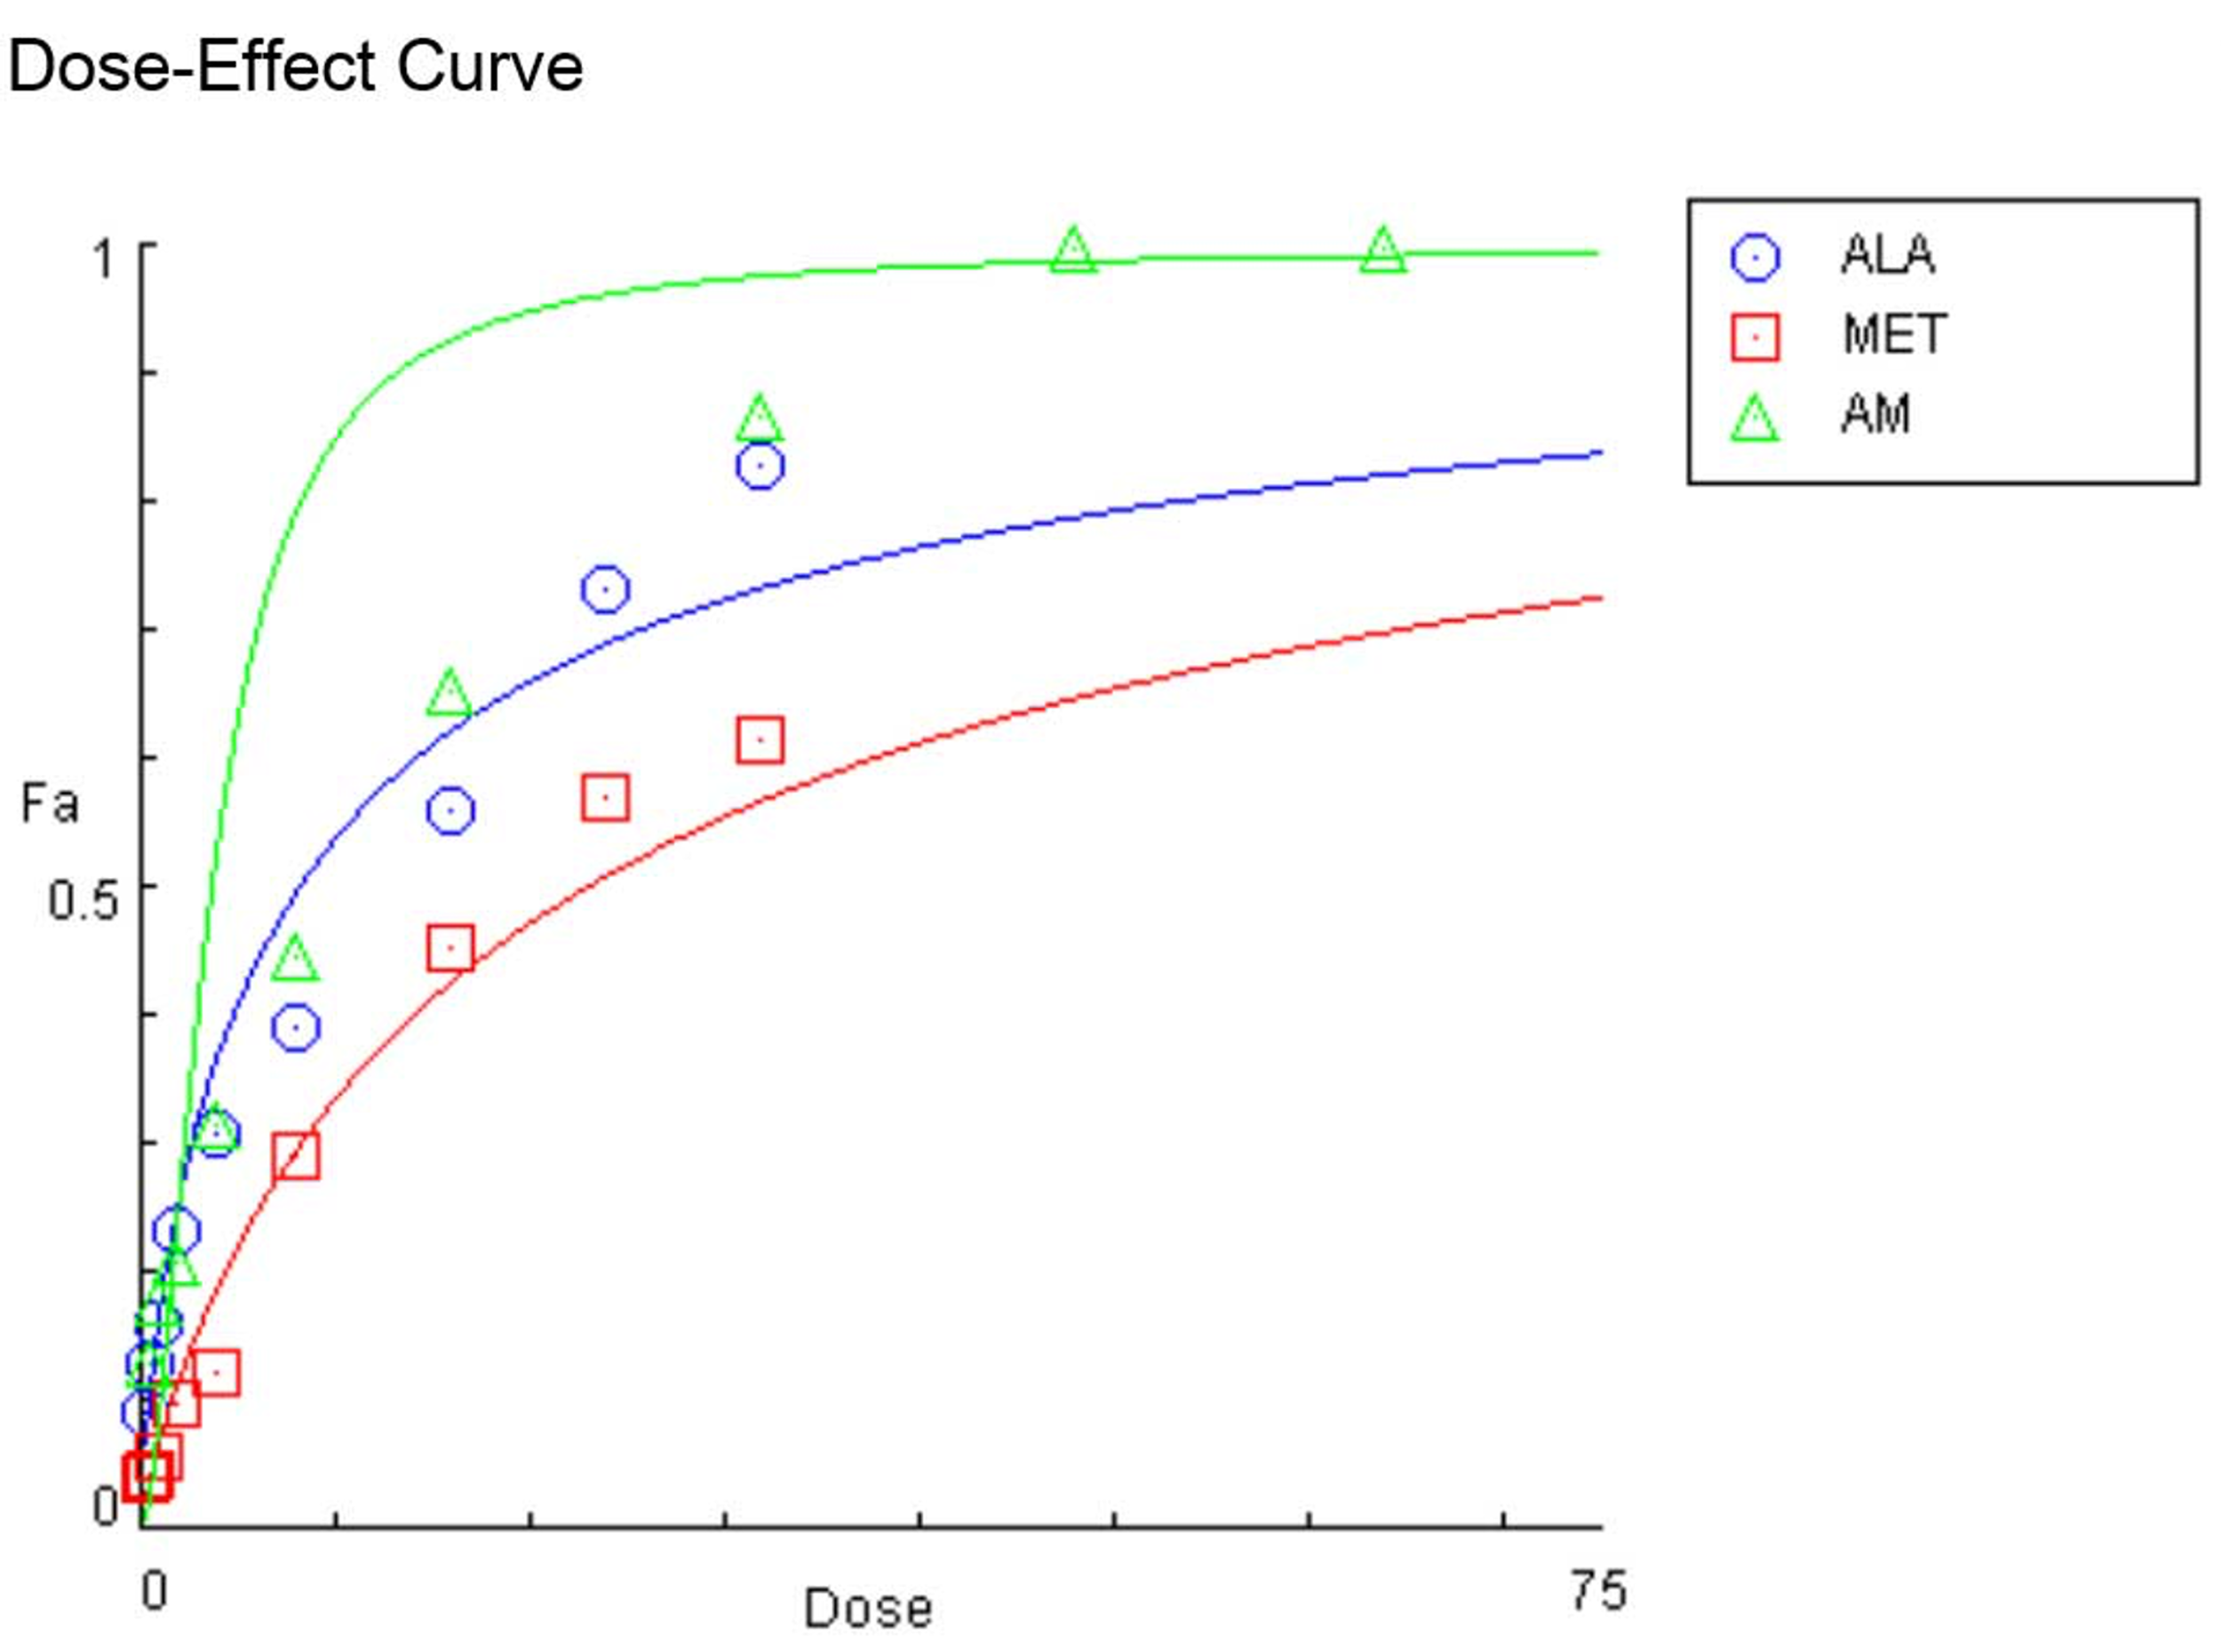
6A 6B
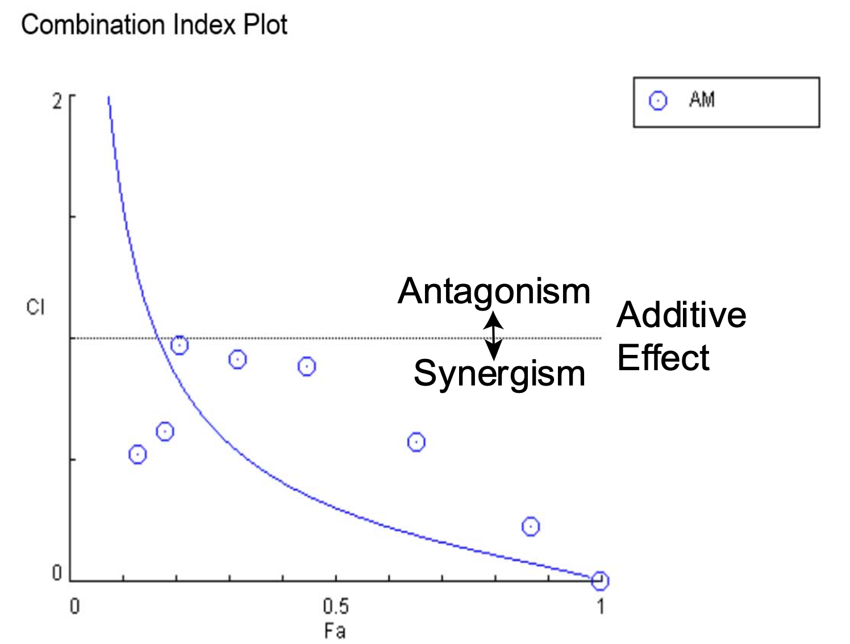
Figure 6. Graphical representations obtained from the CompuSyn Report for the ALA and MET combinations (see Supplementary Materials). (A) Dose-effect curves; (B) Median-effect plot.

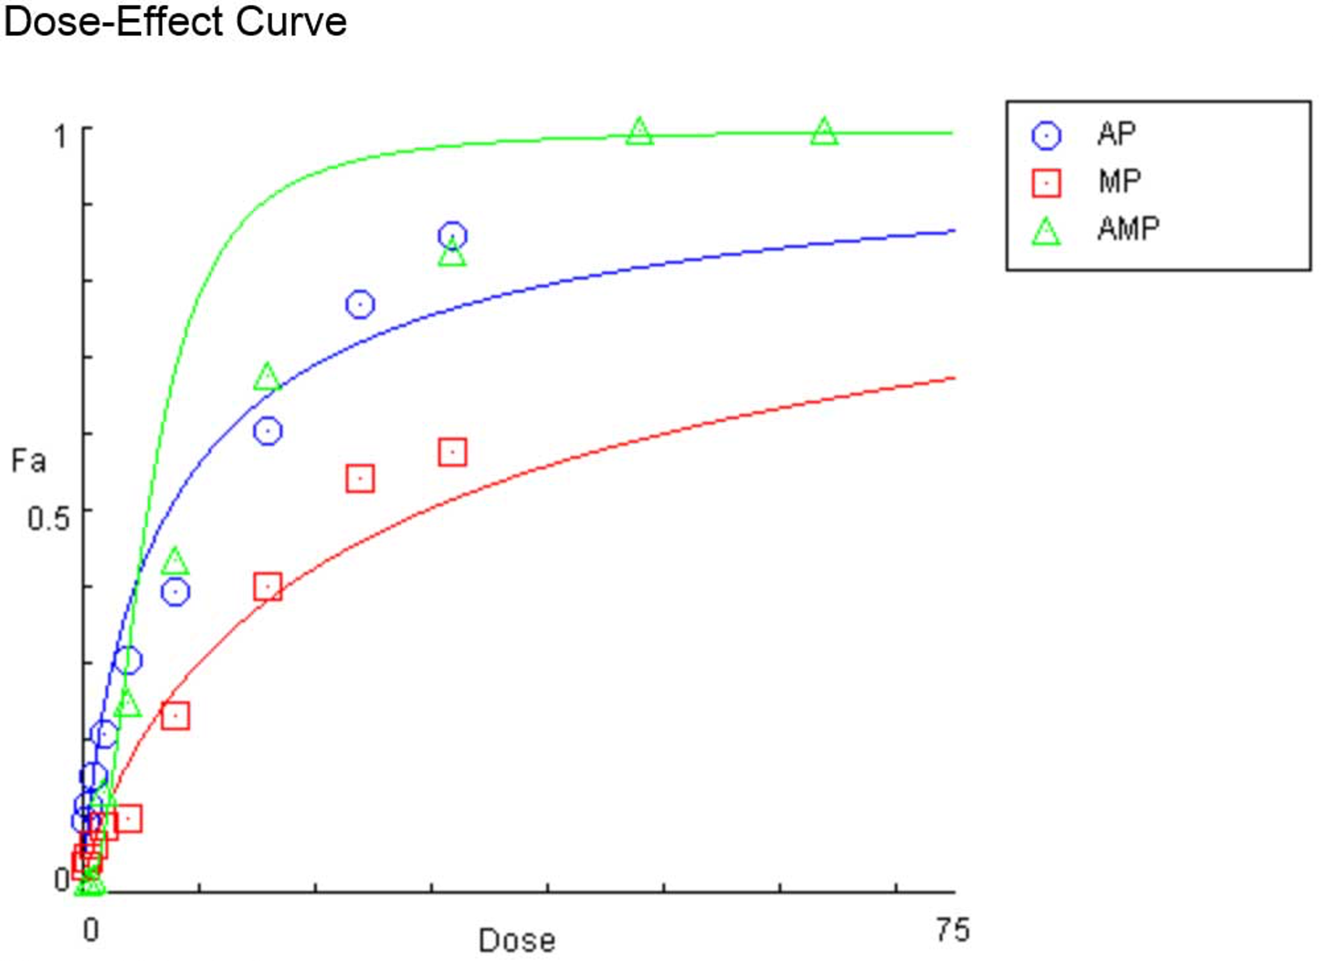
7A 7B
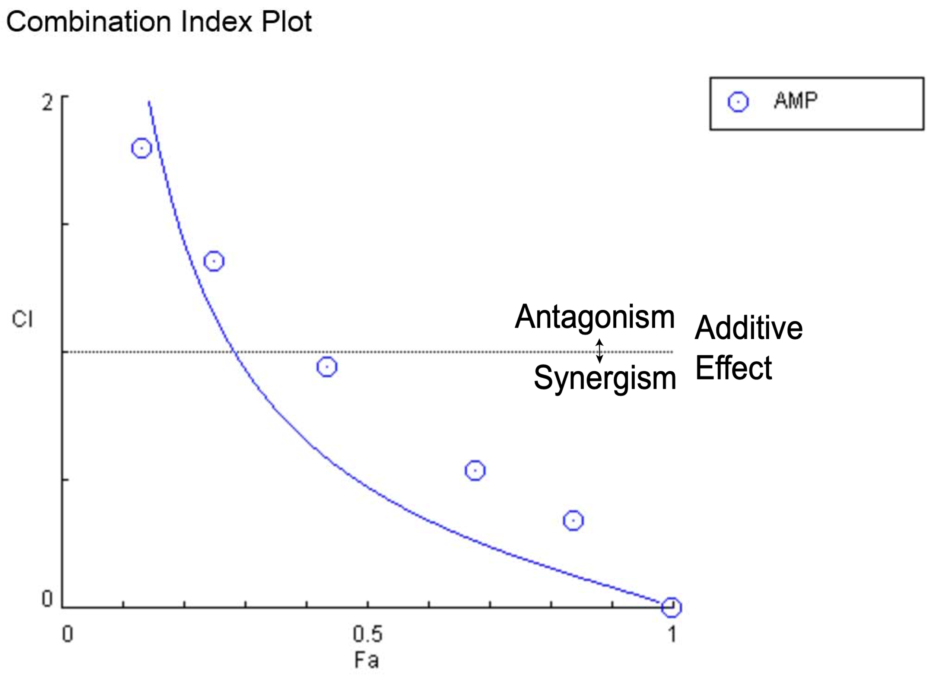

Figure 7. Graphical representations obtained from the CompuSyn Report for the ALA-PDT and MET-PDT combinations (see Supplementary Materials). (A) Dose-effect curves; (B) Median-effect plot.

8A 8B
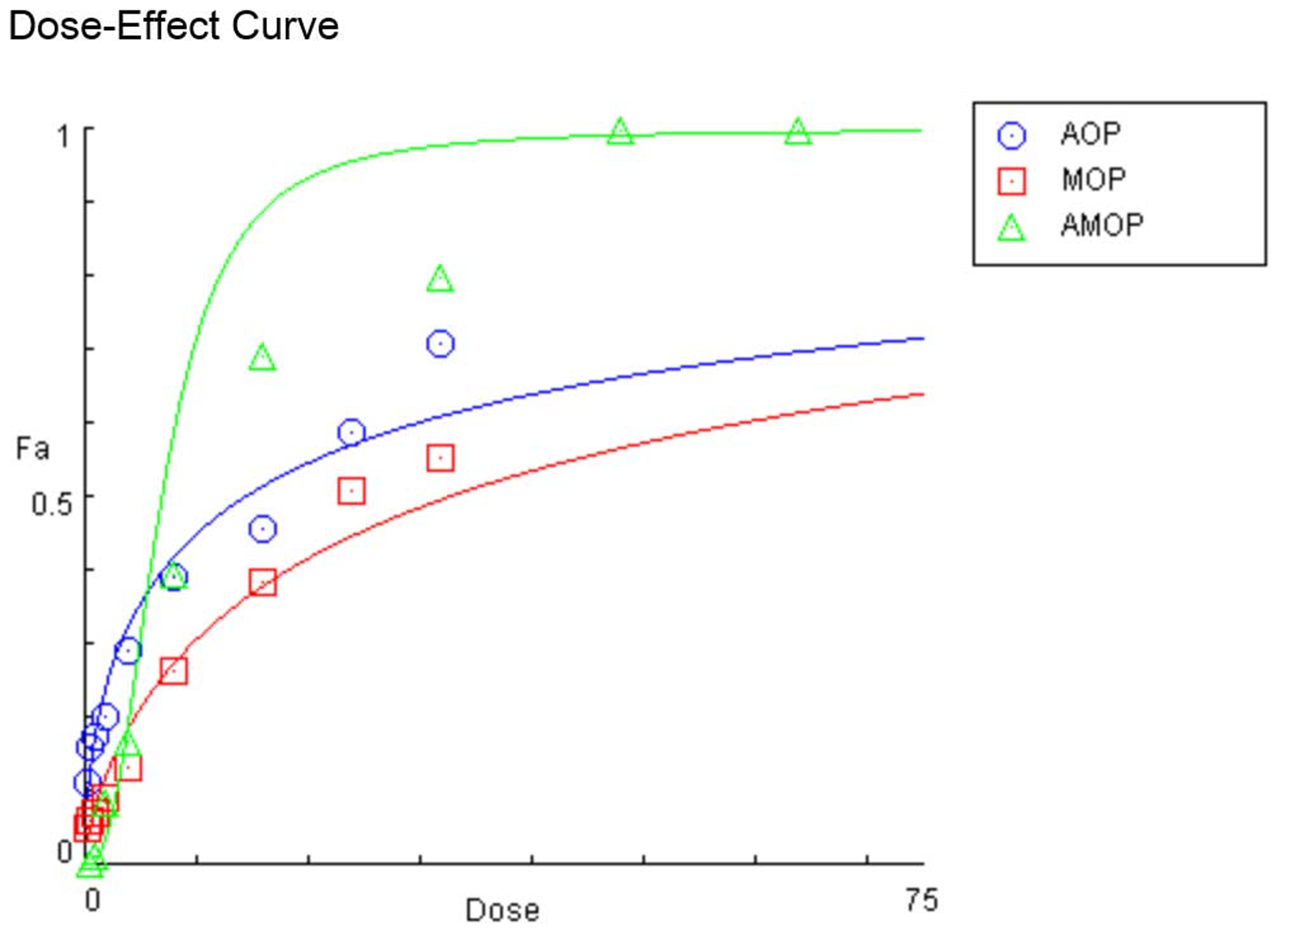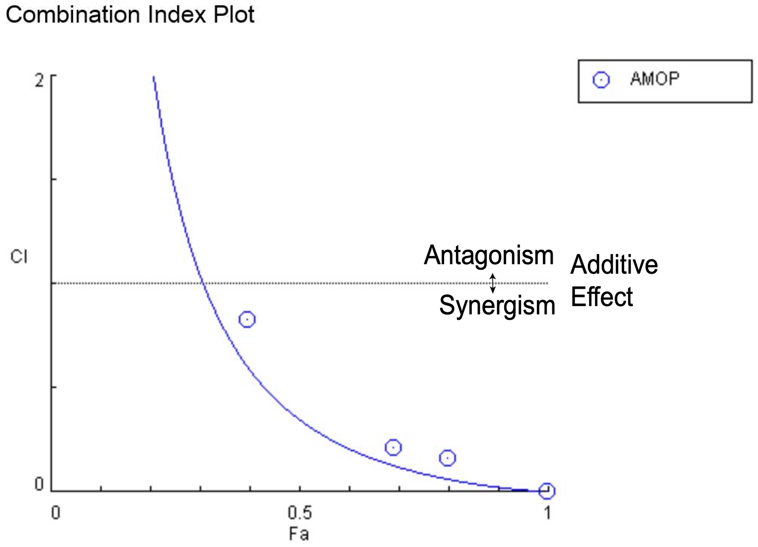
Figure 8. Graphical representations obtained from the CompuSyn Report for the ALA-OPDT and MET-OPDT combinations (see Supplementary Materials). (A) Dose-effect curves; (B) Median-effect plot.

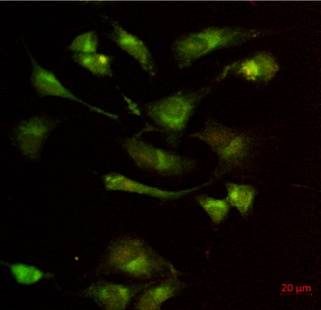
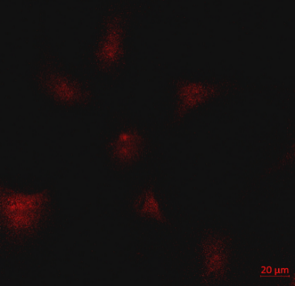
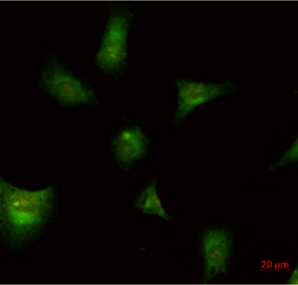
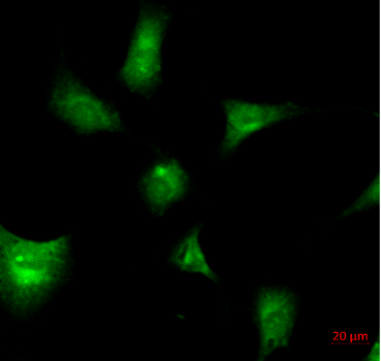
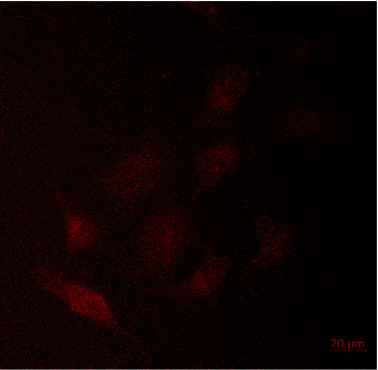
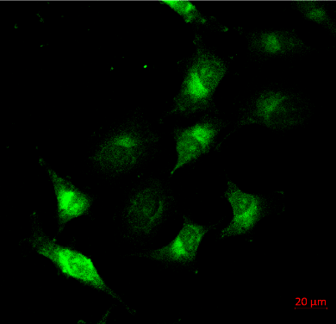
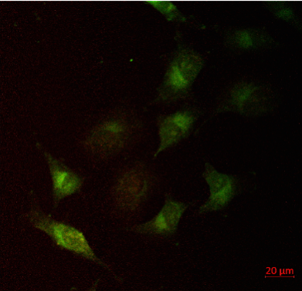
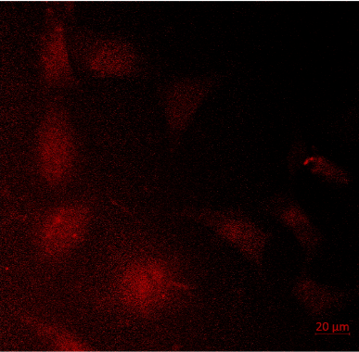
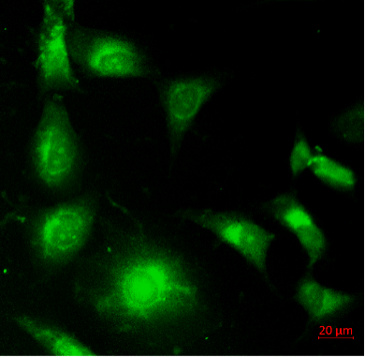
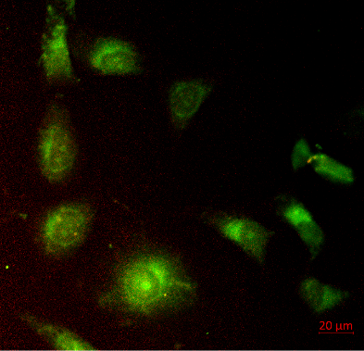
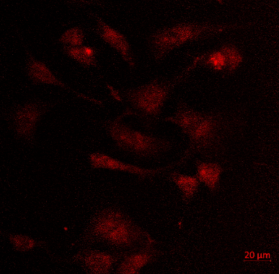
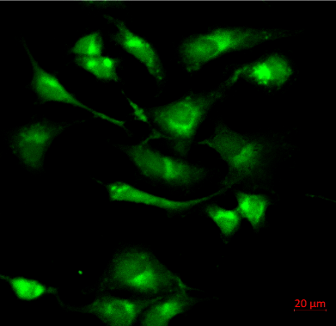
PPIX
MTG
Merged
ALA
ALA-MET
A
B
C
D
F
E
G
H
I
ALA-OPDT
J
ALA-MET-OPDT
K
L

Figure 9. Confocal microscopy analysis of (A) Protoporphyrin IX (PpIX) and (B) MitoTracker Green (MTG) fluorescence in MDA-MB-231 cells after oxyphotodynamic therapy (OPDT). Cells were incubated with 2 mM ALA then irradiated at 12 J/cm². (C) Co-localization of mitochondria. Fluorescence images were captured through the control of a monochromator under the conditions of 610 ± 20 nm for protoporphyrin IX and 530 ± 30 nm for MTG.

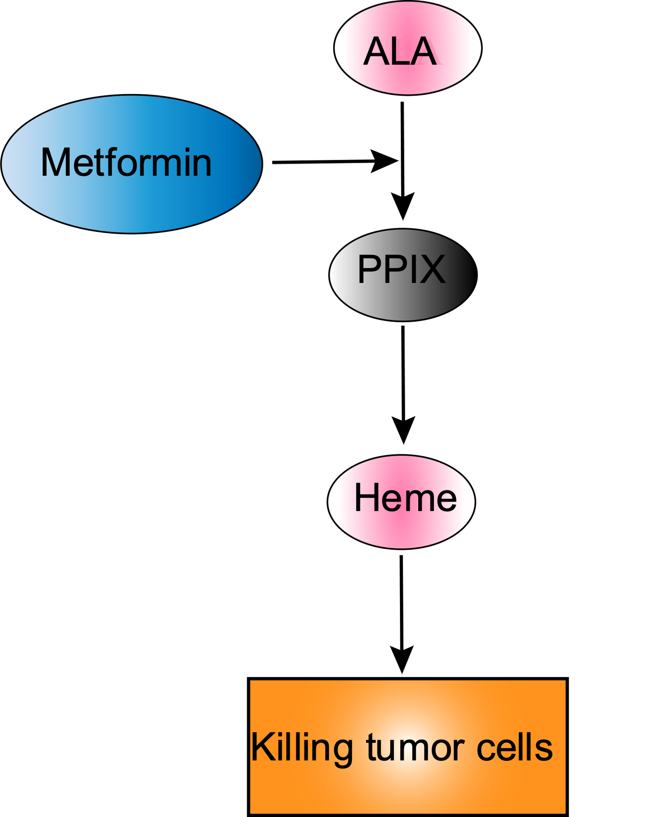
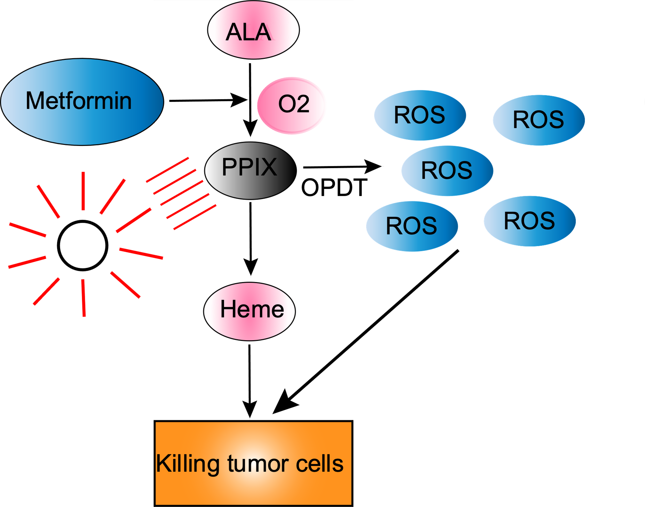
Figure 10.

