Tess
The Flight of the Valkyries

ILLUSTRATED EDITION
ANDRES MANN

Novel Green Publishing

Copyright © 2018 Andrew Manzini
All rights reserved.
All rights reserved. Except as permitted under the U.S. Copyright Act of 1976, no part of this publication may be reproduced, or transmitted in any form or by any means, or stored in a database or retrieval system, without the prior written permission of the publisher. This is a work of fiction. Names, characters, places, and incidents either are the product of the author’s imagination or are used fictitiously. Any resemblance to actual persons, living or dead, events, or locales is entirely coincidental.
Novel Green Publishing
V 177

To the real Tess, the inspiration for this story.

Tess – The Flight of the Valkyries

Table of Contents
Tess
Preface
List of Characters
1 Justice and Retribution
2 Making a Deal
3 An Interesting Idea
4 Growing Up
5 Sweet Freedom
6 Planning the Enterprise
7 Recovering Assets
8 Doing the Homework
9 Reunion
10 Funding the Project
11 Recruiting
12 A Base of Operations
13 Pick up and Deliver
14 Digging for the Truth
15 Cheerful Russians
16 Introductions
17 Family Time
18 Flight Simulators
19 Music in Spain
20 The MiG 21
21 Mechanical Things
22 Empty Hands
23 Making Fighter Pilots
24 Showing Off
25 The Barking Babysitter
26 Cossacks
27 An Acquired Taste
28 Young People
29 Covert Spy
30 Tracking Enemy Planes
31 Carmen Suite
32 Fighter Tactics
33 Upping the Ante
34 Maneuvers
35 The Agony of Defeat
36 Lose and Learn
37 Multitasking
38 Group Exercise
39 Hard Work and Jealousy
40 A Little Incident
41 Chasing Culprits
42 Blue Flag
43 Competition
44 German Interlude
45 Meet the Press
46 Nasty Surprise
47 Closing Shop
48 Wheel and Deal
49 Russians to the Rescue
50 Nice New Toys
51 A Life Not Lived
52 Eva’s Story
53 The MiG-29
54 Meet the Parents
55 Blockbuster
56 To Hell in a Handbasket
57 Talk to a Friend
58 Frustration and Rage
59 Selling Services
60 Come Back to Me
61 Help from Your Friends
62 Red Flag
63 Elephant Walk
64 A Whisper in the Ear
65 A Wrench in the Works
66 Help from a Rival
67 Reprieve
68 Moscow
69 Settling for What You Have
70 Two Sides of the Coin
71 Dinner at the Kremlin
72 Deception and Subterfuge
73 The Big Fight
74 News Summary
75 Enough is Enough
76 Farewell
77 Running Away
78 Face to Face
79 Melancholia
80 Two Wolves
81 Tying Up Loose Ends
About the Author
Other books in the Tess series
References

Preface
In a story of high passion and conflict, Claudine Bisson returns to the Valkyries team. She persuades Tess and her colleagues to provide adversary services to the Air Force, a plan that requires learning how to fly jet fighters. The Team acquires surplus aircraft and hires a team of Russian specialists led by the abrasive Colonel Peter Brusilov, a hard taskmaster. Laurent Belcour, the notorious villain, is back and continues to create obstacles. Claudine further complicates things because she has an ulterior motive: to get Jake back by undermining Tess. She pulls all the stops and uses Tess’s ex-lover, Vaughn Wentworth, to help compromise her. While the team struggles to prepare for the upcoming operation, they must deal with the destructive collision between Claudine and Tess, leading to unpredictable consequences.
This is an illustrated version of the book. Why? I thought that by providing pictures of the many aircraft in the story would help the reader better understand the scope of the challenges faced by Tess and her friends. Once I started searching for appropriate images, I couldn’t resist adding pictures of venues, people and other material that might be of interest. The choice of illustrations is entirely arbitrary.
The first draft of this book became an overwhelming treatise on pilot training and aerial dogfighting tactics. Subsequent revisions significantly reduced the technical material at the expense of possibly not meeting the exacting standards of professionals with knowledge and experience of the demanding art of military air combat. I apologize in advance for the oversimplification.
The narrative also describes classical music the talented Valkyries play on the side. If you don’t care for this type of content, please go to my Web site http://www.andresmann.com, leave a message and if you have a PayPal account, I will personally reimburse you.
The characters come to us from the U. S., France, Spain, Great Britain, Italy, Iraq, and Russia. In some cases, the syntax of the dialogue reflects its provenance.
This book is a work of fiction. Any resemblance of the characters to real persons is entirely coincidental. Much of this story is based on documented contemporary events that have been reported by international media. I have taken the liberty of adapting events featuring real persons and public figures, but the material in this book is invented.
The opinions and political commentary expressed in this work are solely those of the author.
Andres Mann

List of Characters

The Team at Strategic Resources Development (SRD)
Tess Turner, a military pilot and Vice President of the military services company, SRD.
Jake Vickers, married to Tess. An ex-CIA agent and President of SRD.
General Morgan Turner, retired. Tess’s father and now CEO of NTC, a manufacturer of advanced weapon systems.
Carmen Cabrera, military pilot, a great friend of Tess’s and a top manager at SRD.
Nicola Orsini, Carmen’s husband, Italian pilot, expert in European weapons systems and an accomplished linguist.
Galina Kutuzova, Russian military pilot, and database expert.
Alexander Mikhailovich Tukhachevsky, Alex Tuck for short, Galina’s lover and Russian weapons specialist.
Giuliana Malatesta, an Italian Air Force pilot qualified to fly helicopters and jet fighters.
Eva Bar-Lev, ex Mossad Agent, military pilot, and General Manager of SRD’s Paris office.
Yasmin Badawi, a Syrian archeologist, helicopter pilot and a member of SRD.
Claudine Bisson, military pilot, and former head of SRD in Paris
Ifeyinwa Idigbe Ukume, called Alice, a Nigerian detective.
George Kimmel, SRD military intelligence professional.
Joe Slezak, SRD Information Technology Manager at SRD.
John Powers, SRD Weapons Specialist.

The Villains
Laurent Belcour, former head of the International Development Organization (IDO).
Bertrand Dubois, aka Bert the Pimp, an associate of Belcour.

Other Characters
Aara Vickers, Tess and Jake’s adopted daughter.
Peter Brusilov, a retired Russian colonel, and legendary fighter pilot.
Boris Kovalenko, Brusilov’s lead engineer.
Gil Epstein, chief Technician for an Israeli electronics firm.
Vaughn Wentworth, Claudine’s husband. Renowned classical music conductor.

1
Justice and Retribution
ISIS, a terrorist group also known as the Islamic State, ISIL, or Daesh, swept through Syria in 2014, seizing a broad swath of territory and establishing its capital in Raqqa. It also conquered a third of Iraq and occupied Mosul, a large city north of Baghdad. ISIS soon engaged in genocide of minority groups, enslaved women, and used primitive methods of execution. They broadcasted videos documenting crucifixion, cutting throats of helpless people, and other unspeakable abuses against conquered people, all done according to an extreme version of Sharia law and in the name of Allah. After an epic and brutal struggle, Iraq and Syria defeated the cruel self-declared Islamic Caliphate thanks to the active participation of American and Russian air power, various insurgent groups hostile to the Syrian government and Kurdish forces who arguably did a lot of the fighting.
The victorious Iraqi government soon proceeded to conduct terrorism trials in a Spartan courtroom outside the newly liberated city of Mosul and invited Tess Turner and Jake Vickers to observe the trials, because they and SRD, their military company, fought against ISIS from the very beginning.
The Iraqi government built a wooden cage in the middle of the courtroom. Corralled behind bars, captured ISIS defendants faced a panel of three judges on a high bench, with two Iraqi flags behind them. A prosecuting attorney sat below the platform along with secretaries whose job was to record the proceedings. Lawyers occupied three rows of benches behind the cage. The families of the defendants were not allowed in the room.
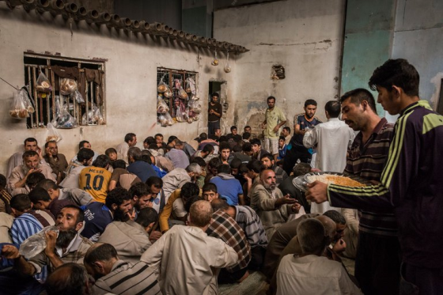
Source: deathpenaltynews.blogspot.com
ISIS Detainees in Mosul Jail
Guards brought a man called Raham into the courtroom. He stood facing the judges while a public defender sat behind him and took notes. The accused read a small banner above the judge’s heads imprinted with a partial Koranic verse:
'When you judge between people, judge with justice.'
One judge stood up and read the charges against the man. He then looked at the disheveled man standing in front of him and asked him a simple question.
“Did you come to Mosul from Turkey to join Daesh and murder Iraqi citizens?
“No, your excellency. I came to find work as a plumber. Daesh forced me to become a fighter.”
“In your capacity as a Daesh fighter, did you kill Iraqi citizens?”
“I had to follow orders. I regret everything.”
The judge raised his eyebrows and picked up a pen. He didn’t even look at the man when he said: “I find you guilty, and your sentence is death.” He signed the sentence and said “Next.”
The man’s trial lasted less than ten minutes. Guards dragged him out of the courtroom, and an hour later, they took him to the gallows and hanged him. That day, 36 other ISIS fighters followed him on the scaffold.
The men were among hundreds of foreigners detained in Iraq on terrorism charges. The accused, men, women, and children hailed from Turkey, Asia, Europe, Africa and even from the U. S.
Up to 6,000 more men and some women were on death row, and according to the United Nations, their nationalities, had not been disclosed. Many more militants were in custody, including at least a dozen Europeans.
Tess and Jake had seen enough and left for Paris. Such severe justice was hard to witness, but they understood that the extreme actions of ISIS made such retribution inevitable.

2
Making a Deal
The next day, cigarette haze lingered in the hallways of the Iraqi court. The prison guards passed smokes between them, lawyers and even the defendants held in two waiting cages at the end of the corridor. The guards and bailiffs allowed the detainees’ families to exchange furtive and tearful kisses through the yellow prison bars. But the guards had no sympathy for the accused.
One bailiff looked at captives with hostility. Daesh killed his brother, a police major, in the fight to reclaim Mosul. “And now I look after the ones who killed him,” the man said, pointing to his eyes, an Arabic expression of duty and selflessness. “I condemn you,” he said to the prisoners.
That day, the judges heard nine more cases alleging a variety of atrocities and killings of innocent citizens.
The guards ushered in two Turkish sisters. The prosecutor accused their husbands of having been administrative officials for the Islamic State in Tal Afar. When questioned by the judge, the women claimed to be housekeepers. They also said their husbands quit ISIS. Their court-appointed lawyer did not dispute the facts and just asked for mercy because his clients were women. The judges conferred, then the chief judge ordered the bailiff to bring the women in front of him. He told the sisters to come forward and sentenced them to life in prison.
Next, guards dragged six women into the courtroom. The prosecutor accused them of helping ISIS fighters by assembling explosive devices and even fighting against Iraqi troops.

Source: deathpenaltynews.blogspot.com
ISIS Woman on Trial in Mosul
The judge looked at the group and asked: “Are the allegation true? Did you kill Iraqis?” He did not wait for an answer. “I sentence you to death,” he proclaimed. The women gasped, and two of them cried as the bailiffs dragged them out of the courtroom.
The bailiff then called in two French citizens, Hassan and Yakout. The judge didn’t even bother reading the charges. “I condemn you to hang until death,” the judge said, not lifting his eyes from the papers in front of him.
There was little recourse for the condemned. European countries had given little indication they wanted to reclaim their citizens.
The bailiffs pushed the two men out of the courtroom, but instead of taking them to death row, they led them into a private room. An elegantly dressed man and an Iraqi lawyer were sitting in front of a desk, smoking cigarettes and sipping tea.
The guards forced the two prisoners to sit on two chairs and tied their hands behind them. Then they left.
One of the visitors took a puff of smoke and looked at the two captives, now resigned to their fate. He spoke to them in French.
“Messieurs, I understand that you are French citizens of Algerian origin. Is that correct?”
Hassan saw a glimmer of hope.
“Are you from the French embassy? Are you going to rescue us?”
“I am not sure we can do that since the Iraqis proved that you cut off a few heads on behalf of ISIS.”
“That’s a lie. They tortured us to admit we did that.”
“It doesn’t matter,” the Frenchman said while swatting a fly and extinguishing the cigarette on the ashtray. “I see only one chance for you to escape execution.”
Hassan waited for a minute. He looked at his fellow condemned and turned to the Frenchman.
“I assume you have a proposal that would save us from the gallows. What do we need to do?”
“It’s not complicated,” the Frenchman responded. “I can explain, and if at the end you agree to do what I suggest, we will board a private plane and fly back to France.”
“Please tell us what you want.”
The Frenchman talked for ten minutes and the men agreed to the terms he presented. Iraqi guards released the prisoners and shook the Frenchman’s hand. A substantial sum of banknotes changed hands. The deal was over.
A man driving an SUV picked up the Frenchman, two bodyguards, and the two prisoners and speeded to a private plane waiting on the tarmac. They boarded the aircraft and took off for Paris.

3
An Interesting Idea
At a country house just outside Paris, Jake and Tess had spent the weekend visiting little Jacques and Thérèse, Jake’s twins with Claudine Bisson.

Source: Pixshark.com
My concept of Little Jacques and Thérèse
Jake and Claudine conceived the children when they got together after Tess’s steamy affair with Vaughn Wentworth, a renowned conductor with whom Tess played a piano concerto in Moscow, a performance that became famous for her display of virtuosity. After many vicissitudes, Jake and Tess reconciled. Claudine accidentally met Vaughn and shortly thereafter married him because she wanted an official father for the children. Jake didn’t know about the situation until a year later. He came to love the toddlers and prevailed with Tess to see the kids on a regular basis. During the visits, Claudine and Vaughn stayed out of the way because Jake never forgave Vaughn for seducing Tess, even though the affair had been a matter of mutual attraction.
After visiting the children, Tess and Jake left them with the nanny and left before Claudine and Vaughn returned.
Even though Tess created the situation, she resented Claudine poaching Jake while Tess was involved with Vaughn. Tess’s reasoning was that Jake should not have sought succor from Claudine, let alone have kids with her. Nevertheless, at Jake’s insistence, they managed to see the toddlers on the weekend at least every two weeks while keeping Claudine and Vaughn at arm’s length.
As they were packing their weekend bags, Tess’s smartphone rang. It was Claudine, obviously not one of Tess’s favorite persons. Tess swiped the screen of her smartphone and answered the call.
“Hi, Claudine. We are packing and will be gone before you arrive to pick up the kids.”
“Tess, if you don’t mind, I would like you to stay so we can talk about something.”
“No can do, Jake is flying to Baku, Azerbaijan this evening.”
“That’s disappointing. I would have liked to see him.”
Tess suppressed her temper. “If you have something important to say, I can hang back, but Jake needs to go to the airport.”
“All right. I will arrive in 30 minutes.”
“Is Vaughn with you?”
“No. Of course, Vaughn would have loved to see you, but regrettably, he has to do a concert in London.”
Tess again tried not to express her annoyance.
“Fine, I will be waiting.”
Jake had finished loading the bags in his Land Rover and walked in to announce they were ready to go. Tess told him that Claudine wanted to talk with them.
“Is Vaughn with her?” Jake asked, hostility manifest in his expression. He could not abide being in the same room with the man.
“No, he is in London.”
“What does Claudine want?”
“I don’t know, Jake. She says it’s important. Take my luggage out of the car and go ahead to the airport. I will hang back to learn what Claudine wants. I will take a taxi to go home.”
“Okay, I am leaving. I am running late.” Jake kissed Tess on the cheek and made for the door. “Keep me informed, please. Love you.”
“Stay safe,” Tess said.
Jake left, and ten minutes later Claudine’s pulled up the driveway in her beautiful burgundy Maserati.
Tess took the toddlers by each hand and told them “Maman et arrivée,” mom has arrived.
The kids squealed as Claudine, looking gorgeous in a burgundy leather pantsuit the same color as the car, walked toward them. She crouched on the ground and opened her arms. Love and kisses all around. Claudine picked up little Thérèse and walked into the house with Jacques in tow. The toddlers now wanted to check out the toys that mom brought for them. The nanny retrieved several packages from the car’s trunk and the children promptly started to tear up the wrapping paper from the boxes.
“Did you enjoy my children, Tess? Did they behave?”
Claudine could not resist turning the knife every time she dealt with Tess, fully aware that due to an accident she couldn’t have children.
“Claudine, I don’t have time for your cattiness. Let’s get down to business. What do you want to talk about?”
“I am sorry, Tess. I didn’t mean to upset you,” Claudine said sheepishly. “I would like to explore a business proposition with you.”
“You want to come back to SRD?”
“Yes and no. just hear me out, and I will explain.”
“Okay, I am listening.”
“Last week, Vaughn and I had dinner at the house of a man called Cristian Benoit. He owns several military aircraft that his company uses to simulate dogfights against various European Air Forces. The American military used to do this type of thing by itself but recently concluded that it would be far cheaper to outsource the adversary role to companies that specialize in that kind of service.”
“Okay, so the boys like to play war. They use jets fighters to fly and chase each other. How can contractors do this cheaper?”
“Simple,” Claudine elaborated. “They buy surplus jet fighters from the U. S., Eastern Europe and Israel. They hire retired Top Gun pilots and other foreign pilots with the necessary skills. The contractors also set up schools to qualify pilots on various aircraft and foreign dogfighting tactics, and when they fly, they can do it at a price of four sorties for one compared to the costs incurred by the Americans. Another benefit of working with contractors is that the Americans don’t have to wear out expensive first line jets fighters to play the hostile squadrons. Everybody wins.”
“Claudine, obviously you miss flying, but now you have a musical career and two kids. Is it wise to jump into a dangerous new venture? What does Vaughn think?”
“Vaughn is not a factor. Frankly, I am ready to dump him. I was fun for a while, but his catting around is getting to be a bit too much.”
“Claudine, you knew that going in. In any case, I thought that you had an open marriage and regularly play concerts with him.”
“Let’s say that I am looking to get back in the game, Tess. I am bored.”
“Who will take care of the kids if something happens to you?”
“No problem. If anything happens, I am sure that Jake would love to take the babies. In any case, it’s not that we are getting into a real shooting war.”
Tess was still skeptical. “We got this far, but I am sure you have a strategy in mind.”
“I thought you would never ask,” said Claudine. “Let me share what I am thinking. We visit one or two of the contractors to find out how they operate. They are always looking for experienced pilots. As you know, I flew Mirages and MiGs, playing the big bad hostile against the French Air Force. I was pretty good at it, and I never lost an engagement. It didn’t make me popular with the French pilots because I invariably kicked them where it hurts. Anyway, I am well known as an outstanding fighter pilot.”
“That’s great, but at SRD we don’t have people with that kind of experience.”
“I don’t know, Tess. You can fly choppers and A-10 Warthogs. You have been delivering F-15s and 16s to Eastern Europe. Giuliana was in the Italian Air Force and Eva flew with the Israelis. The rest of the girls fly any number of aircraft. We’ll have to train them on dogfighting, and I know who can do it. Besides me, I know several excellent fighter pilots that would love to get involved in this. It would probably take six months to a year, but when we are done with training, we will have enough qualified people to do the job.”
“Why do you just talk about the girls?”
“Aha! That is my brainstorm. We create a separate division of the company. Let’s call them, say the Valkyries, a female squadron. This dovetails neatly with the name of your music group. Once we get going, we will present our adversaries with their balls on a platter. We will be in demand as the squadron to beat.”
Tess was intrigued. “Well, you sure think big, Claudine. I am sure that you know I will need to check with Jake about this. We would have to arrange financing for procurement of the fighter jets and find an air base we can use. We need to think this through.”
“I agree. There is no one else out there that can plan such things like Jake. I will, of course, be happy to help him in any way I can.”
“Claudine, you know that can’t happen,” Tess said with a sudden display of anger. “I don’t want you anywhere near Jake.”
“Come on, Tess. You need to get over this. It wasn’t my fault. You know that Jake came to me when you when you were making beautiful music in Vaughn’s arms.”
“You had no right to jump on his bones.”
“Why not? You were busy doing the same with Vaughn.”
“That was none of your business.”
“Let’s agree to disagree. In any case, it’s a moot point. Jake says he loves you and you guys are back together. Pity.”
“Claudine, I still don’t want you to have anything to do with Jake. It’s over. Just steer clear of him.”
“Promise, I will be a good girl. I will keep everything strictly professional.”
“Let’s hope so. I must go; my taxi is here. I will call you if Jake is interested in the venture.”
“That’s great, Tess. Please kiss Jake for me and say hello to the girls.”

4
Growing Up
Tess and Jake flew to New York to enjoy the debut recital of their stepdaughter Aara, who had just graduated from the Julliard School of Music. The event was held in Carnegie Hall.
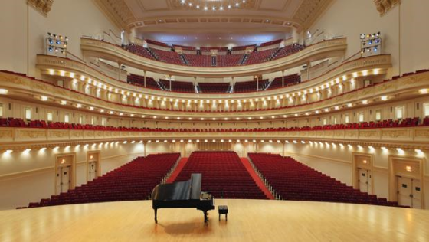
Source: WQXR.org
The intimidating venue of Carnegie Hall
Access to such an august venue was not usually possible for a new artist, but money talks. Jake and Tess rented the hall and hired a publicist to promote the concert. They also priced the tickets lower than those commanded by established artists. An impartial observer might suggest that the couple blatantly used their money to gain Aara an unfair advantage. Jake, on the other hand, was pragmatic and believed that in a competitive environment, playing fair was an unnecessary impediment. Life is often cruel and unfair, and he and Tess could afford to game the system. In any case, they felt that Aara had exceptional talent that should be presented to the public as soon as possible. The strategy worked. The hall tonight was almost full of discerning music lovers and tourists.
Aara walked on stage, dressed in a nice black dress, looking like the epitome of an elegant, accomplished exotic beauty she had become.
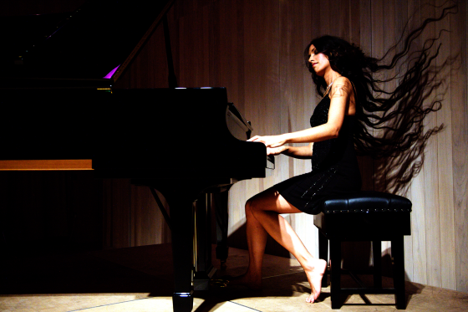
Source: HKW.de
Pianist Zoe Rahman
She started the piano recital with a few of Eric Satie’s Gymnopédies and Gnossiennes, atmospheric pieces each sharing a common theme and structure, using deliberate, but mild, dissonances against the harmony, producing a piquant, melancholy effect. Aara played with her hallmark sensitivity and delicacy. Next, she played some pieces from Mozart and Rachmaninov, finishing with an elegant interpretation of Schumann’s Symphonic Etudes.
The audience applauded enthusiastically while Tess and Jake made their way to the Green Room. They got there before Aara and met Madeleine, her friend that was visiting from Paris. Aara arrived a few minutes later and introduced her. It was hugs of congratulations all around for an auspicious debut. After Aara signed many program booklets for the fans, the four of them went to an upscale Chinese restaurant to celebrate. Jake, the resident gourmand, insisted on sharing several dishes. The food was excellent and the conversation even better. Tess made it a point to make Madeleine comfortable, and the poised young woman shared her passion for music and her native city. She was the financial officer of a small firm and had an apartment in the middle of Paris. There was no question that she greatly admired Aara and kept showering the girl with compliments about her gorgeous gown and her artistry. The warmth between the two young women was infectious, and the group ended up spending more time than planned at the restaurant. Eventually, Jake and Tess took a cab to their apartment, and Aara elected to stay with Madeleine at her hotel.
Once home at their high-rise apartment, Tess and Jake enjoyed a familiar routine. They changed into comfortable clothes and had some brandy while sitting on the balcony, admiring a splendid view of the lighted city.
Tess was quieter than usual, and Jake detected that something was percolating in her mind. Finally, Tess shared her thoughts.
“Jake, I am concerned about Aara’s relationship with Madeleine. They seem to be very affectionate toward each other. It’s almost romantic.”
“Why are you worried about that?” Jake asked. “Aara is a big girl now, and I am sure that she can handle herself.”
“I am not concerned about that, but I would not approve of a lesbian relationship or any relationship at this stage. Aara is young, and her priority must be to develop a musical career.”
“First of all,” Jake pointed out, “Aara is mature enough not to get into situations she can’t handle. She proved that when she wrenched the shoulder on that unruly Turkish fellow in Istanbul. In any case, if she prefers girls, I don’t see that as a negative. It’s much better than putting up with men, most of whom are pigs anyway. All you have to do is look at the #MeToo movement to get a compendium of how truly despicable men can be.”
“Jake, here you go again. Stop that! Certainly, none of the guys in our team fit that description. I am proud of every one of them.”
“I agree, our guys are great, but you must admit that we were very selective when we hired them. I still maintain that the average man is a lascivious pig, rutting after every skirt he sees. So, I don’t feel comfortable judging Aara on her choice of companion. I will support whatever she wants to do.”
“So, you are not upset that Aara might be gay?”
“No, I am not. It’s her life, and she has the right to do whatever she wants.”
“Jake, sometimes I think you need a shrink.”
“Why?”
“Because you are still mad about what happened between Vaughn and me. You refuse to believe that it’s over. I am here with you, am I not?”
“Yes, that correct, but are you really done with that man? When we were at Belcour’s place last year, everyone noticed that you still had the hots for each other.”
“I wish you would stop insulting people. Vaughn is an extraordinary man, a musical genius and the only man that can compete with your level of intellect and accomplishment. He doesn’t deserve your contempt.”
“He is lucky I did not cripple him for looking at you that way. What bothered me even more, however, was your reaction in his presence. You still are attracted to him.”
“Get over it, Jake. I’m done with Vaughn. How many times do I have to tell you that?”
“When you show that you mean it.”
Tess was now frustrated. “You are acting like you are the innocent party. How did you end up knocking up Claudine? Do you think it’s easy for me to visit the kids most weekends, knowing that they are not mine? Claudine never lets me forget it.”
“You know damn well that I went with Claudine after you got involved with Vaughn.”
“And you couldn’t wait until things worked out? I was about to dump Vaughn.”
“Thank you very much; very magnanimous of you,” Jake said with anger. “It’s late. I’m going to bed.” He stood up, put his glass on the counter and walked away.
Tess did not like these frequent fights. Jake consistently flew off the handle at the mere hint of his past rival, and it appeared that he was getting worse. He was still acting like a wounded animal, his bitterness gnawing at him. Tess had acknowledged her mistake, and she wanted to move on, but it seemed that Jake was not ready to do the same. When they reconciled, Tess and Jake rekindled their flame for a brief time, but slowly regressed into a routine and sometimes testy relationship. She was starting to worry. It seemed that every time they visited his children, Jake’s joy was always tempered by the circumstances that led them there.
Tess now realized that she had made a mistake in agreeing to Claudine’s business plan. It was evident that Claudine still wanted Jake back. The new venture would bring all the players in contact with each other again. Tess resolved to keep the situation from getting out of control. She never shied away from challenges, but this was a tough one.

5
Sweet Freedom
Laurent Belcour’s reliable friend and partner Bertrand Dubois managed to get him released from prison by producing two ISIS terrorists that under questioning by the French judiciary confessed that they had smuggled dirty bombs from Russia and hid them in the basement of Belcour’s chateau without him being aware of it. This improbable story raised skeptical eyebrows, but Belcour’s case was helped by a group of politicians and influential people that put pressure on the government to accept the new evidence and release the ‘wrongly accused’ distinguished gentleman who at one time could have been elected as the President of France. Much of the support came from people that enjoyed Belcour’s famous Soirées, orgies attended by well-heeled participants.
Dubois obtained the cooperation of the two ISIS men by helping them avoid execution in Iraq, bribing the appropriate people and by providing financial support for the men’s families.
Once released, Belcour had a lot of catching up to do. Now that he was out of jail, he took a few days to relax and indulge in the pleasures of his bordellos.
Having temporarily satisfied his sexual cravings, Belcour took a private plane to his chateau in Provence. The government had seized the estate when they first arrested him, but now he could use the house while waiting for the processing of paperwork restoring the property back to him.

Source: Houseplanshelper.com
Laurent Belcour’s Chateau
The chef had prepared a sumptuous repast that Laurent enjoyed with Dubois. Afterward, the discussion turned to retribution against Tess and her Valkyries. Laurent would never forgive them for engineering his downfall. Dubois suggested that perhaps it would be better to forget about the women who had been a constant source of trouble for them, but Belcour was determined to make them pay for what they did to him. He was particularly upset that his own daughter Giuliana was the key to his downfall. Belcour wasn’t aware of having a daughter in the first place because years ago he had walked away from her pregnant mother. Even so, he resented that the first thing Giuliana did was to work with Tess to bring him down. She also tried to shoot him dead and would have succeeded if it wasn’t for Tess talking her out of it.
Laurent was upset about another issue: his plan to run more of his famous soirées, essentially orgies for wealthy people, now faced competition from an unexpected quarter: California’s Silicon Valley. It seemed that geeks who in their early years were busy programming computers and for the most part did not find the time or were too unattractive and disheveled to date and have sex with women were now able to make up for the lost fun. The techies were now owners of substantial companies that made them obscenely wealthy.
The Silicon Valley get-togethers were similar to Belcour’s soirées, but they seemed to be hosted by different affluent people and were held in various places in California and sometimes in European resorts. No one was charged for attending, and female tech entrepreneurs were pressured to participate. Refusal to do so was labeled as “not cool,” with potentially adverse consequences both personally and for their businesses.
Laurent resolved to investigate this development by participating in the next event. He knew he would be welcomed because he was a substantial investor in the tech industry. People with money were always welcome. In the meantime, he reviewed a few solicitations for investment from several sources. It was time to pay attention to his neglected financial portfolio.

6
Planning the Enterprise
Tess was mad at Jake. All too often, every time she came up with a new scheme to save the world or whatever, he had the annoying habit of pouring cold water on her plans. The problem was that Jake was often right because many of Tess’s well-intentioned do-gooder schemes were either not feasible, impractical, or too expensive to pursue. A few years ago, she had almost bankrupted the company when she got everyone involved in a worldwide struggle against human trafficking that unfortunately didn’t even put a dent into the heinous practice. She also wanted to get involved in helping with the refugee crisis in Europe, but Jake managed to talk her out of that scheme.
Four years ago, Tess and Jake needed to raise funds to continue fighting against human trafficking, and Jake had a brainstorm. Tess as a young woman was planning to study piano at a conservatory, but she decided on an army aviation career instead. She was still a fine pianist, however, and gave many recitals that were well received. Jake thus proposed to increase revenue by creating a classical chamber music group composed of talented female employees as players. Tess thought that it was a great plan and recruited her closest colleagues to play several benefit concerts. At the beginning, their playing was spotty, so Tess, an obsessive perfectionist, hired music teachers to enhance the skills of the Valkyries Ensemble, the name Jake coined for the group. The women greatly improved their playing and gradually became well known. The company ended up as a peculiar group of military women who could also play great music and make some money from it at the same time.
When Tess presented Claudine’s plan to Jake, surprisingly he did not find reasons why it couldn’t work, so the next day they went to visit General Morgan, Tess’s dad. He had retired from the Army a few years ago and became the CEO of NTC, an advanced armaments firm that supplied aircraft components to the aerospace industry. Tess and Jake valued his advice and met with him often to discuss business issues. This time, they wanted to talk about Claudine’s idea.
As they walked into the lobby of the office complex, Tess and Jake noticed that Claudine was already there. She waved and walked toward them, wearing a sexy business suit, and sporting her usual devastating smile. She went straight to Jake and gave him a little kiss on the cheek. Tess tried not to show her annoyance. Sensing an impending storm, Jake quickly suggested they meet General Turner in his office.
After the usual greetings, they all sat on comfortable chairs around a large coffee table.
Claudine started the meeting by presenting the flying Valkyries concept. The General was intrigued, mainly because he was perennially on the lookout for new profitable ventures. However, he was aware that persuading Jake to embark on a new scheme invariably meant slamming against his son in law’s formidable intellect and memory, and the fact that he always came impeccably prepared.
“So, Jake, do you think that the military will save money by using contractors to play the bad guys against our pilots?”
“Well, in 2014, partly due to budget restrictions, the Air Force deactivated its 65th Aggressor squadron, one of three units responsible for ‘Red Air’ duties. They did it because of the high cost of maintaining squadrons of F-15 jet fighters for that purpose. I am not sure that move made sense, but they did it anyway.”
“To be fair, the Air Force leadership had to deal with severe budget constraints due to the sequestration policy,” said the General.
“You are correct,” said Jake. It’s hard to stick to the budget when the F-16C goes for $8,278 for an hour of flight, the F-15s ranges around $21,000 to $23,000. But that pales when we look at the new fifth generation of fighters. Now, in the name of progress, we developed stealth aircraft like the F-22A that costs $33,538 per hour to run. We stopped making these planes because their cost was astonishing, topping at 300 million a copy. Now the defense industries have come up with the F-35, which costs a mere 89.2 million a copy and $28,445 per hour of operation. The new budget spreads $36.3 billion across a couple of dozen different aircraft, but $22.7 billion are earmarked to buy 255 F-35 Joint Strike Fighters. You do the math.”
The General was used to Jake’s encyclopedic prowess and smiled. “Look at the bright side, Jake. My company is making a lot of money.”
“Seriously,” Jake continued. “Claudine is correct. The service is currently looking to outsource more adversary training and must admit that it could be an opportunity for us.”
“Outsourcing Air Force duties to private contractors is nothing new,” Claudine noted. “There are now several companies currently providing training and operational services. Draken International, based in Pensacola, Florida operates a fleet of former military aircraft flown by experienced retired pilots. Their claim is that they can fly three to four sorties for the cost of one the Air Force can do with its F-15 fighters.”
“Yes,” the General pointed out, “but I recall an article that said such contractors are overpriced and underwhelming.”
“Even so, the Air Force and Navy have little choice but to hire them.” Jake referred to information displayed on his smartphone. “Nellis was short 3,000 adversary training sorties in 2016 — a total expected to rise as training on the F-35 program ramps up. They contracted with Draken because the latter can do it cheaper and because they represent adversary tactics."
Tess was getting bored listening to the tech talk.
“Where do we go from here? Is it feasible for us to get involved in this business? I believe we can. Most of us are qualified to transport various jet fighters. We have trained foreign pilots to do basic flying and our guys showed the ground crews how to maintain the planes.”
Jake ran his fingers through his hair. He always did that when thinking hard.
“Delivering planes and teaching people how to fly them does not make us fighter pilots. We are talking about skills that are way beyond our current capabilities. What you propose means taking most of our female associates off current projects and spend at least six months in intensive training, assuming we can win contracts with the military.”
“Oh Jake, don’t be a party pooper,” Claudine interjected. “Let’s look at what we can bring to the party. We can all fly fighter planes. All we need to do is to learn how to simulate combat, shoot down other planes, and avoid getting ourselves shot down, of course. I can be fun. The French pilots still hate me for beating them during combat simulations. I can share my experience and get everyone up to speed sooner than you think.”
Tess suddenly flared. “Are you suggesting that you want to be the squadron leader?”
Claudine lighted a cigarette and took her time to respond. “Tess, I know that you are used to be the top hen in the coop, but you must admit that you don’t have the experience to teach combat flying skills to the girls.”
“I can become as good as you are.”
“Perhaps,” Claudine said while inspecting the shade of her nails, “but this time I get to run the show, for the simple reason that I am the only one with the requisite experience. After you get up to speed, I would be happy to fight a memorable duel in the sky with you.”
Jake saw that Tess was about to blow her top.
“Cut it out, you two. This is serious business,” said Jake, now clearly annoyed.
General Turner looked at his watch.
“Can we get back to the agenda? Please.” He turned to Jake. “How about financing this crazy venture; where are going to do the training and buy the planes?”
“We don’t need state of the art fifth-generation aircraft,” said Jake. “In any case, we can’t afford them. We need to find surplus refurbished planes and update their avionics, install advanced radar and such. For financing, I am sure that with a good business plan we can find investors.”
“I know where we can buy MiG-21s cheap,” said Claudine.
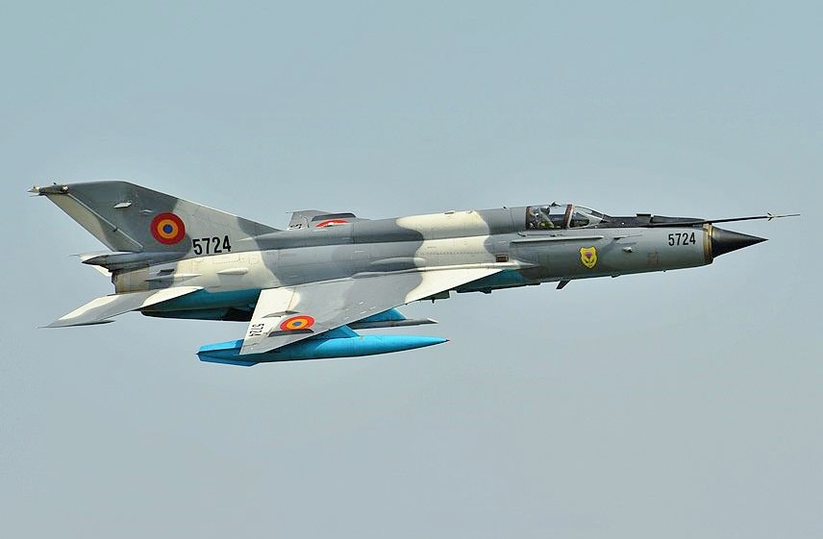
Source: Photo by Cristian Ghe on Wikimedia Commons
Romanian Air Force MiG-21 Lancer C.
“You have to be kidding,” Tess interjected. “MiG-21s are ancient. In any case, didn’t you get almost killed flying one of those things in Nigeria?”
“It was a poorly maintained Chinese clone,” Claudine said, dismissively.
“These planes are obsolete,” Tess said.
“Yes, and no. The MiG-21s are still viable, plentiful, and cheap. Draken has 30 of them, and they are trying to unload them. We can get them for a song.”
Jake shook his head. “The MiG-21 is not known for its range. It can only fly for 30 minutes before refueling, not to mention it’s radar capabilities are limited.”
“True, but many of the available planes have very low-time airframes, and they include the latest bis models. They are low-cost supersonic fighter jets, and they would make a great platform for air war simulations, but as of now, there has been almost no demand for them. That’s why Draken stores the planes at their Lakeland facility.”
Tess folded her arms under her chest and laid back on the chair.
“In other words, you suggest we buy planes nobody wants.”
“We can make this work,” Claudine responded. “I have flown this aircraft, and with upgraded avionics, it will do the job.
“How about maintenance? These things are relics,” Tess said.
“Tess, stop sniping and look at what can we can do, “Jake noted. “Alex Tuck and Galina have contacts in Russia. I am sure they can hire technicians and trainers, and they will be cheap to employ. This crazy idea might work.”
General Turner tried to conclude the meeting.
“So, it appears that this scheme is feasible. My question is why you would want to do this work. You currently have a very successful business training, delivering planes and weapons. Now you want to up the ante and pursue a new extremely demanding new business. Does it make sense to you?”
“I have to admit that currently, we have a comfortable business situation, but that’s a problem,” Tess said.” The work has turned routine, and people are starting to get bored. Yes, what we are talking about will be a very challenging new venture, but I believe the staff will go for it. We can’t keep working as glorified bus drivers with no end in sight. It’s getting old.”
“If you are looking for investors, I’m in,” General Turner said.
“Are you going to buy surplus MiG’s from Draken?” Claudine asked.
“No. I don’t want to let our competition learn about our plans,” Jake said. “We will buy aircraft from somewhere else and keep a low profile.”
Jake stood up. “This is it then. We will put together a team to work on finance and logistics and hire a Russian crew.” He then turned to Claudine: “Welcome back.”
Claudine flashed her famous smile, stood up and gave Jake a peck on the cheek. Tess frowned.

7
Recovering Assets
Laurent Belcour settled comfortably in his beautiful chateau in Provence. Consumed by a desire for revenge, he spent several days obsessively planning the downfall of Tess and her Valkyries. By now, he was acutely aware that the women and their organization were formidable, particularly now that they had managed to get their hands on the considerable inheritance bequeathed to the young Aara by General Amir al-Saadi, her late father. A key provision of the will required that Aara marry into a Muslim family, a condition that Laurent suspected would not be acceptable to Tess and Jake. Laurent plotted to grab the money by working with his lover at the time, Amir’s sister Fadime al-Saadi. In the end, Jake and Tess surprised him and grabbed the cash by having Aara marry a young Turkish student, thus fulfilling the primary requirement of the will. The money, almost half a billion, was appropriated the next day, leaving Laurent and Fadime facing the failure of their scheme to get their hands on the fortune. Laurent now smelled a rat. Did the young Aara marry the young Turkish man, or was the wedding nothing more than a sham? Laurent suspected so because Jake initiated divorce proceedings the day after the wedding. That fact alone was enough reason to question the validity of the marriage. If Laurent could prove that, there was a chance that Fadime could have a shot at becoming the true heir.
After laying out a preliminary plan, Laurent got on Skype and connected to Fadime in Buenos Aires. When Fadime opened the application, she saw a smiling Laurent waving.
“Laurent, are you out of jail? I thought they put you away for a long time.”
“Fadime, my love, you sound almost disappointed that I am no longer incarcerated in a god-awful prison. I am out, liberated, fit as a fiddle and good to go.”
“How did you get out?”
“It’s a long story, and it doesn’t matter anymore. Let’s rejoice. Come back to Paris, and we’ll talk. I miss you.”
“Well, I am kind of bored,” Fadime said. “I would love to come back to Paris, but you must swear that you are done with your schemes. I don’t think I can take any more drama.”
“Fadime, our very existence is based on drama. It’s what makes life interesting. Just come on over, and we will have a lot of fun. I assure that I have no intention of getting in trouble again. I just want to see you. I missed your company.”
“I’ll bet. Don’t insult my intelligence, Laurent. Tell me what you are up to.”
“Not much, other than the possibility of reopening the issue of Amir’s money.”
“Laurent, I don’t want to deal with Tess and her crew anymore. I think you should get over it too.”
“What if I tell you that Aara’s marriage was a fraud and that we have a good chance of proving it.”
“What are you driving at?”
“I think that we can grab the money after all.”
“Laurent, now you are scaring me.”
“Fadime, are you telling me that you couldn’t use a lot of millions in your bank account.?”
“Amir made sure that I would have a nice income.”
“Think about what you could do with a few hundred million more.”
“You are incorrigible, Laurent. Now that you are free, why don’t you keep a low profile?”
“You know me, my love. I hate to be bored. I also think the time has come for revenge. We can’t let Tess and her people get away with what they did. They literally stole your money.”
“Laurent, the money was meant for Aara in the first place. We were the ones trying to take it for ourselves.”
“So? We now have an opportunity to revisit the issue. In any case, wouldn’t it be nice to come to Paris and enjoy my attentions? I miss you. Please come, and we will talk some more.”
“Let me think about it.”
“No need to worry, love. Shortly, a messenger will deliver a first-class ticket for the next flight out of Argentina. Don’t even bother to pack. We will go shopping as soon as you get here.”
“You assume too much, Laurent.”
“I am merely lusting after you, love. You are still gorgeous, I see. I am craving your magnificent breasts. My mouth is salivating, not to mention my loins. Also, I hear you don’t have a boy toy presently. What do you have to lose?”
“All right, Laurent. I’ll come, but you better have your act together. I don’t want any trouble.”
“Don’t worry about a thing, my love. Just think what I will do to your yummy body when you get here. I am ravenous.”
“Now that you put it that way, how can I resist? I will see you in a couple of days.”
“I can’t wait. Please hurry.”

8
Doing the Homework
Jake and the company’s Russian weapons expert Alexander Mikhailovich Tukhachevsky, aka a less tongue-twisting Alex Tuck, did some research and concluded that the most cost-effective fighter jet for their purpose was indeed the Russian made MiG-21 that Claudine suggested. Moreover, Alex found out that the U. S. Air Force simulated adversary aircraft to mimic the maneuvering characteristics of the Russian MiG-21 and MiG-29. The former was an older fighter jet, available in great numbers, and was by far the cheaper option.
Before making a commitment, Jake wanted to talk with someone who could share information on operating the aircraft. He and Alex found an aircraft hobbyist that might be able to help. They drove to a small New Jersey private airport to talk with Jules Berman, aka JB, a wealthy businessman who was a qualified MiG pilot and a collector of warbirds.
When Jake and Alex arrived at the airport, a mechanic told them that Berman was still flying one his planes. Sure enough, a MiG shrieked overhead, made an almost 90-degree move upwards and pivoted in mid-air, then inverted.
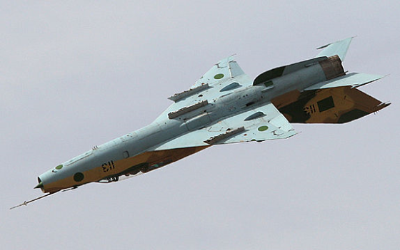
Source: Incredible-adventures.com
Inverted MiG-21
Next, the pilot returned to a lower altitude, flying into a corkscrew. It looked like it was going slam to the ground, but at the last minute, the plane recovered, circled the airport, and made a noisy landing.
An airport worker wheeled a ladder to the cockpit, and the pilot stepped down to the ground.
“Sorry to keep you waiting, gentlemen, JB said. I was trying a new fun routine.”
“For a moment, I thought you were going to crash,” Jake said as he shook the man’s hand. “I am Jake Vickers, and this is my colleague Alex Tukhachevsky.”
“Let’s go cool off in the bar,” Berman said while handing the flight helmet to an attendant.”
“That was an impressive demonstration,” Jake said.
“Flying that thing is a blast, but it’s it an expensive and dangerous hobby,” Berman said. “I love to do this, but I don’t claim that flying that thing is for everybody. It’s kind of crazy, not to mention expensive.”
The three men settled at the airport’s watering hole and Jake bought beers.
“I now see why they recommended you as someone that knows a lot about these planes, Mr. Berman.”
“Call me JB, the man said.” He took a sip of beer. “I have two MiG-21s, and I fly them at least a couple of days a month. On the surface, they seem cheap, but in fact, they’re expensive as hell to run. I’ve seen airworthy MiG-21’s going for as little as about 50 thousand, although the latest version with low hours and some updates will probably sell for $150,000 a copy. However, the seller is often on the other side of the planet, you need to transport the aircraft to where you live, and no one will let you fly it to the U. S. as it is a genuine threat to commercial aircraft. These fighter planes are still serving aircraft in some places, so your prospective purchase might come complete with a GSh-23 autocannon, which you cannot import, so you can expect the Feds to require its removal.”
“That’s no problem,” Jake said. “We certainly don’t need any real weapons for war games.”
“In any case,” Berman continued, “these aircraft are expensive to operate for the average person. They guzzle fuel; they need specialized and rare parts, there are almost no mechanics in the USA who know how to work on them, and they require constant upkeep.”
Alex interjected. “The MIG-21 is still a popular top of the line fighter jet, so a lot of parts are relatively inexpensive if you know where to look. Many of the countries that own the planes kept up with necessary upgrades.”
“How can you reduce the cost of flying these things?” Jake asked.
JB thought for a moment. “If you get a cream puff MiG already licensed and flying, with all the radio and avionics set up, and fly it conservatively – although I don’t know who in their right mind would fly a MIG-21 conservatively – you could probably manage the operating costs to around $5,000 an hour. Now, remember, this is operating expense, we haven't broken anything yet; things break, expensive things. Nor does it include the cost of ownership such as airport space, hangar or insurance.”
“That’s still much cheaper than running a current Air Force jet fighter,” Jake said. “The F-15 costs 23,00 dollars per hour to fly. That’s where the competitive advantage of the MiG comes in.”
“Well, you have a commercial enterprise, it probably makes sense to you. I hope you succeed.”
Jake and Alex shook hands with Berman. “Thank you, sir,” Jake said. “You have been very helpful. Enjoy your planes.”
“You too. Good luck gentlemen. I wish you well.”
On the way to the car, Alex asked: “Are we going to buy the MiGs from Draken?”
“No. We will buy the planes from Romania. They are divesting their MiG-21s and upgrading to surplus F-16s from Portugal. Our people have a contract to ferry the new planes to Romania. They will return with the newly acquired MiGs to a base in Spain that I am leasing.”
“Why go to Spain?”
“It will be cheaper to operate there for the six months of training, and it will also be good for secrecy. I don’t want competitors to find out what we are up to.”
“How are we going to transport the jets across the Atlantic when the time comes? We can’t do in-air refueling.”
“We will put the planes on a car freighter. In any case, I don’t want to wear out the equipment to cross the pond.”
“Okay, what now?”
“We will go to Russia and recruit an experienced instructor and a skilled maintenance crew. On the way back, we will pick up some Israeli techs who have upgraded the avionics of this type plane before. We set up shop in Spain and get to work.”
Alex’s mind was spinning. “You think big, Jake. I hope your plan works.”
“Me too, Alex. Me too.”

9
Reunion
Laurent Belcour beamed when Fadime arrived at the Georges de Gaulle airport in Paris. He marveled at how she managed to look fresh and gorgeous after a long trip, her smile revealing that she was happy to be there. Laurent kissed her on her cheek, took her hand and led her to a Mercedes limousine.
“What about my luggage, Laurent?”
“Don’t worry, my love. I have arranged for one of my men to pick it up and take it my apartment. Later in the week, we will go to my chateau.”
“I am glad we are going to spend a few days in Paris. I miss the food and the shopping, of course.”
“You can shop to your heart’s content, my dear, but first we need to catch up with each other.”
“I thought you knew everything that’s going on in my life. Not much, I am afraid. Things have been boring lately.”
“We will remedy that in no time. Are you hungry?”
“Yes, I am. I can’t stand airplane food.”
Laurent opened the window separating the passengers from the driver.
“Pierre, take us to Le Petit Canard in Pigalle.”
“Oui Monsieur,” said the driver.
Laurent and Fadime walked into the restaurant and were greeted effusively by the Maire D’ who obviously knew them. He led the couple to the best table in the dining room and asked them about drinks. Laurent ordered champagne. The waiter gave them menus.
“I am starved, Fadime said, as she perused the offerings.”
“I am starved too,” Laurent said, “but not for food. I have been craving getting my hands and lips on your beautiful breasts.”
“One thing at a time, you beast,” Fadime said as she slapped his wrist.
“Alas, I have no choice but wait. Life is cruel.”
Fadime took a sip of champagne. “I have to admit that I was worried about your being locked in that awful jail. I didn’t expect you to be released any time soon, yet here you are. That was quite a feat. How did you do it?”
“Simple. We found a couple of jihadists on the way to the gallows in Iraq who confessed to hiding the bombs in my basement. Now they are comfortably resting in a French jail. Not a bad way to escape execution.”
“You must think I am stupid, Laurent. I know you tried to wipe out Tess and her people with one of your bombs. Unfortunately, that ticked her off, and she came after you with her crew and the French security forces. You are lucky that Italian girl didn’t shoot you.”
“She did shoot me in the ear. Her name was Giuliana, and it turned out that she was my irate long-lost daughter. I didn’t appreciate meeting her like that – at all.”
“No matter, you are creative enough to pin your sins on other people, and I am glad you are out of jail.”
“You are hurting my feelings, my love. You shouldn’t attribute such nefarious deeds to me.”
Fadime smiled. “You are incorrigible, Laurent. Let’s eat.”
Laurent hailed the waiter and ordered dinner.
The food made up for the revolting fare that Fadime turned down on the plane. She had duck a l’orange, mashed potatoes with chestnuts, mushrooms, and green beans. Laurent had confit of duck, fried potatoes, mushrooms, and salad. For dessert, they had a rum baba and crème brûlée.
“It is good to be back to civilization,” Fadime proclaimed.
Back at Laurent’s large apartment, they had a little bit of cognac and retired. Once in bed, Fadime grabbed her large vibrator which she always used before sex, but Laurent took the tool away from her. She protested, but he was determined to wean her away from the annoying implement. He got on top of her, kissed her hungrily, and spent some time caressing and kissing Fadime’s delectable breasts. He used his lovemaking skills to made sure that she had several orgasms. He finally got off her and offered her a glass of champagne.
Fadime wasn’t happy that her routine was disturbed but had to admit that Laurent’s lovemaking was still quite adequate. He soon fell asleep, but she stayed awake for a while. She now regretted getting back with him. Laurent didn’t know that she had warned Tess about Laurent’s plan to release a dirty bomb in SRD’s Paris offices that under the right circumstances would have killed or injured most of the staff. She had also facilitated the raid of Laurent’s chateau by Tess’s team and the French Sûreté that led to his imprisonment. Fadime hated Tess, holding her responsible for driving her brother Amir mad and causing his death, but she wasn’t keen on risking legal problems that would have jeopardized her comfortable lifestyle. If Laurent learned of her betrayal, Fadime knew it would not end well.

10
Funding the Project
The Valkyries Squadron was going to be an expensive enterprise, and even though Jake and Tess could finance the project through their company, SRD, and from an investment from General Turner’s company, prudent fiscal policy demanded to spread the risk by finding investors to cover at least part of the venture. Jake issued a Letter of Invitation to Finance and Investment. Interested prospects responded and in short order, Jake, Tess, Carmen and Claudine hosted a meeting in New York to present their plan. The event lasted one day, and the team discussed the details of the project and the budget.
Besides the profit projections, Jake explained that SRD would finance the lease of a suitable facility, including the leasing of computers, and the salaries of pilots, instructors, and maintenance personnel. The investors would fund the acquisition of 20 used fighter jets for three million dollars, plus a percentage of the operating costs. They would legally own the aircraft and lease them to SRD, who would be responsible for maintenance and upgrades, plus the lease of flight simulators from Russia. After preliminary negotiations, an investment group called Dubai Strategic Investments agreed to fund 51% of the Joint Venture to be called ‘Valkyries Squadron LLC.’ Jake insisted that SRD own the name and logo of the squadron. The deal would give the investors financial control of the enterprise, but Jake figured that once things got underway, SRD would eventually be able to buy them off. Within a few days, the parties set up a line of credit and funds were deposited in the bank, to be withdrawn as needed.
Jake conducted standard due diligence to verify the credentials of the investors, and since the financing was provided with no fuss, he thought that there was nothing to worry about.

11
Recruiting
Jake, Tess, Alex, and Galina flew to Moscow to search for people who knew MiGs and could maintain them. After settling at the Metropol Hotel, they scheduled several interviews with Russian contractors who had the necessary expertise. They talked with several retired military people and were ready to decide when Alex suggested they postpone doing that until they met with a candidate that his uncle highly recommended. The next morning, they made their way to an unremarkable, slightly rundown office building. They used a creaky elevator to the third floor and walked into a shabby office suite. There was no one to greet them, and they had to wait for a few minutes until a very fit man of undetermined age walked in.
“I am sorry to be late,” the man said. “I am colonel Peter Brusilov. Please come into my office and take a seat.”
“Coffee, tea? Would you like a pastry?”
They all opted for coffee and a man who introduced himself as Boris Kovalenko brought it to them.
“Boris can do more than serve coffee,” Brusilov said with a smile. “He is our chief engineer. He knows more about MiGs than anyone else on the planet.” He then turned to Alex.
“Alexander Mikhailovich, I knew your father. We were great friends. I still get together with your uncle occasionally.”
“My father often mentioned you with respect, Colonel Brusilov,” Alex responded. “That’s why I thought you might be interested in our project. Let me present Colonel Jake Vickers, President of SRD, Major Tess Turner, the Vice President, and my colleague Galina Kutuzova.”
“I remember you, Galina,” said Brusilov. “You were a great Olympic gymnast. I am sorry you left for greener pastures, but to be honest, I can’t blame you.”
Jake started the meeting in perfect Russian.
“Colonel Brusilov, I believe that Alex has already briefed you on some details about our plan. I will get right to the point. You are highly regarded and seem to have the assets and expertise we need.”
“Yes, Alex told me that you need an experienced MiG tactical instructor, pilots, and a maintenance crew. I am surprised that you intend to use MiG-21s to simulate combat against the American Air Force. That’s quite an ambitious plan.”
“I understand that you are the right person to conduct a training program for our pilots. We also need a top maintenance crew. The planes we have bought are old, but still sound. To upgrade these planes, we will employ technicians from Israel who are experts in avionics and radar.”
“I am glad to hear that you are planning upgrades. I know that Israelis can do a good job.”
Tess’s Russian language skills were nowhere near as good as Jake’s, so she just settled in to listen. Brusilov noticed that and switched to very acceptable English.”
“I will be honest, Colonel Vickers. Pitting old planes against the cream of the US Air Force is what you Americans call ‘gutsy.’ I would normally advise you not to take that route, but I know about your company’s reputation. I am quite sure that you are serious about this plan.”
“Can you help us, Colonel Brusilov?” Tess asked.
“Yes, you present a challenge I can’t resist. My team consists of seven very experienced people. I can offer a package that includes comprehensive fighter plane instruction and maintenance. I will also provide skilled pilots to fight as adversaries against your people during the last stages of training. By the time we are done, you will be ready to take on the U. S. Air Force.”
“How long would it take to prepare our people to participate in the Red Flag exercises?”
“Six months of intensive training. You already know that you will need to either purchase or lease flight simulation units and upgrade the planes.”
“One more thing,” Jake added. “Our pilots will all be women. The unit will be called the Valkyries Squadron.”
“Brusilov looked surprised. “Very interesting.”
“Colonel, I need to know that this will not be a problem for you and your people,” said Tess.
“No problem. We have female fighter pilots in Russia too.”
“And they are all very good looking,” Boris added with a lecherous smile. Brusilov gave him a dirty look.
“Well, it looks like we are on the same page,” Jake concluded. “Colonel Brusilov, your reputation precedes you, and we are comfortable that you are the right person with the proper team to work with us. So, if you are interested, we have a deal.”
“Before we sign the contract, you need to know that I shot down a few American fighter jets in Vietnam and that I trained the North Vietnamese pilots to do the same. I fought with the Syrians in the Six-Day War with Israel. I also trained Arab pilots during the War of Attrition, the Yom Kippur War, and the Lebanon War. In Asia, I flew Indian MiG-21s in the 1965 Indo-Pakistani War and made many kills in the 1971 War and the Kargil War between India and Pakistan in 1999. I also was involved in air combat in the Iran-Iraq War. I will get involved in your project only if you assure me that my experience will not be a problem.”
Jake thought for a moment. “Well, we intend to impersonate Russians and simulate shooting down American planes, so you are the right man for the job.”
“One more thing,” Brusilov said. “I require full authority to conduct the training as I see fit. Even though your pilots have some experience, we will start as if they are apprentices. This is necessary to achieve uniformity of pilot skills and get them to the point where they react instantly to commands from my control center. You said that a couple of your people have combat flight experience, but I want them to forget what they know and learn to dogfight my way.”
“Colonel Brusilov, that could be a problem,” Tess said. “You will be dealing with women who are accomplished, confident, and have combat experience. Furthermore, they are used to work in a collegial environment, where mutual respect is the norm.”
“I am sure that what you say is true, Tess,” Brusilov responded. “But we have only six months to prepare you for Red Flag, and I can’t cater to egos. If the pilots don’t operate as a coordinated well-oiled machine, they will not win against a world-class adversary.” He paused for a moment.
“I always win.”
“We want to win too,” Tess said. “I have some concerns, but if that’s how you train pilots, we will make an effort to work with you.”
Jake stood up. “Colonel Brusilov, if you are willing, we have a deal.”
“We are honored to join your team, Colonel Vickers,” Brusilov said with a smile. “I am sure the project will be a lot of fun. I will have the services contract prepared and mobilize my men in a couple of weeks.”
They all shook hands.

12
A Base of Operations
Jake and Carmen, the company’s logistics chief and Tess’s best friend, searched for an inactive airport suitable for storing and maintaining the planes and with enough airspace for training the pilots. They considered several abandoned airbases in the US and Europe, and finally found one that fit the bill: Ciudad Real Central Airport, located south of the beautiful Spanish city. The city of Ciudad Real had a population of 74,000 and was located on a fertile plain between two rivers. Travelers could be in Madrid in an hour thanks to a high-speed-train connection.
Jake read about the history of the city. One event stood out: late in the 15th century, Ciudad Real became the seat of the Inquisition. The dreadful institution subsequently moved 75 miles north to Toledo.
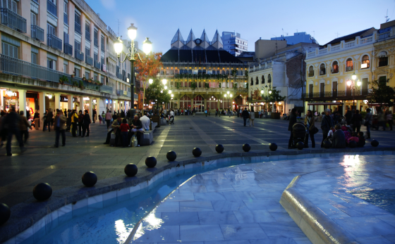
Source: Flickr - Photo by Kiezitri
Plaza de Major de Ciudad Real
The local real estate agent gave Jake and Tess a tour of the city’s notable landmarks including remains of the 14th-century walls; the Gate of Toledo and the 15th-century Gothic Cathedral of Santa María del Prado.
Ciudad Real was convenient, standing at the center of a road network and boasting of an agricultural processing and market center, lumber, flour milling, wine production and distillation of liquor.
The airport facility was located about 120 miles from the center of Madrid and next to the A-41 motorway which ran to Toledo and Ciudad Real.
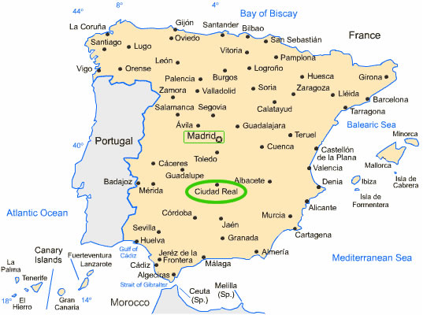
Source: Paddockpost.com
Ciudad Real, Spain
In April 2012, the airport closed after just three years in operation, its management company having gone into receivership. The press and some politicians suggested that the investors planned the failure of the airport at the outset so that they could profit from construction contracts awarded to their own companies. The important factor for Jake was that the airport was in good shape and had a single runway, 13,500 feet long and 200 feet wide, one of the longest in Europe, that could handle all commercial airliners. Part of the airport was still used for private and sport flight facilities.
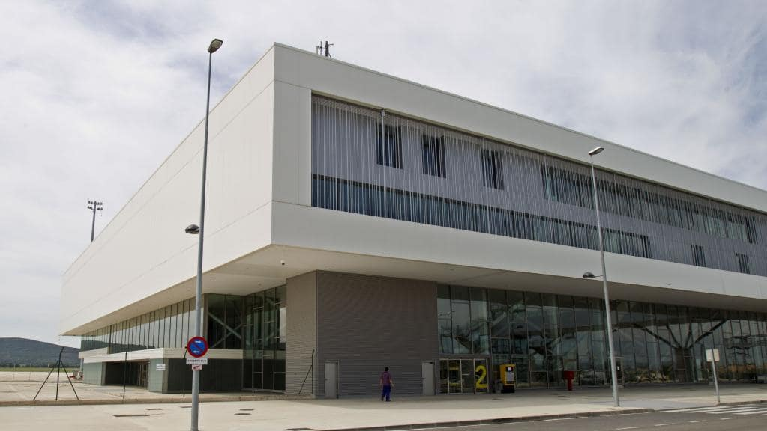
Source: AP
Ciudad Real Terminal
The passenger terminal was designed to process as many as ten million passengers a year, and its cargo facilities could handle up to 47,000 tons a year. The place was perfect for what Jake planned to do. He leased the facility for a great price and hired a construction company to build temporary shelters for the planes. The training facility for the pilots was installed in the spacious terminal building.
Thanks to Carmen’s project management genius and her ability to coax, nag and scream at the workers in Spanish, the place was ready to operate in 30 days.

13
Pick up and Deliver
Romania had purchased 12 surplus F-16s fighter planes from Portugal, and it was the job of the Valkyries to pick up and deliver the first batch of six aircraft to their destination. The rest of the jets would be turned over to the Romanians later.
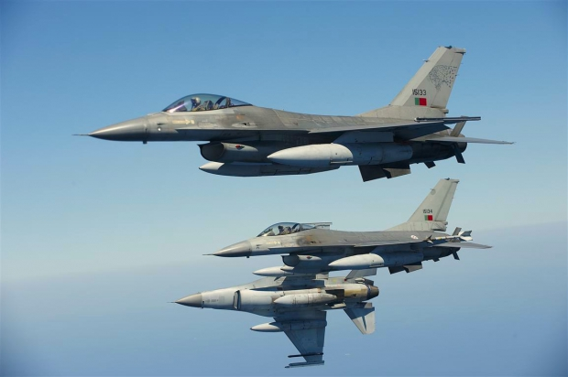
Source: Avia News
General Dynamics F-16 Fighting Falcons
Tess and her colleagues strapped themselves into the first six F-16s and flew across Europe to the Câmpia Turzii Air Base in Romania. The planes had a range of about 2,425 miles. Since the trip from Portugal to Romania was 1,711 miles, the were able to make the trip non-stop without refueling.
Picking up the Romanian MiG-21s that Jake purchased and flying them to the middle of Spain was a little more complicated.
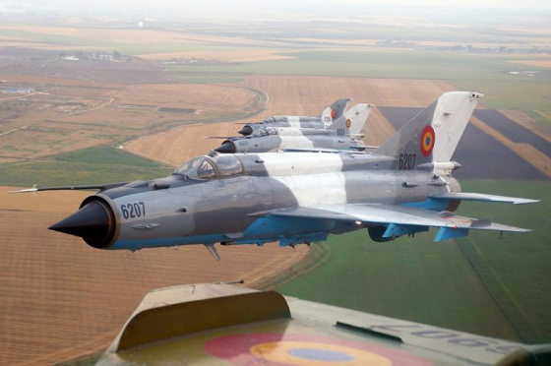
Source: Europafm.ro
MiG-21s
The range of the MiGs was only 685 miles, and the trip to Ciudad Real was over 1,500 miles, so the Romanians installed auxiliary fuel tanks under the wings the aircraft. Even so, the pilots had to land and refuel at Amendola Air Base in central Italy. The base was used by the Italians’ newly acquired F-35 stealth jet fighters and Predator drones.
As the MiGs landed, a group of pilots and technicians congregated on the tarmac, curious about the novelty of Russian fighter planes landing on an Italian base. When the Valkyries jumped off the aircraft to refuel and take a break, the crowd broke into gallant spontaneous applause. Italians always appreciated beautiful women. Tess and the girls just waved.
After refueling, the second leg of the trip still had to be done in extreme fuel conservation mode, meaning as slowly as possible without crashing the planes to the ground. The pilots barely made it to Spain, their jets running on fumes.
Within a week, other SRD pilots flew the remaining F-16s from Portugal to Romania, picked up the MiGs and flew the rest of them to the base in Spain. Their arrival was a momentous event, six jets at a time landing as if preparing for war. As soon as they finished one delivery, the pilots boarded a private plane and flew back to Romania to pick up more planes. The temporary storage facility was ready just in time to accommodate a total of 20 MiGs. Now the team was ready to welcome the Russian and Israeli technicians.

14
Digging for the Truth
Laurent Belcour owned Dubai Strategic Investments and concealed his identity through a paper corporation. He had secretly invested in Tess and Jake’s new venture as an opportunity to monitor what they were doing and to find a way to spoil the party for them. He was also determined to get to the bottom of what he regarded as a devious plot by Jake and Tess to deprive Fadime of her right to the fortune her brother Amir had bestowed to his daughter. He didn’t care about Amir’s intentions. The kid did not need the money, Laurent reasoned. She was well taken care of by Tess and Jake when they adopted her. He and Fadime would have put the money to better use and were denied what he felt was rightfully theirs by a deception that circumvented the inconvenient stipulation of the will, namely, that Aara was to marry into a Muslim family. The records in Turkey showed that marriage did take place between Aara and Serhan Hazinedar, the son of University professors in Istanbul. What bothered Belcour was that Jake filed divorce papers the day after the wedding. Laurent was shrewd enough to conclude that the marriage was a sham, thus potentially invalidating the wedding and breaking the key provision of Amir’s will.
Turgut Ertegün, the Turkish lawyer, appointed to manage the paperwork of the bequest, disappeared soon after Jake and his lawyers claimed the inheritance on Aara’s behalf. Laurent suspected that the lawyer had been bribed and received enough money to abandon his law practice in Turkey, sell his house and fly out of the country never to be seen again. Belcour hired investigators to try to find the man.
While waiting for results, he and two of his enforcers landed in Istanbul to visit Nazar Hazinedar, whose son Serhan married Aara and fulfilled the provision of Amir’s will, thus enabling the release of the fortune.
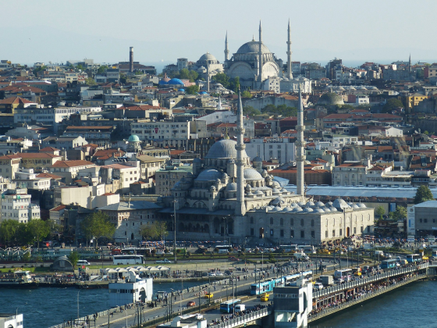
Source: Wikimedia Commons
View of Istanbul
Laurent and his men drove to Hazinedar’s house. The housekeeper said that the master was not available, but that did not dissuade Laurent and his two goons to barge into the house and find Hazinedar at his desk. When the man saw Belcour, he panicked and tried to escape through the other door, but Laurent’s men collared him and put him on a chair facing Laurent who made himself comfortable on a leather sofa.
“Nazar Bey, you don’t seem happy to see me,” Laurent said while lighting a cigarette. “If I recall correctly, we were supposed to work together on a small matter involving a lot of money.”
“I met my obligations,” the man said. “My son married the girl.”
“He did, but I am afraid that things did not go as planned. I thought we agreed that my man Selim was supposed to impersonate your son, thus enabling us to access the money. I am sure you remember our deal.”
“The deal required me to engage in fraud and deception. In the end, I could not compromise my honor.”
Laurent shook his head. “Nazar Bey, I am not stupid. You disclosed our plan to Jake Vickers. I am disappointed. I was counting on your loyalty. It seems that you stabbed me on the back, spilled the beans to Jake and derailed the plan. I lost a lot of money because of you.”
“You were not entitled to that money. It was a fraudulent plan from the beginning.”
"That didn’t keep you from accepting financial assistance from Fadime and me. I find your protestations of Muslim morality specious. Not only you stole from me but betrayed me as well. You were bad, Nazar. Did you really expect to get away with it?"
“What’s done is done. What do you want from me?” Nazar Bey said defensively.
“Just a little of clarification. For example, did the happily married couple spend the night together?”
“That is an offensive question,” Nazar Bey said indignantly.
“Let’s be a little more specific,” said Belcour while lighting a cigarette. “Did the newlyweds consummate their marriage?”
“I am not one to encroach on such matters.”
“Why did the happy couple file for divorce the next day?”
“All I know is that they didn’t get along.”
"How do you explain that Jake Vickers paid you three hundred thousand dollars after the divorce?”
“How do you know that?”
“You forgot that finance is my specialty, Nazar Bey. I can find out everything I want about money.”
“Congratulations. Your scheme didn’t work. Now please go away.”
“This is getting tedious,” Belcour said while lighting another cigarette. “Now, for the last time, are you going to tell me what happened?”
“You know that I lost my position at the university due to Erdogan’s purges. Mr. Vickers just helped me out.”
“In other words, you betrayed me for a little bit more money.”
“I told you that it was a matter of ethics.”
“Nazar, this is getting tedious. Since you won’t talk, I am afraid I will have to hurt you.”
Laurent turned to his men.
“Break his knees. Make it painful.”
“You are crazy. You can’t do that,” Hazinedar protested.
The two burly men grabbed a sturdy chair and smashed it on the wall. They then took two of the disassembled legs and approached their victim.
Suddenly, they heard police sirens and cars screeching to a halt.
One of the men looked out of the window.
“It’s the police. The maid must have called them.”
Laurent was now really annoyed. “It looks like you will escape punishment this time, Hazinedar. I am sure that you will say the right things to the police. Am I correct?”
Hazinedar nodded his head.
Two policemen barged into the room with guns drawn.
“Hands up, all of you,” said the senior man.
The men complied.
“What is wrong, officers?” Hazinedar asked.
“We received a call from a woman about a house invasion.”
“There must be an error, officer,” Hazinedar said. “I was just talking business with my guests.”
The officer noticed the shattered chair.
“What happened?”
“I am afraid I am a little heavy,” Belcour said. “The chair collapsed as I sat on it. I will be glad to pay for the damage, Nazar Bey.”
“No need, Mr. Belcour,” Hazinedar said. “I apologize for the fragile furniture. I am happy you didn’t get hurt.”
“The policeman was not convinced. “Nazar Bey, are you sure you don’t want to press charges against these men?”
“Absolutely not, officer. We have concluded our business. I apologize for the confusion.” He then turned to his ‘guests,’ “I am sorry about this, gentlemen. I am sure that you are anxious to catch your flight. I will send you a letter confirming our agreement.”
Belcour rose from the chair and shook Hazinedar’s hand. “It was a pleasure to do business with you, Nazar Bey. We will be in touch.”
The trio made a speedy exit. The policemen stayed with Hazinedar to fill in some paperwork.
Belcour and the men got into their car and speeded away. Irritated by the failed attempt to gather information from Hazinedar, he cursed when his cell phone rang.
“Yes!” he said. He listened for a minute and closed the call.
The driver asked: “Did they find the lawyer?”
“No. It’s as if he fell into a black hole.”
“That’s too bad.”
“There is a little bit of interesting news, however. It seems that Aara pledged most of the inheritance to benefit the Valkyries Foundation. Apparently, Tess and Jake are planning to waste the money fighting Human Trafficking.”
The driver did not respond.
“Damn!” Laurent said while throwing the cell phone to the car’s floor.
Back at the house, Nazar Hazinedar called Jake and told him what Belcour tried to do. That raised alarm bells in Jake’s mind, but he was too busy at the moment, so he put off looking into the matter.

15
Cheerful Russians
Jake and Tess jumped in their Jeep and drove on the tarmac to welcome the Russian team and six Israeli technicians.
A huge Antonov 124-100 military transport landed. The aircraft was so big that it seemed a miracle that it could fly at all. Jake had leased the Ukrainian-made plane to transport a load of MiG-21 parts, ten spare engines, and a crew that knew all about keeping the planes flying. Part of the cargo included six computer simulation units for training the pilots on basic operation of the MiG aircraft and for practicing combat techniques.
The cargo plane had made a stopover in Israel to pick up a six-man team of techs and their paraphernalia whose job was to upgrade the MiGs’ avionics and radar systems. General Turner, Tess’s dad, offered to provide avionics built by his U. S. firm, but Jake insisted that the jets be configured with foreign equipment thus providing a platform approximating the capabilities of modern Russian jet fighters. This was one of the buildings blocks for impressing the U. S. Air Force. The most crucial factor, however, was training pilots to employ authentic Russian tactics. Jake and Tess had laid the groundwork to systematically build a crack team of pilots and enhanced jets fighters destined to become a formidable foe against sophisticated fifth-generation jets like the American F-22 and F-35.
The massive cargo aircraft parked away from the terminal. The front of the aircraft pivoted upward and dropped to the ground, disclosing its cargo.

Source: Airsoc.com
Antonov Cargo Aircraft
Two groups of men exited on the tarmac, led by Alex Tuck and Galina Kutuzova. Colonel Peter Brusilov and his men appeared to be excited to be in Spain and warmly shook hands as Jake welcomed them in fluent Russian. Jake then greeted the Israeli team led by Gil Epstein. Alex and Galina remained with the aircraft to direct the unloading the equipment. Six trucks arrived and picked up the large crates as soon as they were unloaded from the transport plane.
Two passenger vans arrived, and the techs piled in for a short ride to the terminal for customs. Jake had prearranged much of the necessary clearing, and soon the group was on its way to a new apartment complex in Ciudad Real that he had rented to house the crew.
That evening, the SRD team treated the newly arrived crew to an excellent Spanish feast at a local restaurant. Vodka was a necessary staple for the Russians, who true to form, managed to put away an astonishing amount of liquor. Colonel Brusilov just ordered a glass of orange juice. The Israelis were much more temperate, mostly sticking to wine. The all spoke fluent English and traded war stories with Jake and other SRD team members that had joined them to greet the newcomers.
Jake proposed that the visitors take a few days to acclimate, but most of them stated they were anxious to assemble their equipment and to inspect the planes. They planned to show up at the airbase first thing in the morning. Jake, Tess and the team left the restaurant to get some rest. Claudine hung back to talk with the men.
The next morning, Jake and Colonel Brusilov expected the techs to report for work, but only the Israeli team arrived in the company’s van. The driver said that he couldn’t find the Russians. Jake and the Colonel waited for an hour, but none of the Russians showed up. Brusilov was furious. Eventually, after a few phone calls, they learned the men were in the town jail. Jake, Nicola, and Brusilov rushed to the facility only to find their skilled team of technicians totally drunk. The police said that they went to a brothel, had a lot of fun, and being quite inebriated, wrecked the place. After Jake paid substantial fines and restitution, he, Nicola and the Colonel packed the hung-over men into the van and drove them back to their apartments to sober up. Brusilov looked like he was ready to call the KGB firing squad and assured Jake that he would take care of things. Jake left Nicola behind to help, a smile on his face. Whatever Brusilov was going to do, it was unlikely to be pleasant.
Sure enough, the dried-out techs showed up the next day, ready to work under the implacable stare of the Colonel.
Jake asked Nicola what happened.
“Well, all I can say is that Brusilov unleashed an astounding barrage of imprecations and profanities that must have scorched the hair off the hapless Russians. It was truly a virtuoso display of expletives.”
“It seemed to have worked. They are all here.”
Boris Kovalenko, the maintenance crew’s lead engineer, was fully aware that he and his men had to redeem themselves, so he energetically exhorted the team to climb all over the MiGs and prepare a comprehensive list of repairs, upgrades, and tests necessary to ensure the airworthiness of the planes. The Israeli team, joking about the sudden demonstration of alacrity by their Russian colleagues, unpacked several crates containing modern avionics equipment. The schedule was tight: six months to update the MiGs and train the pilots in air combat techniques.
The Israelis assembled the six flight simulator units in a ‘war room’ inside the terminal and managed to get the equipment running in record time. It was now time for Claudine and Colonel Brusilov to design the aggressor routines to be used for the pilots’ training. Claudine soon found out that Brusilov had his ideas on how to do things and didn’t seem to be interested in suggestions from anyone. Claudine had a lot at stake. After all, the venture was her idea. She found the man’s attitude annoying, but she decided it would be best to hold back and give him the benefit of the doubt.
Within two weeks, the maintenance crews commissioned the first ten aircraft with the help of the Israelis who upgraded the combat electronics and radar systems. Jake insisted on rehabilitating the entire group of 20 planes, fully expecting that some of them would break down once the war games started.

16
Introductions
The Team walked into the conference room to get acquainted with Colonel Brusilov and his team, including the Israeli techs. On the SRD side, the whole gang was there: Tess and Jake, Claudine, Carmen, Giuliana, Galina, Eva and Yasmin, Nicola, Alex Tuck, George Kimmel, and John Powers. The women, who were now formally labeled as the Valkyries, laughed, and told stories until it was time to start.
Jake walked in front of the group and formally introduced the Chief Training Officer.
“Colonel Peter Brusilov is one of the world’s most experienced and celebrated fighter pilots, having flown just about every fighter plane ever made. He is a graduate of Voronezh, the Russian air academy, equivalent to a Western air command and staff college. He's been in dogfights with pretty much every fighter plane out there and is a graduate of the prestigious Aviadarts air exercise, a Russian version of Top Gun. He was the commander of Lipetsk Air Base, the combat training center of the Russian Air Force, analogous to the U.S. Air Force's Nellis Air Force Base. Peter retired from the Russian Airforce, and he's here to share his expertise with us.”
Jake prudently omitted that Brusilov’s record included shooting down quite a few American planes in Vietnam.
The audience applauded.
Next, Jake presented the team.
“Claudine Bisson is by far our most experienced fighter pilot with a legendary reputation. She flew Mirages and MiGs-21s playing a hostile combatant against the French Air Force, and she has never been defeated.”
Claudine smiled, apparently satisfied with the compliments.
“Tess Turner started as a Black Hawk helicopter pilot. She participated in several combat operations in Iraq, Syria, Mexico, and Nigeria. She then qualified to fly Apache helicopters, A-10 ground attack aircraft, Super Tucano props and lately on the delivery of jet fighters, primarily F-15s and F-16s.”
“Carmen Cabrera works alongside Tess and has experience in combat helicopters and jet fighter aircraft transport. She is also our logistics guru. If you want anything done, she is the person to see.”
“Galina Kutuzova joined us from Russia and is a helicopter and jet fighter transport pilot and IT expert. There is little about computers that she doesn’t know.”
“Eva Bar-Lev is the General Manager of our Paris office. She was in the Israeli Defense Forces and spent a few years in the Mossad. She occasionally helps with the transport of fighter aircraft.”
Brusilov looked at Eva and frowned. “Mossad? That should be interesting.”
“You have no idea,” the fearless Eva answered.
Jake resumed the introductions.
“Giuliana Malatesta is a graduate of the Italian Air Force Academy and is qualified to fly many helicopters and jet fighters. She had combat experience in Afghanistan and Syria.”
“Yasmin Badawi, helicopter pilot, will provide transportation services to the team.” Jake paused for a moment. “Yasmin trained as an archaeologist, working primarily in Palmyra, Syria, but now she is an amazing sniper. You don’t want to know what she did to ISIS fighters in Syria.”
The group chuckled. Yasmin’s escapades were legendary, even though her colleagues had to rescue her on a couple of occasions.
“The flyers will be supported by Alexander Tukhachevsky, our Russian weapons specialist; Nicola Orsini, our European weapons specialist and John Powers, American weapons specialist. George Kimmel is our Intelligence officer, but he will go back to New York to run the company in our absence.”
“As a footnote,” Jake continued, “the Valkyries are also highly regarded for their work as chamber music players. They started doing concerts to benefit their foundation against human trafficking, and they are now a going concern. Tess and Claudine also perform as soloists, playing the piano and violin, respectively.”
The group clapped hands. There was no question that this was a tight, enthusiastic team.
After Gil Epstein presented the Israeli team, Colonel Brusilov introduced his team of aircraft technicians, led by Boris Kovalenko, the Chief Engineer. Finally, he walked in front of the room and started the initial briefing.
“Before we begin, we need to understand our priorities: First, safety is our primary concern. During our training, there will be zero tolerance for risky maneuvers and show-off behavior.”
“Ow, no fun!” Claudine said. The team laughed. The Colonel didn’t.
“Second, we will start from scratch as if you had never seen a MiG.”
“But most of us have flown MiGs and other planes,” Galina exclaimed.
“Perhaps,” said the Colonel, now annoyed. “But we need to assure uniformity of training and procedures, so on this point, it is non-negotiable. You will all need to pass a program of qualification that I designed before we even think of getting into dogfighting.”
The group emitted a big sigh.
“Third, for as long as we are in training, I am the commander, and I will treat you as rookie flyers. You must earn your stripes through perseverance and hard work.”
“Boring,” Claudine interjected.
“Shut up, Claudine,” said Tess, who as a matter of principle got annoyed every time Claudine spoke.
Claudine looked at Tess as if she wanted to commit murder.
“That’s all I want to say at the moment,” Colonel Brusilov concluded. “You are to study the tech manual in front of you. Training on the flight simulators starts in two days.”

17
Family Time
The team was going to work in Spain for at least six months, so it was necessary to bring over family members to keep everyone from going crazy.
Two of Brusilov’s techs brought down their wives but no kids because, in Russia, few people had them. The Israelis planned to leave soon after they completed upgrading the avionics.
Alex flew Nicola to Genoa on the company plane. Nicola then rented a car and drove to Chiavari, his hometown on the Italian Riviera, to pry his toddler Luca from his granny’s clutches, who warned she would die of heartbreak. He also had to endure cries of despair and assorted drama from his sisters, but he finally made it back to the plane and returned to Ciudad Real. As Nicola got off the ramp holding the toddler in his arms, he had to duck Carmen’s rushing up the stairs to appropriate little Luca and smother him with kisses.
Yvette, the governess of Claudine’s twins, arrived, holding hands with Jacques and Thérèse. Claudine was late, but Jake was there on time, and he joyfully picked the little ones, kissing them on the chubby cheeks. Claudine finally arrived, and she put on a marvelous display of love and affection on the kids. Jake could not help noticing that Claudine, tough as she was, was genuinely doting on the toddlers. He wished that circumstances were different, thinking how joyful it would be to be with the kids all the time. He would have to see the children later because he was sure that Tess would probably be depressed. It would take a while for her to deal with the absence of a family she wanted so much.
Jake tried to mitigate the situation by bringing down Aara from New York. She had made the most of the concertizing opportunities organized by Tess and Jake and now needed a little break. Not for long. She needed to prepare for her first international piano competition.
Finally, the pet carriers arrived. Jake’s bulldog Sebastian awakened from his slumber and enthusiastically ran toward him.

Source: https://www.pets4homes.co.uk
Jake’s dog Sebastian aka Tubby
Maggie, Tess’s aristocratic Cavalier, serenely walked toward her owner, disdainful of Sebastian’s lack of decorum.

Source: Pinterest.fr
Maggie, Tess’s Cavalier King Charles Spaniel

18
Flight Simulators
The team gathered in a room where the Israelis had installed the six flight simulators leased from Russia.
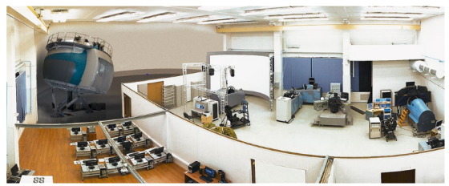
Source: Alexander Tigr - Russian Aircraft Corporation MiG
Flight Simulation System
Colonel Brusilov gave them a quick tour. He showed the various components of the interactive computer-based training system designed for training pilots and technical personnel on aircraft operations and maintenance. The system included a main computer server with training programs, a reference library, an interactive training control system, operation tracking, troubleshooting and logistic support of aircraft and technical training aids.”
Next, he walked to one if the six large spherical devices mounted on servo cylinders that rotated the pod in response to flight and combat simulation scenarios.
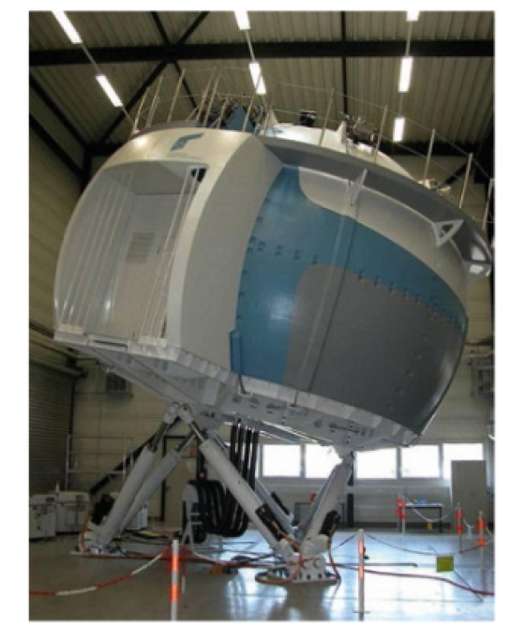
Source: Alexander Tigr - Russian Aircraft Corporation MiG
Mission Simulator
“When you sit into these simulators, you will see an exact reproduction of the MiG-21 cockpit and its armament controls. Besides simulating motion, the equipment generates combat scenarios that include navigation and tactics, combat routines, aircraft system failures, and emergencies.”
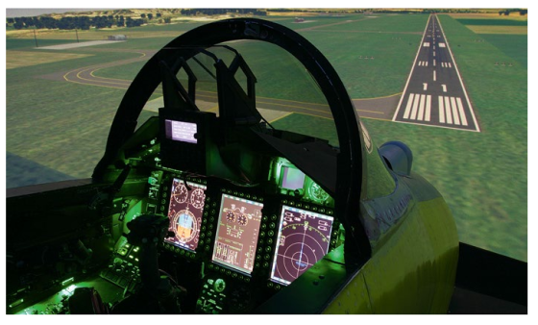
Source: Alexander Tigr - Russian Aircraft Corporation MiG
Flight Simulator’s Cockpit
“Whew!” said Carmen.
Brusilov shot an irate look at the sassy petite woman. Carmen was not intimidated.
The Colonel resumed his presentation. He showed a system that simulated weather conditions, atmospheric illumination, and seasons including mists, clouds, and animation effects such as explosions, bursts, smoke, fires, condensation trails of missiles and aircraft, and projectile tracers.
By this time, the trainees were dazed by the rapid torrent of information. Brusilov was aware of that, but that didn’t slow him down.
“You will perform simulated takeoffs and landings, in-flight refueling, low-level flights over various terrains and other high precision piloting tasks. You will experience engine failure, control system failure, etcetera. You will do these exercises until you can demonstrate proficiency in how to deal with these events without thinking.”
Brusilov now led the group to another workstation.
“For the rest of the day, you will get familiar with the simulators, practice basic aircraft takeoffs, flying and landing protocols.”
“We already know how to fly these planes,” Tess said. “Why do we need to use the simulators?”
Brusilov looked a little annoyed.
“The purpose of this exercise is to create uniformity, so all of you handle the aircraft the same way. This will facilitate your working as a synchronized team once we get underway. Any other questions?”
Claudine was supposed to be the squadron commander, so she tried to say something. “Why can’t we do that by actually flying the planes?”
“Because I say so,” Brusilov responded, clearly annoyed. “That is all for today. You have tonight to study the books explaining additional aspects of the equipment. Dismissed! Be here first thing in the morning.”
“I feel that I am back in high school,” Carmen complained.
“That’s just about right,” Tess agreed.
“It’s only day one, and I am ready to kill that guy,” Claudine said.

19
Music in Spain
The team and the technical crews met for dinner at La Caleta, a nice restaurant in town, to celebrate the start of training. Jake, the incorrigible gourmand, was in seventh heaven, having ordered a buffet with a fantastic selection of Spanish dishes. He gathered the team around the food and provided a thorough description of the victuals. To honor the local region, the spread included cuchifritos, a fried lamb and goat meat along with olive oil, garlic, vinegar, basil, rosemary, bay leaves, and spearmint. Jake did not want to neglect dishes from other parts of Spain, so he had zarangollo appetizers, a typical dish in the Murcian countryside in Spain, consisting of several types of grilled vegetables, including eggplants, spicy red peppers, red tomato, and sweet onions, seasoned with olive oil, garlic, and salt. There was also black paella, with cuttlefish, and rice very similar to seafood paella made with cephalopod ink, garlic, green cubanelle peppers, sweet paprika, olive oil, and seafood broth. The list went on and on, the spread displayed on a large long table, the bounty celebrating the cuisine of Spain. Tess finally lost patience and elbowed Jake on the ribs. He got the message and suggested digging in on the food.
The Russians were not used to fancy food, and gingerly tasted the spicy dishes, then immediately piled food on their plates, groaning in pleasure as they started to devour the unfamiliar delights. The Israelis were more cosmopolitan and didn’t need to be coaxed into enjoying the splendid repast.
Having promised under duress to exercise temperance, the Russian crew skipped vodka and turned to Spanish wine. That reasonable posture was reinforced by Colonel Brusilov, who was now affectionally called ‘Peter the Terrible’ behind his back.
As the group finished dessert, a dapper Spanish gentleman approached Tess.
“Good evening Señora Turner. I was wondering if you could spare a moment. My name is Herman Rodriguez. I am the General Manager of the Teatro Municipal de Tomelloso.”
“I am pleased to meet you, Señor Rodriguez. What can I do for you?”
“We have a small symphony orchestra in Ciudad Real, and we are honored to have the famous Valkyries Ensemble in our city.”
Tess smiled. “I am not so sure we are that famous, Señor Rodriguez. We just like to play beautiful music.”
“I watched the video of your playing the Prokofiev third concerto in Moscow. It was spectacular. The whole orchestra loved it.”
“Thank you. You are too kind.”
Two other well-dressed gentlemen joined them.
“I would like to introduce Chief Conductor Pascual Bonillo Jiménez and Artistic Director Agustín Pradillos Rivera.”
“I am delighted to meet you,” Tess said, trying hard to be cordial.
Rodriguez continued. “Our Orquesta Sinfónica is a private symphony orchestra sponsored by Bodegas Y Viñedos Marquez, our local winery that is also the main benefactor of the orchestra. We aim to develop a musical ensemble of the greatest artistic rigor by providing young local musicians with an opportunity to develop musical proficiency. The orchestra has 55 to 60 members, all conservatory graduates with the necessary technical skills to produce performances of the highest artistic level.”
“That’s quite admirable,” Tess said, amused by the flowering language of the man.
“I have a great favor to ask of you, Señora Turner,” said the conductor. We scheduled a concert next Saturday, but the solo violinist was detained in Singapore. We can’t get a substitute with the requisite skills in time. I was wondering if one of your colleagues would be willing to play with us.”
“What is on the program?”
“The Wieniawski second violin concerto.”
“Wow. We have never played that piece.”
“I have,” Claudine said as she walked over with a drink in her hand. “I am sorry, I overheard. I played that concerto in London a month ago with Vaughn Wentworth as the conductor.”
“Impressive,” Jiménez said.” Maestro Wentworth has a legendary reputation. Would you be willing to play the piece for us, Señora Bisson?”
“I would be delighted,” Claudine said, flashing her devastatingly charming smile. “Let’s rehearse on Friday afternoon.”
Rodriguez was instantly smitten. “You are most kind, Señora. May I add charming?”
Tess was not pleased. ‘Claudine is up to something,’ she suspected.

20
The MiG 21
After assembling into the training room, the Valkyries settled down. Colonel Brusilov discussed the results of the first simulation exercise and declared that the team performed adequately. Next, he projected a profile image of the MiG-21 fighter jet.
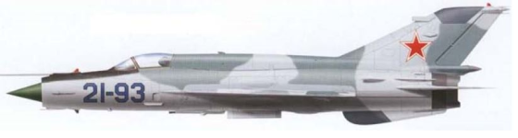
Source: Airwar.ru
MiG-21
“The Mikoyan-Gurevich MiG-21 is the aircraft that you will use to simulate dogfights against the American Air Force. The MiG is a supersonic jet fighter and interceptor aircraft. Even though some call it obsolete, it is a legendary, extraordinary plane. More than 11,000 are still used in Russia, China, and several other countries. Many of the aircraft have been updated with modern avionics systems, new cockpit displays, and modern missiles. Italian tech companies have upgraded many aircraft for Egypt and Syria. Our Israeli friends also have also built businesses upgrading these planes for non-Arab countries.
Eva raised her hand. “I heard that the Egyptian MiGs did not fare well against the Israeli Mirages. What do you say about that?”
“Considering the high kills-to-losses ratio of the Israeli Mirage III over the Arab MiG-21, I used to think that although these planes were roughly comparable, the Mirage was superior to the MiG. However, when an Iraqi defector surrendered a MiG-21 to the Israelis, they thoroughly evaluated the plane, and many pilots said that they would have preferred to fly it in dogfight rather than their own Mirage. The Israelis were happy that the Arab pilots were so poorly trained in working with each other.
“I must say that the Colonel is correct,” said Gil Epstein, the chief Israeli tech. “The disparity was due primarily to poor training and tactics.”
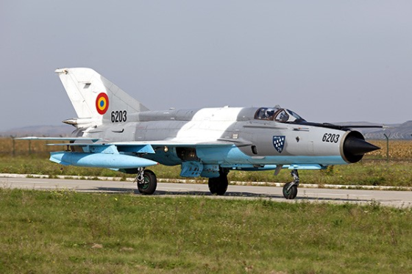
Source: Tony Osborne/Aviation Week
A Campia Turzii-based MiG-21
Colonel Brusilov continued.
“In the 1990s, Israel’s Elbit Systems, a defense electronics company that specializes in upgrading existing military platforms, modernized 110 of Romania’s MiG-21s to Lancer standard, installing upgraded avionics and weapons systems that enable the aircraft to drop precision-guided munitions. The 20 planes that we acquired are from this group.”
“To aid with our training, two of the aircraft we acquired are two-pilot planes. Soon, you will be flying these, and you will have the dubious pleasure of having me sitting behind you breathing down your neck as you attempt to fly the plane.
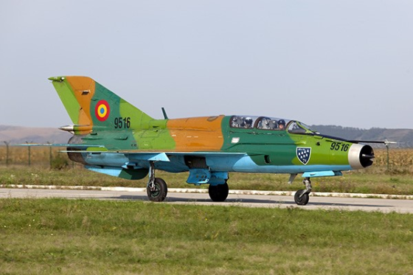
Source: Tony Osborne/Aviation Week
Two twin-stick MiG-21 at Campia Turzii.
Incidentally, as you found out by transporting the MiGs, most landings involve the use of a brake parachute.”
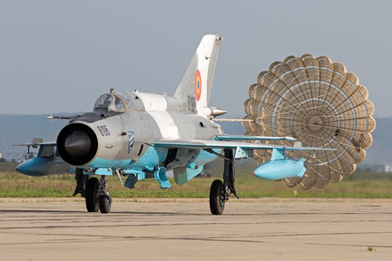
Source: Tony Osborne/Aviation Week
Brake parachutes are needed with a landing speed of 190 kts.
“Yeah, that’s a lot of fun we hadn’t anticipated,” Galina wisecracked.
Brusilov ignored the remark and continued his presentation.
“The MiG-21 is reasonably simple to maintain. As a pilot, I learned to service the fuel, oil, hydraulics, and pneumatic systems and had to demonstrate proficiency in these areas before I could take a jet off-station. You will be trained to do the same.”
Giuliana, who was still a reserve pilot in the Italian Air Force, couldn’t believe her ears.
“Are you saying that you want us to become mechanics?”
“Yes, because that’s how it's done in Russia.”
Grumbling from the audience.
Brusilov continued. “The plane’s handling qualities are mediocre at best. The flight control system is a little sloppy and not very responsive.”
Tess was starting to get concerned. “How are we going to fight modern American planes with this equipment?”
“I didn’t mean to give you the impression that the plane isn't very maneuverable. It is. Even though it’s much older, I put it between the F-15C and the F-16. It’s just that the MiG pilot must work harder to get the jet to respond the way he wants. On the plus side, the plane has a lot of ponies under the hood. People often described the plane as a ‘rocket that has wings.’ Once in the air, the MiG-21 is an agile dogfighter, and it can match, and can even outfly, the F-16.”
Tess, who as usual had done her homework, raised her hand. “Isn’t the short range of these plane a disadvantage?”
“There is no question that the MiG-21 lacks the range of western fighters like the F-16. Combat missions last 30-45 minutes before needing to refuel. During the training, we will discuss how to live with this limitation. Now, let’s continue.”
Tess was still skeptical. “I don’t want to repeat myself, but why do you think we can fight the American Air Force with these old planes?”
“Romania does it all the time. Their MiGs are in regular demand as a simulated threat and have gone up against American F-16s, F-15s, F/A-18s, and A-10s, and various European fighters. Romanian pilots use hit and run style tactics to deal with air threats. Their jets lack a beyond visual range missiles, although they could carry one, and now carry a range of different short-range air-to-air missiles from the Israeli Python to the Russian R-73. We will simulate using these weapons.”
Brusilov now brought up a slide showing the snout of the plane.
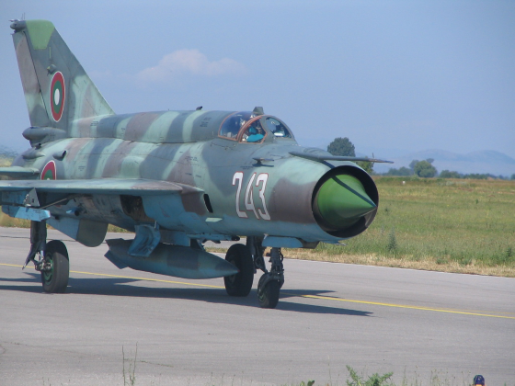
Source: U. S. Embassy Photo by Army Major Dana Hampton (Public Domain)
The MiG-21 Inlet Cone
“The air flow to the engine is regulated by an unusual inlet cone in the air intake. The cone transitions forward and backward in response to different power requirements from the engine. We could spend a lot of time discussing the fine points of how this works, but it is not relevant at this time.”
“In the air, if you experience a malfunction or lose a fight and must eject, the SK-1 ejection seat connects with the canopy to make a capsule that encloses the pilot.
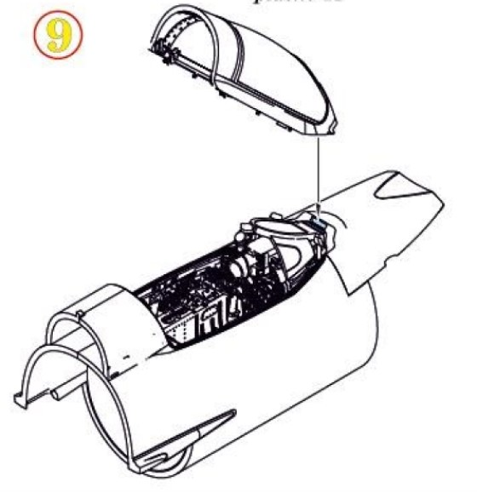
Source: Eduard.ma
SK-1 MiG-21 Canopy Capsule Seat
“The capsule protects the pilot from the high-speed airflow he or she will encounter. After ejection, the capsule opens to allow the pilot to parachute to the ground. However, you must avoid ejecting at low altitudes because the canopy sometimes takes too long to separate, resulting in the death of the pilot.”
“Good to know,” Eva said.
Brusilov gave her a dirty look and continued his presentation.
“The nose gear retracts forward into the fuselage under the radar. If it gets stuck, you can lower the nose wheel manually by simply unlocking its hatch from inside the cockpit. This means that landing with the undercarriage locked in the up position due to an internal failure is not a major issue as it would be in Western planes fighter planes that are more dependent on electronics and hydraulics.”
Brusilov noticed that the students were taking copious notes, a good sign.
“That’s enough for the moment. After you practice on the simulators, you will study the manuals stacked behind you.”
“Great, more homework,” Carmen complained.

21
Mechanical Things
The Valkyries showed up in the morning, ready to fly the fighter jets. Brusilov instead paired them up with his techs in the hangar.
“Today, we are going to learn how to take care of the planes.”
“I thought that today we were going to fly,” Claudine protested.
“No. You are going to learn how to tighten every nut and bolt in your plane. Let’s go.”
Giuliana chipped in. “This is a waste of time. We are pilots, not mechanics.”
“I don’t care that the Italians treat you like a princess, sweetheart. Kindly shut your mouth and grab a wrench,” the Colonel ordered. “You are not flying anywhere until you know the plane like the back of your hand.”
Claudine could tell that Giuliana was close to slugging the man. She had to settle for a dirty look.
Boris Kovalenko ushered the pilots to the MiGs maintenance area.
Grumbling, the girls put on gloves and grabbed some wrenches.
Claudine was allergic to autocratic men. She had enough of misogynists in the French Air Force. She rushed over and faced down Brusilov.
“Colonel, I am the squadron leader, and I insist that you work with me when we develop the training protocols. You can’t just do it by yourself without getting my approval.”
Brusilov scowled. “You are not the squadron leader yet. You need to prove yourself first.”
“That was not the deal!” Claudine exploded “We are supposed to work together. Who do you think you are?”
“I am the guy that is going to shape up this gaggle of self-satisfied women into a force that can win against overwhelming odds. If you want to win, you better listen to me, or you are just going to be pretty girls playing with planes.”
“You are an arrogant Neanderthal prick! You can’t get away with this. I am going to tell Jake.”
“Jake will not interfere. Unlike you, he understands what it takes to win. Go and complain to him like a spoiled little girl.”
“I am a respected fighter pilot, and you know it.”
“Congratulations, but you have no clue what it takes to take on the American Air Force. Now, stop complaining, and grab a wrench.”
Claudine understood why Giuliana wanted to hit the man, but she suppressed her temper and turned on her feet, fuming. She decided that she wouldn’t humiliate herself by whining to Jake. She was pretty sure that the rude Russian bastard would fall flat on his face after the Valkyries got through with him. He’ll see. She walked to her aircraft, picked a wrench and slammed it against the landing gear.
“Be careful,” Boris Kovalenko said. “You don’t want to break the plane.”
“If that is all it takes to break the plane, we are in trouble.”
Boris smiled. “I guess you had your first real chat with the Colonel. Get used to it.”
Claudine hit the plane again with the wrench. Then she saw her colleagues crawling all over their aircraft, opening hatches, tightening screws, removing components, and replacing parts under the guidance of the techs. The girls looked like they were enjoying themselves. All, that is, except Tess, who arrived late.

22
Empty Hands
Laurent Belcour was in a bad mood. He raised himself from the stuffed chaise lounge, poured himself a glass of wine and stared out of the bay window of his luxurious Paris apartment. He almost resented the pedestrians below who were enjoying the beautiful city, some of them stopping on a bridge to watch the tourist barges on the Seine go by. For a moment, he wondered why he could not join his neighbors and take advantage of the simple pleasures of basking in the sun or walking in the park. Fadime interrupted his revelry when she walked in dragging loot from yet another shopping trip.
“I love Paris!” she exclaimed. “I could shop like this every day.”
Laurent did not respond and continued to stare out the window. Fadime walked to him and gave him a peck on the cheek.
“You don’t look happy, Laurent. Please tell me that you are not obsessing about Tess.”
Laurent turned to face her.
“I am not getting anywhere with the search of the Turkish lawyer involved with Amir’s will. I have paid three detectives, and after spending a lot of money, I still don’t have a clue where to find him.”
“Sounds to me that your search is a waste of money. Why don’t you focus on something else?”
“What?”
“Me, for example. I need attention. You know that good shopping puts me in a romantic mood.”
Laurent put his arms around her hips and nuzzled her breasts. Fadime moaned in pleasure.
“Take me to bed. I want to try the new vibrator I bought.”
Laurent let go of her. “Fadime, what is between you and electronics? You don’t need the thing.”
“I like the vibrator. It puts me in the mood. Take me to bed.”
Laurent’s disposition got worse. He really did not like that an electronic gizmo was going to upstage his legendary bedroom prowess. He was tempted to leave Fadime to her own devices, but he was also aware that he needed her around to pursue the inheritance issue. He went along when Fadime took him by the hand to the bedroom, dropped her dress to the floor, and loaded batteries in the vibrator. She laid down on the bed, started the gizmo and proceeded to pleasure herself.”
“Get us some champagne,” said Fadime in between moans.
Laurent had no choice. He went to the wine cooler, pulled out a bottle of Veuve Clicquot, put it in an ice bucket, popped the cork and picked up a couple of glasses. He returned to the bedroom, removed his clothes and laid next to Fadime, who was now thrashing from an intense orgasm.”
Laurent waited until she settled down, then poured the champagne and offered her a glass.”
“Thank you, Laurent. Fadime took a sip. “That was good.” She didn’t mean the drink. After a couple of sips, she fluffed her pillow.
“You can have me now if you want.”
“Do I have a choice?” Laurent said.
“It’s okay if you want to pass. I am satisfied.”
Laurent put his robe on.
“What can you tell me about your niece?”
“Back to business, eh?” Fadime took another sip.
“Yes. Tell me about your niece.”
“There isn’t much that I can tell you. Aara was five years old when I allowed Jake to adopt her. I was distraught after Amir’s death and wasn’t in the mood to mother anyone.”
“Have you kept in touch?”
“No. In any case, Aara does not like me very much. When she was with me, things were touchy. She was very young, but smart, and knew that Amir and I were using her for something.”
“Something?”
“Amir was using Aara as a bargaining chip to lure Tess into his arms. Tess felt she owed a debt of gratitude to Kejal, the child’ mother. Amir was using the woman as a slave. She was a Kurdish captive that got killed when she helped Tess escape captivity during the Iraq war. Later, when Tess met Amir in Istanbul, he promised to let her have the child if she slept with him. Tess fell for Amir’s ploy and spent the night together. In the morning, Tess wanted to leave with Aara, but Amir revealed that the child was his daughter, expecting Tess to stay with him. Tess stormed out and became his worst enemy, even after she found she was pregnant.”
“I understand that she married Jake and kept the child.”
“Yes, and she adored the boy. The problem was that Amir now wanted to take his son away from Tess, plus he was still insanely possessed with her. He did a lot of stupid things, including kidnapping the child and staging a car accident that caused Tess to lose Jake’s child in her womb, rendering her unable to have any more children. To make things worse, Amir accidentally killed his own son when he tried to shoot Jake.”
“Sounds that Amir was out of his mind.”
“Yes, so much so that after he escaped the prison, he invaded Tess’s New York apartment. He had a brutal fight with Jake and killed himself after Jake broke his leg.”
“Why is Tess mad at you? Just because you are Amir’s sister?”
“You don’t want to know,” Fadime said defensively.
“Try me.”
“When Tess and her people managed to get her son back by invading my vacation home in Sorrento, I threatened to release of the sex tape Amir had made the night they got together. Tess threw me across the room and broke my arm. She retrieved the video, but I had already released it to the internet. Jake unleased his computer people and damaged many of the websites showing the video. People got the message, and the video disappeared in short order.”
“Well, that explains Tess’s hostility toward you.”
“Don’t forget that she is also mad at you,” Fadime said. “Besides trying to kill her staff with your dirty bomb, you made a really stupid mistake when you tried unsuccessfully to kidnap Aara. What were you thinking?”
“It just was a mistake by couple of morons that worked for me.”
“What a mess,” Claudine said.
“Let’s go back to my original question, Fadime. What do you know about Aara today?”
“Very little. When I met her in the lawyer’s office to discuss the inheritance, she came across as a lovely, talented young woman. She graduated from Julliard and is pursuing a career in music. She is excellent on the piano.”
“Does she have any boyfriends?”
“I doubt it. Aara was always very shy. In any case, how is that relevant?”
“It could be the key to our quest to get the money. If we can prove that she is still a virgin, the marriage she had in Turkey is probably null and void. That is a straightforward violation of Amir’s will and would make you the beneficiary of his fortune.”
“I don’t understand. How would you prove that?”
“I need to think about it,” Belcour said.

23
Making Fighter Pilots
Peter Brusilov started the next training session with his definition of what makes a fighter pilot.
“A fighter pilot is a military aviator trained to engage in air-to-air combat with a fighter aircraft. Fighter pilots undergo specialized training in aerial warfare and dogfighting which means close range aerial combat. A fighter pilot with at least five air-to-air kills becomes known as an ace.”
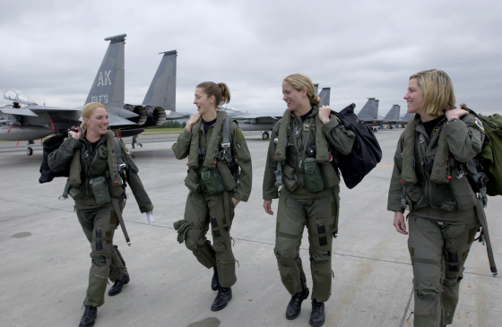
Source: U. S. Air Force Photo by Tech Sgt Keith Brown
USAF fighter pilots heading to their jets before takeoff.
“Yeah, we know that,” Giuliana whispered to Eva.
Brusilov continued. “Fighter pilots must be in optimal health to handle the physical demands of modern aerial warfare. The increased "G's" a pilot experiences in a turn causes stress on the cardiovascular system. One "G" is equal to the force of gravity experienced under normal conditions, and two "G"s would be twice the force of normal gravity. Your MiG-21 can go to 8.5G. Some fighter aircraft accelerate to up to 9 Gs. Pulling 9Gs at 600 knots will cause you to blackout almost instantly as the blood is pretty much pulled from your brain. It goes without saying that fighter pilots must have strong muscle tissue in the extremities and abdomen, to handle tight turns and other highly accelerated maneuvers. It also helps if a pilot has a highly desirable and valuable trait such as better-than-average visual acuity.”
Claudine perceived a slightly condescending tone. “Are you suggesting that we don’t fit that profile, Colonel?”
“Not at all,” Brusilov responded. “All of you seem to be physically fit. You will all have a chance to prove yourselves. I just want you to understand that you will have to be in top form to fight against the best of the best in the American Air Force.”
The Colonel looked at the women almost like a dare. “May we resume?” He didn’t wait for a response.
“Now let’s talk about air combat maneuvers.”
“The training of the Russian pilots is very different from that of NATO or other Western countries. In the weapon-employment phase, the Russian tactical jets only use unguided ordnance. That means onboard cannon, free-fall dumb bombs and unguided rockets and no precision-guided munitions or guided missiles.”
Eva raised her hand. “Isn’t that type of combat flying obsolete? The F-22 and F-35 fighters use stealth and advanced electronics to kill you before you are even aware that they are around.”
Brusilov resumed. “Dogfighting might seem old-fashioned, but the Russians consider it the best way of assessing individual aircrew skill. Even in the West, skill in dogfighting is a fundamental part of a pilot’s training even though actual encounters are now rare. In 1999, an F-15C Eagle fighter jet shot down two Yugoslav MiGs. Recently, a Navy fighter shot down a Syrian combat aircraft that was attempting to engage anti-government Kurdish and Arab militias. The Syrian pilot survived the shootdown, parachuting to the ground.”
Brusilov looked at his students. “Did I make my point?”
He got no response, so he resumed the presentation.
“Now, for the rest of the day, you will cram into your simulators. I will upload various advanced combat scenarios to test whether you can fly the jets under pressure. This time you will probably embarrass yourselves. We do this to assess the level of instruction that you will need to become fighter pilots. We will then evaluate your performance and if necessary, take remedial steps.”
And so, it happened. The team worked into the evening, going through several unfamiliar flying scenarios without preparation. The next day, the pilots climbed into the cockpit of the fighter planes and tried to replicate most of the routines. They soon found out that there was a difference between simulated flying and the real thing. They also found out that high-G maneuvers placed very uncomfortable stress on the body. Overall, they did reasonably well under the circumstances.

24
Showing Off
On Saturday evening, the whole gang assembled at the Ciudad Real city theater. Brusilov made sure the Russians were reasonably sober and more or less dressed appropriately for the occasion. The Israelis were the picture of propriety, wearing ties and jackets, and Tess interspersed the SRD people among the men to make sure everyone behaved.
The smallish orchestra started with Beethoven’s Egmont overture and played the piece reasonably well, considering they were a regional ensemble. The conductor then waved at the left wing of the theater, welcoming a beaming Claudine dressed in a devastatingly gorgeous full-length black gown.

Source: the-violin.com
Concert Violinist
She walked to the front of the orchestra and stood sweet and demure holding the violin to her side while the orchestra started playing the introduction of the Wieniawski concerto. She then raised the violin, resting it slightly over her left shoulder and started playing a somber, restless first subject, its lyrical pendant begun by a solo horn followed by Claudine’s dazzling embellishments with her solo violin.
Sitting in the audience, Tess had to admit that Claudine’s playing was ravishing, effortlessly employing a dazzling variety of techniques, deftly handling the rhapsodic passage and the solo cadenza, leading to the finale, a spirited rondo in the gypsy style, delivering a memorable cascade of lush and moving melodies and harmonies. The orchestra players were inspired to play their best.
The audience unleashed a thunderous applause, and Claudine flashed her trademark smile that completed her seduction of the audience while affecting modesty. She graciously accepted a large bouquet of flowers.
A small party afterward turned into a big one, local politicians and admirers having muscled in to admire a beaming Claudine and her lovely colleagues. Tess tried to be nice, and when she managed to approach Claudine, she offered a compliment of sorts.
“That was gorgeous, Claudine. It appears that Vaughn worked miracles to help you improve your playing.”
Claudine smiled. “You are correct, Tess. Vaughn is a genius. I believe that he did the same for you, in and out of the sack.”
“Touché,” Tess said. “By the way, do you know who Vaughn is sleeping with tonight? I hear he has lots of female admirers in Russia.”
“Alas, I am sure he would prefer to take you to bed tonight. You can still catch a flight to Moscow if you leave now.”
“Funny.” Tess walked away in a huff and ran into Herman Rodriguez, the theatre’s General Manager.
“Senora Turner. Let me present Señor Gonzalez, the City Mayor, and Señora Lucia Garcia, the city’s head of cultural affairs.”
“I am pleased to meet you.”
Rodriguez continued. “Señora Turner, we know that this would be an imposition, but we thought that since you and your colleagues are our honored guests for a while, you would consent to do a few concerts for us. It’s not often that we are fortunate to host artists of your caliber. If you agree to play with us, it will work miracles for the orchestra, and we might qualify for government grants to elevate the quality of its artistry.”
“Señor Rodriguez, I am flattered,” Tess said, “but we are very busy flying our aircraft at the base.”
“We are just asking to play for us on alternate weekends,” Rodriguez said, almost pleading. “If you are looking for compensation, we might be able to do something.”
“I will need to discuss the matter with my colleagues, Señor Rodriguez. I will get back to you as soon as possible.”
“We would be most grateful.”
Tess excused herself and joined the team who had gathered on the balcony for drinks. Since they were all there, she relayed the proposal and asked for their thoughts.
“At this point, I feel that we could all take an occasional break from Brusilov,” Carmen said.”
“I agree,” Giuliana added. “It would be a pleasant thing to do after a week of screaming and harassment.”
It didn’t take long for the Valkyries to buy into the plan. Tess went back to Rodriguez with the good news. They committed to a concert every other week. The Valkyries would not charge for playing, provided their artistic fee would go toward the orchestra development fund.
Shortly afterward, Tess called Kiev in Ukraine and talked with Sofia Mazur, the renowned piano teacher. She asked her to come down to Spain along with her husband, who was a prominent musical pedagogue. Money no object. Sofia agreed, and Tess the perfectionist was now assured that the Valkyries’ musical standards would be maintained.

25
The Barking Babysitter
Brusilov wanted to assess first-hand the progress of the pilots under his command and decided to use the two-seater planes for this portion of the training.
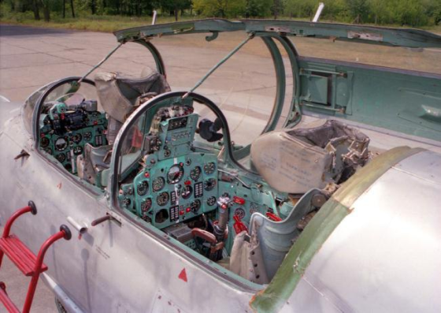
Source: deviantart.com
Two-seater cockpit of MiG-21
Claudine had the dubious pleasure of being the first victim, with the Colonel taking the cockpit seat behind her. She expertly taxied the aircraft on the runway and took off. Once in the air, the Colonel told her to perform maneuvers such as Spit S and the Immelmann turn. Pretty soon, he started to bark orders, greatly annoying Claudine who considered herself an ace pilot. Brusilov put her to the test, goading her to impress him. She didn’t need encouragement. Drawing on her experience, she accelerated, performed a few loops, tilted the plane upside down, performed more loops and did her best to turn his stomach. It didn’t work. The only thing that he said was: “Do you have enough fuel to return to base?” In that instant, the fuel warning beeped, and Claudine had to rush back to base.
They got off the plane, and Brusilov asked: “What did you learn?”
“I tried a few hot dog maneuvers and forgot that the MiG’s fuel range is very limited.”
“Exactly. Don’t make the same mistake again. Also remember, showing off doesn’t impress the enemy. You need to save your resources for when you need them, such as shooting down your adversary.”
Claudine was annoyed at the man but had to admit to herself that he had a point. In a dogfight, one didn’t have much of a margin of error.
Now it was Tess’s turn in the cockpit. She thought that she had a leg up on Claudine because she had listened in on the conversation during the flight, so she took off and gently maneuvered the plane to conserve fuel. On the seat behind her, Brusilov just observed Tess doing her thing. She glanced at her radar and saw Boris Kovalenko’s plane rapidly heading toward her position and maneuvering behind her, apparently getting ready to shoot her down.
Tess yanked the controls and instantly streaked the plane vertically, hoping Boris would overshoot her position, giving her a chance to turn the tables and get behind him. She almost made it, but her adversary had anticipated the move. The moment she was ready to shoot him down, he shot up vertically, and Tess overshot her position, just in time for the fuel alarm to go off. Reluctantly, she had to break the engagement and return to base.
Brusilov went into his customary inquiry. “What did you learn?”
“Watch out for an ambush and be ready to react. Also, watch your fuel.”
Brusilov just grunted.
After lunch, the Colonel got back in the plane with Giuliana, who was obviously impatient with the training because she considered herself more than proficient. They took off, and Brusilov immediately started yelling at her, criticizing everything she did. Giuliana lost her patience and performed a dangerous maneuver, sending the plane into a corkscrew. The instruments blared warnings, and she was barely able to recover before the fuel warning activated. On the ground, she knew she was in for a yelling, but surprisingly the Colonel talked to her calmly.
“What was that stunt? Did you have a tactical reason for performing such a dangerous maneuver? Did you realize you were a few seconds from stalling the plane and killing us both?”
“I don’t like to be yelled at and wanted to show you that I know what I am doing. I did two tours in Afghanistan battling the bad guys, and I will not be treated like a novice.”
Brusilov smiled. “I hope you will have that attitude when we fight the enemy.”
The girls had assembled to observe the tiff, but the Colonel was relentless. He told Eva to get on the plane so that they could entertain the girls and once in the air, he proceeded to harass her without mercy. By the end of the day, he flew with each of the women and ran them through different scenarios.
At the end of a long day, they all returned to base and the women did not look happy. They decided that the man was a monster and started to refer to him as ‘The barking babysitter’ behind his back.

26
Cossacks
Vaughn Wentworth was in Moscow to conduct two concerts. The day before a performance, he usually met his old friend President Vladimir Putin for dinner. As the limousine approached the Kremlin, it had to stop due to a massive demonstration that had turned violent. The driver was concerned about possible damage to the vehicle, so Vaughn tipped the man and got off the car.
Making his way on foot to the Kremlin’s gates, Vaughn saw people inveighing against an assemblage of police and paramilitary men, some of them sporting traditional red papakha hats, big mustaches and shoulder patches identifying them as Cossacks of the Russian Federation.
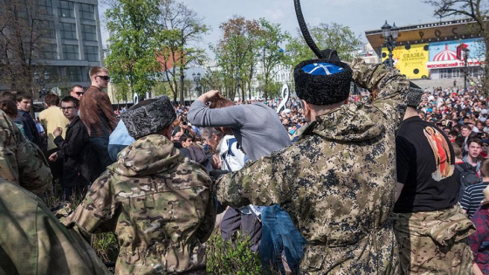
Source: Ilya Varlamov / varlamov.ru via The Moscow Times
Cossacks beating demonstrators with traditional leather whips called nagaikas. Moscow on May 5, 2018
Vaughn knew that Russia’s political minority opposition was used to harassment – but this time few of the demonstrators were prepared for the scene that greeted them in front of the Kremlin. They thought that they were going to an anti-Putin rally, but found that pro-government demonstrators and Cossacks paramilitary soldiers had already taken up positions on the main square, some of them using leather whips. In the uneasy standoff and violent crackdown that followed, the Cossacks appeared to work in sync with police forces, peeling off protesters one by one. Police arrested over 700 people that day. Several protesters had to be hospitalized.
“What’s going on?” Vaughn asked a man in the crowd.
“For the first time in a century Putin now uses Cossacks to suppress protests,” the distraught man said. “Cossacks in southern Russia is one thing,” he continued, “but they have a bad reputation in Moscow. To this day, people remember how the Czar used them against the people.”
“The new Cossacks are part of a broader movement of armed Russian nationalism,” said a man called Nikolay. “Most of them fought in the Ukrainian Donbass, and many of them took part in the occupation of Crimea. It appears that the Kremlin is using them in Moscow in the same way.”
Vaughn was conflicted. Before fleeing to England after the Russian revolution, Vaughn’s family served in regiments that protected the Czar. During Russia's post-1917 civil war, the Cossack caste, which was militantly anti-Soviet, was largely driven out of the Soviet Union. Those who remained suffered intense persecution and were mostly liquidated during the 1920s.
Vaughn excused himself and made his way to the Kremlin entrance. He showed the guards his invitation and was rapidly led into the interior of the massive complex and to the Kremlin Palace. He was accompanied to the President’s office, where Putin warmly welcomed his dear friend.
“I am sorry you got caught in the demonstration, Vasily. You should have called me, and I would have sent help.” The President preferred to call Vaughn by his Russian name.
“It was no problem, Mr. President. I got a chance to talk with people of my blood.”
“I understand, Vasily. One should never forsake his identity as a Russian.”
“That is true, Mr. President. That’s why I like to come to Russia often. If you permit me though, I would like to say that I don’t think it’s a good idea to use Cossacks to control a crowd. The people cannot forget that the Czar used them the same way one hundred years ago.”
“I admit that it looks that way. I am going to ask the Cossacks to be gentler in the future.”
Vaughn knew the President well and understood that this part of the conversation was over. For a moment, there was an uncomfortable silence. Putin continued.
“Vasily, I would like to pick your brain on my problems with Europe and America. The USA has imposed sanctions on many of my close friends, and that was done despite my efforts to develop a relationship with their new President.”
“Can I speak frankly, Mr. President?”
“Please call me Vlad, Vasily. I have asked you to see me because I need your counsel.”
“All right, this is how I see it. Europe does a lot of business with Russia. Many Europeans understand that the misbehavior attributed to you has a lot to do with the hostile attitude of the USA toward Russia, primarily but not exclusively due to the Crimean situation. The current occupant of the White House tried to warm up relations with you, but for the wrong reasons. Many in America are convinced that you are blackmailing him or that he is beholden to you for whatever reason. That severely restricts what he can do. Officially, he must act tough for political reasons.”
“That is all conjecture. It’s a curious way to do business. All I did is help him get elected. Frankly, I didn’t think it would work, and I was surprised like everyone else when he captured the White House. In any case, I expected a little gratitude. Unfortunately, the American President doesn’t have the authority I have. Pity.”
“If I may, Mr. President, I would like to offer my perspective. Pragmatic people understand that Russian cyberwarfare is based on weakness, not strength. Russia is in no position economically to wage a real war. The best scenario going forward would be for the right people in Europe, America and Russia to meet and work out their differences and recognize that helping Russia achieve a measure of prosperity is the right way to go. The problem is that the military-industrial complex in the US is strategically hostile to such rapprochement because they want to continue selling obscenely expensive aircraft carriers, nuclear submarines, and stealth fighters to the government and its allies. The more anxiety is there about a potentially dangerous Russia, the more weapon systems they sell throughout the world. Bottom line, feeding hostilities is profitable, and for that reason, few people in the US are interested in creating harmonious relations.”
An aide came into the room, reminding the President that his next appointment was waiting.
“By the way,” Putin said as he stood up. “I understand that your wife Claudine is back working with Tess Turner. I also learned that they and their group are going to conduct war games against the American Air Force.”
“That’s correct, Mr. President, although I must to say that I don’t understand why they would want to do that.”
“I agree, Vasily. Good performers should stick to making music. In any case, I appreciate your insights,” Putin said on the way out. “I am looking forward to attending your performance tonight.”
“I would be honored, Mr. President.”

27
An Acquired Taste
Tess assembled her colleagues to rehearse for the concert scheduled on the upcoming Saturday. Since the orchestra was on a brief hiatus, this was an opportunity for the Valkyries to play chamber music. Tess conferred with the teacher Sofiya before handing out the tablet computers with the music scores to her colleagues.
“Tess, you got to be kidding,” Giuliana exclaimed after she looked at the music score displayed in the tablet. “We are going to play Bartok all evening?”
“Yes, I wanted to do that for a long time. It’s great music.”
The women became agitated.
“Tess, do you want to scare people to death?” Claudine scoffed. “I don’t think our audience here is that sophisticated. Bartok is an acquired taste.”
“This city has been here since thirteen hundred, so I don’t think the people lack sophistication. I am sure that enough of them will enjoy the music.”
“Perhaps,” Claudine said, “but I won’t do it. You are making a mistake, Tess.”
“Fine, go do your nails, Claudine. “You are no longer part of our group anyway.”
Claudine turned on her heels and waved her hand. “Good luck, girls.”
The altercation unsettled the women. Tess did not give in.
“We can do this,” she said to her colleagues. “This music is seldom played. I think that occasionally we can get away from the tried and true.”
Jake was in a corner reading a book on Medieval Spain and was reluctant to interfere. Thankfully, there was a knock on the door. He got up and welcomed Alice who had just arrived from Nigeria.
“Hi, Jake,” the stunning and statuesque Alice pecked him on the cheek. “I am sorry to be late.”
The women flocked to Alice with hugs and kisses. The ever-practical Tess soon asked, “Did you bring your cello?”
“Of course,” Alice smiled. Omi is lugging the thing upstairs.”
Sure enough, Alice’s husband showed up with the huge instrument case. “Hello, everyone! Glad to be here.” Omi Okafor was an up-and-coming General in Nigeria, and a close friend of Jake’s since their days at Harvard.
The team dispensed with a rehearsal that evening. They and their guests retired to a restaurant and spent some time receiving updates on Nigeria’s struggles against the Boko Haram Islamic insurgents. Even though they suffered several defeats, they were still a threat and even occupied several towns near their territory. It was going to be a long fight before the government could claim victory.
On performance evening, the Valkyries played Bartok’s two rhapsodies and the piano quintet.
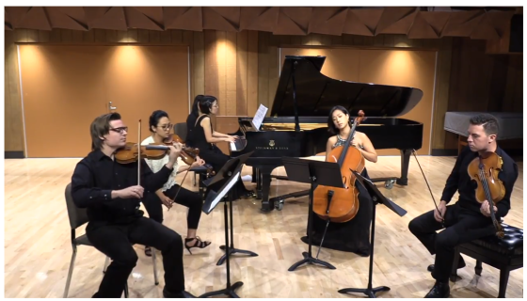
Source: Moore Musical Arts Center, Bowling Green State University, Ohio, USA
A typical piano quintet
The music, sad and tortured, sometimes terrifying, traversed the breadth of human emotion. Raw passages mixed with percussive elements, expressing anger, angst, and tenderness. It was a remarkable performance, but the theater was half full. The applause was restrained. As a listener in the audience, Claudine smiled.
Tess sensed that she needed to do more to please the audience, so she improvised. She recruited Aara and had a second piano brought on stage. After the break, they sat at the respective instruments and played the piano version of Prokofiev’s Classical Symphony and the virtuosic Variations on a Theme of Paganini by Lutoslawski. To top things off, Carmen performed two gorgeous vocalizes.
Much to Claudine’s disappointment, the applause this time was thunderous. She walked out, determined to up the ante against Tess.

28
Young People
After several days of intensive piano practice, Aara needed a break from Sofiya Mazur, the demanding music teacher Tess hired to prepare her for the upcoming International piano competition and help the Valkyries to perform music for their chamber music concerts.
Aara decided to get some fresh country air and go horse riding. She dressed for the part, complete with show shirt and jodhpurs, paddock boots and a cowgirl hat to protect her skin from the sun. She asked the company’s shuttle driver to take her to a riding stable slightly out of town. Once there, she selected a beautiful mare, put her foot in the stirrup and swung on the saddle.
Several local young men saw her handle the horse expertly as she trotted around the paddock. As she passed by the guys, they cheered her performance. Aara just waved and took off at a gallop in the countryside. The ride was exhilarating, just what she needed after pounding on the piano for days on end.
A man riding a magnificent white stallion followed and caught up with her. Aara stopped her ride and turned her horse toward the handsome fellow.
“Hi, my name is Rafael,” he said in perfect English. “I enjoyed watching you handle the horse. I haven’t seen you here before, but I know who you are. I saw you playing the piano at the theater.”
“I hope I didn’t strain your ears, Rafael, Aara said with a smile.”
“On the contrary, you were marvelous. May I call you Aara?”
“By all means.”
The couple returned to the paddock, and the appreciative observers were still hanging on the fence, clapping their hands in sincere appreciation of an excellent rider. Aara dismounted and had to run a gauntlet of young men. Their appearance struck her, all physically fit, classically handsome with neat light beards. They also wore expensive sports clothes.
“Can I buy you a glass of wine?” Rafael asked.
“No, but I could use a glass of ice water.”
“Come with me,” the handsome dude said while taking her hand and heading to the clubhouse. They sat a table overlooking the track and ordered their drinks. The waiter brought two glasses of red wine and a glass of water.”
Aara took a sip of water. “You seem to like wine, Rafael.”
“I am partial to what my family has produced for centuries. Try it.”
Aara gave the glass a swirl, and after a few seconds lightly sniffed the wine.
“This wine has a lovely aroma. I like it.”
Rafael smiled. “My family made this wine for generations. Take a sip.”
Aara did that and let the taste dance in her mouth. She waited a minute and took another sip.
“It’s complex, changing even as you taste it. My stepfather Jake is a connoisseur and says that fine wines are like good paintings; the more you look at them, the more there is to see. He also said that in older wines, these complexities sometimes evolve into the realm of the sublime. The flavors in this wine linger after you swallow.”
“I am glad that you like it,” Rafael said, pleased that the girl appreciated what she tasted.
Aara took another sip. “What’s the name of the winery?”
“Bodegas Y Viñedos Marquez. It is only a couple of miles out of town.”
“So, you are the one that sponsors the orchestra.”
“It’s not my winery; it belongs to my parents.”
“Well, your family is very generous. Everyone appreciates its support of the orchestra.”
“The musicians got a lot better after your friends got involved,” Rafael said. “Your mother and her friends are marvelous. I confess I am surprised. No one would suspect that they are part of a military enterprise.”
“They are all amazing in their way. They are true warriors that my stepmother Tess transformed into artists; some would say that she beat them into it. She is somewhat of a perfectionist, so she hired teachers to help them play their musical instruments to a professional level. Carmen has a beautiful soprano voice, but she initially couldn’t read music. Now she can. They started playing concerts to benefit a human trafficking project. Most of the proceeds go to charity.”
“Do you have a boyfriend, Aara?”
“Goodness, no. I am too busy preparing for a piano competition and working on my musical career. How about you? I am sure you have many girlfriends.”
“I haven’t found the right one yet.”
“I am sure you say that to all the girls. What do you do for a living, Rafael?”
“I just graduated from the University of Salamanca, and I am expected to take over the family business sometime in the future.”
“It sounds like you are being forced into it.”
“Not at all. I have been learning how to make fine wine since I could walk. I love doing that.”
Aara looked at her watch.
“Excuse me, Rafael. I need to call for a ride back to the airbase.”
“No need to do that. I can take you in my car.”
“I don’t want to inconvenience you.”
“I insist. It’s my pleasure.”
They left the restaurant, and Rafael opened the door of his flashy red Mercedes convertible for her.
“I need to go to the airbase to attend a rehearsal with the Valkyries,” said Aara.
Rafael looked puzzled.
“Valkyries?”
“Yes. Jake called them that when the women started playing chamber music to fund their human trafficking project, and the name has stuck to them ever since. They even have painted the tails of their fighter jets with the head of a Valkyrie wearing a helmet.”
“You are fascinating people,” Rafael said. said. “Who were your parents, Aara?”
“I suspect you wouldn’t approve.”
“Why do you say that?”
“Your parents would probably say that you are giving a car ride to a Moor.”
Rafael fell silent for a minute.
“That explains your exotic looks. I mean it as a compliment, of course. You are quite beautiful Aara.”
“I didn’t mean that my ancestors hail from Spain. My father was an Iraqi of noble Turkish heritage, and my mother was Kurdish.”
“Fascinating. Why did you say you were a Morisco?”
“I was thinking about what happened to the Moors in Al-Andalus in the 1600s. Your ancestors expelled 300,00 them from their homes just because they weren’t Christians.”
“That is true. History is rarely pleasant. I would add, however, that the reign of the Muslims in Spain was anything but benevolent. They ruled over a majority Spanish population with an iron hand, and they applied a very conservative form of Sharia law.”
“A funny thing to say, considering that Ferdinand and Isabella started the Inquisition, and over the years Spain prosecuted 150,000 people and executed anywhere from 3,000 and 5,000, many of them Jews.”
“You seem to be remarkably well informed, Aara.”
“I credit my stepfather Jake. He is a walking encyclopedia.”
Rafael felt that he had to do more to defend his countrymen.
“Did he tell you that a growing number of Hispanics from the United States benefit from a 2015 Spanish law seeking to atone for the expulsion of thousands of Sephardic Jews in 1492? The law offers citizenship to descendants of those Jews, many of whom converted to Catholicism but secretly adhered to Jewish traditions as they settled in various parts of the world.”
“I suppose that is something,” Aara said with a skeptical look.
Rafael was smitten. The girl next to him, besides being gorgeous, with jet black hair, large black eyes, a beautiful slim figure, was talented, ambitious, and well informed. He thought about the local girls of good family, whose endeavors mostly focused on doing lunch, and perpetually prowl for a good marriage.
“Aara, will you have dinner with me tonight?”
“You don’t mind been seen with a Morisco?”
“No, I just want to take out a beautiful girl.”
Aara smiled, intrigued by the charming young man.
“I can’t tonight, but tomorrow is fine.”
“Great, it’s a date,” Rafael said as they arrived at the base.
As he pulled in front of the airbase terminal, Rafael observed the hectic pace of the operation, the noise of jet fighters taking off and landing, and the activity of ground crews busily working on the equipment. The bustling activity of the place was a lot more exciting than making wine, he thought.
Tess had just completed a flight and stepped down the cockpit of her aircraft. She noticed Aara and the young man in the car and walked over holding her flight helmet, looking every inch the fighter pilot. Rafael ran around the car and opened the door for Aara.
“How are you doing, sweetie? Did you have a nice horse ride?” Tess said.
“Yes, it was a lot of fun. Mom, I would like you to meet Rafael Marquez who was good enough to give me a ride.”
“It’s a pleasure to meet you, Rafael,” Tess said as she shook his hand. She noticed that the handsome young man wore high-end clothes, and she liked what she saw.
“It’s an honor to meet you, Señora Turner,” Rafael said with a smile. “Aara told me a little about your adventures. I also loved hearing you play the piano.”
One of the fighter jets landed, the noise temporarily drowning the conversation.
“We need to go to a rehearsal,” Tess said. “Thank you for taking care of Aara, Rafael. I hope to see you again.”
“Absolutely,” Rafael said. “It will be an honor.”
Walking to the terminal, Tess was buoyant. “Did you meet that nice young man at the horse track Aara?”
“Yes. Rafael's parents own the winery that sponsors the orchestra.”
“Are you going to talk again with him?”
“Yes, he is taking me out to dinner tomorrow evening.”
“That’s great, sweetie. I am very pleased you are making friends.”
Privately, Tess was relieved that perhaps Aara was not gay. She was dying to tell Jake about it.
***
Rafael drove home, and when he arrived, he noticed a large black Mercedes parked in front of the manor. He walked in and saw his parents talking with two men that he hadn’t met before. His father waved him over.
“Ah, Rafael, my son. Please meet Monsieur Laurent Belcour and his partner, Monsieur Bertrand Dubois.”
Rafael was well mannered and shook the men’s’ hands with a smile. He was struck by Belcour’s face: handsome, with an impeccably groomed light beard and cruel eyes. He got a chill down his spine.
“These gentlemen are interested in investing in our vineyard,” Rafael’s dad said. “We just finished a tour of the winery.”
“You look like a proper heir, Rafael,” Belcour said. “Perhaps you might want to share your ideas about winemaking soon. You have a very interesting operation here.”
“I am at your disposal,” Rafael said.
He didn’t mean what he said.

29
Covert Spy
Laurent Belcour rented a large house outside Ciudad Real and was looking for an excuse to interfere with the Valkyries operation and even shut it down if warranted. Regrettably, his accountant confirmed that the project was well managed, on schedule and doing well. The only positive event for Belcour was that the negotiations to acquire the winery were on track. Of course, if he did manage to buy it, he had no intention of making wine. He would instead make money the easy way, by developing the land for a profitable complex of office buildings.
While he was in Spain, Belcour also hired a spy. His name was Manuel Molina, a local Spaniard with a technical background. Belcour bribed the local employment agency and managed to get the man hired as the airbase terminal’s janitor. As he performed his duties, mainly mopping floors, Molina had access to all the facilities, including the classrooms, simulator equipment and the hangars where the fighter planes were kept.
Manuel worked inconspicuously, kept a low profile and feigned ignorance of the English language. He also managed to look busy during the team’s meetings and the training sessions. Regularly, he e-mailed pictures of the crew in action to Bertrand Dubois who in turn forwarded them to Laurent Belcour. Manuel even took short videos whenever he could. The man was unobtrusive and did his best to be virtually invisible. Once a week, he met with Belcour and his men in the evening. They debriefed him and instructed him to seek more information on the progress of the team.
Belcour diligently read the reports and scrutinized the pictures provided by his spy. He spent a lot of time examining images of Tess and her Valkyries, looking dashing in their flight uniforms, walking toward the planes like swashbuckling confident fighter pilots.
Manuel also provided pictures of documents. Laurent scrutinized the records and had to admit that Jake kept a tight ship. He and Carmen had impressive managerial skills and were very prudent with expenditures. Laurent was hoping that Jake would dip his hand in the till, just so that he could find something to complain about, but he was disappointed. Jake withdrew funds only after the needs of the operation were identified and maintained records that even the FBI could not find wanting.
Laurent also paid for a dossier on Peter Brusilov but was disappointed when he received it. The man had a reputation as a skilled ace pilot and was known as expert on anything having to do with fighter planes. He was passed over for promotion to the rank of General because he had the habit of slugging incompetent superior officers. His personal life was an enigma. No hint of impropriety anywhere and he appeared to lead an ascetic lifestyle. He might as well have been a monk. On the job, Brusilov was considered a hard taskmaster and was not always liked by people working with him. Reportedly, Claudine was particularly hostile toward him, because he did not allow her to be the leader of the group yet and because she did not like to be told what to do. He learned that Tess didn’t like him much either, not surprising since she wanted to be in charge and Brusilov could not be controlled. However, the Colonel consistently produced results and reportedly was shaping up the Valkyries into an effective combat squadron.
Laurent joined Fadime on the sprawling deck overlooking the gardens of the house. She had just returned from a shopping trip in town and had purchased a nice Swiss watch for him. He kissed and thanked her for the present.
After a couple of champagne glasses, Fadime asked him how long they were going to stay in Spain. The place was beautiful, she said, but she preferred the excitement of Paris.
“We have to stay here a little while longer, my love,” he said. “I need to be close to the action. I am still hoping that Tess and company will give us an opening to slam them.”
“Are we making progress to find out what happened to the money?”
“It seems that Aara pledged the entire fortune to the Valkyries Foundation that works on anti-human trafficking activities. What a waste!”
“Did you find the Turkish lawyer that was involved with the inheritance?”
“No. It’s as if he disappeared in thin air.”
“So, we are stuck with nothing to show for our efforts. Now what?”
“I don’t know. I have lawyers looking into this, but so far, they can’t come up with a solution. All we can do is monitor what Tess and Jake are doing in Spain and hope that they slip. Don’t worry; I will find a way to ruin them.”
“Good luck,” Fadime said as she stood up and headed inside the house. “I hope they are not too smart for you.”
“Fadime, I have always admired your optimism.”

30
Tracking Enemy Planes
Early in the morning, it was Tess’s turn to lead the regular physical training session for the staff. As usual, Tess was merciless, leading the group through various extreme exercises. Her colleagues cursed her, a couple of them threatened to quit, and at the end of the session every one of the Valkyries laid on the grass trying to catch their breath. Situation normal.
Brusilov observed the torture from the bleachers and smiled, secretly pleased. Despite their gripes, the women were taking their work very seriously. They would not have any problems withstanding the G-forces of a fighter plane in action.
After the workout and a shower, the Valkyries dragged themselves to hear Brusilov discuss the newly upgraded onboard radar systems used to track an enemy aircraft. His instructional method now changed. Instead of lecturing, he posed questions and asked the pilots to respond and elaborate.
“Aircraft radars typically have two modes: search and track. What does that mean?”
Galina responded. “In search mode, the radar sweeps a radio beam across the sky in a zig-zag pattern. When the radio beam is reflected by a target aircraft, an indication is shown on the radar display. In search mode, no single aircraft is being tracked, but the pilot can usually see what a radar return is doing because, with each successive sweep, the radar return moves slightly.”
“I am glad that at least one of you did her homework,” Brusilov acidly observed. “Now, let’s look at this video showing the fire control radar display when the radar is in a search mode.”
The Colonel showed what a radar return looked like and discussed the difference between scanning and tracking, where no other information is available about the radar targets. He addressed the measurement of the Doppler shift of the radar return to estimate how fast the aircraft is traveling towards or away from you, much like the pitch of an oncoming train's whistle can tell you how fast it's coming at you. He covered how to lock up this target, thus putting the radar into a track mode, enabling it to focus its energy on a specific target.
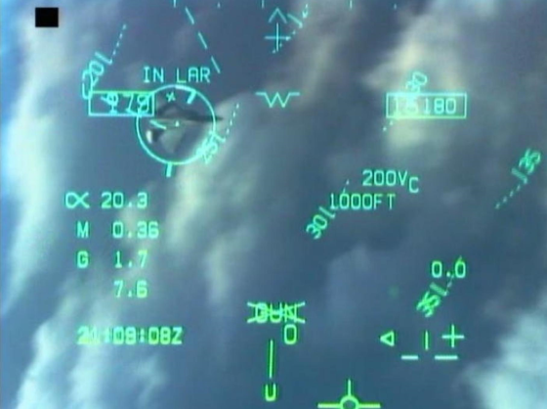
Source: Aviation/Stackexchange.com
Target indicator on a jet fighter
Brusilov now looked at the class, looking for his next victim.
“Tess, tell me what this video shows about what the radar target is doing.”
The ever-prepared Tess did not hesitate to respond.
“The aspect angle between the enemy’s nose position and my nose position, in this case, is 160° to the left; its heading is 190°; its airspeed is 450 knots, and the closure rate is 828 knots.”
“Does this tell you everything you need to know?” asked Brusilov.
“With this information, the pilot gets a much better idea of what the opposing aircraft is doing, but at the expense of information about other aircraft in the area.”
“Precisely, Brusilov said.” He continued by showing how the radar locked on a target, how other targets further away are tracked, and how to identify radar returns even further away. He described an advanced feature of modern radars, Situational Awareness Modes. This meant combining both tracking and scanning to allow a pilot to track one or a small number of targets while not losing the big picture of what other targets were doing. In this mode, the radar beam sweeps the sky, while briefly and regularly pausing its scan to check up on a locked target.
Throughout the presentation, Brusilov kept asking questions to test comprehension. He finished by discussing the use of missiles, demanding answers from the group. His students delivered.
“I am glad that you ladies are getting with the program,” Brusilov said, again making sure that his remark would not be construed as a compliment.
“Looking at you now, it’s obvious that you are suffering from information overload. Tomorrow, we will work on the simulators to practice everything that we learned today. I now suggest we retire to our favorite watering hole in town.”
The Valkyries suddenly perked up.

31
Carmen Suite
The city’s orchestra was back from vacation. The music started with an overture. The main piece of the program was the Carmen Fantasy based on Bizet’s opera by Pablo de Sarasate. Because the score replicated the passion inspired by the opera, it was one of the most challenging and technically demanding pieces for the violin.
Claudine was radiant as she walked to the front of the orchestra in an emerald green gown. By now she had rabid fans in the audience, and it took them a couple of minutes to calm down. Claudine nodded to the conductor. She lightly swayed during the introduction, looking demure and pensive, then raised her violin and started to produce a ravishing sound that was utterly seductive. When playing Habanera, the most famous melody of the opera, Claudine envisioned the temptress Carmen as she flirted with the crowd of soldiers. In the passage called Seguidilla, Claudine showed off her skills by handily working her way with flying spiccato, left-hand pizzicato, persistent trills over a melody, rapid ascending arpeggios, and scales in both thirds and artificial harmonics. Tess was mesmerized, at the same time sure that Claudine could not have developed such virtuosity without Vaughn’s coaching.
Predictably, the applause from the audience was overwhelming. That evening in the restaurant, Claudine basked in adulation from the locals. Tess also reluctantly congratulated her. Claudine just produced a satisfied smile. So far, she was still on top. There was no need to brag.
The newspaper in the morning published an article titled ‘The Valkyries unleash musical war.” The piece was in fact complimentary, noting that Tess and Claudine were locked into a competition on who would dazzle the audience more.
Jake read the article, and he started to worry that Tess and Claudine, rather than collaborating and focusing on the job at hand, were locking themselves into a destructive struggle for dominance. He hoped to be wrong.

32
Fighter Tactics
After a couple of days supervising exercises on the simulator, Brusilov started his usual droning presentation. The Valkyries were eager to do some real flying and did their best to avoid looking bored.
“Air combat maneuvering, also known as ACM or dogfighting, is the tactical art of moving, turning, and situating one's fighter aircraft to attain a position enabling an attack an enemy’s aircraft. Air combat maneuvers rely on offensive and defensive basic fighter maneuvering to gain an advantage over an aerial opponent.”
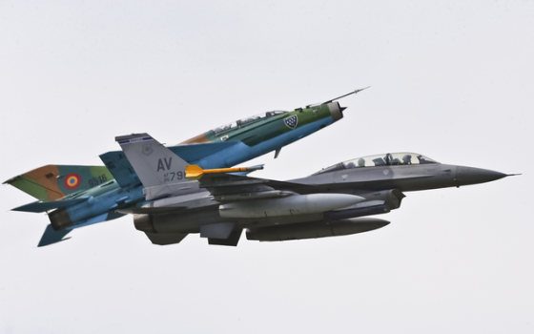
Source: AP/Mircea Rosca
Romanian MiG-21 mixes it up with a U. S. F-16
“In the past, pilots soon learned to get into a firing position, while avoiding the threat of enemy guns, by maneuvering behind an enemy aircraft; this is known as getting onto an aircraft's ‘six o'clock’ or onto their ‘tail,’ plus a wide variety of other terms. This type of combat became known as dogfighting and goes all the way back to World War One.”
Brusilov noted that a couple of the pilots were nodding off.
“Wake up, people!” he yelled. “You need to know this stuff if you expect to defeat your enemy.” He looked at the group like an old-time schoolmaster. “Or maybe you are bored and don’t give a damn!”
The Valkyries all sported a murderous look.
Brusilov proceeded by asking rapid-fire questions on many aspects of aerial combat. He picked on every student and kept testing their theoretical knowledge. It was a blizzard of inquiries conducted rapid fire. The pilots responded without hesitation.
“I’ll be darned, you do have a brain,” Brusilov said sarcastically. Tess fulminated a stare that left no doubt that in ordinary circumstances she would have stabbed the man’s gonads.
“Congratulations,” said Brusilov. “From now on, you will do the talking. You seem to enjoy it. It must be a female thing.”
“You are a sexist, Brusilov,” Claudine said. “You will not break us!”
“We’ll see,” the Colonel responded. “Tonight, I want you to bone up on advanced fighter maneuvers. Make sure you have a light breakfast before you get into the simulators. The manuals are behind you.” He walked out, secretly smiling.
“This is getting to be a pain,” Galina complained. “When are we going to really fly?”
“Let’s do it Brusilov’s way,” Claudine responded. “The bastard knows what he is doing,” she grudgingly acknowledged

33
Upping the Ante
Claudine was still scheming to compromise Tess in Jake’s eyes and was convinced that the key to this was to take advantage of Tess’s relentless competitive behavior. So far, the two rivals limited their contest by showing off their musical skills and impressing audiences. Claudine intended to go much further, thinking of a trap that could work to her favor. This meant upping the ante by importing Vaughn Wentworth to Spain. The man needed a break from a hectic conducting schedule anyway, he told her when he called from Milan.
Vaughn enjoyed being home with Claudine and the kids, which he was genuinely fond of, even if they were not his. The couple’s marriage was odd, strictly a matter of convenience. Neither was in love with each other, but they had a good relationship. Claudine was funny and sexy and did not mind Vaughn’s trysts with other women when he was out of town. Claudine had her escapades as well, indulging in what the French called Cinq à Sept, meeting a regular lover between five to seven on a regular basis. No one observing the couple would have guessed the odd dynamics of their relationship. The fundamental problem was that both wanted to swap with Tess and Jake.
It was only after Tess dumped Vaughn that he ran into Claudine. They liked each other and got together. Shortly afterward Claudine learned she was pregnant and asked Vaughn to marry her. He was initially reluctant to do so because the kids were not his but Jake’s. The more he thought about it, however, the better the scheme grew on him. In a twisted way, the kids created a strong connection between Claudine and Jake, and by osmosis, he hoped that in time that would lead to his own reconnecting with Tess because he thought she was unlikely to live with the fact that Jake had kids with her hated rival. As it turned out, Tess, under pressure from Jake, reluctantly accepted the situation and became fond of the twins. Still, Vaughn hoped that somehow, he would be able to get back with Tess, a hope that was reinforced when the previous year he locked eyes with her during a raid at Belcour’s chateau. Tess and Vaughn involuntarily felt a sudden resurgence of the powerful sexual attraction between them. The problem was that Jake detected the hormonal heat the two of them generated, so he slugged Vaughn in a fit of jealousy. As unpleasant as the episode was, it did confirm that the pheromones between Vaughn and Tess were still alive and well, giving Vaughn hope that someday things could be resolved, perhaps with Claudine’s help, because she was still in love with Jake.
Now Claudine wanted Vaughn to conduct the orchestra to help her play a blockbuster because she was now overtly trying to overwhelm Tess. A performance with Vaughn conducting the orchestra was a guarantee of success. Claudine kept pressuring Vaughn and eventually prevailed. He spent a few days preparing Claudine to deliver the performance of her career.
During a break, Vaughn brought Claudine a cup of tea and sat down with her.
“Claudine, I have lived with you long enough to know that something’s up. Why all this effort to learn and deliver a blockbuster concert? Why are trying to beat and humiliate Tess? You know that she will try to match you move per move.”
“That’s exactly what I am counting on,” Claudine said. Tess is competitive, and no matter what I do, she will move heaven and earth to try to beat me. The only way she can do that is to persuade you to help her. Only your conducting and preparation will enable her to match my performance.”
“I still don’t understand,” said Vaughn. “What’s the point of this competition?”
“The point is to achieve what you always wanted. You are still in love with her. This will give you an opportunity to work with Tess again, and if everything goes well, the hormones will flare up again. When Jake finds out you two are again playing beautiful music together, especially in bed, he will finally dump her for real and get back to me. Everyone’s happy.”
“Claudine, your scheme is dangerous. There’s a good chance that Jake will get violent this time and I will be obliged to respond in kind. The situation can escalate out of control. Also, you must consider the children. Don’t forget that I love them. I don’t care that Jake is their father. If you get back with him, I am pretty sure that he will keep me away from them.”
“Vaughn, you can’t have everything you want all the time. If you reconnect with Tess, you will benefit from her affections, and I will get what I want.”
“I never expected to say this, Claudine, but you seem to have no scruples. You are messing with everyone’s life. I am not sure this will end well.”
“Don’t be a wimp, Vaughn. If we do this properly, we will both get what we want. Wouldn’t it be nice to have Tess in your arms again?”
“You forget that I blew it with Tess. From what I know about her, she is not the forgiving type. She no longer trusts me, and that’s quite an obstacle to overcome.”
“Let’s be positive. Once you get close again, Tess will not be able to resist your charms.”
“I need to think about your scheme,” Vaughn said. He looked at his watch. “Now, let’s go back to work on the fine points of the music.”
The night of the performance, the theater manager walked in after the orchestra members were settled down and announced a surprise: the famous conductor Vaughn Wentworth had agreed to conduct the Tchaikovsky violin concert with Claudine as the soloist.
Vaughn had brought in extra players from Madrid and made the augmented orchestra sound like a first-class ensemble. Claudine’s playing revealed Vaughn’s thorough coaching, resulting in a performance that was passionate, exciting, and sublime. Predictably, the concert was a tremendous success.
Tess was in the audience, and she resented Claudine’s sleight of hand. This manipulation was typical of her duplicity, she seethed. The woman would stop at nothing to prevail and humiliate her. Jake had to refrain her from leaving the theatre in a huff.
“Not fair. Absolutely not fair,” Tess raged.
Once more, Jake made a futile effort to calm her down.
When they got back to the apartment, Jake made Tess a drink and sat across her.
“Tess, I am worried that you and Claudine are spending too much energy in a silly competition instead of working on what’s important. The only way we can get the squadron in shape is to work together. Instead, I see you and Claudine acting like cats in a bag. It’s not healthy for you and the team. It’s time to put this silly behavior aside, or we won’t be successful.”
Tess often took feedback as direct criticism, and this was one of those times.
“Jake, the team is working very well with that bastard Brusilov. I feel that we are making progress. That does not mean that I should ignore Claudine’s provocations. She is a ruthless bitch, and I will deal with her any way I see fit. Just stay out of the way.”
“You two quarrel like teenagers and are jeopardizing the project. Get a grip, Tess. Act like an adult.”
Jake did not wait for a response. He grabbed his jacket and slammed the door on his way out. He resorted to his usual way of working things out in his mind – taking a solitary walk.

34
Maneuvers
After several sessions on the simulators, the Valkyries gathered in the classroom. Brusilov spent considerable time discussing advanced air fighter maneuvers. The man was a fountain of knowledge and painstakingly covered virtually all possible fighter tactics. Using projected slides and short videos of aircraft in the air, he discussed several maneuvers including the Combat spread, Pitchback, Bell Tailslide, Split S, Immelmann turn, Thach Weave, Scissors, and Chandelle. He peppered the description of each maneuver with video clips, stories, and personal experience. The Valkyries were now used to the overwhelming sheer mass of information and managed to keep up. After a lunch break, and they were subjected to more descriptions of complex fighter maneuvers, with strange names like High Yo-Yo, Low Yo-Yo, High-G Barrel Roll, Pugachev's Cobra, Cobra Turn, Kulbit, and the Herbst maneuver.
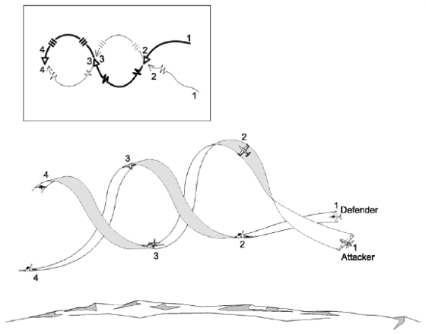
Source: United States Navy - Public Domain Wikimedia Coomons
Rolling Scissors Maneuvering
At the end of the session, Brusilov handed out a ton of reading material that he wanted the pilots to study before the next meeting.
Claudine was reaching the end of her tolerance and raised her hand.
“Yes. What’s your question?” Brusilov asked, clearly annoyed.
“Colonel, in real life, it’s highly unlikely that a pilot will need to use even a fraction of the maneuvers you discussed. Wouldn’t it be better to focus on just a few of the most useful tactics?”
“Exactly which one of the maneuvers would you dispense with?” Brusilov asked.
“I am sure that each one of us would choose those they we are most comfortable with.”
“And what will you do when faced with an adversary that is more experienced and creative than you are?” Brusilov asked. “Would you bet your life using a few tried and true moves when chances are, they might not always work? Your experience is with the French, and I am fairly sure that the pilots you fought against were trained exactly the way you were, so you knew in advance what they were likely to do.”
Claudine defended her statement. “You are correct, Colonel, but the fact is that the maneuvers we used worked most of the time.”
“We must take into consideration an important fact. You will fight the American Air Force, and they have been at war since 2003. That translates into combat experience that no other pilot in the world can match. They also train all the time. Many nations cannot even afford the cost of the fuel the Americans use in training. You can count on facing a formidable foe with access to a repertoire of tactics and maneuvers that most of us just can’t match. Add to that the expertise of allied and NATO pilots, and you will have to deal with a smorgasbord of tried and true maneuvers that will challenge you beyond measure. The only way to deal with these conditions is to be ready to use the entire inventory of proven dogfighting tactics.”
Brusilov paused for a few seconds.
“I just will not allow you to face such an environment without proper preparation.”
“I get your point, Colonel,” Claudine conceded.
Tess and the group formed a study group and spent most of the evening at the terminal. Jake ordered catered food. They all slept in cots at the base, and the next morning they went back to lock themselves into the simulators, practicing every combat scenario known to man. They also learned how to deal with emergencies, sudden weather changes, simulated breakdowns, and coping against overwhelming odds. This was in preparation to flying the fighter planes to put that knowledge to use by flying mock battles with each other.
At this point, the women no longer complained about Brusilov slave-driving ways. They were conscious of how much they had learned and were eager to put that knowledge into practice.

35
The Agony of Defeat
After the stupefying theoretical training and hours in the simulators, it was now time for intensive live combat flying. The first exercise involved all the planes attacking a fortified enemy position of scrapped tanks and artillery that Carmen has purchased from the Spanish army. It looked like a piece of cake.
The Valkyries took off one by one, gathered into a formation in the sky and proceeded toward the objective. What appeared a routine shoot-up soon turned hot. Brusilov, acting as an enemy defending pilot, rapidly flew behind them with his fighter plane and confronted the squadron. Claudine assessed the situation and took the lead. She hurled her jet toward the enemy and made a loop to get behind Brusilov’s fighter. As Claudine got him into her sights, Brusilov’s plane looked like a lame duck. Seconds before she pushed the button to fire, Brusilov pulled a Pugachev maneuver and shot his aircraft vertically into the sky, stopping the fighter’s momentum.
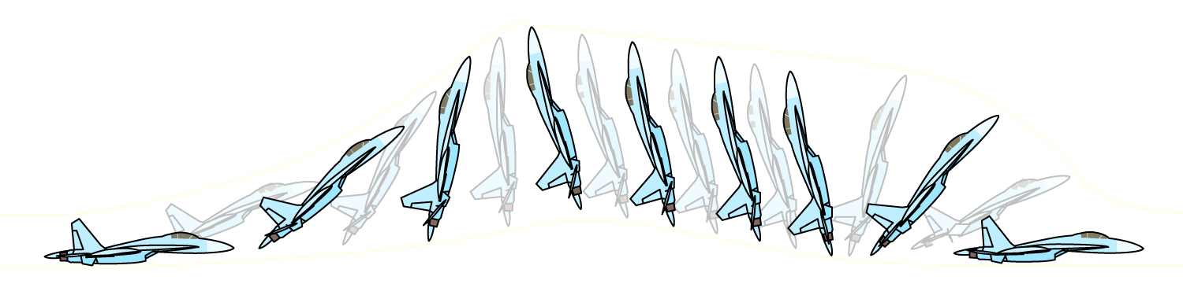
Source: Henrikson
The Pugachev Cobra Maneuver performed by a Su-27
It was a dramatic and demanding maneuver in which an airplane flying at a moderate speed suddenly raised the nose momentarily to the vertical position and slightly beyond, before dropping it back to normal flight. Brusilov used his aircraft’s potent engine thrust to maintain constant altitude through the entire move. He then resumed the arch, and got behind Claudine, delivering a simulated volley that registered as a hit. The flashing light on Claudine’s instruments signaled that she had lost the fight. She had to return to base and face the fact that for the first time in her career, she had been defeated in aerial combat.
Recognizing what happened, Tess saw her chance and flipped her plane to face the aggressor. She saw what Brusilov did, and she was determined to avoid the trap. Her jet screamed through the air, trying to get behind Brusilov’s plane and Tess thought she had him cold until he performed another surprise maneuver, forcing Tess to overshoot his aircraft. The Colonel inverted his fighter aircraft and dived behind Tess. The instruments of her jet screamed danger, but she couldn’t escape the attack and Brusilov painted her. Furious, Tess was tempted to try again, but the rules were clear, and she returned to base. That left the rest of the Valkyries to fight Brusilov, but all for naught. One after another, the colonel shot down every single one of them. It was a massacre.
Back on base, the women were so distraught that they skipped the debriefing session. They needed to go back to their quarters to lick their wounds. Claudine was in shock. This was her first defeat. Tess, ever competitive, was upset. She could not believe that after the many hours she spent studying, practicing on the simulator, and flying many sorties, she was shot down like a sickly bird. The demoralized team piled into the van to return to town. Once they got there, there was no get together, no drinks, no war stories. They felt like failures, and they didn’t like that feeling.

36
Lose and Learn
The next morning, the Valkyries dragged themselves to the training room some of them suffering from a hangover. Brusilov was already in the classroom and was going through some notes. Once the class seated, he stood up before them and stared at the dejected group.
“You are not a winner until you lose.”
That statement reverberated into the women’s’ consciousness.
Brusilov continued.
“An American businessman and author called Robert Kiyosaki said: Winners are not afraid of losing, but losers are. Failure is part of the process of success. People who avoid failure also avoid success.”
Brusilov knew that he had the women’s’ attention.
“Trust me when I say that most pilots go through your experience. You need to know that you are vulnerable, that theory only goes so far. One of the best pieces of advice I can give you is: learn from your failures and don’t make that mistake again. You must also be thoroughly prepared for the next fight. This means that you know the flight rules cold. Know when you need to pursue an enemy plane and when to avoid it. Anticipate various scenarios and always be ready for a surprise. When you see an opportunity to attack, allow for the possibility that you could fall into a trap. When you engage the enemy, don’t assume anything. Keep your options open and be ready to use any of the maneuvers you learned. You must know how to execute your moves without a second thought. Always anticipate that your adversary might use countermeasures and additional tactics to avoid your attack and turn the tables on you. Be prepared to react to moves you didn’t anticipate. Most of all, be aware that your adversary’s job is to challenge and kill you. You must be prepared and willing to kill him first. There is absolutely no room for scruples or mercy in a dogfight. Usually, when engaged, only one of you will survive.”
Brusilov paused for a moment while the pilots took notes. He then started to ask questions.
“What’s the most important thing that you learned yesterday? Claudine, please.”
“Before you attack, think about how your adversary can turn the tables on you and plan accordingly.”
“You have experience. Why didn’t you do it?”
“I treated the exercise as a game. I was shooting at the tanks on the ground and failed to consider that an aerial defense was possible. I didn’t see things through as I did when I was flying against French pilots.”
Brusilov turned to the next victim. “Tess, why did I kill you?”
“I thought I had you in my sights, and I made the mistake of getting excited because I thought I had you cornered. I got overconfident and forgot the lessons we had in the classroom and the simulators.”
“Giuliana, why did I kill you?”
“When you shot down Claudine and Tess, I got emotional and maneuvered to avenge them, but you didn’t do what I thought you would do.”
“What about you, Eva. Why did you lose the fight?”
“Because I failed to think ahead. I focused on killing you and did not consider that sometimes you need to anticipate several scenarios at the same time.”
“Carmen, why did I defeat you?”
“I saw that my fellow teammates were in trouble and tried to defend them without paying attention to the enemy’s own intention to defend their territory.”
“Great answers and I must say that all of you are correct,” said Brusilov. “When you fly in combat, you cannot afford to let emotion dictate your actions. If you chose to fight, you must have the entire set of tactics in your head. What’s the best way to defeat my opponent? What is he likely to do to evade my attack? How can I cause him to make a mistake? The key is to stay consistent with as many variables as you can handle and only change your approach when things don’t go as anticipated. You just need to practice, and as your instructor, I will help with this.”
“However, let me offer my take on what you're reporting so far, “Brusilov continued. “I will say right up front that your experience is typical, and that you aren't experiencing any show-stoppers. The hard work takes place in the classroom, the cockpit procedures trainer, the simulator, and the aircraft during training. Once you're in the air, most flights will go through the same sequence of events at the beginning and the end of each sortie. Some people love being in that groove because it helps them enjoy the flying environment itself. To me, the real fun starts when you make the transition from using an airplane to go from point to point to using it to perform a mission.”
“In conclusion, what you learned is that practice takes time and gets you to proficiency. Once you are proficient, remaining calm and ahead of the aircraft becomes a natural occurrence.”
“Use visualization to heart; it’s a powerful technique to assist you in your training. When you work on the flight simulator and the joystick and rudder pedals, practice your exercises before and after each flight with the same discipline that you take to the aircraft. If you're always prepared, you'll have fewer things to work on improving after each flight, and that's climbing the ladder one rung at a time. Eventually, you'll be at the top, and you'll stand out.”
“So, your homework for the next week is to take a hard look at the various maneuvers, practice scenarios in the simulator, and get ready for the next stage of training: fighting several enemy planes at the same time.”
“What do you mean?” Tess said. “Who are we fighting?”
Brusilov raised his palm, and the whole Russian tech group rose to their feet. They awkwardly waved in a friendly manner and with a smile.”
Tess couldn’t believe her eyes.
“Colonel Brusilov, are you saying that the entire tech team is made up of fighter pilots?”
“Yes,” Chief Engineer Boris Kovalenko said. “We can multitask. I believe the Colonel told you that Russian pilots also know how to fix their planes.”
Tess dropped down on her chair.
“Best of luck,” Brusilov said. “Remember, always be prepared and practice gets you to proficiency.”
On the way out, Tess grabbed Jake’s arm.
“Did you know that Brusilov’s techs are also pilots?”
“I know that he was going to provide pilots to engage with our group, but I had no idea they were part of the same team.”
“I thought you always did your homework.”
“The contract clearly states that Brusilov was to provide techs and pilots. It doesn’t say that they are one and the same. That explains why they work so cheap.”
“Nuts!” Tess walked away.

37
Multitasking
The team continued the familiar after work routine of meeting at a local bistro for tapas and drinks. Sometimes they would have dinner together, other times everyone went their way for meals and entertainment.
Peter Brusilov and Boris Kovalenko were sitting at a table enjoying their vodkas and caviar. Jake and Tess spotted them and walked over.
“May we join you, gentlemen?” Jake asked.
“Absolutely! We were waiting for you.”
Jake ordered drinks.
“Peter, I thought you were going to fly in pilots from Russia for this stage of the training. Why didn’t you tell me that your techs are one and the same?”
Peter shrugged his shoulders. “Would it make any difference?”
“I don’t know. I just expected a different crew.”
“Don’t worry, Jake. The men are fine pilots that can also fix planes. Convenient, no?”
“How did that happen?”
Brusilov lighted a cigarette, took a puff and held it between the thumb and index fingers. “It’s simple. When the Soviet Union collapsed in 1991, there was a period of uncertainty when many state institutions, including the armed forces, fell into disarray. A lot of soldiers, including skilled pilots, were let go. It was then that I selected my best men and established a small company who could maintain aircraft and on occasion contract to train pilots for the 15 separate independent countries that were formed from the Soviet state. It was touch and go for a couple of years, but after a while, we stabilized and since then we have done that kind of work.”
“Of course, we saw Boris flying MiGs during our exercises,” Tess said. “But why didn’t you tell us that all of your guys started as pilots?”
“Nobody asked,” Brusilov said while taking another puff. “In any case, we fully intend to deliver what we contracted to do for you. My men will fly against you.”
Brusilov expelled a puff of smoke. “You seem to be confused, Jake, is anything wrong?”
Jake paused for a moment.
“Well, I don’t see anything wrong with your team, in fact, we developed a high regard for them. I am just surprised.”
“If you look at the contract …”
Jake raised his hand. “There is nothing wrong, Peter. I just got caught off guard. If you say your guys can do the job, I believe you.”
“I am glad to hear you say that, Jake,” Peter said. “The men are anxious to get back in the air and dogfight against the Valkyries. I am sure it will be a lot of fun.”
Tess was not so sure it was going to be fun. The Russian team was formidable and tough to beat.

38
Group Exercise
The pilots gathered in the control room to receive a briefing on the combined exercise. Brusilov was to act as the Russian commander in the control center and direct the squadron led by Boris Kovalenko. Jake played the American commander, leading the Valkyries thought its own control facility and using Claudine as the squadron commander. The point was to provide the women with a taste of the other side’s tactics.
Jake and Nicola would manage the excursion by maintaining situational awareness for the Valkyries. Brusilov and Alex Tukhachevsky would do the same for the Russian side. They all sat at their respective radar screens, ready to do battle.
The Valkyries now practiced American tactics favoring stealth tactics and using long-range missiles to down their adversaries. Boris, as the Russian squadron commander, relied on the situational awareness provided by the ground radars.
The exercises began with the American squadron taking off first, followed by the Russians. Claudine was thirsting for revenge. She was also sure that the rest of her team felt the same way.
Once in the air, ground control and the Valkyries soon detected the enemy planes on the radar and deployed their missiles against the Russian planes without bothering to come into visual contact with the targets. This action was consistent with the American tactics based on superior avionics that enabled them to target hostiles without a ‘real’ dogfight. They scored on two enemy planes.
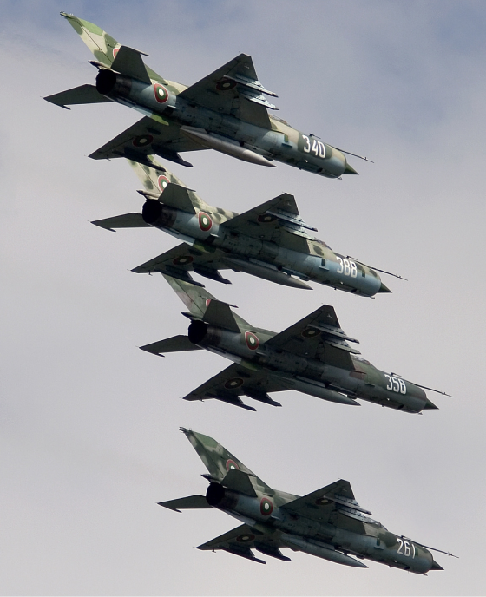
Source: Chris Lofting in Wikimedia Commons
Bulgarian Air Force Mikoyan-Gurevich MiG-21bis
Claudine ordered the dispersal of all aircraft and prepare for the expected onslaught by the surviving adversaries. Jake directed them to achieve visual as soon as possible and prepare to dogfight the Russians. The missile signals from the Russian side followed the Valkyries’ planes, and one of them scored an electronic hit on Galina’s fighter, forcing her to return to base as a downed aircraft. The Valkyries rapid maneuvering, however, managed to outrun and lose the other missiles aimed at them, enabling their aircraft to swoop on the rival jets and score two hits. The remaining opposing fighters executed their maneuvers and downed both Tess and Giuliana. Claudine made a couple of hairy maneuvers that bagged a couple of rivals. Carmen managed to score a final hit on a rival plane. Since they were all running out of fuel, the aircraft returned to base.
The simulated dogfight was exciting, and both crews gave each other hi-fives. Jake immediately corralled the Valkyries for a debriefing and assured them that for a first group air battle they did very well. He knew, however, that Tess would not be happy, so Jake went out of his way to compliment her flight performance.
“Jake, I don’t need a pat in the back,” Tess said, having seen through the ruse. “I was shot down, and I will not rest until I wipe the floor with all of them.”
“Come on, Tess. It was just the first time. You will improve with practice.”
“You can count on that Jake. I will spend every minute of my time flying until I get it perfect.”
Jake shook his head. He knew that Tess would not quit until she won, and on the way out, he hoped that they wouldn’t run into Claudine, who would not hesitate to rub it in. He rushed Tess into the SUV and suggested they change and have a nice dinner all by themselves. No exotic food – promise.

39
Hard Work and Jealousy
During the next two weeks, Tess attended class, but the rest of the time she worked with the simulators until late at night. She paid overtime to have two of the Russians handle the consoles and work with her on combat scenarios. Next, she boarded her MiG to practice maneuvers, challenging her body to withstand the painful G-forces exerted by the plane. After spending time flying loops and backflips, Tess had her fighter plane refueled and took it back on the air. She obsessively practiced every maneuver and scenario, ran out of fuel, landed, topped up her tanks and sped back into the air. She only quit when exhaustion forced her to get some rest. Every muscle in her body was sore, and she had to take a painkiller.
Jake was not happy. He was lonely, waiting for Tess to return to the apartment. She got home late and took a shower, and Jake fixed her something to eat. After a few bites, she crashed and kept doing maneuvers in her sleep.
Vaughn had left to conduct concerts in Germany, so in the evening, Jake spent more time with Claudine and the kids. Claudine did her best to create a family atmosphere, fully aware that Jake enjoyed being with the little ones. She cooked some of Jake’s favorite French dishes and was very affectionate toward him. It wasn’t an act. She sincerely would have loved for Jake to stay with her and their kids. Jake did his best to evade her affections without provoking Claudine to remove his access to the children.
One evening, Tess’s fighter jet broke down and needed repairs, so she got back to the apartment early. Jake wasn’t there. She called him on the cell phone, and he told her he was with his kids.
“Is Claudine there?”
“Of course, she is here. It’s way past working hours.
“I am home, Jake. Please come.”
Jake soon walked in the door and was met with Tess’s glacial stare.
“Are you enjoying your time with Claudine while I work?”
“I enjoy spending time with my kids, and Claudine is good enough to allow me unfettered access to them. You are constantly playing with airplanes, and don’t want me around when you do that. What am I supposed to do, wait at the door for you?”
“I think you like spending too much time with Claudine.”
“I will be glad to spend more time with you if you can be found.”
“Jake, you don’t understand! I must find a way to win. It’s the whole point of this enterprise. Am I the only one that cares?”
“Everyone cares, but we all try to maintain a balance between challenging work and having a life at the same time. You seem to miss that point.”
Tess was feeling hostility build up. She turned and went to bed. Jake poured himself a drink. He was having second thoughts about the enterprise, wondering if it was worth it.

40
A Little Incident
Tess practiced flying the MiG even on Sundays when everyone was off duty. In the control tower, Jake helped by monitoring her maneuvers. Other than a Russian tech, Claudine was the only other person on the base, practicing in the simulator.
Suddenly, Tess called on the radio that Jake was monitoring.
“Jake, I got a bunch of problems. I am trying to land the plane, but the nose landing gear seems to be stuck and won’t drop. I am also losing hydraulics; the plane’s controls are getting sluggish. Oh, I am also low on fuel.”
“Tess, Brusilov said that the MiG has a mechanical lever to unjam the front landing gear. Didn’t you see it during maintenance training?”
“No, I skipped that session; actually, I got there late. I must have missed that portion of the training.”
“Can’t you rummage around and find the lever?”
“All I see is a bunch of handles labeled in Russian or Romanian. I can’t figure out which is the right one.”
“Hold on, let me try to raise someone that knows where the lever is.”
“Hurry up, Jake. I am running out of fuel.”
Jake got on the intercom and tried to raise Anatoly Istomin, the tech on duty. He didn’t respond. Jake then called Brusilov. All he got was a message and realized that he didn’t have the phone numbers of any of the other Brusilov’s crew. He started to panic, then remembered that Claudine was on the premises. He ran to the simulator room and saw Claudine practicing maneuvers inside one of the pods. He knocked on the simulator door and stuck his head in.
“Claudine, I need your help.”
“Can it wait, Jake? I am in the middle of an interesting routine.”
“Claudine, I need your help. Tess is in trouble.”
“She is a trouble magnet; what’s new?”
Jake physically dragged Claudine out of the simulator pod.
“I am serious, Claudine. The nose landing gear of the plane won’t drop. She needs to know where the release lever is so that she can unjam it. She is also leaking hydraulic fluid.”
“How am I supposed to know about this? Call Brusilov.”
“I can’t get a hold of him or anyone in the crew. They are probably at the wine festival.”
“I don’t know where the lever is, Jake. Tell Tess to look harder.”
Jake was starting to panic. “There are many levers in the cockpit, and they are all labeled in Russian.”
“Tell Tess to bail out, then.”
“Tess doesn’t have enough fuel to achieve the necessary elevation. Brusilov cautioned against bailing out at low altitude. Pilots have died trying to do that.”
“I just don’t know, Jake.”
“Claudine, you have many faults, but you have never lied. I know that you know where the lever is. Now, please tell me where the heck it is!”
“Why don’t you let fate happen, Jake? If Tess gets herself killed, it will solve a lot of problems. I am sure you know what I mean.”
“Tess and I have some problems, but the last thing I want is to see her dead. Use your head, Claudine. Please tell me what to say to Tess. She is in mortal danger.”
“She got herself in such a predicament.”
Jake took Claudine by the arm and forced her to walk to the control console.”
“Now, call Tess and tell her what to do.”
Claudine folded her arms under her breasts and defiantly looked at Jake in the eye. “No! I won’t do it. Tess got herself in trouble, and I refuse to bail her out.”
Tess called the control tower.
“Jake, I am without fuel, and I can barely control the plane. The engine is shutting down.”
Jake, desperate, grabbed Claudine by both arms and looked her in the eyes.
“Claudine, you must help Tess. I know you are not a murderer.”
She paused for a moment and shook Jake off.
“All right let’s bail out Tess once more. I am sure I will regret doing this.”
“Just do it, Claudine.”
She went to the mike and hailed the plane in distress.
“Tess, pay attention. The lever you need is the third in a row of three. Just pull it, and the landing gear will drop.”
Tess examined the cockpit and found what Claudine was talking about. She pulled the lever and felt a jolt. The front wheel dropped just in time. The jet hit the tarmac hard and skidded to the end of the long runway. Tess had to deploy the brake parachute and step on the foot brakes aggressively to keep the aircraft from rolling outside of the paved area. When the plane stopped, she froze in the cockpit and caught her breath.
Jake arrived in his jeep and helped Tess out of the cockpit. He looked her in the eye and hugged for a couple of minutes. Claudine saw the scene through the glass of the control tower. She was sure that she made a mistake but also acknowledged that Jake was right. She wasn’t a murderer.

41
Chasing Culprits
After Tess almost crash landed her aircraft, Jake drove her to the terminal and went to find Anatoly, the tech on duty. The man was still not answering his cell phone. After a search in the aircraft maintenance area, he found the man under a plane. He had a woman with him, and it was apparent that they just had sex.
“Anatoly, what the hell are you doing? Tess almost got killed, and you are messing around instead of responding to my calls!”
The woman grabbed her clothes and ran away. Embarrassed, Anatoly pulled up his pants. “I am sorry, Jake. That woman just showed up and took her clothes off.”
“Don’t you think that it was strange?”
“She was really good looking, and I fell for it.”
Jake wanted to strangle the stupid man but resolved to keep his temper in check.
“Get on the runabout and go check Tess’s MiG at the end of the runway. I want to know what caused it to malfunction.”
Anatoly didn’t hesitate, got on the service vehicle, drove to the aircraft, and opened various access panels. Jake checked on Tess, who was uncharacteristically shaken. Claudine was with her, asking questions.
It didn’t take long for Anatoly to return.
“I am afraid that someone punctured the hydraulic lines in three critical areas. It was a professional job. He temporarily capped the holes with plastic plugs designed to fail once the plane got into the air and pressure built up in the system. If you didn’t figure out how to lower the front wheels mechanically, we would have a fatal crash on our hands. I am sorry, I got set up, and I feel like a jerk.”
“Anatoly, any idea who could have done this?”
“None of my colleagues. I know them and have worked with them for years.”
“Who was in the maintenance area? Did you see anyone?”
“Just Manuel, the janitor.”
“Where is he?”
“I don’t know. He seems to have disappeared.”
“Where is the woman?”
“She is gone too.”
“I saw a car leave the airport in a hurry,” Claudine said. “They might be the culprits.”
“Anatoly start the helicopter,” Jake said. “We will try to catch them. I will be back in a minute.”
Jake ran to the terminal and briefly told Tess what happened. “Hurry let’s get to the chopper. I want to catch the man that did this.”
Jake, Tess, and Claudine jammed into the small helicopter. Jake took the controls and took off in the air. It didn’t take long for them to see a car heading to town at high speed.
“If they get to the city’s streets, we might lose them,” Tess said.
“I will catch them if it is the last thing I do,” Jake responded.
The helicopter caught up with the speeding car and Jake buzzed them a couple of times.
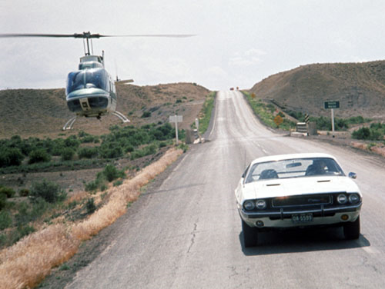
Credit: Omaha Police Officers Association
Helicopter Chasing Car
The third time, he pulled beside the car and raised a dirt cloud off the parched earth. The driver of the car was temporarily blinded and drove off-road, where it hit a small mound, and the car almost capsized. Jake quickly landed the chopper and ran toward the disabled vehicle. It appeared that the two passengers were disoriented. Jake and the women took advantage of the temporary confusion, surrounded the car, and opened the doors. Jake grabbed the woman and passed her to Tess and Claudine. He then dragged the man out and dropped him on the dirt. The man appeared dazed, but then got back on his feet and pointed a gun at Jake.
“Get back!” the man said in Spanish. “I will shoot if you come any closer!”
Jake stood in front of him and spoke in Spanish.
“You are Manuel, the janitor. Why did you sabotage the plane?”
“I will not answer your questions. Stay away, or I will shoot!”
“Just in case you are interested, we have already called the Guardia Civil. They are on the way,” Jake said.
Manuel started to panic. He yelled at the woman.
“Pilar, get back in the car and drive it back to the road.”
Manuel pointed the gun at Tess and Claudine who were holding Pilar. Jake nodded, indicating that he wanted them to let her go.
The woman ran to the car, cranked the starter, but could not get it going.
“Manuel, the front wheel is bent. I can’t make it move.”
Manuel dropped his guard for a second, and that was all that Jake needed to slug him on the jaw and grab his gun. Tess and Claudine swooped in to open the car’s door and dragged Pilar out of the car. Within a minute, they forced the couple to sit on the sand. Now the hapless duo had to deal with Tess, who was not amused by the recent events. She went to Manuel, grabbed his hair, and pulled his head back against the car.
Claudine looked at Jake. “Oh no. Tess is on the rampage again.”
“Okay, Manuel,” Tess said. “Now we know that you are not a janitor and you have sabotaged the plane. I am upset about that, and I want to know who is paying you to do that.”
“I will not talk to you people. I didn’t do anything!”
“Is that why you ran away? Come on; we are not stupid. We will go easy on you if you talk.”
“Go to hell!” was the response.
“Oops, I believe the man just made a mistake,” Claudine said. “He’s in for a treat.”
Tess did not believe in negotiating or engaging in gentle persuasion. Instead, she resorted to her patented, guaranteed way to make a man talk — threaten his manhood. She pulled out a knife that she usually packed in the flight uniform and immediately stabbed the man in the crotch, just enough to draw a little blood.
Manuel panicked. “What are you doing, woman?”
“You can talk to my colleagues, Manuel. They will provide testimony that I got a lot of people to talk by using my little knife.”
Jake and Claudine smiled. Pilar started to move, and Claudine casually slugged her down.
Tess stabbed Manuel one more time. The man whimpered.
“Manuel, your gonads are not big enough for my collection, but if you don’t talk, I will regrettably make you into a eunuch.”
Pilar started to cry, her tears flowing in rivulets.
“Manuel, tell them, dammit.”
Tess indulged into another short stab.
“Fine, I will talk,” Manuel said, looking at Jake. “Just get this mad woman off of me.”
“Sorry, when she is mad, she gets very mean,” said Jake. “Come on, talk and we will all go our merry way.”
“All right, I will talk. Just get that knife away from me.”
“Too bad,” Tess said as she withdrew the knife and ran her finger on the blade.
“Let’s get this over with, Manuel,” Jake said while grabbing the man by the neck. Who paid you to do this?”
“All I know is that a man called Dubois paid me to distract the mechanic and sabotage the plane.”
“His name is Bertrand Dubois?’ Tess asked.
“I think so,” Manuel said, now anxiously looking at the blood oozing through his pants.
“How come I am not surprised?” Tess said. “Belcour is back at it.”
“You got to give the man an “A” for persistence,” Claudine said.
Tess was now ready to go on. “Do we have to wait for the Guardia Civil to show up?”
“No,” said Jake. I didn’t call them. It would only complicate things. Let them go.”
Tess was disappointed but had to admit that Jake was right. She now wished to slug Manuel but decided that she didn’t want to mess her hands. She needed to play the piano in a couple of days.
Tess got at the controls of the helicopter and noticed that Jake was thumbing his smartphone.
“What are you doing?”
“Sending the video of our little interaction with Manuel to a friend of mine that runs Interpol in Spain.”

42
Blue Flag
Tess and Jake talked about how to deal with Belcour, but first, they had to attend to urgent business. Brusilov strongly suggested that the women gain some experience flying in real war games before approaching the US Air Force to offer the Valkyries services. Eva used her contacts in the Israeli military to get the Valkyries squadron admitted as a supplement to their aggressor forces. The team flew their planes to Israel to participate in Exercise Blue Flag, led by the Israeli Airforce. The exercise hosted fighter planes from the US, Poland, Italy, Greece, India, France and for the first time, Germany.
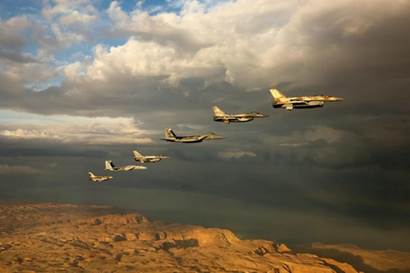
Source: IAF
Blue-Flag 2015 Exercise
The gathering was at Ouvda Air Force Base on the southern part of Israel. Throughout the combined training exercise, the visiting squadrons prepared to fly alongside Israelis to simulate extreme combat air combat scenarios as realistically as possible.
Brusilov’s maintenance crew arrived and set up their operation. They would have to do this during Red Flag as well, so they expected to benefit because the exercise was also a test of support capabilities. Generating sorties from an airfield without home station support was an excellent test for maintenance and logistics personnel.
The Valkyries landed and lined up their MiGs on the tarmac. It was difficult to detect what country they belonged to because their planes did not have national colors, just the Valkyrie icon painted on the tail. When the women left their aircraft, it didn’t take long for the other pilots to notice that they were dealing with a group of capable good-looking ladies, who gracefully turned down suggestions of socializing. They were there to do an important job and were determined to focus on the challenge ahead. It was best to keep as low a profile as possible.
As they women headed for the command building, Julien Boutin, a French pilot, recognized Claudine. He remembered her humiliating him during war games in France, and he held a grudge. He made a point of confronting her.
“Claudine Bisson,” he said. “I see that you are a mercenary now. How does it feel?”
Claudine did not suffer fools easily and gave him the finger.
“Hi, Julien. Being a mercenary is quite profitable, thank you. By the way, I thought that they would have kicked you out of the Air Force for non-performance. I guess you survived, somehow. Are you here to redeem yourself?”
“Now that we are both here, I will make it a priority to shoot you down first,” the man said with a sneer.
Claudine now was amused. “I kicked you in the testicles the first time. What makes you think that you will do better this time?”
“I am looking for revenge, Claudine,” the man said. “Providence has brought us here, and I will take advantage of this opportunity to thrash you.”
“Bring it on then. I am trembling with fear.”
“I will beat you this time, Claudine.”
“In your dreams,” Claudine said as she walked away. Now she was looking forward to taking down the arrogant prick.
During the first five days of the two-week-long exercise, the aircrews acclimated themselves to the base, got to know each other and rehearsed complex scenarios.
During some of the sorties, the participants flew against the ‘Flying Dragon’ Squadron, the IAF’s aggressor unit, which simulated enemy forces via ‘enemy’ aircraft, surface-to-air missile batteries and MANPADS (Man-portable air-defense systems). The Valkyries Squadron participated as an adjunct adversary resource. They used this opportunity to hone their skills and did well enough to bolster their confidence.
The highlight of the event was Claudine tricking Julien Boutin, the French pilot into thinking that he had her in the sights of his Dassault Rafale. As the man positioned his plane behind her, Claudine used a couple of Brusilov’s tricks, outmaneuvered the pursuer, swung around, and splashed him. That felt good. She made it back to base with a smile in her face.

43
Competition
After the exercises in Israel, most of the team returned to Spain. Brusilov, Jake, and Eva flew by airliner to Paris to attend the International Air Show. Colonel Brusilov wanted to see a flight demonstration of the F-35 stealth fighter.
When they landed at Charles de Gaulle Airport, they rented a car and Eva started to drive to the venue. Brusilov thumbed his smartphone and read a long message.
“A friend of mine is in the Spanish Air Force and has some interesting news. It seems that Draken International has purchased 22 Spanish Air Force Mirage F1 Fighters and plans to modernize them.”
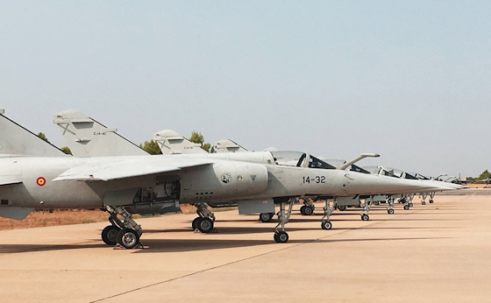
Source: Defense Media Network
Mirage F-1 Planes

“Why do we care?” Eva asked.
“Draken is obviously trying to enhance adversary services for the Americans and their allies,” Brusilov said. “They also acquired twelve supersonic South African Denel Cheetah fighter jets. If my numbers are correct, these increase Draken’s fleet size to over 150 fighter aircraft.”
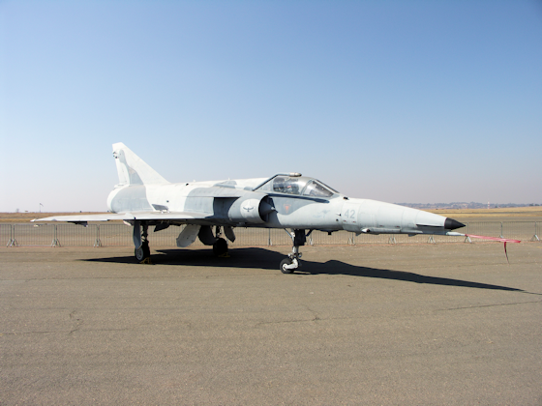
Source: NJR-ZA
Denel Cheetah jet
Jake used his tablet computer to get more information.
“Draken has announced that they plan to restore and certify the aircraft at their maintenance facility in Lakeland, Florida.”
“This means that our competition is becoming formidable,” Brusilov said, shrugging his shoulders. “No need to panic. We will continue to do our thing.”
They reached Le Bourget, a commune in the northeastern suburbs of Paris and the site of the Paris Air Show. The exhibit was huge, with 2,381 exhibitors from 48 countries, showing 140 aircraft. After walking around examining the various spanking new airplanes offered for sale by several manufacturers, Brusilov, Jake and Eva took their seats in a reserved section of the bleachers for a demonstration of a fully combat ready F-35, loaded with everything it needed to go to war.
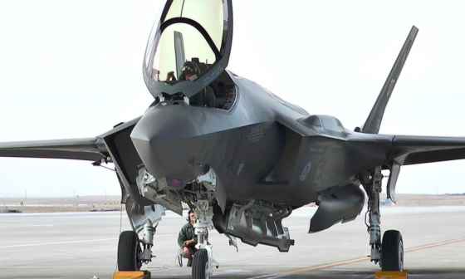
Source: U. S. Air Force
The Awesome F-35 Aircraft
This demonstration was unusual because other fighter airplanes at such shows usually were all slicked off without all the external missiles and auxiliary fuel tanks. The F-35 was fully armed, but it still retained its sleek exterior profile because it was designed to store the weapons inside the fuselage.
The flight demonstration was carefully scripted to highlight the capabilities of the F-35A, particularly its slow-speed handling qualities. The pilot started with an afterburner takeoff, and almost immediately pointed his nose to the sky, climbing away vertically.
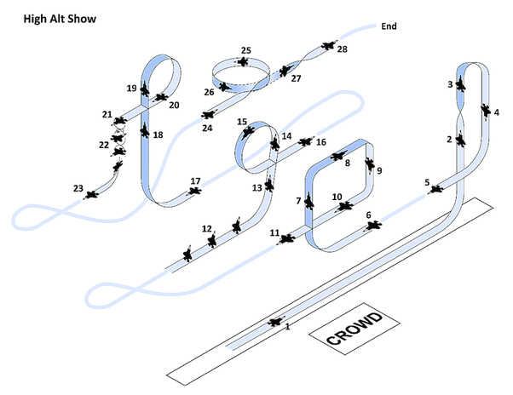
Source: Lockheed Martin via Aviation Week
F-35 Demonstration at Paris Air Show
Next, he turned around, reversed back in front of the crowd, and performed a slow-speed, high angle of attack pass. Afterward, he lighted the afterburner and flew straight up into the sky once again. From there, the pilot pulled up vertically in front of the crowd and executed a maximum angle-of-attack power loop, flipped the aircraft on its back, followed by a spiral at 50 degrees called a ‘pedal turn,’ which was the most impressive part of the entire routine. The pilot then lighted up the afterburner and flew straight up into the sky once again. He kept performing amazing maneuvers and demonstrated that the F-35 was indeed an extraordinary aircraft beyond its stealth capability.
After the impressive demonstration, a crowd of enthusiasts crowded the pilot, Major Joe Campbell. Jake, Eva, and Peter waited for the crowd to dissipate, and approached the pilot, who immediately recognized his old friend Brusilov.
“I will be darned,” he said, “None other than the most dangerous pilot in the air has come to my show. I am flattered.” He warmly shook hands with Peter.
Peter introduced Jake and Eva, briefly explaining their relationship.
“I thought you retired, Peter,” Campbell said. “At least this time you are on our side. I heard about you guys playing in the Israeli exercises.”
“You are not a slouch yourself, Joe. You impressed the crowd with your stunts.”
“I was just trying to squelch the critics of the F-35 once and for all. It shows that it can hold its own in a knife-fight with the Sukhois, MiGs, Chengdus, Shenyangs and other likely adversaries.”
“I have to admit that you succeeded, Joe. You were amazing. Please tell me that you are not going to fly in the Red Flag exercise. We are planning to go there.”
“You are in luck, Brusilov, I can’t go, but don’t underestimate the F-35 jockeys you will meet. They know what they are doing.”
“I am sure they do, Joe. You know that I never underestimate my adversaries. Do you have any advice?”
“Don’t forget, we don’t dominate with fancy flying—we dominate because of stealth and long-range sensors.”
Several American officers arrived.
“I got to go, Peter,” Campbell said. “Best of luck with Red Flag. I will be watching you.”
“Thanks. Stay well, Joe.”
As they walked to their car, Jake looked worried.
“At the back end of Red Flag, we will have to fight F-35’s,” he said. “How are we going to survive?”
“I have to think about this,” Brusilov said. “Good show, by the way.”

44
German Interlude
Jake, Peter, and Eva returned to Ciudad Real with the good news that the US Air Force had agreed to discuss the use the Valkyries as an adjunct to the adversary squadrons in the upcoming Red Flag exercises in Nevada.
Brusilov and his crew had to return to Russia for a week to do some business and buy more aircraft parts. Yasmin squeezed everyone into the helicopter and ferried them to the Madrid airport just in time for them to catch a plane to Moscow.
During the break from flying, Tess, Galina, Eva, Alice, and Giuliana went to Berlin to play two concerts that were scheduled almost a year ago. They were looking forward to visiting the city, an exciting classical concert destination, with three major opera houses and eight professional orchestras, including the world-famous Berlin Philharmonic.
Their venue for their concert was the Pierre Boulez Saal designed by Frank Gehry.
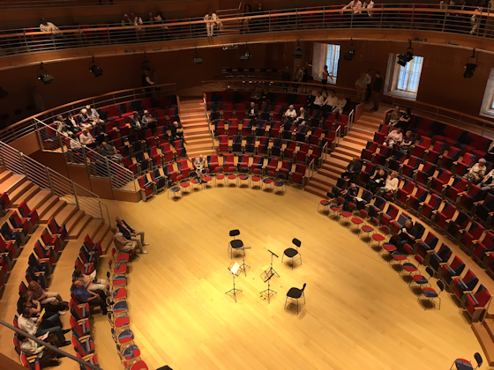
Source: Jroepstorff on Wikimedia Commons
Pierre Boulez Saal in Berlin
The wood-clad hall had flexible seating configurations for up to 700 people over two levels that surrounded the musicians on all sides. The upper level was a set of two oval shaped, column-free, sloping balconies, which rotated slightly against the axis of the oval stage, enhancing the sight lines.
The Valkyries program included two great quintets, the Chausson concert, and the Brahms piano quintet. The performance impressed the discerning German audience. After the applause, flowers, and accolades, the girls changed and were planning to hit a couple of clubs.
As they walked out of the building, they Valkyries ran into an uproar. Several bearded men that looked like refugees were harassing people that had just attended the concert. It was hard to understand what the men were saying, but Tess finally figured out that the men disapproved the practice of making music, something that was forbidden in conservative Islam. The well-dressed Germans did their best to avoid the harassment and got into their cars or the Metro as soon as they could.
Tess was furious. She tried to keep her temper in check and attempted to move through the increasingly hostile crowd. The Muslim men saw the group of women, and went into overdrive, trying to steer them toward the bulk of the group. One of them made the mistake of grabbing Tess by the arm. A couple of seconds later, he was on the pavement holding his privates. Mayhem followed, the mob now surrounding and screaming at the women. Things were rapidly getting out of hand, and the men accosted the women aggressively. Such a move was a big mistake because the Valkyries used their martial skills to unleash a world of hurt on them. The harassers bucked under well-placed punches and kicks, some on their heads. It didn’t take long for the girls to create a heap of hurting and bleeding disheveled men. It was at this moment that the German police arrived in their cars. Two of the injured men, holding their stomachs and trying to staunch the bleeding from their noses hailed the cops. One of the refugees, who had learned to speak some German, screamed and pointed at Tess.
“These women attacked us,” they kept saying. “They attacked us without provocation. They are prejudiced toward Muslims. Arrest them!”
Tess looked like she was ready to rip the men’s throats and would have pounced on them some more if Galina and Eva had not restrained her. The policemen noticed that, and the senior cop approached the team.
“I need all of you to come with us to the police station.
Tess shrugged off her colleagues’ arms and looked at the cop with incredulity.
“You have to be kidding me! These men attacked the concert audience, and you want to take us into custody?”
“Madam, we only want you to leave the premises for your safety,” the policeman said.
“How about those goons,” Tess screamed. “Are you going to arrest them too?”
The sergeant gave an order to his men. They started to disperse the crowd.
“Aren’t you going to arrest them?” Tess asked again.
“Madam, you beat them up. We can’t detain them.”
“So, when is it a good time to arrest these goons, after they hurt and rape women?”
“Madam, I insist that you come with us.”
“Tess was trying hard not to take out her ire on the bureaucrat, prompting Galina to tell the policeman that they agreed to go to the police station.
A black police van arrived, and the women were urged to get in the back. As soon as they were all inside, the driver turned on the siren and took off. It only took five minutes to reach the station, and the policemen led the Valkyries to a large room.
A burly police captain walked in, taking the measure of the startlingly attractive group.
“Are we under arrest?” Tess said defiantly.
“No madam. You are here for your protection.”
“Did you arrest any of those goons?”
“That’s none of your concern. I must ask you to leave Germany as soon as possible.”
“We are the ones that they attacked, and now you want us to leave?”
“We are just trying to keep thing peaceful, madam. Let me remind you that you and your colleagues beat up the men.”
“Are you suggesting that we should have let them attack us? What’s wrong with you people?”
“Please leave in the morning, or I will be forced to arrest you on charges of assault and battery.”
Tess was speechless, and it was apparent to her colleagues that she was within a millisecond of unleashing her rage. The Valkyries were not in a mood to spend the night in jail and took Tess aside to tell her to calm down, so they could leave.
“Tess, tell them that we will leave as soon as possible,” said Giuliana. “This is getting weird.”
Tess reluctantly agreed, and they left the police station. The clubbing was no longer on the cards, so they walked to the hotel. Before retiring, Tess took Galina aside.
“I need you to use your computer and do your database magic, Galina. This is what I want to know.”

45
Meet the Press
Galina did her thing and provided the results of her search to Tess before they went to bed.
The next morning, the Valkyries were checking out of the hotel, and a news crew with video cameras suddenly mobbed them. A reporter approached Tess and pointed a microphone at her.”
“Frau Turner, do you have any comments on last night’s altercation in front of the concert hall? Did you beat up the refugees because of your prejudice against Muslims?”
Tess couldn’t believe what she heard.
“You people let in over a million Muslim refugees in the country, many of whom are unlikely to assimilate, are harassing and raping your citizens, and you say that I am prejudiced? For your information, I have fought against ISIS, Boko Haram, and various terrorist groups. I know first-hand how hateful Islam can be. I am not prejudiced against Islam itself, but I have experienced how certain aspects of the religion damages and enslaves millions of people.”
“Are you confirming that you have disdain for the Muslim religion?”
“Yes, there are aspects of the religion that I consider barbaric and oppressive. I will not go into detail because you are not interested in the facts.”
“What facts do you want to share with us?”
“Very well. If you are interested in the facts, why don’t write about Germany’s migrant rape crisis that is sowing terror and destruction?”
“Aren’t you exaggerating so you can push your agenda?”
“The real obscenity is that in Germany, Sweden, France and Belgium women and children are sacrificed on the altar of political correctness. Up to 90% of the sex crimes committed in Germany do not appear in the official statistics. There is a strict order by the authorities to not report on crimes committed by refugees. The only respond to specific requests from media representatives about such acts."
“How do you know that?”
“I just asked for detailed information. The sad fact is that Germany's migrant sex-crime problem is being exacerbated by its lenient legal system, in which offenders receive relatively light sentences, even for serious crimes. In many instances, individuals arrested for sex crimes are released after superficial questioning from police. This practice allows suspects to continue committing crimes with virtual impunity. I assure you that the thugs that attacked me and my people last evening fit neatly into that scenario. Instead of jailing the culprits, the police tried to detain us instead. What’s wrong with that picture?”
“I am not sure you have the right to criticize our justice system.”
“As someone that has fought against Muslim extremists, I feel that I am qualified to point out that Germany's migrant rape crisis continues unabated. The facts are that migrants committed more than a dozen rapes or sexual assaults every day in 2017, a four-fold increase since 2014, the year before Chancellor Angela Merkel allowed into Germany more than a million mostly Muslim male migrants from Africa, Asia, and the Middle East.”
The torrent of information that Tess spewed out dazed the reporter who realized that if he let her talk, he would get more than he bargained for, so he withdrew the microphone. In any case, he got what he was looking for.
“Just for the record,” Tess told the man as he was leaving, “My stepdaughter was born a Muslim.”
Tess and her team got into the van that was to take them to the airport.
Once underway, Eva smiled. “Well, it looks like Tess took a leaf from Jake’s famous data dumps. He couldn’t do better. Very impressive, Tess.”
“I have an irresistible urge to hit somebody,” Tess responded.
“I am glad we are on your side, Giuliana quipped, and the girls heartily agreed.”
“By the time they arrived at the Madrid Airport, the international news kiosks already had copies of the German newspaper. The headline was:
“Prominent American mercenary attacks the German Government over its handling of the refugee crisis. States hatred of Islam.”
“Oh Lord, the Giuliana said. We have been set up.”
Carmen picked up a Spanish newspaper, read the headline, and grabbed Tess’s arm.
“Tess, look at this.”
Tess quickly scanned the article complete with pictures and said: “Good Lord.”
Spain was hit by its worst terrorist attack in more than a decade on Thursday, when a van driver plowed into dozens of people enjoying a sunny afternoon on the Rambla, one of Barcelona’s most famous thoroughfares, killing at least 13 people and leaving 80 bloodied on the pavement. This latest attack is similar to when Spain suffered the worst Islamist attack in European history on March 11, 2004, when blasts from 10 bombs on Madrid commuter trains killed 191 people.

46
Nasty Surprise
Jake went to the airbase after dinner to catch up on some work and checked his messages before going home. His bulldog Sebastian, who usually scrambled to flop on Jake’s feet every time he settled at his desk, this time was taking a nap on the cool floor, snoring like a champ. As Jake sat down, a messenger delivered a large envelope with an URGENT stamp prominently displayed.
Jake used a letter opener to open the envelope and pulled out the document. It was a legal instrument from Dubai Strategic Investments demanding an immediate cessation of operations. Jake scrutinized the legal language and quickly understood the implications of the document. It stated that the stop action was due to unacceptable statements that Tess Turner made to the European press, where she demonstrated overt hostility toward the refugee population in Europe, most of which was Muslim. The document further stated that a legal team would freeze the use of the MiG aircraft and related equipment. Lawyers and solicitors would arrive the next day to execute the order.
Jake scratched his head. He could not understand why an investment group would singlehandedly shut down an expensive operation without even a discussion. He needed to deal with the situation before Tess and the Valkyries returned.
The next day, Jake asked Nicola to pick up the Valkyries at the Madrid hotel where they spent the night and fly them home in the helicopter. Before doing anything, he wanted to talk to Tess.
When she arrived, Jake opened the door for her and put down her small travel bag. Tess thought that it was strange that Jake didn’t kiss and hug her as she expected, and instantly suspected that the events of the last couple of days were the culprit.
“Tess, please talk to me,” Jake said. “What happened in Germany? Why didn’t you call me and let me know?”
“I didn’t want you to worry. We had some trouble with some Muslim refugees, but we handled it.” Tess slapped a newspaper on the table. “Now the terrorists hit Barcelona.”
“What happened in Germany?”
‘The press interviewed me, and I was less than sensitive about my opinions. Frankly, I slammed the German authorities for their atrocious handling of a dangerous situation.”
“Tess, did you rant against Muslims?”
Tess got defensive. “Yes, I did. It seems that a malevolent tide is trying to swamp Europe, and I wasn’t in a mood to be diplomatic. How much longer are we going to tolerate the deliberate undermining of our values by a primitive religion?”
“Tess, the problem is that our joint venture partner is an Arab conglomerate that has a majority stake of our company’s shares. Now they are shutting us down because of what you said.”
“They wouldn’t dare.”
“Yes, they dare. A planeload of lawyers and solicitors will descend on us tomorrow to close us down.”
“How can that happen, Jake? We still own 49% of the shares.”
“It doesn’t matter. They can shut us down if they want.”
Tess went to the liquor cabinet and poured herself a straight double Scotch.
“Jake, we must find a solution. I can’t tell the team that after all the work we did we won’t be able to fly. There must be a way around this.”
“Frankly, I am too confused to think right now,” said Jake.
“Jake, you are the magic man. You always find a way to deal with a situation. Think harder.”
“Before I do anything, I suspect that something fishy is behind this and I am going to find out what’s going on.”
“Okay, it’s a start.”
“Tess, pour me another Scotch too, please.”
***
The next morning, Jake and Tess convened the team in the terminal classroom and broke the news to them. It took a few minutes for the people to process what they were hearing.
Carmen started. “Tess, are you saying that after all the work, sweat and tears, that it was all for nothing?”
“We haven’t given up yet. We are still looking at other options.”
“What options? They are going to shut us down tomorrow and take the planes.”
“We will meet with the investors later this morning and figure out what they really want, Jake said. “I am sure there is a way to deal with the situation.”
“Tess, as usual, it seems that your big mouth screwed thing up,” Claudine said with a measure of venom.
“You bitch!” Tess jumped at her and would have decked her if Jake hadn’t anticipated the reaction. He managed to get between the women and restrained Tess. She fought furiously, but Jake was behind her, locking his arms like a vise much as he had when they first met in Las Vegas when she was about to beat the daylights out of her first husband whom she caught cheating.
“Tess got a flash of that event, and her rage exploded, but Jake managed to restrain her.”
“Leave us alone for a moment, please,” Jake said to the team who quickly walked out.
Tess was practically foaming at the mouth and continued to struggle until she was exhausted.
“I can’t believe you did this to me again, Jake. Let me go.”
“Are you going to calm down? This is not the way to solve problems.”
Tess shook violently, but this time Jake let her go.
“Jake, if you do that to me again, I am going to dump you!”
Jake ignored her rant. “Tess, Claudine deliberately provoked you, and you fell right into her trap. You aren’t going to solve anything this way, and you know it.”
“I just want to break things, preferably on Claudine’s head!”
“Tess, get over it. You don’t have to be defensive. I don’t believe for a minute that your talking to the press caused the problem. There’s something else going on, and I am going to find out what it is.”
Tess sat down, her hands on her eyes.
“I can’t believe this. I just can’t believe it.”
“Tess let’s take a break and go home. We will deal with this tomorrow.”
Jake went to the next room where the team had assembled.
“People, something weird is going on, and I am going to find out what it is. Go home and get some rest. We’ll find a solution soon enough.”
“Are you sure, Jake?” Giuliana asked, skepticism on her face.
“Trust me; we will fix this. See you tomorrow.”
The team walked out to take the van to town. They were uncharacteristically quiet.
“I hope I didn’t lie to them,” Jake thought.
Jake went to Tess, who still had her hands on her eyes. He helped her up gently and gave her a soft kiss.
“We will find a solution as soon as the Dubai people show up. We will listen to what they have to say and see if anything makes sense.”
Tess hoped that Jake was right.

47
Closing Shop
A small caravan of three black SUVs approached the airport. Jake and Tess met them at the front door of the terminal and led them to a conference room.
The lawyers and accountants in the group sat down and pulled a stack of documents from their briefcases. A man called Zufar Rabbani appeared to be the leader and started the proceedings.
“We are here to initiate the dissolution of the partnership between Dubai Strategic Investments and SRD.”
“I read the dissolution documents,” Jake said. “I find it difficult that you, as investors, would want to liquidate a going enterprise with significant assets. With all due respect, it doesn’t make sense.”
“Our management directed the dissolution of the firm as a matter of principle,” Rabbani said that. “Our organization cannot support an operation led by people who are hostile toward Muslims.”
Tess slapped her copy of the documents on the table, but Jake grabbed her hand.
“What do you expect to do with the venture’s assets, primarily fighter jets?” he asked”
“I am sure that we will be able to sell the hardware to interested parties. Our primary responsibility is to shut down the operation and divide the remaining assets based on the number of shares owned by the respective companies.”
Jake was quite an expert in financial matters and was sure that the Muslim thing was just a pretext. There had to be more.
“Who is the real power in your organization?”
Rabbani hesitated for a moment. “The gentleman wishes to remain anonymous. He has given us power of attorney to initiate the corporate dissolution.”
“Okay, play it your way,” Jake said. “You take the MiGs. SRD leased the simulators, the runway, and control tower equipment separately, so that doesn’t count. We will dispose of all assets and divide the cash accordingly. Frankly, there isn’t much left. We just tapped the line of credit as necessary.”
Jake stood up. “Please be advised that you will be charged a storage fee of a thousand dollars a day for each aircraft. I believe that works out to 20,000 dollars a day.”
The investors chocked.
“Good day, gentlemen.” Jake took Tess’s hand, and walked out of the room.
Tess wasn’t sure of what Jake was doing.
“Jake are you sure you don’t want to salvage at least half the planes?”
“I am very sure.”
“So, what do we do?”
“I need to talk with Brusilov. He is still in Russia and told me he is working on something.”
“Do you trust him?”
“At this point, we don’t have much of a choice.”

48
Wheel and Deal
It didn’t take long for the people representing the Dubai enterprise that they had a problem. The MiG-21s were dated aircraft, and even their upgraded status did not help to find customers. On top of that, Jake charged his former partners for the planes’ avionics upgrades. Now they faced a daily bill of $20,000 a day to store the aircraft classified as military, which prevented their storage in commercial facilities. The planes were allowed into Spain on a temporary basis, with the understanding that SRD would remove them after six months. The accountants and lawyers spent a few days calling potential buyers without success. They asked Jake to reduce storage fees, but he refused, and he told them that regrettably, he would have to double the fees in a week due to increasing costs. That was going to cost them $40,000 a day.
In the meantime, Jake talked with Alice’s husband, General Somi Okafor and suggested he consider acquiring the MiGs. The investors were between a rock and a hard place and jumped at an opportunity to talk business with the General, who represented the Nigerian Air Force. Nigeria could use the fighters to fight Boko Haram.
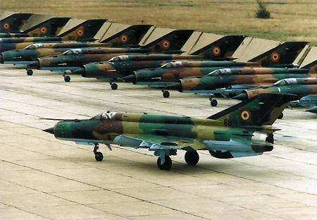
Source: geocities.ws
MiGs lined up on the tarmac
Somi made a show of inspecting the jets, fussily nitpicking over details. He then made an offer to get the planes off the investors’ hands. The men balked at the paltry sum that Somi was willing to pay but were facing outrageous storage fees imposed by Jake, plus they faced pressure from the Spanish government to remove the planes from their sovereign territory. They didn’t know that Jake was friendly with the Minister of the Interior, who enjoyed watching the ‘Moors’ squirm. Soon the deal was made. The investors sold the MiGs to Nigeria for a pittance, and Jake magnanimously agreed to waive the storage fee to allow Somi to arrange for Nigerian pilots to pick up the planes in due course. Somi immediately offered to make the aircraft available to the Valkyries, but Jake turned down the offer, mainly because he was considering the dissolution of the enterprise. Regrettable, but he felt it needed to be done. He blamed himself because his due diligence had failed this time. He did not know who was behind the investors, but he suspected that Laurent Belcour was the culprit.

49
Russians to the Rescue
Late in the evening, Jake was at the airport’s control tower, sadly contemplating the possible dismantling of the operation. The radar screen came alive, showing a squadron of planes approaching. Jake pressed the button on the comm and tried to raise the leader of the pack.
“Incoming aircraft, you are approaching an inactive runway. Please state your intentions.”
After a brief pause, Brusilov responded.
“Valkyries central, request permission to land six aircraft.”
Jake did not bother to ask any questions, other than saying, “You are welcome to land.”
Jake looked out of the control tower and saw an extraordinary spectacle: twin-tailed MiG-29 fighters landing one after the other. Jake called Nicola and told him to assemble the crew on the tarmac to help the pilots out of the aircraft. As they rolled toward the hangar and parked, the scream of the jets’ engines was deafening.
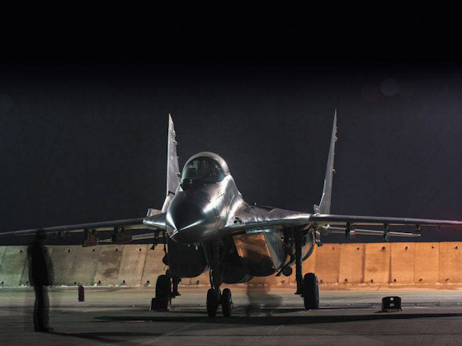
Source: Maciek Wolanski at Airliners.net
MiG-29 at night
In the dark, the planes looked both formidable and sinister. Brusilov was the first pilot to open the canopy. Alex rolled the ladder to the cockpit for the Colonel who swiftly dropped down the stair steps and jumped on the ground with a fluid motion. A Jake approached, Brusilov saluted.
“Sir, I present you with a new squadron of MiG-29s for your consideration.”
Jake shook hands. “Welcome back Peter. We missed you. Now, would you care to explain how you got new planes?”
“I dug into my pocket and purchased the beautiful things for $5 million apiece. A pretty good deal, no?”
“Stop joking Peter. You know that we can’t afford these planes.”
“As the Australians say, no worries, mate. I just persuaded the Poles to lend me the equipment.”
“Just like that? Who is going to pay for them?”
“No problem. A few high-ranking people owed me and agreed to let me borrow the jets for a while.”
“I am sure that there is more to the story,” Jake said as they were walking to the terminal.
“Don’t worry Jake. I just promised to take care of the equipment, return it in good working order, and force my team to work for the Poles as indentured servants to end of our days.”
“I assume you are jesting.”
“Yes and no. I had to promise that my team would bring the equipment back to snuff.”
“Brusilov, I am impressed,” Jake smiled. “You didn’t have to do this for us.”
No, I didn’t, but if you think I would let a bunch of bean counters ground the Valkyries, you are mistaken. The ladies will fly Red Flag, show what they can do and as you Americans say, kick ass!”
Tess barged into the conversation.
“I have no idea what you guys are talking about, but I like what I hear.”
“Hi, Tess,” Brusilov smiled. “I brought you a bunch of shiny new toys.”
“I saw the planes, and they look fantastic. Quite impressive. How long it is going to take for us to fly them?”
“Normally, a year, but we will do it in four weeks.”
“You got to be kidding.”
“I never jest about my training. Your girls just need to hate me a little longer, get familiar with the planes, and we’ll be ready to go.”
“I can’t wait,” Tess said with enthusiasm. “What do we have to do?”
“Just show up with your team tomorrow, and you will fly the new beasts by the end of the day.”
“That’s awesome! I will tell the girls.”
“Just be here in the morning. We have work to do,” Brusilov said with a smile.
Tess ran to find the Valkyries.
Jake shook Brusilov’s hand. “Peter, my hat off to you. You saved the day.”
“We have a lot of work to do, Jake, but we have an amazing group of people. The American Air Force won’t know what hit them!”
“I like your optimism.”
“Me too, but now I need a drink.”

50
Nice New Toys
It was early morning, and the team had already congregated around one of the MIG-29s, an awesome looking fighter plane with double tails and engine air intakes under the cockpit. The aircraft still had the black cross of the German Airforce painted on the side. The fluidly beautiful aircraft looked like a huge snake with wings, ready to bite.
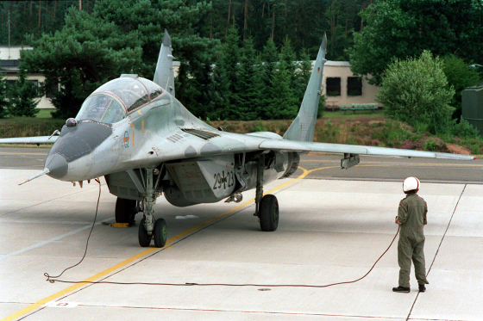
Source: TSGT Gary Tomoyasu – Public Domain via Wikimedia Commons.
German MiG-29
Alex was an expert on Russian weapons and pointed out some key features of the planes.
“Observe the twin engines placement. Very few western fighter aircraft place the intakes below the cockpits, barring the F-16 and probably a few others. American and European fighters normally have the air intakes to the side.”
“So, what’s the advantage of the Russian design?” Giuliana asked.”
“It adds to maneuverability, and as you know, Russia tends to focus on that,” Alex explained. “I never dreamt we would be able to fly MiG-29s.”
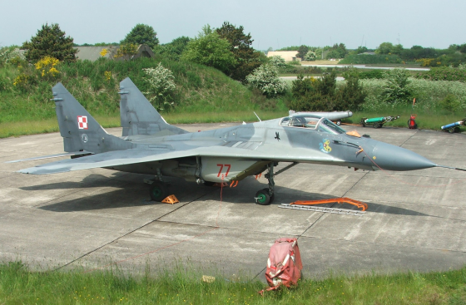
Source: Wikimedia Commons
MiG-29
Brusilov arrived in his Jeep and stepped on the brakes, raising a little dust. He walked toward the group that was still admiring the planes.
“I see that Alex has started bragging about the new equipment,” he laughed. “You haven’t seen anything yet. Let’s go inside.”
The gang settled in the classroom.
Brusilov was in a good mood. He projected a profile of the aircraft on the screen.
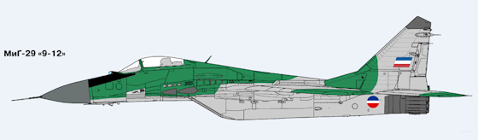
Source: Tdhla1 on Wikimedia Commons
A digital representation of a MiG-29B
“After reunification, the Germans inherited a whole squadron of MiG-29 aircraft. The former East German pilots helped the Luftwaffe study and test the planes, impressing their new colleagues with the MiG's performance. At the time, no western fighter could rival the MiG-29 on a similarly high level. The flight characteristics were only matched by modern aircraft like the Eurofighter Typhoon or the F-22 Raptor, produced thirty years later. In the hands of a competent pilot, the MiG-29 fighter is unbeatable. These planes can perform maneuvers that seem to defy physics, capabilities intended to disorientate enemy pilots.”
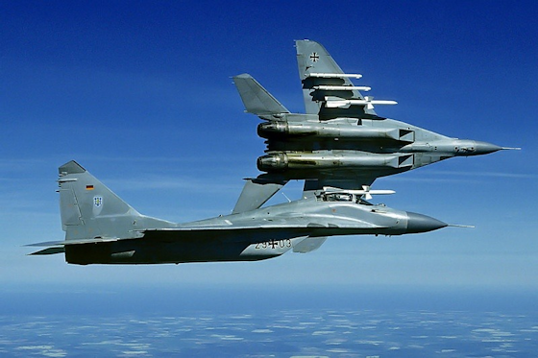
Source: AcesFlyingHigh
German Mig-29s in Flight
“The aircraft has extremely powerful engines that give it a thrust ratio greater than the F-16, F-18 and F-15. Has a climb rate of 50,000+ feet a minute from the ground up. F-16 and F-18 are 40,000 feet a minute.”
“The Pilot has a helmet mounted sight that allows the pilot to lock on with missiles or with the gun. No other fighters are known to have either of these features.”
Brusilov projected a slide on the screen.
“The MiG-29 has an optical locator system mounted on top of the nose that allows pilots to designate targets with long-range infrared guided missiles passively. With the latest updates, they can detect and designate an aircraft from 50 to 90 kilometers.
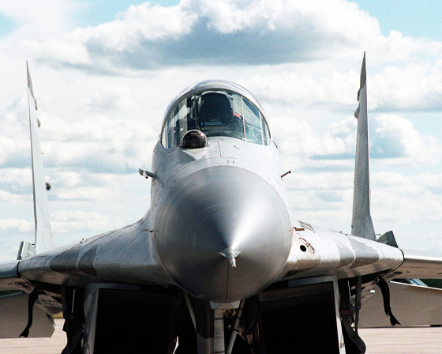
Source: LCPL C. E. Sellers, USMC in Wikipedia Commons
German MiG-29 Radome
Even the most powerful radars today may not be able to maintain target lock at such distance, depending on the conditions. Bottom line, this will help somewhat when dealing with the stealth planes.”
Giuliana raised her hand. “If the planes are as good as you say, why did the Germans give them to Poland?”
“The Germans are part of NATO,” Brusilov said, “so they can’t be dependent on Russia for parts and support. The Poles are not that fussy and gladly accepted the planes, especially since the German sold them for a symbolic one Euro.”
“What a deal!” Eva said.
“Enough with the theory,” Brusilov continued. “After I show you the basics, this afternoon we will fly the planes. We have a month to master them. When we are done with practice, we will go to Red Flag and become the worst nightmare of the American fighter pilots.”
The team cheered.

51
A Life Not Lived
On family night, the team was snacking on tapas and sampling the new wine of the season at one of the city’s restaurants. Tess and Jake were in Madrid for a couple of days of business. Claudine brought her twins and was showing them off to her colleagues. Carmen a Nicola had a booth and were playing pattycake with little Luca, who was giggling in delight. Aara seemed to have connected with Rafael Marquez, the son of the vineyard owner. The handsome young man must have had a good sense of humor because Aara often laughed when he told stories. Alex and Galina sat at a round table exchanging war stories with their fellow Russian compatriots. Giuliana and Eva were at the bar sipping wine and fending off admirers. Yasmin was smooching with her fiancé George Kimmel, who had just arrived from New York to discuss business with Jake and Tess.
Colonel Peter Brusilov sat alone in the bar corner, keeping his distance from the group he was forging into a cohesive team. His men had found Spanish girlfriends, a good thing, because it kept them from imbibing too much.
Peter’s efforts had succeeded in creating a confident and skilled team of pilots, but the Valkyries project was coming to an end. Intense weeks of training had brought a welcome respite from his recurring nightmares. Now he was no longer working 16 hours a day, and that was bad. Free time brought on bad thoughts and his persistent depression was starting to rear its ugly head. After a long dry spell, tonight he was planning on getting stinking drunk. He needed that, he told himself. He owed it to himself.
He went to the restaurant’s bathroom and looked at himself in the mirror. His forehead had a few wrinkles, and his eyes had some bags underneath. Asides from smallish love handles, his body was still in reasonable shape. He worked out regularly, mindful that the specter of aging was inexorably approaching, although he was healthy for his age. He splashed cold water on his face, dried up, walked back into the restaurant, and found that other people had taken his seat. He moved on and appropriated a booth furthest from the bar.
Dreaded feelings came back with a vengeance, accompanied by overwhelming regrets. Peter looked twenty years younger than he was, but there was no reason to rejoice. All it meant was that he had not fully experienced life. He was just a fighter jockey that didn’t know how to do anything else. He spent his life working with machines whose sole purpose was to kill people in wars imposed by old men at the top, safely distant from the destruction and pain they caused.
Peter hailed a waiter and ordered a bottle of vodka. The dreaded familiar reverie was now upon him, reminding him that his life had been a banal journey of no significance. He never broke bones in athletic contests, nor had herpes, gonorrhea, or any venereal diseases. “Shame on me,” he thought while observing his men partying the night away. “I wish I had some evidence of having lived, of having had lovers, perhaps a prostitute or two to throw into the mix.
A life not lived.
Eva extricated herself from the group that was becoming raucous and walked to Peter’s booth.
“Looks like our brave colonel needs some company.” She sat across him without waiting for an invitation. She hailed a waiter and ordered a glass of wine. Peter said nothing and poured another shot from the Vodka bottle.
“Peter, at this pace, you are going to live up to the reputation of a boozy Russian. Want to talk about what’s troubling you? I have never seen you indulge before. Also, why don’t you have a girlfriend as your men do?”
“Eva, perhaps you should ask yourself the same question,” Peter said, inebriation taking hold. “All you drink is a little white wine, and it seems you have been avoiding men. Perhaps you have ghosts of your own, no?”
“I don’t need to be with a man.”
“So, who do you want to be with, a woman?”
“No. I happen to agree with Jake’s opinion that most men are pigs.”
“When did you gain that valuable piece of intelligence?”
“I overheard Jake speak with Tess. By the way, she disagrees with him.”
“Good to know,” Peter said, as he downed another shot of Vodka. “I happen to think that on occasion, the reverse is true.”
“Are you saying that women can be pigs?”
“No. Women are far too beautiful and delicate to be pigs. Sometimes, they are worse. They are more likely to deceive and destroy a man. They can do it without the subject knowing it’s happening.”
Eva was taken aback. “Are you telling me that you did not sow your wild oats when you were young? It seems to be a male rite of passage.”
“Alas, I did exactly the opposite. No, I have done none of that. Soon after I graduated from the academy, I screwed up, and I impregnated my first and only girlfriend, so we got married and lived in a state of dubious bliss for 42 years. Over time, our daughter became estranged. It took a long time to discover I was a cuckold, what Nicola calls a cornuto, an Italian term that perfectly describes that unfortunate condition. I am now getting old, living on a state pension, and consulting gigs like this one.”
Peter downed another Vodka. Eva was worried that at this rate, he was going to finish the bottle.
“You are saying that your wife had an affair. That kind of thing happens. It’s not necessarily the end of the world.”
“It is if you are madly in love with your wife. Even though we were both often apart, traveling for our work, I never occurred to me that she would take serial lovers.”
“Didn’t you do the same?”
“No, I was a world-class idiot. I never pursued other women, and always turned down overtures. No other woman was more beautiful, accomplished, or charming than my wife. No one smelled as good as she did.”
“It’s not too late to live again,” Eva said.
Peter ignored Eva’s optimistic statement. “So, there it is,” Peter said while pouring the rest of the bottle. “I have not lived like a man. I did not enjoy many women as others did, I took the path less complicated, eventually realizing that I had been clueless about what was happening behind my back. I might as well have lived on Pluto. In the end, I had to tolerate unspeakable humiliation. I found out that I was not an alpha male, but a loser, a cuckold, a poor excuse of a man.”
“I think you need to go to bed, Peter,” Eva said while hailing Alex over.
“Help me get Peter out of here.”
Alex roused the man to his feet and helped him out of the bar. Carefully, he put him into the SUV. Eva went along, and they dragged Peter to his apartment, where they put him to bed.
“I think I should stay with him tonight,” Alex said. “I have never seen him so drunk before.”
“No, Alex. Go home to Galina. I will take care of him. Just pick me up in the morning.”
Eva spent the night putting cold compresses on Peter’s forehead. When he woke up in the morning, she presented him with a bloody Mary and painkillers. Peter did not have the energy to get out of bed. Eva kept administering meds and made him breakfast. He promptly threw up. She called Alex and told him not to bother to come over. The Colonel was taking the day off.
Eva spent the rest of the day nursing the man.

52
Eva’s Story
The next morning, Peter had to some extent recovered from his alcohol overdose, apologized, and promised he would lay off the stuff, at least for a while. Eva picked up her handbag and headed to the door.
“I will see you at the base in a couple of hours, Peter.”
He grabbed her arm.
“Eva, would you have dinner with me tonight? I promise to lay off the vodka.”
“Are you asking me out?”
“I am just asking to have dinner with you.”
Eva smiled. “Good enough. Pick me up at seven after work.”
After a day at the base, Eva retreated to her apartment. For the first time in years, she applied makeup and put on a sexy black dress. Just in time for a chime on the door. She opened it and saw a cleanly shaved, cleaned-up Peter Brusilov wearing a jacket and awkwardly holding a bouquet of roses. Eva smiled and put the flowers in a vase.
“You look handsome, Peter. You look like a gentleman and not a fearsome Cossack.”
“How do you know I am a Cossack?” he asked.
“I don’t,” Eva said. “It’s one of the epithets that the girls call you when they are mad at you.”
“Alas, I have not looked like a Cossack for a long time. In any case, I am no longer sure it is a good thing. I need to face the fact that we live in the twenty-first century.”
Eva took his hand and walked to the elevator doors. “Do you know Claudine’s husband, Vaughn Wentworth, the conductor?”
“No, but I know he is supposed to be of Cossack ancestry, even though he is hopelessly anglicized now.”
“Perhaps not. Wentworth is rumored to be a close friend of Vladimir Putin.”
“That’s interesting. I would love to be a fly in the room when they talk.”
They took a taxi to a restaurant slightly out town. Eva suggested ordering some wine.
“Tell me about yourself,” Peter inquired. “It’s only fair since I already told you far too much about my vicissitudes. I embarrassed myself and probably bored you to death.”
“You were honest. I appreciated that.”
“I had no right to subject you to my pity party.”
“We all have our stories,” Eva said.
“So, what’s yours?”
“Do you really want to know?”
“Yes, I do,” said Brusilov. “I sensed that you were hostile toward me since I started with the company. Am I correct?”
“Yes. I never liked Russians.”
“Why? Not all of us are boors and alcoholics.”
“It goes back to what happened to my ancestors,” Eva explained. “They lived in Kishinev in Moldavia under the Russian Empire. In 1903, the Russians unleashed a pogrom against the Jews. The killed 49 people, several of them children. The also burned Synagogues, raped, pillaged, and burned homes. My ancestors barely managed to escape and eventually made their way to Palestine. My family never forgot that dreadful experience. It’s still like it happened yesterday.”
Peter was silent for a moment. “You are perfectly entitled to feel that way, Eva. Some things cannot ever be excused. Throughout history Russians have sometimes done dreadful things. Just about every Eastern European country was savaged after World War Two and even earlier than that. It’s a national disgrace that we still haven’t fully acknowledged.” He paused for a minute. “Of course, the Russian people themselves have a long history of being victims. Our past is a horror story, culminating with Stalin, Communism and the German onslaught in both world wars.”
“It’s refreshing that you aren’t trying to make any excuses for the deeds of your people,” Eva said. “I take it back. You are not a bad person, just a grumpy one.”
Peter changed the subject. “Forget about ancient history. Let’s talk about you. A beautiful and accomplished woman like you shouldn’t be alone. Tell me why you feel that you need to avoid men.”
“It’s not that complicated. I was born to a Jewish Haredi Ultra-Orthodox home in Jerusalem. When I was growing up, all I was expected to do was to get married, procreate, and support a husband whose sole vocation in life would be to attend the Yeshivah and study the Talmud and the Torah. I rebelled against that notion and ran away. I joined the Israeli Defense Force and went through basic training. I soon learned that surviving in the Army as a woman required a certain degree of toughness. I was relentlessly harassed and abused by men who firmly believed women did not belong outside the home. For the most part, the men got away with that behavior even when the authorities investigated them. The upshot was that some of the culprits were genuine war heroes and that it would not have been in the interest of the State to punish them.”
“I am sure that there is more,” Peter said as he took a sip of wine.
Eva continued. “Somehow, I caught the eye of Mossad recruiters, so I went through their training. I survived the experience and went on several assignments that sometime had slight chances of succeeding. I killed terrorists and assassinated Iranian nuclear scientists until I realized that the system would never recognize my achievements on the same level as men. I managed to get transferred to the Air Force and applied for pilot training. Despite constant harassment, I qualified to be a fighter pilot. I spent a couple of years flying, but the pressure continued. So, I quit and was fortunate enough to go to work for Tess and Jake in Paris. Even there, the supreme arrogance of French men turned me off. I chose the path of least resistance and focused on the job, which I enjoyed immensely. That was enough for me. I have no intention to compromise just to get a man. It’s not worth it.”
“Eva, most of your colleagues are either attached or happily married. Did you notice that?”
“Yes, but I always felt that having a life companion was not something that would happen to me.”
Peter raised his glass. “To licking wounds. We are not alone.”
“I am not sure that sharing our misery is the way to go.”
“I agree. Let’s change our attitude and see if we can change things.” Peter paused. “I think it’s too late for me to stop self-flagellating and to feel sorry for myself, but you are young, and it’s time to stop feeling like a victim. You can take charge of your life.”
“Perhaps I will,” said Eva.
After dinner, Peter drove Eva to her apartment. When they arrived, he walked her to the door.
For the first time in years, Eva felt a need to be close to someone.
“Peter, would you like to sleep with me tonight?”
“You are a beautiful young woman. Who wouldn’t want to be with you? But we have a problem: I am old enough to be your grandfather.”
“All I see is a man worth knowing.” Eva took his hand and kissed him.
That night, Peter reverently took Eva’s clothes off, gradually revealing the soft contours of her beautiful body. He kissed her gently and moved his lips lightly on her breasts. Eva felt a thrill like she had seldom experienced before, and laid down on her back, craving more pleasure, offering herself to her lover. He kissed every inch of her soft skin then moved his tongue to her center, eliciting moans of pleasure. He then gently descended into her and slowly moved inside, until he felt her tighten against his manhood, climaxing with pleasure. He stayed with her and pleasured her several more times until he eventually reached his own Paradise. It was a magical experience, making love with a woman that joyfully accepted him into her body. She curled into him, and they both fell asleep.

53
The MiG-29
After several days of flying to get familiar with the handling characteristics the MiG-29 fighters, the Valkyries were ready to play war games. The MiG-21s acquired by Nigeria were still on the premises, and General Omi Okafor gladly made the planes available to Brusilov’s people, so they could practice dogfighting against the Valkyries.
In the pilots’ locker room, Tess and her fellow flyers felt a sense of anticipation, and their heart rate increased when they suited up in their flight gear. They walked out on the tarmac, each of them checking out their new menacing and powerful fighter jets and climbed aboard as if they owned them. The ground crew helped the pilots sink into their cockpits, strap in, and put on their helmets full of electronics.
The Valkyries taxied to the runway and rapidly took off, experiencing the thrill of being in control of a powerful and extreme machine that responded instantly to everything they wanted it to do. Nothing else could compare!
Once in the air, the Valkyries executed the prescribed maneuvers, going head to head with other fighters at a closing speed of 1,000 miles an hour, getting their heart rate going. They pulled up to 8.5 g's while talking to their wingmen, sorting out the good guys from the bad guys, simulating shooting missiles and avoiding missiles aimed at them. Strangely, they felt alive while engaging in an activity whose sole purpose was to kill the adversary. The Valkyries experienced the thrill and challenge of competing against some of the best fighter pilots in the world, in training if not in combat.
Tess now wanted to treat herself. She felt the extreme sensation of speed while flying at low level, then lighted the afterburners to zoom vertically over 30,000 feet within seconds, rolled inverted over a towering cumulonimbus cloud and then descended while gathering up all her speed again. The G-forces hurt, but the ride was exhilarating.
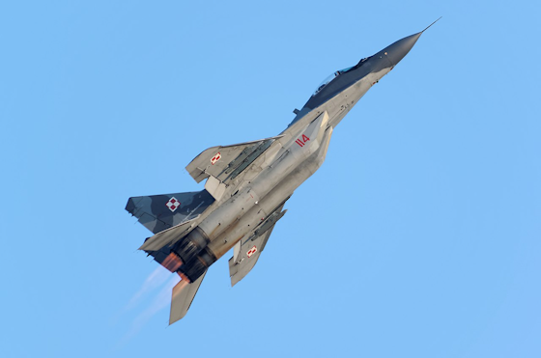
Source: Jacub Alun
MiG-29 Soaring
After the flights, the pilots assembled in the squadron ready room for the debriefs where they reviewed and re-enacted the missions just flown. They analyzed, complimented, critiqued, and laughed at each other constructively. Afterward, the informal debriefs at the club in town were especially fun, loud, boisterous, and often memorable, especially with wine and cold beers and highly animated hand gestures representing their in-flight maneuvers. Such raucous dining-outs had become part of the flying routine and helped to reinforce the teamwork necessary for success.

54
Meet the Parents
Aara went out several times with Rafael Marquez, the son of the vineyard owner and sponsor of the local orchestra. They spent most of their free time together and enjoyed each other’s company. The young man entertained and amused Aara with an inexhaustible repertoire of stories. The problem was that Rafael was falling in love with her, but Aara was conflicted. She still felt that at this stage of her life, pursuing a career in music was more important than romance, so she discouraged a physical relationship.
Rafael finally asked Aara to go to dinner at his parents’ house.
“Isn’t that a big deal in Spain?” Aara asked.
“Yes, it is,” Rafael responded. “I wouldn’t dare bring a girl to see my parents if she wasn’t worthy.”
“That sounds old-fashioned.”
“Perhaps, but it’s a custom among good families. In any case, I am sure my parents will love you.”
“Nice to know, Aara said. “I would like to meet your parents, but shouldn’t my parents be there too?”
“Of course, if you wish.”
“I am just kidding,” Aara said with a smile. The last thing that she needed was to have Tess on her case.
“It’s a date then,” Rafael said with a smile. “Let’s do it on Friday evening.”
On the appointed day, Rafael picked up Aara with his convertible and drove to the beautiful estate of his ancestors. The main house was in the middle of a compound with several other dwellings located in the middle of vineyards that ranged as far as the eye could see. He gallantly opened her door and took her hand while climbing the steps of the impressive manor house. He led her to a large entryway and showed off the place.
Rafael then introduced Aara to his parents. His father, Don Francisco, was the quintessential Spanish aristocrat, a handsome man with a classic well-groomed beard. He would have been a suitable subject for a Velasquez painting. Doña Inez, Rafael’s mother, was refined and beautiful even at her age. She smiled when she saw Aara with her dark hair, huge black eyes, and a slender figure. The young woman looked fantastic, exactly what she hoped to find for Rafael.
Aara spoke decent Spanish, and it didn’t take long for her to charm Rafael’ parents. After dinner, Rafael talked her into playing something on the piano. Aara complied by playing Chopin and Albeniz to the delight of her hosts. Rafael scrutinized the reaction of his parents, and they seemed to be impressed by the charming young lady.
Afterward, they retired to the salon for some Port wine.
“You have a lovely home, Don Francisco,” Aara said. “I love its location in the middle of the vineyards with the hills on the background. I also love the wine you produce. You must be very proud.”
“The vineyard has been in our family for centuries,” Don Francisco responded. “We are now trying to increase production without compromising the quality of the wine. We are talking with a couple of French investors, and it looks like we might have a deal.”
“I am not sure that these investors have our best interests in their hearts,” Rafael said. “Belcour looks to me like a mean son of a bitch.”
“Rafael, watch your language,” Doña Inez admonished.
Aara startled. “Rafael are you dealing with Laurent Belcour?”
“Yes, he seems to have deep pockets, but I don’t like him.”
“You are right, Rafael. Belcour is a degenerate that dealt with nuclear bombs and went to jail for that. Moreover, he owns several brothels in France and Belgium. If my stepparents did not stop him, he would have bombed Paris and Israel.”
Don Francisco was shocked. “Are you sure, Aara? Belcour appears to be legitimate.”
“Don Francisco, you should take a hard look at that deal. Just because the French could not keep Belcour in jail, it doesn’t mean he can be trusted. He is up to something.”
“I will ask our lawyer to look into the matter. Thank you for letting us know,” Don Francisco said.
Doña Inez was anxious to get back to the issue she cared about.
“Tell us something about yourself, Aara. I understand you are studying to be a pianist.”
“Yes, I have graduated from the conservatory, and I have played a few public concerts thanks to help from my stepparents. They are very supportive.”
“I am sure. You turned out to be a lovely young woman. I gather that your real parents are deceased.”
“Yes, they are.”
“How did you get adopted?”
“It’s a long story, Doña Inez. I am grateful that I am now part of a loving and a wonderful small family. Jake and Tess are the ideal parents. I love them very much.”
“You are an exotic beauty, Aara. Who were your parents?”
Aara was getting annoyed by the relentless questions.
“I was four years old when they died. I don’t remember much.”
Doña Inez sensed that Aara was getting tired of the third-degree questioning, so she pulled back.
“I am sorry if I seem inquisitive, Aara. Rafael said that he is quite fond of you, and we want the best for him and whomever he chooses to be his bride.”
“Rafael and I are just good friends, Doña Inez. I enjoy his company.”
Doña Inez knowingly smiled.

55
Blockbuster
Busy as she was, Tess was still obsessed by what she considered unfinished business. She couldn’t stand to be upstaged by Claudine, and she was furious about her rival having enlisted Vaughn Wentworth as the conductor for her piece. Predictably, under Vaughn’s magical baton, Claudine’s performance was a smash hit.
Tess was still fuming about Claudine’s underhanded tactics to prevail upon her and now wanted to best her rival’s performance by playing a blockbuster of her own: the Brahms first piano concerto. Tess knew all too well that the local orchestra was barely up to the task of playing the monumental piece, so she and Sofiya asked the conductor to add players and supplied him with a list of what they wanted. The conductor shook his head and said that for Claudine’s performance, Maestro Wentworth had paid for the extra musicians out of his own pocket. The orchestra had no budget to pay for the extra players. Tess would not let financial issues to get in the way, so she arranged for the hiring of additional musicians at her own expense. Tess figured that her performance was what counted but was also conscious that the piece she planned to play emphasized the use of a strong orchestra which needed to dazzle as well.
The rehearsal did not go well. The orchestra had potential, but the conductor was not up to the task. To his credit, he readily acknowledged his inadequacy and generously suggested asking Maestro Wentworth to conduct the concerto. He had just returned from one of his tours, so he might be willing to do it.
Tess knew that asking Vaughn to help her out was going to be a non-starter with Jake, who surely would blow his top. He still hated the man with murderous intensity and was not likely to be reasonable about Vaughn’s renewed involvement with Tess, innocent as it might have been.
Tess kept ruminating about her predicament in her head, sure that she and Vaughn could deliver the transcendental performance she wanted. She badly wanted to upstage Claudine, even though she knew in her heart that her own behavior bordered on adolescent immaturity. Even so, Tess succumbed to her obsessive need to prevail over her rival even though she was well aware that there were more important things to do. Against her better judgment, Tess decided to take a considerable risk by asking Vaughn to help her. That meant that she had to gently neutralize Jake.
Suddenly she had a brainstorm. Jake had been reading history books about Spain, and he told her that he wanted to visit Moorish palaces like the Alcázar of Seville and the Alhambra in Granada. Jake escaped to such forays as often as possible in futile attempts to satisfy his insatiable curiosity. That evening at dinner, Tess suggested that he visit the sites before the team left Spain. Jake usually had to argue with her about his tourist escapades and was pleased that Tess now acknowledged the legitimacy of his intellectual interests. He gladly agreed to take a few days off and visit the attractions. It never occurred to him that Tess was manipulating him. The next morning Jake left, leaving the coast clear for Tess to ask Vaughn for help.
Tess’s breakup with Vaughn after their intense affair had been contentious because he had publicly displayed a breathtaking nude portrait of her that he had painted. Proud of his work, he lent the picture to a downtown New York gallery without asking for her permission. By chance, Tess walked by the gallery, got curious about the commotion, and was shocked when she saw her picture on the wall surrounded by eager buyers. She felt utterly violated and forced her way into the gallery, appropriated a knife from the buffet table and destroyed the painting on the spot. To make a long story short, the police arrested her, she almost had a breakdown and ended up in the Bellevue mental ward. Since Vaughn did not have an official relationship with Tess and was not a relative, he was not allowed to see her, so he called Jake who was getting ready to take Claudine to a Broadway show. Jake dropped everything, went to Tess, bailed her out and spent the night consoling her. Claudine, feeling betrayed, dumped him. Tess followed suit, promptly left Vaughn, and eventually got back with Jake.
Vaughn was still in love with Tess, and she, in turn, had to suppress latent feelings of erotic attraction for him but managed to keep things on an even keel and avoided contact with him.
After Jake left for Granada, Tess told Claudine that she planned to ask Vaughn to have dinner with her to discuss a possible musical collaboration. The sly Claudine did not object. Vaughn and Claudine were supposed to meet with Tess, but the kids were sick, so Claudine begged off. Vaughn picked Tess up at her apartment and drove to a restaurant out of town. They sat at their table and ordered drinks. They looked like a privileged, handsome, and sophisticated couple enjoying a lovely dinner together.
Vaughn was aware of what Tess wanted, but he acted as if he didn’t know. Characteristically, Tess went straight to the point.
“Vaughn, I want to ask a favor from you. I also want to tell you that if you agree, that does not mean that we will get together again. I love Jake, and that is that.”
“So, why do you want to meet in private, Tess?” said Vaughn. “You look lovely tonight, by the way.”
“Vaughn don’t get your hopes up. I am not looking to restore our relationship. I just want to ask you to help me with a piece that I want to play.”
“I am listening.”
“I need you to help me to prepare for Brahms’ first piano concerto, and I would like you to conduct the orchestra.”
“As usual, you show yourself as a woman of ambition. I like that.”
“Vaughn, will you help me?”
“Does that mean that you are going to talk with me again?”
“I am still mad at you for what you did with the painting, Vaughn. Regardless, I am willing to set that aside and work with you on this project.”
“Does this mean that you forgive me?” Vaughn said with a smile.
“I am willing to set those feelings aside. I realize that working together requires a certain amount of trust. I can do that.”
“I am so glad to hear you say that, Tess. It’s much more desirable to be friends. I am sure that working together again will produce amazing music.”
“That’s what I want, Vaughn, but I don’t see us rekindling a romantic relationship. In any case, you have Claudine and the kids.”
“You know that I like Claudine and love Jake’s kids. Regarding you and me, I would welcome what the French call a rapprochement. I don’t see why we can’t work together.”
“With no strings attached,” Tess said.
“You are a tough customer, Tess. I reluctantly agree although that doesn’t reduce my desire to spend time with you.”
“Let’s not go there, Vaughn. Do you agree to help me?”
“Of course, I do, Tess. I am at your disposal.”
Tess and Vaughn spent the dinner talking about the music. The next day, they audited the extra musicians that they required, met for rehearsal, and worked out points of interpretation. This was going to be a memorable concert.
***
That Saturday evening, Tess and Vaughn walked in front of the orchestra, and the magic commenced.
Vaughn started the concerto by doing what Tess wanted, unleashing a ferocious, intense storm of sheer sound. With an ominous inevitability, the opening theme growled, snarled, and lashed its teeth, rising like an awesome supernatural power. Immediately, the listeners were drawn into the bold, intense, and monumental music.
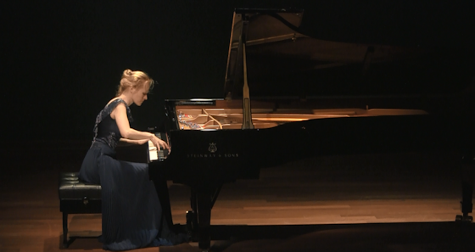
Source: TaniaGoburnova.com
Pianist Tania Goburnova - This could be Tess playing the piano
Tess now was in her element and attacked the keyboard, eliciting vehement turmoil by expressing feelings of regret, aggression, transitioning into a feather-light rippling of notes, culminating in a brutally hammered climax. In the final movement, the coda brought this massive, symphonic concerto to a transcendent close filled with warmth and majesty.
The audience went wild and jumped to its feet. Tess smiled, satisfied with her performance. The cheering continued, and in the audience, Claudine had to admit that Tess did very well. She also noted the still smoldering chemistry between her and Vaughn. She was hoping that Tess would succumb to desire, go to sleep with him and provide her with the opportunity to finally bring down her rival.
After the concert, Vaughn, Tess, and Claudine were to go to dinner together, but Claudine again begged off, reportedly because the kids were still not feeling well. She suggested that Vaughn stay at a hotel.
Claudine smiled. She was looking forward to finally drive a wedge between Jake and her rival.

56
To Hell in a Handbasket
Jake made it back from his trip, and he enthusiastically shared with Tess the wonders of what he had seen. He described his visit to Spain’s best-known Moorish site, the vast hilltop fortress of the Alhambra, whose picturesque setting with a background of the snowy peaks of the Sierra Nevada looked like it came straight out of a fairy tale.

Source: Bernjan at Flickr
The Alhambra Complex
Next, he went to see the Great Mosque of Córdoba, its design inspired by the mosques of Damascus and al-Aqsa in Jerusalem.

Source: Berthold Werner on Wikimedia
Great Mosque of Córdoba
The next stop was the Royal Alcázar of Seville, more a homage to Moorish architecture than a Moorish site itself because it was built for King Peter of Castile and some of the same artisans who worked on the Alhambra over the years helped fashion its ornate interiors.

Source: Cat from Sevilla
Royal Alcázar of Seville
The palace was still used by the Spanish royal family as their official residence in Seville, making it the oldest royal palace still in use in Europe.
Even though Jake had already seen Antoni Gaudi’s Sagrada Familia cathedral in Barcelona, he couldn’t resist revisiting the stunning edifice started in 1883 and still under construction to this day.

Source: C. Messier on Wikimedia Commons
The Sagrada Familia Cathedral in Barcelona
He marveled about the building’s unique other-worldly design, featuring Gaudi’s signature mosaics and modernist flourishes.
Jake’s last stop was a short visit to the Valencia City of Arts and Sciences, a modern architectural marvel comprising a series of domed glass buildings housing a planetarium, science museum and an open-air aquarium that was the largest in Europe.
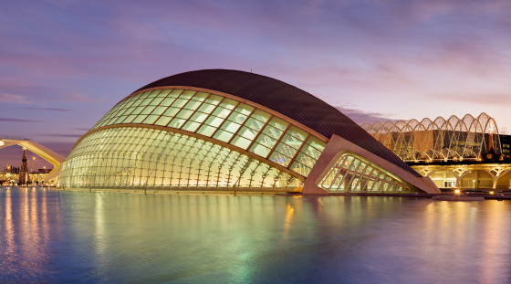
Source: Photo by David Iliff on Wikimedia Commons
Valencia City of Arts and Sciences
Tess listened spellbound to Jake’s enthusiastic narrative of his travels. She made him a nice dinner, and while they were eating, he asked her how the Brahms concert went. Tess said that she was satisfied with her performance but provided no details. Jake was in a good mood, and that night, she made sure they made love to keep him that way.
***
At the airbase the next day, Claudine cornered Jake as he left the car and told him how much she had enjoyed Tess’s concert. Walking toward the training facility, Claudine continued talking about the exciting performance and how well Tess and Vaughn worked together.
Jake stopped dead on his tracks.
“Did you say that Vaughn conducted for Tess?”
“Yes, and they were truly marvelous together.”
Jake didn’t bother to say anything more to Claudine and almost ran into the terminal. He found Tess organizing the training materials for the next session. Jake took the papers from her hand and threw them on the ground. He then grabbed her arm and dragged her to a small adjacent room.
Tess shook him off. “What’s the matter with you, Jake? You are hurting me.”
“Why didn’t you tell me that you played the Brahms with Vaughn? How did he come back into the picture?”
“It’s no big deal. I just needed a good conductor. Vaughn was back in town, so he was available and agreed to help me.”
Jake was furious. “Isn’t it strange that you managed to get me out of town during the event? What did you do afterward? Did you sleep with him?”
“No! Nothing happened. We just played music that evening.”
“Tess, I thought you aren’t capable of lying. Did you sleep with him?”
Tess did not respond.
“Where is the bastard? Wait until I get my hands on him.”
“Jake stop it! Come to your senses. You are acting crazy. Nothing happened.”
“Considering your past adventures, please excuse me for expressing skepticism about your veracity. Did you fuck him?”
Tess slapped his face.
“I will not be subjected to your tantrums. Grow up! Nothing happened, and that’s the truth.”
“Why did you encourage me to get out of town?”
“I did it precisely to keep you from losing your marbles.”
“Tess, you betrayed me twice. Why should I believe you now? Do you see my problem?”
“Jake, get it through your head: I love you. I chose to be with you. What else do you want?”
“I want to trust you, and now I no longer can.”
“What does that mean?”
“I’ll move out and get my own place. My lawyers will arrange for a divorce. I will continue to work with the team until we are done with Red Flag. After that, I will leave the company.”
“Jake, you are out of your mind. Please let’s talk.”
Jake turned on his heels, went outside and got into the Jeep. He left a trail of rubber on the pavement.

57
Talk to a Friend
Jake leased his own apartment in town and on the job, talked with Tess only about business matters. Outwardly, his behavior appeared normal, but Tess felt the chill. Jake was not interested in talking with her about anything personal, and she became increasingly frustrated.
Reluctantly, Tess sought advice from Carmen, her best friend. They met at her place. Nicola sensed that the two women were going to talk about serious stuff, so he took little Luca out for a walk at the park, with a promise of ice cream.”
“Tess, you are this way only when you have problems with Jake,” said Carmen. “What happened this time?”
“Carmen, I am going out of my mind. Jake thinks that I rekindled my affair with Vaughn, so he moved out and is divorcing me.”
“Did you sleep with Vaughn after the concert?”
“Of course not. I just went to dinner with him.”
Carmen was very close to Tess and could read her like a book.
“Tess, you are my dearest friend, and you have never lied to me. Did you sleep with Vaughn?”
Tess started to cry. “Okay, he turned me on, and I did go to his hotel room, but I changed my mind and left.”
Carmen waited for the sobbing to subside.
“Now I understand why you sent Jake away to play tourist. That wasn’t smart, Tess. Let me guess, Claudine told Jake what happened.”
“All I know is that Claudine told Jake that the concert went well, and that Vaughn conducted for me. Jake flipped and moved out. I just received divorce papers.”
“Tess, I have always been on your side, but this time you really screwed up. You know how sensitive Jake is about you and Vaughn. I can’t believe that you took that chance. Now everything is messed up.”
“Carmen, I need your sympathy, not your scolding me. It just happened, but it’s over. I didn’t make love with Vaughn; I felt that the magic was gone.”
“What was different this time?”
I don’t know. Maybe it was me. Vaughn was his usual charming self, but this time I felt like he was putting on a familiar performance. It’s as if he was ticking a checklist. I felt that I was just one of the many women he had. Then it dawned on me that he probably acted in concert with Claudine. I suspected that she encouraged him to sleep with me, plotting all along to tell Jake about it when he came back. I was unbelievably stupid. Claudine set me up. What’s worse is that I suspected going in that she was very much a part of this equation, yet, I stupidly went to Vaughn’s room anyway.”
“What happened afterward?”
“I told Vaughn how I felt. He kept assuring me that he loved me, but he sounded hollow.”
“I am afraid the damage is done,” Carmen said. “Now what are you going to do?”
“I realized that what I really wanted and needed was Jake. I could never live with Vaughn and put up with his lifestyle, not to mention that he is married to Claudine.”
“Why didn’t you tell this to Jake?”
Tess was getting increasingly agitated. “He didn’t listen to me and just walked out.”
“I don’t know what to say, Tess. This is bad. I am sure that Jake feels you manipulated him to get him out of town so that you could play with Vaughn. I just don’t know how you can repair this mess.”
“Jake must believe me that it’s really over between Vaughn and me. I made a terrible mistake, but I still want to be with Jake. I’m over it.”
“Perhaps, but I know Jake. As smart as he is, sometimes he sees things only in black and white. This time he doesn’t believe you. It’s like a bad legal trial. The circumstantial evidence is damning.”
“What am I going to do, Carmen?”
“I don’t know, Tess. I guess all you can do is wait and see. Concentrate on the job, and after a while, Jake might forgive you.”
Tess felt that her whole world was collapsing. She thanked Carmen for listening and left. Her blouse was stained with tears.
That night, Tess had a recurrence of her familiar nightmare. Amir had invaded the farm in upstate New York and was shooting at Carmen and Nicola. Tess and the police subdued Amir, but he managed to shoot a few rounds at Jake that had just arrived with little Morgan in his car. Tess then saw Jake, tears in his eyes, approaching with her dead child in his arms. She took the listless child and forced Amir to hold him in his arms, smearing his blood all over him, making him realize what he had done.
Tess woke up screaming, looking for comfort that only Jake could provide. She desperately needed his arms around her, but Jake was gone. Curling in a fetal position, she sobbed, keening into the night.
Jake was in his apartment, sitting on a sofa, staring into space, and scratching Sebastian behind his head. He was struggling with thoughts of what had become of his life and what do now that he was no longer with Tess.

58
Frustration and Rage
Laurent Belcour paced back and forth, hurling insults at four hapless men sitting in front of him.
“You guys are morons,” Belcour bellowed. “I don’t know why I bother to pay you. You are utterly useless!”
The men sat quietly, enduring the abuse, and staring at the floor.
“Let’s start with you, Rabbani,” Belcour bellowed. “Tell me why your incompetence cost me almost my entire investment with the Valkyries operation.”
Zufar Rabbani hesitated for a moment, wringing his hands.
“Come on, speak up man!” Belcour said impatiently.
Rabbani finally found the courage to respond.
“When we dissolved the joint venture with SRD, we took possession of the fighter planes expecting that Jake Vickers would want to repurchase them, so he could continue operating. Instead, he threw us out and deducted the cost of upgrading the planes from the remaining funds. Moreover, Vickers started to charge us storage fees for the equipment. After a week, he doubled the fees. That put us under pressure to divest the jet fighters as soon as possible.”
“Why did it take so long to get rid of the planes?” Belcour asked with a sneer.
“We put the planes on the market, thinking that developing countries would be interested, but we didn’t get any takers,” said Rabbani. “We were under tremendous pressure to sell the planes fast because the storage fees increased to $40,000 a day.”
Belcour seemed skeptical.
“Why didn’t you lease another storage facility?”
“We tried,” Rabbani said, “but we didn’t find any available warehouses in the vicinity. They were all full due to harvest season. We even looked as far as Madrid, but it seemed everyone was reluctant to store warbirds. Then an official of the Spanish Government told us that we needed to remove the airplanes from the country within 30 days because they could stay for only six months, and the original permit had been issued to the Valkyries squadron, not to Dubai Strategic Investments, even though we owned the planes.”
Belcour, exasperated, sat down. “In other words, when you dissolved the Joint Venture with SRD, you guys didn’t think this through things and didn’t have a contingency plan.”
Rabbani stayed silent, wringing his hands.
“Speak up, man!” Belcour demanded.
“The only customer that expressed interest in the aircraft was a Nigerian General,” Rabbani continued. “He inspected the planes, nitpicked everything and didn’t look impressed. He finally made an offer that was ridiculously low. Then Jake Vickers advised that we had to remove the planes by the end of the week because the Spanish authorities withdrew the permits. We didn’t have any alternatives, so we sold the planes to General Okafor for a pittance. I am sorry, Monsieur Belcour. We were between a rock and a hard place.”
Belcour was looking out the window, trying to calm down. He turned around and stared menacingly at Rabbani.
“Okafor, Somi Okafor?”
“Yes, that is the General’s name,” Rabbani said. “What of it?”
Belcour sat and covered his eyes. He stayed that way for a minute, then leaned toward the lawyer.
“You are more stupid than I thought, Rabbani. Omi Okafor is tight with the Valkyries, and his wife Alice plays the cello with them. Are you telling me that you didn’t know that when you were dealing with him?”
“Monsieur Belcour, Okafor is a real Nigerian General who was willing to buy the airplanes. That’s all that counted. We didn’t see a reason to research his background.”
“Congratulations Rabbani. You were outsmarted and lost most of my investment. Well done,” Belcour said sarcastically.
“One more thing,” Rabbani added. “The Russian Colonel Brusilov somehow managed to get his hands on six MiG-29s, so the Valkyries are back in business. They are still training to go to Red Flag.”
“Let’s change the subject before I get a heart attack, “Belcour said. “How about you, Aguirre. Please tell me something positive about the pile of money stolen from me.”
Robert Aguirre, an American lawyer, was working on the issue of Aara’s inheritance now controlled by the Valkyries Foundation against human trafficking.
“Well, we examined all aspects of the inheritance that General Amir al-Saadi provided for his daughter Aara. We scrutinized everything, from the marriage of the girl in Turkey to the legal provisions that created the endowment for the Foundation. They did everything by the book. The funds are controlled by the girl Aara and the foundation’s board which consists of Tess Turner, Jake Vickers, Carmen Cabrera, and Nicola Orsini. Bottom line, the way they set things up is legally unassailable. There is no way for any other party, including Madame Fadime, to gain access to the money.”
“What about contesting the marriage?” Belcour asked.
“Again, everything was done by the book. Turkish records indicate that Aara’s marriage was legal, even though she filed for divorce the next day.”
“Are you telling me that nothing can be done?” Belcour asked. “Have you checked if the marriage was consummated? That would give us an opening.”
“Well, we would have to prove that Aara is a virgin, but doing that is practically impossible, particularly since the girl now has a boyfriend. His name is Gabriel Marquez.”
Belcour looked like he was going to have a stroke.
“Where is the boy from?”
“He lives in Ciudad Real in Spain. His father owns a vineyard and winery.”
Belcour now really needed a drink. He poured himself a Scotch and downed the glass in one gulp. He stared into space.
“That explains why the deal to acquire the winery fell through. This mess has all the footprints of Tess and Jake.”
Belcour took a big breath. “Did you look into the failed sabotage of Tess’s plane?” he now asked his partner Bertrand Dubois.
Dubois shrugged his shoulders.
“My man in Spain did a professional job of disabling the MiG’s hydraulic system so that it worked well enough for Tess could take off. Once in the air, the equipment failed as intended, but Tess managed to land the plane unharmed anyway. We don’t know how she managed to do that. We also have another problem. The saboteur was arrested by the Spanish police, and they along with Interpol are still interrogating him.”
Belcour broke out in a rage.
“We are done here. All of you, get out!”
Apparently, the men were not moving fast enough, so Belcour bellowed: “Get the hell out of here! Go away.”
The men scurried away like a bunch of rats.
Belcour poured himself another double Scotch and collapsed on a comfortable chair. He couldn’t believe that everything he did to damage the Valkyries had failed. He brooded, frustration building, his hatred for Tess and the Valkyries implacable, but ineffective. He just couldn’t think of another way of hurting them. Realizing that he couldn’t think straight if he didn’t calm down, he closed his eyes and let the frustration ebb.
After a couple of hours of contemplation, Belcour got an inspiration. He jumped up to his feet.
“Yes, that might work!” he told himself. “It’s not over yet.”

59
Selling Services
The experience the Valkyries obtained in Israel was invaluable, because it confirmed that they had developed the necessary skills to be credible jet fighter pilots. I was time to sell their services to the U. S. Airforce.
Jake, accompanied by Peter Brusilov and Claudine Bisson, boarded an airliner in Madrid for the long trip to Las Vegas. Once there, he rented a car and drove to Nellis Air Force base.
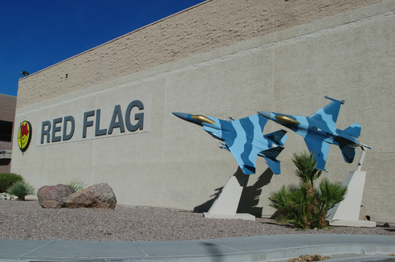
Source: airshows.co.uk
Red Flag building at Nellis AFB
When they arrived, Jake met with Brigadier General Janine Roberts, who was one of Jake’s friends from Harvard. She was one of the Air Force's first female fighter pilots and the first woman to command a USAF combat fighter wing. She was now leading the Red Flag exercises. The first ten minutes were spent catching up with things.
“Tell me about your new venture Jake,” General Roberts asked. “Are you really going to peddle adversary services? I thought that your company was doing well. Why are you changing focus?”
“It’s a long story, Janine. Let’s say that we have developed an outstanding squadron with world-class fighter pilots led by Russian Colonel Peter Brusilov and Claudine Bisson, formerly an ace with the French Air Force. They are here with me if you wish to meet them.”
“Wow! Bisson is famous for single-handedly giving the fits to the French Air Force. Brusilov is a legend. Unfortunately, he gained his reputation by teaching the Vietnamese how to shoot down our fighters. I have a feeling he will be less than welcome here.”
“We are not here to be popular, Janine. If your pilots feel hostility toward us, so much the better. We are supposed to act as the enemy, and we will fight in that role.”
“Okay Jake, I get your point.” the General said.
Jake pulled a bound proposal from his briefcase.
“Here is what we offer: a squadron of MiG-29s with pilots trained in Russian fighter tactics. Our fighters are equipped with upgraded avionics installed by the Israelis. We painted the planes in Russian colors and added our insignia. We propose an exercise pitting your pilots against ours. If my pilots perform well, we will get the option to participate in future Red Flag exercises.”
“What you propose is similar to the services proposed by current contractors.”
“Similar, but not the same,” Jake said. We offer encounters with pilots trained in the latest Russian tactics and flying highly maneuverable Russian-made planes. Furthermore, we will do it for 20% less than the competition.”
“Now you have my attention,” the General said. “How did you manage to do that?”
“That’s my problem. I guarantee that your pilots will experience flying against a formidable enemy that uses pure Russian tactics.”
“Okay, Jake. I will get the first session approved and see what happens. You have considerable personal credibility, and your squadron is led by pilots with outstanding reputations.”
“Thanks, General. Let’s make this happen.”
Jake went back to see Brusilov and Claudine who were hanging out at the local bar on the base. It was evident that they had buried the hatchet between them and they were now getting along. Brusilov lit a cigarette and got a nasty look from the bartender. He ignored that and looked at Jake and Claudine.
“Jake, did you tell the General that we will have ladies flying the planes?”
“No. The less said, the better.”
“You are the gutsiest people I have ever met.”
“No biggie,” said Jake. “You two have created an amazing team. Now we just need to perform.”
“I need a drink,” said Brusilov.
“Me too,” said Claudine.
Soon after, they returned to spend the night in Las Vegas before the long trip back to Spain. They had dinner, and afterward, Brusilov excused himself and retired to his room. Claudine and Jake stayed to have a nightcap.

60
Come Back to Me
At the hotel's bar, Jake and Claudine talked mostly about the children. Claudine, usually cheerful and bubbly, suddenly turned serious.
“Jake, when are you going to put an end to the farce and come back to the kids and me?”
“Claudine, give it up. What’s done is done. You have built a life with Vaughn, and thanks to your scheming, I am divorcing Tess. I am planning to leave the company after Red Flag.”
“Jake. I see you with the kids, and your love and longing to be with them is heartbreaking.”
“Yes, I wish I could spend more time with the children, but I need to go away for a while.”
“Why are you resisting us getting back together?”
“Claudine, please stop. I have made up my mind. It would be dishonest for us to do so. You deserve to live with someone that loves you. I am just a wounded animal that needs to run away.”
“After what’s happened, why do you want to be with Tess?”
“I told you that we are getting a divorce. Unfortunately, I still love her.”
“Yes, but does she love you the same way? Did you forget that the moment you went out of town, Tess started to play beautiful music with Vaughn? She didn’t tell you that was her plan all along? Why do you still trust her? Don’t you realize that he still has the hots for the man?”
“She just played music with him.”
“Really? Tess manipulated you to go out of town. Do you really think that she didn’t sleep with Vaughn afterward?”
“Claudine, you married the guy, you should know.”
“All I know is that Vaughn did not spend the night with me. He didn’t even bother to explain. What am I supposed to think?”
“Perhaps he was with a local woman.”
“Do you really believe that? Jake, get real.”
“You know that for all her faults, Tess doesn’t lie. Claudine, why do you persist in creating a gulf between her and me?”
“Because Tess is using you. You are the ever-reliable Joe, always available when she needs you, even when she screws up.”
“Claudine don’t forget that you are the one that dumped me.”
“I was mad that you ran to Tess when she got in trouble after destroying Vaughn’s nude portrait of her.”
“They arrested her and put her in the Bellevue nut house. I just got her out of there.”
“Yes, and you spent the night with her.”
“Nothing happened. I just comforted Tess. She was going out of her mind.”
“Jake, why did you give Tess the time of day? She posed nude for Vaughn and carried on a torrid affair with him. How could you forgive her?”
“I could not leave her alone in that state of despair. It was the right thing to do.”
“Jake, Tess would still be with Vaughn if he didn’t display the painting in the gallery. Even now, she melts into a puddle every time she sees him.”
“Claudine, cut it out. Nothing happened last week other than playing a concert with him.”
Claudine sensed that Jake was trying to rationalize things. He did have doubts, she felt it.
“Jake, you are a fool. Tess is a user, and you let her use you again and again. Leave her and come back where you belong. I am the one that loves you. I have given you the children you always wanted. We can be a family.”
“Claudine, I am not sure that I like you anymore. You have connived and manipulated to compromise Tess, and you succeeded. You almost killed her when you resisted helping with the plane problem. How can you expect me to trust you?” Jake stood up. “I am going to sleep.”
“Shall I keep you company? No one needs to know.”
“Good night, Claudine.”

61
Help from Your Friends
Brusilov had made it clear that the transition to the new fighter planes would take a month of intensive training leaving little time for anything else. This requirement created a problem for Tess who had committed to perform four more concerts. She sat down with her piano teacher Sofiya to discuss the situation.
“I don’t think it’s good to cancel the concerts, Tess,” said Sofiya. “The locals are pulling all the stops and have already printed flyers announcing the performances.”
“I know, Sofiya. That why I am asking you for ideas.”
“Well, all that’s left is a cello concerto and three chamber music programs. Alice is here until the end of the month, and she is wonderful with the cello, so she might be interested in doing the concerto. Aara has been working with me to prepare for her upcoming music competition, so she can play the piano part in the chamber music pieces. Yasmin plays the violin and viola, and she doesn’t fly fighter jets and can contribute, so you only need two or three more players. This should be workable.”
“That looks like a plan, Sofiya. Let’s get together with the conductor and talk about this tomorrow.”
“I will make the arrangements, Tess.”
Tess went home and found Aara rehearsing pieces that she planned to play at the piano competition. Tess asked her to help, and she was happy to participate.
The next day, Tess, Sofiya, Alice, Yasmin, and Aara met with the conductor and talked about the plan. He didn’t have a problem with the proposal, and in any case, he needed to replace the cellist who was going to play the Dvorak Cello Concerto. Alice said that she didn’t care for the piece, and suggested they perform the Elgar Cello Concerto instead. The conductor agreed, and they got things in motion.
Classwork for the next few weeks was minimal, and the Valkyries spent most of the time flying the new MiGs. The work was hard, but the women enjoyed flying the awesome jets. Just approaching the dangerous looking planes with the snake cockpit created anticipation and excitement, and they reveled in the added maneuverability and power afforded by the MiG-29s. They also appreciated the upgraded radars that the Israeli team had installed.
The flying practice was relentless and intense, everyone working into the evening until they became fully confident with the Fulcrums, the name the Valkyries adopted for the fighters. The techs painted the Valkyrie logo on the vertical stabilizers of the jets, announcing pride and enthusiasm. The Valkyries from now on referred to the squadron as the Snake Pit. Quite fitting.
Tess barely managed to attend the concerts. Alice did a fantastic job of playing the Elgar concerto, her interpretation of that beautiful piece gorgeous and poignant.
The next week, Aara on the piano with Yasmin on the violin and Alice on the Cello played one of Rachmaninoff’s elegiac trios and the Glinka trio, impressing the audience with beautiful, melodic pieces. The third piece was the Brahms Piano Quintet, engaging Aara, Yasmin, Alice, Giuliana, and Eva in a marvelous, dynamic, and challenging composition which Aara first played in Istanbul after Tess engineered a subtle ploy to help her gain confidence. The quintet became Aara’s favorite piece to play, and her intense performance did justice to the marvelous music.
For the final concert, Tess imported Armando Martini, an Argentinian employee who played the bandoneon, a type of concertina favorite in Argentina and an essential instrument to perform the Tango. Along with half a dozen dancers, the Tango show was a hit.
At the end of the concerts, Jake and Tess created the Valkyries endowment fund, enabling the Spanish orchestra to hire more musicians not only to bolster its ranks but also to help the new players gain experience. On their last day in Spain, the Mayor and dignitaries held a ceremony and bestowed civic medals on the Valkyries in recognition of their contribution to the city’s musical endeavors.
The team, sad to leave the gracious people that had generously hosted them for six months, headed for Madrid airport. Jake and Carmen had arranged to load the MiGs on a car carrier ship headed for the United States. In two weeks, the planes would reach the port of Savannah, where they would be trucked to the local airport. From there, the Valkyries planned to fly the planes to Nevada for the Red Flag exercises.
In the airliner heading for the United States, Tess sat next to Aara, who appeared somber and sad.
“You seem upset, Aara. Do you want to talk?”
“I broke up with Gabriel.”
“Why?”
“It was for his own good.”
“What do you mean?”
“We had lunch, and he thanked me for letting him know that doing business with Belcour was not a good idea. Gabriel and his father took a hard look at Belcour’s proposed investment proposal and turned it down. The document had fine print that would have given him control of the winery. Furthermore, they found out that Belcour had no interest in making wine. He was going to tear out the vines and build office buildings.”
“That sounds like Belcour, but it doesn’t explain why you broke up with the boy.”
“Gabriel told his parents that I was born in Iraq. In their book, they couldn’t allow their son to marry what they call a Morisco, even though my father had a distinguished lineage and was a top General, not to mention that he left me half a billion dollars. Gabriel said he didn’t care about that and was planning to relinquish his inheritance and leave his family to be with me. I couldn’t allow him to do that.”
“I understand, sweetie. It must have been hard.”
“It was probably for the best. I will be traveling extensively to play concerts anyway. I must keep my priorities straight.”
“I am sorry Aara, but I believe you made the right decision.”
“Mom, what’s happening between you and Jake?”
“Jake wants a divorce.”
“I am sure he will change his mind.”
“I am not sure,” Tess said, trying not to cry.

62
Red Flag
Red Flag was a realistic combat training exercise conducted on Nevada's vast bombing and gunnery ranges. It involved a variety of aircraft from many nations practicing interdiction, attack, air superiority, defense suppression, airlift, air refueling, and reconnaissance aircraft. The current exercise brought in more than 7,000 participants and 120 aircraft from the U.S military and air forces from Spain, Singapore, Germany, France, and the United Kingdom.
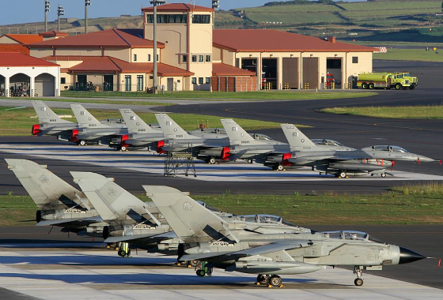
Source: canacopeg.dl.com
Nellis AFB
On the side of the good guys, most of the aircraft and crews made up the exercise's Blue forces. They used various tactics to attack targets such as mock airfields, vehicle convoys, tanks, parked aircraft, bunkered defensive positions, and missile sites. These targets were defended by a variety of simulated ground and air threats to give participant aircrews the most realistic combat training possible. The E-3 Airborne Warning and Control System (AWACS) aircraft played a significant role in the exercise by using its unique radar capability to monitor and support many aspects of the Blue force effort.
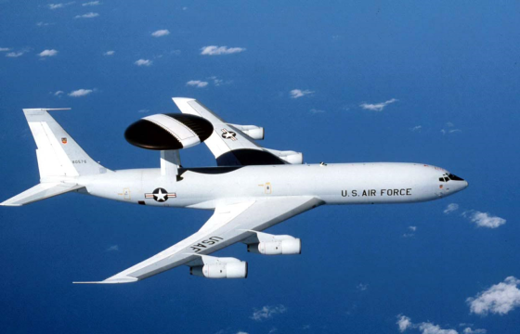
Source: U.S. Air Force photo [Public domain], via Wikimedia Commons
USAF E-3 Sentry Aircraft
The Red or aggressor forces' threats included electronically simulated surface-to-air missiles and anti-aircraft artillery, duplicating the tactics and techniques of potential adversaries.
Participating units, regardless of their provenance, were required to perform all aircraft maintenance on site, being as self-sufficient at Nellis as they would be in a wartime environment. The Valkyries team had this under control, having previously done the work at the Israeli exercises.
The Valkyries squadron arrived at the air base, landed, and taxied their planes to join dozens of fighter jets from the many nations lined up on the tarmac. As the team approached its designated area, their birds got a lot of attention. Pilots of many nations approached the menacing MiG-29s whose sole identifying insignia was the Valkyrie icon painted on the vertical stabilizers or tails. When Tess and her team opened the aircrafts’ canopies and climbed out to jump to the ground, they elicited admiring whistles, mostly from the Italian pilots. A young captain exclaimed “Che bellezze!” what beauties. His commanding officer ordered him to cut it out. He had seen the Valkyries in action at the Israeli exercises and was less than confident that bravado from his pilots would carry the day. Moreover, he expected the Valkyries to bring the older MiG-21s and was surprised that they were now sporting the significantly more lethal Mig-29s.
The Valkyries waved and made their way through the crowd of admiring pilots. As they entered the large control facility, the seven female pilots from three countries that they met in Israel approached them and shook their hands. They had all heard about the adventures of the Valkyries and gave them a warm welcome.
Julien Boutin, one of the French pilots that the Valkyries fought and defeated in the Israeli exercise walked over.
“Hello, ladies. I just wanted you to know that this time you won’t win. I will personally enjoy shooting all of you down.”
Claudine looked at the man with contempt.
“We shot you down twice. Are you trying to tell us that now you have learned to be a competent pilot?”
“Claudine, watch out. You will be the first to fall off the skies.”
Claudine looked around. “I don’t see who will make that happen. Any ideas?”
The man scoffed and walked away.
That evening, the Air Force threw a reception complete with barbeque, wine, beer, and speeches.
The next day, the ground crews, who had arrived a week before, completed assembling the maintenance tools and lined up the missiles making up the weapons inventory. Next, they checked the fighters and made them ready for use. They all took their work very seriously.
On the day of the first sortie, Brusilov asked the Valkyries and the team to assemble for a briefing.
“As you say in America, this is where the rubber meets the road. You have worked hard to get here, you are prepared, and you will show the world what you can do.”
The team hooted and hollered.
Brusilov continued. “I know that we talked about tactics, but I want to review what we will do to win.”
More hooting and hollering. The Valkyries were like horses at the starting gate, eager to do their stuff.
“On the air, we will think, plan and fight like the best Russian crews. We will employ real teamwork. We will not do individual stunts. Let the other guys do that. Whether in the air and on the ground, we are going to operate as an integrated team. I, Jake, Alex, and Nicola are going to act as Ground Control managers. We will direct fighter maneuvers and tell you when to turn on your radars. We will sort targets for you, and to some extent, we even will tell you when to fire your missiles. Ours will be a classic Russian command-and-control way of fighting.”
“Remember, the Russians fight air battles like chess. The fighters are pieces to be moved about at the discretion of their Ground Control Interceptors, GCI. The Americans fight air battles as a basketball game. They call their shots, their direct the movements of their teammates but ultimately, they are a bunch of individuals running around making decisions to best benefit the team. They take shots or pay attention to where their teammates are so that they can provide the assist.”
“Finally, there is always going to be the issue of training of individual pilots. No Air Force on the planet gets as much flying time as the US military, but that should not be a concern for you. Unfortunately for the American pilots, many of those hours are spent flying in combat situations which don’t truly improve their advanced flying techniques, and that’s why events such as Red Flag were invented.”
“For the first few sorties, I am asking you to play by the book. Obey my commands, trust me that I can see what is happening, and when I tell you to maneuver a certain way and shoot, do it. Later, the best of you will get to run the show on the ground and guide your colleagues to victory.”
The Valkyries eagerly walked toward their fighter planes. It was time for action.

63
Elephant Walk
The time had come to prove that all the hard work was worthwhile. Tess and the pilots climbed into the cockpits of the MiGs, attached the restraining belts and put on the helmets full of electronics. The ground crews helped to start the engines.
The screaming howl of the aircraft engines became increasingly louder as the fighters moved, positioning themselves on the tarmac.
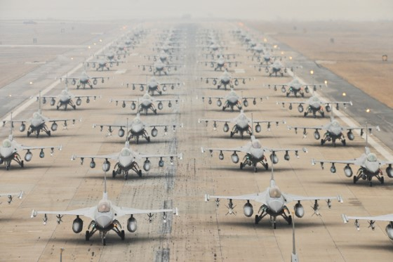
Source: Senior Arman Brittany Y Auld in Wikimedia Commons
The F-16 Fighting Falcons demonstrate an "Elephant Walk"
at Kunsan Air Base in South Korea, December 14, 2012.
The Valkyries' jet fighters started to line up in an elephant walk, a USAF term for the taxing of military aircraft right before takeoff, when they are in close formation. The idea was to maximize the number of aircraft launched in the least amount of time possible before the base faced a nuclear strike, which would obliterate all remaining aircraft.
The first row of fighters included Claudine in the middle flanked by Tess and Giuliana’s planes. Carmen, Galina, and Eva lined side to side on the second row. Once in the air, they broke up into pairs.
As soon as Tess and Carmen deployed, two French Rafale fighters swooped on them.
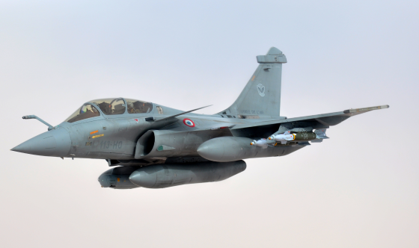
Source: Capt. Jason Smith via Wikimedia Commons
Dassault Rafale Aircraft
Tess heard Brusilov’s words in her head.
“If you happen to be in a defensive Basic Fighter Maneuver, you are in the worst position a fighter pilot can ever be in. It’s the proverbial knife fight in a phone booth, where your bandit has somehow obtained a position of advantage at or near your six o’clock and has entered his gun WEZ (weapons engagement zone).”
Tess realized that she and Carmen were getting in trouble fast. Falling back on their training, they executed a very High-G maneuver, straining their necks to watch what the bandits behind them were doing. They knew that there was no magic move and that they were going to have to work really, really hard to avoid getting themselves shot down. They were also aware that even if they flew perfect defensive maneuvers and the bandits happened to fly perfect offensive maneuvers, if this was a real war there was an excellent chance that their families were going to be planting flowers next to their name in a garden of stone.
Tess and Carmen again drew on Brusilov’s wisdom. Their strategy was to create problems for their bad guys and force them to make a mistake. If they couldn’t, all they could do is make the enemy work hard to kill them, try to force an overshoot and regain a position of advantage. Doing so was neck-straining, gut-wrenching, breath-stealing, rivet-popping brutal.
The radar warning receiver alerted Tess that an adversary aircraft had locked on to her. The symbology confirmed that it was a French Rafale at her right 1 o'clock.
Tess and Carmen hit the afterburners and risked passing out by pushing to climb vertically at 0.9 Mach to an altitude of 31,000 feet.
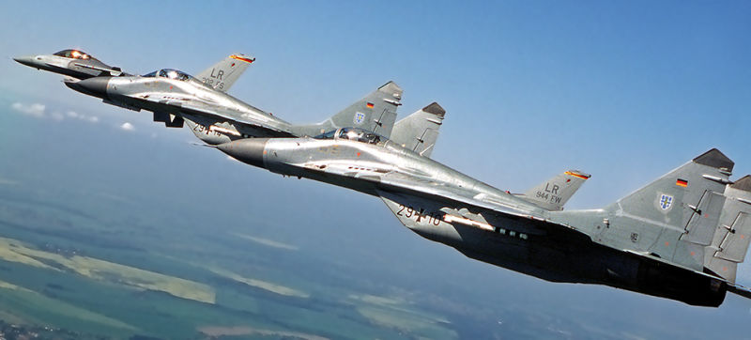
Source: Foxtrotalpha.jalopink.com
German Mig-29s in Flight
At two miles from the Rafale, Tess expected the pilot to turn into them and take away the lateral turning room; instead, he turned away and started to head back north. She cut across his turn and ended up about 200 feet above him a couple of hundred feet out at his right 4 o'clock. She continued to move closer when the Rafale spotted her about 100 feet out, too late to avoid being shot down. Tess painted her enemy, then settled onto the right wing of the Rafale. She noticed from the fuselage number that the pilot was Julien Boutin, the arrogant prick that annoyed her and Claudine during the war games in Israel. She switched to the emergency frequency of 243.0, and made some disparaging remarks about the French, then flipped off and left. Carmen took care of the other Rafale.
The Valkyries landed their MiGs and climbed out of the planes, did hi-fives, and accepted the accolades of the ground crew. Giuliana and Eva did well too, but Claudine barely avoided getting shot down by an American F-15. She was furious. This near miss needed thinking through what had just happened. For a change, Claudine was the one that spent most of the night in the one simulator the team had brought with them.
The ultimate goal of air combat remained the same as it ever was: kill the enemy as quickly as possible. Brusilov said that it didn’t have to be pretty, or by the book, it just had to be done fast. The Valkyries now understood that.

64
A Whisper in the Ear
In the countryside outside Moscow, Vladimir Putin was riding horses with Laurent Belcour. The two men previously met at the Kremlin, but the optics of doing so after Belcour’s stint in jail were not good.
After a good gallop, the men dismounted and caught their breath under a tree. Putin got right to the point.
“I see that they released you from jail, Belcour. Do I need to know how you made that happen?”
“It was just a mistake on the part of the authorities, Mr. President. I tried to help a few Muslim refugees by giving them work at my chateau. Unfortunately, the men turned out to be ISIS operatives, and they managed to hide two dirty bombs in my basement without my knowledge. Very upsetting.”
“You really didn’t know that you had two dangerous bombs in your wine cellar?” The President didn’t believe a word that Belcour uttered but went along with the story. He further inquired: “Didn’t the ‘refugees’ try to blow up SRD’s headquarters in Paris?”
“Alas, yes,” Belcour tried to elaborate. “It was a nasty business, particularly because Tess Turner blamed me for the incident and persuaded the French Government to raid my chateau. Very embarrassing.”
The President tried to uncover the extent of Belcour’s lies. “The authorities threw you in jail, I believe.”
“Regrettably yes,” Belcour admitted. “Fortunately, two captured ISIS fighters facing execution in Syria later confessed to the crime. My people brought them back to France to testify. They were jailed in France and avoided execution in Iraq.”
“Very fortunate that it worked out for you.” Putin used to be a KGB Colonel and knew all the details, but he chose not to pursue the matter. It was more important to review the performance of his investments that the Frenchman managed for him. Despite his faults, Belcour was in demand as an astute financial consultant, and many leaders used his services throughout the world.
“I have read your report on the status of my accounts, and it appears that you successfully diverted the funds threatened by the disclosure of the Panama Papers.”
“That is correct, Mr. President. I have redistributed the assets immediately after the news from the offshore services company were made public. I have created new shell companies to hide the assets in various places around the world that maintain absolute secrecy. I have done the same for your oligarch friends. Now, there is no longer a suspicion that you have consorted with dictators, drug cartels, mafia clans, fraudsters, weapons dealers and regimes like North Korea and Iran to hide their shady business transactions.”
“That is good. You have taken a burden off my shoulders. What do you plan to do now that you are free from prison?”
“I am investing in promising new ventures,” Belcour shared. Now he had an opening to go after Tess and her friends.
“One of my recent investments is interesting,” Belcour continued. “I believe you know the pianist Tess Turner who is a principal with SRD. She is now involved in providing adversary services to the American Air Force. She and her associates have purchased MiG fighters and have been training in Russian tactics under the guidance of a prominent Russian aviator, Peter Brusilov.”
“Are you telling me that one of my best fighter pilots is training the Americans on how to dogfight against Russia?”
“It seems so, Mr. President, but I am sure Brusilov means well. After all, he is retired. I supposed he needs to find work for his people. He has brought his entire crew of technicians and pilots with him.”
Belcour’s benevolent attitude toward Brusilov’s actions was coached as an innocent observation but was intended to raise concerns in Putin’s mind. If nothing else, this bit of knowledge could evolve in a real nuisance for Tess and friends.
“I will look into this,” the President said. “Now, let’s discuss specifics about my investments.”

65
A Wrench in the Works
The most challenging portion of the Red Flag exercise, simulated dogfights against the F-22 and F-35 stealth fighters, was coming up in three weeks. Brusilov and Jake were in the control trailer finalizing a tactical plan that hopefully would lead the Valkyries to victory.
They heard a knock on the door, unusual since people routinely just walked in. Brusilov opened the door and saw two men in dark suits.
One of the men flashed his ID.
“Colonel Brusilov, my name is Pavel Ignatiev and this my colleague Semyon Gulin. We are from the Russian consulate, and we need to talk with you.”
Jake walked over and invited the men to take a seat.
“Sir, we would like to talk with Colonel Brusilov in private.”
“I prefer that Colonel Vickers stay,” Brusilov said. “He owns this operation.”
Ignatiev shrugged his shoulders.
“As you wish.” He pulled an envelope from a briefcase and gave it to Brusilov.
“Colonel Brusilov, we have instructions from the Russian Air Force Command to advise you that you are to cease and desist from participating in the Red Flag exercises. You are to leave immediately and return to Russia.”
Brusilov lighted a cigarette.
“What makes you think that I would willingly comply with your request? I am retired and working for SRD under contract.”
“You are training potential adversaries to use Russian fighter planes and tactics. Your actions are not in the interest of the Motherland, and if you continue to do so, you risk being accused of treason. The Russian government demands the termination of your services in the USA and orders you to return to Russia for further discussions.”
“Why should I accept that your demands are legitimate? Brusilov said. I am now a private citizen working for a living.”
“Colonel Brusilov, our instructions come from the highest levels of government. You are required to comply with our request and return to Russia.”
“You sound like a broken record. I need some time to review this document,” Brusilov said. “In any case, I intend to complete my contracted work before I even consider complying with your demands.”
“I agree with Colonel Brusilov,” Jake chimed in. “We have a contract for services, and we insist on completion of the work.”
“The work cannot continue,” Ignatiev said. “Our instructions are to stop work immediately, and Colonel Brusilov is to follow orders and return to Russia.”
“I am sorry,” said Jake, “but if the Colonel refuses, I am obliged to support his decision. Furthermore, his departure at this time would jeopardize our project.”
“You can take up your commercial issues with the Russian Embassy. We have procedures for dealing with this type of situation.”
Ignatiev looked at Brusilov with hostility. “Colonel, you are ordered to come with us.”
Brusilov stood up and grabbed the man by the throat. He slammed him against the wall and kept him there.”
“I had my fill with petty bureaucrats that have nothing better to do than harass long-suffering citizens. You will leave now, and I will provide my answer when I am ready.” He let the man go.
“You have twenty-four hours to comply with our demand,” the man said while massaging his neck.”
Brusilov cracked his knuckles, telegraphing that he was ready to turn the men into mincemeat. The Embassy men got the message and left in a hurry.
Jake sat down. “Peter, if you leave now, we will have a tough time fighting the stealth fighters.”
“I am aware of that, Jake. I can’t believe that the Russian Air Force is worried about what I do here.”
“I agree with you. I smell a rat.”
Brusilov became agitated. “How can we deal with the problem Jake? We all worked so hard, and I really want to see the Valkyries win. There must be a way out of this predicament.”
“Perhaps there is,” Jake said.

66
Help from a Rival
Jake and Peter Brusilov went to the pilot quarters where the Valkyries were gathered around a television, talking about the upcoming event. Jake took Tess aside and asked her to bring Claudine along to a quiet spot outside.
They met in the maintenance tent where the crew had just sorted out the missiles. Tess and Claudine sensed that something was not right, and when Jake asked them to sit, they complied without a fuss.
“We have a problem,” Jake announced. “It seems that the Russian government wants Peter and his people to stop work immediately and return to Russia. They don’t like one of their top pilots teaching Russian tactics to the allies.”
For once, Tess and Claudine were on the same page. Claudine spoke first. “But we have only one fight left against the F-35, and it’s going to be the hardest. We cannot do that without Peter and his crew. You know that we need his guidance to accomplish what we set out to do.”
“Jake, there must be something we can do,” Tess said. “I can’t face the girls and tell them that all our work was for nothing. Peter, you must stay until we complete the exercise.”
“I would like to do that, Tess,” said Peter, “but they gave me direct orders to cease work immediately and return to Russia with my men.”
“Jake, we must find a solution,” Tess said. “We can’t accept this.”
“There is a slight chance, and it kills me to suggest this, but we must get Vaughn involved.”
“Vaughn is in Moscow tonight,” Claudine interjected. “What do you want him to do?”
“Claudine, you need to get a hold of Vaughn and ask him to talk to Putin or at least someone in the Russian government. They must allow Peter and his men to complete their work here or we are toast.”
Tess turned to Brusilov.
“Peter, who do you know in Russia that will listen to reason?”
“I have been retired for a while, and I know a few senior officers, but I wouldn’t count on them countermanding a direct order from the government.”
Jake felt that time was slipping by. “Claudine, you must call Vaughn and ask him to talk to someone in power to reverse this order. He needs to do this in a couple of days, or we are through with the project. Without Peter, we can’t win a fight against the stealth planes.”
“Jake, this enterprise was my idea,” Claudine said. “The last thing I want is for it to be derailed. I will call Vaughn right away and ask him to look into this.”
“Please do it now, Claudine. We don’t have time to waste.”
Claudine pulled her cell phone out of her uniform’s pocket and went to a quiet spot to call Vaughn. She was relieved that she got him right away, and explained the situation, talked for ten minutes and hung up.”
“It took some doing, but I persuaded Vaughn to talk with Putin. We are lucky that he is to have dinner with the President tonight.”
Jake turned to Brusilov. “Peter, it would be wise to contact the Russian consulate in Las Vegas to make sure we have all the facts.”
“We already have all the facts They want me to quit and return to Russia.”
“We might learn something,” Jake insisted. “Please go to the consulate in Clark County right away. Yasmin will take you there in the chopper.”
“As you wish. I am ready.”
Jake turned to Tess and Claudine.
“Please don’t say anything to the girls. This is not the right time to upset them. I need them in fighting form.”
“Jake, I have never kept secrets from my people,” said Tess. “They need to know what’s happening. They are adults with a lot of skin in this game.”
“All right, do it your way.”
Tess and Claudine gathered the Valkyries and shared the news. After a minute of silence, Eva talked.
“If they take Brusilov from us, we will have to do the job with what he has taught us. We will do our utmost to succeed.”
“I applaud your confidence, Eva,” Tess said. “Of course, we will do our best, but it’s not over yet. Jake and Peter are working on the problem, and we involved Vaughn who has a lot of influence in the Russian government. Just hang in there and keep preparing for the exercise.”

67
Reprieve
Claudine, Tess, and Jake did not sleep and waited for news from Vaughn. Four hours later, Claudine’s phone beeped, and she picked it up. She talked for a few minutes while Tess and Jake anxiously awaited the news.
Claudine turned around and handed the cell phone to Tess, who reluctantly picked it up, afraid that Jake would blow his top. Thankfully, Jake did not react.
“It’s me, Vaughn. What can you tell us?”
“Hi Tess, I had dinner with Putin and discussed the situation. It seems that he met with Belcour over some financial consulting. The French bastard mentioned what you were doing in Red Flag and suggested that Brusilov’s involvement did not seem proper. Putin casually ordered the Air Force to investigate the matter, and they took his instructions as a directive to impose a stop work order. Putin does not seem to care very much about this and is willing to withdraw the order to repatriate Brusilov and his people.”
“Vaughn, what does ‘willing’ mean. Did he do it?”
“Well, there is one condition.”
“Oh God, please tell me.”
“He is willing to rescind the order, provided you return to Moscow and play a concert for him.”
“Vaughn, Russia has a truckload of great pianists. Why does he need me?”
“That’s what he wants. Are you willing to do it?”
“It seems that I don’t have a choice.”
“Also, he wants Claudine to go a do the same.”
“Okay, so you need to talk with Claudine.”
“There is more, Tess.”
“Do tell me.
The President wants a musical duel. He wants Claudine to play the Beethoven violin concerto. Then he wants you to play the piano version. All this needs to happen in one session.”
“That is pure harassment! I have never played the Beethoven sixth piano concerto. It’s not even in the normal repertoire.”
“I told him that, but he insists.”
“Oh, God.”
“One more thing. Putin also wants the Valkyries to replicate the concert they played in Istanbul. That includes Aara on the Brahms piano quintet.”
“How did he find out about that?” Tess was now really annoyed. “Did he send his spies to watch what we do?”
“Apparently.”
“He is not greedy or anything.”
“One more thing,” Vaughn said. “He also wants you to close the festivities with your performance of the Appassionata.”
“Is that all? Does he want our kids too?”
“No. The music will do.”
“Vaughn, perhaps Putin is just pulling our chain.”
“No, he is deadly serious.”
“I don’t get it,” Tess said. “Why is Putin doing this to us?”
“Because he can. He wants to bust our chops. The man is difficult at times.”
“I need to talk to Jake and the girls.”
“You have no time to waste. Say yes or no.”
“Damn, okay. Yes. We will figure out how to pull this off.”
“Very good,” said Vaughn. “I understand that Sofiya Mazur and her husband spent time with you while you were in Spain. I suggest you bring them with you to Moscow to help all of you to prepare.”
“I don’t know if they are available.”
“It’s not a problem if there is enough cash.”
Tess sighed. “Fine, Vaughn. We will gear up to do this.”
“Wonderful. The concert will be seven days from now. I will send you the program.”
“Who is conducting?”
“I will, of course,” Vaughn said. “I wouldn’t miss an opportunity to play with you. You always stirred my soul.”
“Vaughn you are a bastard.”
“I am just your eternal admirer, Tess. I am looking forward to seeing you. Perhaps we can connect again.”
“Oh Lord,” Tess said. “Vaughn, we don’t need to start World War Three. Jake will kill you.”
“I will do my best to defend myself. In any case, things are looking better for us. Jake is divorcing you, isn’t that right?”
Tess was now even more annoyed. “Goodbye, Vaughn. Here’s Claudine.” Tess handed her the phone.
Tess went back to the team and shared the news. The girls looked at her.
“Tess, are we going to play the concert?” Giuliana said.
“We don’t have much of a choice, do we?”
“Okay, we are back in business girls,” Claudine exclaimed triumphally.
The gang broke into a hurrah.
On the way out, Giuliana asked Tess to talk with her.
“Tess, why didn’t you tell me that Laurent Belcour is the culprit behind our troubles?”
“Giuliana, we will handle it. Please stay out of it.”
“The man has been sabotaging us since day one, and you want me to keep cool?”
“Giuliana, Belcour is a bastard, but he is also your father, and you tried to kill him before. You shouldn’t even think of getting involved in this mess. Let us handle the situation.”
“How can you expect to keep me on the sidelines? I still want to kill him.”
“I know, and that’s why you need to let us take care of things. You are too young to go to jail for murder.”
“I have wanted to kill him all my life. You can’t keep me on the sidelines.”
“We haven’t decided what to do yet, so there is no hurry to do anything yet.”
“Tess, I insist that you keep me involved in this, no matter what you do.”
“Let me talk to Jake, Giuliana. Calm down. We will do something.”
Giuliana left in a huff.
***
Brusilov returned late that evening, having resolved the ‘misunderstanding’ with the consulate. The Russians heard about the arrangement from Moscow. By the time he left, the diplomatic staff was practically kissing his feet.
Peter learned of the trip of the Valkyries in Russia and would have loved to go along, but he felt it was best if he remained behind. He didn’t want to risk being arrested. As he left for the night, and Eva followed him.
Jake did not go to sleep. This time he determined to deal with Belcour come hell or high water.

68
Moscow
The team arrived in Moscow, checked into state apartments provided by the Russian government, and immediately embarked is a series of rehearsals.

Source: Mos-ru on Wikipedia Commons
A Panoramic View of Moscow
Tess had the toughest challenge - learning to play Beethoven’s sixth piano concerto. The piece was rarely performed because it was an adaptation of the great violin concerto. On the plus side, Sofiya Mazur’s husband, the musicologist, said that Beethoven himself wrote the piano adaptation, so it was unquestionably a great piece. Tess and Sofiya spent the next two days working out the intricacies of the music, a task that was particularly important to Tess because she was to play the concerto immediately after Claudine performed the original violin version. There was no question in Tess’s mind that she was obliged to deliver something special because Vaughn was going to make sure that Claudine’s performance would be divine.
***
While Tess, Claudine, and the Valkyries were practicing, Vaughn and Jake were invited to visit the President of Russia. The ride to the Kremlin was a tense affair, both men restraining from talking. Shortly afterward, an aide ushered them into the President’s gilded office.
President Putin rose to his feet and shook hands with the visitors. He then turned to Jake.
“Welcome, Colonel Vickers. I have been looking forward to meeting with you again. I truly enjoyed your candid perspectives last time we talked. Perhaps you can give me your analysis of current events.”
“As you know, Mr. President, a lot has happened since we talked last year,” Jake said. “At the time, I was not optimistic about Russia’s ability to sustain a conflict with major powers, but I must admit that you have successfully managed to have things go your way. It does appear that you now have an opportunity almost unimaginable just months ago: to overhaul frosty relations with a European Union infuriated by President Trump on a host of issues, from climate and Iran too, most recently, tariffs and trade.”
Putting smiled. “You give me too much credit, Colonel. It seems that Europe and America are going through problems no one anticipated.”
“I admit that you are correct, Mr. President. The Brexit movement looks like it will happen, and it is sending the European Union in a tizzy. The new American administration appears to be fanning the fires, potentially threatening the NATO alliance. Trump has called NATO obsolete and now insists the European nations live up to their commitment to spend two percent of their GNP on defense. On top of that, he has withdrawn the US from the global warming agreement.”
“On the positive side,” Putin added, “it looks like Trump had adopted a different attitude toward Russia.”
“That’s true, Mr. President,” said Vaughn. “The problem is that Trump is widely perceived as being beholden to you. He has steadfastly maintained that Russia did not interfere in the American elections. He has consistently ignored the conclusions of his intelligence services and stated that it is time to improve relations with Russia.”
“Is that bad?” Putin affected a puzzled look.
“Not at all,” Jake added, “but the general perception is that you are probably blackmailing Trump.”
“Those are fantasies of your liberal press,” Putin said. “The way I see it, the Western Alliance is falling apart without my help. I did not tell Trump to start a trade war with China, Canada, Mexico, and Europe. I do agree, however, that it is high time to reset unfair trade practices. Perhaps, this is a step toward more rational relations between our countries.”
Jake detected Putin’s sense of accomplishment. Though careful not to gloat, Putin was taking great satisfaction in the recent turn of events. Often dismissed as a tactician and opportunist, he was now looking more like a grand strategist as Trump continued to carry out baffling policies.
An aide knocked on the door and reminded the President that he was overdue for an important meeting. Putin excused himself and thanked his guests for the interesting conversation.
“I will see you at the theater, gentlemen.”

69
Settling for What You Have
On the way back to the state apartments, Vaughn asked Jake to have a chat.
“I have no interest whatsoever in talking with you,” Jake angrily responded.
“I am just asking for ten minutes, Jake. What I have to say is important.”
Vaughn directed the driver to a small restaurant tucked between two buildings just outside the Kremlin walls. Reluctantly, Jake got out of the car. The men took a seat at a table, and Vaughn ordered vodka and caviar.
“Jake, all I ask is that you listen.”
“Let’s get it over with, Vaughn. Did you enjoy sleeping with Tess last time? Adultery seems to agree with you.”
“Jake, I will not try to say that working with Tess again didn’t matter. Being with Tess is something that I always wanted, but the last time it didn’t work.”
“What happened? You didn’t get to fuck her enough?”
Vaughn did not rise to the bait.
“Jake, it was clear that Tess expected more from me. She didn’t fall for my usual passion and wouldn’t let me touch her. It didn’t take long to realize that she was greatly conflicted. The magic is gone. She couldn’t wait to leave.”
“Perhaps you should work on your moves, Vaughn. You are getting old.”
“Jake, what I want to do is to make it right. Tess made it clear that it’s over, and in a way, that’s a relief for me.”
“What do you mean?” Jake asked, hostility in his eyes.
“I realize that my future lies with Claudine and yes, the children. They may be yours, but I am their father in real life. I love them, and I always look forward to spending time with them. If it makes you feel better, I am conscious of the fact that Claudine loves you, but I also know that you don’t reciprocate the feeling. At the same time, Claudine and I recognized that our arrangement has progressed toward a real marriage. We now accept that life isn’t perfect, but it’s good enough. Claudine and I like and respect each other. Besides the children, we also have the music we play together. We decided to make it work. I don’t need women in every city. I plan to cut my concertizing to a fraction of what it was. I am evaluating offers to join the music faculty at a few universities. I can go home more often, and we will be a real family. Both Claudine and I agreed to forego dalliances. We are going to work hard to make our marriage work.”
“What are we going to do with the children? Can I keep seeing them?”
“Of course. You can see them any time you want.”
“Thanks. Are we done?”
“One more thing,” Vaughn said. “I know that Tess loves you. There is no way that she and I will get together anymore. She made it clear that she wants you.”
“Vaughn, I reluctantly concede that you weren’t the only culprit when you and Tess started fornicating with abandon. I didn’t want to believe that Tess was an enthusiastic participant, but I was delusional. The ugly truth is that she was as guilty as you were. That said, I realize that I was the real fool. I should have dumped Tess a long time ago. You just accelerated what was inevitable. Tess and I no longer lived in the same universe, and I was oblivious to that. My bad.”
“Jake, you should not leave Tess. I truly believe she loves you.”
“I am not a forgiving man that way, Vaughn. I am going to divorce Tess. At least you will have the satisfaction of having fucked up our lives.”
“You are making a mistake, Jake.”
Jake put some money on the table.
“I have made many mistakes in my life. Perhaps the worst was to ignore what was happening with Tess. Good night, Vaughn. Enjoy family life.”
Jake walked out of the restaurant and turned down the car driver’s offer for a ride back to the apartments. He needed a walk on the chilly streets of Moscow.

70
Two Sides of the Coin
After Tess worked on individual sessions with Sofiya Mazur and her husband to learn the music, Vaughn spent three days coaching both Claudine and Tess on the fine points of the mighty Beethoven Violin Concerto and the piano version. Both women were terrified about tackling what many considered the perfect work of its genre, one that only the most mature, accomplished artists attempted to play. Tess was particularly worried that the music was neither showy nor demonstrative, seeking instead to express the noblest aspiration of the human soul. The work was a model of majesty, serenity, and grandeur. The slightest hint of ostentation would be an insult, a problem for Tess who favored outright virtuosity and was not known for exquisite subtlety. Ironically, she thought, since nuance in performance was a quality that the young Aara had almost mastered.
Vaughn patiently coached Claudine and Tess at the same time, highlighting the differences between the two versions of the concerto as well as the similarities. The good news for Tess, Vaughn explained, was that Beethoven, when he reworked the original violin conception for the keyboard, extended and developed the original with brilliant, virtuoso solo cadenzas, something that Tess could do very well. The trio worked late into the evenings, and the food was catered. They didn’t come up for air until the night of the concert.
The gala event took place at the Tchaikovsky Concert Hall. The President of Russia and his entourage took their seats in the VIP boxes.
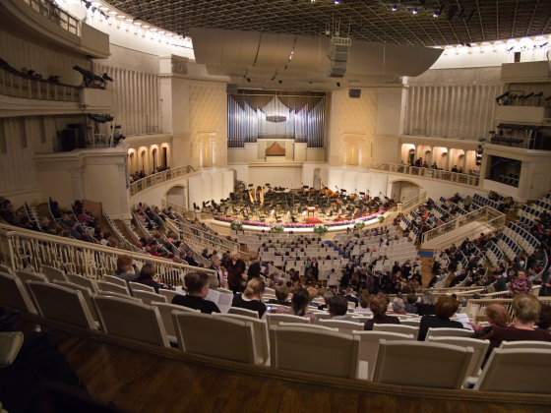
Source: Senekin on Wikimedia Commons
Tchaikovsky Concert Hall in Moscow
As they waited for the end of the overture, Claudine and Tess sat on a sofa behind the curtains, aware that what was ahead of them was not the usual competition against each other, but the performance of two sublime works born from the same root. If all went well, the performance would be historic. If not, it could be a humiliating disaster.
Claudine went first, dressed in a full-length emerald gown, a style that the Valkyries had made their own. Mindful of what Vaughn taught her, she poured her heart into the music and realized the grandeur and majesty of the iconic work. The audience jumped to their feet and lavished applause. Claudine could not believe that she survived the ordeal.
In the green room during the break, Claudine hugged Tess, sincerely wishing her good luck. Tess had struggled to subdue the fear that plagued her the last few days, but as usual, steeled herself to deliver the performance of her career.
The curtain rose, and Tess, resplendent in a sleek, body-hugging ivory long gown, slowly walked to the piano and waited for the audience to calm down. She paused for a minute after silence fell, nodded to Vaughn, and steeled herself as the orchestra started the opening passages. As her time to play approached, she now felt a sense of peace, realizing that she was there to play exquisite music, not to show off. As she traversed the work, for the first time she was able to achieve a balance between the subtle passages and the virtuosic episodes. Tess got into a trance and immersed into the music for herself, not the audience. Toward the end of the piece, she deftly handled a virtuoso Coda as a prelude to the feather-light fading of the composition before the final, dramatic conclusion.
As thunderous applause reverberated in the theatre hall, Tess hesitantly rose from the piano, exhausted, and exhilarated at the same time. She was going to remember this night.
Jake experienced the performance, emotionally moved, his soul collapsing into despair. He realized that Tess had continued to grow, tackled enormous challenges, and prevailed through sheer talent and dogged determination. Jake felt that he no longer belonged into her universe. He was one of the first to exit the theater, convinced that a huge part of his life was lost. Again, he walked the streets of Moscow all night.
Tess looked for Jake, and when she found that he was gone, the triumph of the evening faded away. Aara found her crying and wisely she did not ask questions. She just hugged Tess and got into the limo with her back to the apartment. Tess was exhausted, and Aara helped her to bed. Next, Aara tried to raise Jake on the phone, but all she got was a message.

71
Dinner at the Kremlin
The next evening at the Kremlin, it was the turn of the Valkyries Ensemble to play the strings with Aara at the piano. Galina, Eva, and Alice performed the same concert that they delivered in Istanbul, where Aara had her first breakthrough success playing two Shostakovich trios. The last piece was the Brahms piano quintet, and Giuliana joined in with her violin. The performance was marvelous, validating Aara and her fellow players as genuine artists.
After the concert, the Valkyries were invited to have dinner with the President and a few of his top ministers at the Kremlin Grand Palace. Jake, Vaughn, Alex, and Nicola escorted them.
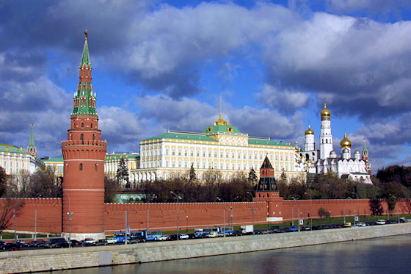
Source: Russian Presidential Press and Information Office
The Grand Kremlin Palace
The team walked into a beautifully ornate room with gold accents everywhere and sat at an enormous long table with the President. Tess and Claudine were invited to take their place on each side of Putin.
Careful to avoid tension, the group engaged in a light conversation focusing mostly on the sights of Moscow. Tess barely touched the food. She was anxiously waiting for the President to announce that he would allow Brusilov to help the Valkyries. She couldn’t stand the suspense, so she decided to use the direct approach.
“Did you enjoy the performance, Mr. President?” said Tess.
“Yes, I enjoyed your playing immensely,” the President said. “I truly appreciate your musical talent and virtuosity, but I have something else to say to you all.”
The team at the table anxiously waited to hear what the man had up his sleeve this time.
“My real objective was to meet the remarkable women that will fly Russian fighter planes to humiliate the American air force. I have thrown many unreasonable demands at you, and you have consistently dealt with the challenges and overcame them every time. You will win this time as well. I shall follow what you do at Red Flag with great interest.”
“Thank you for your vote of confidence, Mr. President,” Claudine said.
Putin turned to Tess. “Tess Turner, now, if you please, I would like you to play the Appassionata for me.”
Tess sat at the piano and delivered her signature piece, speeding through the notes at unimaginable speed and with stupendous ferocity. Beethoven probably would not have approved.
On the way out, Vaughn and Putin had a last brief meeting.
“May I ask you a question, Mr. President?”
“Certainly, Vasily. What’s on your mind?”
“I am grateful that you will allow Colonel Brusilov to continue working with the Valkyries, but in the end, are you aware, if they defeat the American stealth planes in wargames, they will in effect help the U. S. Air Force improve their tactics against Russia?”
“It’s possible, Vasily, but it’s not that important. Russia does not have the resources to conduct a real war against NATO or the Americans. We do a lot better fighting an asymmetrical war using computers and other means. The real value of what the Valkyries do is that they will help our political propaganda, demonstrating to the world that Russian technology is still able of producing outstanding military aircraft. That will also help us to sell advanced aircraft to India and other client states.”
Vaughn smiled. “Forgive me for saying this, Mr. President, but you sound Machiavellian.”
“Machiavelli was a great man. He understood the value of power politics.”
Vaughn was startled by the pragmatism of his friend.
“I suppose that the political progress you have made during the last couple of years speaks for itself. You are winning on your terms. I am impressed, Mr. President.”
“I am not Donald Trump, Vasily. I don’t need to be flattered.”
“My apologies, Mr. President. I beg your leave. I hope to see you again soon.”
“Have a safe trip home, Vasily.”
Just before leaving for the airport, Vaughn formally announced that Colonel Brusilov and his team would be allowed to lead the Valkyries at Red Flag. The team was too tired to cheer.
Putin still had a piece of theatre up his sleeve. He provided a Russian plane for the long trip back to Nevada, a perk very much appreciated by the exhausted members of the team. There were only three days left before the final exercise against the stealth fighters.
The legions of international pilots participating in Red Flag by now knew that a glitch might have prevented the Valkyries Squadron to continue participating in the last stage of the war games. Now they were startled to see a Russian transport aircraft land and disgorge the Valkyrie team. If anyone had reservations, now it was evident that the Valkyries were ready for a brawl.
A smiling Brusilov and his crew were waiting on the tarmac and insisted on carrying the pilots on their shoulders while singing Russian tunes. The observers recognized that the stakes in the competition had been raised.

72
Deception and Subterfuge
Peter Brusilov didn’t waste time and scheduled a briefing in the morning. Once everyone gathered, he delivered his last lecture to the Valkyries.
“By now, we have learned that the Americans are not interested in a fair fight, in fact, they will avoid it until they have the advantage. Then all hell breaks loose; they will throw everything they have at you. I must reluctantly acknowledge that the current American doctrine is correct. A fight between planes is, if executed correctly, should always be a surprise attack. Erich Hartmann, a German fighter pilot during World War II and the most successful ace in the history of aerial warfare, downed 352 opponents. He followed the principle of superiority. Do not engage in a dogfight if you can. Come out of the sun and kill the enemy before he can see you. The same applies today even if the way we surprise our opponents has changed. This is also the reason why stealth fighters like the F22 and F35 can achieve such impressive kill ratios. They avoid dog fights because they can see their adversaries at a distance. This means that our only chance of victory is to surprise the enemy.”
The Valkyries were stunned. They had never heard Brusilov praise American tactics before.
“Ladies, your task is to confuse and outsmart the seemingly invulnerable F-35. Technically, your adversary can cloak itself and disappear from your radars. It doesn’t matter. We are prepared to do whatever it takes to win.”
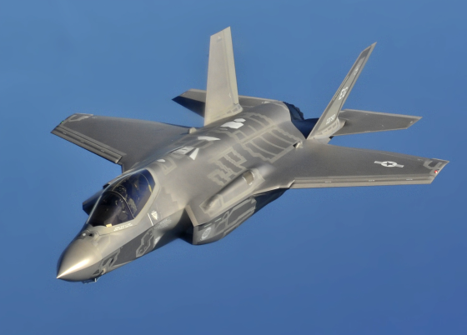
Source: Wikimedia Commons
F-35 in Flight
“Stealth is the main reason why F-35s are achieving kill ratios of 20-to-1 in simulated combat against adversary aircraft. Initially, you will not be able to see the stealth planes, but they will see you. It’s going to feel like you are out there with a blindfold on trying to find someone in a huge space.”
Tess was still worried. “The way it looks, we are like lambs led to the slaughter, but it seems you have a solution.”
“Good point,” Brusilov responded.
“So, what do we do?”
“We will not fight the F-35s on their terms,” Brusilov said. “We will employ old-time deception and subterfuge. The key is to get close enough, so you can dogfight the stealth planes, because in such a case, your MiG-29s will have a good chance to win. You will out turn and outmaneuver any F-35 in just about any situation.”
Tess thought that Brusilov was exaggerating but decided to remain quiet.
The Colonel now projected an image on the screen.
“Now, I would like to show you a picture of a fighter plane towing a radar decoy.”
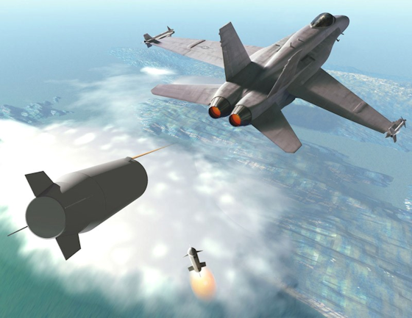
Source: Gian Luca Onnis (image released for use)
Radar Decoy
“A towed decoy system is an ejectable canister designed to confuse both surface-to-air and air-to-air missiles into thinking it is a plane, thus protecting the parent aircraft by attracting the missiles away from the intended target. The British use such decoys on their Tornado strike aircraft. You will be pleased to know that I have borrowed a couple of these decoys for this exercise. Our techs have installed a Fiber Optic link that sends commands to the decoy radio to produce jamming signals to lure the missiles away from the parent aircraft.”
“That is so cool,” Giuliana said. “I can see where you are going with it.”
Brusilov continued. “We will release the decoys from what I reluctantly call our two sacrificial planes. Its purpose is to divert a missile from hitting the other fighters in the squadron. The point is to entice the F-35s to shoot a missile, thus revealing themselves to our pilots. Now, do I have volunteers?”
“You want two of us to be the bait and risk getting shot down?” said Eva.
“In a word, yes. But I am confident that the adversary missile will follow the decoy, giving you an opportunity to escape, find the stealth planes, get close to them, and assault them with reckless abandon.”
The Valkyries looked at each other, then said “Okay.”

73
The Big Fight
The Valkyries Squadron took to the air. The mission of their six fighters was to engage three F-35 stealth aircraft even though initially they could not see them. The women communicated with the central control trailer stacked with computers and radars managed by Peter and Jake assisted by Nicola and Alex. The team had rehearsed their tactics but still needed to follow the instructions of their ‘handlers.’
Since the Valkyries were not going to maintain stealth, each of their MiG-29s carried one 1,500 liter drop tank that allowed them to stay in the air longer. The two planes towing the decoys had three drop tanks each giving them an additional range that allowed them to stay in the air longer than the other MiGs.
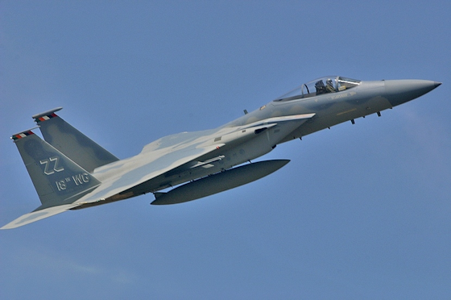
Source: NE-JP
A Jet Fighter fitted with a drop tank
Galina and Eva had reluctantly agreed to fly the fighters equipped with the decoys. Once in the air, they deployed the devices and started towing them behind the planes. They made no effort to hide, thus presenting a juicy target for the stealth pilots.
Brusilov instructed Tess and Carmen to head away to the left of the probable location of the stealth fighters. Claudine and Giuliana were to do the same to the right. The point was to give the F-35s the impression that the Valkyries were rummaging the skies to find their adversary but were veering off from their position.
The MiGs warning system detected the release of a missile from one of the F-35s. It locked on Galina’s plane. She quickly released the line to the decoy, shot off bright countermeasures to further confuse the missile, veered away from the area and hit the afterburners to race in support of her mates.
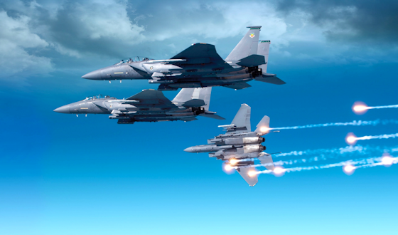
Source: BAE Systems
Jet Fighters releasing countermeasures
Eva also detected a missile heading for her fighter. She released the decoy as well and speeded up to join the squadron. This was what Brusilov was hoping for. Now the stealth factor was no longer in play, and the F-35s were probably low or out of missiles. Brusilov triangulated the approximate location of the F-35s and ordered the Valkyries to race toward the stealth planes. It was now time to unleash the hunt. They all dropped their fuel tanks and rushed toward the adversary aircraft. When the F-35 pilots detected the MIGs heading toward them, they realized that they were in for a hell of a dogfight. The Valkyries in the MiG-29s finally showed their stuff. They jumped on the F-35 like eagles chasing a meal.
Brusilov issued his order. “Valkyries, you are now up close and personal with the F-35s, and now they are as good as dead. Do your stuff!”
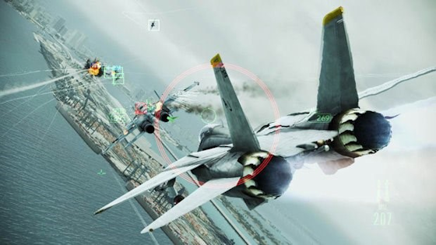
Source: Eurogamer.pt
A dogfight portrayed in a video game
One F-35 pilot reacted and turned to engage, but he faced more maneuverable planes flown by well-trained pilots. Tess had the thrill of her life. She managed to get behind one of the F-35s and simulated shooting it down. The other F-35s tried to maneuver against the MiGs, but the critical factor in the contest was the superior maneuverability of the MiG-29s. The Valkyries did not provide any quarter and shot down the other two F-35.
Brusilov, overjoyed, called his MiGs back to base. The embarrassed F-35 pilots retreated. They were all facing an intense debriefing session back at the airbase.
The Valkyries landed and taxied their planes on the tarmac. They got off their fighters to meet a cheering group of people, including several allied women pilots. Tess and her colleagues savored their moment of triumph until Brusilov approached, looking grumpy. He faced the women with a sneer on his face, just enough to make them uncomfortable, then broke into a smile.
“Well done. I am proud of you!”
Brusilov crouched and lifted Eva to his neck like a little girl. The ground crew did the same with the other women and walked to the hangar in a raucous procession. The allied pilots clapped their hands and congratulated them. The American pilots joined the applause with considerably less enthusiasm.
After a break, a tense debriefing took place. One of the defeated pilots complained that the Valkyries did not play fair because they used a British Typhoon decoy that generally would not be common to MiGs. Jake and Brusilov pointed out that they should have been expected deception, which was a time-honored practice in war.
In the end, General Roberts invited Jake, Brusilov, Tess, and Claudine to meet in the conference room and asked them to bid on the next round of war games.
Jake and Carmen arranged to move the MiGs to Jacksonville, Florida so they could be put on a car cargo ship for return to Poland. Next, Jake and Tess offered a partnership to Brusilov and made his position permanent. His people elected to stay as well. The Valkyries Squadron was now a going concern. The next project was to search for a new batch of MiG-29 aircraft.

74
News Summary
Tubby, aka Sebastian the bulldog, elected to pass on in his favorite activity after eating: sleeping on Jake’s shoes, and indulged instead in a good nap on the sofa while Jake reviewed the daily News Summary.

Source: Aobranc at Wikimedia Commons
High energy dog
This time, the headline stated that China was sending some of its most lethal bombers and fighter jets to Russia for major joint war games.
"The International Army Games 2018, is co-organized by China, Russia, Belarus, Azerbaijan, Kazakhstan, Armenia, and Iran."
"Participation in the International Army Games is an effective way to improve fighting capabilities under real combat conditions," the press statement added. “The exercises will help learn more about the strengths and weaknesses of its aircraft and also learn from Russia about hardware and pilot training.”
China and Russia's militaries had grown increasingly close lately, the two nations having forged a strategic partnership against a unipolar world dominated by the U. S.
“So much for Putin’s declaration that he is not planning to wage war,” Jake said to himself.
***
CAIRO — Islamist gunmen killed at least seven Coptic Christian pilgrims in Egypt on Friday and wounded at least 16 in an attack later claimed by the Islamic State. The attack — an ambush on two buses — ended a nearly yearlong lull in major attacks on Copts in Egypt and may signal a resumption of the Islamic State’s campaign to
The same desert road was the site of an almost identical attack in May 2017. In that incident, gunmen wearing military fatigues opened fire on three buses that were traveling in a convoy toward the monastery of Saint Samuel. At least 28 people were killed.
In the past two years, Islamist suicide bombers have hit prominent churches in Cairo, Alexandria and Tanta, a city in the Nile Delta, killing at least 100 people.
But the worst act of sectarian bloodshed, in November 2017, targeted Muslims. Dozens of militants opened fire on a mosque in Sinai affiliated with the Sufi strain of Islam, which extremists view as heretical. The militants killed at least 311 people, in the deadliest act of terrorism in Egypt’s modern history.
***
BERLIN: Thousands lined the streets of Berlin and other towns in Germany to protest Angela Merkel's "open door" immigration policy. The protesters blame the Chancellor for the recent spate of terrorist attacks in the country and across Europe. More than a million migrants entered the country last year, almost equal to the population of Munich, the country's third largest city.
***
PITTSBURG. Two Muslim organizations have raised nearly $200,000 to help victims and their families following the shooting massacre at the Tree of Life Synagogue in Pittsburgh on Saturday.
The online fund-raiser was part of a broad outpouring of assistance in response to the anti-Semitic attack, which killed 11 people and left six others injured, including blood drives, vigils and a separate crowdfunding campaign that has raised hundreds of thousands of dollars.

75
Enough is Enough
Back in New York, Jake and Nicola spent time brainstorming a strike against Laurent Belcour. The man had been a constant impediment to their plans, and he wasn’t likely to quit harassing the Valkyries any time soon. Their potential actions had to take into consideration Giuliana, a valued member of the team that unfortunately was Belcour’s daughter. Complicating things was her hatred for the man. As a professor in Italy, he had an affair with a bright student. When she became pregnant, Belcour just walked away. After Giuliana was born, her mother never got over the affair and abandonment. Her last act was to hang herself under a bridge. Giuliana’s life from that point on was dedicated to find and strike back at her father. She worked hard to graduate from the university with honors and joined the Italian Air Force to become a pilot. Later she joined SRD without disclosing the full details of her personal story. She kept her counsel to herself, and when a year ago the Team worked with the French Sûreté to raid an orgy Belcour was running at his chateau, she shot and wounded him and was going to finish the job until Tess talked her out of it.
The current problem was whether or not tell Giuliana that Jake was planning to take care of the Belcour problem. Giuliana was cool under pressure, but Tess feared that she would freak out if she knew she was not going to be part of the action.
Jake unleashed an investigation using the resources of SRD’s IT department led by Joe Slezak and Galina, helped by various members of the staff. Soon they amassed a mountain of data, including the whereabouts of Belcour’s assets, front companies, offshore deposits, and a complete list of his brothels in Europe. The man engaged into so many unsavory activities that it boggled the mind. Complicating things, somehow, he still managed to maintain a good reputation with the wealthy class and was scheming for a comeback, plotting once again to become the President of France.
All that research did not help much. The team was still unsure of what they could do to retaliate against Belcour.

76
Farewell
Tess was at her desk working on some paperwork when Jake walked in and pulled a chair.
“I am leaving this afternoon, Tess. If you agree, Nicola can take my place. I can’t think of anyone on our team that could do a better job.”
“Jake, are you sure you want to do this? You are giving up on our marriage and the company that we worked so hard to make successful. I still love you.”
“I need to get away and think about things. Please don’t try to talk me out of this. I have made my decision.”
“Where are you going?”
“I don’t know. I will grab the first flight out of town and travel for a while.”
“Jake, please don’t leave. I love you.”
“Tess, way back when we first met, I told you that you were entitled to your secrets, but I finally realized that in practice I ended up having no idea who I was living with. You are a mystery to me. Now I no longer trust you, so it’s best for me to leave.”
“What do you want to know, Jake? Do you want to know my secrets? I don’t think I have any. Would that make things better?”
“I used to think that your coming clean would help, but at the same time, I am afraid that I couldn’t handle knowing more about you than I already know. In any case, it’s my fault. I suppressed my suspicions, deceived myself for years and stayed with you way too long.”
Jake dropped a thick document on the desk.
“This is a complete new business plan for the company. I have lined up contracts in the U. S., Europe and Asia, financing for the new equipment, operational procedures, future staffing plans and just about anything else you would need for the near future. I have briefed Nicola and Carmen on the details. I don’t have to add that they have my full support and confidence. I retained my shares in the company, but over time you or the staff can repurchase them.”
“Jake, I want you to stay, and the team needs you too. Please don’t go.”
“I am leaving, Tess. I have already said goodbye to Aara. She is a wonderful young woman and has a great future ahead of her. I wish you the best. I hope that things work out the way you want. I must leave now. Nicola is taking me to the airport. Goodbye, Tess.”

77
Running Away
Nicola pulled up to the curb to pick up Jake and take him to the airport. Jake lifted the bag of bricks called Sebastian to the back seat and dropped a small suitcase in the back of the SUV. He thanked his dear friend for taking care of the dog while he was away.
On the way to JFK Airport, Jake told Nicola that he was putting his classic car collection up for sale. Tess was not interested in the jewelry that Jake bought her over the years. He had arranged with an auction house to dispose of the jewels, including his collection of antique knives and swords. He suggested that Nicola and Carmen take first dibs on anything they wanted.
“Jake, aren’t you overdoing it? You are burning all the bridges behind you. I am not sure that falling off the cliff makes sense.”
“Nicola, Tess was my universe. Now that it’s over, there isn’t much in life that I care about. I need to go away and think about the future. I am sure that I sound like a California airhead trying to find himself. I used to be contemptuous of people that indulged that way, but perhaps that’s exactly what I need to do.”
“Jake, Tess did not sleep with Vaughn, so I find it difficult to understand why you want a divorce. It doesn’t make sense.”
“After the concert, Tess went with Vaughn to his hotel room. That tells me everything I need to know.”
Nicola shook his head. “Where are you going?”
“I have no idea. I will play it by ear. I need to get away from everything. I wonder what Patagonia looks like this time of the year. I always wanted to go there.”
“Is there a chance that you and Tess will get back together?”
“At this point, no. I think that she would be happier with someone else. At least she is giving up on Vaughn. It looks like he and Claudine are making a serious go at their marriage. I am grateful that they will allow me to see the kids whenever I want.”
“Jake, if I may, I would like to tell you a tale.”
“I am not sure where you are going with this Nicola, but I will listen.”

78
Face to Face
Tess was at her desk working on the computer when Eva walked in.
“Tess, I need a few minutes of your time.”
“Sure Eva. What’s in your mind?”
“I am sure you know that I am in a relationship with Peter Brusilov.”
“Eva, I hate the word relationship,” Tess said. “What’s wrong with just saying that you are lovers? It’s a beautiful thing. In any case, you know that the team never gets involved in personal matters.”
“I just want to make sure that my relationship with Peter is not an issue, particularly since he is now going to stay as part of the team.”
“Eva, what you do on your own time is your business. I am a little surprised about your getting together with Peter, because he is much older than you are, but as I said, it’s not anyone’s business but your own.”
“I am glad to hear that, Tess. Peter and I are happy to have each other, and I want you to know that he didn’t make the first move. I am aware of the age difference, but it doesn’t matter. Behind his gruff exterior, Peter is a gentle and caring man, and he is bringing me out of my shell.”
“I am very happy for you, Eva.”
“Thanks, Tess, I appreciate it.”
Eva left and ran into Claudine who was also heading for Tess’s office. They greeted with a high-five.
Tess had asked Claudine to meet at her office. They both settled on two opposite chairs with a small table in between.
“I don’t suppose you want to congratulate me on our victories, Tess.”
“That’s correct, Claudine. I want to talk about something else.”
“It looks like you have your big boss hat on. Are you trying to fire me?”
“Frankly, I am tempted to fire you, but obviously you are key to our operation. Besides, the girls would get upset.”
“So, what do you want to talk about?”
“Jake is divorcing me, and I blame you for making that happen.”
“You can blame me all you want, but that’s not going to change the fact that Jake is fed up with you. It’s about time.”
Tess held her temper in check, even though she wanted to bludgeon Claudine.
“You set me up, but in the end all you accomplished is to hurt both of us. We both lost Jake. To his credit, he is not going back to you.”
“Alas, you are correct, Tess. I was hoping for a far better outcome.”
“Claudine, don’t you have any shame? Aren’t you capable of having any regrets? You messed up my life, and Jake has fallen off the cliff. How can you live with yourself?”
“Don’t exaggerate, Tess. We both know that all is fair in love and war. I am just more overt about doing it. I don’t have any pretenses. I know what I want and go after it.”
“But this time what you did backfired.”
“You can’t win all the time, Tess. That’s the way it goes. I am surprised, however, that you decided to pass on getting back with Vaughn. You are making a mistake; he still wants you.”
“It’s not a mistake. I don’t want to be with Vaughn anymore. It’s really over.”
“That’s too bad. On the positive side, Vaughn and I have concluded that it’s no longer productive to try to swap mates. We had a long chat and decided that it makes sense for us to say together. He is going to give up his women and reduce his travel, and I will stop my dalliances. Despite everything, we like each other, so we are going to try to have a real marriage for the sake of the children. It’s time to move on with our lives.”
“That nice for you to say,” said Tess. “You still messed up my life.”
“You can’t pin that rap on me, Tess. You knew how Jake felt about your cavorting with Vaughn, yet you persuaded him to get out of town. Did you expect to get away with it?”
“Claudine, I find your cynicism appalling.”
“That’s the way it goes, Tess. Is there anything else?”
“No. We just have to find a way to work together without the drama. Let’s do our job and stay out of each other’s way.”
“Very sensibly said, Tess. May I go now?”
Claudine did not wait for an answer and walked out.

79
Melancholia
Jake took a flight to Buenos Aires with a connection to Puerto Natales, a city in Chilean Patagonia. After a quiet night in town, he purchased hiking clothes and trekking poles. The next morning, he dodged tourist tours by hiring a private driver to take him to the Torres del Paine, twin granite pillars that rose almost vertically more than 6,561 feet above the Patagonian steppe.

Source: Karen Chan on Wikimedia Commons
Torres del Paine, Patagonia
As they approached the national park rising within the snow-capped ridges, Patagonia turned from dramatic backdrops to a spellbinding reality, the landscape captivating and even surreal, with magnificent views of the mountains, glaciers, and lakes.
Against the driver’s advice, Jake decided to hike up the mountain by himself. The trail got steeper as it threaded its way between boulders and groves of stunted southern beeches to reach the Torres del Paine Lookout. After hours of negotiating steep and dangerous paths, some just inches from deep cliffs, Jake finally reached a ledge on a granite block high up on the mountain, overlooking an immaculate icy indigo lake below, one of the most beautiful vistas he’d ever seen. He sat on a block of granite and pitched a small stone over the edge. One. Two. Three. Almost four seconds before it exploded on the rocks below.
‘What am I trying to escape from?’ Jake thought. ‘What is the point of taking risks up here? Am I really, this alone?’
The valley below him lit up with late-afternoon light, and shortly afterward, rain started to fall. Jake made no efforts to find shelter. He took his hat off and let the rivulets of icy cold water run down his face. His shivering reminded him that he was still alive.
The rain kept falling, and there was no place to find refuge, so Jake had to make the trek back down the mountain, the path now even more dangerous and slippery. In the narrow portions, Jake had trouble getting through. The rain got worse, and dusk rolled in. Jake had trouble seeing his way down the mountain and slipped several times.
At one point, he thought that falling down the precipice would not be so bad after all. He was alone, cut off from people he loved, no longer useful to anyone. He couldn’t even define what he wanted to do, who he was meant to be. Perhaps the answer lay in understanding who he was. Perhaps that was the whole point of this trip: to find out what he truly needed, what he loved, what would be worth living for. He thought that he knew what all of that was, but sadly that was no longer the case.
Jake now conjectured that perhaps the estrangement was not wholly Tess’s fault. Jake remembered what a professor said when he was a student.
To lend clarity to a situation, one must ask himself a question: What did I do or not do to make something happen or not happen?
Jake had made Tess the center of his universe, asking little for himself. Sadly, he thought, in the end, his devotion limited his own development as a social being. By subordinating himself to Tess’s needs and desires, he didn’t attend to his own. In many ways, his emotional development atrophied. He did not make progress because he saw no need to do so. Then Tess expanded her horizons by pursuing new challenges, trying to save the world by engaging in occasional Quixotic quests, learning how to fly new planes, fighting the bad guys, becoming a first-class musician, and driving everyone in her orbit to excel and continuously improve. Jake failed to follow Tess’s lead. He focused on his role as the protector, the organizer, the researcher, manager, and planner, providing stability to Tess's often chaotic world. He became less attentive to what counted, his connection with her, eventually sinking into married routine and boredom. When Vaughn Wentworth entered the picture, he embodied glamour, charm, excitement, and growth. He helped Tess to fulfill the promise of her native musical talent and for a time captured her heart.
On the rebound, Jake fell in with Claudine, but she could not help him overcome the loss of his collapsing universe. It was not her fault. Jake blamed himself. For all his intellect, he now recognized that he had failed. He took much for granted and now found himself wet and freezing in no man’s land.
‘Perhaps the time to die is right now,’ Jake thought. ‘Or maybe I should endure living as penance. Or maybe dinner will taste so much better if I eat it like it is my last supper.’
Jake made it back to base level in one piece, with a few scrapes, miserably wet and chilled to the bone, but no worse for wear. Surprisingly, the driver was still waiting for him at the base of the mountain. When they reached his hotel, Jake gave him a huge tip.

80
Two Wolves
The next morning, Jake didn’t hurry through breakfast nor made a mad dash back to the mountains. He started thinking about an old tale that Nicola told him as they were heading to the airport.
An old Cherokee is teaching his grandson about life. “A fight is going on inside me,” he said to the boy. “It is a terrible fight, and it is between two wolves. One is evil – he is anger, envy, sorrow, regret, greed, arrogance, self-pity, guilt, resentment, inferiority, lies, false pride, superiority, and ego.” He continued, “The other is good – he is joy, peace, love, hope, serenity, humility, kindness, benevolence, empathy, generosity, truth, compassion, and faith. The same fight is going on inside you – and inside every other person, too.”
The grandson thought about what he heard for a minute and then asked his grandfather, “Which wolf will win?”
The old Cherokee simply replied, “The one you feed.”
Nicola was wise to tell him the tale. Jake had to admit that he was indeed feeding his evil wolf and that his negative thoughts were his own worst enemy, allowing them to rule his actions. The graphic images that he contrived in his mind of Tess naked in bed making love with Vaughn yielded nothing but agony in his soul. It didn’t matter that all of that happened in the past. He still allowed that episode to haunt him, preventing him from forgiving Tess, even though she professed that she loved him. Jake now wished that his infallible memory would stop summoning his contrived visions of Tess in Vaughn’s arms. He forced himself to believe it was possible to win this battle within because he did have the power of choice. He needed to forgive Tess so that he could be part of her life again, but he was not yet ready to do so. He needed more time to heal.
Jake hated loose ends and decided that he needed to do one more thing before losing himself into the unknown. He needed to confront Laurent Belcour and put an end to his persistent attempts to destroy the Valkyries.
Jake, Tess, and the team had dealt with Belcour many times, achieving some victories, causing him to lose his exalted position at the prestigious International Development Organization, spoiling his chances of becoming the President of France and helping to send him to prison for trying to set off a dirty bomb in Paris, but they were never able to overcome the man’s talent for gaming the system and escaping from justice.
While still in Spain, Jake commissioned a psychological study of his nemesis and the results confirmed his own assessment. Belcour was an aristocrat who truly believed he was ordained by the Gods with the divine right of lording over lesser beings. He possessed an inherent sense of superiority and believed that truth and righteousness were overrated and contrary to the fulfillment of what he wanted. Belcour disdained most philosophers, because he was convinced that they used fancy words to mask the truth. He did buy into what Nietzsche wrote, that philosophers are advocates of their own brand of truth, developing ideas based on false axioms and preaching them like a truth that enforces their point of view. To Belcour, truth was what he made it and morality was relative and overrated. He fully subscribed to the thesis that immorality was essential to achieving one’s needs and wants. That explained why he profited from promoting war, prostitution, and debauchery.
Jake called Nicola and told him that he had a plan to take care of Belcour once and for all. The man relentlessly attempted to damage the Valkyries and Jake was going to finally put an end to that.
Nicola asked Jake to come back to the office and talk about his plan, but Jake made it plain that he did not want any help. He was going to do it alone.
Sitting next to Nicola while working on a report, Giuliana overheard a snippet of the conversation.

81
Tying Up Loose Ends
Jake parked his rental car off the road and concealed it in the woods. He packed his handgun in the side pocket of his leather jacket and walked toward Laurent Belcour’s chateau, checking the wrought iron fence for security cameras. All he saw was one guard leaning outside the security booth, apparently bored, and checking his smartphone. He was probably surfing or engaging in the disease of the times - making dates on the internet.
It was late in the afternoon, and Jake waited until dusk. Thanks to his CIA training, he found several security cameras around the perimeter and disabled one of them with a precise shot of his silenced weapon. The guard was still on his smartphone and didn’t notice that one of the cameras had gone out. Jake picked the lock of the front gate and walked around the garden’s perimeter. Stealthily, he got behind the guard and stuck the needle of a small syringe behind his neck. The man fell to the ground like a sack of potatoes. He would be out for a while. Jake then gingerly walked toward the chateau. Having previously conducted a raid on the premises, he knew the location of the backdoors. Most of them were secured, and he was about to pick one of the locks when he tried the access door to the kitchen and found it open. He slipped inside and looked for servants or cooks, but he didn’t see any. Apparently, they all had gone home.
Jake had a good idea of where Belcour was. He did not hear a television, but classical music could be heard from the study. Jake peeked around the corner and saw his target sitting in front of three large computer screens filled with financial data and spreadsheets. Silently, he approached Belcour and put the muzzle of his gun behind his neck.
“Good evening, Monsieur Belcour,” Jake said. “Please turn around slowly.”
Belcour rotated on the chair to face Jake. He did not look scared.
“Mr. Vickers, what a surprise,” the man said. “To what do I owe the pleasure of you visit? Is the beautiful Tess with you? It has been some time since I laid eyes on her.”
“It’s just the two of us, Belcour. I have come to settle things once and for all.”
“It sounds that my little meddling with your plans has annoyed you. Personally, I had a lot of fun tossing a few obstacles in front of the Valkyries. You, on the other hand, don’t seem to have a sense of humor.”
“My sense of humor disappeared the day your man sabotaged a MiG fighter plane hoping to kill Tess.”
“That was just a little fun. You people handled that incident well, by the way. I am impressed.”
“Belcour, I came here to dispatch you. I could have done it before you knew what happened, but I felt it would be better to do it face-to-face.”
“Very noble of you, Vickers. Do you expect me to beg you for my life? It’s not going to happen.”
“I don’t expect you to do anything, other than understand why you need to die.”
Belcour laughed. “Come on, Jake. We both know that you are severely constrained by a self-imposed sense of morality and rectitude. Killing me in cold blood goes against everything you and Tess believe in. You only dispatch villains in the heat of the moment or when they try to kill you, but you can’t murder defenseless persons. So, let’s get to the bottom line. I presume that you want me to leave your people alone. I must think about that. You are asking me to relinquish my primary means of entertainment.”
“It’s over, Belcour. You need to stop what you are doing, or I will blow your head off. You only have one chance. Stay away from us, or I will be back and finish the job.”
“So, my initial feeling was correct. You are not here to kill me, after all. In any case, what I did to your people was not just to be mean. You forgot that Tess engineered my downfall and torpedoed my chance of becoming President of France. Then your people invaded my home, towing the incompetent Sûreté with them, interrupted a lovely party and had the government throw me in jail just because I played with a couple of dirty bombs. Well, I am still here, and mad as hell at you and your Valkyries. When I become President of France, I will unleash the power of the state on you.”
“You are delusional, Belcour and keep forgetting that I am the one with the gun.”
“Jake, you are a boy scout. I don’t care that you were with the CIA. You can’t kill anyone in cold blood. Please don’t bore me. By the way, I believe that you are acquainted with Madame Fadime al-Saadi. Hello, Fadime, please join us.”
Fadime had just arrived from a shopping trip in town and dropped the packages as she approached the two men. She froze when she saw Jake holding a gun.
“You are Tess’s husband. You killed my brother Amir.”
“That is not correct,” Jake said as he grabbed Fadime’s arm and forced her to sit on a plush chair next to Belcour.
“Let get this straight,” said Jake. “Amir invaded our home with the intent of killing Tess. I fought him and broke his leg, and as you well know, he shot himself.”
“Amir wouldn’t have done that if it wasn’t for his obsession with Tess.”
“Whatever,” Jake said, now out of patience.
“What are you going to do with that gun?” Fadime asked.
“Well, the original plan was to blow Belcour’s head off. Now you are here, and it complicates things.”
“Are you going to kill us?” Fadime asked as she moved closer to Belcour.”
“Well, if you think about it, shooting the two of you would solve a lot of problems.”
Fadime looked at Belcour in panic. “Laurent, what are you going to do?”
“Nothing, Fadime. He doesn’t have the guts to kill us.”
“Fadime started to shake.”
Jake looked at the distressed couple with contempt.
“Now, what am I going to do with you two?”
Fadime whimpered like a puppy.
“You may want to discuss that with my friends, Mr. Vickers,” Belcour said with a grin.
Two men with guns drawn appeared behind Jake.
“Drop your gun,” one of the men said.
Jake raised his hands above his head and slowly put the gun on the floor.
“Much better,” said Belcour. “Now we can have a civilized conversation. “Please sit down, Mr. Vickers.”
“I’d rather stand,” Jake responded.
“As you wish.” Belcour lighted a cigarette. “I truly enjoyed playing with the Valkyries. I felt I was in a video game, watching you people squirm, confused and helpless.”
“You forget that we dealt with everything you threw at us. You haven’t accomplished a thing, other than waste time and money.”
“True, although I almost witnessed the demise of Tess. I would have enjoyed seeing her slamming her aircraft to the ground. My man on site was prepared to make a video, just like an action movie - explosions, fire, sparkles, and her roasting inside. It would have been such a pretty sight.”
“Belcour, you are a sick man,” Jake observed.
“I disagree. I am a proud and vengeful sociopath.”
Suddenly, two shots from a silenced handgun sent Belcour’s men to the ground. Giuliana Malatesta casually walked in, kicking away their guns.
“I am sorry to come uninvited, Papà,” Giuliana said to Belcour, “but I couldn’t resist participating in this scintillating conversation.”
“This is getting tedious,” Belcour said. “Everyone let me present my prodigal daughter. Her name is Giuliana, I think.”
One of Belcour’s men, wounded in the leg, tried to grab Giuliana. She casually shot him in the other leg without even turning around.
“Down, boy. The next shot will take out your balls.”
The man was now in too much pain to argue. The other guy apparently got the message. He just sat against the wall, tying his necktie around his wounded leg.
“You have to excuse my lovely daughter,” Belcour said sarcastically. “She didn’t have a proper upbringing and is under the impression that things can always be solved with a bullet.”
“You are correct, Papà. I have wanted to shoot you dead for a long time.”
Belcour turned to Jake. “What’s the matter with you people? You seem to be fond of shooting your way out of a little conflict. What happened to polite conversation?”
Jake was not happy. “Giuliana, didn’t I tell you that I was going to handle Belcour? What the hell are you doing here?”
“Jake, did you really expect me to stay out of the way and let you take care of something that should be my job? I have waited my entire adult life to make sure my loving father gets what he deserves.”
“Giuliana, my darling daughter, I don’t suppose reminiscing about family history is something you would be interested in,” Belcour asked.”
“Not really, Papà. I just want to blow your head off. I failed the last time, so I would like to get another shot at doing the job - no pun intended.”
“Please don’t make me laugh, my sweet.,” Belcour said. “Tess might have taught you how to pierce a man’s balls, but I am sure that her tedious moral code rubbed off on you, preventing you from killing defenseless people.”
“Papà, you are pretty arrogant for someone that is facing a gun.”
“My darling daughter, you seem to want to talk about things; otherwise you would have shot me by now. Would you care to pull a chair next to me, so we can get better acquainted?”
“No, not really,” said Giuliana. “It’s more fun to blow your legs off to start. Are you ready?”
Fadime whimpered like a puppy.
“Giuliana, hold on,” Jake said. “Trust me, you don’t want to do that.”
Suddenly, there was a sound of sirens from police cars surrounding the estate.
“Ah,” Jake said. “It looks like the incompetent Sûreté is joining us.”
Giuliana was annoyed. “Wouldn’t it be better to blow Belcour’s head off, Jake?”
“Yes, but it’s not worth it to go to jail for a long time over this bag of shit.”
“I heard that!” Belcour said. “That’s a very vulgar thing to say.”
Six black-clad French agents barged in.
“Laurent Belcour, you are under arrest,” the leader said.
“This is getting tedious,” Laurent uttered.
“Laurent Belcour,” the government agent advised. “Interpol has provided evidence against you for attempted murder by tampering with an aircraft in Spain.” The man looked at a piece of paper in his hands. “Also, you are accused of illegally obtaining your release from prison by bribing two ISIS prisoners to assume culpability on your behalf.”
“That is nonsense,” an indignant Belcour said.
“We have their confessions,” the man said, while signaling his men to put cuffs on Belcour. A team of medics started to cater to the two wounded men on the floor.
As the agents took Belcour away, Jake took Fadime aside.
“Fadime, I recommend that from now on you make yourself scarce. I know you are distressed about how Amir died, but there is nothing anyone can do about that. I could charge you as an accessory to the sabotage of Tess’s plane, but I will pass if you go away. Laurent will go to jail for a long time, and the last thing you want to do is to be associated with him.”
“I understand,” said Fadime. “I will go back to Argentina.”
“Excellent. On a positive note, you may want to attend Aara’s performance in Buenos Aires at the end of the month. Your niece is now a beautiful, talented young woman that you and Amir should be proud of.”
Fadime scurried away.
Jake turned over his smartphone with the recording of the conversation with Belcour to the government agents, he then took Giuliana aside.
“Belcour will not be able to beat the rap this time, Giuliana. Let it go and start living your life.”
“I guess you are right, Jake. I will try. By the way,” she added, “you may want to do the same.”
“What do you mean?” Jake said, puzzled.

Source: https://www.quickanddirtytips.com/
Jake’s Bulldog
Sebastian, Jake’s bulldog, was sitting on his haunches at the door, then saw Jake and made a beeline toward his master. He slid on the marble floor and frantically whimpered, jumping on Jake’s legs.
“Hi Jake,” Tess said as she walked in with the entire team, all armed and wearing military fatigues.
“What are you guys doing here?” Jake said as he crouched to pet the dog on the back of his head. “How did you know where I was?”
“You talked to Nicola and told him what you were planning to do,” Giuliana said. “I overheard, and I decided there was no way to keep me out of the action.”
“That goes for the rest of us,” Tess added. “We always dealt with problems as a team.”
Jake shook his head. “So, you got the French security service to tag along. It wasn’t necessary. This time I was going to shoot Belcour.”
“I believe you Jake,” Tess said. “The bastard deserved to be shot, but you don’t need to be a murderer. It’s better to send him away for a long time without getting your hands dirty.”
“It looks like I don’t have a choice,” Jake said. “I hope that Belcour stays in jail this time.”
The team gathered around him.
“Jake, we want you to come back,“ Nicola said. “We need you. The team is not be the same without your leadership.”
“You have always been a great friend to all of us.” Carmen said. “Besides, we can’t do without the encyclopedia in your brain,” she added jokingly.
Tess silently signaled that she wanted to talk with Jake alone. The group scurried out, making themselves scarce.
“Tess, I know what you are going to say,” Jake looked at her, trying hard not to succumb to his need to be with her. “I told you that I wanted to go away.”
“Jake, you want to disappear because you are mad, and I get that. I fully admit that I screwed up, but ultimately, I decided that you are the man I love and want to be with. You are my rock and compass and I need you now more than ever. I will not take no for an answer. You also know that you don’t want to leave me and your friends behind. Let’s come to our senses. We all need you, Jake. Please come back.”
“What’s going to change if I come back to you?”
“I have been doing a lot of thinking, Jake. We need to go back to the way we were. We need to nurture our passion, make sure that we don’t take each other for granted, and above all keep having fun. We have a lot of years ahead of us, and I believe that we can make them the best of our lives.”
Jake couldn’t resist. He grabbed Tess in his arms and gave her a passionate kiss.”
“Wow!” Tess said. “Let’s take a long cruise. I want more of that.”
Carmen stuck her head through the door.
“Time to go guys. The bus is ready to leave.”
“Just a minute,” Tess said as she pulled Jake over for another sloppy kiss.

About the Author
Before I started writing fiction, I was an Army Officer and a business executive. My education includes degrees in Political Science and International Relations. I am a published author of three management books and various business articles.
I have been fortunate to meet many remarkable people from all over the world, most of them virtuous, others not so much. Some were extraordinarily talented, able to perform well in multiple endeavors. My novels are based on the actions of real people I have observed dealing with challenging situations. I believe that it is interesting to understand multi-faceted personalities that are fascinating and sometimes evil at the same time, making it difficult to render quick judgments about right and wrong.
Currently, I am following my passion by writing the Tess series of adventure novels. Based on real contemporary events, the stories explore the challenges posed by international political developments and the issues that professional women face in today's world. The setting of the stories starts with the second Gulf War in Iraq and continues up to the current era.
Action, intrigue, deceit, obsession, sensuality, the use of wealth to achieve one's goals, the struggle between good and evil are a constant theme.
If you have any comments, complaints or suggestions, you can reach me at andres.mann@yahoo.com.
I really appreciate your reading my book! Here are my social media coordinates:
Website
http://www.andresmann.com
Facebook
https://www.facebook.com/profile.php?id=100009404265635
Twitter
https://twitter.com/andres_mann
Pinterest
https://www.pinterest.com/Andres_Mann/
If you are interested in pictures and more details about the characters, venues, music, planes, and helicopters mentioned in my books, you will find more information on my Web site and my Pinterest pages.
Please remember to leave a review of my book at your favorite retailer. Your feedback is valuable because it encourages me to keep writing and helps me develop new stories that you might like to read.

Other books in the Tess series
Tess Awakening
https://www.amazon.com/Tess-Awakening-ebook/dp/B019O2CL1U/
This first book in the series started the amazing Tess saga.
Tess Valkyrie
http://www.amazon.com/Tess-Valkyrie-Andres-Mann-ebook/dp/B00Z7JEOVA/
The exciting sequel to Tess Awakening
Tess Awakening: The Complete Story
https://www.amazon.com/Tess-Awakening-Complete-Andres-Mann-ebook/dp/B019SBY2EG/
This book combines two previous novels, “Tess Awakening” and “Tess Valkyries.”
Tess: The Abomination of Human Trafficking
https://www.amazon.com/Tess-Abomination-Trafficking-Andres-Mann-ebook/dp/B018JDF2BQ/
A compelling exploration of global human trafficking.
Tess: Day of Reckoning
https://www.amazon.com/Tess-Day-Reckoning-Andres-Mann-ebook/dp/B01MCVBWP6/
In this action-packed story, Tess and Jake battle terrorists who acquired nuclear weapons. They also try to keep Russia from starting a war. At the same time, they need to address their own relationship issues.
Tess: Clash of Civilizations
https://www.amazon.com/Tess-Clash-Civilizations-Andres-Mann-ebook/dp/B074WKM651/
Tess and Jake struggle with an unusual situation. Her nemesis Amir left their stepdaughter Aara a fortune, but it comes with a condition that may not be acceptable: She must marry within a Muslim family.
ALL BOOKS ARE ALSO AVAILABLE IN ITALIAN, SPANISH, FRENCH, AND PORTUGUESE
Thank you for reading my book. If you enjoyed it, won’t you please take a moment to leave me a review? Thanks!

References
Justice and Retribution
Pipes, Daniel. “For ISIS, It’s Not the Walk, It’s the Talk.” Chicago Jewish Star, vol. 25, no. 600, Chicago Jewish Star, 12 June 2015, p. 1.
Captured ISIS fighters go on trial in Iraq - Yahoo.
https://www.yahoo.com/news/captured-isis-fighters-iraq-justice-swift-conviction-certain-174952840.html
Planning the Enterprise
The Air Force is struggling to keep pilots in uniform, and ....
https://www.longroom.com/discussion/647922/the-air-force-is-struggling-to-keep-pilots-in-uniform-and-now-its-outsourcing-a-key-part-of-their-training
Making Fighter Pilots
https://www.popularmechanics.com/military/aviation/a23085909/how-a-us-navy-pilot-shot-down-a-syrian-combat-jet/
Showing Off
Violin Concerto No. 2 (Wieniawski) - Wikipedia.
https://en.wikipedia.org/wiki/Violin_Concerto_No._2_(Wieniawski)
https://stringschool.duke.edu/news/youth-symphony/wieniawski-concerto-no-2-opus-22
Cossacks
KGB General In Cossack's Clothing: Meet The Man Behind The .... https://www.rferl.org/a/kgb-general-in-cossack-s-clothing-meet-the-man-behind-the-whips/29240578.html
Meet the nationalist paramilitaries set for an official ....
https://www.independent.co.uk/news/world/europe/cossacks-russia-moscow-putin-rally-demonstration-world-cup-a8348221.html
Tracking enemy planes
How Fighter Jets Lock On (and How the Targets Know).
https://gizmodo.com/how-fighter-jets-lock-on-and-how-the-targets-know-1644871272
Fighter Tactics and Maneuvers
Air combat maneuvering - Wikipedia.
https://en.wikipedia.org/wiki/Air_combat_maneuvering
Lose and Learn
Robert T. Kiyosaki Quote: “Winners are not afraid of ....
https://quotefancy.com/quote/901672/Robert-T-Kiyosaki-Winners-are-not-afraid-of-losing-But-losers-are-Failure-is-part-of-the
Blue Flag Exercise
Israel Just Proved Why No Nation Wants to Fight Its Air ....
https://www.yahoo.com/news/israel-just-proved-why-no-021300262.html
Strange notches on F-35 raise questions over first combat ....
http://www.businessinsider.com/strange-notches-on-f-35-raise-questions-over-first-combat-with-israel-2018-5
Checking the Competition
The Aviationist » Lockheed Martin F-22 Raptor.
https://theaviationist.com/tag/lockheed-martin-f-22-raptor/page/2/
F-35 could finally see combat as Marines reveals plan for ....
http://www.usarmy4life.com/f-35-finally-see-combat-marines-reveals-plan-2018-baptism-fire-mission/
Concert in Germany
Gehry | a f a s i a - AFASIAARCHZINE.COM.
http://afasiaarchzine.com/2017/03/gehry/
Meet the Press
Germany: Migrant Rape Crisis Still Sowing Terror and ....
https://www.gatestoneinstitute.org/12066/germany-rape-crisis
A Tangled Web » Blog Archive » IMMIGRANT RAPE CRISES AS ....
http://www.atangledweb.org/?p=73676
Red Flag
Red Flag - GlobalSecurity.org - Reliable Security Information.
https://www.globalsecurity.org/military/ops/red-flag.htm
MiG-29 | Bharat-rakshak Wiki | FANDOM powered by Wikia.
http://bharatrakshak.wikia.com/wiki/MiG-29
Elephant Walk
Minimum interval takeoff - Wikipedia.
https://en.wikipedia.org/wiki/Minimum_Interval_Take_Off
From The Cockpit: Defensive BFM | Fighter Sweep.
https://fightersweep.com/1405/cockpit-defensive-bfm/
Modern Air War - defence.pk.
https://defence.pk/pdf/threads/modern-air-war.369052/
The purpose of Missiles and Guided Weaponry: Planetside. https://www.reddit.com/r/Planetside/comments/49fj9b/the_purpose_of_missiles_and_guided_weaponry/
Moscow
Putin Sees an Opening in Europe’s Fury With Trump - The ....
https://www.nytimes.com/2018/06/05/world/europe/putin-trump-europe-tariffs.html
The Big Fight
Electronic Warfare: The Part Of The F-35 Fighter Story You ....
https://www.forbes.com/sites/lorenthompson/2018/01/09/electronic-warfare-the-part-of-the-f-35-fighter-story-you-havent-heard/
These may be the only F-22’s Achilles’ heels in a dogfight ....
https://theaviationist.com/2014/09/30/these-may-be-the-only-f-22s-achilles-heels-in-a-dogfight-against-4th-gen-fighter-jets/
U.S. F-22 Raptor Allegedly Interfered With Russian Su-25s ....
https://theaviationist.com/2017/12/09/u-s-f-22-raptor-allegedly-interfered-with-russian-su-25s-over-syria-and-chased-away-by-su-35s-russian-mod-claims/
Have you ever seen a picture of a fighter plane towing a ....
https://theaviationist.com/2012/04/16/towed-decoy/
Two Wolves
The Story of Two Wolves - Urban Balance. https://urbanbalance.com/the-story-of-two-wolves/

