**REPORT OF INVESTIGATIONS NO. XX**

**MAPPING EVAPOTRANSPIRATION FOR 2016 GROWING SEASON USING LANDSAT 8 IMAGES AND METRIC MODEL, SUSSEX COUNTY**

By

Changming He1, Scott Andres1, Kevin Brinson2 and Tracy DeLiberty2

1Delaware Geological Survey, 2 Department of Geography, University of Delaware

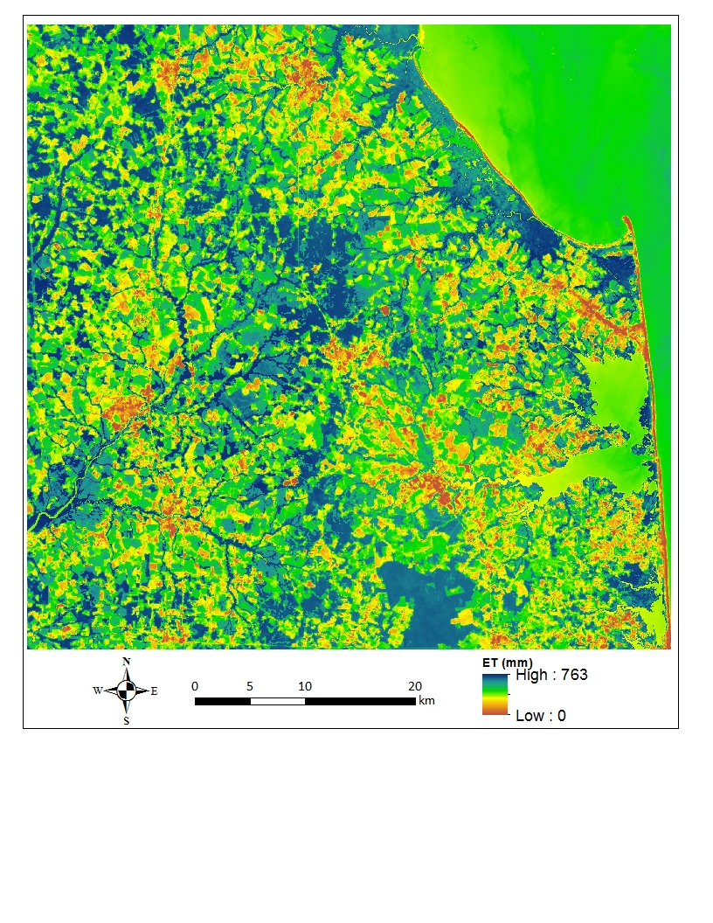

University of Delaware

Newark, Delaware

Month 2018

# ABSTRACT

Evapotranspiration (ET) is a major part of the water cycle. ET-based irrigation scheduling of farmland has proved efficient in reducing water runoff volumes and nutrient leaching. Thus, using ET-based irrigation scheduling is of interest. However, direct measurement of ET is difficult, making ET-based irrigation scheduling even more challenging. Measuring ET requires not only specific devices such as eddy covariance instruments (ECI), but also well-trained research personnel to get accurate data (Allen et al., 1998). To overcome these limitations, a variety of indirect methods have been developed in recent decades. Among them, remote sensing methods have proved cost-effective in providing regional and global coverage of actual ET data with favorable accuracy.

In Sussex County, Delaware, the state’s leading county in crop production, the ET distribution for the 2016 growing season was estimated with the Mapping Evapotranspiration at high Resolution with Internalized Calibration (METRIC) model, which uses satellite images and weather station data, and was then compared to field measurements by an ECI. The total ET during the Sussex County growing season (May-September) in 2016 accounts for 77-87% of historic averaged annual ET in this region. The model-simulated seasonal ET for agricultural land is about 69% higher than urban/suburban areas and about 17% lower than forest areas. This study shows that when forestlands are converted to urban/suburban uses, significant amounts of water are diverted from ET and available to run off and/or infiltrate. Given that urban/suburban land has impervious surfaces in the forms of rooftops, roads, driveways, parking lots, sidewalks, etc., much of the water not lost to the atmosphere through ET becomes part of the surface runoff portion of the water budget, thus underscoring the need for adequate storm water management systems for urban/suburban lands. The results also imply that the practice of ET-based irrigation scheduling could be valuable in Sussex County and throughout the 20% of Delaware farmland that is irrigated.

# INTRODUCTION

Evapotranspiration (ET), the sum of evaporation (E) from the soil and transpiration (T) from plant leaves, is a primary component of the water cycle. Knowing a watershed’s ET rates make it possible to use ET-based irrigation scheduling of farmland, which has proved efficient in reducing water runoff volumes and nutrient leaching.

In a previous study (Johnston, 1976), baseflow separation and climatic water budget methods were used to estimate that ET could account for approximately two-thirds of the long-term annual average water budget in four Delaware watersheds. But knowledge of ET rates at shorter intervals or for smaller watersheds, not measured or estimated in the previous study, would be valuable for water resource management and river basin hydrologic studies. In addition, direct measurements or at least solid estimates of instantaneous, daily or weekly ET are needed for precise scheduling of irrigation (Riley, 2005).

Direct measurement of ET is difficult. It requires not only specific devices such as weighing lysimeters or eddy covariance instruments (ECI), but also well-trained research personnel to get accurate data (Allen et al., 1998). To overcome these limitations, a variety of indirect methods have been developed in the past decades. Among them, remote sensing is cost-effective in providing regional and global coverage of actual ET data with favorable accuracy (e.g. Choudhury, 1989; Granger, 2000; Moran and Jackson, 1991; Kustas and Norman, 1996; Du et al., 2013). For example, the Mapping EvapoTranspiration at high Resolution with Internalized Calibration (METRIC) model, using the Surface Energy Balance Algorithm for Land (SEBAL) as its foundation (Allen et al., 2005), has been widely applied and validated under various conditions around the world (Bastiaanssen et al., 1998; Bastiaanssen, 2000; Hemakumara et al., 2003; Morse et al., 2000, Zwart and Bastiaanssen, 2007; Singh et al., 2008; Zhang et al., 2011; Ruhoff et al., 2012). The METRIC model uses the visible, near-infrared and thermal infrared spectral bands from satellite images along with weather data from traditional meteorological stations to calculate ET on a pixel by pixel basis.

In March 2015, the Delaware Geological Survey, in collaboration with analysts for the University of Delaware’s Delaware Environmental Observing System (DEOS), a real-time system dedicated to monitoring environmental conditions across the State of Delaware, installed an ECI at Warrington Farm in Sussex County (Fig. 1, Delaware DEOS station ID: DWAR). The ECI can accurately measure the spatially averaged ET over a large area in the upwind direction (footprint area). Combining information derived from remote sensing in conjunction with DEOS weather station data and ECI measurements from this farm, we applied the METRIC method to estimate the seasonal ET for the whole Sussex County (Fig. 1).

### Purpose and Scope

The main objectives of the study were to use the METRIC model to process Landsat 8 images to produce seasonal ET estimates for Sussex County and to evaluate the performance of Landsat 8-derived ET estimates against ET estimates from an ECI. The results can be used to identify how the conversion of agricultural lands to urban/suburban uses will reduce overall ET for Sussex County and the rest of the state, underscoring the need for adequate stormwater management systems for urban/suburban lands and helping farmers to understand how to use ET-based irrigation scheduling.

### Acknowledgments

TKTK.

# METHODS

### The METRIC Modeling Approach

METRIC is a spatial actual *ET (${ET}_{a}$*) estimation method based on energy balance (Allen et al., 2005). Energy is partitioned into: net incoming radiation (Rn, both solar and thermal) [W/m2], ground heat flux (G) [W/m2], sensible heat flux to the air (H) [W/m2], and latent heat flux (LE) [W/m2]. The latent heat flux is calculated as the residual of the energy balance and represents the energy consumed by ET. Equations 1-4 describe the energy budget equation and calculation of each component.

$LE=R_{n}-G-H$ (Eq. 1)

$R_{n}=R_{s↓}-αR_{s↓}+R_{L↓}-R_{L↑}-\left(1-ε_{0}\right)R_{L↓}$ (Eq. 2)

$G/{R_{n}}={T_{s}}/{α\left(0.0038α+0.0074α^{2}\right)\left(1-0.98{NDVI}^{4}\right)}$ (Eq. 3)

$H=\frac{ρ_{a}C_{p}∆T}{γ_{ah}}$ (Eq. 4)

Where $R_{s↓}$ is the incoming shortwave radiation [W/m2], α is the surface albedo [-], $R_{L↓}$ is the incoming longwave radiation [W/m2], is the emitted longwave radiation [W/m2], is the surface thermal emissivity [-], $T_{s}$ is the surface temperature[°C], $ρ_{a}$ is the density of air [kg/m3], is the specific heat capacity of air [J/kgK], $γ_{ah}$ is the aerodynamic resistance [s/m] between levels z1 and z2, is the temperature difference between z1 and z2, which is computed by assuming a linear relation between $∆T$ and $T_{s}$:

$∆T=b+aT_{s}$ (Eq. 5)

Where a and b are the correlation coefficients.

An instantaneous value of ET in equivalent evaporation depth is computed as:

${ET}_{a}=3600\frac{}{λ}$ (Eq. 6)

Where *ETa* is the instantaneous ET [mm/hour], 3600 is the time conversion from seconds to hours, and λ is the latent heat of the vaporization [W/m2].

The overall approach of the METRIC model is presented in Figure 2. In the model, sensible heat flux *H* is estimated using an approach called “calibration using inverse modeling at extreme conditions” (Allen et al., 2013). This method selects pixels with near extreme conditions (“hot” and “cold” anchor pixels) from which the *ETa* can be estimated and assigned. The selected cold pixel is a wet surface fully covered by vegetation. The instantaneous *ETa* at the cold pixel is assigned a value based on scaled weather-based reference ET (*ETr*) [mm/hour]. Normally, a rate of 5% larger than the *ETr* is given. The selected hot pixel is a dry, bare agricultural field where *ETa* is assumed zero. The selection of these anchor pixels determines the quality of the METRIC-computed ET values. A semi-automatic, multiple-step selection technique (Allen et al., 2013) was used in this study to choose anchor pixels.

**Step 1** was to identify several Areas of Interest (AOIs) in the study domain. The optimal AOIs were located within 5 miles (8.1 kilometers) of a weather station where *ETr* was determined and the ratio of agricultural pixel area to the total area were more than 80%.

**Step 2** involved identifying the top 5% normalized difference vegetation index (NDVI) pixels within the prescreened AOIs for cold anchor pixels and then the coldest 20% pixels based on calculated surface temperature (*Ts*). For hot anchor pixels, the lowest 10% NDVI pixels within the prescreened AOIs were identified, as well as the hottest 20% pixels based on calculated surface temperature (*Ts*).

**Step 3** was to manually pick the appropriate cold and hot pixels from the areas identified in step 2. The ideal pixels were located close to a weather station within a relatively large area of uniform land use.

Instantaneous *ETa* calculated at each pixel was then compared with an alfalfa reference ET (*ETr*) that was calculated using the FAO Penman-Monteith equation based on climatic data at the time the satellite passed overhead.

The ratio between these two parameters is calculated using Eq. 7.

${ET}_{r}F=\frac{{ET}_{a}}{{ET}_{r}}$ (Eq. 7)

${ET}_{r}F$ is similar to the well-known crop coefficient (Allen et al., 1998). It is assumed that the ${ET}_{r}F$ computed for the time when the image was captured is constant for the entire period represented by that image. Generally, one satellite image per month is sufficient to construct an accurate ${ET}_{r}F$ curve for the purposes of estimating seasonal ET (Allen et al., 2007). This assumption has been verified by field measurements (Allen et al., 2002). Eq. 8 gives the calculation of monthly ET by multiplying the accumulated monthly reference ET (${ET}_{r_month}$) with a representative ${ET}_{r}F_{month}$ *:*

${ET}_{a_month}={ET}_{ref}F_{month}*{ET}_{r_month}$ (Eq. 8)

### Landsat 8 Data Processing

The Landsat 8 satellite was launched in 2013 and collects a variety of sensor data of the entire Earth every 16 days. Landsat 8 carries two sensors: the Operational Land Imager (OLI) and the Thermal Infrared Sensor (TIRS). OLI collects data at a 30m spatial resolution with eight bands located in the visible, near-infrared and shortwave-infrared regions of the electromagnetic spectrum (bands 1-7 and band 9), and an additional panchromatic band of 15m spatial resolution (band 8). TIRS senses the thermal infrared radiance at a spatial resolution of 100m using two bands (bands 10 and 11) located in the atmospheric window between 10 and 13 μm.

Band 10 was used to calculate the surface temperature(*Ts*) in this study for two reasons. First, at the present time, the TIRS thermal infrared band 11 has larger calibration uncertainty (USGS, 2016). Second, the METRIC modeling approach evaluates the *Ts* as a relative fraction between the hot/dry ET and cold/wet ET limiting values. With this approach, the consistency of Eq. 4 across space and time is more important than getting the absolute magnitude of *Ts* correct.

In the 2016 growing season (May-September), 10 images were captured between 4/6/2016 and 10/31/2016 and downloaded from the USGS EarthExplorer Program (<https://earthexplorer.usgs.gov/>) for initial prescreening and evaluation. Images with small cloud coverage and following periods of no precipitation in the three days prior to collection were prioritized for additional analysis. Three images — collected on 6/8/2016, 7/11/2016 and 8/28/2016 — met the selection criteria and were processed by METRIC.

### Eddy Covariance Measurements

The eddy covariance (EC) method provides direct and reliable values of sensible heat flux *H* and latent heat flux *LE* (Arya, 2001) from measurements of turbulent heat fluxes. The ECI was mounted on a tower 2.5m aboveground at DEOS station DWAR (Fig. 1). Instrumentation included a sonic anemometer for measurement of orthogonal wind and an open-path mid-infrared absorption gas analyzer for measurement of water vapor density at a sampling rate of 10 Hz. Covariance among the vertical wind speed, water vapor density and virtual air temperature were used to compute 5-minute averages of *LE* and *H*.

### Climate Weather Data Collection and Reference ET Calculation

METRIC utilizes *ETr* calculated by the Penman-Monteith equation (ASCE-EWRI, 2005) for calibration of the energy balance process. In this study, the meteorological variables (wind vector, air temperature and solar radiation) required for the Penman-Monteith equation were obtained from the DEOS network. The data were collected at 5-minute intervals from 13 DEOS stations within the study area. REF-ET software (Allen et al., 1998) was used to calculate *ETr* at 5-minute intervals on the days when the Landsat 8 images were captured.

# RESULTS AND DISCUSSION

### Reference ET: Instant and Seasonal

Satellite observation and DEOS station data were collected at the exact same time. The instantaneous *ETr*, of 11:40 a.m. was obtained by taking the average *ETr* of time periods when the satellite passed over between 11:35 and 11:40 a.m. and 11:40 and 11:45 a.m. An example of a calculated instantaneous *ETr* on 8/28/2016 is shown in Table 1. The average instantaneous *ETr* in the study area is approximate 0.55 mm/hour with a small range of 0.06 mm/hour.

Table 1. Calculated instantaneous reference ET at local time of 11:40 a.m. 8/28/2016, when Landsat 8 satellite image was captured.

|  |  |  |  |  |
| --- | --- | --- | --- | --- |
| Station  ID | City/Location | Easting(m) | Northing(m) | ${ET}_{r}$ (mm/hour) |
| DADV | Adamsville | 441339.5 | 4298283 | 0.55 |
| DBNG | Bethany Beach | 494536.2 | 4266444 | 0.55 |
| DBRG | Bridgeville | 448832.1 | 4285936 | 0.55 |
| DELN | Ellendale | 462906.4 | 4295594 | 0.55 |
| DGES | Georgetown | 460399.6 | 4276494 | 0.52 |
| DGUM | Gumboro | 460693.4 | 4257506 | 0.57 |
| DJCR | Jones Crossroads | 461973.1 | 4271894 | 0.53 |
| DLAU | Laurel | 448347.3 | 4266065 | 0.57 |
| DLNK | Long Neck | 489722.3 | 4274184 | 0.54 |
| DSBY | Selbyville | 481293.5 | 4258140 | 0.58 |
| DSEA | Seaford | 438775.9 | 4278450 | 0.56 |
| DSTK | Stockley | 472194.6 | 4275582 | 0.57 |
| DWAR | Harbeson | 478496.3 | 4281203 | 0.56 |

DEOS also uses the FAO-56 Penman-Monteith equation to routinely calculate daily *ETr* for many DEOS stations. Monthly *ETr* values from the 12 stations in Sussex County from May 2016 to September 2016 (Table 2) shows that June to August is the peak of the growing season (Fig. 4) in Sussex County, with *ETr* during these three months being 50% greater than during May and September.

Table 2. Monthly reference ET calculated using Penman-Monteith equation (mm)

|  |  |  |  |  |  |
| --- | --- | --- | --- | --- | --- |
| StationID | May | June | July | Aug | Sept |
| DADV | 96.6 | 138.1 | 142.8 | 135.3 | 88.8 |
| DBNG | 95.8 | 130.0 | 150.7 | 146.4 | 88.3 |
| DBRG | 96.9 | 145.5 | 154.2 | 139.0 | 89.9 |
| DELN | 88.9 | 129.1 | 141.5 | 133.7 | 78.1 |
| DGES | 100.0 | 147.7 | 150.9 | 143.0 | 86.8 |
| DGUM | 96.6 | 137.9 | 143.7 | 130.7 | 81.9 |
| DLAU | 97.9 | 129.6 | 160.6 | 153.7 | 92.8 |
| DLNK | 93.6 | 136.0 | 145.1 | 142.4 | 87.0 |
| DSBY | 93.6 | 132.9 | 141.8 | 136.3 | 76.1 |
| DSEA | 101.2 | 150.2 | 152.2 | 144.1 | 84.5 |
| DSTK | NA | NA | 143.0 | 140.5 | 81.8 |
| DWAR | 101.7 | 145.3 | 148.1 | 139.9 | 83.7 |
| Average | 96.6 | 138.4 | 147.9 | 140.4 | 85.0 |

### METRIC Implementation, Results and Validation

The METRIC model in this study was implemented in Fortran 90. Main functions of the code include reading satellite data and reference ET data calculated by the ET REF program, dynamically prescreening AOIs for later manual selection of anchor points, accepting manual selected cold/hot anchor points, and calculating instantaneous *ETa* as well as the ratio of ${ET}_{r}F$ for each pixel.

An example ${ET}_{r}F$ distribution map for 8/28/2016 (Fig. 5) shows that urban areas, including highways and roads, typically have lower values of ${ET}_{r}F$ compared to forest and farmland. Farmlands show two opposite extreme values. Some areas have very high ${ET}_{r}F$ values, which indicates they are heavily vegetated and are likely to be irrigated, while other areas have low ${ET}_{r}F$ that likely represent bare soil. Daily *ETa* calculated by multiplying the daily reference ET ${ET}_{r_{daily}}$ with ${ET}_{r}F$ generally agree well with the ECI-measured ET and METRIC-modeled ET (Fig. 6). Data from multiple years of satellite and weather station data are needed to compute meaningful statistics.

### Calculation of Monthly and Seasonal ET

The first step in calculating monthly *ET* is to determine the appropriate representative ${ET}_{r}F$ for each month. From the ${ET}_{r}F$ on 6/8/2016, 7/9/2016 and 8/28/2016, we applied a cubic spline interpolation/extrapolation method to calculate ${ET}_{r}F$ on the middle day of each month from May through September (Eq. 9).

${ET}_{r}F_{May}≈{ET}_{r}F_{5-15-2016}=f\left({ET}_{r}F_{6-8-2016},{ET}_{r}F_{7-9-2016},{ET}_{r}F_{8-28-2016}\right)$ (Eq. 9)

where *f()* is cubic spline interpolation function. Next, the daily *ETr* values were summed to monthly values (Table 2). The ${ET}_{r_{monthly}}$ map was created using kriging interpolation method for each month (${ET}_{r_{May}}$, ${ET}_{r_{June}}$,…, ${ET}_{r_{September}}$*)*. The last step is to calculate the monthly ET by applying Eq. 8. For example, the total ET in May is calculated as:

${ET}_{May}={ET}_{r}F_{May}*{ET}_{}$ (Eq. 10)

Figures 7–11 show the monthly ET values from May through September. Figure 12 shows the monthly ET values as summed to seasonal values.

Previously, the water budget in four small drainage basins (Stockley Branch Basin, Sowbridge Branch Basin, Nanticoke River Basin and Beaverdam Branch Basin) located in southern Delaware (Fig. 1) were studied using a hydrograph separation technique (Johnston, 1976). Though the estimated average annual ET in that study was based on 1959-1968 data, it is worth comparing with the METRIC method-calculated ET in this study (Table 3). The total ET of the 2016 growing season calculated by the METRIC method accounts for approximately 77%-87% of annual total ET in three of the basins. Stockley Branch Basin, where the METRIC-calculated ET is only about 55% of annual total ET for the period of 1959-1968, was the outlier, at least partly because of land-use changes in recent decades within the small basin, namely the reduction of farmland area due to the expansion of the Sussex Correctional Institute.

Table 3. Comparison of the 2016 growing season ET calculated from the METRIC method to the annual ET during the period of 1959-1968 based on the water budget method.

|  |  |  |  |  |
| --- | --- | --- | --- | --- |
|  | Area  (square miles) | ET (inch) | |  |
| Water Budget  (annually, 1959-1968) | METRIC  (2016 growing season) | Difference  (%) |
| Beaverdam Branch | 2.83 | 23 | 20.05 | 87% |
| Nanticoke River Basin | 75.4 | 25 | 19.29 | 77% |
| Sowbridge Branch Basin | 7.08 | 23 | 19.4 | 84% |
| Stockley Branch Basin | 5.24 | 26 | 14.25 | 55% |

The added power of the satellite data-based estimates of ET is underscored by considering the assessment of ET by land cover and watershed. Aggregation of pixel-based ET values calculated from satellite data by land cover at each pixel (Fig. 13a) finds that the average seasonal ET for cropland (~425mm) is about 69% higher than urban/suburban areas (~251mm) and about 17% lower than forest areas (~510mm). This implies that the conversion of croplands or forestlands to urban/suburban uses would reduce overall ET for the county, an assessment that would not be possible to determine from weather station data alone.

In Sussex County, approximately 32% of cropland is irrigated (Delaware Department of Agriculture, 2017). The average model-simulated total ET of irrigated cropland is 423mm, which is about 7% higher than that of nonirrigated cropland of 394mm (Fig. 13b). It should be noted that the 2016 growing season (May-September) was relatively wet (a total of 852mm of precipitation) compared to normal (approximately 514mm of precipitation), meaning that the difference in ET rates between irrigated and nonirrigated cropland would be greater in years having normal or below normal precipitation.

Detailed analysis of the relationship between irrigation and total ET are of interest but cannot be done because of a lack of reported irrigation water-use data. Reported irrigation rates in the literature for Virginia (Levin and Zarriello, 2013), which has similar climatic conditions and irrigation practices, ranged from 51mm (wet) to 211mm (dry) for corn and 41mm (wet) to 175mm (dry) for soybeans. Given the similarities, the Sussex County results suggest that irrigation rates of 41-51mm of water only produced an additional 30mm of ET.

### Land-Use Impacts on the Water Budget

Changes in land use have significant impacts on the water budget (U.S. EPA, 2015). The Sussex County study shows that when forestlands are converted to urban/suburban uses, nearly 260mm of water is diverted from ET and available to run off and/or infiltrate. Given that urban/suburban land has impervious surfaces in the forms of rooftops, roads, driveways, parking lots, sidewalks, etc., much of the water not lost to the atmosphere through ET becomes part of the surface runoff portion of the water budget, thus underscoring the need for adequate stormwater management systems for urban/suburban lands.

# CONCLUSIONS

Calibration of METRIC by the energy balance at the cold and the hot pixels effectively eliminates errors and biases generated in albedo, surface temperature and surface roughness predicted by relatively simple methods. The resulting ET information has a great potential to improve water management, and especially irrigation management, although some uncertainties and challenges remain to be solved.

A potential shortfall in computing integrated ET averages from periodic satellite observations is that precipitation events antecedent to the satellite images may bias the ET images and may not represent evaporation from rainfall averaged over the monthly period. In addition, if satellite images are collected too infrequently, some rain events may not be captured in any image, and therefore those evaporation amounts would not be fully accounted for. ECI measurements at multiple locations and under different climate conditions would also likely reduce errors in ET estimated from satellite data.

The METRIC method has proved to be a powerful tool to estimate ET across different land uses. If satellite and ECI data are collected and quickly analyzed during dry years, this tool has potential for monitoring and managing water resources at smaller watershed scales during drought conditions.

# References:

Allen, R.G., Pereira, L.S., Raes, D. and Smith, M., 1998, Crop Evapotranspiration: Guidelines for computing crop water requirements. FAO Irrigation and Drainage Paper No. 56, FAO, Rome.

Allen, R.G., Tasumi, M., Trezza, R., Waters, R. and Bastiaanssen, W.G.M., 2002, SEBAL Surface energy balance algorithm for land, Idaho implementation, Advanced Training and User’s Manual. University of Idaho, Kimberly, ID, USA, 98 p.

Allen, R.G., Tasumi, M. and Trezza, R., 2007, Satellite-based energy balance for mapping evapotranspiration with internalized calibration (METRIC)—model. Journal of Irrigation and Drainage Engineering. Vol. 133, Issue 4, p. 380-394.

Allen, R.G., Burnett, B., Kramber, W., Huntington, J., Kjaersgaard, J., Kilic, A., Kelly, C. and Trezza, R., 2013, Automated calibration of the METRIC-Landsat evapotranspiration process.

JAWRA Journal of the American Water Resources Association. 49(3): 563-576.

Arya, S. P., 2001, Introduction to Micrometeorology, Volume 79, Second Edition. Academic Press, San Diego, CA, 415 pages., ISBN 9780080489261**.**

ASCE-EWRI, 2005, The ASCE standardized reference evapotranspiration equation. Technical Committee Report to the Environmental and Water Resources Institute of the American Society of Civil Engineers from the Task Committee on Standardization of Reference Evapotranspiration, 173 pages.

Bastiaanssen, W.G.M., Menenti, M., Feddes, R.A. and Holtslag, A.A.M., 1998, A remote sensing surface energy balance algorithm for land (SEBAL), part 1: Formulation. Journal of Hydrology. 212-213, 198-212.

Bastiaanssen, W.G.M., 2000, SEBAL-based sensible and latent heat fluxes in the irrigated Gediz Basin, Turkey. Journal of Hydrology. Vol. 229, Issues 1-2, p. 87-100.

Choudhury, B.J., 1989, Estimating evaporation and carbon assimilation using infrared temperature data: Vistas in modeling. Theory and Applications of Optical Remote Sensing. 628-690.

Delaware Department of Agriculture, Delaware Agricultural Statistics Bulletin, 2016-2017, <https://agriculture.delaware.gov/wp-content/uploads/sites/108/2018/05/2016-2017-Delaware-Agricultural-Statistics-Bulletin.pdf>

Du, J., Song, K., Wang, Z., Zhang, B. and Liu, D., 2013, Evapotranspiration estimation based on MODIS products and surface energy balance algorithms for land (SEBAL) model in Sanjiang Plain, Northeast China. Chinese Geographical Science. Vol. 23, Issue 1, p. 73-91.

Granger, R.J., 2000, Satellite-derived estimates of evapotranspiration in the Gediz Basin, Journal of Hydrology. Vol. 229, Issues 1-2, p. 70-76.

Hemakumara, H.M., Chandrapala, L. and Moene, A.F., 2003, Evapotranspiration fluxes over mixed vegetation areas measured from large aperture scintillometer. Agricultural Water Management. Vol. 58, Issue 2, p. 109-122.

Johnston, R.H., 1976, Relation of ground water to surface water in four small basins of the Delaware Coastal Plain. Delaware Geological Survey Report of Investigations No. 24.

Kustas, W.P. and Norman, J.M., 1996, Use of remote sensing for evapotranspiration monitoring over land surfaces. Hydrological Sciences Journal. Vol. 41, Issue 4, p. 495-516.

Levin, S.B., and Zarriello, P.J., 2013, Estimating irrigation water use in the humid eastern United States. U.S. Geological Survey Scientific Investigations Report 2013-5066, 32 pages, <http://pubs.usgs.gov/sir/2013/5066/>.

Morse, A., Tasumi, M., Allen, R.G. and Kramber, W.J., 2000, Application of the SEBAL methodology for estimating consumptive use of water and streamflow depletion in the Bear River Basin of Idaho through remote sensing, final report. Idaho Department of Water Resources. Boise.

Moran, M.S. and Jackson, R.D., 1991, Assessing the spatial distribution of evapotranspiration using remotely sensed inputs. Journal of Environmental Quality. Vol. 20, No. 4, p. 725-737.

Ruhoff, A.L., Paz, A. R., Collischonn, W., Aragao, L. E.O.C., Rocha, H.R. and Malhi, Y.S., 2012, A MODIS-based energy balance to estimate evapotranspiration for clear-sky days in Brazilian tropical savannas. Remote Sensing. Vol. 4, Issue 3, p. 703-725.

Riley, M., 2005, The cutting edge of residential smart irrigation technology. California Landscaping. July/August p. 19-26.

Singh, R.K., Irmak, A., Irmak, S. and Martin, D.L., 2008, Application of SEBAL model for mapping evapotranspiration and estimating surface energy fluxes in south-central Nebraska. Journal of Irrigation and Drainage Engineering. Vol. 134, Issue 3, p. 273-285.

U.S. EPA, 2015, Green Infrastructure opportunities that arise during municipal operations. U.S. EPA 842-R-15-002, 36 pages.

U.S. Geological Survey, 2016, Landsat 8 (L8) data user’s handbook, Version 2.0.

Zhang, X., Wu, J., Wu, H. and Li, Y., 2011, Simplified SEBAL method for estimating vast areal evapotranspiration with MODIS data. Water Science and Engineering. Vol. 4, Issue 1. p. 24-35.

Zwart, S.J. and Bastiaanssen, W.G.M., 2007, SEBAL for detecting spatial variation of water productivity and scope for improvement in eight irrigated wheat systems. Agricultural Water Management. Vol. 89, Issue 3, p. 287-296.

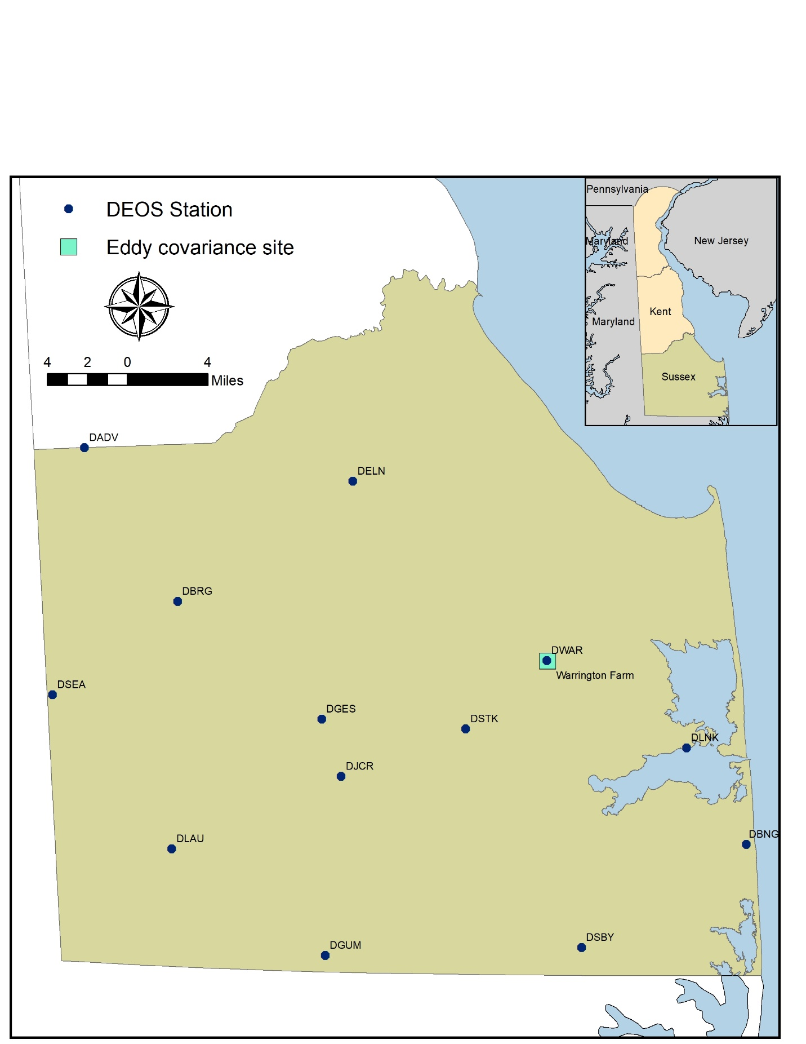

Figure 1. Location of study domain and DEOS weather stations.



Figure 2. Flow chart of METRIC method.

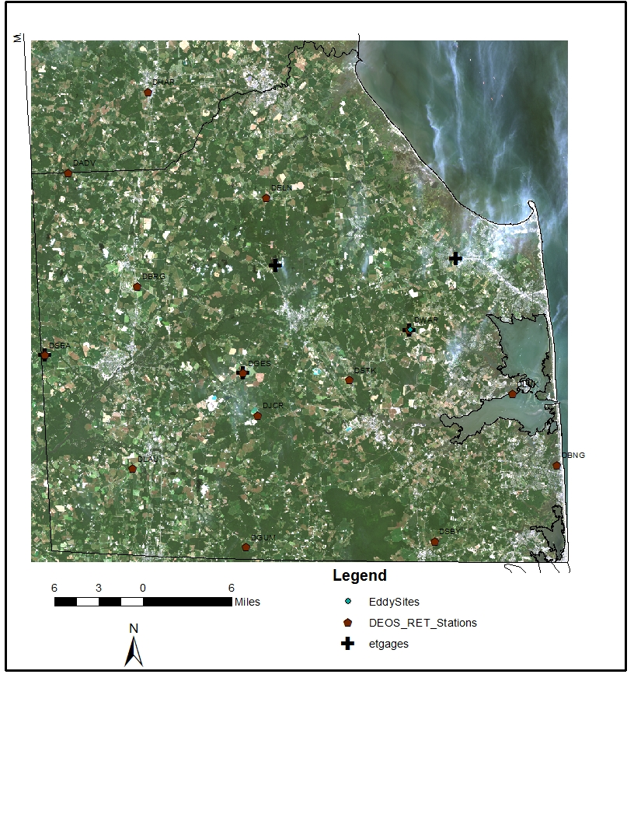

Figure 3. Color composite Landsat 8 image corresponding to 08/28/2016.

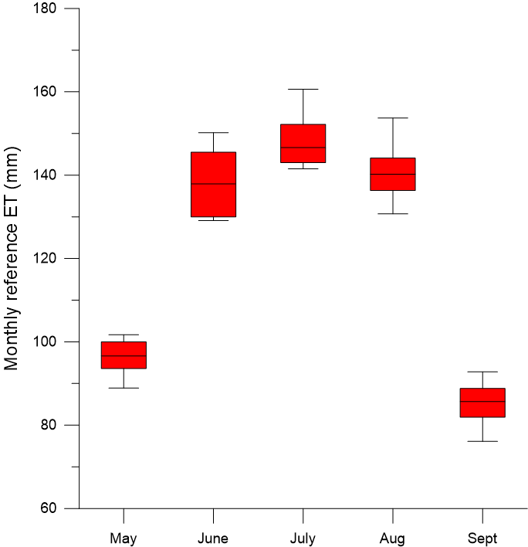

Figure 4. Statistics of monthly reference ET between May 2016 and September 2016.

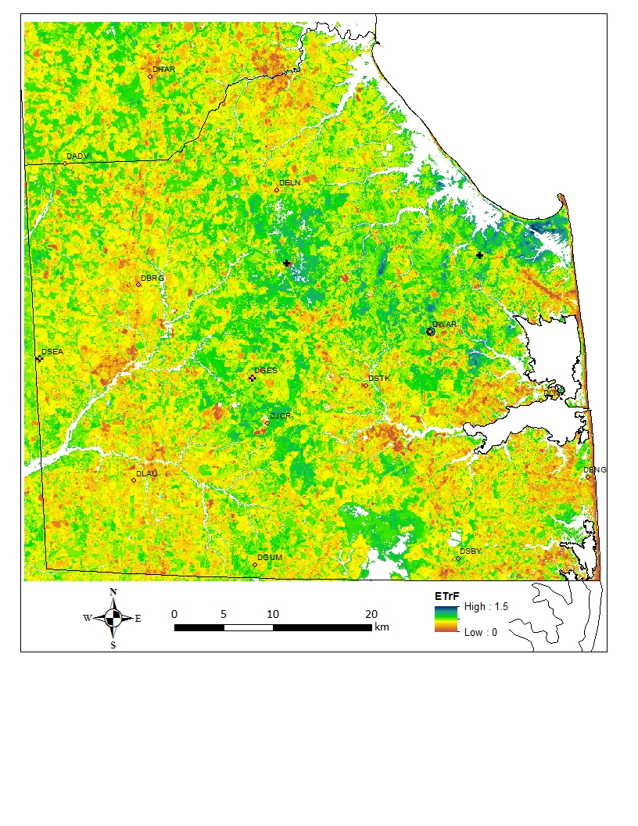Figure 5. ${ET}_{r}F$ Map (11:40AM, 8/28/2016)

Figure 6. Comparison of ECI-measured evapotranspiration (ET) and METRIC-calculated ET at the Warrington Farm site (a. instantaneous ET when the image was captured, 11:40AM local time; b. total ET on the day when the image was captured).

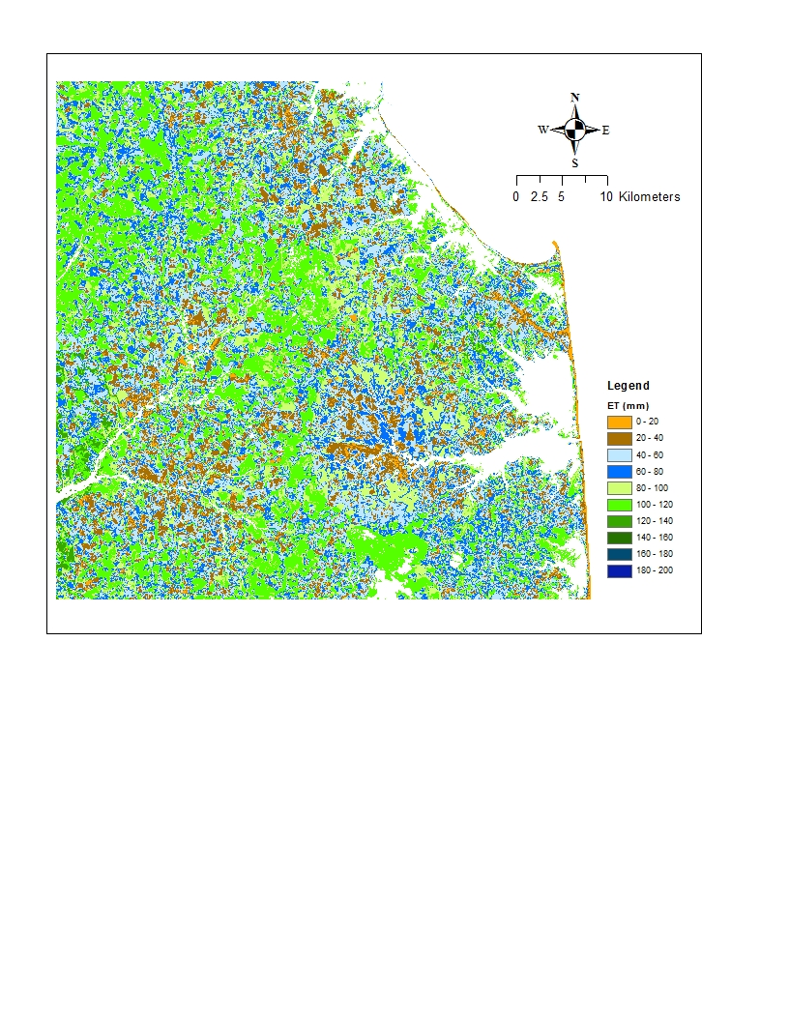

Figure 7. Actual ET for May 2016.

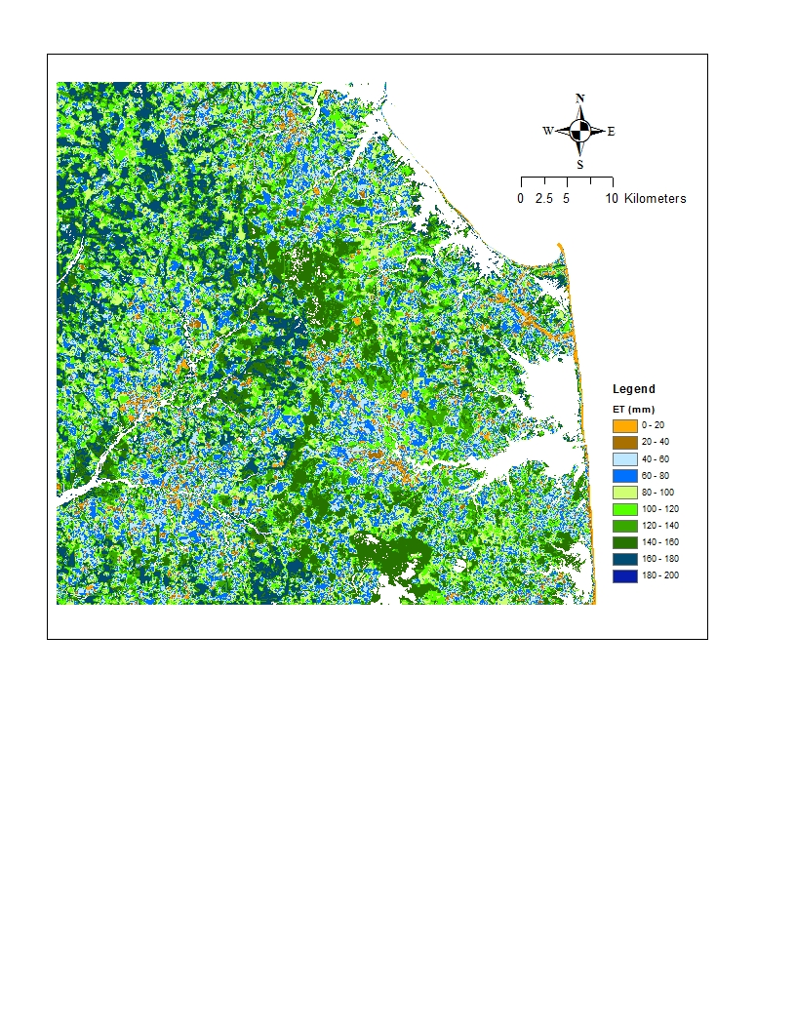

Figure 8. Actual ET for June 2016.

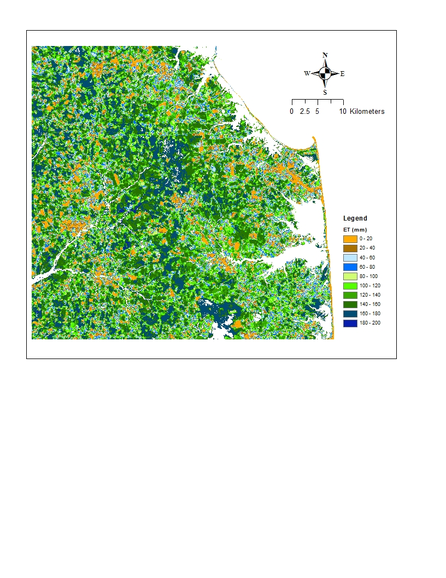

Figure 9. Actual ET for July 2016.

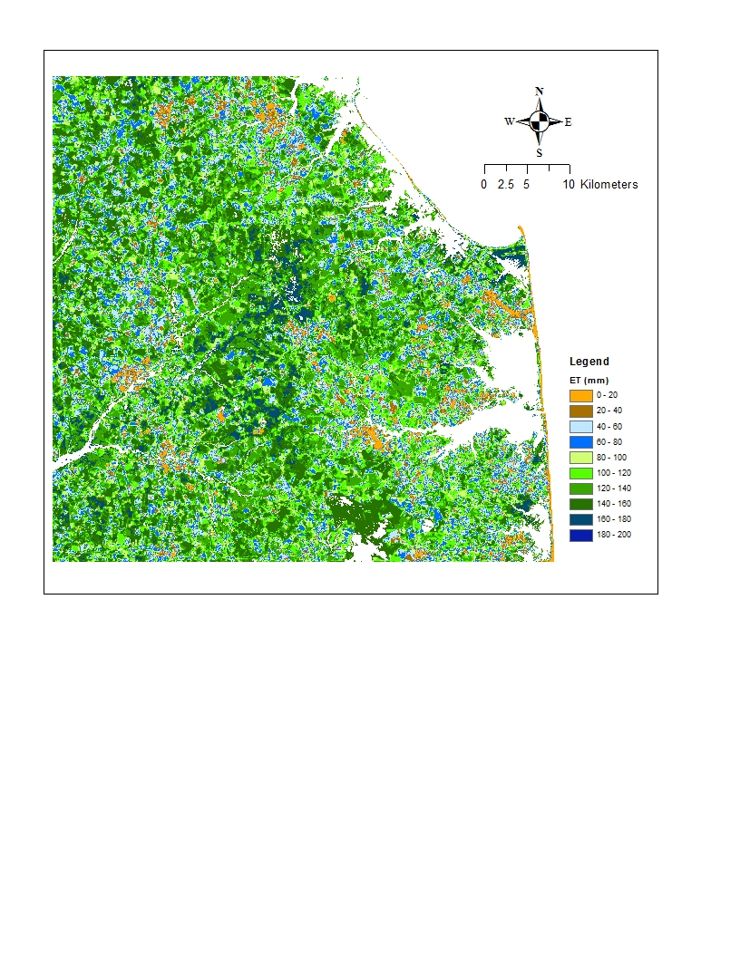

Figure 10. Actual ET for August 2016.

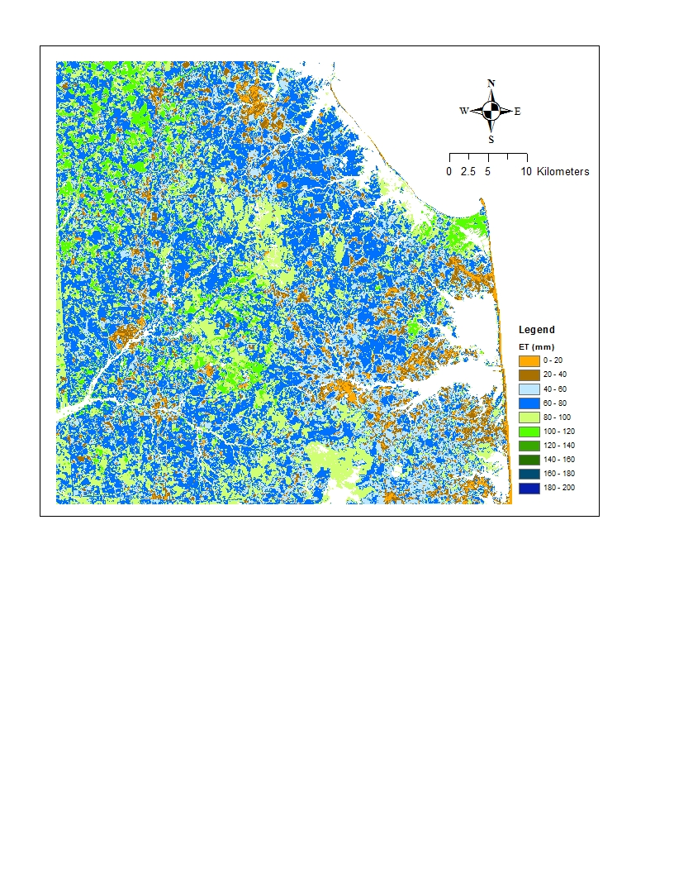

Figure 11. Actual ET for September 2016.



Figure 12. Seasonal ET (May-September 2016) map.

a

Figure 13. Histogram of seasonal ET rates for different land-use categories.