Title: Development of a Support System for Measurement and Analysis of Thinking Processes Based on a Meta-Cognitive Interpretation Framework: A Case Study of Belief Conflict Thinking Processes

Abstract: The ability for metacognitive thought, or "thinking about thinking," is recognized as an increasingly important skill for the future enrichment of social life. On the other hand, training this skill is difficult because it involves implicit cognitive activities that cannot be perceived by an outside observer. In this study, we propose an interpretative framework for metacognition as one approach to metacognitive thinking processes. This framework serves as the design document for the development of a system that makes it possible to give interpretations based on gaze behaviors and thought manipulation activity to metacognition, and provides a common base for sharing and comparing knowledge from analysis results. In this paper, as an example of framework-based system development, we constructed a thinking externalization application and thinking analysis support system with belief conflict thinking as the theme, and show as an application example part of the process of thinking about conflict as derived from low-level and higher-level thinking interpretation representations.

Keywords: metacognitive thinking processes, gaze behaviors, interpretation of thinking processes, thinking of dissolution of belief conflicts.

1. Introduction

As there are multitude of beliefs in social life, there has been no shortage of attempts to directly confront difficult problems by defining unique solutions. In these cases, it is critical to cultivate metacognitive thinking abilities, or "thinking about thinking." Moreover, the ability to logically explain the thinking that takes place in our head is increasingly recognized as an indispensable skill in social life [1]. Then again, it is also understood that training such metacognitive skills is difficult because of the implicit nature of thinking [2], and teaching methods appropriate to developing this skill have not been developed.

The "thinking aloud method," wherein one completes a task while successively vocalizing everything one is thinking, has been proposed as one means of capturing a part of this implicit thinking process [3, 4]. Although this method is commonly used for the purpose of analyzing the thinking process, several problems with it have been identified: it is difficult to collect data on the subject in their natural state; completing a task while verbalizing each step produces a cognitive load; and task executioners with low introspective abilities find it difficult [5, 6]. Alternative techniques have also been documented, such as the retrospective method of answering questions about one's thinking during a task after it is completed, or stimulated recall in which one watches and reflects on a video recording of the task [7, 8], but these require introspective work by the thinking subject.

In response to these problems, the field of cognitive psychology is conducting studies that use physiological information about one's gaze, as it appears as a by-product of the thinking process, as a clue to approach thinking. Additionally, variations in the gaze during the verbalization [9] and reading comprehension processes [10] are being analyzed. Moreover, in the field of Intelligent Tutoring Systems, initial attempts are being made to understand how gaze information can be used and applied to support learning. Learners' level of learning [11] and internal states during task execution, for example level of interest [12] or confusion [13], are being analyzed using machine learning methods. On the other hand, most of these studies tend to analyze quantitative trends in subjects' gaze measurement results, and as far as we are able to determine, established methodologies for analyses of the thinking process itself do not exist.

Meta-cognitive monitoring and control is performed on base-level thinking during internal dialogue occurring inside the head. Of course, in context-independent conditions it is difficult to capture the entire contents of a person's metacognitive thinking from gaze information alone. Assuming a thinking externalization application with an interface that establishes a correspondence between a limited thinking task context and its results without constraints of a range that would create a sense of discomfort during use, our research hypothesis is that a part of the metacognition process that is indefinite and strongly dependent on individuals can be grasped from the gaze and the act of reviewing and correcting externalized thinking (hereinafter referred to as thought manipulation activity).

In this article, we elaborate an interpretive model that assumes the formless process of thought taking place in the head can be given an interpretation. Based on this, we propose an interpretive framework for metacognition that could serve as a common foundation for system development. Our framework provides a frame for the work process necessary to capture the thought process, and defines the conceptual series of steps necessary to carry out this series of tasks. Furthermore, in order to demonstrate that our proposed framework possesses the capacity to take our idea of ​​capturing metacognition through to the development of a support system for the measurement and analysis of actual metacognition processes, we develop a metacognition process measurement system (thinking externalization application) and analysis support system based on it. To demonstrate that a mechanism leading to system development and utilization can be realized, we present the results of a case study of metacognitive interpretation in a corrective context using belief conflict thinking tasks as an example.

In Section 2 we explain the concept behind the meta-cognitive interpretive framework and how it can be used to understand the thinking process, as well as the operation details for stakeholders intending to analyze the metacognitive process. In Section 3, we explain the base thinking expression ontology that plays a role as an explicit contract connecting the concept of ​​this framework to the development of a thinking analysis system. With reference to this ontology, Section 4 demonstrates the expression structure (interpretive expression) that gives an interpretation capable of capturing base thinking and metacognition. Section 5 demonstrates both a thinking analysis support system and a thinking externalization application for belief conflict thinking as real examples of system development based on the metacognitive interpretation framework, and Section 6 illustrates these example with applied results of interpretive expressions based on the thinking analysis support system.

2. An Interpretive Metacognition Framework for Understanding Metacognitive Processes

2.1 An Interpretive Model for Metacognitive Processes

Figure 1 shows the assumptions of this study that allow for the capture of meta-level thinking processes in a schematization of the concept of the interpretive model of the metacognitive thinking process. The thought process, which takes place in an area that cannot be observed from the outside world, is understood to be composed of two layers [17, 18]: base-level thinking, and metacognitive monitoring and control thinking or "meta-level thinking" (Figure 1, ①, ②).

Gaze behaviors can be measured from the outside world by using eye-trackers and other gaze-measurement devices (Fig. 1, ③). Eyeball movement occurs as repetitive alternation between a saccade, as one shifts the focus of the gaze when trying to see an object, and a stationary gaze at the object [19]. By specifying gaze times, it is possible to track gaze behaviors such as "gazing at an object," "change in target object of gaze", and so on, from a series of information about saccades and fixations.

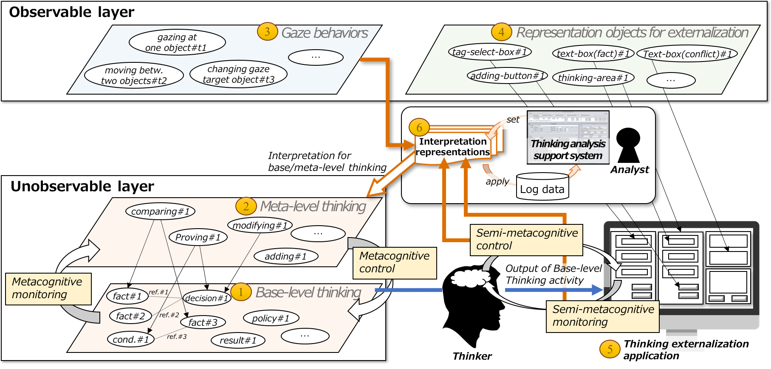

Figure 1　Model to Capture Meta-level Thinking Processes.

Our basic idea is to assume that the logical relationships between the products of base-level thinking activity taking place inside the head can be reflected and externalized into an interface, thus allowing metacognition performed by the thinker to be captured via gaze behaviors and thought manipulation. For example, in the thinking activity, "decide on tomorrow's holiday resort," where one might "take as a 'basis the fact that the chance of rain is 80%', 'hypothesize that it will rain,' and 'decide to go to the aquarium'," the products of thought are created in the head. However, we propose they could be externalized onto an interface. In this study, we refer to the results of such thinking activity as the "output of base-level thinking activity." In addition, we introduce the concept of "representation objects for externalization" to externalize the output of base-level thinking activity in a visible form (Fig. 1 ④). These representation objects for externalization correspond with commonly used components in GUI applications such as "panel," "text box," "selection box," and so on. By assuming that the output of base-level thinking activity can be externalized onto these representation objects, it becomes possible to observe the gaze behaviors and thinking manipulation acting on it.

In this study, we focus on the isomorphism observed between the "metacognitive monitoring and control taking place as base-level thinking inside the head" and "gaze behaviors and thought manipulation activity leading to the output of base-level thinking externalized to representation objects." By assuming the thinking externalization application can externalize the output of base-level thinking activity to appropriate representation objects (Figure 1 ⑤), we propose the research hypothesis that a part of the metacognition process may appear in gaze behaviors and thought manipulation activity. Here we consider gaze behaviors and thought manipulation on the metacognitive level of monitoring and control of the latter as "semi-metacognitive monitoring and control" activity.

The structure of the thinking task influences the way that metacognition monitors and controls base-level thinking. For example, in a situation (Section 6) where the results of nurses' belief conflict thinking are corrected, the corrector is asked to engage in thinking activities such as understanding and modifying the thinking of others (nurses). In order to cope with the diversity of interpretations of metacognition influenced by the structure of the thinking task, we introduce "interpretation representations" (Fig. 1 ⑥). Interpretation representations are formal expressions that extract sections of base-level thinking and metacognition from the thought manipulation activity and gaze behaviors, including the activities of semi-metacognitive monitoring/control, and give them an interpretation. These interpretation representations are assumed to be established and applied by an analyst through the thinking analysis support system.

Table 1　Framework to Capture Meta-level Thinking Processes.

|  |  |  |  |  |
| --- | --- | --- | --- | --- |
|  | Framework concepts | | Contents | Operation Reference |
| (1) | Base-level thinking expression ontology | Output of base-level thinking activity concepts | Ontology prescribing the output concept for base-level thinking activity assumed for target thinking task (Section 3.1) | (A), (B), (C), (E) |
| (2) | Representation objects for externalization concepts | Ontology prescribing thinking expression objects as parts of externalized thought (Section 3.2) | (B), (C), (E) |
| (3) | Interpretation representation notation | | Notation for giving interpretation to captured metacognition and base-level thinking from a series of gaze behaviors and thought manipulation activity (Section 4) | (C), (E) |

|  |  |  |  |  |
| --- | --- | --- | --- | --- |
|  | Phase | Stakeholders | Work | Contents |
| (A) | Design | Analyst | Realization of (1) | Addition of output concept of base-level thinking of target thinking task as ontology |
| (B) | Development | Analyst & Developer | Mapping and realization of (1)→(2) | Define correspondence between the base-level thinking concept prescribed in (A) and the representation objects for externalization concept, and develop a thinking externalization application based on it (section 5.2) |
| (C) | Developer | Realization of (3) based on (1) and (2) | Define gaze behavior / thought manipulation activity measured by thinking externalization application (B) as specific instances of interpretation expression class and develop a thinking analysis support system to capture semi-metacognitive monitoring and control activity (Section 5.3). |
| (D) | Measurement | Thinker | ― | Using thinking externalization application of (B), thinker performs thinking task (measure gaze behaviors and thinking manipulation acts) (Section 6.1) |
| (E) | Analysis | Analyst | Apply (3) | Using the thought analysis support system of (C), give an interpretation expression, define interpretation expressions of gaze behaviors and thought manipulation activity measured in (D), and analyze the results (Section 6.2) |

In the framework we propose, we will develop a conceptual system (base-level thinking expression ontology) for the formal expression of the output of base-level thinking activities related to the task and externalized thought components as representation objects for externalization. Because it clarifies which gaze behaviors and thought manipulation in response to representation objects for externalization should be understood as semi-metacognitive monitoring/control activity, the use of this ontology as a foundation makes it possible to implement the thinking externalization application that specifies the design layout of that process. Furthermore, we think that by describing interpretation representations based on the concepts of this ontology, it becomes possible to express analysts' intentions within the series of processes from measurement for interpretation of metacognition to interpretation itself in a form that facilitates agreement about the results.

2.2 Metacognition Interpretation Framework

Definitions of the interpretation model of the metacognition process shown in Fig. 1 are shown in Table 1 as the metacognition interpretation framework. A frame for the process to capture the thinking process is given by our framework, and we define both concepts for carrying out this sequence of work: the base-level thinking expression ontology ((1), (2)) and the interpretation representations notation ((3)). This section describes the working process (Table 1, bottom row), while the concepts defined by the framework (Table 1, top row) are described in detail in Sections 3 and 4.

Specific work processes are organized into four phases: the "design phase," "development phase," "measurement phase," and "analysis phase." We assume someone to perform metacognition analysis (analyst), someone to develop the system used in metacognition analysis (developer), and someone whose thinking is the subject of metacognitive analysis (thinker) as stakeholders corresponding to each task.

Design phase (A): The analysts organize an ontology from the concept of output of base-level thinking activity assumed for the thought task.

Development phase (B): Correspondences between the output of base-level thinking activity concept prescribed in (A) and the representation objects for externalization defined in advance as an ontology are discussed by the analyst and the developer, and they construct a thinking externalization application that adopts an interface design composed of instances of the representation objects for externalization concepts based on such correspondences.

Development phase (C): Implement and develop thinking analysis support system which can extract the object of analysis from thought manipulation activity and gaze behaviors measured in (B), and establish interpretation representations (Section 4) to give an interpretation.

Measurement phase (D): The thinker performs the work of the thinking task through the thinking externalization application constructed in (B).

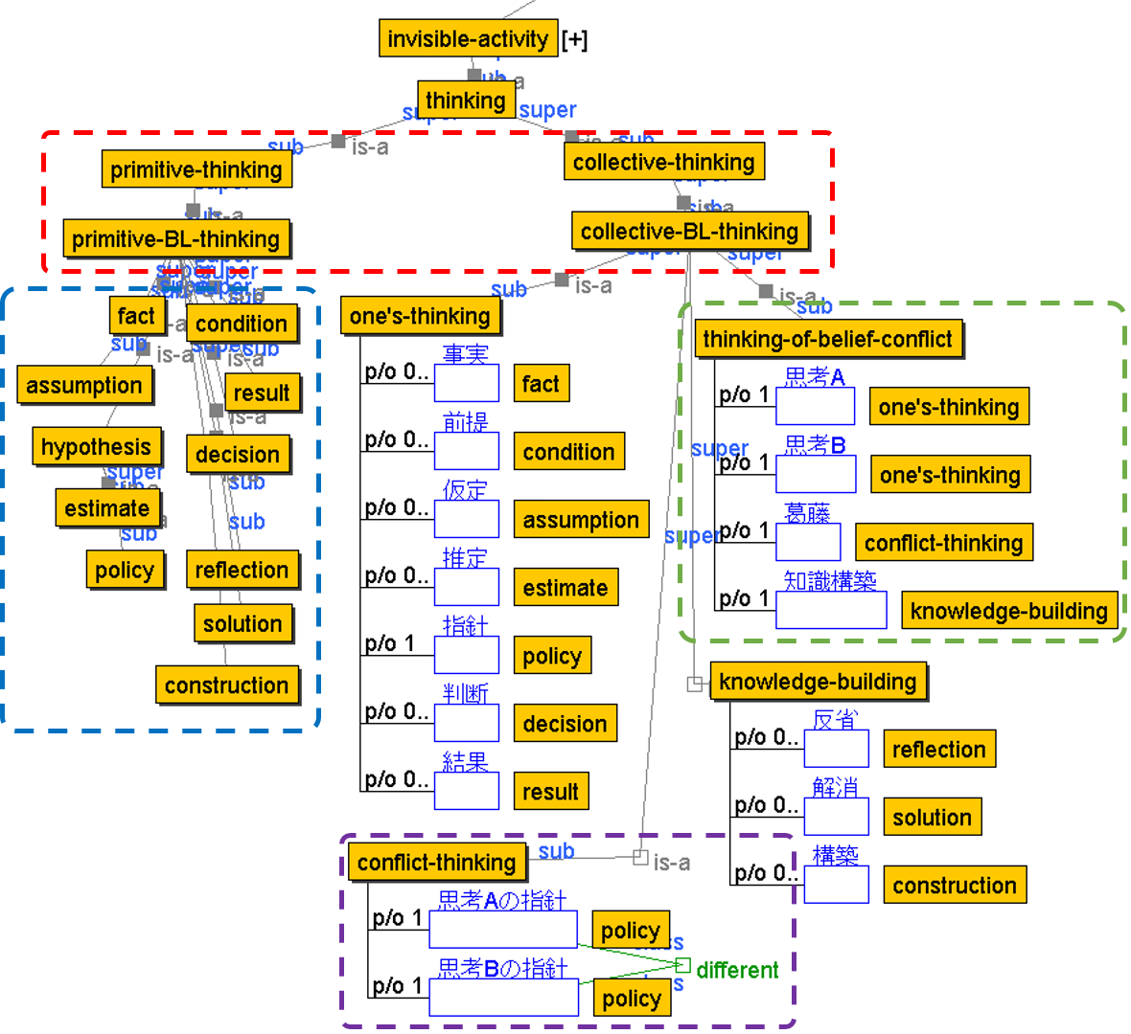

Figure 2　Concepts of Output of Base-level Thinking Activity in Thinking of Belief Conflict.

Analysis phase (E): Set and apply interpretation representations on the thinking analysis support system developed in (C) to the thinker's gaze behaviors and thought manipulation activity information measured in (D), and through refinement of this process, capture a verifiable hypothesis on metacognition.

Below we explain the base-level thinking expression ontology defined by the framework in Section 3, and the interpretation representation notation in Chapter 4.

3. Base-level Thinking Expression Ontology

The base-level thinking expression ontology (Table 1 (1) (2)) defined by the framework is the basis for connecting the interpretive model of the metacognition process shown in Figure 1 to the development of the thinking externalization application and thinking analysis support system. Here, concepts common to the thinking task type are defined, and below the analyst defines the concept of the output of base-level thinking activity specific to the target thinking task (Table 1 (A)), so that the basis for system development can be established.

3.1 Output of Base-Level Thinking Activity Concept

Figure 2 shows the base-level thinking activity output concept (hereafter, "base-level thinking concept") in the thinking expression ontology.[1] Even though we can say it is “thinking,” it can be captured in a variety of ways according to the target thought task. In order to prescribe differences in the granularity of such thinking, it is necessary to distinguish the output of base-level thinking activity concept from two major concepts: the primitive concept (primitive-BL-thinking) representing the minimum unit of base-level thinking activity below the thinking concept (thinking), and the base-level thinking concept (collective-BL-thinking) that expresses the integrated whole (Fig. 2, red frame).

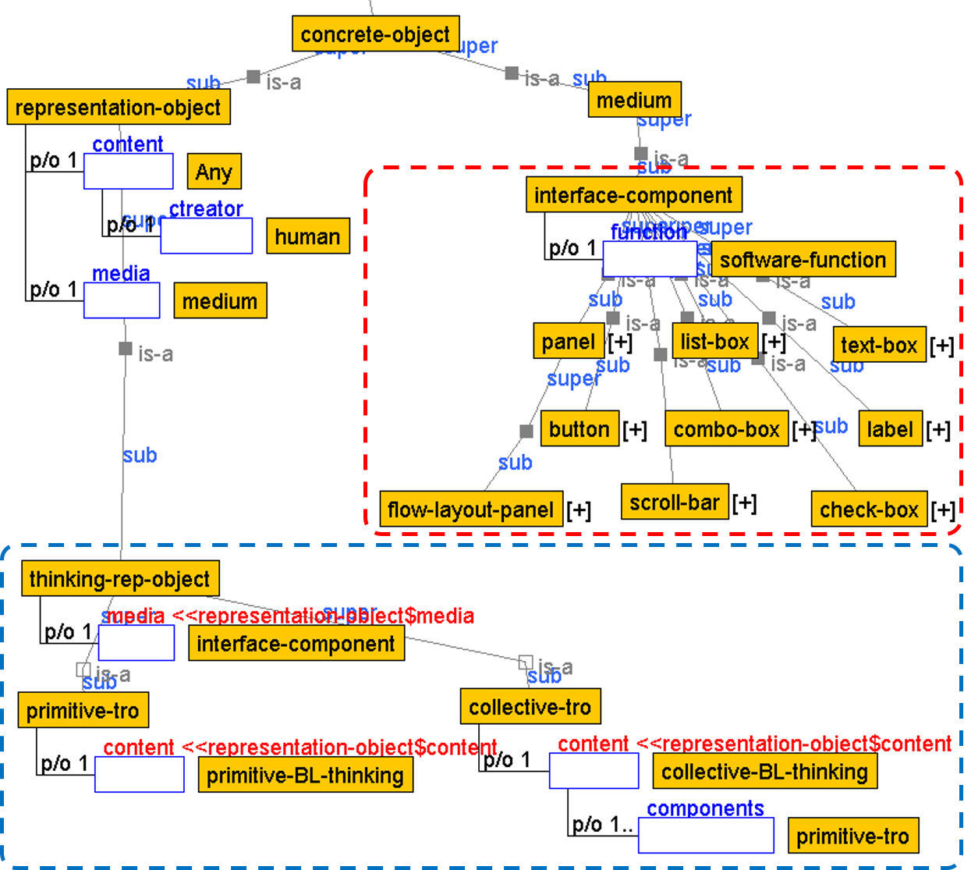

Figure 3　 Concepts of Thinking Representation Objects.

Concepts subordinate to primitive-BL-thinking include "fact," "condition," "estimate," "policy," "decision," "result," and so on, all organized into base-level thinking concepts of the smallest possible units, which are generally considered to be important for constructing logical thought (Fig. 2, blue frame). We allow analysts to supplement these with additional concepts required for specific target thought tasks.

In the subordinate concepts of collective-BL-thinking, the analyst specifies the thinking concepts according to the target thinking task as it is composed of an aggregate of primitive-BL-thinking (Table 1 (A)). In Figure 2 we describe a conceptual system as an example of thinking-of-belief-conflict (Section 5.1), which this paper takes as its case. Thinking-of-belief-conflict is specified as thought (one’s thinking) representing the logical path of base-level thinking that causes belief conflict. It is defined to be composed of (part-of) a concept of one's own thinking or another’s thinking (thought A, thought B), the conflict concept representing the origin of the conflict for each thought (conflict-thinking), and the concept of constructing knowledge to overcome the conflict (knowledge-building) (Fig. 2, green frame). Furthermore, one's-thinking, conflict-thinking, and knowledge-building are defined as consisting of concepts specified as subordinate to primitive-BL-thinking. Conflict-thinking, for example, represents the root of belief conflict, and is defined as a conflict between two different judgment policies of thought A and thought B (Fig. 2, purple section). In design stage (A) analysts specify the base-level thinking concepts they wish to target as collective-BL-thinking, which is represented by an aggregate of primitive-BL-thinking.

Primitive- and collective-BL-thinking are defined as invisible-activity that cannot be observed from the outside world. In the metacognition being targeted, thoughts such as "to think about the premise of a given judgment," "to compare policies leading to belief conflict," "to examine whether an assumption is correct," "to check and correct judgment policies," and so on are all relevant, and the framework gives interpretation representation notation (Section 4) for capturing metacognition unique to these thinking tasks.

3.2 Representation Objects for Externalization Concepts

As described in Section 1 this research takes as a premise the interface (thinking externalization application) that affixes a correspondence between the thinking task context and the results, and in the previous section the output of base-level thinking activity was verbalized into representation objects for externalization. The framework defines this premise as the relation between the base-level thinking concept and the representation objects for externalization concept.

Figure 3 shows an ontology that organizes the representation objects for externalization concepts. We define the subordinate concepts of concrete-object as medium and representation-object, which is composed of content and media.

Parts such as panels, buttons, labels, text boxes, and so on are defined as subordinate concepts of the interface-component, a concrete example of medium, and are specialized according to a software-function (Fig. 3, red frame).

Among the subordinate concepts of representation-object, medium specifies representation objects for externalization (thinking-rep-object) as specialized interface-components (Fig. 3, light blue frame). In order to associate the granularity of verbalized thoughts as representation content with Section 3.1's base-level thinking concepts, the content constituting the thinking-rep-object is defined as a specialized representation object concept (primitive-tro) that stores primitive-BL-thinking, and as an expression object concept (collective-tro) that stores collective-BL-thinking. Collective-tro is defined as an aggregate of primitive-tro. Therefore, regardless of the granularity of base-level thinking concepts (primitive- and collective-BL-thinking), and of the kind of representation objects for externalization (primitive- and collective-tro) that are intended to be verbalized, they will be represented.

Because we have taken as a premise that the interface we have defined here can be provided, that it can be applied to the context of other thinking tasks is the hypothesis of this research, and therefore we have clearly defined it as a concept system.

4. Notation for Interpretation Representations

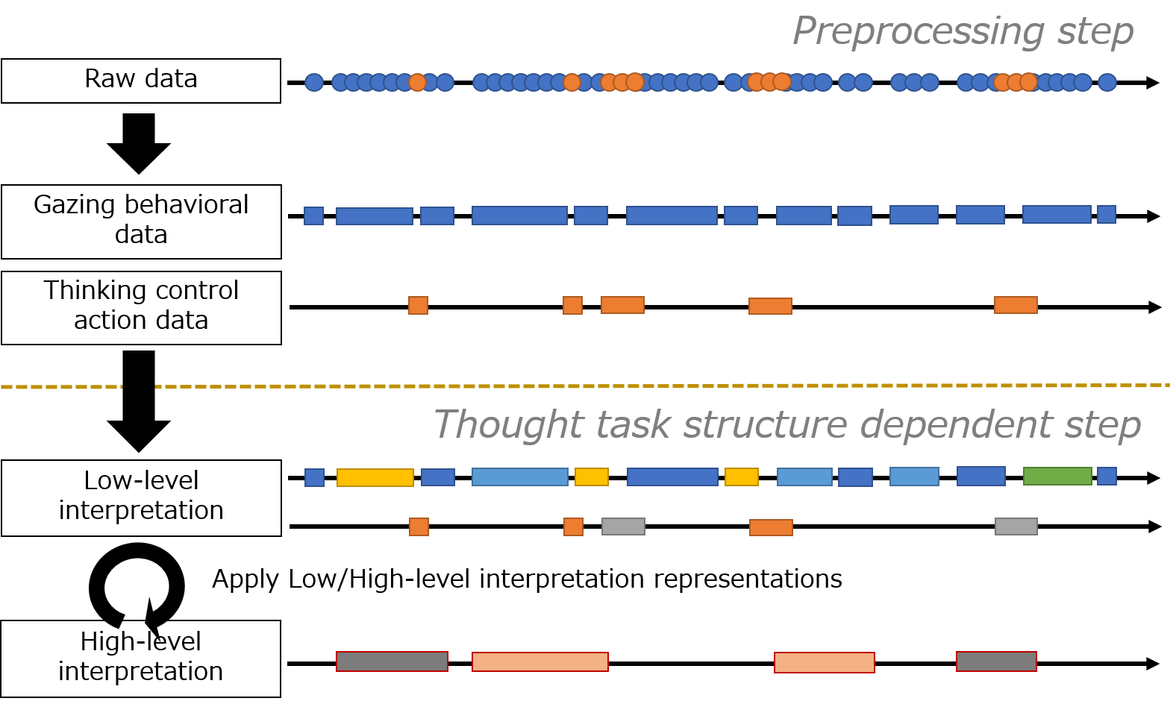

Figure 4　Concept Image of Applying Interpretation Representations.

By constructing the thinking externalization application based on the base-level thinking expression ontology described in the previous section, it becomes possible to measure the gaze behavior and thought manipulation behavior of the user working on the thinking task in association with the thinking concepts defined in the ontology. In this section, we will describe the premise of the interpretation process prescribed by the framework to give metacognition interpretation dependent on the thought task structure to the raw data measured in this way, as well as the interpretation representations notation (Table 1 (3)) based on this premise.

Figure 4 shows a conceptual diagram of the application of interpretation representations. Interpretation representations that capture the characteristics of the thinking task structure are applied (Fig. 4, lower part) through a preprocessing stage that is independent of the thought task structure (Fig. 4, upper part).

Preprocessing: Processing to prepare raw data consisting of gaze behaviors and thought manipulation activity for representation objects. It is realized by noise elimination based on prescribed gaze fixation time, gaze behaviors involving gazing at one expression object with very short breaks, and setting a time interval to decide whether thought manipulation activity counts as one act or not.

Thinking task structure-dependent processing: This is a process of giving interpretation to each data series classified via preprocessing. Interpretation processing consists of two processes: processing that provides a low-level interpretation (low-level interpretation); and for sections given an interpretation in this stage of processing, high-level interpretation representations processing (high-level interpretation) that gives interpretations including metacognition.

4.1 Low-level Interpretation Representations Notation

The interpretation representations notation which gives the low-level interpretation PI_L to the data series of gaze behaviors and thinking operation behavior is expressed by the following (1):

$${lr}_{x}\left(Act({tro}_{i}),PI_L\right) (1)$$

Table 2　Function List for Condition Setting.

|  |  |
| --- | --- |
| Function | Interpretation |
| *ALL* (L1) | *all* L1 |
| *BEFORE* (L1, L2, t) | L1 *takes place before* L2 *within* t *msec.* |
| *OVERLAPS* (L1, L2) | L1 *overlaps with* L2 |
| *DURING* (L1, L2) | L1 *during* L2 |

The first argument *Act* (*troi*) represents gaze behaviors and thought manipulation activity attributed to representation object for externalization (*troi*) in the above preprocessing. Elements of gaze behaviors include *GazeAt* (*troi*), and elements of thought manipulation activity include *Keypress* (*troi*), *Delete* (*troi*), and *Press* (*troi*). This shows that the lower-level interpretation *PI_L* of the second argument is given to the time interval identified here.

4.2 Higher-level Interpretation Representations Notation

Interpretation representations notation for lifting low-level interpretations from the level of base-level thinking to the metacognition level interpretation *HI_L* is shown in (2):

$${hr}_{x}\left(Cond,HI_L\right) \left(2\right)$$

The first argument *Cond* is composed of a function group representing matching conditions.[2] Table 2 shows functions that can be specified as arguments. The arguments *L1* and *L2* represent data intervals that can be given interpretation according to a low-order / high-order interpretation. *ALL* (L1) expresses all the L1s, and *BEFORE* (L1, L2, t) expresses the data section in which L1 appears *t*milliseconds beforeL2. *OVERLAPS* (L1, L2) represents the overlapping section ofL1 and L2*, DURING* (L1, L2) represents the section in which L1 is included in the section of L2, and both represent a high-level interpretation *HI_L* given to these sections.

Applications and other specific examples of low order and high order interpretation representations are described in Section 6.2.

5. Example System Development Based on Framework

This section shows an implementation example of the thinking externalization application and thinking analysis support system based on the metacognition interpretation framework. This work corresponds to the implementation of the design and development phases (A) to (C) in Table 1, and in this system development, the analyst and system developer stakeholders are the authors. In Section 5.1 we explain the thinking process of "belief conflict thinking" that we focus on in this study and outline the "Sizhi" training environment. Section 5.2 takes Sizhi as the basis of a thinking externalization application called "Eye-Sizhi," which is equipped with a training environment for belief conflict thinking based on our framework. Section 5.3 establishes interpretation representations for interpreting gaze behaviors and thought manipulation activity measured by Eye-Sizhi, and explains the thinking analysis support system for visualizing the interpretations based on those representations.

5.1 Target Thinking Process and its Training Program

Ito has examined the verbalization effect of thought from the viewpoint of learning strategy and proposed a verbalization achievement model as learning strategy composed of three processes: the knowledge statement cycle, cognitive conflict, and the knowledge building cycle [21]. According to this process, it is thought that by actively conducting internal dialogue focused on thinking logically, one's own thoughts are refined, and the thinking process is clarified [22].

Based on this goal attainment model that treats "thinking (base-level thinking) about thinking (metacognition)" as a learning environment to train thinking skills, the inner dialogue promotion environment "Sizhi" has been proposed [23]. When thinking about building high quality knowledge, it is crucial to dig up the fundamental conflicts created by conflicting beliefs in different values. In Sizhi, the challenge is to construct knowledge for overcoming belief conflict structures which are based on one's own experience and have no correct answers [24], and to verbalize the logical path from each of one's own judgments (thought A) to other subsequent judgments (thought B) in terms of "statements" expressed in the smallest units of thinking. Next, after specifying "policies" that form the beliefs of thought A and thought B, as well as a statement about the "grounds," clearly express the "conflict" as the root cause responsible for those belief conflicts. In addition, build a solution (knowledge construction) to overcome it. In order to clarify and increase awareness of the logical structure of one's own thinking, require thinking activities to consciously and explicitly give each statement "Sizhi tags," which represent the role they play in the logical structure.

Sizhi has been implemented in classes for first-year university students [22], as well as for medical care workers in a thinking method training program [25], with improvements in learner's metacognition skills being reported.Proposals for tools linked to Sizhi include: tools for rehabilitative demonstration of the expressive process of learner and corrector thinking [26]; tools for expressing graphs of logical structures [27]; and tools for correctors to review and correct conflict structures in cases created by workers.

However, since the thought process leading to expressions of thought on Sizhi remains implicit, its interpretation is left to the student who reflects on thought, or the corrector who makes a review or correction. If there is a possiblity of interpreting this implicit thinking process, then we suggest that while it has been to date impossible to understand both the differences observed between learners in thinking expression processes that deepen conflict, and differences in the correction thinking process between those experts with abundant experiences of correction and correctors with relatively little experience, we nevertheless believe that we can capture a part of the thought process of learners and correctors that could not be grasped before.

5.2 Eye-Sizhi

Assuming that it will be used as a teaching tool to encourage verbalization of belief conflict thinking, we have built an application called "Eye-Sizhi" for measuring users' gaze behaviors and thought manipulation activity based on our framework. Figure 5 shows the Eye-Sizhi interface. Implemented in a form that follows from the Sizhi design philosophy, it allows for verbalization of belief conflict thinking structures in four thinking areas, "thought A," "thought B," "conflict", and "knowledge construction."This application is based on the base-level thinking expression ontology described in Section 3.

Specifically, in framework tasks (A) and (B) shown in Table 1, the base-level thinking concepts primitive-BL-thinking and collective-BL-thinking are defined as expressions corresponding to the statement area for representation objects for externalization concepts (Fig. 3) and the thinking area concepts, respectively. Then, based on these definitions, Eye-Sizhi is implemented in (C), as shown in Figure 5.

By using stationary eye-tracker, Eye-Sizhi has the ability to track the objects users are gazing at. Representation objects for externalization located on the interface are given an area of ​​interest (AOI), and the system records information in millisecond units about the point in time at which the user's gaze coordinates entered or exited an object's AOI. Target objects for which an AOI is set include thought areas (thought A, thought B, conflict, knowledge construction), statement areas, and conflict text areas. In addition to automatically detected gaze behavior information, keyboard input operations on representation objects for externalization and operation of the mouse are recorded as thinking operation information.

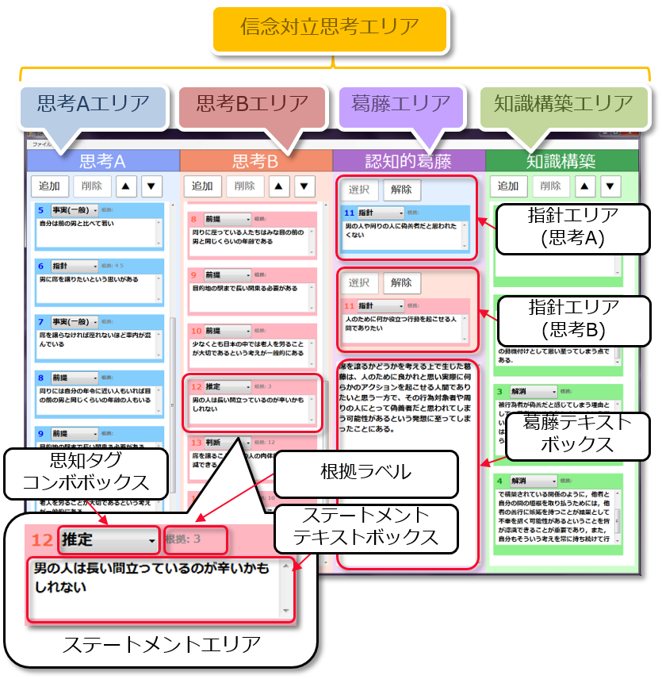

Figure 5　Interface of Eye-Sizhi.

5.3 Thinking Analysis Support System

We developed a thinking analysis support system that takes an Eye-Sizhi log file as input, applies the lower-level and higher-level interpretation representations described in Section 4, and visualizes the results. Figure 6 shows the system interface. The system is largely composed of the following three areas and a visualization screen of interpretation results.

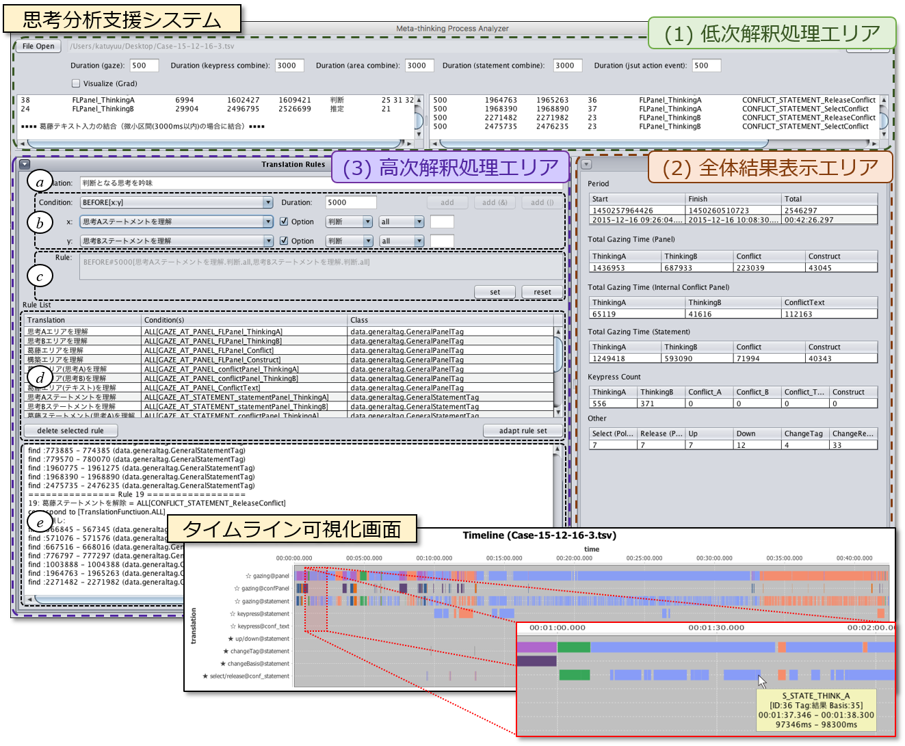

Figure 6　Interface of Thinking Analysis Support System.

(1) Low order interpretation processing area: (1) gaze time; (2) coupling interval time of the gaze behaviors and thought manipulation activity that occur together (gazing at the thinking areas, gazing at the statement areas, keyboard input operations); (3) establish the time intervals of thought manipulation activity observed instantaneously, such as mouse button clicks. Then, by reading the log file of Eye-Sizhi, the system extracts the time interval data for each action from the raw data, and assigns it to each time segment of the lower-level interpretation representations (corresponding to processing from raw data to low-level interpretation as in Fig. 4).

The applied results of the low-level interpretation representations is displayed on the timeline visualization screen (Fig. 6, lower right). The contents of this screen can be enlarged by designating a specific time section with the mouse, making it possible check details. In the example shown in Fig. 6, the whole session (about 42 minutes) display is enlarged to focus on the section "1:00 - 2:00," showing detailed confirmation of the gaze segment information for the target statement. When moused over, Eye-Sizhi statement information on target gaze behaviors (statement ID: 36, Sizhi statement: "result", grounds statement ID: 35, gaze interval time) is displayed on the tool tip screen.

(2) Overall results display area: This area comprehensively displays the amount of gaze behaviors and thought manipulation activity that occurred throughout the session, such as gaze time to each thought area and key input operation, thus facilitating an understanding of what the Eye-Sizhi user is paying attention to and for how long.

(3) Higher order interpretation processing area: This area is used to display interpretation results that have been raised to the metacognition level by applying higher-level interpretation representations to lower-level interpretation results from (1).

In setting the higher-level interpretation representations, the analyst creates a new interpretation representation name in the text area of ​​(a), and can use the combo boxes to set and select the conditional part of the function described in 4.2, as well as the label for the lower-level/higher-level interpretation results that will become the argument. Here, as a function relying on Eye-Sizhi, when the target argument is a thinking statement, it is possible to specify the Sizhi tag attached to the statement, the Sizhi tag of target grounds, and the statement ID. It is possible to confirm and add interpretation representations in the area of ​​(c), and interpretation representations added in this way will be displayed in the interpretation representations display area of ​​(d).A list including the lower level interpretation representations processed in (1) is displayed in this area, and it can be used as an argument of the function established in (b). Pushing the apply button after setting a series of interpretation representations divides each applied interpretation representation and displays them on the timeline visualization screen (Figure 8 (detailed in Section 6.2), and detailed information on them is shown in (e).

In this way, the process of giving an interpretation to the semi-metacognitive monitoring and control activities, which are comprised of gaze behaviors and thought manipulation activity about belief conflict thinking as measured by Eye-Sizhi, thereby making it possible to visually grasp the accumulation of higher-level interpretations, is realized.

6 Interpretation of Thinking Processes Based on Interpretation Representations

The metacognition interpretation model shown in Fig. 1 has been embodied in the metacognition interpretation framework shown in Table 1, and in order to develop and analyze the thinking externalization application and thinking analysis support system based on this, it is necessary to confirm that this series of processes is possible. To do this, we demonstrate an example of the operation of the developed system.

6.1 Target Data

Using the Eye-Sizhi system described in Section 5.2, corrector data on belief conflict thinking was collected (corresponding to Table 1 Measurement Phase (D)). Specifically, we used a nursing thinking method development program [25] as an opportunity to present belief conflict thinking in the field as a theme, and ran an actual implementation of Eye-Sizhi on the nurses' results (case) as recorded by Sizhi.[3]

Given that one of the important thinking skills is to understand belief conflict as an opportunity for knowledge creation, in this educational program correctors evaluated whether or not conflicts have arisen from to the formation of a logical, rational structure. Because metacognitive monitoring and control was implemented under these conditions with the objective of correcting results, we expect one part of this metacognition will be exposed as semi-metacognitive monitoring and control in the form of gaze behaviors and corrective action (thought manipulation activity).In addition, during corrections, we did not set the program end time as usual, and instead allowed corrections until correctors were satisfied.

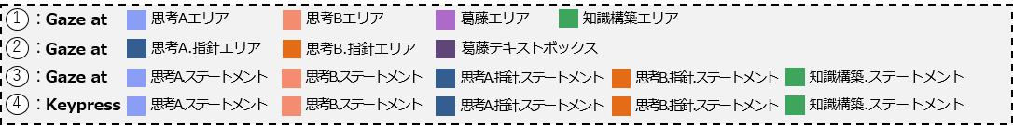

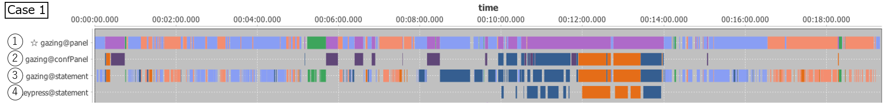

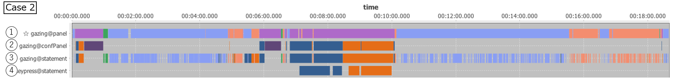

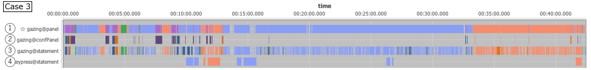

Figure 7　 Result Examples of Applied Low-level Interpretation Representations.

6.2 Applied Results of Interpretation Representations

The applied results of the lower-level interpretation representations (part of the visualization screen) for the case correction data are shown in Figure 7 as an example of the Analysis Phase (E) in Table 1. In this example, we apply four types of lower order interpretation representations shown in Table 3, based on the correspondence between the representation objects for externalization and the base-level thinking concepts defined by the ontology. Corresponding to each interpretation representation, the following is displayed in the timeline: ① understanding each of the four thinking areas (*lr1*); ②understanding of thought contents of the conflict area (*lr2*: policy statement of thought A, policy statement of thought B, conflict text); ③ understanding the statement contents (*lr3*); ④ section where the statement text was edited using the keyboard (*lr4*).

Based on the timeline visualization results of ① and ②, we can see that the corrector does not make chaotic gaze movement, but takes their time in each thought area to grasp and correct thoughts described by others (nurses). Also, in the four cases shown here, one can see that immediately after starting the correction, the corrector moves from understanding the content described in the conflict area (purple) to begin digging down into the conflict in order to grasp the its logical structure.

Figure 8 shows the results of applying higher-level interpretation representations. This is where the four kinds of higher-level interpretation representations shown in Table 4 are applied to Case 1 in Figure 7.

In Figure 8, the application results of each interpretation representation are classified and visualized, and (i) represents a section in which the corrector compares thought A and thought B as a result of applying higher-level interpretation representation *hr1*. In the conditions of *hr1*, sections of thinking activity about thought A and thought B which are consecutive within 5000ms are extracted from the application results of *lr1*, and the two thoughts which are sources of conflict (thought A, thought B) are compared (meta-cognitive monitoring) and interpreted. From these results it can be seen that this corrector monitors metacognition to compare thought A and thought B in the first half and the second half of the correction activity (Figure 8, in the blue frame). *hr2* and *hr3* represent the extraction of a section of the understanding process of a conflict statement that forms a belief conflict (*hr2*) and a correction section (*hr3*), respectively. Furthermore, *hr4* represents extraction of the metacognitive thinking process section by designating the interpretation result of *hr2* and *hr3* as the condition part, and the application result is shown in Figure 8 (iv). Here a section (meta-cognitive monitoring) examining two conflicting policies constituting a conflict important to the belief conflict thinking task is extracted, and a section leading to a conflict statement modification (metacognitive control) is shown.

表4　高次レベルの解釈表現例

Table 4　 High-level Interpretation Representations.

|  |
| --- |
| High-level Interpretation Representation |
| *hr1 ((BEFORE (lr1.ThoughtA, lr1.ThoughtB, 5000) OR*  *BEFORE (lr1.思考B, lr1.思考A, 5000)), “思考Aと思考Bの比較”)* |
| *hr2(ALL (lr3.policy), “Understanding of Policy”)* |
| *hr3 (ALL (lr4.policy), “Correction of Policy”)* |
| *hr4 (BEFORE (hr2, hr3, 5000), “Consideration of Policy leading to Conflict”)* |

Table 3　 Low-level Interpretation Representations.

|  |
| --- |
| Low-level Interpretation Representation |
| *lr1 (GazeAt(ThinkingArea[all]), “Understanding of Thought”)* |
| *lr2 (GazeAt(ConflictArea[all]), “Understanding of Conflict”)* |
| *lr3 (GazeAt(Statement[all]), “Understanding of Statement”)* |
| *lr4 (Keypress(Statement[all]), “Correction of Thought”)* |

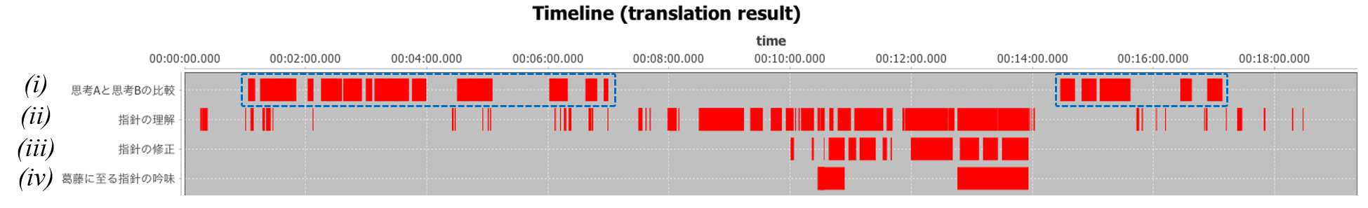

Figure 8　 Result Examples of Applied High-level Interpretation Representations.

In this way, by constructing a thinking externalization application based on the base-level thinking expression ontology far a given thinking task, it is possible to apply interpretation representations to gaze behaviors and thought manipulation activity on representation objects for externalization. This suggests the possibility that one part of the metacognitive thinking process can be grasped from this example. Of course, whether the extracted interpretation section has a certain degree of validity is dependent on the interpretation representations defined by the analyst. Despite this assumption, the analyst clarifies the prerequisite concepts for analysis to target highly implicit, latent thoughts, and sets interpretation representations based on it, so as to enhance agreement about the kinds of metacognitive thinking processes and semi-metacognitive monitoring and control activity is being considered. We believe thinking analysis based on our framework will contribute to the accumulation of knowledge.

7. Conclusion

In this study, we proposed a metacognition interpretation framework that presumes an isomorphism between gaze behaviors and thought manipulation activity on meta-cognitive monitoring and control for base-level thinking inside the head and the output of base-level thinking activity on externalized representation objects as one methodology to grasp a part of the metacognitive thinking process which cannot be observed externally. We presented the framework premise by introducing base-level thinking output concepts and representation objects for externalization concepts in order to maintain the continuity of the support system for the measurement and analysis of the metacognition process and the concept of this study, as well as to enhance agreement on the intended design. Furthermore, this framework was developed from the viewpoint of structural concepts and the working processes of stakeholders. Moreover, as a case example of system development based on this framework, we built a thinking externalization application and thinking analysis support system around the theme of belief conflict thinking.

In order to share and compare knowledge from the analysis results, and to obtain consensus among researchers about the premises of not only system development but also the way to capture the target thinking (metacognition), it is critical for discussion to take place on a common foundation so that sound research results can be accumulated. There still remain many points awaiting future verification regarding the validity of the expression form in this framework, as well as the applicability of the interpretation results. However, using the our framework, we were able to realize a thinking externalization application and thinking analysis support system based on a base-level thinking expression ontology. In addition, we can confirm the desired behavior showing the possibility of capturing the thought process based on the prescribed interpretation representations. We believe that this research contributes to the possibility of approaching the challenge of grasping the metacognition process and accumulating knowledge about it.

In future work, we plan to refine our research framework and, using thinking analysis support system, further analyze correction data obtained during the implementation of the nursing thinking method training program. In addition, we are also implementing a study to measure the of first year students' thinking in practical lessons for college first year students [22]. Finally, we intend to engage in continuous verification of the hypothesis of this study; that is, that a part of the thinking process can be grasped from gaze and thought manipulation activities.

1. We are using ontology construction tool "Hozo" (http://www.hozo.jp/hozo/). In addition, the first appearance of certain concepts are underlined in the text.
2. At present, we are selecting those available for time series analysis with reference to Allen's time interval logic [20]. In order to be able to define more flexible interpretation representations, we plan to add SUBTRACT (L1, L2) (L1 section excluding L2) and so on.
3. In the Nursing Thinking Method Training Program, which has been continuously since 2012, Eye-Sizhi has been implemented since the end of 2015. Currently, there are 26 cases of correction data for 2 correctors working on 14 nurses' results.