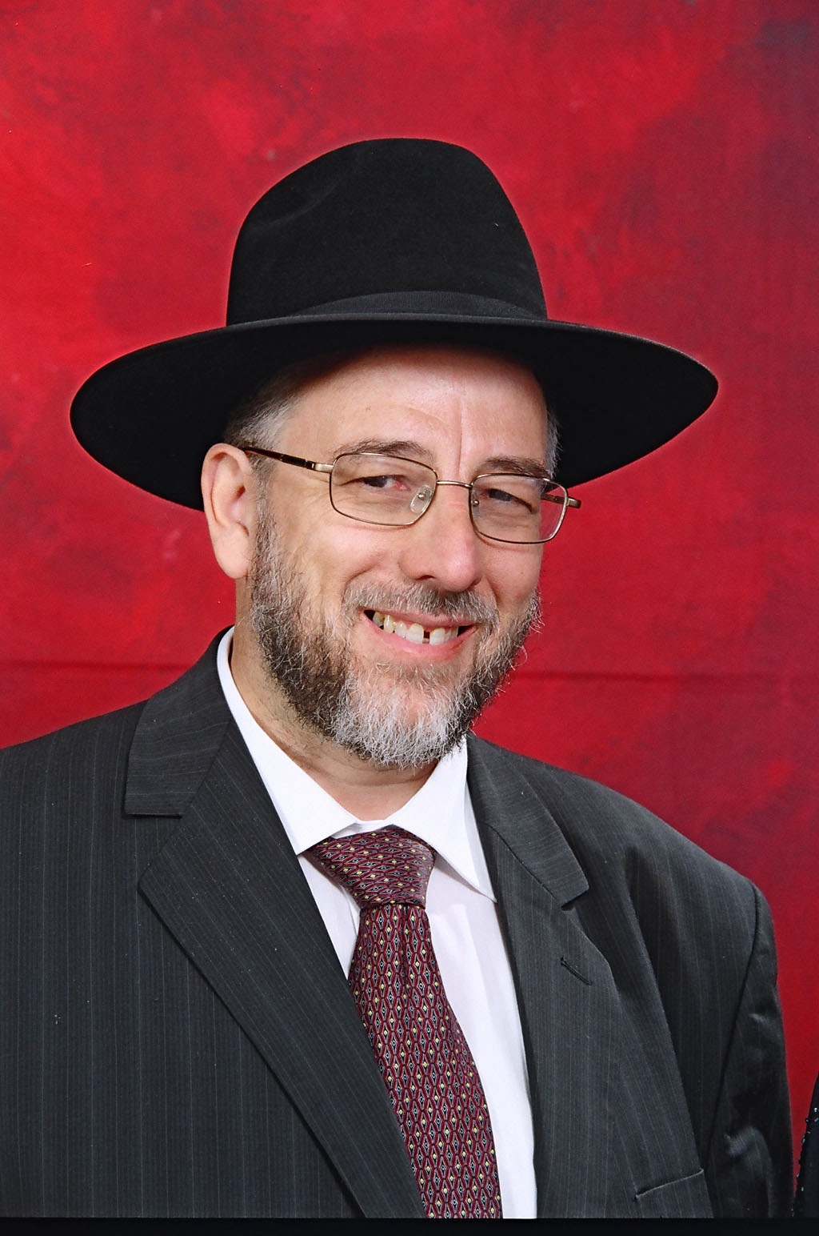
Geoffrey Black
972-2-9923539 Skype: geoffblack4440
geoffblack@bezeqint.net

56/1 Nachal Dolev Street,
Ramat Bet Shemesh 96000
Israel

Profile
I am a professional, with over 20 years of experience in the IT field, supporting clients with their software or hardware needs on many platforms. Quality work, customer satisfaction and timely delivery are very important to me. My strengths focus on guiding clients in using their tools properly, and to achieve their objectives. This could be through project management, technical support, business management, administrative support, or even technical writing. In addition, I have done a considerable amount of translation and editing.
As a freelance provider, my goal is to give you the most efficient solution possible, within the shortest time, and with optimum results. If you need software or hardware support or training, business analysis, documentation, editing, or even translation, then I am your man.

Experience
Translator 1974-present
I have been translating and interpreting Hebrew <> English since 1974.

P.C. Clark (Israel)
Throughout Israel
Manager 1982–present
I export industrial scrap silver to the UK for recycling purposes. I am responsible for purchases, negotiating with suppliers, and sorting and exporting the goods.

Ramat Bet Shemesh
Watchmaker 1985-present
I repair all types of watches.

Jerusalem & Ramat Bet Shemesh
Computer Consultant 1988-present
I am a self-employed “computer doctor,” mainly working with English-speaking clients at their homes or offices. I deal with a complete range of hardware and software problems.

Maaseh Choshev
Jerusalem
Night School Director 1992-1993
I was a partner, and established a night school. Courses included Computers, Languages and Accounting. I taught the computer courses.

Machon Devorah
Jerusalem
Teacher 1992-1993
I taught computer and program usage at a girl’s seminary.

IDT Global
Jerusalem
Telemarketer October to December 2005
I made two months' intensive telemarketing (approximately 16000 calls) to the UK, on behalf of a telephone company.

Odesk.com – Now Upwork.com
USA
July 2009-present
Translations and technical writing in both Hebrew and English.
This is a job site, and I have done many different varied projects, generally in these fields. I am also Top Rated there, with a 92% Job success rate.

Proz.com May 2017-present
This is a profession translator site, and I have been working with translator companies there from all over the world.

Proz.com May 2017-present
This is a profession translator site, and I have been working with translator companies there from all over the world.

Translators Café April 2017-present
This is a profession translator site, and I have been working with translator companies there from all over the world.

Skills and achievements
I am an expert translator and Hebrew-English interpreter and speak passable French & Yiddish. I have also had a lot of experience in Web design, and in writing Web content.

Education
Kollel Shevet U’M’Chokek
Jerusalem, Israel 1979-1983
Post-Graduate Dayanut (Jewish Ecclesiastical Judge) Studies

Yeshivat Hanegev 1974-1979]
Netivot, Israel
Rabbinical Ordination
Rabbi (Yoreh Yoreh)

Hasmonean Grammar School 1967-1974
London, England
3 A-Levels, British Constitution, Economics, & English Literature
7 O-Levels, English Literature & Language, French, Classical & Modern Hebrew, Mathematics, Geography

Training
- I have been trained to teach English as a second language.

Interests
- My passion is Jewish studies, and I have written a study guide on the Jewish Sabbath, and have been writing another on the Jewish prayer book for the last 8 years.

References
- My Upwork profile, https://www.upwork.com/freelancers/~0123a982f7a9dc7578.
- My Proz.com profile: http://www.proz.com/translator/2361808
- My Translation Café profile: http://www.translatorscafe.com/cafe/member328243.htm

