Release and Deployment Management

The goal of release and deployment management is the planned implementation of changes to the IT infrastructure in the operational state. A release is the logical pooling of all changes. A deployment is the actual execution of these changes. The current configuration of the IT infrastructure is modified in the course of a release or deployment. The integration of changes usually results in IT services being unavailable for the duration of the deployment process. Furthermore, the change to a working configuration always brings with it the risk that unplanned effects will lead to faults and restrictions in availability. The release and deployment management activities shown in Figure 28 should firstly minimize the risks of a fault after deployment, while the choice of deployment deadline should also ensure no – or only minimal – restrictions for the service consumer.

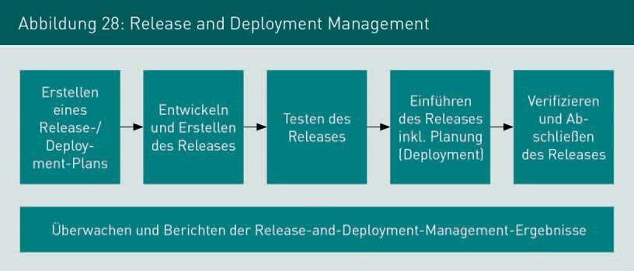

A Release and Deployment Plan is thus created to plan and communicate the development and implementation of a release. Several changes are typically bundled into one release. The planned release is then developed. Aside from the ongoing development and maintenance of IT components, all the documentation required for the development and operation must be created. The release is then tested when the development work is complete. Apart from checking the release’s functionality, it is tested whether the rollback procedure intended for the release can be performed successfully. If the test is successful, detailed planning and the implementation of the release follow in the form of the deployment. As well as the changes to the software and hardware, all accompanying IT service management activities are performed for this. These include the update of the CMDB and, if required, of the service catalogue, the performance of the change management processes and monitoring activities, as well as the revision of contracts for the provision of IT services, if needed.