Dear Hiring Manager,  I'm a Mandarin Chinese and English interpreter/translator  based in the SF bay area, and I would like to offer my services  to your prestigious agency. I have 17 years of experience  working as a interpreter and translator on numerous projects, many of them business and legally related such as conferences, trade shows, depositions, asylum interviews, sight translations, and investigative work for law firms and litigation services.  My specializations include general business, finance, web app/game, legal, IT, Telecom, software, hardware, arts,  humanity, health care and Chinese herbal medicine.  Please see the attached resume for details. Thank you very much for your time.  Sincerely,  Ginger Wang, M.A.  NCTA certified, ATA member 260301, OHT certified Gold  Mandarin Chinese/English Interpreter/ Translator/ Localization/Certified Mandarin teacher/Web  http://www.atanet.org/onlinedirectories/tsd_view.php?id=16843  www.gingerwang.com |  | 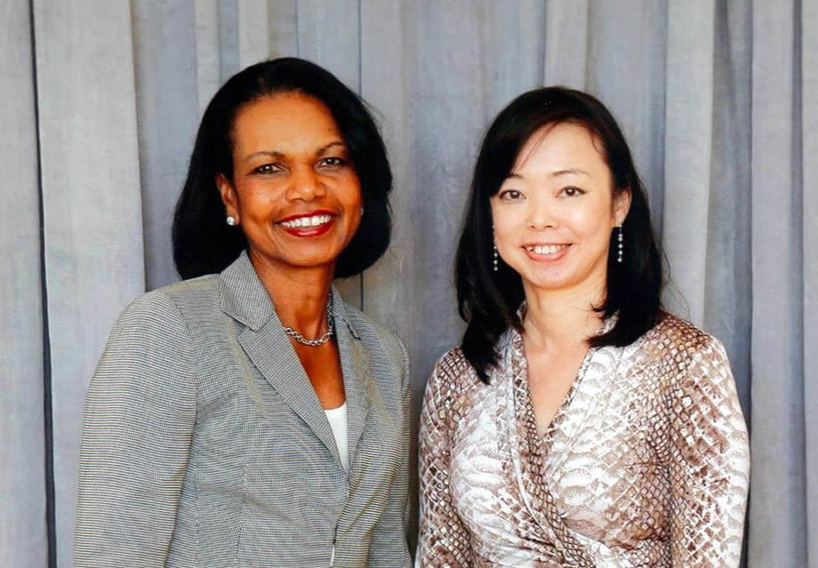  Dr. Condoleza Rice, former  US Secretary of State.  T3 Semiconductor Summit 2015  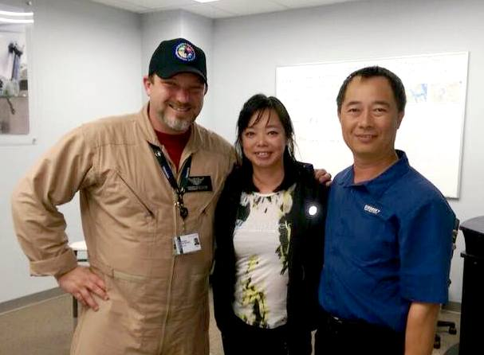  UH60MIC helicopter (Black hawk) training, US Army and Sikorsky for Taiwan NARSC
References:

USCG – US Coast Guard North Pacific  Lieutenant Aaron Dorrian,  USCG Linguist Jimmy Zhang  408 839 3353 | Sarah Stahnke  sstahnke@durietangri.com  Durie Tangri LLP  217 Leidesdorff Street  San Francisco, CA 94111 (415) 362-6666
Janice Souza  JSouza@kslaw.com  King and Spaldings Law  601 South California Avenue  Palo Alto, CA 94304-1050 | HG Litigation Services  1 Embarcadero Center #500  San Francisco, California 94111  Phone: 415.404.7333
Taylor Long | Communications Counsel  McClenahan Bruer  taylor@mcbru.com | 503.546.1007 | Heather Neuman  ALS Global  heather@alsglobal.net  (310) 829-0741
NOW INTERPRETERS, INC.  Lori Sequeira  408.708.7061  San Jose, CA  LS@NOWINTERPRETERS.COM | Jennifer Serna  jennifer@atlasinterpreters.com  Atlas Interpreters, Inc.  3150 Almaden Expwy., Suite 241  San Jose, CA 95118  Tel: 800-835-0339
Dr. Ramesh Patil  CTO, Digite, Inc  408 418 3834  rpatil@digite.com | Eryc Branham  GM, RocketSpace SF  415 613 8570  eb@roket-space.com

Location: SF Bay Area, CA
415 260 2954

Ginger Wang
American Translators Association member profile
www.atanet.org/onlinedirectories/tsd_view.php?id=16843

Certificates:
- American Translators Association member 260301
- NCTA (Northern California Translators Association)
- OPI, Weyi certified phone interpreter
- HIPPA certified Health Interpreter
- EDI and TCSOL certified Mandarin Teacher
· EDI (Education Development International www.ediplc.com)
· TCSOL (Teachers of Chinese to Speakers of Other Languages www.tcsol.us).

Education

M.A. in Speech Communication, University of Georgia

Specializing:
- Chinese-English two-way translation/interpretation/QA/Localization/proofread/voice over
- Commercial writing: sales/marketing/event planning/press materials/tech manuals.
- Internationally certified Mandarin Chinese Teacher.
- Web project and graphic interface.

Major Projects in 2016 and 2015:
Bi-way Chinese and English Interpretation and translation
- Apple. Tech meeting with vendors. Cupertino, August, 2016
- Transperfect. Transcreator for Alibaba since July 2016.
- Mediation at ADR Services. San Fransico, July 2016
- Court hearing. Jiang & Jiang Law. San Jose. July 2016
- accenture Lab. Workshop on Virtual reality, robots, machine learning, and AI. San Jose. June 2016.
- T30 Semiconductor Summit, McKinsey & Company. June 2016. Keynote speakers: Jeff Forbes, General Keith Alexander.
- Lenovo Tech World. Topics： Virtual reality, robots, machine learning. CCTV press conferences. SF, CA. June 2016.
- C. Wesley Christensen, M.S. LMFT. Custody evaluation related supervised visits
- San Mateo County. San Mateo General Hospital. Mental Health Awareness Conference. May 2016
- Guidewire. on-site Localization QA Linguist for software update. Guidewire is a software company specialized in personal and property insurance apps. Foster city, CA. April 2016.
- KŐLI. Proposal for grand for Chinese government. Translation, interpretation, and cultural consulting. Project: Device for non-surgical cure for Gall bladder stones. March 2016.
- Netflix Global Launch press event & Daredevil Season 2 premier. Los Gatos, CA. March 2016.
- Tenant right meetings. The Law Foundation, San Jose, CA. December 2015-Janurary 2016
- US Army contract. Sikorsky and National Airborne Service Corp of Taiwan. Aviation pilots and mechanics training. FL Sep – Dec 2015
- accenture Lab, San Jose, 09/2015 Conference with Chinese utilities companies
- Medical interpretation for SF bay area and nation wide language services (Transperfect, OPI, Avid)
- Clinical trials study, marcom writing/transediting. Chinese medicine. Tango Nutrition. SF
- Alston & Byrds, Palo Alto, CA. Land developers and tax experts meeting 09/2015
- Hewlett Packard Global Experts Meet up, 3-day conference in SF 08/2015
- Political Asylum interview for Jiang & Jiang 03, 08/2015
- T-30 Semiconductor Summit 2015, CA. Keynote speaker: Condoleezza Rice.
McKinsey & Company.
- Apple Education Affiliate Program. 06/2015
- World Economic Forum – Global Growth Companies and Technology Pioneer. 06/2015
- Police interviews audio to translation. 05/2015, Morena Family Law.
- Training Program, Singularity University, NASA Center. CA, 2015
- Related CA, Construction developers partnership meeting, 2015
- Two-day press conference at Juniper Network, Sunnyvale, CA, 2015
- Internal control documents for Apple Inc.
- Recaro Plant, supplier for TESLA, for Chinese import audit, Fremont, CA
- Postal worker compensation hearing, Federal Building, SF. Hearing Rep: D. Polonsky
- 2014 World 3D Printing North American Summit. SF.
- Business presentations at Google and Cisco. Delegates from Wuhan City, Hu-Bei Province
- Evidence collecting visits with investigator and forensic specialist, Cambell, CA. Durie Tangri LLP
- USCG (US Coast Guard) Conference，Burlingam, CA
- Dolby vs Arcsoft. Deposition at King and Spaldings, Palo Alto
- Digite Client meeting with Huawei, Santa Clara
- Bank of Orient Board meeting, SF
- Legal deposition. Subject: IP & copyright
Wilson Elser Moskowitz Edelman & Dicker LLP San Francisco, CA
- Product launch, Benefit Cosmetic Inc. Bently Reserve, SF,
ALS Global. Simultaneous interpretation.
- Completed over 2500 document translation projects with over 10 agencies, law firms, IT/software, and game developers in CA and nation wide.
LANGUAGES
Mandarin and English – translation and interpretation
Spanish and Mandarin - translation

ACADEMIC PAPERS

- China and Taiwan: Peace Talk as Cultural Rhetoric, Ginger Jouchung Wang. Master’s Degree thesis (unpublished), University of Georgia, Athens, GA 1996.

- Effects of Language and Race on Undergraduates’ Perceptions of International Instructors: Further Studies of Language and Attitude in Higher Education, Ginger Jouchung Wang, UGA Seminar in Intercultural Communication; presented at the AREA Convention, New York, April, 1996

