|  |  |
| --- | --- |
|  | **□ Confidentiel** |

**Titre:**

**The Impact of Messaging in Automotive Distribution**

**Programme :** SUP DE CO - 3A - Grenoble (2016 - 2019)

**Année :** 2018-2019

**EA - Session de programme :** Grand Mémoire PGE-Titre1 2018-2019

**Nom de l'étudiant :** Mathieu Mouton

**Nom du tuteur / évaluateur :** James Barisic

**Résumé informatif de la mission :**

**Mots-clés principaux décrivant la mission** [*(cf. Thesaurus du Management) :*](https://library.grenoble-em.com/Thesaurus/Thesaurus.html)

MARKETING OPERATIONNEL

PARC AUTOMOBILE

GESTION DE LA RELATION CLIENT

TRANSFERT DE TECHNOLOGIE



GRAND MEMOIRE

The Impact of Messaging in Automotive Distribution

Problem Statement: To what extent can conversational marketing benefit automotive distribution?

Mathieu MOUTON

Thesis Advisor: James BARISIC

Published: 05/09/2019

CLASSIFIED  : YES

DISCLAIMER

This dissertation has been prepared by the author as a student of Grenoble Ecole de Management for academic purposes only. The views expressed in this report are personal to the author and do not reflect the view of Grenoble Ecole de Management or any of its staff or personnel and do not bind the Institution in any manner. This report is the intellectual property of the author and may not be used in any manner whatsoever, in whole or in part without their express permission.

**ABSTRACT:**

**Purpose:**

The first aim of this study was to understand what conversational marketing fully entails. Traditional marketing has prevailed as a topic of conversation in higher education. However, traditional marketing has today been put aside in favor of digital marketing. A third form of marketing, called conversational marketing, is believed to exist. It is a response to the evolution of the market and the advent of the messaging era.

The purpose of this thesis was therefore to analyze conversational marketing itself, in both an abstract and theoretical way, so as to understand its characteristics, challenges, and current impact.

As creator of a company in conversational marketing specialized in automobile distribution, this particular market revealed to be one of particular interest for the subject of this thesis.

This study will provide an overview of the best methods in which one can use conversational marketing and how these can be applied to the automotive industry today. The overall aim is to allow digital managers as well as car brand executives to have a clearer vision of future marketing decisions.

**Approach / Methodology:**

The study began with an examination of the concepts of messaging and conversational marketing in the literature review. The authors, articles, and books that will be principally used in this thesis were identified. Automobile distribution in general as well as the different sales methods used in this field were also examined in this literature review.

In a second step, a quantitative study (to be followed later by several qualitative studies) was carried out. The objective was to collect a substantial amount of responses regarding how potential customers envision conversational marketing and how they use it on a daily basis. These figures were then examined, and a preliminary hypothesis was established as a result of insights from these studies.

Behind the purely academic aspect, this thesis aims to provide concrete elements on how to use conversational marketing to improve the image and increase the turnover of car dealerships.

**KEYWORDS:** **Marketing, Distribution, Advertising techniques, Automotive sector**

**Table of Contents**

I. INTRODUCTION 7

I - Context 8

II - Research Issues and Purpose 11

III - Research Problem 11

A - Research Question 1: Why should car dealerships use conversational marketing? 12

B - Research Question 2: What conversational marketing techniques should or should not be used ? 12

C - Research Question 3: How to make conversational marketing the core of car dealers' digital strategy? 12

II. LITERATURE REVIEW 13

I - Introduction to Conversational Marketing 14

A - Characteristics, History, and Different Approaches 14

B - Direct Benefits and Limits 17

II - Conversational Marketing Techniques in the Automotive Industry 20

A - Online Chat Managed by Online Advisors (Genius) on Dealership Website 20

B - Online Chat Managed by Chatbots on Dealership Website 21

C - Other Forms of Conversational Modules 21

III - Conversational Marketing: The Next Challenge for the Automotive Industry 23

A - Conversational Marketing in the Automobile Industry: Challenges 24

III. METHODOLOGY 27

I - Methodology 28

A - Research Objectives 28

B - Qualitatives and Quantitatives Studies 29

II - Sampling 29

III - Design of the Data Collection Tool 30

IV - Data Collection Process 36

IV. RESULTS 37

I - Automotive Dealerships Remain “Old School” 38

A - Some Sales Opportunities not Seized 38

B - Mitigated Dealership Experiences 40

II - A Potential Solution: Conversational Marketing 41

A - Conversational Marketing: At the Beginning of the Customer Journey to Convince and Respond to Online Demand 41

B - Solution Remains of Little Repute, and Better with Humans 44

V. CONCLUSIONS 47

I - Managerial Recommendations 48

A - Why Use Conversational Marketing? 48

B - Which Techniques? 48

C - How? 50

D - Conversational Marketing Can Serve Many Purposes. 51

II - Limits of the Study 51

III - Future Research Approaches 52

VI. REFERENCES 54

# INTRODUCTION

## Context

3 billion. This is the number of active users of monthly messaging solutions worldwide, according to tourmag.com magazine. Of the top 10 most downloaded applications in the world, 5 are related to messaging. In fact, people use messaging applications more often than they use social networks. Analysis of surveys regarding upcoming marketing trends has determined that 29% of those polled consider consumer personalization to be a top priority; artificial intelligence came in second with 26%, and voice search came in third with 21%. 80% of the most successful businesses use chatbots to increase their leads. Estimations that 80% of companies will use chatbots by 2020 are therefore no surprise. Facebook Messenger alone had 1.2 active monthly users in 2018, and 1.3 in July 2019, beaten only by WhatsApp with 1.6 active users in July 2019.

These figures reveal that many companies use messaging as a tool, with several methods such as chatbot / real advisors (“Geniuses”) and artificial intelligence. The many resources and possibilities will, as a result, be analyzed in this thesis.

From traditional channels (e-mail, telephone), customer journeys are now almost entirely digital. Quite often, they start with a click, a swipe, or a message. From the furniture spotted on Instagram to the latest story of an influencer presenting a product, companies must have complete control over their customers' journey to ensure that they are not overtaken by it. This is especially evident in customer relationship management, for companies must be available at all times and able to deliver a personalized, continuous, and quality experience. Messaging reveals to be the answer to all these challenges.

Messaging can be used for many purposes. The main reason for its use is to improve customer service and therefore brand image. In fact, the use of telephone and email is decreasing in favor of social networks and messaging applications to address brands. Messaging is used throughout the purchasing process. 65% of Millennials (a word coined by sociologists to define the generation born between 1985 and 2000) prefer to use messaging rather than make a phone call; 67% polled said they will interact more with brands by message over the next two years, while 53% revealed they are more likely to buy from a company that uses messaging services.

According to Gartner, the phone will represent only 12% of customer service interactions by the year 2022. Major messaging applications such as Facebook Messenger or WhatsApp have clearly understood the extent of the phenomenon and the challenges ahead for companies. An offer must therefore be developed so that companies can exploit the potential of their applications used by customers. This can be drawn back to Jeff Lawson, CEO of Twilio, who said that "Businesses need to talk to their customers in the way that their customers want to talk to them, whether it's SMS, Messenger or something else."

WhatsApp Business Solution and Apple Business Chat were thus created in 2019, and in April 2016, Facebook launched its "bot platform" on its messenger application. Messenger for Business was launched in 2016 and is mainly intended for companies that own a community Facebook page. This allows them to chat with decision trees and communicate through API with Facebook’s messaging application, Messenger. Facebook ensured companies that they could answer questions regarding the price of a trip, a hotel, or a flight schedule, without the need for human interaction by instead employing a chatbot. This guaranteed maximum satisfaction and less investment. In 2016, USA Today announced that "Analysts are betting Facebook will find a way to make money if legions of businesses start using Messenger to chat with customers and sell goods and services."

Messaging is not just a myth; some companies already use it very well. The perfect example is La Redoute, which has been using Apple Business Chat since 2018 to manage customer orders. As a result, 60% of order flows are now treated via mobile. This example is particularly fascinating, for the company, which was aging and on the downward slope, was able to turn the situation around thanks to its digital strategy primarily based on messaging for customer relations.

Messaging became a major component of the company I co-created with my business partner as we capitalized on its future growth potential. Our choice of the automotive industry was determined due to its reputation of lagging behind others in the digital world yet possessing all the necessary elements to effectively and efficiently use messaging services.

Involved in the automotive world since a very young age, my partner discovered that a website selling vehicles did not have anyone to advise him online. He found that he needed to visit the dealership in person for any information about the vehicle. The idea of integrating an online chat on this website arose from this situation, and he consequently became the dealership's online advisor, or, in other words, its "virtual seller." The online chat was additionally open until 11pm, resulting in the "virtual dealership" being open for four hours after the "physical dealership" closed.

The results were unexpected, as dozens of messages per day arrived from prospects with a multitude of questions. These questions revealed to go beyond those about the product (such as dimensions, vehicle prices, fuel consumption etc.) and encompassed the dealership itself (such as opening hours). The report was irrefutable: visitors did not only have a plethora of questions, but they were additionally delighted to be able to exchange with a real advisor and outside normal office hours! At the time, the main objective was to inform and identify prospects via this new communication channel before sending them directly to the dealers.

Our company in conversational marketing was launched in the few days following this experiment. Our challenge was to turn IPs into identities, and identities into sales. This approach is promising for the automotive industry, whose sales techniques have proven obsolete amidst a constantly evolving market and product line as well as declining traditional marketing methods.

The customer journey is at the core of everything in automotive distribution. The customer no longer buys a car because it is better than any other, but rather because they’ve had a better experience! Customers used to visit a dealership five times before buying a vehicle; today, they only visit 1.6 times before finding the one they want. A customer now looks to experience an adventure, a story, a relationship with the brand when searching for the vehicle of their dreams.

“Conversational marketing” is the term used by most to describe these techniques of communicating through digital channels. It consists of establishing a dialogue between the company and its customers or prospects. This should not be confused with relational marketing, which incorporates traditional channels; conversational marketing is used only in new discussion techniques on all digital channels, hereafter referred to as "messaging".

## Research Issues and Purpose

Most marketing managers in car dealerships are now adding "digital" to their titles. They have understood that their businesses and missions have evolved and now involve more digital-related missions than so-called "traditional" marketing. With this title, topics related to conversational marketing and the exploitation of their virtual communities are included in their scope.

This can be approached in many different ways. For example, should they use only known communities (social networks / database)? Should they use specific channels (website or social networks only)? Should they use conversational marketing to simply generate business (sales and after-sales), or should it also be used to develop customer relationships? Which solution is the most ROI-oriented and positively perceived: chatbots, online advisors, product experts (Geniuses)?

**To what extent can conversational marketing benefit automotive distribution?**

## Research Problem

In this thesis, we will discuss several theoretical elements to understand the concepts, issues, and benefits of conversational marketing for automotive distributors and why it is crucial to them. We will study the French market, which also bears a great similarity to the European market.

To conduct this research, questions have been established and answered by this study, and several hypotheses will be put forward and either confirmed or disproved.

### Research Question 1: Why should car dealerships use conversational marketing?

H1: Conversational marketing creates a link with the customer or prospect and is profitable for car dealerships on two key points: its sales revenue, and its reputation.

### Research Question 2: What conversational marketing techniques should or should not be used?

H2: We can identify four techniques on the market today: Geniuses, chatbots, artificial intelligence, and community assistance. These four resources can potentially be used in multiple processes.

### Research Question 3: How to make conversational marketing the core of car dealers' digital strategy?

H3: Even if we can define an optimal conversational marketing strategy, each car distributor must build its own based on its strategy, its products (and brand in general), and its customers.

# LITERATURE REVIEW

## Introduction to Conversational Marketing

This research was primarily founded on existing books as well as on the experiences of automotive actors and white papers due to the early age of the concept. The goal was to acquire a thorough and comprehensive amount of information on conversational marketing topics in the automotive distribution world.

In this literature review, we will first focus on the area of the concept, with a historical review on messaging and conversational marketing that results from it. The concept itself as well as its features, advantages, and direct limits will be examined in this review.

We will subsequently review existing documents and studies on the different conversational marketing techniques that exist and have been proven or disproven effective for automotive distributors. We will then demonstrate with concrete examples how conversational marketing will to be the challenge for tomorrow's automotive distributors.

This literature review highlighted all the techniques and information that existed on the very concept of conversational marketing in order to provide the reader with a global vision while identifying the remaining questions to be clarified in this paper.

### Characteristics, History, and Different Approaches

Conversational marketing is a still emerging concept and can as a result be poorly or inappropriately used. In fact, conversational marketing is so often used that Joe Lazauskas, in a 2015 article for contently.com, predicted that it would become one of the next buzzwords—a popular word or phrase in business circles—of the upcoming years. "Get ready to hear the term ‘marketing conversation’ from the 19-year-old who's going to take over your social media department in Q2.”

Before its 2015 buzzword predictions, it seems that this term appeared in Joseph Jaffe's book *Join the Conversation* which was published in 2007. Jaffe explained to his clients, tired of inbound and outbound marketing techniques, how to re-engage their customers or prospects through dialogue.

In fact, to go back further, the concept of conversational marketing is over a thousand years old. This is why local bakers and butchers still exist: as conversations are initiated and developed in the shop, relationships are fostered, and merchants exchange with customers, going beyond their task of product advisor to listen to and support their customers’ lives and daily worries. This thesis will demonstrate how this process of creating connections between baker and customer are similar to that of the advisor who converses on the Internet with their prospect.

Dharmesh Shah explains: “Conversational marketing isn’t new, we’ve been having conversations with customers for decades, the reason for the renewed interest in conversational marketing is because of advances in technology.” To put it another way, the rise of digital has shaped how we view exchange.

However, despite the obvious existence of human links in physical sales locations, the emergence of the term “conversational marketing” only appeared in the 2000s. Why? This is because it is associated with messaging and the age of online messaging applications. Conversational marketing, as a result, has only been possible, thanks to the rise of digital technology. Conversational marketing is the fastest way to move buyers through marketing and sales funnels through the power of real-time conversations. It builds relationships and creates authentic experiences with customers and buyers. (Drift company).

An interesting definition of conversational marketing comes from Ian Lurie: “Conversation Marketing ensures that you know your audience, target them with an appropriate message, and then observe their response and adjust that message accordingly. It can do this because of the two-way nature of the Internet." This can be found in his book *Conversation Marketing: Internet Marketing Strategies,* which was published in. 2007.

Ian Laurie goes on to explain that conversational marketing has emerged to counterbalance marketing techniques that make very broad targeting operations with the objective of having a small percentage buy a product. The aim is to have a “person that listens” rather than an abundance of emails with discounts to encourage consumption. In other words, rather than using the "Come and buy with this coupon!” one uses the technique of "My name’s Marc, how can I help you?".

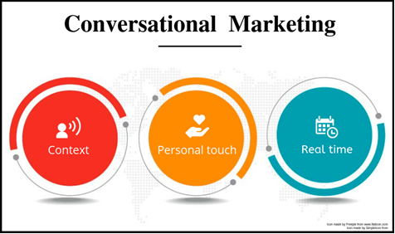

The company iAdvize, which has made conversational marketing its business, was created in 2010, three years after the term and its subsequent studies first appeared. Leader in the field in France, it provides this simple definition on its website:   
 “Conversational marketing makes the conversation between the brand and its customer the core of the online shopping experience. [...] conversational commerce includes more broadly all conversations that participate in the engagement and conversion of a consumer: a chat discussion on the website or mobile, an exchange on Twitter, Facebook or Instagram with the sharing of a link, an offer or the sending of a buy button, etc.”

Conversational marketing is considered by some to only encompass human interactions. However, conversations can also be held with a robot; this is what one calls a chatbot. According to an IPSOS study, conversational marketing is more effective when it is linked to humans.

The idea behind this comes from the argument that conversational marketing only works if it creates a relational link, and that this link cannot be established with robots (ie: chatbot). However, the question arises: what if customers were directly emotionally connected with the brands? (Fournier, 1988). Human bonds create affection and, as a result, develop love for a particular brand. Humans are therefore required to forge bonds between the prospect and the brand and consequently build loyalty. (Albert & Valette-Florence, 2010).

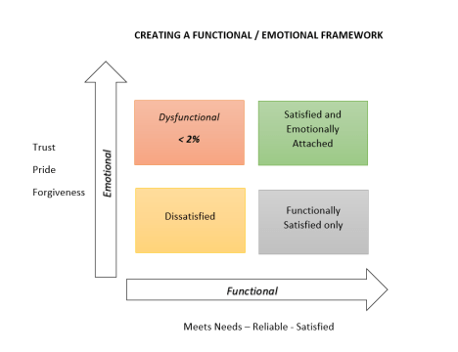

*(a graph made by Ipsos, explaining how conversational marketing works better once an emotional link is established)*

On the other hand, other approaches exist that are more familiar with the use of chatbots in conversational marketing. A conversation that is not necessarily held with a human can nevertheless create connections and is additionally able to generate leads 24 hours a day, 7 days a week, 365 days a year (Cancel & Gerhardt, 2019). Conversational marketing can thus be performed through three approaches: initiate conversation, find the right words, and automate (via a chatbot). This is a different approach than that which takes place entirely between humans but is just as effective, given that these three conditions are met (Wastell, 2018).

### Directs Benefits and Limits

Conversational marketing reveals to be one of the new flagship approaches to tomorrow's marketing, as the aspect of direct exchange plays a major role today. The following is a study of the advantages and direct limitations of conversational marketing established as a result of available research documentation.

Messaging and conversational marketing is used to deliver an optimal customer experience (especially in customer service), to generate business (through lead generation), to build loyalty, or to obtain feedback on products and services. Conversational marketing is also accessible twenty-four hours per day and, as a result, is a quick and efficient response to any problem.

#### Optimal Customer Experience

Conversational marketing is where the company's added value and its major differentiating element conjoin for the customer. Investing in a fully digital customer relationship is an indisputable method to optimize a company's overall strategy. First, it provides companies with detailed knowledge of customer desires and behavior as a result of direct data from the conversations the company held with its customers (such as frequently asked questions, accounts, feedback, and tension points). Furthermore, the company guarantees customers are provided with relevant answers to their questions and irreproachable customer service by cross-referencing conversation data and its studies. A virtuous circle is the end result, for the company analyses customer feedback and from that adapts its discourse and products, which ultimately benefits the customer again.   
 This is all possible thanks to a company’s ability to gather data from these messages. As Alicia Collins of Hubspot declared, “Your conversational marketing audience is much more insightful than your other channels. They'll tell you in their own words how they want to interact with your business. There's no inferring or guessing, like with web traffic.” (Collins, 2018). Messaging allows for a permanent link between the brand and its customers to be created, which allows natural conversations and “opportunities to cross-sell, encourage sharing, solicit input, and flow seamlessly between commerce and support.” (Harvard Business Review,2016).

#### Generating Business (Leads)

According to an article released by Medium in 2018, conversational marketing is used on Messenger, WhatsApp, and directly on websites. Its three key objectives are to capture, qualify, and connect. By integrating conversational modules on pages or social networks with the most traffic or a large community, the rate of engagement with prospect or customer is much higher. Exchanging with and qualifying the customer will facilitate connections between them and the sales force. Lead is thus generated using conversational modules in a condensed way

However, this goes beyond just generating leads. In fact, customers are highly qualified because the questions asked are pertinent to the prospect’s request. By adding human contact to the process, the customer or prospect is not only informed, but also guided and listened to. The latest study on lead generation in B2B identified the lack of lead quality as the second most important challenge, so it is important to best understand the advantages of producing qualified lead. (bopdesign.com study).

#### Fast Accessibility, 24/7

One of the many advantages of conversational marketing comes from the fact that it is accessible at any time of the day and thus meets the needs of visitors in the famous ZMOT (as highlighted by Google in 2011). Google's Zero Moment Of Truth is the moment when a consumer compares and looks for alternatives to a specific product before making the decision to buy it. A first successful contact with clear answers to questions will help a prospect become a customer. However, the importance of speed should not go overlooked. In fact, this is predicted to be the next major challenge in customer relations in 2020. (Pegasystems, 2018). For example, 28% of French people consider waiting time to be the most important element of the customer experience.

#### Limits

The limitations do not relate to the very concept of conversational marketing and its characteristics, but rather to its possible techniques, such as chatbot in particular, which may be unconvincing. When well-developed, a chatbot is a wonderful tool to handle repetitive requests that are easy to detect algorithmically. Today, it fails to meet expectations. According to Reforge, chatbots have a hard time convincing customers because they do not understand natural language. For example, it is impossible to be sarcastic or joke with a bot, and discussion reveals to be problematic if one has the misfortune of making a typing error. This problem is similar to artificial intelligence. And because chatbot is a form of artificial intelligence, users may often feel like they are exchanging with a low-quality search engine, with search results being one-dimensional answers entered in by the developer. In other words? It’s an automatic FAQ.

It should be kept in mind that most bots follow a decision tree, which necessarily limits the discussion. Moreover, Justin Lee, Head of Growth at Hubspot, a company specialized in chatbots, confirms that 70% of the more than 100,000 Messenger robots do not respond to even simple requests from users. This ultimately frustrates the customer who feels misunderstood or does not want to talk to an entity with limited artificial intelligence and unable to grasp certain complex concepts. The existing literature and documents demonstrate that conversational marketing has significant advantages. But how can its use be further developed? Are the mentioned techniques suitable with all digital strategies? Can chatbots be used in any sector, especially in the automotive industry? Must they be available 24 hours a day? How can a chatbot be used at a lower cost? These questions will be addressed and answered in this thesis.

## Conversational Marketing Techniques in the Automotive Industry

### Online Chat Managed by Online Advisors (Geniuses) on Dealersip Website

Having direct and personal interaction with customers is a strong advantage for automotive distributors. At each stage of the purchasing process, conversational marketing allows operators to capture, reassure, and convince the casual visitor so that they become a buyer and later on an ambassador.

The most relevant example for achieving this direct and personalized interaction is the conversational module more commonly referred to as the “live chat” that can be found on websites. By choosing to integrate such a module, brands are responding to a request from customers who prefer to be received and guided through direct interaction.

As Forrester Research reveals in its February 2016 study, consumers are tired of the vectors of traditional customer relations. For a customer to feel that they are valued, the company must make the first step. For a digital market, where the competitor is only one click away, each company must invest in attracting and retaining the visitor who comes into contact with it. Companies must be able to answer every visitor question, be reassuring, and, above all, make each visitor feel unique. Conversational modules with geniuses allow dealerships to conduct a fully personalized discussion that’s adapted to each profile. They are a discreet and non-intrusive marketing and customer relationship solution. Two major advantages can be identified for these tools. The first is personalization of the discussion, as the customer receives unique answers to their questions. Furthermore, visitors are an authentic and great source of information for companies. By collecting customer issues daily, companies will more effectively meet their needs.

### Online Chat Managed by Chatbots on Dealership Website

Chatbots could be used in the automotive industry for three major purposes (Matthews, 2019):

1. To respond to the demands of customers searching for vehicles in an original way.

2. To provide customers the option of purchasing the vehicle online. Valassis Digital, an agency in Michigan, develops a system to match the perfect vehicle according to customer demand and directly offers an appointment.

3. To develop the post-purchase relationship. When a customer needs to have their vehicle repaired or maintained, they often call the dealership. Current dealers are overwhelmed with and unable to answer incoming calls. Most fail to even respond to after-sales requests! "We think the bot can provide a full-concierge service by automating scheduling, diagnosing and deciphering what's wrong and connecting the consumer with the right dealer.” (Kurtzig, 2018).

### Other Forms of Conversational Modules

In the automotive industry, most references to conversational marketing encompass the bots or geniuses that animate websites in order to generate leads and obtain feedback. However, conversational marketing can take many forms in the automotive industry. Jérémy Auribot, Digital Marketing Director for an automotive group that has been studied via a qualitative interview in this thesis, explains in an article published in May 2019 his way of using messaging to generate after-sales appointments in his dealership. It is possible for him to link a specific digital community management strategy with messaging to receive qualified appointments.

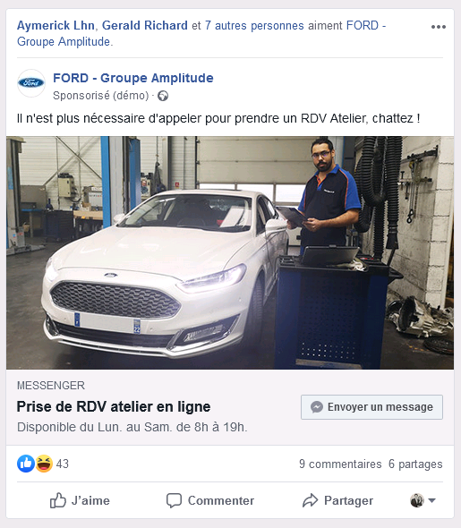

Jeremy goes on to explain that it began with his theory that customers shared his propensity for social networks. He in turn published a Facebook post with a call to action offering customers the option of scheduling an appointment via Messenger. A robot was put in place to determine the customer's need via a funnel technique and redirected each one to a human who subsequently offered an online appointment.

Other topics related to conversational marketing exist. One example in particular is showcasing a vehicle by videoconference. Another is the requalification of leads that were previously accomplished by telephone and relaunched through messaging. Re-Mind PHD agency, which oversees Porsche's communication, used this idea to ensure more qualified leads. This will be developed later in the qualified interviews further on in the thesis. In this study, a community management operation was linked to a conversational marketing operation and used the power of social networks and conversational marketing techniques to achieve effective results. This is different from other conversational marketing techniques, human or bot, which constituted the marketing operation itself.

It is evident that many conversational marketing techniques exist. We’ve identified the existing techniques on the market, from animated chats on websites to that of car dealerships’ social networks. We’ve also acknowledged innovative techniques which have linked conversational marketing to a company’s digital strategy. However, some questions remain. What are the best conversational marketing techniques to use in the automotive world? Does human interaction prevail? Can the chatbot be used? Is it wise to use both? Is conversational marketing in the automotive industry limited to online chat?

It would appear from current sources and literature that the use of conversational marketing in the automotive industry is at present quite limited, but the power of such processes seems boundless. Will be possible to one day sell vehicles online? Will companies be able to re-engage customers directly on social networks? These leads will be analyzed further on in this thesis.

## Conversational Marketing: The Next Challenge for the Automotive Industry

In the automotive industry, 86% of new car buyers use digital tools to search for information during their purchase journey. This figure climbs to 89% for used car buyers.

According to Datafirst, the car purchase process takes an average of 24 weeks, including 21 weeks for information research alone. The fact that leads spend such a significant amount of time doing research online indicates that this research is crucial. With that in mind, the question is: what are the future challenges for the actors of the automotive industry?

21 weeks of information research with no human support. This statistic is confirmed by an article written by Lisa Gevelber, Vice President of Global Marketing at Google, who explains that during this research, the customer goes through 900 digital interactions, including 186 on manufacturers' websites. On average, this person will visit fourteen different manufacturing websites to eventually select only two to vehicles to view. This allows one to better understand the importance for manufacturers to provide human contact via their digital tools. An IPSOS survey has also revealed that the use of digital channels remains modest, with 62% of contacts going directly through the dealership, compared to just 15% on the automotive website.

### Conversational Marketing in the Automobile Industry: Challenges

Automotive groups have all agreed that a digital revolution is underway. They’ve additionally acknowledged that they must act accordingly to avoid being overwhelmed by this digital revolution. Those who do not adapt will disappear, as current-day market acquisition by larger and digital-friendly groups has become quite evident. It is not yet too late for traditional companies to turn digital into an opportunity and an ally, rather than find themselves subjected to it. (Landré, 2019).

One major challenge of digitization is contacting the customer during their research phase. The customer takes less and less initiative to go directly to the dealership. It is therefore necessary to contact them beforehand and invite them visit the dealership. It is during the research phase, which can occur at any time, particularly outside the dealerships opening hours, that the opportunity to create a contact should be seized. However, two situations must be responded to in first order. The company must meet the customer’s new needs and solicit a visit into the dealership. To ensure customer loyalty, visitor satisfaction is essential. First contact is vital, as this is it what will determine the return of a customer for subsequent vehicle purchases. A study lead by PH Media Group in 2016 revealed that 95% percent of customers won’t buy from a company in which they had a bad first contact.

Visitors must be able to obtain all the information they need quickly, and a website is often the first image a customer encounters during their purchase process. Capgemini's 14th annual report has indicated that 74% of respondents polled state that they would not visit a dealership if they were not satisfied with the showcase site. Also, the speed of a response is a variable not to be overlooked, according to another Capgemini report: 49% of respondents would expect a response within 4 hours after a contact request; this rises to 95% for a response within 24 hours.

Today's customer is looking for all the advantages of direct contact (personalized information, option of viewing the vehicle, negotiation), coupled with those offered by the Internet (remote shopping, ease of search in total autonomously, instant response). Dealerships must therefore use their websites as a point of contact with the potential customer in order to set up a future meeting with a sales representative. Another Ipsos study showed that 60% of French people would not buy on the Internet because they still look for a sales contact. On the other hand, 62% already have a specific model in mind before going to the dealership. A dealership and its website are therefore complementary, for the website captures leads and the sale is eventually concluded in the dealership with a sales representative.

It is not just the sector itself that is changing, but also the professions within the dealerships themselves. The sales profession in the automotive industry has evolved. In fact, because the number of visits to dealerships is decreasing, dealers are now increasingly using lead-generation tools. Dealerships are additionally confronted with the challenge of processing leads quickly, with recall time being a key factor in lead transformation rates. For the visitor to make the step of coming to the dealership, they must be satisfied with their online experience. It has already been established that the automotive sector remains one in which human contact continues to be very important for the customer.

Customer relations, often neglected, are a major challenge in the automotive industry. According to Benoît Landré, many prospects are never called back following an inquiry and many others do not receive sales proposals. In fact, only a small portion of prospects are even registered in the database. It has been determined that only 35% of leads receive a call from the dealership. (Landré, 2016).

The Internet has made prospects increasingly unstable and requires dealerships to therefore offer an exclusive experience in face of the competition. Dealerships must also heavily rely on virtual showrooms to compensate for the physical and capture the huge flow of potential Internet leads. Given that these new digital prospects already possess most of the information they might want, a salesperson’s mission is thus refocused on the sale and transformation of the leads they receive.

The remaining questions are nevertheless pertinent: How is conversational marketing made the focus of one’s digital strategy? How can one bring in quality traffic and turn it into leads? What must be done to ensure sales personnel adapts to the upcoming changes in the sector?

# METHODOLOGY

## Methodology

### Research Objectives

As previously explained in the literature review and introduction, there are three major questions to answer.

Interesting insight into the very concept and emergence of conversational marketing as a result of digital and messaging applications were established as a result of in-depth literature review analysis. Conversational marketing techniques that may be used such as online advisors (geniuses), chatbots, and videoconferencing were also determined as a result of literature review analysis. The literature review subsequently revealed that car dealerships are significantly behind in terms of adopting digital tools and the first to embrace the digital shift are rewarded. Finally, the issues of delay in handling customer leads and inappropriate sales methods are addressed.

A qualitative analysis of market actors (dealership managers, sales representatives, car brand marketing managers) will determine how they feel about these changes as well as conversational marketing. Customers will additionally be interviewed about car distributors and how these actors could improve through conversational marketing.

In other words, these studies will respond to the three major questions presented in this thesis. The aim is determine why car dealers should use conversational marketing, which techniques they should adopt, and how conversational marketing can be made the core of their strategy.

### Qualitative and Quantitative Studies

Two types of studies were adopted to collect research for this thesis: one qualitative, one quantitative. The idea is to first understand, through qualitative studies, conversational marketing in its entirety in order to understand its characteristics as well as its challenges. Interviews with conversational marketing agency directors and conversational marketing experts unrelated to the automotive industry have been arranged in order to validate the concepts already established in the literature review.

Actors in the automotive industry will subsequently be interviewed so as to understand the issues they are currently facing. Questions will be posed about the relationship between conversational marketing and digital marketing in car dealerships and how this may be used to improve services. Actors who already use these techniques will also be interviewed in order to determine impressions and results.

Once the subject has been defined by experts and the first interesting insights have been found, quantitative studies can provide leads for digital players in the automotive world. This study will focus on customers' general perceptions of car dealerships and determine customer opinion of conversational marketing. This will help us establish whether customers think conversational marketing can help build brand confidence and facilitate tasks such as making appointments online or buying a vehicle without going to a dealership.

## Sampling

The study sample consisted only of those who owned a car, making the process quite difficult. Sixty-five responses were received which reveals to be a limited but reasonable number. For the benefit of the thesis, efforts are currently underway to receive twice as many responses in the upcoming month. It has already provided some interesting insights. Most of the respondents are male between the ages of eighteen and thirty-five. Efforts to poll an older population to receive more consistent results are also currently underway.

Meetings in September have been set up with digital managers in dealerships, CEOs of car dealerships, and digital marketing experts to ensure a well-rounded qualitative study is achieved. Appointments with car salespeople have also been arranged in order to get a more field-based view. Finally, to establish a field vision of online advisors, appointments with online advisors who are experts in the automotive industry have been set up.

The qualitative and quantitative studies will be included in this thesis to enhance its analytical rigor.

## Design of the Data Collection Tool

The first three questions were initially posed to establish a profile of the person polled. These questions asked about age, gender, and one’s professional domain. It was important to know these criteria to determine whether perceptions regarding connections with the automotive industry were dependent on a particular age, gender, or socio-professional category.

1st Question: What is your age group:

* Between 18 and 25 years old
* Between 26 and 35 years old
* Between 36 and 45 years old
* Between 46 and 55 years old
* Between 56 and 64 years old
* More than 65 years old

2nd Question: What is your gender:

* Male
* Female

3rd Question: What is your socio-professional category:

* Farmers
* Craftsmen, sellers, and entrepreneurs
* Executives and intellectual professions
* Intermediate professions
* Employees
* Worker

The next question was used to directly filter out those who would not be able to provide relevant answers to this questionnaire and therefore resulted in not being used.

4th Question: Do you have, or have you ever had a vehicle?

* Yes
* No

The questionnaire then inquired about car dealerships and, in particular, about the reception received at dealerships following the ways in which the study subject came into contact with them. This provided some initial answers and gave insight on what is to be improved with car dealerships. It additionally provided feedback regarding the overall perception customers had of dealerships in general. Another indispensible inquiry went into whether the methods of first contact with dealerships had evolved during the past few years.

5th Question: Have you ever bought a vehicle from a professional car dealership?

* Yes
* No

6th Question: Do you service your vehicle in either the car dealership where your vehicle was or its affiliate dealership nearest you?

* Yes
* No

7th Question: How would you generally evaluate car dealerships’ customer service according to your past experiences? (1 being the poorest customer service, 5 being the best customer service)

* 1 Very bad. The dealerships and salespeople are cold, and the advisors are only trying to sell you the most expensive vehicle without worrying about your real needs. There is no follow-up after the purchase, and you leave with a bad image of the dealership.
* 2 Fairly bad. The reception is rather mediocre, and the advisors are cold. You get the feeling that you are not welcome in a dealership.
* 3 Medium. The greeting is normal but without real attention. The advisor will answer your questions but will not go beyond if unable find the vehicle that matches your needs.
* 4 Good. The welcome is relatively warm. The advisor is really looking to help you so that you can leave with the vehicle that suits you the most.
* 5 Very good. You had exceptional reception. The salesperson seems honest and almost friendly. You feel like you have made the right choice and you'll come back for your next vehicle as well as maintenance repairs without any problem.

8th question: Do you need to visit a dealership to get an idea of the vehicles before you make your choice?

* Yes
* No

9th question: How does the automobile sector communicate with you??

* Mail / Flyer
* Radio / Television
* Tele-prospecting
* Text Message
* E-mail
* Digital Marketing (sponsored link, banner, advertising on social networks)

The following questions then focused on conversational marketing. It was necessary to know the study subjects’ profiles and helped effectively study individual interactions with dealerships. Once these first results were obtained, the aim was to determine customer connections with conversational marketing.

Knowing whether the study subjects were familiar with the concept was important but not the aim, as they could use messaging every day without knowing its particular marketing term. Rather, the objective was to determine whether their daily use of messaging could match with the automotive industry for services such as a purchase, a lease, or maintenance.

10th Question: Do you know what conversional marketing is?

* Yes
* No

11th Question: Conversational marketing is a marketing technique close to relationship marketing which consists in establishing a continuous or occasional dialogue with customers and prospects. This dialogue makes it possible to work on the quality of the relationship and to get to know the customer better (in order to identify and collect data, for example).

Have you ever been approached by a conversational marketing technique (online chat, chatbot, social network exchange etc.)?

* Yes
* No

The following questions inquired whether the study subject had better results in terms of customer relations upon the use of these techniques. It was necessary to know if this method of approaching the client was more qualitative and less intrusive than the "barbaric" methods one currently finds. Finally, the study subject was inquired if they were able to advance in the customer experience, such as buying a vehicle or making an appointment online, following a digital conversational approach.

12th Question: Did you have a good experience with the counselor or chatbot you talked to? (This question was held only if the previous question was responded to positively).

* Yes,
* Moderately, without any real interest
* No, no interest

13th Question: Would you say that an online chat on a website is more or less intrusive than a phone call?

* More intrusive
* Less intrusive

14th Question: Would you be able to purchase a vehicle online if you were guided by:

* A chatbot
* A real online advisor
* Both
* Neither of the two

15th Question: Which methods would you use to make an appointment for an after-sales service (oil change, repair, tire purchase) online?

* An online appointment booking form
* With a chatbot
* With an online advisor
* By going to the dealership or calling the dealership directly

16th Question: Do you think that having a human contact on your dealership's website or Facebook page to answer all your questions (via an online chat) could help you make your choice?

* Yes, absolutely. Having someone to guide me and answer me directly on the dealer's site would greatly help me in my decision.
* Maybe. In any case, advisor's answers will only be complementary and won't help me to make my choice.
* No. I don't need an online advisor; I can find all the information I need online.

Understanding what the study subjects evaluated as important criteria before buying a vehicle was additionally valuable. It was, for example, especially vital to see if reception and follow-up by the sales consultant (customer service) was as important as the price or the product. It was crucial to demonstrate with this question that the price or product itself was just as important today in a decision as the help and support during the research phase.

17th Question: Rank from 1 to 10, in order of importance (10 being a criterion to which you attach great importance) the criteria that are decisive for you when purchasing a vehicle from an automobile distributor.

* The price of the vehicle
* The product (motor, color, range, etc.)
* The reception and follow-up by the salesperson
* The brand

In order to obtain interesting insight from the public that would contribute to the thesis, it was necessary to know if the chatbot was considered equivalent in terms of quality to an online advisor.

18th Question: Would you prefer to be guided by a chatbot or a real advisor when you have questions about a vehicle?

* A real advisor
* A chatbot

The logical conclusion was to inquire about whether the traditional purchase method (i.e. exchange with a sales representative in a dealership) was sufficient or if every visit of a dealership was preceded by online research. This question would determine whether one could place advisors upstream of the purchasing tunnel.

19th Question: Could you skip your research before visiting dealership?

* Yes, I visit multiple dealerships to find my vehicle
* No, I do research on the Internet or through magazines before going to the dealership.

## Data Collection Process

This survey was conducted on the Qualtrics platform with access provided by the school. This was then shared via social networks (Facebook, LinkedIn) as well as numerous forums and specialized groups to receive additional responses.

Posting this questionnaire on specialized groups for car enthusiasts could slightly skew the responses. Current efforts are underway to poll individuals with little ties to the automobile industry for the remainder of this thesis. The French population was the subject of this research as the study is based on the French market. It was conducted in September 2019 but will be extended into October in order to receive more responses and obtain more relevant insight.

# RESULTS

The first results of the quantitative survey are quite logical, given the websites on which the questionnaire was published and the targeted audience. 90% of those polled are under 35 years old, and 90% are male.

However, the socio-professional categories are quite diversified; this is useful for the study as different approaches may exist according to the various professions. This consequently brings to light some very interesting insights. First, it clearly shows that distributors are lagging, particularly in terms of customer service and customer approach. It furthermore reveals conversational marketing to be an excellent technique, particularly when prospects seek out information at the beginning of their customer journey.

As a result, one can see how automotive dealerships remain “old school,” and how conversational marketing appears to be an excellent solution to bring dealerships business.

## Automotive Dealerships Remain “Old School”

In this chapter, three different graphics will demonstrate how dealerships still operate through traditional methods; from this, we will determine how they must undergo both a digital and showroom transformation.

Furthermore, we will examine the sizable loss of after-sales business opportunities that dealerships are confronted with and how much car research is accomplished well before the customer visits the dealership. As a result, we will determine the extent to which dealerships suffer from a poor reputation due the conveniences of the Internet.

### Some Sales Opportunities Not Seized

#### Aftersales Services are Suffering

This first graph evaluates the rate of loss of after-sales services. This determines that over half of respondents polled (62%) do not go to their nearest dealership for after-sales services or return to the dealership where their vehicle was purchased.

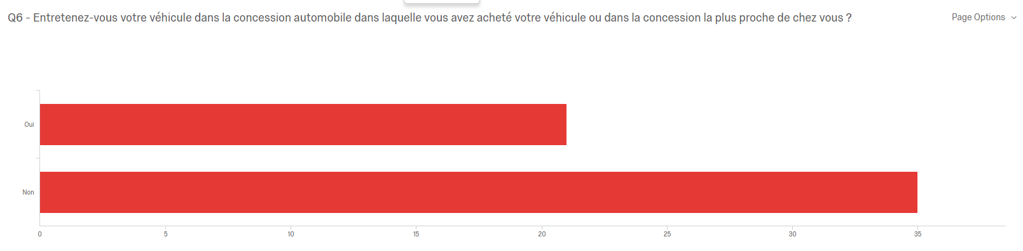

It has been estimated that after-sales service represents 30% of a dealership's turnover. As a result, it has been determined that customers follow-up requires a fair amount of improvement. This was previously touched upon in the literature review.

#### Customers Do Not Feel the Need to Directly Visit a Dealership

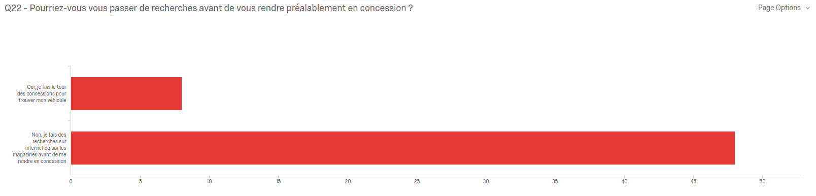

85% of respondents polled stated that they do research online or through magazines before visiting a dealership. This confirms that a substantial amount of work can be done beforehand. The best way for a dealer to ensure an in-house visit is to create a connection with their future customer during their research phase. Though a promising tool, conversational marketing remains in its very early stages in the automotive industry. Very few customers have had the opportunity to test it. As a result, they are left to their own resources.

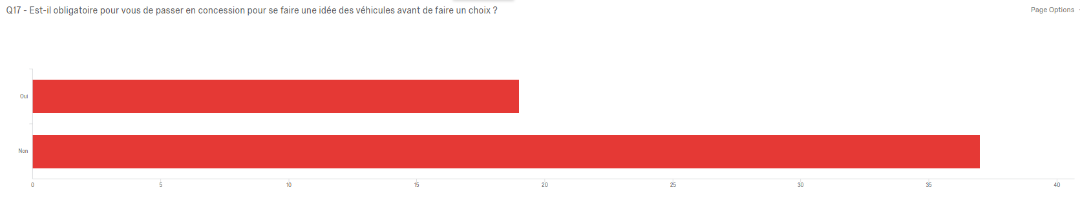

This graph reveals that over 65% of respondents determined that they do not need to see the vehicle in the showroom to make their choice. In the second part of this chapter, it will be revealed that the experience within car dealerships remains quite diverse.

### Mitigated Dealership Experiences

67% of respondents consider their dealership experiences either average or poor.

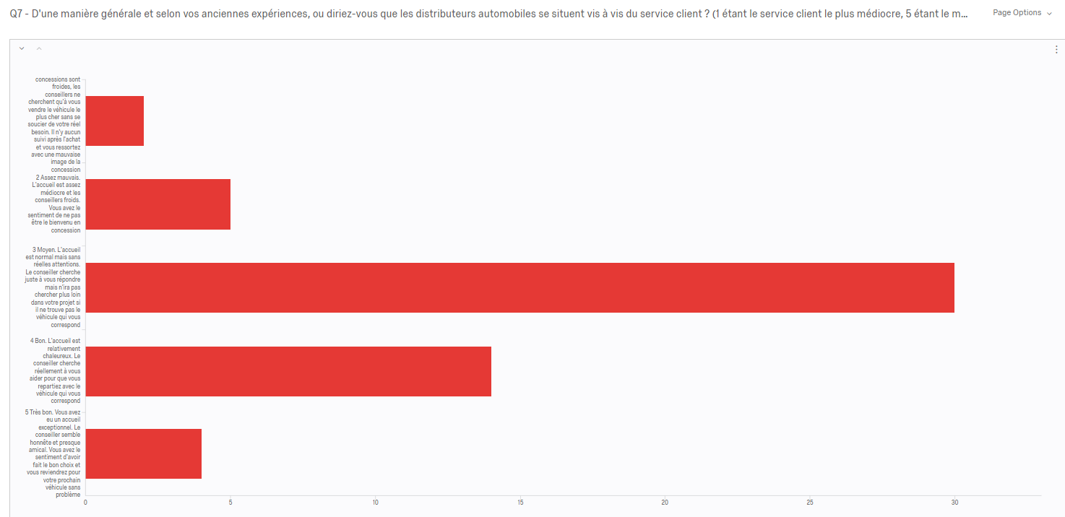

This confirms what was mentioned in the literature review. Leads have a rather poor image of dealerships and, as a result, visit them increasingly less often. This is due to the fact that they feel, above all, that salesmen are apathetic about their projects. 50% of those polled replied that reception is average but without real attention. It can therefore be concluded that the previous statistics regarding after-sales business would be on the rise with better customer reception.

The amount of visits that take place in a dealership is dropping at an exponential rate due to the fact that many potential clients find the reception to be cold and aloof. Sales representatives and car dealerships have not evolved in years: each customer is seen as a potential “target.” This graph confirms that this mentality must change.

As dealerships continue to operate through traditional methods, most people instead turn to the Internet to look for information and avoid having any aftersales service performed on their vehicle by the dealership itself. The second chapter will examine how conversational marketing remains little-known though it can be a real weapon to increase customer relations and bring more people to a dealership' showroom.

## A Potential Solution: Conversational Marketing

### Conversational Marketing: At the Beginning of the Customer Journey to Convince and Respond to Online Demand

#### A Practical and Nonintrusive Method to Respond to Online Demand

This graph illustrates that two-thirds of respondents are willing to make an appointment online via a conversational module or online form located on the website. One-third still prefers to visit the dealership or make a phone call directly.

It can therefore be determined that two thirds can make an after-sales appointment online without direct contact with the dealership. This graph paired with the previous one demonstrates that dealerships have great difficulties keeping their customers in their after-sales portfolios. It would have been interesting to have a similar study performed 10 years ago to demonstrate how much the tendency to schedule an appointment online is on the rise.

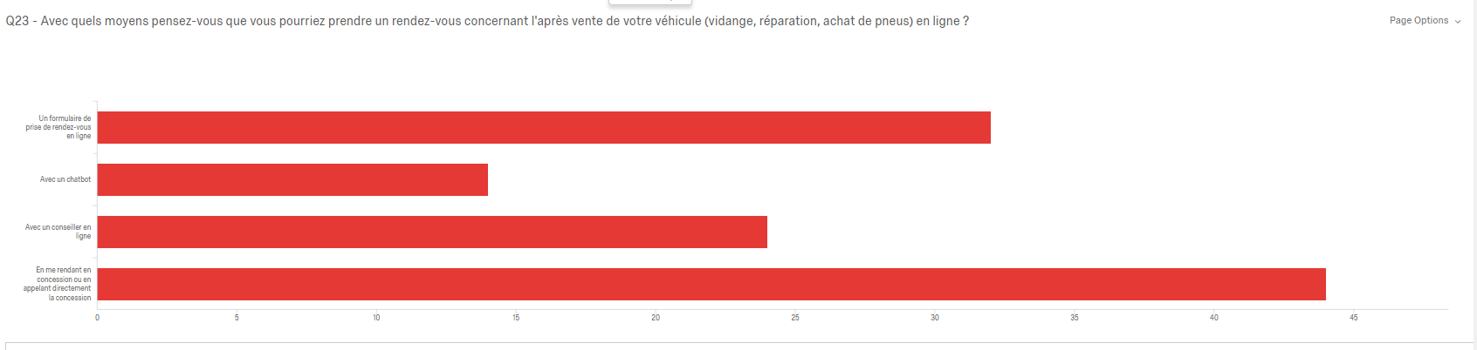

This second graph is directly connected to the previous one. According to 85% of respondents, a conversational module is less intrusive than a telephone call. This provides insight into the future of relationships with dealerships regarding first approaches. What if most appointments were taken using a conversational module? This question is significant, as conversational modules are placed far upstream of the purchasing process.

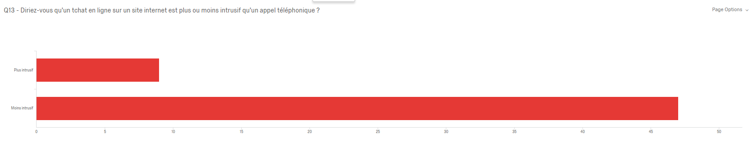

#### The Beginning of the Customer Journey

Only 14% of those polled knew which vehicle they wanted to buy in advance. This could be interpreted that 85% could still be convinced by a particular brand that their vehicles are the very best.

30% of people polled can theoretically be reached through conversational marketing techniques, given that 30% visit brand and car dealership websites to obtain information. This is quite significant, as this entails the first step a prospect undertakes before deciding upon their vehicle of choice. Engaging these prospects on these channels may be decisive. The majority of the remaining 55% search through magazines or are influenced by programs or forums. Having posted the survey on an automotive forum, it can be assumed that the responses are slightly biased.

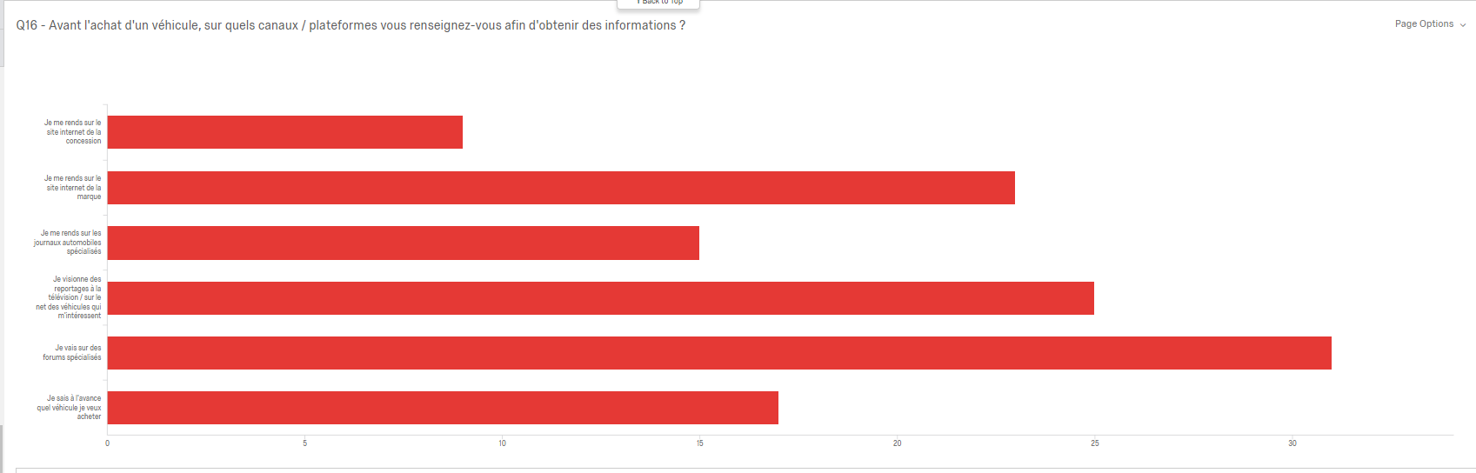

50% of respondents were reached through traditional marketing methods, such as television, paper mail, or telephone. The other 50% of respondents were reached through digital marketing techniques, such as e-mail and text messages.

It is therefore important to note that digital marketing is growing at a rapid rate, but traditional techniques are not necessarily obsolete. This study reveals that the actors of the automotive world are gradually beginning to understand the benefits of digital in promoting products; conversational marketing nevertheless remains weak method when taking responses from previous polls into account.

After taking these responses into consideration, the following question can therefore be asked: Is it possible to link traditional marketing techniques with conversational marketing techniques? The results indicate that appointments are made and information is collected online before customers visit a dealership. Traditional techniques can be used online with customers as they exchange with a live advisor.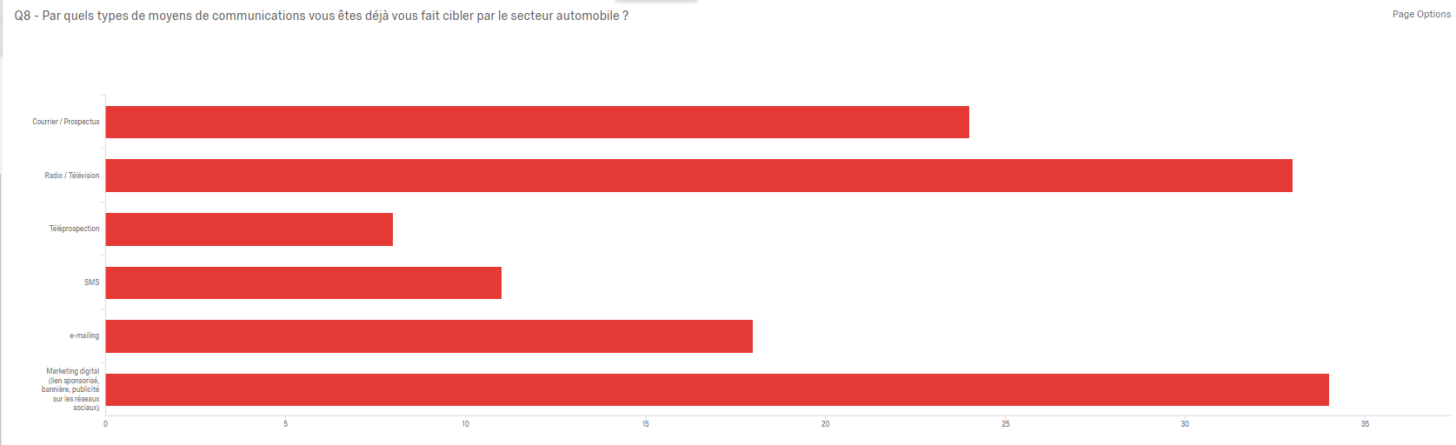

Digital marketing is beginning to establish itself in the automotive sector. Respondents are as affected by these techniques as they are by any other. The following chapter will reveal how conversational marketing techniques are useful but remain unknown.

### Solution Remains of Little Repute, and Better with Humans

#### Of Little Repute

The term “conversational marketing” is not very well known with respondents, as 80% confirmed to not know the term. This can be explained by the fact that is a very recent concept.

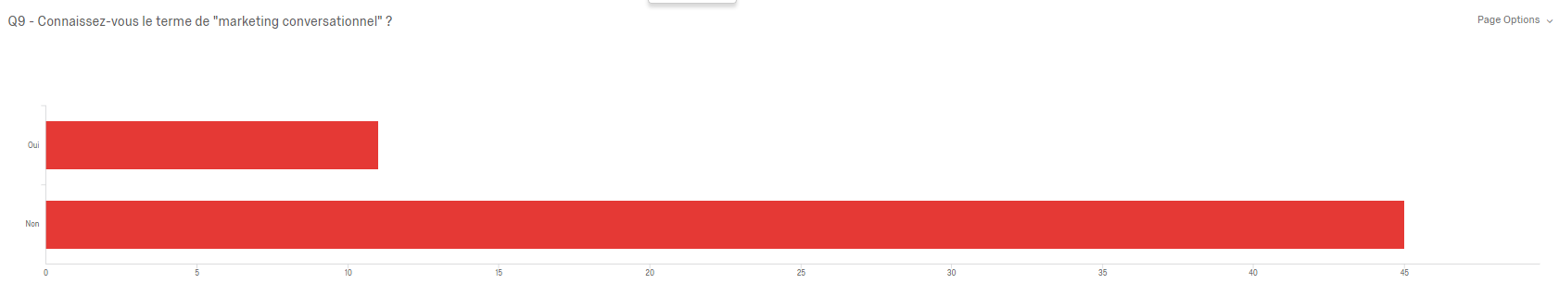

The following question, after explaining the definition of “conversational marketing” asked those polled if they had ever been the target of a conversational module. Almost 72% had never been approached by such a module. This reveals the concept to be new and requires further development if it proves to be a pertinent tool.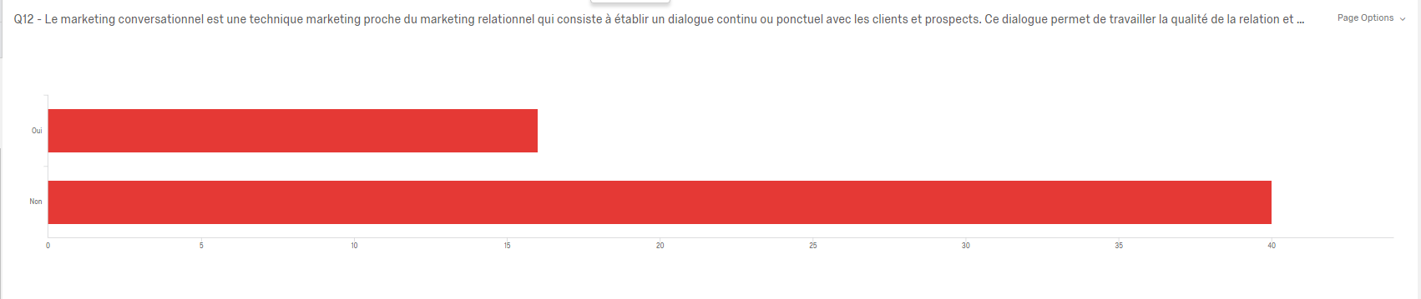

The subsequent question asked participants whether they had a positive experience with conversational marketing. Most responded by confirming it was of little to no interest. In fact, 50% found it had no benefit whatsoever and 50% found it somewhat useful or partially useful. These results could be interpreted two ways: The first being that conversational marketing is useless, which would disprove the hypothesis of this study. Another interpretation could be that current techniques are not necessarily appreciated at present. Qualitative studies on this subject will provide further insight. Furthermore, car enthusiasts who do not necessarily seek for help were the main participants of this survey. To additionally put these figures into perspective, it should be noted that only 16 people responded to this particular question, given that only 16 were helped by this type of module.

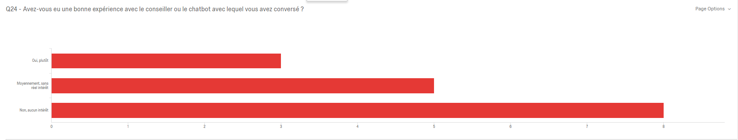

Finally, it can be observed that the French market is still quite reluctant to delve further in online procedures. 66% of people that responded to the survey are not ready to buy a vehicle online. This figure is in fact quite optimistic, as it reveals that nearly one-third of French consumers are willing to purchase a vehicle online. However, of the 34% willing to buy a vehicle online, only 4% would agree to undertake the transaction via a chatbot. This makes an excellent transition to the next point and constitutes a possibility that had already been considered but now is confirmed: In the automotive industry, prospects prefer to talk to human agents rather than chatbots.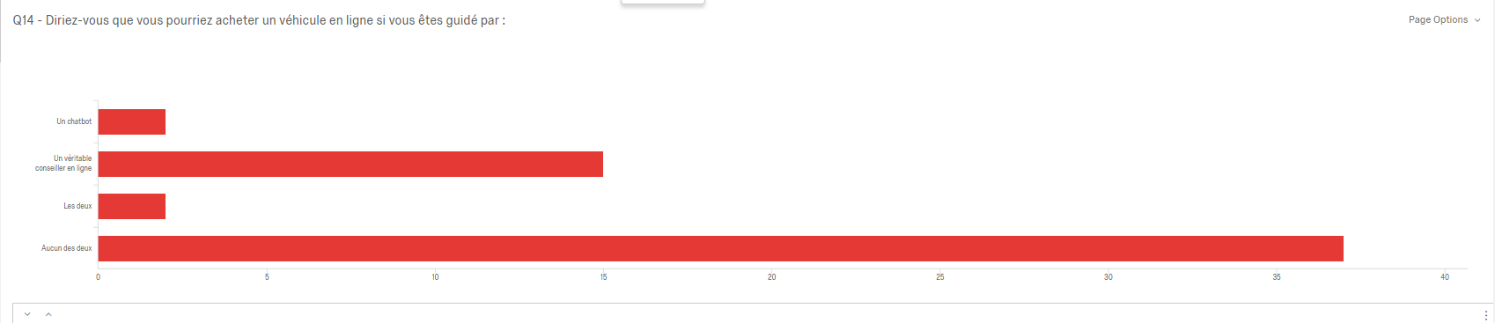

#### Better with Humans

The following two graphs are unequivocal. 92% of those questioned said they preferred to be guided by a real advisor rather than a chatbot for questions about a vehicle. This may be explained by the very complex demands customers have when looking for a car in which a chatbot cannot answer.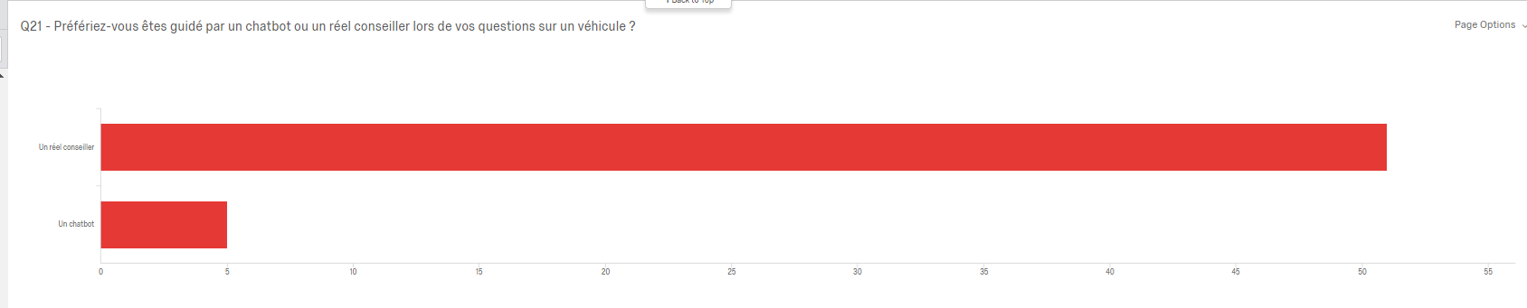

The question that follows demonstrates that requests and questions can be answered by human advisors in 30% of the cases. Furthermore, another 30% of people polled find human contact useless, and 30% find it helping in providing additional answers. These results reveal to be optimistic, for two-thirds of prospects seek out guidance online when searching for a new car. The qualitative interviews will reveal whether the remaining 30% find conversational marketing nonessential due to the fact that they already have the answers or due to the fact that online advisors are not trained well enough to answer all the questions these potential customers may ask.

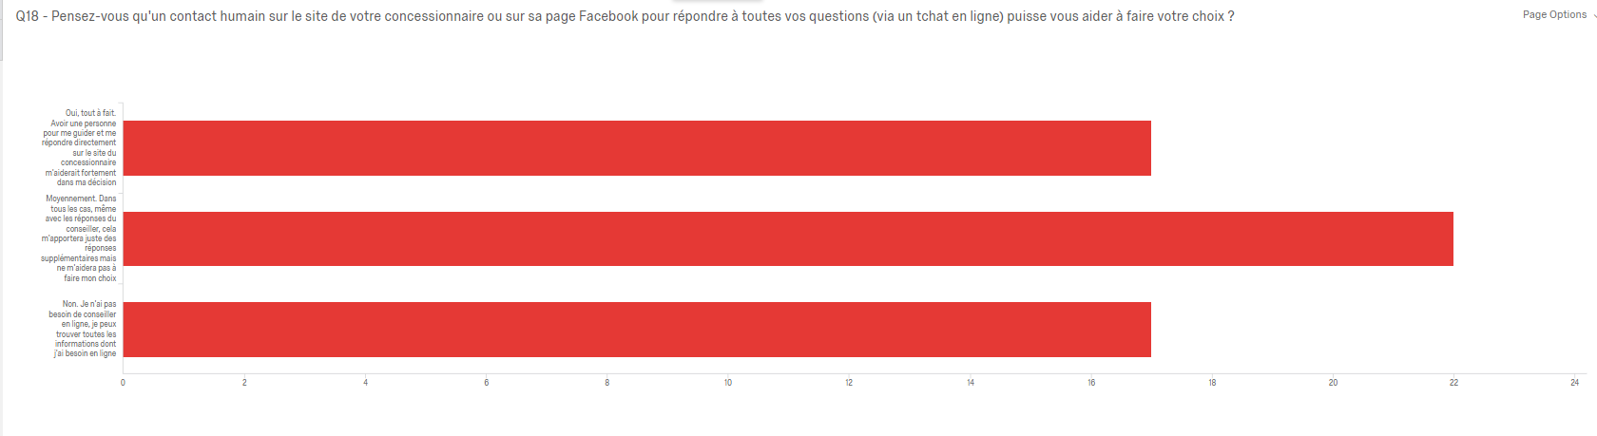

# CONCLUSIONS

## Managerial Recommendations

The subject of the introduction inquired how conversational marketing could be made the core of customer strategy and which techniques are the most pertinent to employ. Quantitative studies have provided some interesting insight and can be completed by further qualitative studies.

### Why Use Conversational Marketing?

The hypothesis of this study speculated that conversational marketing creates a true connection between the company and prospect and consequently increases the company’s image and sales. In the digital age, digital transformation is no longer a choice but rather a mandatory step for any company wishing to develop. Research is performed upstream and lack of an online presence constitutes the cost of many lost potential customers. The quality study has confirmed that the search for a vehicle first entails research through online documentation and dealership websites. This therefore demonstrates that the presence of online agents is mandatory.

### Which Techniques?

#### 24/7 Availability

Lack of complete presence is one of the biggest fears companies face in regards to customer relationships, as it is difficult to be available in the middle of the night or early morning. Digital seems to have solved this problem with chatbots.

However, 80% of people polled replied that responses from non-human automated agents are unsatisfactory, irrelevant, and ultimately do not solve the customer's problem. The quantitative study also revealed that chatbots have difficulty convincing customers.

Companies must be able to provide customers with comprehensive and correct answers even outside office hours in order to ensure purchases during the most favorable hours. A human conversational agent that is available outside office hours reveals to be the only solution.

#### Presence on Every Channel Due to a Multi-Channel Strategy:

A company should avoid investing in one form of media. The study has already revealed that most media reach prospects equally. This also applies to the presence of a company on social networks. Today's customer can connect according to the ATAWAD solution, which means at anytime, anywhere, and from any device.

In 2019, a survey revealed that 84% of companies consider a presence on social network important to remain competitive. (Hootsuite France Report, 2018). In 2016, 65% of French people reported using social networks, a two-fold increase compared to 2009. A multi-channel strategy entails giving customers the choice of how they wish to contact companies. Without this choice, the customer is constrained. However, the use of a single channel can already be an element of frustration for the customer well before they’ve had the opportunity to contact the dealership.

#### Which Tools?

Given the fact that messaging is a simple, instantaneous, and non-binding means of communication, it has proven to be very popular. This means of communication has become part of one’s daily life. Costumers now wish to "chat" with a company as they do with colleagues, friends, or family.

HubSpot surveyed companies to find out how they communicate with their prospects and customers. The responses are the following:

- Live chat | 22%.

- Messenger | 29%

- CRM | 26%.

- E-mail/newsletters | 84%.

- Telephone | 75%.

- Community platforms | 37%.

- Twitter | 35%.

- Other social networks | 35%.

### How?

Having a digital strategy does not simply imply the creation of a Twitter, Instagram, or Facebook account, or launching a smartphone application or website. These actions must be well thought-out and evaluated according to previous objectives set in order to make a significant impact. This is what one can more commonly call “digital strategy.” A company’s digital strategy must fully incorporate its conversational marketing approach, rather than have them separate from each other.

One successful example is the automotive passion group, which has used its community management techniques to link members to conversational marketing by using sponsored posts on social networks to encourage exchange via Messaging. This combination has produced some surprising results.

Companies must have an irreproachable online relationship with customers, as it has been revealed that they attach just as much importance to their pre-purchase experience as the final step of their car purchase possess. Brief and inattentive answers will bring customers to feel as if they are being forced to purchase. The online customer relationship therefore must be continuous and coherent, and the purchase process must be punctuated by benevolent exchanges between customer and company.

A company's added value had previously been concentrated on its physical points (such as showrooms), to the detriment of its digital relationship. This tendency is now changing. Just as customers would previously come into contact with a physical point of sale a minimum of one time during their purchase process, this has revealed to no longer be the case.

Today, a customer's journey from acquisition to transaction can be fully digitalized. Refocusing investments in favor of a quality digital customer relationship is the best way in which a company can develop its standing among customers. In order to accomplish this, companies must be present for their customers from acquisition phase to post-order processing. This will ensure a unique customer relationship and will set the company apart from its competitors.

### Conversational Marketing Can Serve Many Purposes

Conversational marketing can serve a number of purposes. One is that it can generate more qualified leads. Generating a lead entails acquiring information about a person, such as an email address in exchange for informative content during an online discussion

Conversational marketing can additionally assist in the launch of a new product. A new product always attracts curious customers and raises a lot of questions. In this type of exceptional situation, human communications can have a high added value.

Furthermore, conversational marketing allows companies to discuss with website visitors. Thousands of visitors visit car dealership websites every day. Each visitor represents a new opportunity and should, as a result, be immediately seized. While it may not necessarily transform into a lead, it will nevertheless increase overall customer satisfaction.

Finally, conversational marketing relieves call centers. Call centers are often overwhelmed. There are solutions which allow various online users requests to be centralized from different digital media. These are then processed by experts 24/7 to provide an immediate response via instant messaging.

A car dealership can choose to personally manage its human digital strategy, though this requires the mobilization of numerous employees with little to no communication experience. It is therefore preferable for car dealerships to employ communications experts for these missions.

## Limits of the Study

Some limitations to the study are evident. The first major limitation of the study is due to the narrow age range of 18 to 36 years being represented by the majority. These statistics must be improved for the thesis. Furthermore, a fair amount of answers are missing as a result of the panel being too weak to be totally representative. While this reveals an interesting trend, it must be more comprehensive for a more thorough result. The subject of the thesis additionally reveals to be quite new and addresses a concept that appeared a matter of a couple of years ago. The sources are therefore recent and the changes are perpetual. As the market is evolving very quickly, what is true today may be false or completely evolved in upcoming years.

## Future Research Methods

Interviews with professionals in the industry to obtain qualitative responses must be accomplished as a future research method in order to receive extensive insight regarding how conversational marketing is perceived in the field.

Approximately ten interviews with major players in the automotive industry (customers, branch managers, dealership managers, car manufacturing executives, etc.) are arranged for the upcoming months and will therefore be included in the report. The quantitative study must additionally be shared in circles further away from the author to ensure a collection of feedback from a range of ages.

# REFERENCES

* Books:
  + Lurie, I. (2006). Conversation Marketing. Victoria, B.C.: Trafford.
  + Jaffe, J. (2008). Join the Conversation. Hoboken, N.J.: John Wiley & Sons.
  + Cancel, D., Gerhardt, D. and Devaney, E. (n.d.). Conversational Marketing. WILEY.
  + Albert, N., Valette-Florence, P. (2010) : Marché et organisations
* Web articles:
  + Bodoin, D. (2019). Le Marketing conversationnel : l'avenir du marketing. [online] Blog.agencenile.com. Available at: https://blog.agencenile.com/le-marketing-conversationnel-avenir-du-marketing
  + Guynn, J. (2016). Zuckerberg's Facebook Messenger Launches Chat bots' Platform. [online] Eu.usatoday.com. Available at: <https://eu.usatoday.com/story/tech/news/2016/04/12/facebook-messenger-f8-chat-bots/82919056/>.
  + Constine, J. (2017). Facebook Messenger Hits 1.2 billion Monthly Users, up From 1B in July – TechCrunch. [online] TechCrunch. Available at: <https://techcrunch.com/2017/04/12/messenger/?guccounter=1&guce_referrer_us=aHR0cHM6Ly9lbi53aWtpcGVkaWEub3JnLw&guce_referrer_cs=jFitN65zrZ-zEqC7dihGiw>.
  + Statista. (2019). Most Popular Messaging Apps 2019 | Statista. [online] Available at: <https://www.statista.com/statistics/258749/most-popular-global-mobile-messenger-apps/>.
  + nsights.fb.com. (2019). More Than a Message: The Evolution of Conversation. [online] Available at: <https://insights.fb.com/morethanamessage/>.
  + https://www.relationclientmag.fr/. (2019). Messaging et Relation Client : pourquoi se lancer ?. [online] Available at: <https://www.relationclientmag.fr/Thematique/techno-ux-1256/Breves/Messaging-Relation-Client-pourquoi-lancer-338682.htm#h4F3w9QQl1vhmkKw.97>.
  + Bordeau, J. (2019). [Tribune] L'efficacité prime sur l'inventivité de la relation client. [online] https://www.relationclientmag.fr/. Available at: <https://www.relationclientmag.fr/Thematique/strategies-1255/Breves/Tribune-efficacite-prime-inventivite-relation-client-339600.htm#zPXVxWRWBbVwSVcD.97>.
  + Pasquier, N. (2017). Le messaging, nouvel outil de relation client. [online] TourMaG.com, 1er journal des professionnels du tourisme francophone. Available at: <https://www.tourmag.com/Le-messaging-nouvel-outil-de-relation-client_a89070.html>.
  + Nsimba, B. (2017). Facebook Messenger : Le guide complet pour les entreprises. [online] Hootsuite Social Media Management. Available at: <https://blog.hootsuite.com/fr/facebook-messenger-le-guide-complet-pour-les-entreprises/>.
  + Bulard-Luc, R. (2017). Le messaging, une nouvelle ère pour la relation client. [online] Journaldunet.com. Available at: <https://www.journaldunet.com/ebusiness/expert/67512/le-messaging--une-nouvelle-ere-pour-la-relation-client.shtml>.
  + Définitions marketing. (2017). Marketing conversationnel. [online] Available at: https://www.definitions-marketing.com/definition/marketing-conversationnel/
  + Burke, S. (2017). Why You Should Be Focusing on Conversation Marketing. [online] Spokal. Available at: <https://www.getspokal.com/why-you-should-be-focusing-on-conversation-marketing/>.
  + LAZAUSKAS, J. (2015). 10 Marketing Buzzwords You’re Going to Hear Way Too Much This Year. [online] Contently. Available at: <https://contently.com/2015/01/14/10-content-marketing-buzzwords-youre-going-to-hear-way-too-much-this-year/>.
  + iAdvize - FR. (2019). Qu'est-ce que le Marketing Conversationnel ? Définition - iAdvize. [online] Available at: <https://www.iadvize.com/fr/glossary/marketing-conversationnel/>.
  + Drift. (2019). What is Conversational Marketing? – Drift. [online] Available at: <https://www.drift.com/conversational-marketing/>.
  + Pillai, A. (2019). How do You Define Conversational Marketing?. [online] Quora.com. Available at: <https://www.quora.com/How-do-you-define-conversational-marketing>.
  + ABBOU, K. (2015). Google "Zero Moment Of Truth" (ZMOT) : c'est quoi ?. [online] Content Marketing Académie. Available at: <http://www.contentmarketingacademie.fr/google-zero-moment-of-truth-zmot-cest-quoi/>.
  + https://www.relationclientmag.fr/. (2018). Que sera la relation client en 2020 ?. [online] Available at: <https://www.relationclientmag.fr/Thematique/customer-marketing-1251/Breves/Que-sera-la-relation-client-en-2020--335757.htm#K9vwx83KBC16hSO2.97>.
  + MINDS, B. (2018). How to Gain More Leads with Conversational Marketing. [online] Medium. Available at: https://medium.com/@brand_minds/how-to-gain-more-leads-with-conversational-marketing-ce795463ff0b [Accessed 5 Sep. 2019].
  + AURIBOT, J. (2019). Comment générer des RDV après-vente facilement via Messenger ?. [online] Linkedin.com. Available at: <https://www.linkedin.com/pulse/comment-g%C3%A9n%C3%A9rer-des-rdv-apr%C3%A8s-vente-facilement-via-j%C3%A9r%C3%A9my-auribot/?trk=portfolio_article-card_title>.
  + MATTHEWS, K. (2018). How Chatbots Are Influencing the Automotive Industry. [online] Chatbotsmagazine. Available at: <https://chatbotsmagazine.com/how-chatbots-are-influencing-the-automotive-industry-b24a0f7485f8>.
  + KURTZIG, A. (2018). How Chatbots Are Revolutionizing the Auto Industry. [online] VatorNews. Available at: <https://vator.tv/news/2018-01-10-how-chatbots-are-revolutionizing-the-auto-industry>.
  + Collins, A. (2018). Conversational Marketing: How a Messaging Strategy Will Grow Your Business. [online] Blog.hubspot.com. Available at: <https://blog.hubspot.com/marketing/conversational-marketing>.
  + BenMark, G. and Venkatachari, D. (2016). Messaging Apps Are Changing How Companies Talk with Customers. [online] Harvard Business Review. Available at: <https://hbr.org/2016/09/messaging-apps-are-changing-how-companies-talk-with-customers>.
  + Landré, B. (2019). Web : le chantier permanent des distributeurs. [online] largus.fr. Available at: <https://pro.largus.fr/actualites/web-le-chantier-permanent-des-distributeurs-9814390.html>.
  + Boitnott, J. (2016). Why the First Call From a Customer Is the Most Important. [online] Entrepreneur. Available at: <https://www.entrepreneur.com/article/270217>.
  + Gamma (2017) Conversion des leads en clients : quelles solutions pour l’automobile ? Available at: <https://www.datacar.com/conversion-leads-secteur-de-lautomobile/>