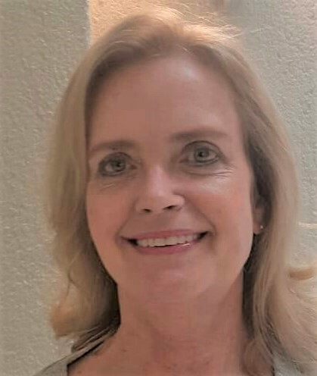

Activity: German to English translator since 2006

Specialisations: Legal, finance, marketing

Education: BA Honours degree – Linguistics: Translation Studies (UNISA)
Bachelor of Arts (UNISA) – psychology and philosophy (logic and the philosophy of knowledge and science)
Bookkeeping Diploma (with distinction) – Centre for Management Development, South Africa
CIS Level I (Management and Administration) through ICSA – Institute of Chartered Secretaries and Administrators - a corporate governance qualification (subjects included commercial law, accounting, marketing, economics, IT)

Experience:
I am a German to English freelance translator specialising in financial, legal and marketing texts, and am a member of the BDÜ (German Federal Association of Interpreters and Translators) and SATI (South African Translators’ Institute). I have been translating full-time since 2006. My prior work experience, spanning more than 20 years, was gained in the commercial, education and non-profit sectors. My translation specialisations thus include business- and finance-related documentation (annual reports, financial statements, management reports, procedure manuals, employee handbooks, accounting manuals, etc), as well as legal (contracts and leases, Ts&Cs, articles of association, case documents, etc) and marketing texts (automotive, telecommunications, IT). I also proofread Masters’ dissertations in English.

