Release and Deployment Management

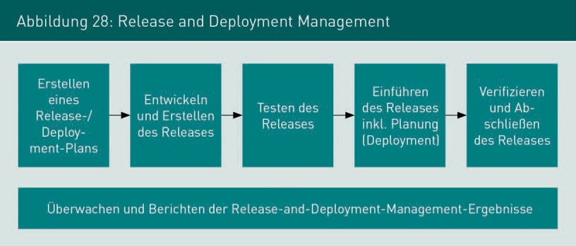The aim of release and deployment management is the scheduled transfer of changes to the IT infrastructure into an operational state. Release is the logical summary of all changes. Deployment is the actual implementation of these changes. In the course of a release or deployment, the current configuration of the IT infrastructure is changed. The import of changes usually has the consequence that IT services are not available for the duration of the **deployment process**. In addition, a change to an operable configuration always bears the risk of disruptions and restrictions to availability due to unplanned effects. With the release and deployment management activities shown in Figure 28, the risks of a disruption after deployment should be kept as low as possible, and the choice of deployment date should result in as few or no restrictions for the service recipients as possible.

|  |  |  |  |  |
| --- | --- | --- | --- | --- |
| Figure 28: Release and Deployment Management | | | | |
| Creation of a release/deployment plan | Development and creation of the release | Testing of the release | Introduction of the release incl. planning (deployment) | Verification and finalisation of the release |
| Monitoring and reporting of release and deployment management results | | | | |

To this end, a **release and deployment plan** is drawn up to plan and communicate the development and introduction of a release. Typically, several changes are combined into one release. The planned release is then developed. In addition to the further development and maintenance of IT components, all necessary documentation for development and operation must be created. After the development work is completed, the release is tested. In addition to the functionality of the release, it is checked whether the rollback procedure planned for the release can be carried out successfully. After successful completion of the tests, detailed planning takes place and then the release is implemented in the form of deployment. In addition to the software and hardware changes, all accompanying IT service management activities must be carried out. These include updating the CMDB and, if necessary, the service catalogue, carrying out change management processes and monitoring activities, as well as adapting contracts for the provision of IT services if necessary.