Release and deployment management

The objective of release and deployment management is the scheduled implementation of changes to the IT infrastructure. Release refers to the logical grouping of all changes. Deployment involves the actual implementation of these changes. In the course of a release or deployment, the current configuration of the IT infrastructure is changed. When changes are being implemented, IT services are typically unavailable for the duration of the **deployment process**. Furthermore, changing an executable configuration always involves a risk of disruption and restrictions to availability due to unplanned consequences. In the case of the release and deployment management activities specified in Figure 28 below, the risk of disruption following the deployment should, on the one hand, be kept as low as possible, while, on the other hand, a deployment date should be chosen so as to ensure that restrictions for users are kept to a minimum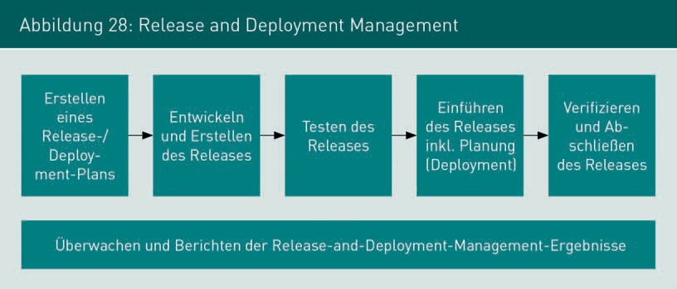.

A **release and deployment plan** is drawn up, through which the development and launch of a release can be planned and communicated. Multiple changes are typically grouped into one release. The planned release is then developed. In addition to the further development and maintenance of IT components, all necessary documentation for development and operation must be prepared. Once the development work is complete, the release is tested. As well as checking the functionality of the release, a check is also carried out that the rollback procedure for the release can be run correctly. Once the tests have been successfully completed, detailed planning is undertaken, followed by launch of the release through the deployment. Here, in addition to changing the software and hardware, all associated IT service management activities must be carried out. This includes updating the CMDB and, if applicable, the service catalogue, implementing change management processes and monitoring activities, as well as updating agreements for the provision of IT services, if required.