(2) When joining members, it is necessary to take care to do everything possible not to use joints with low fatigue strength or joints in which the quality of welded parts is difficult to ensure. The quality of

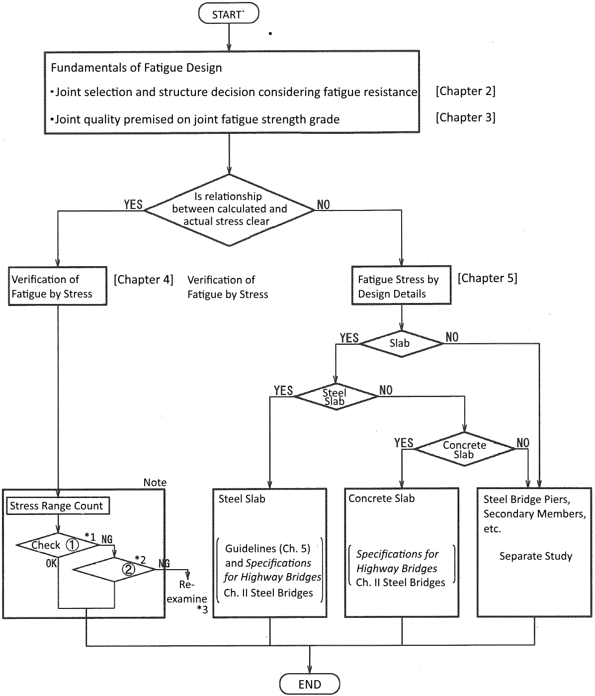

|  |  |
| --- | --- |
| Note: May be omitted when all conditions can be regarded as safe for fatigue. | *1 Check ①: Cut-off limit of stress range for constant amplitude stress used  *2 Check ②: Fatigue verification with cumulative damage taken into account  * Re-examine: Re-examine from appropriate point in flow after studying a change in joint position, joint type, structure, etc. |
| Fig. 2.1 Fatigue Design Flow | |

welded parts, in particular, can often be difficult to ascertain by non-destructive inspection methods after the fact, and it is necessary to thoroughly study weld workmanship and quality inspection methods from the design stage due to the risk of quality loss when working with joints that are difficult to install.

In addition, when adopting joints that have no record of use and uncertain fatigue resistance, it is necessary to conduct due diligence conducting fatigue tests2 that can reproduce stress states at the actual bridge, including the effects of residual stresses, etc.

Even if the load transmission mechanism is the same on each joint, fatigue strength often depends on variables such as its shape and the presence or absence of a finish; therefore, it is important that the design guarantees the required quality of joints in advance by accurately conveying the intent of the design to production and installation teams, as well as clarifying what type of joint will be used after considering fatigue resistance. In addition, when metal hangers and various reinforcing metals that were not considered at the design stage are provided at the manufacturing or installation stage, it is necessary to be aware that they are also subject to fatigue design. When these are removed, it is necessary to take actions according to the relevant provisions of Chapter II Steel Bridges of *Highway Bridge Specifications* to avoid compromising the quality of the base metal so that the required fatigue strength can still be met.

It is also undesirable from the perspective of ensuring fatigue resistance from construction and inspection to design and construct with the assumption that undercut and internal flaws above a certain level will occur in advance, and design and construction should be, in principle, conducted so that they satisfy the strength grades specified in Chapter 3 for each joint.

**Reference Literature**

1) Japan Road Association: *Fatigue in Steel Bridges*, 1997

2) Japan Society of Steel Construction: *Fatigue Design Recommendations for Steel Structures and Commentary*, 1993

**Chapter 3 Fatigue Strength and Classification of Joints**

**3.1 Fatigue Strength**

|  |  |  |
| --- | --- | --- |
| (1) Fatigue design curves are as in Formula 3.1.1 and Formula 3.1.2. | | |
| *Δσ*𝓂⋅*N* = *C*0  *N* = ∞ | (*Δσ* > *Δσ*𝒸ℯ, *Δσ*𝓋ℯ)  (*Δσ* ≤ *Δσ*𝒸ℯ, *Δσ*𝓋ℯ) | } (3.1.1) |
| *Δτ*𝓂⋅*N* = *D*0  *N* = ∞ | (*Δτ* > *Δτ*𝒸ℯ, *Δτ*𝓋ℯ)  (*Δτ ≤* *Δτ*𝒸ℯ, *Δτ*𝓋ℯ) | } (3.1.1) |
| Here,  *N*: fatigue life (number of repetitions until fatigue limit state is reached)  *C*0: 2×106⋅*Δσ*𝑓𝓂  *D*0: 2×106⋅*Δστ*𝑓𝓂  *Δσ*: direct stress range  *Δτ*: shear stress range  *Δσ*𝑓: 2×106 times basic allowable stress range for direct stress  *Δτ*𝑓: 2×106 times basic allowable stress range for shear stress  *Δσ*𝒸ℯ: direct stress range as cut-off limit for constant amplitude stress  *Δσ*𝓋ℯ: direct stress range as cut-off limit for variable amplitude stress  *Δτ*𝒸ℯ: shear stress range as cut-off limit for constant amplitude stress  *Δτ*𝓋ℯ: shear stress range as cut-off limit for variable amplitude stress  𝓂: coefficient for expressing slope of fatigue design curve  Joints subject to static stress (𝓂=3)  Joints subject to shear stress (𝓂=5)  Cables and high-strength bolts subject to direct stress (𝓂=5) | | |