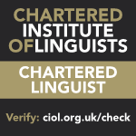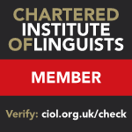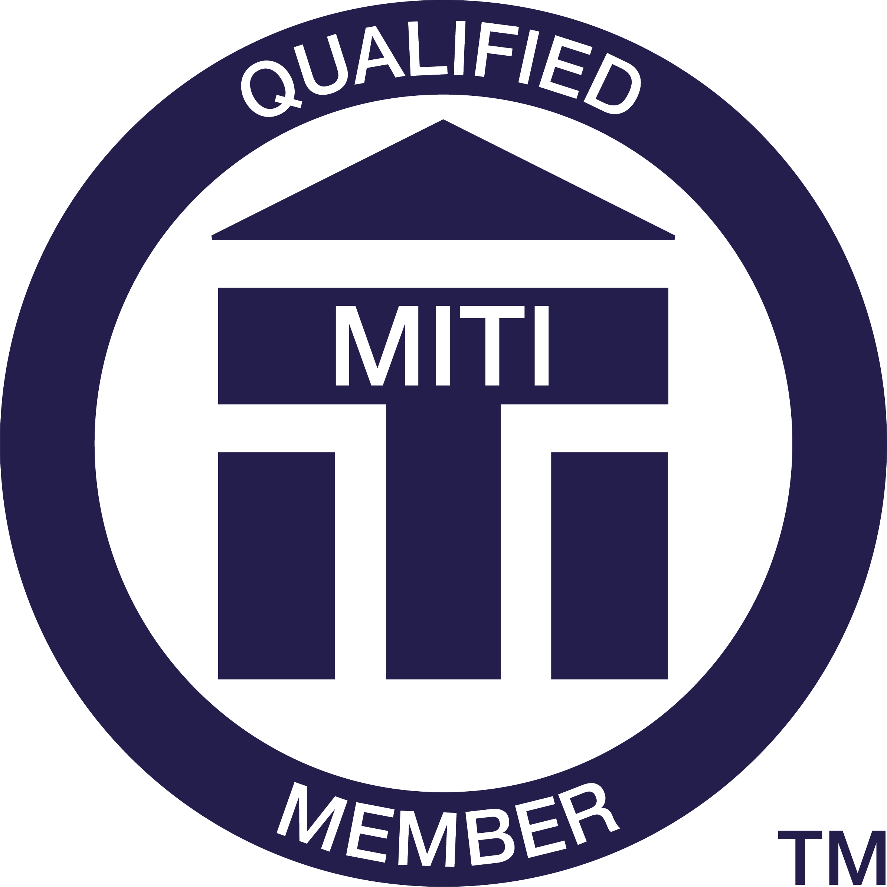
CURRICULUM VITAE
Jasper Tilbury, CL, MA, MITI, MCIL, ISO 17100:2015 Qualified, translator, editor and author, with 28 years of experience in translation (language combination: Polish > English)

personal details

Home/work address: 75c Highbury Hill, London N5 1SX, home: +44 20 7704 8283,
mobile: +44 775 1977 230, e-mail: tilbury@polishtranslations.org.uk
Date and place of birth: 8 August 1965, London
Nationality: British/Polish (dual)
Mother tongue: English
LinkedIn: https://www.linkedin.com/in/jasper-tilbury-cl-ma-miti-mcil-566a355/

education

- Modern History MA Hons, University of St Andrews (1984-88), specialising in twentieth century Soviet and East European History, including Russian language and literature.
- British government research scholarship to the Jagiellonian University, Kraków (1989-90) for postgraduate research on post-war Polish history.

membership of professional organisations

- Institute of Translation and Interpreting (MITI) (http://www.iti.org.uk/), memb. no. 5345
- Chartered Institute of Linguists (MCIL) (http://www.iol.org.uk), memb. no. 021128

professional experience (poland and uk)

1992−present
Freelance translator

Over the past three decades I have translated, revised, and proofread several million words of text (PL > EN) for a variety of public institutions (e.g., BBC, Cracow University of Economics, ECJ, EC, EIB, EP, Government of Poland, HMRC, Scottish Crown Office, Warsaw University), as well as commercial companies, media organisations and publishing houses. Examples include:

2017–present
Regular legal translation work for the European Court of Justice, including Opinions of the Advocates General, Requests for a preliminary ruling, Observations and statements in intervention, and other judicial documents.

2015–present
Translation of articles for the Cultures of History Forum at Jena University in Germany. Examples can be found here:
http://www.cultures-of-history.uni-jena.de/exhibitions/poland/an-engaged-narrative-the-permanent-exhibition-of-the-museum-of-the-second-world-war-in-gdansk/
http://www.cultures-of-history.uni-jena.de/exhibitions/germany/buchenwald-revisited/
http://www.cultures-of-history.uni-jena.de/debates/poland/history-and-memory-of-1968-in-poland-debates-around-the-estranged-exhibition/
http://www.cultures-of-history.uni-jena.de/exhibitions/poland/architecture-in-the-service-of-the-nation-the-exhibition-architecture-of-independence-in-central-europe/

2009–present
Regular work for the Scottish Crown Office and other government departments under the Scottish Government Framework Agreement for Interpreting, Translation and Transcription, including letters of request to judicial authorities, European arrest warrants, extradition orders, court judgements, prison reports, etc. as well as documentation in child protection cases.

2009–2011, and 2019–present
Translation of various documents for the European Parliament, including petitions, speeches, draft opinions, working documents, reports, amendments, statements, and academic studies (e.g. on the definition of refugee status).

2008–present
Technical translation work for the European Investment Bank, primarily motorways and road-building, railway infrastructure, environmental impact assessments, and financial documentation.

2005–2009
Translation of administrative and other texts for the European Commission, including complaints to the Commission, competition and consumer protection law, financial compensation schemes, decision of the Polish state administration, reports on the implementation of Council Directives, shareholders’ resolutions, AGM minutes, etc.

2005–present
Translation of Polish legislation, including the Polish Postal Act (2012), the Act on Payment Services (2012), the Act on EU Nationals (2006), and the Act on Tourist Services (1997).

2002–2009
Regular translation work for HMRC, mainly in the field of criminal law – court judgements, petitions, witness statements, police reports, powers of attorney, forensics, financial documentation, etc.

published book translations

I have published 15 books and over 300 articles/reports/essays in translation, including:

- Włodzimierz Borodziej & Maciej Górny (2021) Forgotten Wars. Central and Eastern Europe, 1912–1916. Cambridge, UK: Cambridge University Press
- Anna Bikont (2021) “Irena Sendler from Żegota. The Heroine and Her Myth” in Natalia Aleksiun, Raphael Utz, and Zofia Wóycicka (eds) The Rescue Turn. Holocaust Memory, Politics, and Debates. Detroit, Michigan: Wayne State University Press
- Tygodnik Powszechny (2019) Kraków. Anthropologies of Heritage (supplement to issue No. 28): https://www.tygodnikpowszechny.pl/krakow-anthropologies-of-heritage-english-20340
- Anna Sosnowska (2019) Understanding Backwardness. Historians’ Debates about Eastern Europe (1947-1994). Budapest, Hungary: Central European University
- Marek Świca (2019) The Museum of Photography in Kraków. London: Scala Arts & Heritage Publishers
- Maria Anna Potocka (2018) MOCAK Museum of Contemporary Art in Kraków. London: Scala Arts & Heritage Publishers.
- Przemysław Barszcz (2018) The Forest. A Good Neighbourhood. Warsaw: The State Forests Information Centre
- Małgorzata Quinkenstein (2017) “A Portrait of Arthur Bryks against the Background of the Events of the Mid-Twentieth Century” in Ferenc Laczó and Joachim von Puttkamer (eds) Catastrophe and Utopia: Jewish Intellectuals in Central and Eastern Europe in the 1930s and 1940s. Jena: Friedrich Schiller University Jena
- Zofia Wóycicka (2014) Arrested Mourning: Memory of the Nazi Camps in Poland, 1944-1950. Bern, Switzerland: Peter Lang AG
- Tomasz Geodecki et al. (2013) Towards a Competitive Poland. How Can Poland Climb the World Economic League Table?. Kraków: Fundacja GAP
- Gregor Thum (2011) Uprooted: How Breslau Became Wroclaw During the Century of Expulsions. Princeton, NJ: Princeton University Press
- Various (2010) Żydownik Powszechny (special supplement). Kraków, Poland: Fundacja Tygodnika Powszechnego. A series of essays and articles about Polish-Jewish relations in the 20th century to mark the 65th anniversary of the Tygodnik Powszechny weekly
- Polish Easy Learning Audio Course (2008). I edited the dialogues for this audio book. London: HarperCollins
- Agnieszka Drewno et al. (2007) Northern Spain. Eyewitness Travel Guide. London: Dorling Kindersley.
- Jerzy Majewski (2006) Warsaw Insight Pocket Guide. London: Berlitz Publishing
- Jerzy Hausner et al. (2002) The Vagaries of Institution Building: Poland’s Adjustment to the European Union. Warsaw: Friedrich Ebert Foundation. A book by Poland’s former Minister for Labour and Social Policy on institution building in the context of EU enlargement. This is the sixth report in the EU-Monitoring series, which I have also translated.
- Various (1999-2019) Argumenta Oeconomica Cracoviensia. I act as editor for this biennial journal published by the Cracow University of Economics. The main subject areas are economics, finance, and social science. Approximately twenty issues have been published to date.
- Jerzy Hausner et al. (1997-2004). EU-Monitoring. Warsaw: Friedrich Ebert Foundation. A series of books by Poland’s former Minister for Labour and Social Policy on the social, economic, political and legal aspects of Poland’s preparations for accession to the European Union. I acted as editor and translator for all seven books in the series, which are as follows:
- The Polish Transformation from the Perspective of European Integration (1997)
- Accession of Integration? Poland’s Road to the European Union (1998)
- Three Poland’s:The Potential for and Barriers to Integration with the European Union (1999)
- The Quality of Governance: Poland Closer to the European Union? (2000)
- The Polish Talk Show: Social Dialogue and Euopean Integration (2001)
- The Vagaries of Institution Building: Poland’s Adjustment to the European Union (2002)
- On Course? Poland on the Eve of EU Accession (2004)
- Various (2001) Doing Business in Poland. Warsaw: Arthur Andersen
- Grzegorz Kołodko (1999) From Shock to Therapy: The Political Economy of Post-Socialist Transformation. Warsaw: Poltext. An analysis of transition economies world-wide by Poland’s former Minister of Finance.
- Stefania Krzysztofowicz-Kozakowska (1999) Polish Art Nouveau. Kraków: Wydawnictwo Ryszard Kluszczyński. A coffee-table album for which I acted as English editor.
- Zygmunt M. Szweykowski (ed.) (1994) Bartłomiej Pękiel. Opera Omnia l & II. Monumenta Musicae in Polonia series. Kraków: Musica Iagellonica. An academic treatise on the 17th-century Polish composer.
- Paul Hockenos (1993) Free to Hate. The Rise of the Right in Post-Communist Eastern Europe. New York: Routledge. I co-authored the chapter entitled “Poland: Christ of Nations”.
CURRICULUM VITAE
2010−present
Visiting Lecturer: University of Westminster, London (http://www.wmin.ac.uk). I teach the Polish to English specialised translation module for the MA in Specialised Translation. I also supervise MA dissertations and give lectures to students taking the DipTrans examination.

2017 (26-31 March)
Lecturer: Warsaw University, Poland (http://en.uw.edu.pl/). I delivered lectures and taught classes on translation to students of the Institute of Applied Linguistics as part of an Erasmus exchange.

2013 (22-26 July)
Lecturer: Birkbeck, University of London (http://www.bbk.ac.uk). Use your Language, Use your English Summer School. I taught classes on how to edit academic texts to a group of multilingual translation students.

2003−present
Assessor and Moderator: I examine and assess candidates applying to become members of the Institute of Translation and the Chartered Institute of Linguists in the Polish to English language combination. I also mark candidates taking the CIOL Diploma in Translation (DipTrans) examination.

1999−present
University of Economics, Kraków (https://aoc.uek.krakow.pl/). My work involves translating and editing academic texts for publication in the Argumenta Oeconomica Cracoviensia journal.

1996−present
Author: Blue Guides (http://www.blueguides.com/), the most comprehensive, detailed and authoritative cultural guide book series on the UK and US markets. This ongoing project requires in-depth research into art & architecture, politics and history, as well as extensive travel. Blue Guides offer an insider’s view of the country, its culture, people, myths and folklore. I am the author of the following books in the series:

- Art/Shop/Eat Prague (2005). London: Somerset Books, 1st edition.
- Blue Guide Prague (2004). London: A & C Black, New York: W. W. Norton, 2nd edition.
- Blue Guide Kraków (2000). London: A & C Black, New York: W. W. Norton, 1st edition.
- Blue Guide Poland (1999). London: A & C Black, New York: W. W. Norton, 1st edition.

1994–2009
Deputy editor: EMERGO: Journal of Transforming Economies and Societies (http://www.emergo-journal.pro.onet.pl/), an English-language peer-review quarterly focussing on transition issues, published by Stockholm University’s School of Business and the Cracow University of Economics. I was responsible for commissioning and editing texts, employing proofreaders, and liaising with contributors.

1989–1992
English lecturer: Jagiellonian University, Kraków (http://www.uj.edu.pl). My responsibilities included organising and conducting residential courses for groups of 50 people, teaching, co-ordinating and monitoring the work of other staff members, designing English language and literature courses, and preparing candidates for the Cambridge First Certificate and Proficiency examinations. I was also employed by the British Council as an external examiner (1990-92).

referees
I am willing to disclose the full contact details of my referees to reputable agencies and clients.

- Grzegorz Paluch, former Deputy Head of Polish Section, British Broadcasting Corporation, Bush House 824 A, Strand, London WC2 B4PH
- Andrew Gillies, Conference Interpreter (EP), 88 Boulevard de Magenta, 75010 Paris

Jasper Tilbury CL, MA, MITI, MCIL Translation services
HOME / WORK: 75c highbury hill, london n5 1SX • tel. +44 20 7704 8283 • mobile +44 775 1977 230 • e-mail tilbury@polishtranslations.org.uk • UK TAX NUMBER (UTR): 14208 59587

specialist areas
advertising, agriculture, annual reports & business plans, art history, commercial & company law, clinical trials, criminal law, economics, environment, EU legislation, film & broadcasting, finance, food & beverages, history, HR, internet, investment funds, IT, legal documents, literature, local government, management, market research, media, music, policing, politics, public administration, public procurement, psychology, public relations, sociology, taxation & duty, transport, town planning, travel guides & tourism, sport & leisure

translation fees to agencies (until 31 december 2021)
Polish > English: £90.00 to £180.00 /1000 words of source text, depending on volume, complexity and repeat business

sworn translations
Polish > English. Translation fees: £90.00 / 1000 words of source text. Certification fees: 1) Self-certification (ITI seal, translator’s declaration and signature, delivery by registered post – £20.00; 2) Affidavit (ITI seal, translator’s declaration countersigned by a solicitor, delivery by registered post) – £75.00; 3) Notarisation (ITI seal, translator’s declaration, notary’s declaration, delivery by registered post) – £125.00

surcharges
Translations in excess of 2000 words/working day (Mon-Fri, 9.00-5.00) attract a surcharge (usually 50%), to be agreed before work proceeds

delivery
Translations are returned by e-mail, ftp or post. Additional despatch charges (e.g. signed-for delivery, courier service, etc.) will be added to the invoice

terms of business
All work is treated in the strictest confidence and is carried out in accordance with the Codes of Professional Conduct of the CIOL and ITI. Although terms of payment are 30 days (invoice rendered with translation), I am willing to negotiate reasonable different terms with reputable clients. I have professional indemnity cover up to £75,000 and a current CRB check.

hardware and security
Quad Core 4GHz PC (Windows 10), laser printer / scanner / copier (1200 dpi), and cable broadband (150 Mbit/sec), GDPR-compliant encrypted hard drive, Norton Security

cat tools
SDL Trados Studio 2021, Wordfast Classic (8.65). I offer discounts on fuzzy matches.

other services
Sight translation, cultural briefings, localisation, copywriting, proofreading, revision, glossary compilation, subtitling, translator training & assessment, transcription, voice-overs

