Contents:
Contents 2
Body 3
Bibliography 8
Illustrations 10
Appendices 15

This article will consider Le Lys (The Lily) (Fig.1) in the context of the embellishment of the Botanical Garden of Brussels. The planning and realisation of the sculpture took place over a long period, from 1895 to 1898. The sculpture, depicting a veiled woman holding a flower in her hand, is one of a collection of decorative sculptures which has been the subject of numerous studies. However, no study focussing entirely on Le Lys has yet been published, and this article is intended to close that gap.
Three scientific studies which consider the Garden’s 52 statues as a whole have been of considerable help to me in writing this essay.
Hugo Lettens, in 1991, published the first analysis of the process of ordering the statues, the themes and the moral message of this iconographic project, as well as its originality and the material difficulties it encountered. In 1993, Pierre Paul-Dupont made the Botanic Garden of Brussels the subject of a study focussing particularly on the historical context, the process of ordering the sculptures and their iconography. Finally, in 2009, Sébastien Clerbois wrote an article on these ornamental sculptures’ typology.
I will aim in this article to give a full analysis of the sculpture in all its aspects, taking into account the historical context together with a material, iconographic and stylistic analysis of the work. While unpeeling every layer of the work is no easy task, this research, while making no claim to be exhaustive, is an attempt to shed light on the sculpture’s different aspects.

In the 19th century, Belgium is in the process of developing as a fully-fledged nation. In 1830, it achieves its independence. Brussels, the country’s capital since 1831 when it was still regarded as a medieval, almost rural, town, is the scene of numerous building projects during the reigns of Leopold the First and Second. Their aim is to make Brussels worthy of its status as a capital with works which will make it larger, tidier and more beautiful. It is in this context that art, architecture and sculpture gain a new importance in the city. (Van Lennep, 1990)
The first half of the nineteenth century is in the grip of true statumania; what this means in concrete terms is that more statues are being produced. The bourgeoisie, ever-present in this period, is frequently represented, as great men see statues being unveiled to them, in honour of their service to the nation. Art and artists acquire a more and more important role in society as statues are exhibited more and more.
The first half of the nineteenth century sees the birth of new ideas, in accordance with the popularity of open air sculpture. Gardens and parks become more and more important as places to walk, and are transformed into open-air museums. (Derom 2000)
See also, “Sculpture and architecture invented a new, harmonious urban language. It needed to translate the values of liberal bourgeois ideology, placing its monumental symbols theatrically in the redesigned space of the city.” (Van Lennep 1990, 165)
Sculpture erected in the open air is there for all to see: it is more accessible, but also more imposing. Placing a sculpture in the open air means something different to an artist than exhibiting it between the walls of a museum where only those who so choose will come to gaze at it.
At the same time the public statue continues to be used for political purposes. In fact the sculptures are often the means of conveying an ideal, a moral message and a socially desirable behaviour pattern. To do this, the artists use a very distinctive language and artistic signs. (Georgel, 2004)
The supporters of this new way of seeing art in the city are, for the most part, its promoters of realism, a growing movement in this period.
Le Lys (Fig.1+2), the subject for this article, is a bronze sculpture in the round which makes up one small part of the great collection of statues produced for the ornamentation of the Botanical Garden at the end of the nineteenth century, an act of decoration which “constitutes the largest public art project in nineteenth century Belgium” (Dupont 1999, 96). Still unique in its field, this is a very ambitious undertaking. With state funding, the decoration of the Botanical Garden with sculpture became a reality in 1899, after years of work.
At first sight, the process by which this sculpture was created seems very simple, but a study of the available archives reveals a very complex creation process in both the planning and the realisation of the Botanical Garden’s works. The project, for which Constantin Meunier and Charles Vanderstappen were given joint responsibility, was conceived as a collection of fifty-two statues to decorate the Garden of State, a collection divided into four groups arranged separately around the garden. Le Lys was part of the group of floral allegories, made to stand at the approach to the Rue Royale. Meunier and Vanderstappen committed to making basic models for all of these statues. They were completed in 1893, in earthenware and at a quarter of the final size. (Dupont, 1999) According to Lettens (1991) the two artists later sent photographs of their models to Interior Minister Jules de Burlet, and these photos subsequently disappeared.
The research I have undertaken for this article, though, has proved him wrong; a document relating to the photograph of the model Lys remains in the Kingdom’s National Archives (Appendix 1). At the bottom of this document is the following inscription: “1. Model for one of the figures, Le Lys, for the approach to the Rue Royale 2.Model for one of the columns. Le Lys. Author Desenfans”. (Appendix 2).
A cursory glance can show that the sculpture in this photograph is not the same as that now decorating the Botanical Garden. The drapery is not the same; the veil does not fall heavily to the subject’s feet. The veil of the woman in the photograph looks like it has been whipped up by a gust of wind. What’s more, the lily flower is smaller and held in the left hand of the character whose arm is outstretched. The other arm is also bent slightly forwards. Desenfans’ sculpture is more compact; there is no space between the different parts of the body, held together by the lily which runs down its side.
The model in the photographic document is obviously earthenware; it is highly likely that it is the work of Meunier and Vanderstappen. No remaining document will allow us to trace the change which produced the final product. Could the minister have expressed his disapproval for this model? Might the woman’s positioning have been difficult to achieve in the foundry? Another explanation is possible: careful reading of the many articles on the Botanical Garden reveals a recurring theme, contemporary criticism of the lack of artistic freedom for the artists, who were under the orders of Meunier and Vanderstappen. It would be interesting to ask whether Le Lys could cast doubt on this depiction, and whether it could be Desenfans who had taken the liberty of diverging from the model. The mystery remains undiminished, but this is a hypothesis which cannot be discounted.
After Vanderstappen and Meunier had received the Minister’s approval for their model statues, they had to hire an artist for every one of them, to create first a clay sculpture of half the final size, then a full size sculpture in plaster.
The statues are then subjected to a process of lost mould casting. (Lettens, 1991). This technique involves creating a mould from plaster taken from the sculpture itself. The term “lost mould” means that what is inside the mould is lost. It would be pointless to look for the mould model of the Lys because it no longer exists.
The contract Desenfans was under obliged him to complete the half size sculpture and then the full size one measuring 2 metres. Upon receipt of his work Albert Desenfans was paid, in July 1986, the sum of three thousand francs. (Appendix 3).
The next stage was hiring a welder to carry out the braze welding of the statue, producing the bronze sculpture which can be seen today. A document comparing different foundries’ prices reveals a contract with the Luppens foundry, dated 10th November 1897, at a cost of two thousand three hundred francs. (Appendix 4) It is specified in the contract that the bronze they must use is a secondary bronze, composed of 87% steel, 8% tin and 5% zinc. After the casting has been approved, the smelters are responsible for positioning the statues in the Botanical Garden on the specially-designed plinth.
The welders were responsible for giving a very special patina to the statues. Emile Leclerq ordered that there be sufficient contrast between the patina and the Garden’s vegetation. (Derom, 2000) A letter dated October 1898 clearly states that all the statues should be placed in the Botanical Garden, with the exception of the work of the Luppen foundry because their patinas (unlike those of the Compagnie des Bronzes and the Petermann foundry) had not been properly applied. (Appendix 5) Another of the minister’s letters shows his dissatisfaction with the young Luppens foundry’s delivery (unlike those from other foundries such as the Compagnie des Bronzes).Their patinas were duller and greyer than required. (Appendix 6)
The collections and archives of the City of Brussels and the Kingdom shed no light on the type of casting used. Lost-wax and sand casting were the two most widespread nineteenth century techniques. Accirding to the study of Elizabeth Lebon (2012) sand casting allowed the creation of bronzes on a bigger scale. This technique developed with the birth of industry, as it was cheaper and quicker. The artworks needed to be cut out before being welded. However, this technique had the disadvantage of leaving statues slightly misshaped, whereas lost-wax could make scratches and imperfections less visible.
What’s more, it has been observed that the woman in Le Lys has a line around the circumference of her waist. This could be a mark which has appeared with time and which would suggest that the statue was moulded in several parts. This mark could be an indicator of the technique used, that of sand.
The last stage in the laborious work of creating Le Lys was installing the sculpture in the Botanic Garden. Each of the statues was placed on a plinth to which it was fastened with two tenons. (Appendix 7) The sculpture is of bronze, but the plinth is of blue stone (Derom, 2002). These plinths were crafted by Tilman-François Suys. (Clerbois, 2009)

It is interesting to note that the sculpture Le Lys, since being moved into the Botanical Garden, has not always remained in the same place there.
First, in accordance with the original plan of the statues’ positions, the Lys was placed on the approach to the Rue Royale. (Appendix 8) It has now been moved to the other end of the garden, close to the pond, opposite the Rue Gineste. This move can be attributed to work started for the construction of the North-Midi Junction in 1941 or to the broadening of the boulevard of the Botanical Garden in 1956. (Dupont, 1956)
The second significant change is in the statue’s position in relation to the pond. The statue now stands facing it whereas, in the study of Patrick Derom (2000), a photo shows the Lys with its back to the pond. (Fig4)
Could it have been moved and badly repositioned after the completion of the work? Or was the current position a conscious choice, intended to give a better view to passers-by or perhaps to better express the sculpture’s symbolic link with water?
It has been established that the sculpture underwent at least two position changes of which no written record remains. Is it legitimate to ask whether it has not been moved more than two times and why these changes have taken place?
Questions which have remained a mystery to this day.

Meunier and Vanderstappen, the two people in charge of the project, wanted to create a link between the park, by extension nature, and the groups of statues, so a certain unification and homogeneity would take up position there.
Le Lys originally belonged to the collection of floral allegories, placed on the approach to the Rue Royale. A column is placed between each statue. (Lettens, 1991)
Over the course of history, the lily has been regarded by many different populations as an extremely valuable flower.
Originally from Lebanon and Syria, the Greeks gave it a place in their ancient mythology. Imported from its country of origin, it was already attributed virtues such as fertility, beauty and spiritual flourishing in the Old Testament. (Impelluso, 2003) The lily was also the symbol of the Virgin Mary from its qualities of chastity and purity. Later it also symbolised power.
According to Zaccone’s Nouveau langage des fleurs (New language of flowers, 1853) it was in the East that the first allegories relating to flowers appeared. This flower language evolved and flowers saw more precise symbols and representational modes attributed to them.
“The Lily-Majesty, Purity (…) The lily is the symbol of virginity, of childlike simplicity, of innocence, of purity.” (Zaccone, 1853,71)
Impelluso writes in la Nature et ses Symboles (Nature and her Symbols, 2003) that the lily as allegorical figure can be represented in two different ways, each with a meaning of its own. First, as modesty, where the woman holds a lily in her right hand, wears a veil and is dressed in white. The second representational mode is that of purity. In this form of representation, the woman only holds a lily in her hand, or she wears a crown of lilies.
Many works evoke the allegorical representation of purity, but with careful attention to Le Lys’ characteristic features, it is possible to conceive it as representing modesty.
The young woman’s hair is covered with a veil, her left hand holds a lily flower and her right hand her veil, which falls all the way to the ground.
Since the flower is in her left hand and not her right, then going by the quotation from la Nature et ses Symboles, the work does not represent only modesty, but purity as well. What’s more, the wearing of the veil, by Impelluso’s criteria, does in fact represent modesty.
Thus the characteristics of both virtues can be found in the sculpture. No clues have been found to establish the artist’s intention, but the representation of modesty cannot be ignored in an iconographic analysis.
What’s more, Lacombre de Prezel writes in his Dictionnaire iconographique (Iconographic dictionary, 1758) that, very often, the allegorical figure of purity pours water from a sieve she holds in one hand.
This statement can be linked to the sculpture’s position next to the lake, which the artist did not originally intend. By setting the sculpture next to water, the symbolism of purity is reinforced. The author also writes that the allegory is sometimes expressed through the woman’s face, with modesty reigning her expression. This can also be seen in Desenfans’ Le Lys; it can be read in the young woman’s half-closed eyes.
To summarise, Le Lys lets itself be read in two ways: on one level it is the flower which links sculpture with nature; at a deeper level, it can be read as a kind of veiled moralistic criticism of society, through the virtue it embodies.

In 1835, the teaching of the fine arts in Belgium was managed by the State. This meant that teachers were subject to the curriculum imposed by the State. From this situation stemmed the “triumph of official aesthetics”. (Duchesne 1995, 235) For a long time this aesthetics followed the Neo-Classical movement, of vital importance from around 1750 to 1830. In reaction to this old-fashioned neoclassicism, some artists then turned towards romanticism. From 1868 to 1914, artists begin cautiously breaking free from the traditional style; at the same time, education becomes gradually freer, and the Société Libre des Beaux-Arts promoted realism, notably by exhibiting realist works. Thus realism, rising in importance, moved further and further from the ancient ideal.
Three distinct trends dominated the art world of the time: realism, particularly in the representation of workers, a theme which was very popular with both a middle and working class public; symbolism; and finally the academic style, halfway between naturalism and idealism. (Duchesne, 1995)
It is very common in the nineteenth century for sculptures to be chosen in parallel with the place where they would be installed and in conjunction with the social functions which that place fulfilled. The allegorical representation of women was at the time a recurring academic theme, but by the end of the nineteenth century, that conception of art had been rejected.
The Botanical Garden is dominated by allegories shown through the personification of plants, and by purely decorative animal sculptures. (Lettrens, 1991)
The collection of sculpture mixes different styles; it constitutes a turning point in the art of the era and in the transitional period it is part of. This orientation was strongly criticised in the press and fairly badly received.
Many newspapers showed their dissatisfaction, expressing a desire to exhibit modern art, realist art of the Belgian school and also to exhibit it at the heart of the Botanical Garden in Brussels. The rather unoriginal designs represented were those common in nineteenth-century Belgium and France. (Lettens 1991)
It is no less true that the ornamental collection was probably supervised more by Vanderstappen than by Meunier. The style and the designs of the Botanical Garden sculptures are not those of Meunier who was a representative artist in the fin-de-siècle realist style; unlike Vanderstappen who was the author of a number of symbolic sculptures. (Derom, 2002) It is that last style which is most often seen in the Botanical Garden’s ornamental collection.
“Symbolism has as its fundamental attitude a moving away from the strict representation of reality in favour of a rich imagination evoked through symbolism, using symbols, of course, but also other figurative strategies such as allegories, myths and emblems.” (Clerbois 2012, 11)
In the 1880s, symbolism developed in reaction to the trend for idealism. (Maillard, 1967) Le Lys is a sculpture in the symbolist style. While several studies attribute the models to Vanderstappen and Meunier, it is Desenfans and Luppens who have given it their names. (Fig.5) Following this symbolist hypothesis, it becomes conceivable that it is Vanderstappen and not Constantin Meunier who did the model.
As Sébastien Clerbord maintains in his article What does a museum mean? a balance was found between symbolism and academicism in the collection. In the case of Le Lys, the desire to convey a moral and a message is visible. For this, the artists call up allegory and have recourse to symbolism. Despite the symbolism, the academic style is still present in the way the young woman is represented.

As indicated above, many have criticised the lack of freedom of the artists taking part in this ornamental project, claiming that everything was closely monitored by the two people in charge. I do not think we can say this with certainty. For the reasons already outlined, I feel able to venture the hypothesis that it was Desenfans who took the liberty of changing the model these two men had made, which originally had a different posture to the final work.
Following this hypothesis, it struck me as interesting to pause for a moment at Desenfans’ biography. After long and fruitless scholarly research into his life, an art enthusiast and member of the Cercle d’histoire et d’archéologie du pays de Genappe (Genappe Area History and Archaeology Circle), Claude Scarnière, sent me an as yet unpublished document on the subject. It is important to take this text into account, while remaining sceptical towards its content.
Albert Constant Desenfans (1845-1938) was born in 1845 in Genappe and died in 1938 at Braine-l’Alleud. It was while he was living in Saint-Josse-ten-Noode that he began his training as a sculptor at the Académie Royale des Beaux-Arts at the age of 15 and that he continued to take classes until 1870. He presented work on six occasions at the Salon de Bruxelles; the sculptor seems to have enjoyed considerable success and an interestingly wide variety of commissions over the course of his life. During his lifetime, the commune of Schaerbeek named one of its streets “Rue Desenfans”. In 1938, Braine-l’Alleud also named a street after the artist. Among Desenfans’ works one can find allegorical, religious and mythological works, as well as works inspired by working class life. In his public commissions, he was invited to decorate public monuments, such as the Josaphat Park, the Parc du Cinquantenaire and the place du petit Sablon. (Van Lennep, 1990). He worked different materials such as bronze, marble, cooked earth and plaster.
The fact that he had already created allegorical works could justify his appointment by Meunier and Vanderstappenn to create the full-size sculpture for Le Lys.

The project of decorating the Botanical Garden of Brussels is a good expression of the Belgian political situation of the time. The criticism which the project received reflects a conflict which us more and more firmly established in society. Belgium enters a new era with the dawn of socialism. The working classes are defended for the first time and this conflict between maintaining tradition and the desire to modernise society can be seen very clearly in the completion of the sculptural collection, as well as in its reception within Belgium.

To conclude, an analysis of the bronze sculpture Le Lys brings out very clearly the work’s moralistic function. A certain knowledge is required to understand it, however. This can justify the dissatisfaction of the general public, more attracted to the more accessible style of realism.

Bibliography

- General bibliography

- Scholarly publications
  - Monographs
- Clerbois, S., 2012. l’Esotérisme et le symbolisme belge, Belgium : Pandora Publishers.
- Derom, P., Marquinie, G., 2002. Les sculptures de Bruxelles (Catalogue raisonné), Brussels : Patrick Derom Gallery Brussels.
- Duby, G., Daval, J-L. (dirs.), 2013. La sculpture, Cologne : Taschen.
- Hall, J., 1974. Hall’s iconografisch handboek. Onderwerpen, symbole, en motieven in de beeldende kunst, Leiden : Primavera Pers.
- Impelluso, L., 2003. La nature et ses symboles, Milan : Hazan
- Lacombe de Prezel, H., 1758. Dictionnaire iconologique ou introduction à la connaissance des peintures, sculptures, médailles, estampes, etc., Gotha : M.P.D
- Maillard, R., 1967. Dictionnaire universel de l’art et des artistes, Paris : F. Hazan
- Lebon, E., 2012. Fonte au sable-fonte à cire perdue, Histoire d’une rivalité, Paris : Editions Ophrys.
- Van Lennep, J., 1990. Sculpture belge au 19e siècle, Brussels : La Générale de Banque.
- Zaccone, P., 1853. Nouveau langage des fleurs, Victor Lecou : Paris.

  - Contributions
- Georgel, C., 2004. Les historiens et la statue. In : Barbillon, C., Agulhon, M., Baridon, L., Ségolène Lemen, La statuaire publique au XIXe siècle. Paris : Editions du patrimoine, 24-31.
- Mcwilliam, N., 2004. Lieux de mémoire, sites de contestations, le monument public comme enjeu politique de 1880 à 1914. In : Barbillon, C., Agulhon, M., Baridon, L., Ségolène Lemen, La statuaire publique au XIXe siècle. Paris : Editions du patrimoine, 100-115.
- Duchesne, J-P., 1995. La sculpture. In : Stiennon, J. (dir.), Duchesne, J. (dir.), Randaxhe, Y. (dir.), L’architecture, la sculpture et l’art des jardins à Bruxelles et en Wallonie, Brussels : La renaissance du Livre, p. 235-245
- Engelen, C., Marx, M., 2006. Desenfans Albert. In : Engelen, C., Marx, M., La sculpture en Belgique à partir de 1830, Louvain : Engelen-Marx.Vol. 2, p 1118-1122
- Lettens, H., 1996. Belgium. In : Turner, J. (éd.), The Dictionary of ART, United Kingdom : Macmillan Publishers Limited, Vol. 28, p. 572-573

- Specialised bibliography

- Scholarly publications
  - Monographs
- Derom, P., Van Lennep, J., Leclercq, C., 2000. Les sculptures de Bruxelles, Antwerp : Pandora

1.2 Contributions
- Dupont, P-P., 1999. Les sculptures du Jardin Botanique : Un chantier d’art public de la fin du XIXe siècle. In : Billen, C., Celis, M., Demanet, M., et al. ,. Art et architecture publics, Spirmont : Madarga, 96-102.

1.3 Scholarly articles
- Clerbois, S., 2009. What does a museum mean? Open-air sculpture display in the Brussels Botanical Gardens. Studies in the history of gardens and designed landscapes, 29 (1-2), 72-82.
- Dupont, P.-P., 1993. La décoration sculptée du jardin botanique. In : Le Botanique de 1829 à nos jours, Brussels : CFC Editions – Les Eperonniers – La Lettre volée, 126-149.
- Lettens, H., 1991. L'ornementation sculpturale du Jardin Botanique de Bruxelles sous la direction de Constantin Meunier et de Charles Van der Stappen : de la sculpture sous surveillance. Folklore brabançon. n°271, 335-395.
- Scarnière, C., 2015. Desenfans Constant, dit Albert. Lothier Roman, 3
- Sources
  - Unpublished and audio-visual sources
- Dossier sur le Jardin Botanique, Fond des Beaux-Arts, Brussels : National Archives of Belgium, (T004 02) 471-472-473-474-475.
- Lettre du Collège de Schaerbeek à Albert Desenfans, sculpteur, 27 mars 1912. Schaerbeek, Fond Local de Schaerbeek, A21-C2.

Illustrations

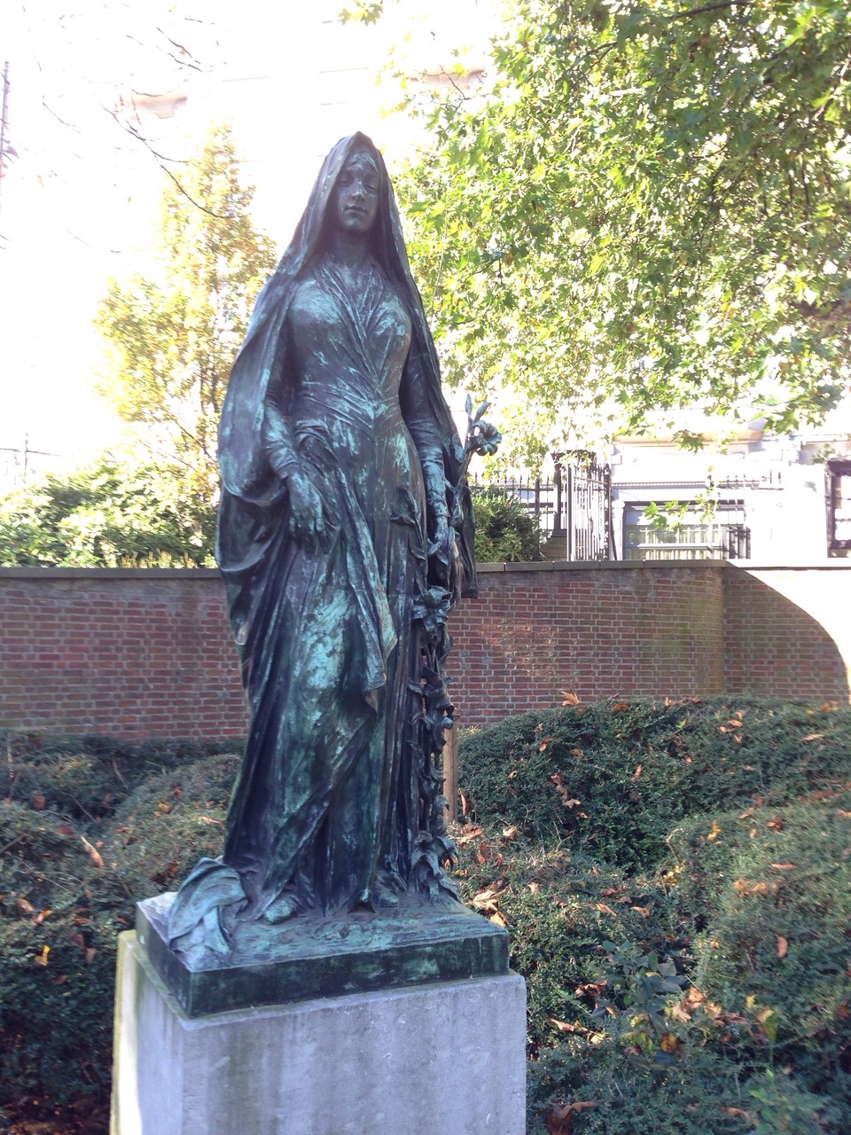
(Fig. 1) DESENFANS, Constant Albert (1845-1938), Le Lys, 1895-1898, cast bronze, 2m00. Saint-Josse-Ten-Noode, Botanical Garden.

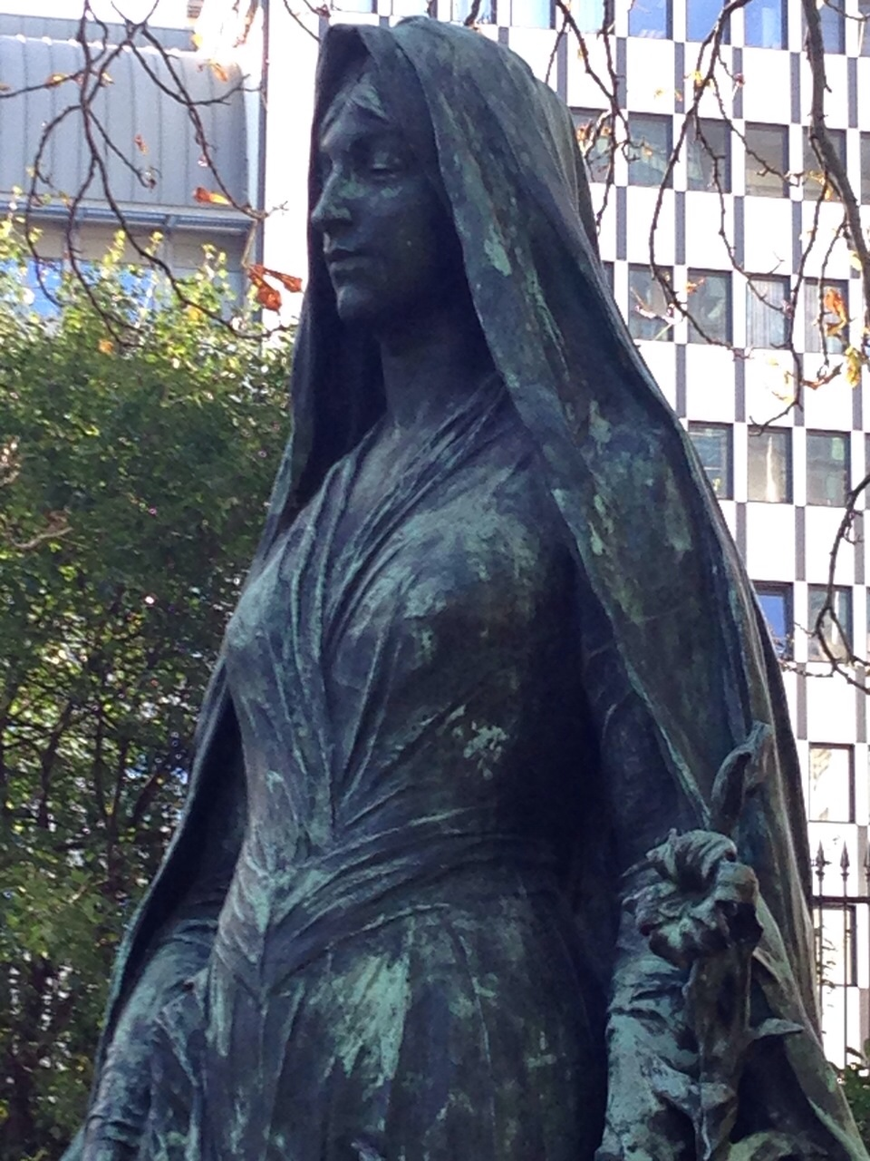
(Fig. 2) DESENFANS, Constant Albert (1845-1938), Le Lys, 1895-1898, cast bronze, 2m00. Saint-Josse-Ten-Noode, Botanical Garden.

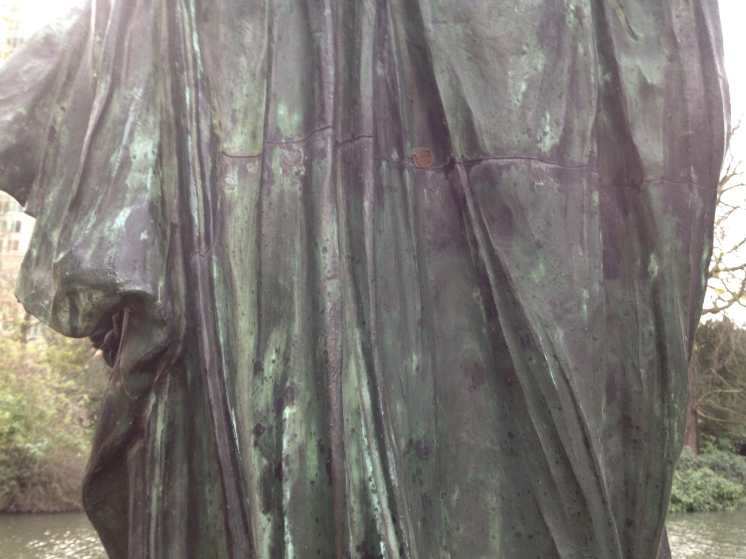

(Fig. 3) DESENFANS, Constant Albert (1845-1938), Le Lys, 1895-1898, cast bronze, 2m00. Saint-Josse-Ten-Noode, Botanical Garden.

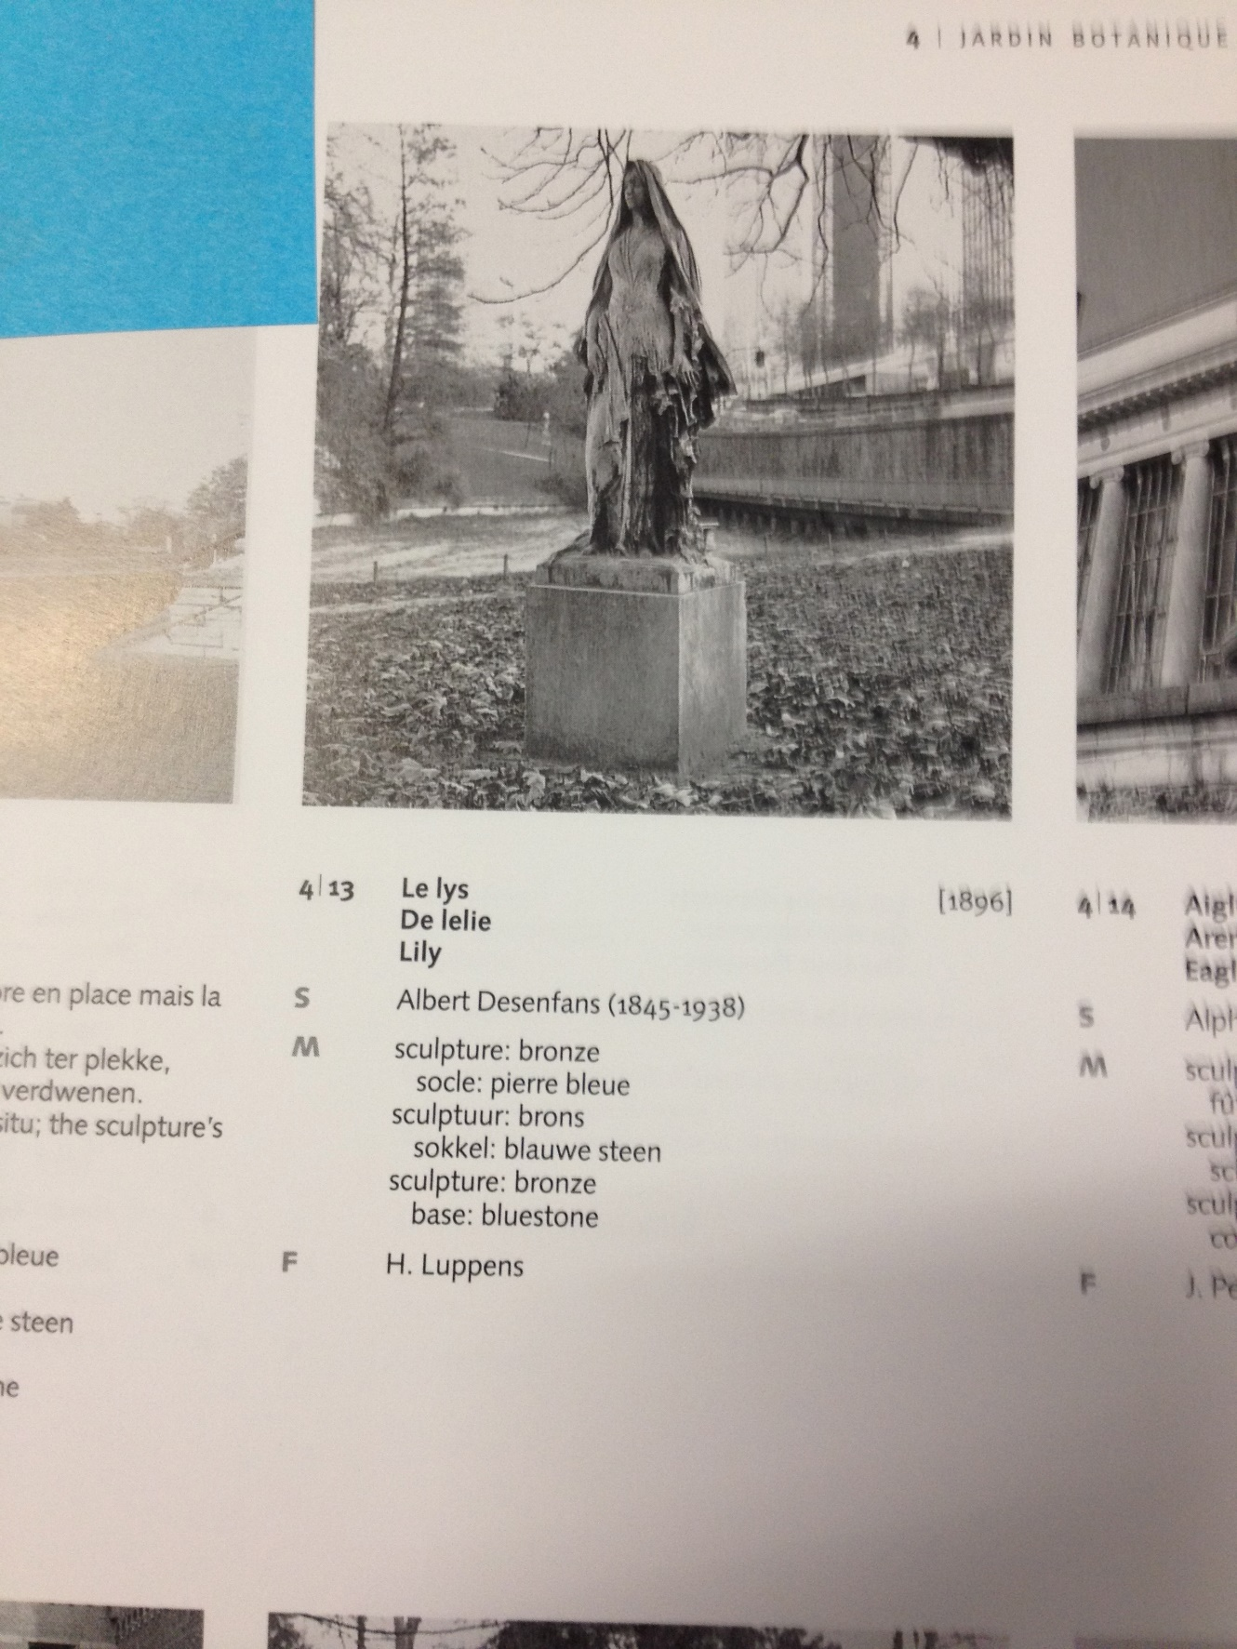
(Fig. 4) DESENFANS, Constant Albert (1845-1938), Le Lys, 1895-1898, cast bronze, 2m00. Saint-Josse-Ten-Noode, Botanical Garden.
(From : Derom, P., Marquinie, G., 2002. Les sculptures de Bruxelles (Catalogue raisonné), Brussels : Patrick Derom Gallery Brussels.)

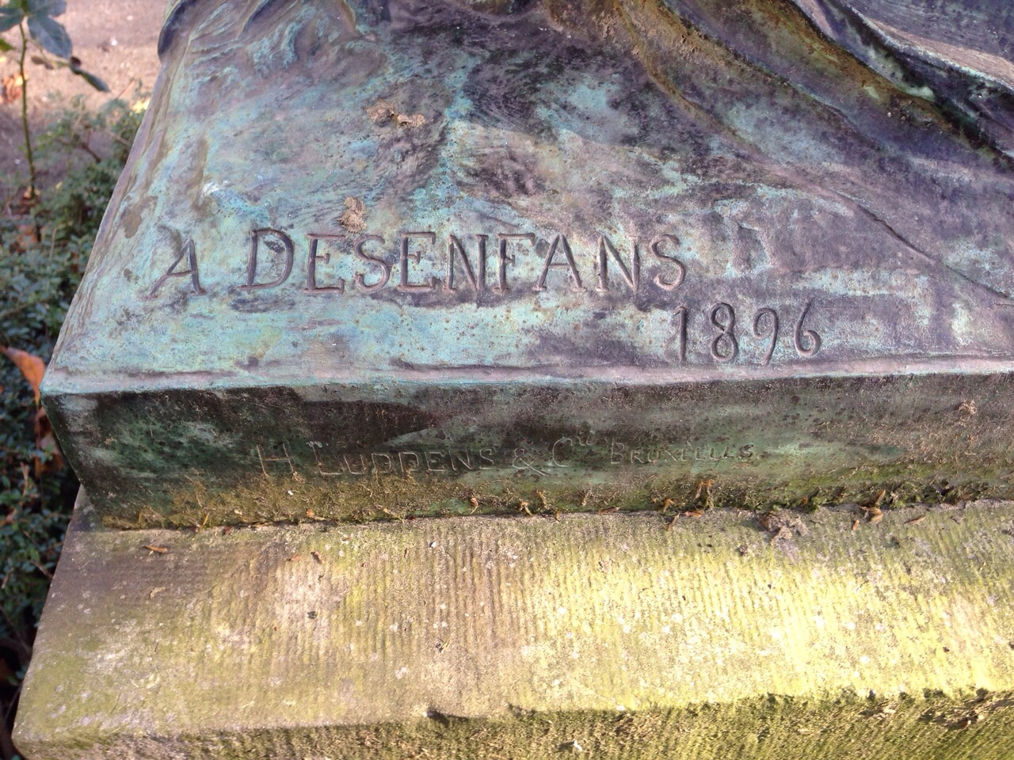
(Fig. 5) DESENFANS, Constant Albert (1845-1938), Le Lys, 1895-1898, cast bronze, 2m00. Saint-Josse-Ten-Noode, Botanical Garden.

Appendices
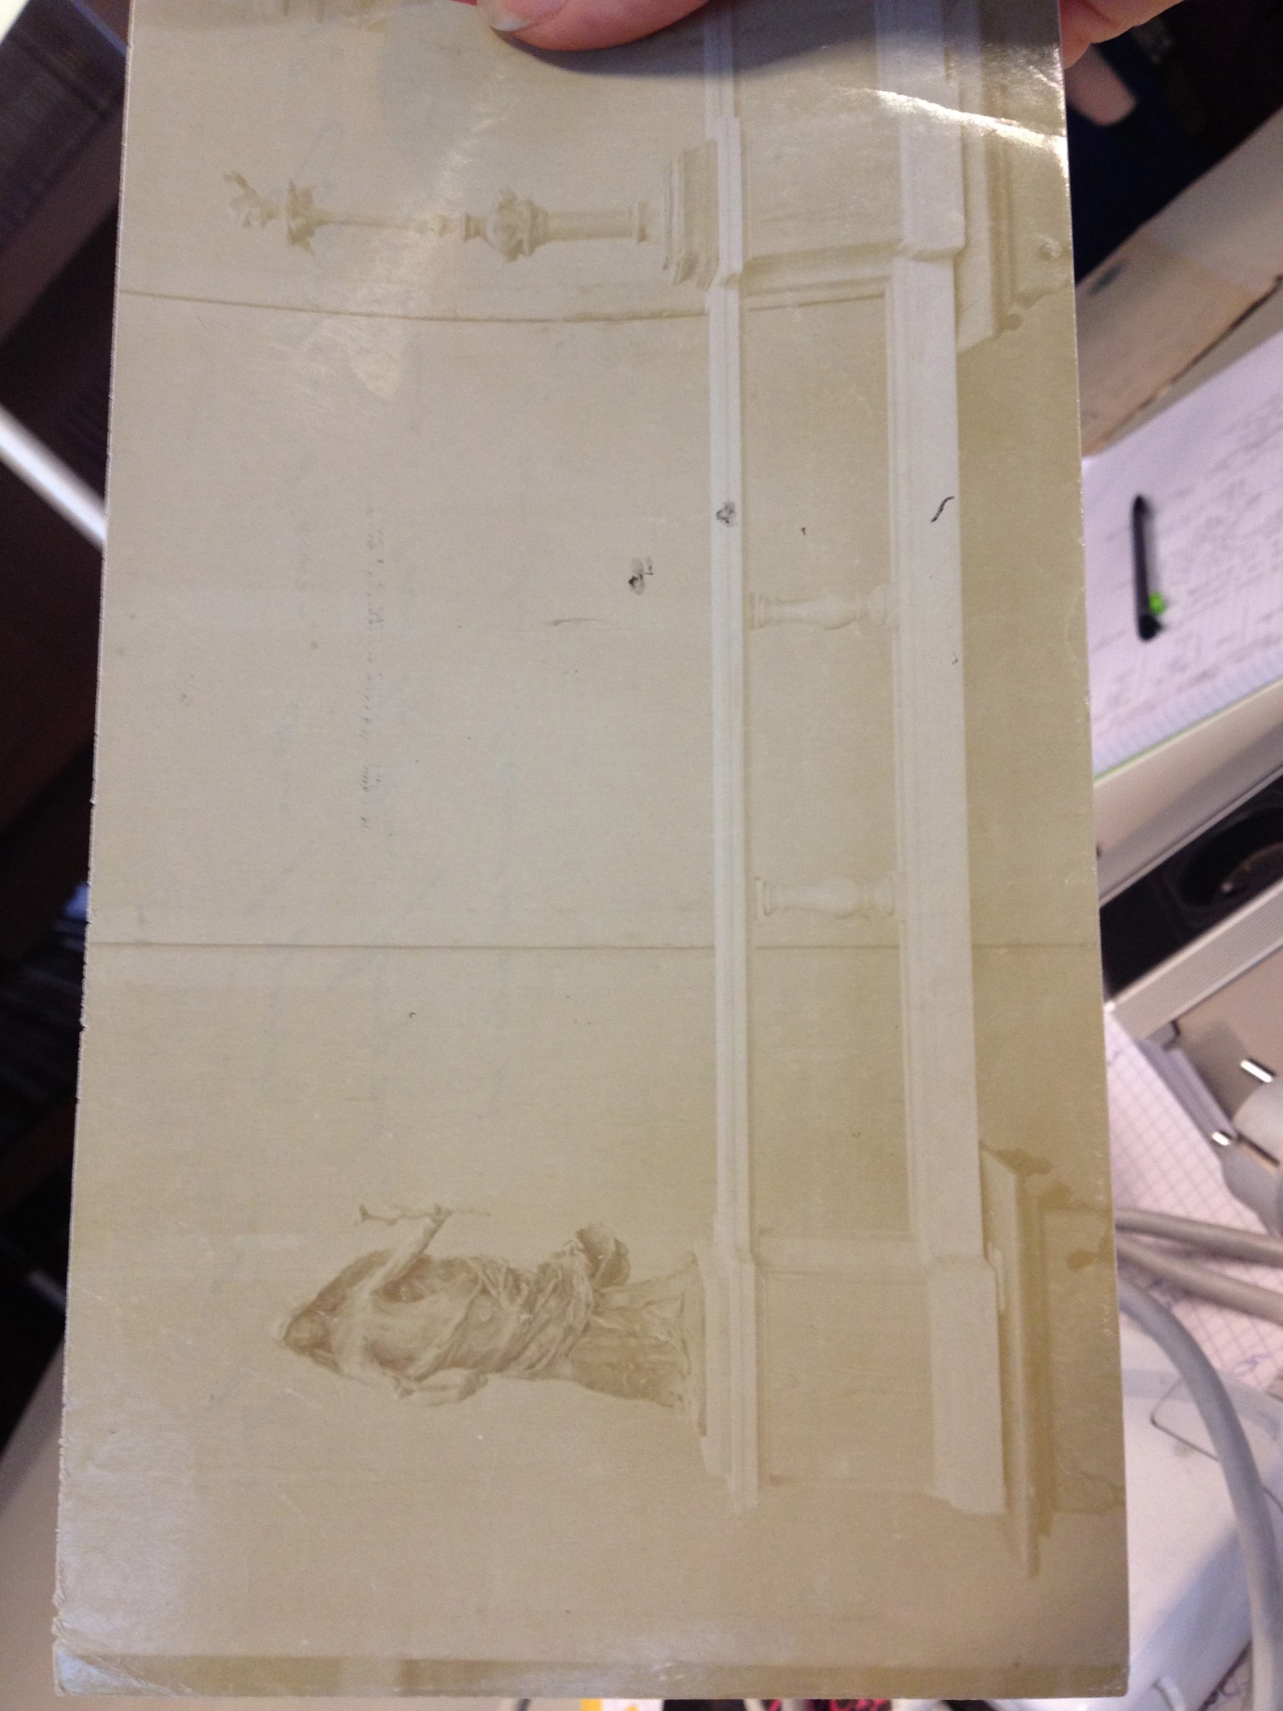

Appendix 1 Photo. Brussels: Belgian Nation Archives 471

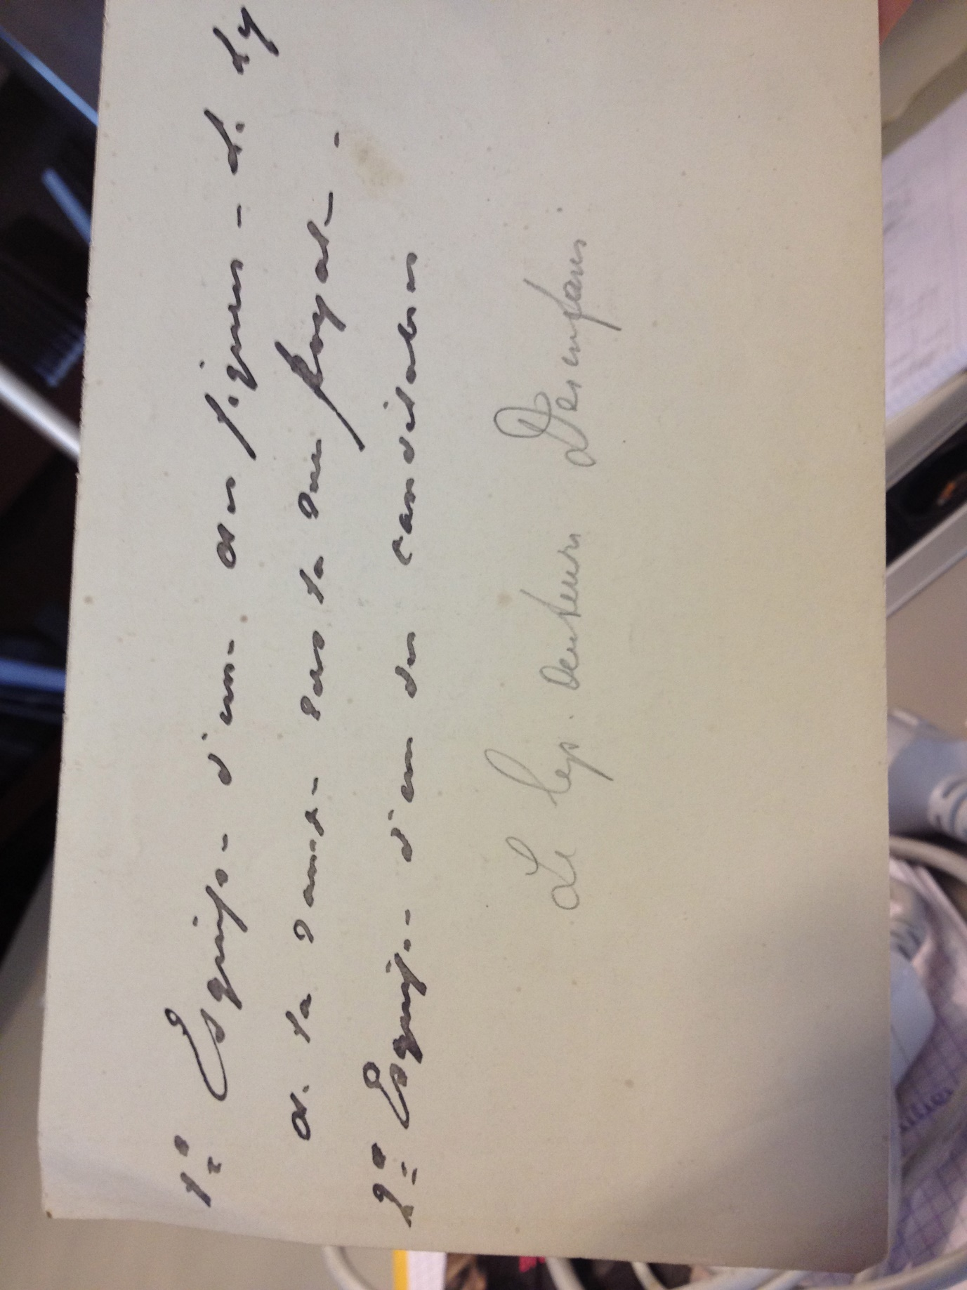
Appendix 2 Back of photo Brussels: Belgian National Archives 471

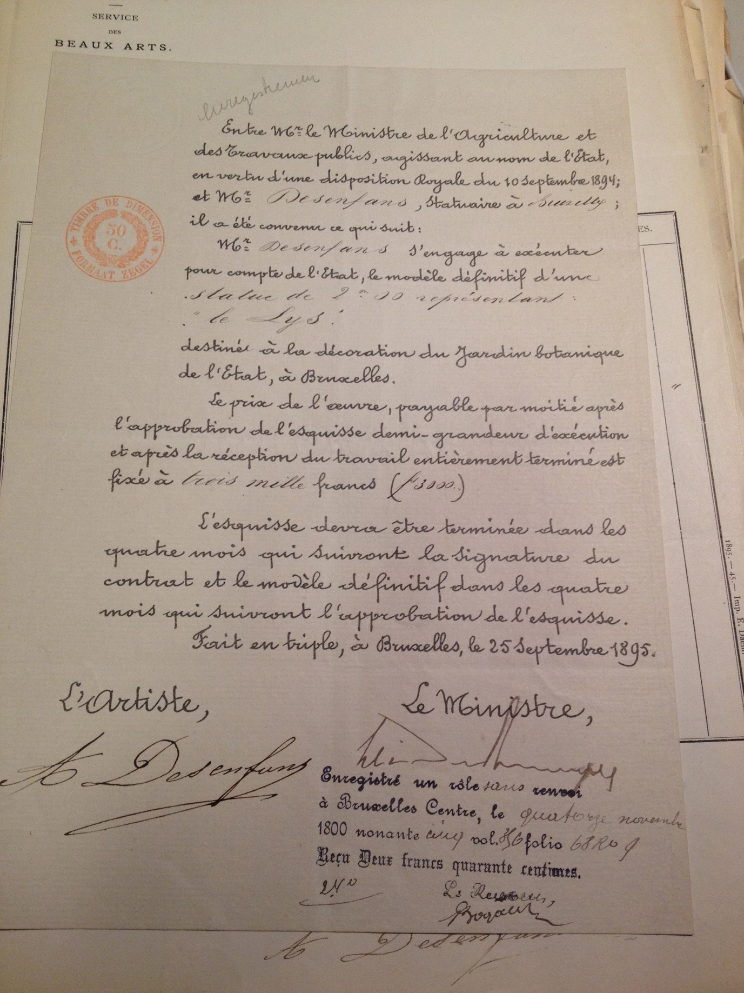
Appendix 3 Contract between the Minister for Agriculture and Public Works and Albert Desenfans, sculptor, 14th November 1895 National Archives of Belgium, Fine Arts Section, 472

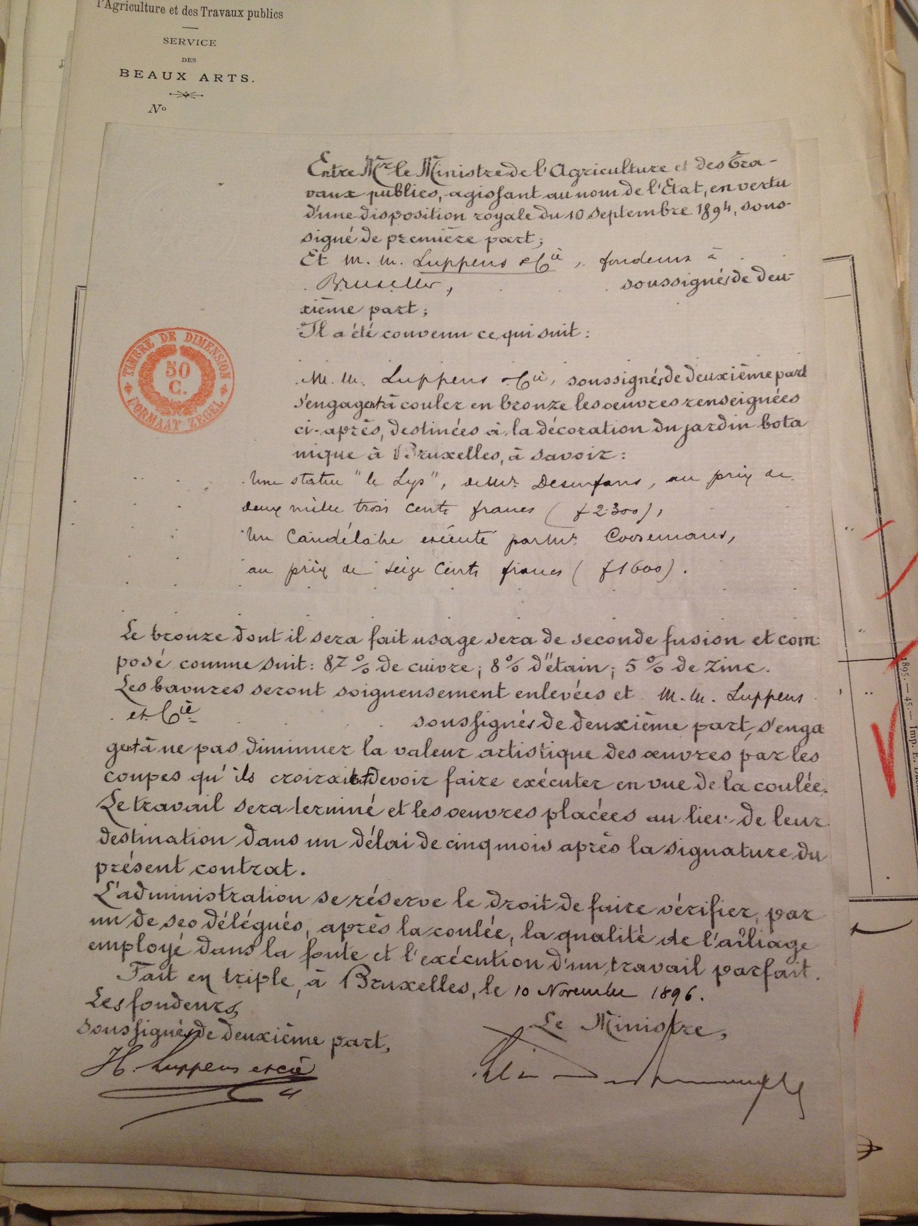
Appendix 4 Contract between the Minister for Agriculture and Public Works and H.Luppens and Co Foundry, 10th November 1896 Brussels: Belgian National Archives, Fine Arts Section, 475

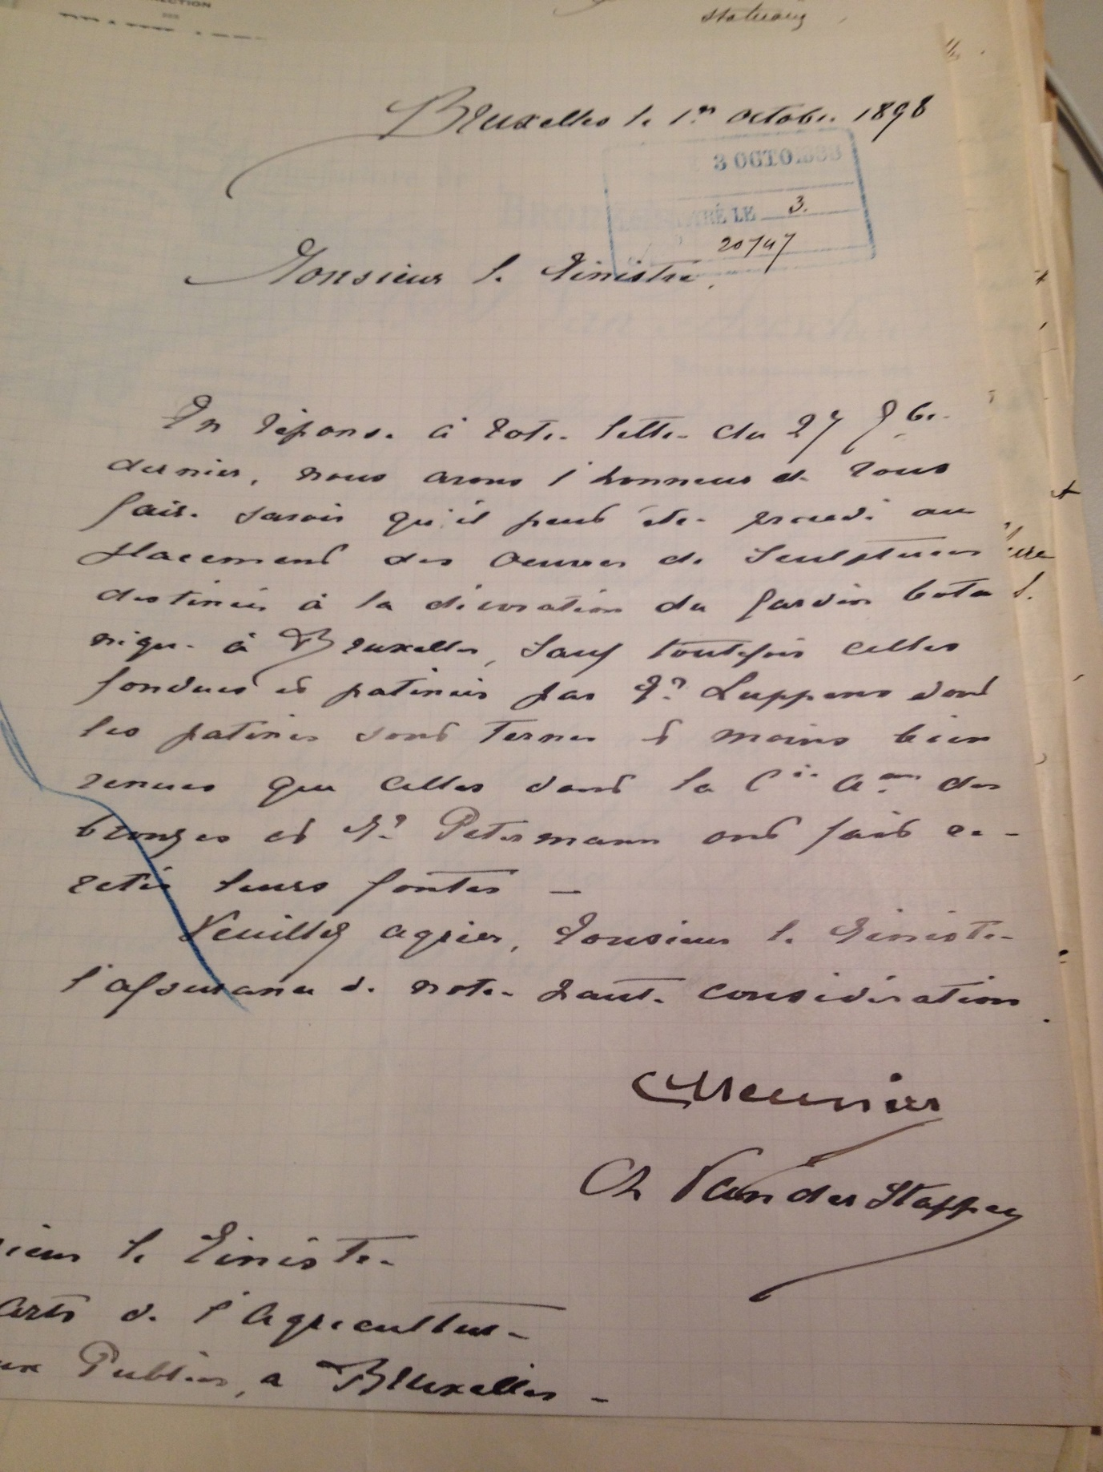
Appendix 5 Letter from Meunier and Vanderstappen, sculptors in charge of the sculptural ornamentation of the Botanical Garden, to the Minister, October 1898 Brussels: National Archives of Belgium, 475

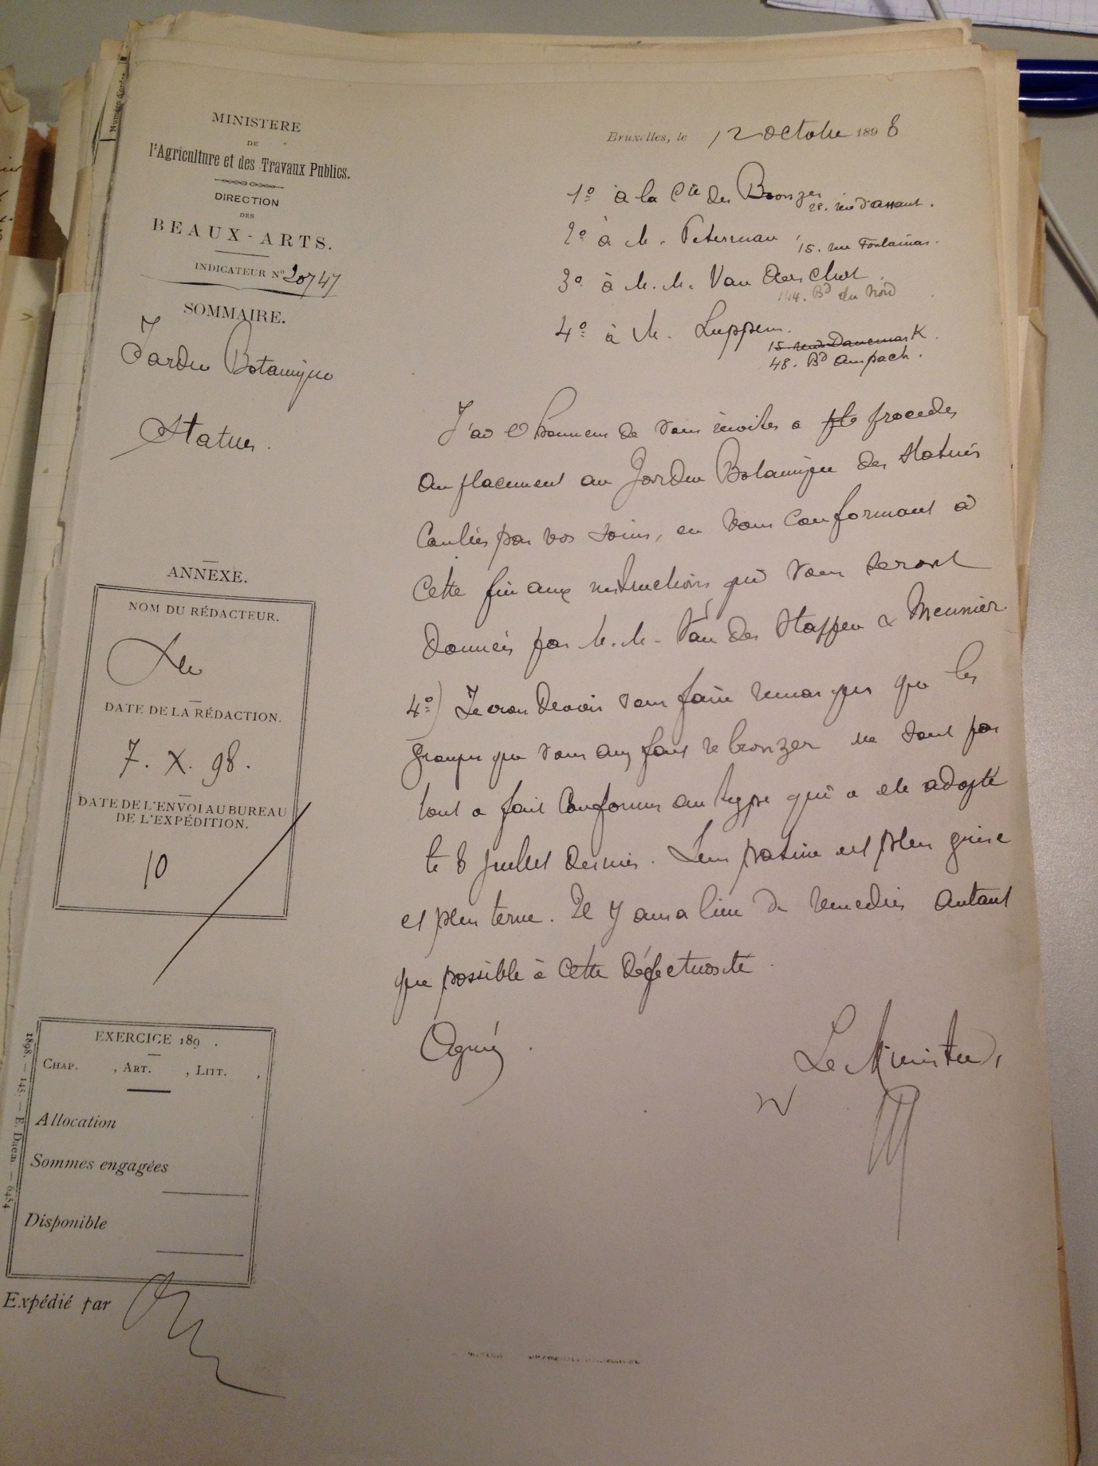
Appendix 6 Letter from the Minister, 12th October 1898 Brussels: Belgian National Archives, 475

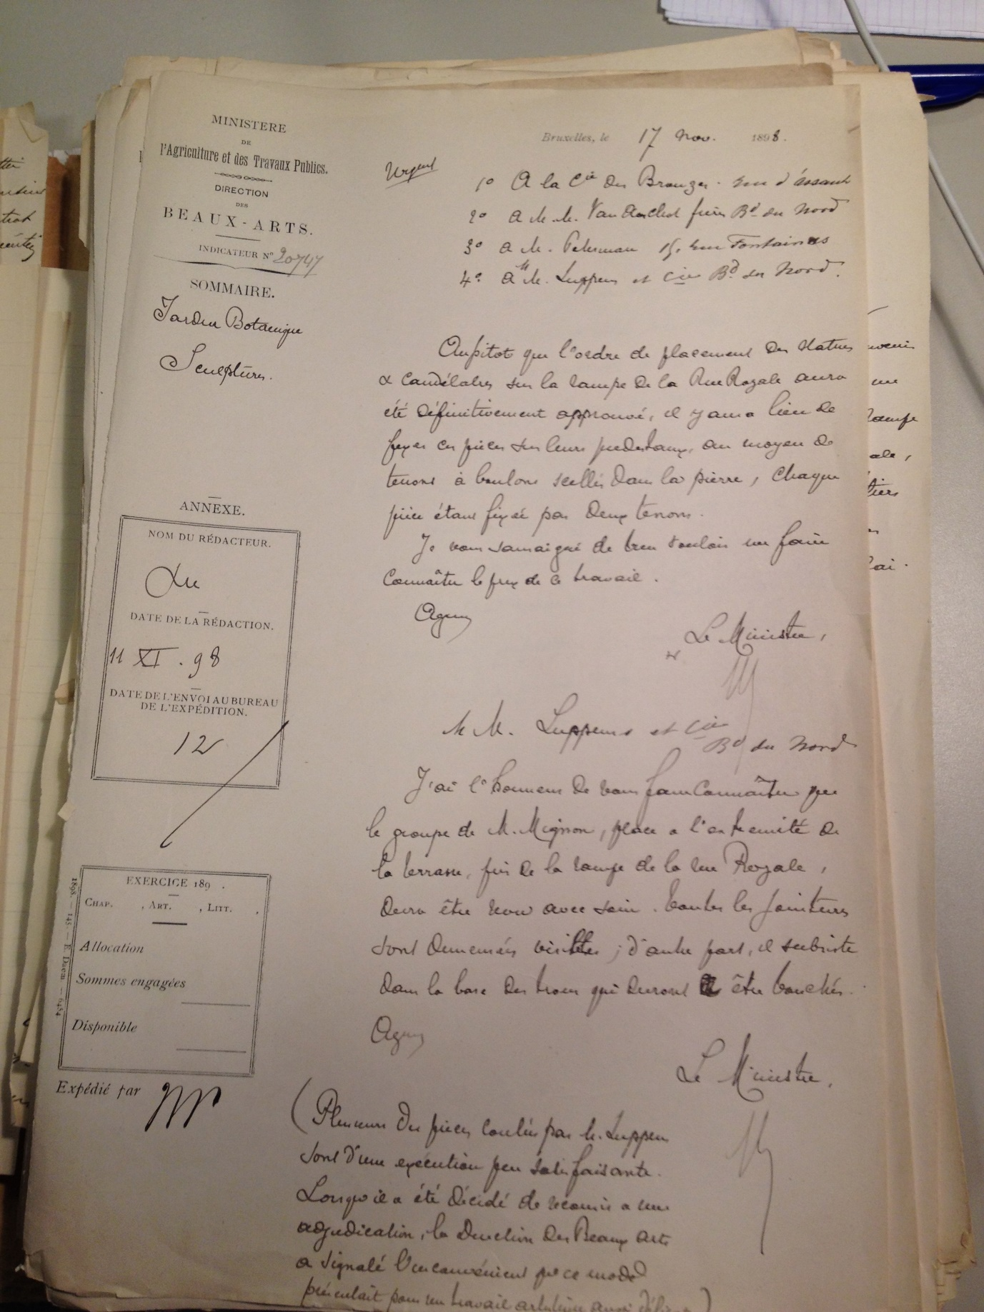
Appendix 7 Letter from the Minister of Agriculture and Public Works to the 4 foundries commissioned for the bronze melding of the statues, 17th November 1898 Brussels: National Archives of Belgium, 475

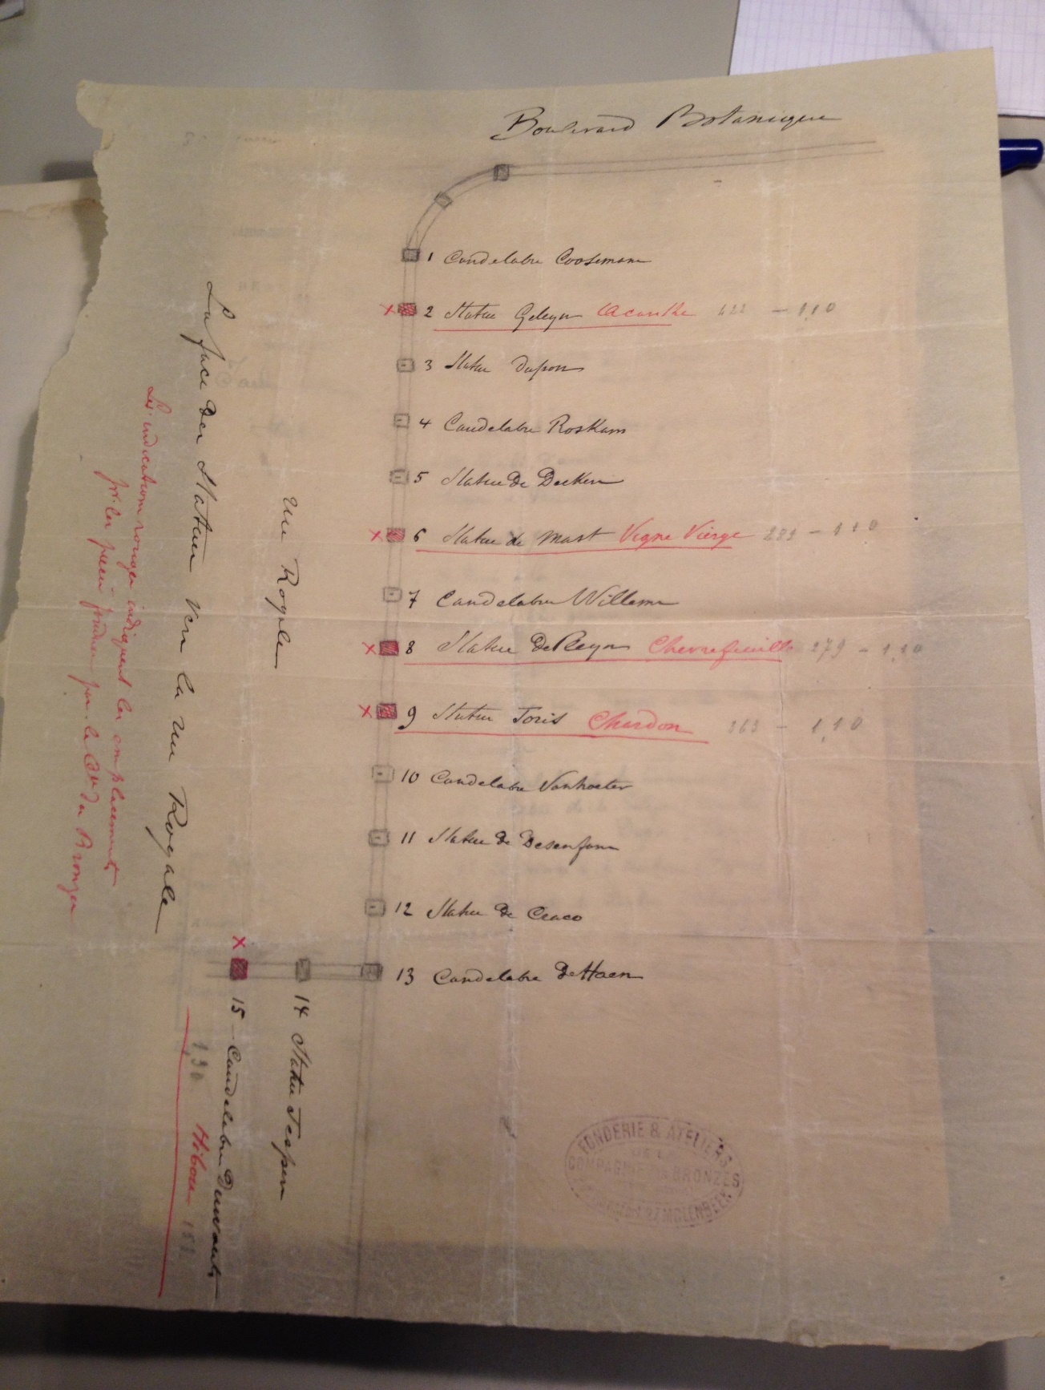
Appendix 8 Map of the positioning of the statues on the approach to the Rue Royale. Brussels: Belgian National Archives, 475

