**Leah Catherine Shoup**

_________________________________________________________________________________________________________________________________________________________________

205 Chandler Walk • Loganville, GA • 770-598-4304 • leahshoup@gmail.com

_________________________________________________________________________________________________________________________________________________________________

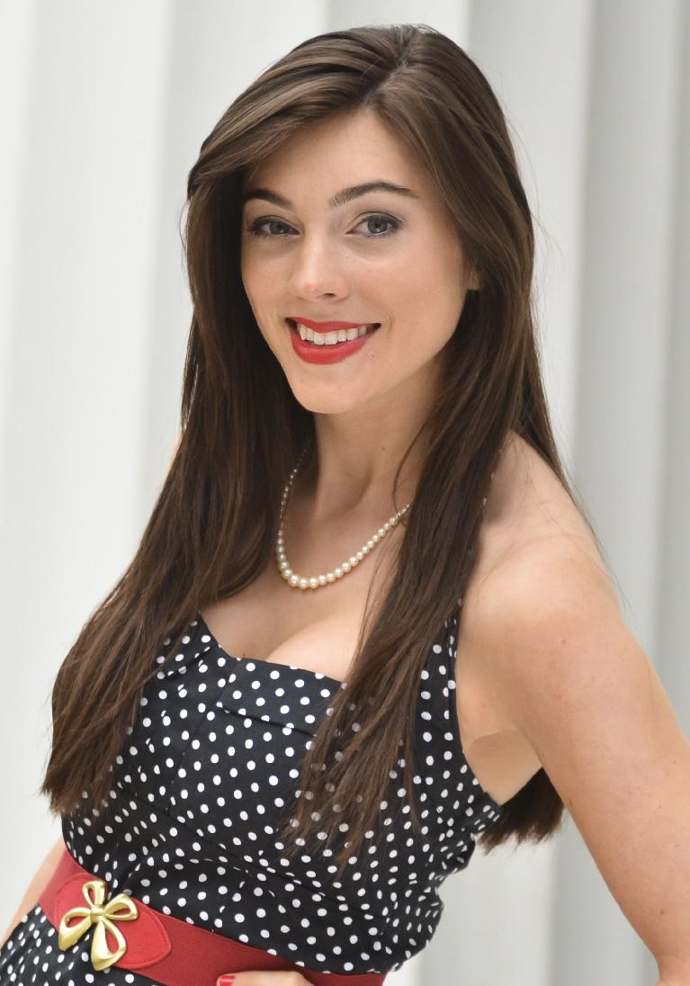**Education**

**Wake Forest University,** Winston-Salem, NC, USA

**Master of Arts in Translation & Interpreting Studies,** May 2014

**GPA**: 3.89

**University of Georgia**, Athens, GA, USA

**Bachelor of Arts in Spanish**, May 2013

**GPA:** 3.86 *Magna Cum Laude*

**Universidad de Cádiz**, Cádiz, Spain

May 2011-July 2011

**International House**, Madrid, Spain

May 2012-July 2012

**South Gwinnett High School**, Snellville, GA

**High School Diploma**, 2010

**GPA:** 3.92 *5th in class*

**Work Experience**

**Journal Revisions,** *Translation Quality Manager (Santiago, Chile)* May 2015- present

Responsible for Spanish to English translation of manuscripts to be published in academic journals as well as

analyzing research papers, assessing their novelty, evaluating references, and choosing scientific journals for

submission.

Collaborator during university seminars on bibliometrics.

**American Journal Experts,** *Independent Contract Translator Spanish-English (Remote)* December 2015-December 2017

Spanish to English translation of manuscripts within the field of Social Sciences. Required 72-96 hour

turnaround on translations.

**Santo Tomás English Program,** *English teacher* July 2014- March 2015

English teacher for the STEP program of the University of Santo Tomás in Santiago, Chile.

**Wake Forest University School of Business,** *Business interpreter* October 2013-April 2014

Interpret seminars on building a better business canvas model to native Spanish-speakers.

Translation of some business course materials into Spanish.

**Special Skills**

A language: English B language: Spanish C language: Portuguese

**Continuing Education**

**Tandem Language School**, Santiago, Chile: Basic, Intermediate 1 and Intermediate 2 Portuguese classes (2014-2016)

**Step1 Language School**, Florianópolis, Brazil: Advanced Immersion course in the Portuguese language (January-February 2016)

**References**

Dr. Luis González, Phone: (336) 758-5428 E-mail: [gonzall@wfu.edu](mailto:gonzall@wfu.edu)

Dr. Olgierda Furmanek, Phone: (336) 758-3924 E-mail: [furmano@wfu.edu](mailto:furmano@wfu.edu)