|  |  |  |
| --- | --- | --- |
|  | **INSTRUCTION MANUAL** | manual KB4  Page 1 of 14 |

**DISPENSER FOR PLASTIC STRAP**

**(width 12-20 mm)**

**MODEL KB4**

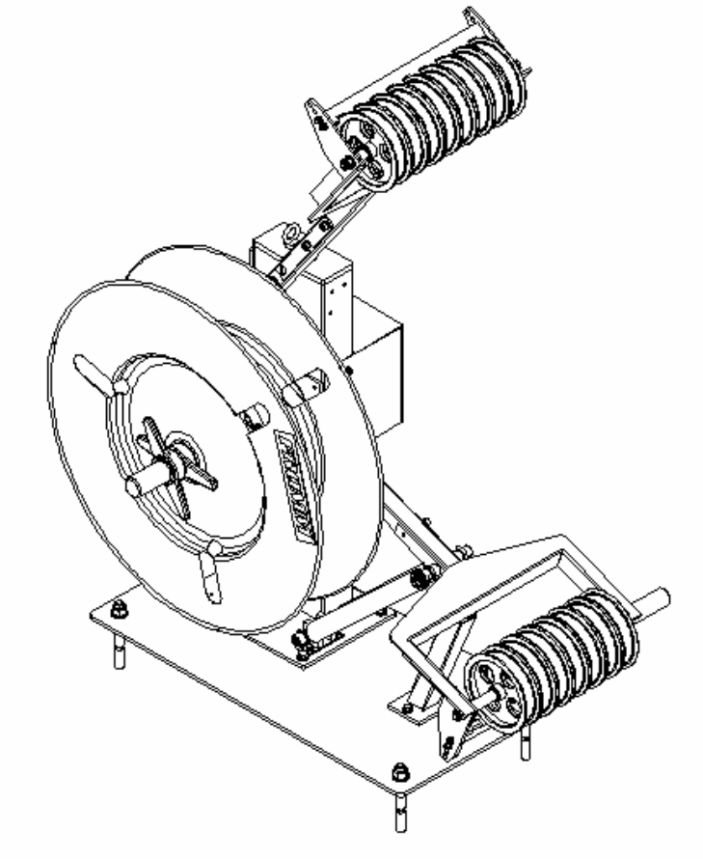

|  |  |  |
| --- | --- | --- |
|  | **INSTRUCTION MANUAL** | manual KB4  Page 2 of 14 |

# INDEX

## Page

* 1. INDEX 2
  2. GENERAL DATA 3
  3. TECHNICAL DATA 5
  4. INSTALLATION 6
  5. MACHINE FUNCTIONING 11
  6. SPARE PARTS LIST AND DRAWINGS 13
  7. ELECTRICAL LAYOUT AND COMPONENTS 14

|  |  |  |
| --- | --- | --- |
|  | **INSTRUCTION MANUAL** | manual KB4  Page 3 of 14 |

# GENERAL DATA

#### GENERAL DESCRIPTION

Plastic strapping dispenser for all current strap coils with a core of 406mm and a coil width of 150mm. This dispenser can be assembled with right or left strap exit.

The dispenser has an electromagnetic brake activated by sensors in order to give the strap fed in the rules set.

When a strap coil is loaded, the front metal cover is taken off by removing the wing nut. The exchange of the strap coil is simple and swift.

The decoiling and the coiling speed is matched to the speed of the strapping unit and guarantees a flawless strap feeding as well as a trouble free strap storing.

#### MANUAL AND OPERATIVE INSTRUCTIONS

The instructions and the manual, supplied by the manufacturer must be known to all the personnel using the machine and to every responsible person.

Personnel are obliged to read and follow the instructions before using the machine.

To avoid accidents regular maintenance is essential of all the parts of the machine according to the instructions of the manufacturer.

#### SAFETY INSTRUCTIONS



**ATTENTION!**

The non-observance of the following recommendations can cause serious accidents and, in this case, we decline any responsibility.

#### GENERAL RULES FOR ALL THE USERS

In order to prevent accidents, it is essential to:

* read and follow the instructions given with the machine. Only personnel with a complete knowledge of the instructions of the manufacturer can work on the machine
* use the machine in a perfect condition, without safety or operative defects
* verify the perfect condition of the safety electric devices and their correct functioning
* the safety electric devices must be always used
* advise the responsible person and people who work on the machine about any anomaly
* check before starting the machine, that nobody is working on a part not observable from the operator’s place
* don’t put the hands or other parts of the body inside or near the action zone of the machine

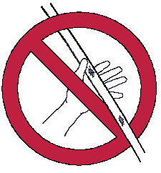

|  |  |  |
| --- | --- | --- |
|  | **INSTRUCTION MANUAL** | manual KB4  Page 4 of 14 |

* when feeding the strap, people must use masks with a suitable protection visor or safety glasses. The non-observance of this rule could cause serious damage to the eyes



* use protective gloves each time you load the strap. The non-observance of this rule could cause serious damage to the fingers and to the hands



* the bad use of the machine or the corners of the pack, could cause the break of the strap during the tensioning or the welding. The elastic effect could cause serious injury on face. If the machine is used for packages with sharp parts that cause the break of the strap, it’s necessary that the client use a corners device system.

#### SAFETY DEVICES

The safety devices refer to parts subjected to normal use. A qualified person, or one specially designated, must check all the safety devices, according to the documentation given by the manufacturer.

The necessity of the safety barrier is due to the fact that the moving carriage can press the operator fingers in the bottom position. During the strap loading operation the operator must insert the arm stop.

#### PEOPLE PROTECTION

As a general rule, for each protective device, check the followings points:

* the device must be complete and in good condition.
* the electric contacts must be clean
* the machine must be stopped when the safety barriers are opened
* the machine must not be used until all the protections are not installed and ready

#### WARRANTY AND LIABILIY

* The machine must only be serviced and repaired by authorised service centres or after Fromm approval.



**ATTENTION!**

If the above-mentioned regulations are not followed all liability and warranty claims are rejected!

* In the interest of improving its quality we reserve the right to change without notice the product subject to the contract.

|  |  |  |
| --- | --- | --- |
|  | **INSTRUCTION MANUAL** | manual KB4  Page 5 of 12 |

# TECHNICAL DATA

#### Strap material

Plastic strap (PP-PET)

#### Strap available in the dispenser

approx. 12 m. (moving carriage in bottom position) Should you need more strap, please ask for additional couples of wheels

**Net weight (approx.)**

95 kg / 209,5 lbs

**Dimensions (approx.)**

Height: 1380 mm / 54,0"

Width: 1120 mm / 43,9"

Depth: 670 mm / 26,2"

#### Bobines dimensions maximales

Diameter ext. 600 mm

Width : 150 mm

Weight approx. 50 kg

#### Electrical data

Voltage: 24 Vdc

Power: 24 W

Max. electrical current: 1 A

Electrical connection: 1 cable with connector joint to the electrical cabinet

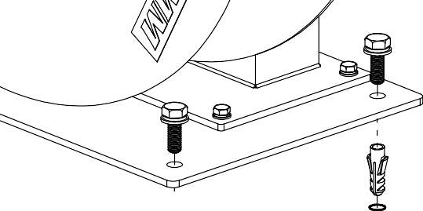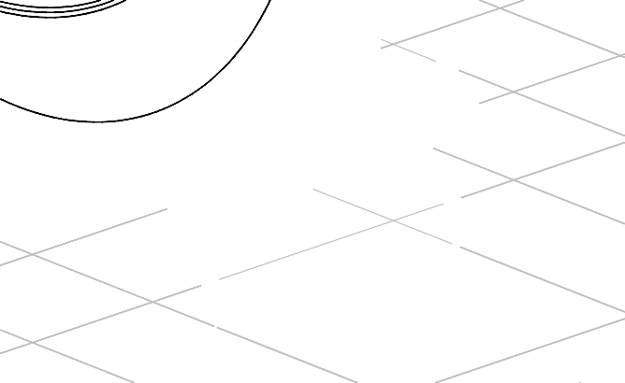

|  |  |  |
| --- | --- | --- |
|  | **INSTRUCTION MANUAL** | manual KB4  Page 6 of 14 |

# INSTALLATION

#### TRANSPORT

For transportation it is preferable, if possible, to keep the assembled mounted for rapid installation and correct functioning.

#### INSTALLATION

Before positioning the dispenser you must be sure that the floor is level and that it is strong enough to support the machine. First of all the dispenser must be placed in the strapping area. The correct position depends on the strapping machine dimensions specified by the foundation drawing.

In order to obtain a proper and certain dispenser installation it is preferable to make a trace on floor for the subterranean passage of the electric cables from the console to the dispenser.

If it is not possible, for an any reason, to make a trace, it is at least advisable to protect the cables with a metal cover.

Once you have installed the strapping machine in the proper position, considering all the foundation dimensions and the alignments, you can drill the floor (Diam. 17 mm) and fix the dispenser basis plates with screws to ground using the supplied inserts (according to the positions of the previous figure).

The dispenser could be placed also over the strapping machine.

Once the machine is fixed to ground and before starting the testing of the machine, it is better to:

* Check the entire strapping path: it must be aligned (from the dispenser to the rollers guides ribbon, exit/entry of the strapping head, strapping arc) and without obstacles. All the components that guide the strap to the head have the necessary regulation and avoid any friction;
* check that the moving carriage is not stopped;
* check that the bottom sensor is activated by the moving wheels in bottom position (it is used for home position); if the moving carriage stays there even when the machine feeds the strap it means that the strap is end and then a message appears on the operating panel of the strapping automatic machine (and if the customer has the 4 lamps column the blue light is on).
* load the minimum number of wheels enough for feed the strap on the arc (usually for arch till 10 meters length is enough to load strap on 4 fixed top wheels and 3 moving bottom wheels). Usually 1 wheel on top and 1 wheel on bottom are without strap;
* check that the top sensor is not activated during the strap feeding (it’ll be activated if we’ve problem during strap feeding and, in that case, we stop feeding to prevent too much strap output and we take away the brake to move down the moving wheels group).

|  |  |  |
| --- | --- | --- |
|  | **INSTRUCTION MANUAL** | manual KB4  Page 7 of 14 |

#### RIGHT AND LEFT ASSEMBLING

The dispenser can be assembled with right or left strap exit. The spare parts are the same but the assembly is different.

Right assembly

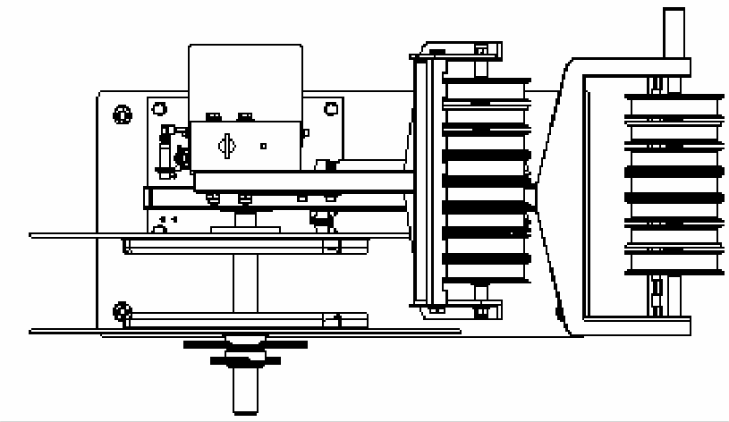

Left assembly

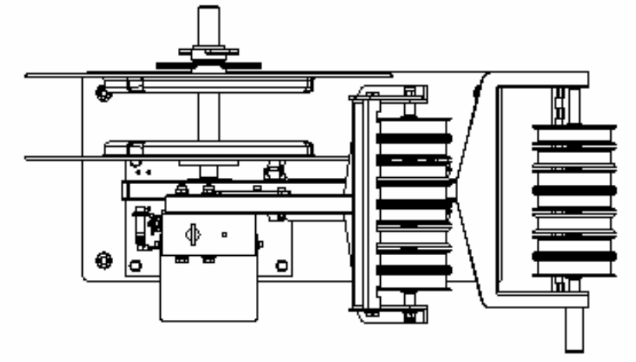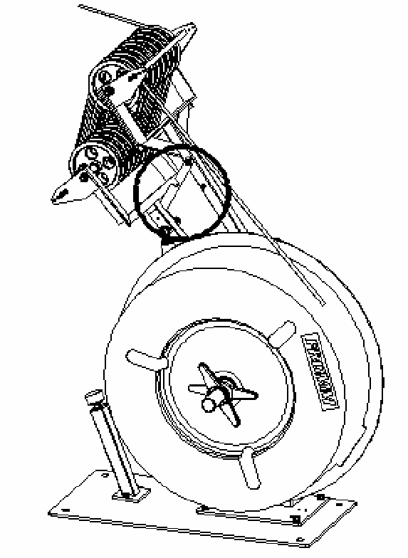

**Picture 1**

|  |  |  |
| --- | --- | --- |
|  | **INSTRUCTION MANUAL** | manual KB4  Page 11 of 14 |

# MACHINE FUNCTIONING

#### MACHINE FUNCTIONALITY

This machine, called dispenser, doesn’t work alone; it works together with the strapping machine. The strapping head feeds the strap inside the arc taking it from the dispenser (when the bottom wheels lift up they feed the strap on the arc). When the head takes back strap the dispenser, with the strap coil braked, loads it on the loops between the top and the bottom wheels created by the weight of the bottom carriage.

Only when the head is in home position the plc takes away the brake from the shaft so the rotation of the strap coil gives straps and the moving wheels go down. To reduce the inertia of the moving wheels, so the strap is always tensioned by the weight of the carriage, the brake is activated for half a second every half a second. When the moving wheels arrive to the home position the bottom sensor activates the brake and gives the signal that the dispenser is ready for next strapping cycle.

#### STRAP COIL LOADING

Rotating the wing nut clockwise you remove the steel cover and you can insert the coil on the support according to the painted arrow. The painted arrow gives the rotation direction of the coil.

After that you must place again the cover and the wing nut.

#### STRAP LOADING

Lifting up the bottom moving carriage you stop it turning the hand lever (see picture 1).

After that pushing the top sensor the brake is not activated (because when there is no electricity the coil is braked) so it is easy to load the strap in the top and bottom wheels to obtain strap loops.

If you raise a little more the bottom carriage, rotate the stop hand lever again and support the carriage while it is falling down, you can load completely the strap.

When the moving carriage goes to the bottom position the coil will be braked again (see picture 2).

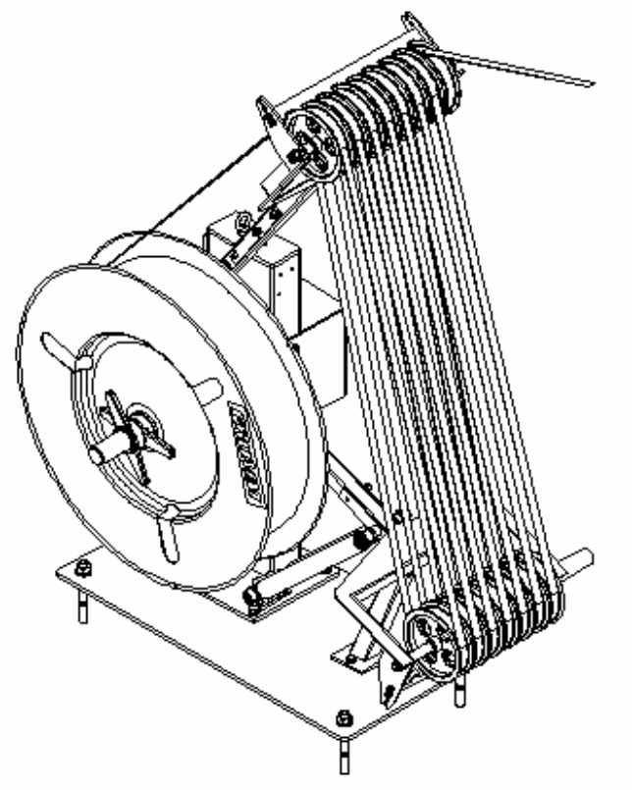

**Picture 2**

|  |  |  |
| --- | --- | --- |
|  | **INSTRUCTION MANUAL** | manual KB4  Page 12 of 14 |

#### CLEANING

If impact of dirt and dust is considerable and if painted straps are used the pulleys and the sensor’s zone must be cleaned regularly.

Normally it is sufficient to blow it out by the use of an air gun.