Curriculum Vitae

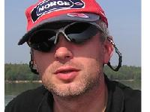
Pawel Michniak
Address: ul. Grabanka 9c
43-600 Jaworzno
Poland
Phone: +48.605.219.110
E-mail address: pavo@burano.pl
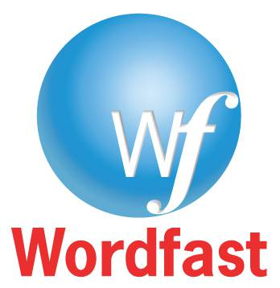
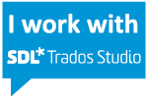
Skype: pavo22
Web: www.proz.com/profile/101254

Date of Birth: 16th June 1972


Language pair: English-Polish

Native language: Polish

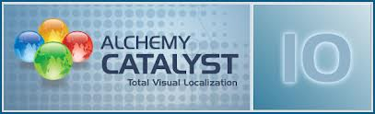
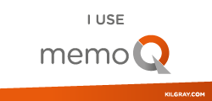

Education:
2010; Tischner European University; Krakow, Poland, Postgraduate Studies in Audio and Video Translation

1997; University of Silesia in Katowice, Poland, Faculty of Law and Administration, Department of Financial Law; Master of Arts

1995; University of Silesia in Katowice, Poland, Faculty of Philology, Business Language College, Bachelor of Arts in Business English

1995; University of Silesia in Katowice, Poland, Faculty of Philology, Business Language College, Bachelor of Arts in Business German

Professional Experience:
1997-present; self-employed; Polish-English-Polish interpreter and translator. Organisation and interpretation of meetings, events and conferences dealing with law, taxation and customs, engineering, HR, e-commerce, ERP (SAP & Microsoft Dynamics AX), economics, environmental issues, power generation, medical instruments, clinical trials (Asthma, Alzheimer Disease, Psoriasis, Psoriatic Arthritis, Polycystic Kidney Disease, Non-Small Cell Lung Cancer, Pancreatic Cancer, Metastatic Bone Pain, Menstrual Distress, Knee, Hip & Shoulder Replacement, Knee Osteoarthritis, Ankylosing Spondylitis, Age-related Macular Degeneration, Dementia, Urinary Incontinence, Crohn's Disease, Ulcerative Colitis, Post-Herpetic Neuralgia, Neuropathic Pain to name only some). Translation of investigator’s brochures, Case Report Forms (CRF), information given to trial subjects, informed consent forms, agreements between involved parties, clinical study protocols, etc. Interviewing and debriefing of numerous patients for linguistic validation of surveys dealing with the above diseases. Interviewing numerous automotive industry players to capture their expectations, preferences and aversions (Vice of Customer). Making of reports of the above interviews, debriefings and VOCs meetings. Translation and interpreting for such customers as: Amcor, Adidas, Atlas Copco, Balfour Beatty, Bauch & Lomb, BP, Bristol-Meyr Squib, Caterpillar, Chevron Phillips, Chiquita, Cisco, Citi, Danone, Dell, FIAT, Google, Hilton Hotels, HTC, Infinity, ING, KIA, Lilly, Johnson & Johnson, Medtronik Sofamor Danek, Merck, Nicorette, Nissan, Novartis, Opel, Pfizer, Philip Morris, Philips, Sandvik, Saxo Bank, Shell, Tesco.

Some interpreting assignments I have done:
Medica 2011 Tradefair - Düsseldorf, Germany
Masters of Architecture - Katowice, Poland
American Glass Research seminars: "Glass Fracture Analysis", "Glass Plant Audit", "Advanced Glass Fracture Analysis", "Glass Coating", "Evaluation and Lightweighting of Glass Container Designs", "Testing and Fracture Diagnosis of Glass Bottles" (2012-2018) - Krakow, Poland
Property Forum 2012 - Katowice, Poland
Quality of Education and Quality of Evaluation - Krakow, Poland
Sustainable Development – Challenge for Modern Europe Conference, Wodzisław Śl., Poland
Ocean Business 2013 & 2015 – Southampton, UK
Globsec 2014 - Bratislava, Slovakia
5th European Congress of Ericksonian Hypnosis and Psychotherapy - Krakow, Poland
EcoPapaerLoop Conference - Krakow, Poland
The First Congress of Polish Museologists - Łódź, Poland
Conference "The Role of Local Governments in Building of the School of Tomorrow" - Warsaw, Poland
World Usability Day Conference (2012-2015), Katowice, Poland
American Day at the Chamber of Commerce and Industry, Katowice, Poland
Meetings with Phil Grabsky, a film director, Gliwice and Katowice, Poland
A Breakfast Meeting of the American Chamber of Commerce in Poland, Kraków, Poland
A press conference of the makers of "Valley of the Gods" movie: Lech Majewski, John Malkovich, Josh Hartnett, Berenice Marlohe and Keir Dullea, Katowice, Poland
2012, 2014, 2016 & 2018 Oceanology International, London, UK
A LIFE Project Conference, Kraków, Poland
12. International Scientific Conference "Forensic and Judicial Expertology: science, study, practice", Warsaw, Poland
European Capital of Culture, Social Congress: “Culture of values – value of culture”, Wrocław, Poland
Hydro 2010 & 2016 - Rostock, Germany
European Congress of Local Governments (2016, 2017 & 2018), Kraków, Poland
Today’s Threats in the Workplace, Rzeszów, Poland
European Economic Congress (2010-2014; 2016-2018), Katowice, Poland
Smart&Green Conference, Kraków, Poland
9th Congress of European Lotteries, Kraków, Poland
17th T-Mobile New Horizons International Film Festival, Wrocław, Poland
Anuga 2017, Cologne, Germany
28th Economic Forum, Krynica Zdrój, Poland
Festival of Innovation and Technology (2017 & 2018), Gliwice, Poland
4 Design Days 2018 & 2019, Katowice, Poland
Lean Camp 2018, Mysłowice, Poland
Dr Frank Kinslow – Quantum Entrainment 2017 & 2018, Warsaw, Poland
UNESCO Creative Cities Network Annual Meeting 2018, Katowice, Poland
Life Science Open Space 2016 & 2018, Kraków, Poland
European Congress of Small and Medium Size Enterprises 2015, 2016 & 2018, Katowice, Poland
Critical Infrastructure of Cities, Rytro, Poland
Congress 590, Rzeszów, Poland
United Nations Climate Change Conference, Katowice, Poland

Would you like to hear me interpreting? Please click here, here, here or here.

Trainings: March 2005; University of Economics in Katowice, Workshops on Translations of Financial Statements.
October 1997; University of Wales, Institute for Financial Education and Training; Bangor, A Technical Approach to FX Trading.

Skills: SDL Trados Studio 2019, MemoQ 2015, Memsource, WordFast 6.0 (Pro), SDLX, Alchemy Catalyst Lite, Across, QT Linguist, Subtitle Workshop, Abby FineReader 8.0 user, fluent in using of all popular MS applications (Word, Excel, Power Point, etc.), fluent in spoken and written English; advanced in German; driving licence, www.proz.com Certified PRO (profile no. 101254).

Interests: Travelling (30 countries all over the world), sport (cycling, ice-skating, swimming, skiing), photography.

