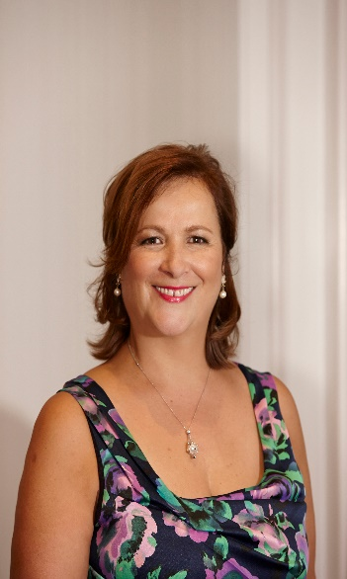

136 BURTON STREET

DARLINGHURST NSW 2010

Mobile +61412 549 527

mhatziplis@hotmail.com

Miranda Hatziplis

|  |  |  |
| --- | --- | --- |
| career profile |  | NAATI Certified translator from Greek to English since April 2020.  Experienced Wedding Coordinator with a demonstrated history of working in the hospitality industry for 35 years  Involvement in Fund-raising for not for profit association since 2010.  Currently Treasurer of Greek Young Matrons’ Association. |
| Professional Achievements |  | President of Greek Young Matrons’ Association (2014-2016)  * Through close liaison with the Sydney Children’s Hospital I was able have the Association inducted into the Hall of Champions by demonstrating that they had donated over 1 million dollars. This was possible due to my accounting skills. * Considerably cut costs and increased revenue in Operation of Charity Functions. * Produced a profitable ball program by seeking out advertising and designing layout in conjunction with graphic designers * Attained Deductible Gift Recipient( DGR) Status for the Association by establishing the GYMA Foundation by successfully applying to the ACNC. A long but very rewarding process given the outcome. * Treasurer of the Greek Young Matrons’ Association 2011-2013 * Active Committee member since 2010  management of westside reception - marrickville  * Oversaw thousands of weddings from booking to execution of function. * Professional Master of Ceremonies * Maintained an excellent relationship which ensured repeat business. * Well known and respected in Greek community, have held a variety of Gala events * Liqour licencee since 1989 and Responsible for Food & Beverage operations |
|  |  | * Strong financial management skills, having an Accounting degree combined with significant experience in budgeting, forecasting and measuring the financial performance of a profitable Event company. * Strong knowledge of Event operations, business development and relationship management. * Public Speaking and speech writing, fluent and well-spoken in English * Accomplished negotiation skills with clients and suppliers * Strong social and networking skills * Professional Master of Ceremonies   **JUSTICE OF THE PEACE (NSW)**  Registered JP since 17 January 2017 – Responsible Person |
| Work History |  | venue manager & event coordinator – westside receptionO Over 20 years experience Wedding Co-ordinator and Food & Beverage Management, Accounts Management, |
|  |  |  |