**Considerations for Mechanical Ventilation in the Critically Ill Obstetric Patient**

**Deloya-Tomas Ernesto**

Hospital General San Juan del Rio, Querétaro, Mexico. Intensive Care Unit & Hospital Materno Celaya. Intensive Care Unit.

**Mondragon-Labelle Tania**

Hospital General San Juan del Rio, Querétaro, Mexico. Intensive Care Unit.

**Lopez-Fermin Jorge**

Hospital General San Juan del Rio, Querétaro, Mexico. Intensive Care Unit.

**Perez-Nieto Orlando R.**

Hospital General San Juan del Rio, Querétaro, Mexico. Intensive Care Unit.

**Carrion-Moya Jorge D.**

Hospital General San Juan del Rio, Querétaro, Mexico. Intensive Care Unit.

**Castillo-Gutierrez Gabriela**

Hospital General San Juan del Rio, Querétaro, Mexico. Intensive Care Unit.

**Olvera-Ramos Maria G.**

Hospital General San Juan del Rio, Querétaro, Mexico. Intensive Care Unit.

**Zamarron-Lopez Eder I.**

Hospital General Regional IMSS, #6. Cd. Madero, Tamps., Mexico. Intensive Care Unit.

**Mendoza-Contreras Luis F.**

Hospital Materno Perinatal “Mónica Pretelini Sáenz”. Obstetric Intensive Care Unit.

**Altamirano-Avila Joyce G.**

Hospital Materno Perinatal “Mónica Pretelini Sáenz”. Obstetric Intensive Care Unit.

**Raudales-Martinez Carlos E.**

Hospital Materno Perinatal “Mónica Pretelini Sáenz”. Obstetric Intensive Care Unit.

**Romero-Llanos Karla J.**

Hospital Materno Perinatal “Mónica Pretelini Sáenz”. Obstetric Intensive Care Unit.

**Tovez-Iscoa Aracely**

Hospital Materno Perinatal “Mónica Pretelini Sáenz”. Obstetric Intensive Care Unit.

**Gonzalez-Bonilla Sarai**

Instituto Materno Infantil del Estado de México. Obstetric Intensive Care Unit.

**Alegria-Peralta Emmanuel H**

Instituto Materno Infantil del Estado de México. Obstetric Intensive Care Unit.

**Herrera-Venegas Christian A.**

Instituto Materno Infantil del Estado de México. Obstetric Intensive Care Unit.

**Pozos-Cortes Karen P.**

Hospital Materno Celaya. Intensive Care Unit.

**Diaz Martinez M. Alfredo**

Hospital General San Juan del Rio, Querétaro, Mexico. Department of anesthesia.

**Soriano Orozco Raul**

Hospital de especialidades T1, IMSS. León, Mexico. Intensive Care Unit.

**Escarraman Martinez Diego**

Centro Médico Nacional “La Raza” IMSS. Mexico City. Department of Anesthesia.

**Salvador Sanchez Jesus Diaz**

UMAE “Adolfo Ruiz Cortines” IMSS. Veracruz, Mexico. Intensive Care Unit.

**Morgado Villaseñor Luis Antonio**

HGZ #15 IMSS. Reynosa, Mexico. Intensive Care Unit.

**Guerrero-Gutierrez Manuel A.**

Instituto Nacional de Cancerología. Intensive Care Unit.

*\*Members of the Mechanical Ventilation AVENTHO team.*

**Corresponding author**

Manuel Alberto Guerrero Gutiérrez

Instituto Nacional de Cancerología

[Manuelguerreromd@gmail.com](mailto:Manuelguerreromd@gmail.com)

**Abstract**

Mechanical ventilation is a type of respiratory support therapy frequently used in pregnant patients in intensive care or during the intraoperative period, and understanding the physiological and pathophysiological changes in the respiratory system that are caused during pregnancy and its complications is key to management. Strategic knowledge of mechanical ventilation is essential to limit damage and reduce maternal and fetal morbidity and mortality.

**Introduction**

The incidence of critically ill obstetric patients admitted to intensive care units (ICUs) ranges from 0.4% to 16%, with an estimated mortality of 5% of all admissions. Acute respiratory failure (ARF) is one of the main causes of admission to an ICU and entails severe maternal-fetal complications if not treated early and adequately. Obstetric patients with ARF exhibit unique characteristics and managing them poses a challenge due to the cardiorespiratory alterations inherent to pregnancy; clinicians must be familiar with these anatomical and physiological changes in order to make necessary adjustments in managing mechanical ventilation (MV).There are no concise recommendations relating to the programming of MV in this specific group of patients. Consequently, we extrapolate the recommendations of prospective studies and clinical practice guidelines adapted to the physiological changes in pregnant patients.1

**Physiological changes in the respiratory system during pregnancy**

During pregnancy, important changes appear in the nasal mucosa and the oropharynx. These include hyperemia, edema and plasma leakage in the stroma, glandular hypersecretion, and an increase in phagocytic activity.These changes are mainly mediated by estrogens; the increase in serum estradiol produces an increase in the tissue content of hyaluronic acid, which enhances tissue hydration, contributing to capillary congestion and hyperplasia and hypersecretion of the mucous glands. As a consequence of these changes, pregnant patients may present with an airway that is difficult to access.2 Humoral changes cause an increase in the production of relaxin, a hormone that is secreted by the corpus luteum and the placenta and causes relaxation of the pelvic ligaments and inferior ribs. The subcostal angle of the thoracic cage widens from 68.5° to 103.5°, increasing the anteroposterior and transverse diameters by 5 to 7 cm in the lower thorax.1 These changes appear early in pregnancy to accommodate the enlargement of the uterus and increased maternal weight, with a peak in the 37th week of gestation.3

Uterine growth displaces the diaphragm up to 4 cm in late pregnancy, and the configuration of the chest wall normalizes 24 weeks postpartum. Ventilatory muscle strength, inspiratory pressure, and transdiaphragmatic pressure do not show changes during pregnancy. However, diaphragmatic excursion increases 2 cm compared to non-pregnant patients, due to a greater zone of apposition in the rib cage.3

The pregnant uterus causes a decrease in functional residual capacity (FRC) and its components (residual volume and expiratory reserve volume) due to the elevation of the diaphragm and decreased abdominal downward traction. FRC decreases by approximately 20% to 30%, beginning in the sixth month, with an additional decrease of 25% in the supine position at the end of pregnancy. As a compensatory mechanism, an increase of 5% to 10% in inspiratory capacity is noted.3 Routine spirometric measurements (forced expiratory volume in 1 second / forced vital capacity) are not significantly different from the values of non-pregnant patients; the stability in spirometry during pregnancy suggests no significant changes in flow resistance. Table 1 and Figure 1 describe the changes in spirometry and lung volumes in pregnancy.2-5 McAuliffe et al. carried out a study in women with twin pregnancies and found no significant difference from a woman with a single pregnancy.6

|  |  |  |
| --- | --- | --- |
| **Lung capacities and volumes during pregnancy** | | |
| **Measurement** | **Definition** | **Changes during pregnancy** |
| Respiratory rate (RR) | Breaths per minute | No change |
| Vital capacity (VC) | Maximum volume of air that can be forcefully exhaled after maximum inspiration (IC + ERV) | No change |
| Inspiratory capacity (IC) | Maximum volume of air that can be inhaled from a normal expiration (VC + IRV) | 5%-10% increase |
| Tidal volume (TV) | Inspired and expired air volume with normal breathing | 30%-40% increase |
| Inspiratory reserve volume (IRV) | Maximum volume of air that can be inspired at the end of a normal inspiration | No change |
| Functional residual capacity (FRC) | Volume of air contained in the lungs at the end of a normal expiration (ERV + RV) | 20% decrease |
| Expiratory reserve volume (ERV) | Maximum volume of air that can be exhaled from the end of a normal expiration | 15%-20% decrease |
| Residual volume (RV) | Volume of air in the lungs after a maximum expiration | 20-25% decrease |
| Total lung capacity | Total volume of air in the lungs after maximum inspiration (VC + RV) | 5% decrease |
| Dead space | Volume of ventilated air that does not participate in gas exchange. | Increase |
| Minute ventilation | The product of respiratory rate and tidal volume. | 45% increase |
| Alveolar ventilation | Total volume of fresh air entering the alveoli per minute. | 45% increase |
| Chest wall compliance | Relationship between the transmural pressure across the chest wall and chest cavity volume. | Decrease |

**Table 1**. Lung capacities and volumes during pregnancy. 2-4

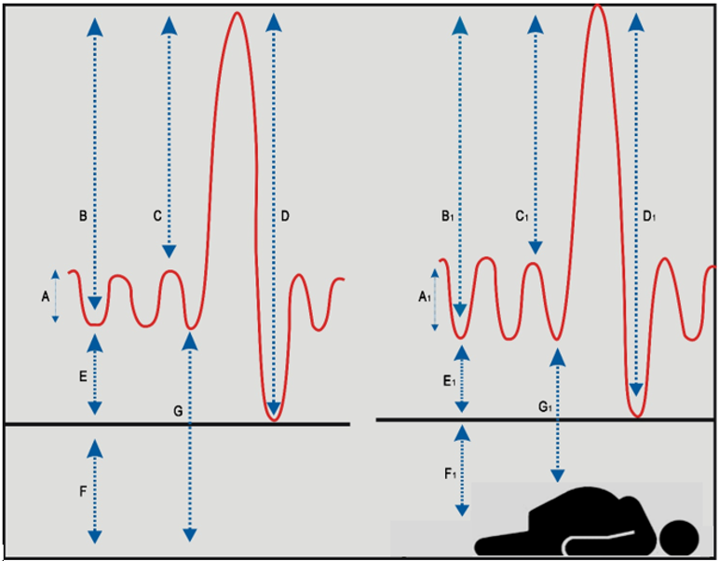

|  |  |
| --- | --- |
| **Non-pregnant women** | **Term pregnancy** |
| A. Tidal volume 450 ml  B. Inspiratory capacity 2500 ml  C. Inspiratory reserve volume 2050 ml  D. Vital capacity 3200 ml  E. Expiratory reserve volume 700 ml  F. Residual volume 1000 ml  G. Functional residual capacity 1700 ml | A. Tidal volume 600 ml  B. Inspiratory capacity 2650 ml  C. Inspiratory reserve volume 2050 ml  D. Vital capacity 3200 ml  E. Inspiratory reserve volume 550 ml  F. Residual volume 800 ml  G. Functional residual capacity 1350 ml |

Figure 1. Changes in volumes and capacities in term pregnant women.5

Oxygen consumption increases by 20% to 40% in obstetric patients, resulting in a decrease in the maternal oxygen reserve, which contributes to susceptibility in stressful situations (e.g. by creating a potential for closure of the respiratory tracts and atelectasis). The alveolar-arterial gradient increases 26 mm Hg and minute volume (MVol) increases at the expense of tidal volume, without altering the respiratory rate. This increase in MVol results in a decrease in the arterial pressure of CO2 (PaCO2) during the third trimester of gestation, increasing the maternal-fetal oxygen gradient and facilitating gas exchange. Measurement of arterial gases demonstrates a mild compensated respiratory alkalosis, with a decrease in PaCO2 to between 28 to 32 mm Hg and a decrease in serum bicarbonate (HCO3) to between 18 to 21 mEq / L (Table 2).7

Serum colloid osmotic pressure is reduced by 10% to 15%. The colloid osmotic pressure/pulmonary capillary wedge pressure gradient is reduced by about 30%, making pregnant women particularly susceptible to pulmonary edema. Pulmonary edema will be precipitated if there is an increase in cardiac preload (such as infusion of fluids), an increase in pulmonary capillary permeability (such as in pre-eclampsia), or both.8

|  |  |  |  |  |
| --- | --- | --- | --- | --- |
| **Blood gas values** | **Non-pregnant** | **Trimester** | | |
| **1°** | **2°** | **3°** |
| Ph | 7.40 | 7.44 | 7.44 | 7.44 |
| PaO2 (mm Hg) | 100 | 107 | 105 | 103 |
| PaCO2 (mm Hg) | 40 | 30 | 30 | 30 |
| Serum bicarbonate (HCO3) (mmol/L) | 24 | 21 | 20 | 20 |

Table 2. Blood gas values in pregnant and non-pregnant women.7

**Indications for mechanical ventilation in obstetric patients**

The indications for intubation and mechanical ventilation are similar to those for non-pregnant women. However, it should be remembered that the normal value of PaCO2 is lower and that obstetric patients have less tolerance to periods of apnea due to the increase in oxygen consumption and decrease in functional residual capacity, so rapid and elective intubation is recommended in case of acute ventilatory failure.9

The objectives of oxygenation in all types of respiratory failure should be a maternal SaO2 greater than 95% or a PaO2 greater than 70 mm Hg, since the fetus does not tolerate hypoxemia or acidosis.

Acute respiratory failure that does not improve with conventional therapy is an indication for mechanical ventilation (MV) in pregnant patients; clinical data such as dyspnea, ventilatory fatigue, nasal flaring, cyanosis, or increased work of the ventilatory muscles are reliable indicators of urgent orotracheal intubation.10, 11

In the obstetric patient many factors may cause airway difficulty, and these can be classified as maternal, fetal, surgical, and situational. Maternal factors include the anatomical and physiological changes that occur during pregnancy; the mucosa of the airway is more edematous and vascularized, which causes changes in the Mallampati score and can lead to potential bleeding problems during intubation of the airway. For these reasons, smaller endotracheal tubes are recommended, and in addition, greater caution must be exercised due to the risk of bronchoaspiration.9

**Mechanical ventilation in the obstetric patient**

Achieving proper management of mechanical ventilation in pregnant patients in ICUs is essential, the goal being to rest the fatigued respiratory muscles while enabling suitable gas exchange. Respiratory muscle rest involves institution of invasive or noninvasive mechanical support and the ventilator must overcome pressures related to airway resistance and elastic properties of the lung to allow adequate ventilation and gas exchange. Based on pathophysiological mechanisms, epithelial and endothelial injury produces pulmonary edema that results in hypoxemia and an increase in airway resistance, but more notably a decrease in lung compliance that leads to excess respiratory muscle activity and eventually institution of ventilatory support.12

**Noninvasive mechanical ventilation**

Noninvasive ventilation (NIMV) is an effective means of ventilatory support that prevents intubation for the treatment of cardiogenic pulmonary edema; however, there is very little evidence in favor of this form of ventilation. However, NIMV should be viewed as an alternative form of ventilatory management and used with caution in obstetric patients – and early in the treatment of hemodynamically stable patients. Maternal respiratory pattern and fetal heart rate should be monitored. A lack of clinical progress or improved oxygenation 30 to 45 minutes after initiation should prompt institution of invasive mechanical ventilation.12

Contraindications for NIMV include respiratory arrest or unstable cardiorespiratory status; uncooperative patients; inability to protect airway (impaired swallowing and cough); trauma or burns involving the face; facial, esophageal, or gastric surgery; apnea (poor respiratory drive); reduced consciousness; air leak syndrome; and gastrointestinal hemorrhage. 13,14

In NIMV, oxygen and positive pressure are delivered to the respiratory system through an interface, usually a face, nasal, naso-buccal or helmet mask.14,15 Conditions like cardiogenic pulmonary edema (caused by severe pre-eclampsia or fluid overload) or hypercapnic respiratory failure due to asthma attacks improve with NIMV.15,16

**Invasive mechanical ventilation**

There is no consensus regarding the programming of invasive mechanical ventilation(IMV) in obstetric patients. However, there are certain considerations that must be taken into account to perform protective ventilation. Adjustments in the fraction of inspired oxygen (FiO2), positive end-expiratory pressure (PEEP) and tidal volume (Vt) may be of utmost importance to avoid damage induced by the mechanical ventilator (VALI) and higher morbidity and mortality for the maternal-fetal binomial.17

FiO2 is the concentration of oxygen in relation to the ambient air: the minimum necessary to maintain a goal of arterial oxygen saturation (SaO2) between 94% and 98% and arterial oxygen pressure (PaO2) that oscillates between 60 and 100 mm Hg.17

Although there are no specific studies in this regard for obstetric patients, in neurocritical patients (e.g.: post-arrest and cerebrovascular events), it has been shown that hypoxemia can contribute to ischemia and cerebral edema, and hyperoxemia to greater damage by oxygen free radicals. Therefore, a normoxemia strategy is recommended, especially in obstetric patients with complications from an acute neurological disease. Furthermore, this will seek to ensure an adequate supply of O2 to the fetal-placental circulation.18,19

Use of PEEP or CPAP (continuous positive airway pressure) in IMV, in spontaneous and NIMV modes, prevents alveolar collapse during expiration and serves to avoid cyclical atelectrauma. A PEEP level of 5 to 8 cm H2O is recommended initially, although there is no consensus on an exact recommendation. As a result, it should be considered that patients in the 3rd trimester of pregnancy present a decrease in pulmonary compliance secondary to diaphragmatic apposition through the abdomen with the pregnant uterus, together with a decrease in functional residual capacity and residual volume.20

Therefore, in a surgical event or acute respiratory or cardiac pathology, these patients could be at greater risk of atelectasis and/or pulmonary edema, which may require PEEP levels higher than 5 cm H2O to improve oxygenation. In special circumstances, such as severe obstetric hemorrhage or high-risk pulmonary thromboembolism, PEEP may be reduced or withdrawn until the shock is resolved.2

Tidal volume (Vt) is directly related to mortality in the case of ARDS. It should be taken into account that ARDS caused by SARS-CoV2 pneumonia is currently the most frequent cause of maternal death in the world, and therefore tidal volume must be programmed adequately.21 In this case, it is necessary to measure the patient and determine her ideal or predicted weight according to the following formulae:

Ideal weight estimation formula in patients without ARDS (adapted from the World Health Organization):

* Size (m)2 x 21.5

Predicted weight formula for patients with ARDS:

* [Size (cm) - 152.4) x 0.91] + 45

Subsequently, multiply the result by a number in the range of 6 to 10 ml / kg if the patient does not have ARDS (e.g. 55 kg of ideal weight x 8 ml = 440 ml of Vt to be programmed), and in the case of ARDS, the recommendation is to start with 6 ml and maintain parameters between 4 and 6 ml / kg of predicted weight to reduce lung injury (e.g.: 55 kg of predicted weight x 6 ml = 330 ml). This Vt can be programmed in volume-controlled mode (VCV). 21,22 The Vt can also be reached indirectly through the pressure support (PS), inspiratory pressure (PI), spontaneous-continuous positive airway pressure/pressure support (CPAP-PS) or pressure-controlled (PCV) modes.22

In VCV mode, the plateau pressure (Pplat) must be measured during an inspiratory pause (performed for 2-3 s, to allow a balance in airway pressures). Plateau pressure is measured every 12 h in patients with confirmed or suspected ARDS, with a target of < 25 to 30 cm H2O.23 When the plateau pressure is higher, Vt should be decreased until this target is achieved, with a lower limit of 4 ml / kg of predicted weight. 24,25

Pplat can only be measured in VCV and is determined by the total compliance of the respiratory system. A plateau pressure > 25 to 30 cm H2O is associated with higher mortality in patients with ARDS. Another parameter associated with mortality is driving pressure (DP), which depends on Vt and the compliance of the respiratory system (CRS), at levels above 12 to 16 cm H2O. The DP formula is Vt / CRS and is obtained by subtracting PEEP from Pplat (Pplat–PEEP). In the case of DP > 12 cm H2O, the programmed tidal volume should be reduced. In moderate to severe ARDS, consider the prone position to optimize PEEP.24, 25

In the case of pressure modes, it is always recommended that the PS or PI value be ≤ 12 to 15 cm H2O to avoid lung injury. The PI adjustment depends mainly on lung compliance and also, if the patient is assisted, on his or her inspiratory effort; the greater the patient's inspiratory effort and lung compliance, the lower the pressure required to obtain the desired Vt. On the contrary, the lower the patient's inspiratory effort and the lower the compliance, the higher the pressure needs to be programmed to obtain the predetermined inspiratory volume (Figure 2). 21,22

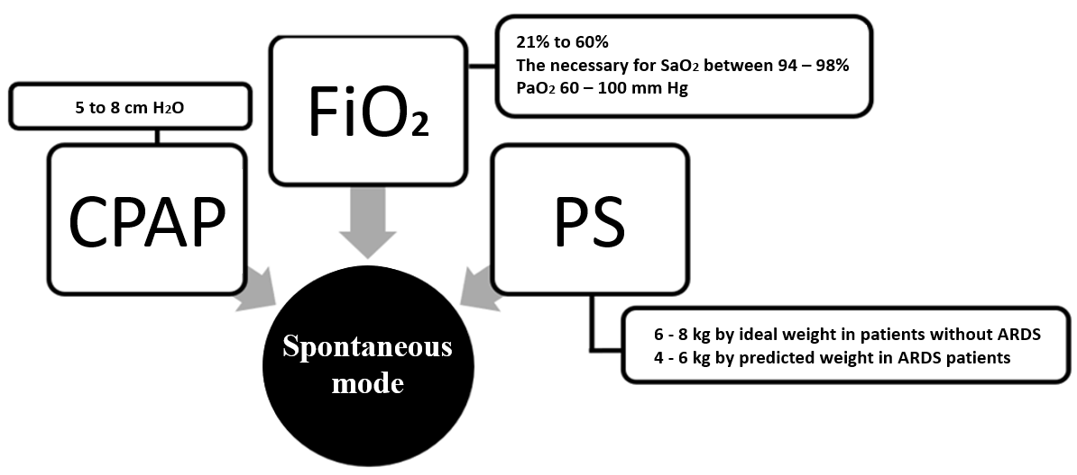

Figure 2. Mechanical ventilation programming in CPAP-PS mode.21,22

**IMV in assisted controlled volume ventilation**

The volume-controlled ventilation (VCV) mode ensures the programmed Vt, and in this mode the Pplat and DP can be observed. Another advantage of this mode is that it ensures an almost exact minute volume (VMin), enabling greater control of PaCO2, which is dependent on this parameter. In serious neurological conditions associated with pregnancy, such as intracranial hemorrhage, post-arrest syndrome, cerebral ischemia, severe cerebral venous thrombosis, etc., this ventilatory modality is recommended since abrupt changes in PaCO2 could result in greater cerebral ischemia (in the case of hypocapnia) or greater cerebral edema and intracranial hypertension (in hypercapnia) (Figure 3).22 VCV can also be used in the event of an airway obstruction problem, such as an asthma attack or other bronchospasm, because a low respiratory rate (RR) setting, high inspiratory flow and low Vt could rapidly reduce air trapping and auto-PEEP. VMin must be programmed by adjusting the RR and Vt as necessary to maintain relative normocapnia for obstetric patients, that is, in a range of 28 to 32 mm Hg.24,25

**Goals of MV in obstetric patients**

Alveolar protection goals must be monitored to prevent damage induced by the mechanical ventilator. These goals include:26

1. Peak inspiratory pressure ≤ 35 cm H2O
2. Plateau pressure ≤ 27 to 30 cm H2O
3. Driving pressure ≤ 12 cm H2O

Arterial blood gas goals: 26, 27

1. PaO2: 60 - 100 mm Hg, values ​​outside these ranges are associated with higher mortality.
2. PaCO2: Normocapnia in pregnancy: 28 to 32 mm Hg (at sea level).
3. SaO2: 94% to 98% in obstetric patients.
4. Peak inspiratory pressure (PIP).

Peak inspiratory pressure (PIP) is the maximum pressure reached by the airway and is determined by Vt, airway resistance (Raw), and lung compliance. PIP is the pressure that must be exerted by the volume of gas to overcome the resistance offered by the airways. An abrupt elevation of the PIP suggests airflow obstruction caused by a bronchospasm, mucus plug, or orotracheal tube occlusion, although a PIP increase can also be caused by situations such as a pneumothorax or severe decrease in lung compliance. A PIP > 35 cm H2O is associated with barotrauma and pneumothorax.26,27

**Plateau pressure**

Pulmonary compliance in pregnant women is slightly decreased but does not cause complications when ventilating the patient. However, in cases of ARDS, compliance may decrease dramatically. Pplat can reach values between 25 and 30 cm H2O and is one goal of mechanical ventilation, and should be limited if transpulmonary pressure cannot be monitored (esophageal balloon).27

**Acute respiratory distress syndrome in pregnancy**

Acute respiratory distress syndrome (ARDS) is uncommon in pregnant patients. The causes of ARDS are associated with obstetric causes such as amniotic fluid embolism, pre-eclampsia, septic abortion, and retained products of conception, or non-obstetric causes that include sepsis, aspiration pneumonitis, influenza pneumonia, blood transfusions, and trauma. An international group of leaders in the field of critical care medicine convened to develop a new definition of ARDS and developed the Berlin definition, which includes the following: onset occurring within 1 week of a known insult or worsening respiratory symptoms; bilateral infiltrates, lobar collapse, or nodules observed on chest radiograph or chest tomography; and radiographic opacities and pulmonary edema that produce respiratory failure not fully explained by cardiac failure or volume overload. The reason for the development of pulmonary edema in obstetric patients is likely diffuse endothelial injury secondary to the underlying infection leading to preterm labor, and not tocolytic use by itself, so excessive fluid administration should be avoided as it will worsen pulmonary edema. The final criterion is the deficit in oxygenation12 (Table 3):

If pregnant patients with moderate or severe ARDS present with preterm labor and require the use of tocolytics, beta-agonists should be avoided since they increase the risk of acute pulmonary edema and cardiac demands. Another drug that contributes to increasing pulmonary capillary permeability is magnesium sulfate.12

|  |  |  |
| --- | --- | --- |
|  | The Berlin definition | Kigali modification |
| Timing | < 1 week. | < 1 week. |
| Oxygenation | PaO2/FiO2 < 300 mm Hg | SaO2/FiO2 < 315 mm Hg |
| PEEP | > 5 cm H2O | No PEEP |
| Chest imaging | Chest Rx or Computed tomography | Chest Rx or Ultrasonography |
| Origin of edema | heart failure excluded | heart failure excluded |

**Table 3.** Definition of acute respiratory distress syndrome. 12

Management seeks to identify and treat the cause while providing maternal supportive care and monitoring the fetus for signs of distress that would prompt delivery. Managing the outcomes of pregnant patients with ARDS also requires good communication between the obstetrics team and critical care specialist and a fundamental understanding of mechanical ventilatory support.12

It is important to assess oxygenation in order to maintain a target SaO2 of 94% to 98 % to ensure correct maternal-fetal perfusion and avoid hyperoxemia (PaO2 >120 mm Hg), which generates superoxide radicals, perpetuating the cytokine cascade.5

Optimizing mechanical ventilation settings during the stabilization phase is the cornerstone of management. In cases of ARDS, the ventilation parameters and treatment should be reevaluated at least every 24 hours to employ lung-protective ventilator strategies: 1) tidal volume at 6 ml/kg of predicted body weight (PBW), 2) plateau pressure < 30 cm H2O (using a 3-second end-inspiratory pause), 3) PEEP value > 5 cm H2O (high PEEP values are associated with a high risk of volutrauma and a decrease in preload and right ventricular afterload), and 4) DP < 12 cm H2O. Recruitment maneuvers should probably not be used routinely. In patients who not reach a PaO2/FIO2 ratio < 150mm Hg with strategies, the prone position should be used combined with a neuromuscular blocking agent12,13 (Figure 4).

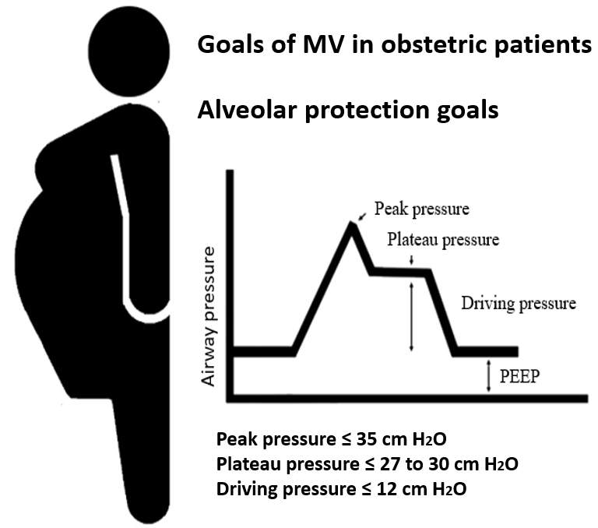

**Figure 4.** Ventilatory monitoring goals.12,13

**Prone position strategy in pregnant patients with ARDS**

In 2013 the PROSEVA trial showed clear benefits from the prone position, which improved oxygenation and reduced mortality in patients with ARDS. Anatomically, the conical shape of the thoracic cavity causes compression of a greater proportion of the lung in the supine position; the posterior pulmonary segments are compressed by the heart, the abdominal viscera, and the increased weight of the lungs due to capillary leakage and edema. All this increases the dorsal pleural pressure, decreasing transpulmonary pressure and causing alterations in the ventilation-perfusion relationship (Figure 5).28,29

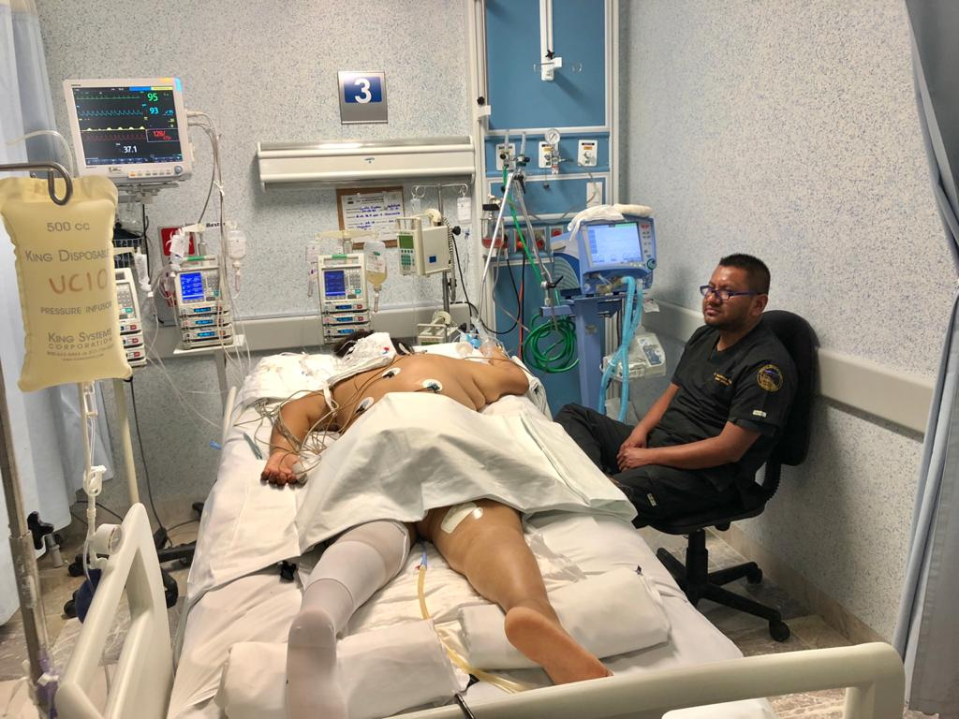

**Figure 5.** Prone position strategy in the obstetric patient.

The prone position is associated with a lower concentration of interleukin (IL) -8, IL-6 and IL-1, reducing the inflammatory response at the lung level. It should be remembered that pregnancy is a pro-inflammatory state. The prone position results in a more even distribution of lung tension and leads to a better perfusion/ventilation ratio, increasing ventilation to the dorsal regions.29

There is little literature on the prone position during pregnancy. However, data does exist from patients in the 2nd and 3rd trimesters of gestation with whom the prone position was used, corroborating its functionality and showing respiratory improvement without fetal alterations.30

In France, Vibert et al. report the case of a multiparous patient who was admitted to an ICU at 23 weeks’ gestation with a diagnosis of respiratory failure secondary to SARS-CoV-2. As part of her treatment she was placed in the prone position for 2 hours a day. After this maneuver, her oxygen requirement decreased and clinical improvement was observed. IMV was withdrawn 15 days later. After 24 days of management, the patient was discharged home and continued her pregnancy.31

In Mexico, Pozos et al. describe the case of a patient with 18 weeks of gestation diagnosed with ARDS secondary to bacterial sepsis. A prone position was used, achieving a reduction in ventilatory parameters until mechanical ventilation was withdrawn. She was discharged from the intensive care unit without complications.32

Samanta et al. reported the case of a 31-week-pregnant patient with severe respiratory failure due to influenza. High ventilatory parameters showed no improvement until protective ventilation was instituted in the prone position; pillows were used under the anterior thorax and pelvis to avoid uterine compression and ventilation in the prone position was alternated for 16 hours, achieving an improvement in oxygenation and a decrease in ventilatory parameters. After 5 days of protective ventilation in the prone position, she was discharged from the ICU with adequate fetal evaluation.33

The protective ventilation strategy in prone position for pregnant patients with severe ARDS should be carried out with specific care, including protection for the face and bony prominences, care of the endotracheal tube, and monitoring of the fetal cardiac rate, as well as gasometric control. The prone position has been little studied in pregnant patients, but is not a contraindication during pregnancy and has shown benefits in reducing mortality in severe ARDS. Medical teams must be trained to avoid complications and maintain fetal surveillance (Figure 6).32

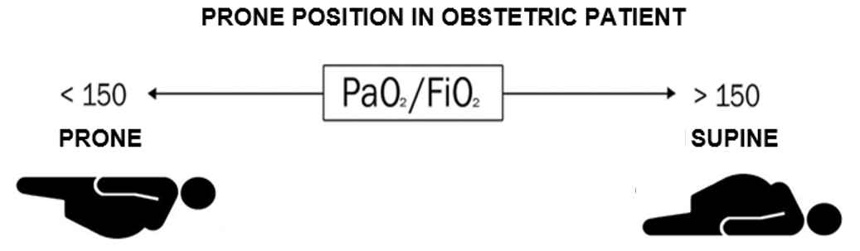

**Figure 6.** Prone position strategy in the obstetric patient.32

**Weaning in obstetric patients**

There is no consensus or guideline for the withdrawal of mechanical ventilation in obstetric patients, so we recommend following the guidelines described for non-obstetric patients. The ATS (American Thoracic Society) recommends a systematic protocol for the withdrawal of mechanical ventilation in patients who have been ventilated for more than 24 hours. Patients should be removed from MV as soon as the cause for MV has resolved or if conditions have improved sufficiently for the patient to sustain spontaneous respiration without assistance.34

The cuff leak test is a predictive method of post-extubation stridor due to laryngeal edema or a decrease in the cross-sectional area of the trachea. Obstetric patients present with general airway and laryngeal edema, which is why it is necessary to perform this test before extubation. The test consists in deflating the cuff and observing leakage in the volume-time curve. A difference in leak > 20% or > 110 ml with respect to that previously recorded by the ventilator is sufficient to tolerate extraction of the orotracheal tube, whereas a leak < 20% indicates tracheal or laryngeal edema that will require immediate treatment and subsequent reassessment (Figure 7). In order to decrease laryngeal edema, corticosteroids are recommended before the cuff leak test and as treatment in the event of post-extubation stridor.35

A failed cuff leak test does not mean extubation should be delayed much longer; intravenous steroids should be started as soon as possible or 4 hours before intubation (usually methylprednisolone 20 mg every 12 hours, for 3 doses; the cuff leak test can be reassessed from the 2nd or 3rd dose and withdrawal from mechanical ventilation can be considered again).34

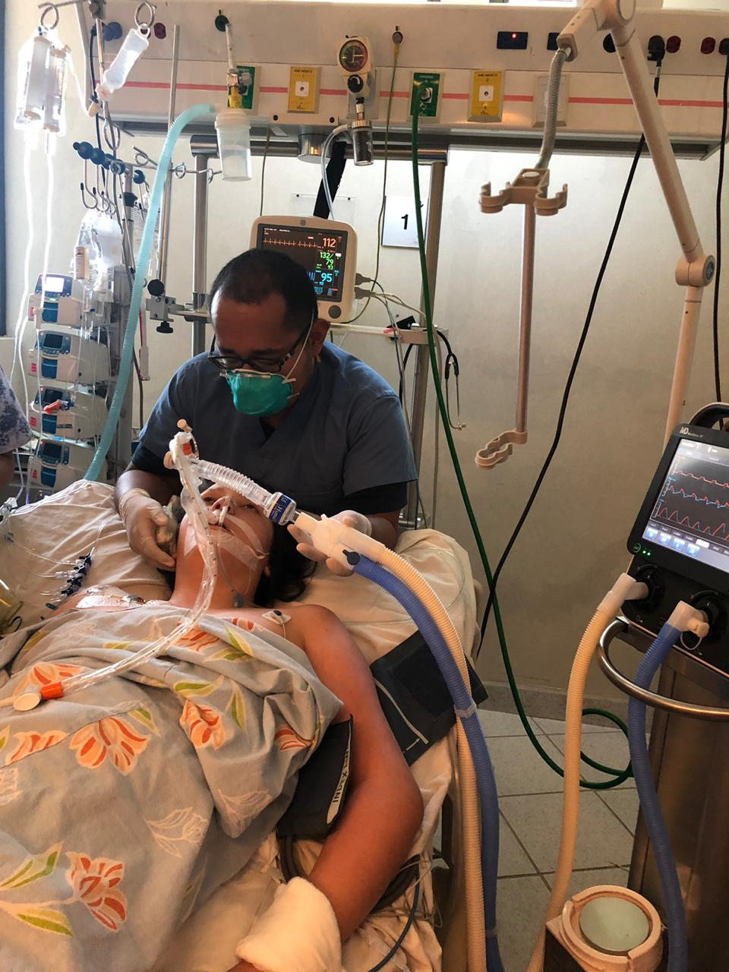

**Figure 7.** Mechanical ventilation in the critically ill obstetric patient.

**Conclusion**

Mechanical ventilation in critically ill obstetric patients has not been widely studied; pathophysiological changes must be considered in order to carry out protective and individualized ventilation for these patients.

**References**

1. Pradeep B, Sadik M, Ghansham B, et al. Acute respiratory failure and mechanical ventilation in pregnant patient: A narrative review of literature. [J Anaesthesiol Clin Pharmacol](https://www.ncbi.nlm.nih.gov/pmc/articles/PMC5187605/). 2016; 32(4): 431–439. doi:[10.4103/0970-9185.194779](https://dx.doi.org/10.4103%2F0970-9185.194779)
2. Hegewald MJ, Crapo RO. Respiratory Physiology in Pregnancy. Clin Chest Med. 2011; 32: 1–13. doi:10.1016/j.ccm.2010.11.001
3. Garcia-Rio F, Pino-Garcia JM, Alvarez-Sala R, et al. Adaptacion respiratoria durante el embarazo. Arch Bronconeumol.1995; 31: 172-180. [doi: 10.1016/S0300-2896(15)30945-5](https://doi.org/10.1016/S0300-2896(15)30945-5)
4. Wasson C, Kelly A, Ninan D, Tran Q. Respiratory. Absolute Obstetric Anesthesia Review. First edition. Lugar: CA, USA. Editorial Springer. 2019. Capitule 2. PP 5–6. doi:10.1007/978-3-319-96980-0_2
5. Pacheco LD, Foley MR, Saade GR, et al. Pregnancy-Induced Physiologic Alterations. E: Phelan JP. Critical Care Obstetric. Sixth edición. Hoboken, NJ, USA. Editorial John Wiley & Sons, Inc.2019. PP 41-67
6. McAuliffe F, Kametas N, Costello J, et al. Respiratory function in singleton and twin pregnancy. BJOG. 2002 Jul;109(7):765-769. doi:10.1111/j.1471-0528.2002.01515
7. Lapinsky SE. Management of Acute Respiratory Failure in Pregnancy. Semin Respir Crit Care Med. 2017; 38:201–207. doi: 10.1055/s-0037-1600909.
8. Soma-Pillay P, Nelson-Piercy C, Tolppanen H, et al. Physiological changes in pregnancy. [Cardiovasc J Afr](https://www.ncbi.nlm.nih.gov/pmc/articles/PMC4928162/). 2016; 27(2): 89–94.
9. Cortés-Yepes H. Algunos aspectos en el cuidado critico de la paciente obstetrica. Revista Colombiana de obstetricia y ginecologia. 2004; 55 (162): 161-166.
10. Schwaiberger D, Karcz M, Papadakos PJ. Respiratory Failure and Mechanical Ventilation in the Pregnant Patient. Crit Care Clin. 2016. 32 (1): 85-95. doi.org/10.1016/j.ccc.2015.08.001
11. Vaishnav S, Desai KN, Raithatha NS, et al. Critically ill obstetric patients requiring mechanical ventilation in rural western India: A retrospective analysis. The national medical journal of India. 2019; 29 (2): 68-72.
12. Duarte A. ARDS in Pregnancy. Clinical obstetrics and gynecology. 2014;57(4): 862–870. doi: 10.1097/GRF.0000000000000067.
13. Papazian L, Aubron C, Brochard L, et al. Formal guidelines: management of acute respiratory distress syndrome. Ann Intensive Care. 2019;9 (1): 69. doi:10.1186/s13613-019-0540-9
14. Rochwerg B, Brochard L, Elliott MW, et al. Official ERS/ATS clinical practice guidelines: noninvasive ventilation for acute respiratory failure. Eur Respir J. 2017;50(2):1602426.

doi:10.1183/13993003.02426-2016

1. Nava S, Hill N. Non-invasive ventilation in acute respiratory failure. The Lancet. 2009;374 (9685):250-259. doi:10.1016/s0140-6736(09)60496-7
2. Scala R, Pisani L. Noninvasive ventilation in acute respiratory failure: which recipe for success?. EurRespir R. 2018;27(149): 180029. doi: 10.1183/16000617.0029-2018
3. Mehta S, Hill NS. Noninvasive ventilation. Am J Respir Crit Care Med. 2001;163(2): 540-577.

doi:10.1164/ajrccm.163.2.9906116

1. Parrillo J, Dellinger P, et al. Critical Care Medicine: Principles of Diagnosis and Management in the Adult. 5th edition. Philadelphia USA. Elsevier. 2019. PP 1263-1272.
2. Helmerhorst HJ, Roos-Blom MJ, van Westerloo DJ, de Jonge E. Association Between Arterial Hyperoxia and Outcome in Subsets of Critical Illness: A Systematic Review, Meta-Analysis, and Meta-Regression of Cohort Studies. Crit Care Med. 2015;43(7): 1508-1519.

doi:10.1097/CCM.0000000000000998

1. Lapinsky S, Posadas J, McCullagh J, Clinical Review: ventilator strategies for obstetric, brain injury-injured and obese patient. Critical Care. 2009;13(206):1-7. doi:10.118
2. De Jong A, Chanques G, Jaber S. Mechanical ventilation in obese ICU patients: from intubation to extubation. Crit Care. 2017;21(1):63. doi:10.1186/s13054-017-1641-1
3. Mora Carpio AL, Mora JI. Ventilator Management. In: StatPearls [Internet]. Treasure Island (FL): StatPearls. Publishing; 2020 Jan. [Updated 2020 May 17]. Available in https://pubmed.ncbi.nlm.nih.gov/28722886/
4. Pham T, Brochard LJ, Slutsky AS. Mechanical Ventilation: State of the Art. Mayo Clin Proc. 2017; 92(9):1382-1400. doi:10.1016/j.mayocp.2017.05.004
5. Amato MB, Meade MO, Slutsky AS, et al. Driving pressure and survival in the acute respiratory distress syndrome. N Engl J Med. 2015;372(8):747-755. doi: 10.1056/NEJMsa1410639
6. Guérin C, Papazian L, Reignier J,et al. Investigators of the Acurasys and Proseva trials. Effect of driving pressure on mortality in ARDS patients during lung protective mechanical ventilation in two randomized controlled trials. Crit Care. 2016;20 (1):384.
7. Lapinsky SE, Rojas-Suarez JA, Crozier TM, et al. Mechanical ventilation in critically-ill pregnant women: a case series. Int J Obstet Anesth. 2015;24(4):323-328. doi:10.1016/j.ijoa.2015.06.009
8. Fanelli V, Ranieri MV, Mancebo J, et al. Feasibility and safety of low-flow extracorporeal carbon dioxide removal to facilitate ultra-protective ventilation in patients with moderate acute respiratory distress sindrome. Critical Care. 2016;20:36. doi:10.1186/s13054-016-1211-y.
9. Juarez-Villa D, Mora-Ruiz P, Saenz-Luna C, et al. Prone Position in Non-intubated Patients with COVID-19, a Useful Maneuver to Avoid Mechanical Ventilation: A Literature Review. J Adv Med Med Res. 2020; 32 (12):5-14. doi:10.9734/jammr/2020/v32i1230538
10. Guérin C, Reignier J, Richard JC, et al. Prone positioning in severe acute respiratory distress syndrome. N Engl J Med. 2013; 368(23):2159-2168. doi:10.1056/NEJMoa1214103
11. Oliveira C, Lopes MAB, Rodrigues AS, et al. Influence of the prone position on a stretcher for pregnant women on maternal and fetal hemodynamic parameters and comfort in pregnancy. Clinics (Sao Paulo). 2017;72 (6):325-332. doi:10.6061/clinics/2017(06)01
12. Vibert F, Kretz M, Thuet V, et al. Prone positioning and high-flow oxygen improved respiratory function in a 25-week pregnant woman with COVID-19. Eur J Obstet Gynecol Reprod Biol. 2020; 250:257-258. doi: 10.1016/j.ejogrb.2020.05.022
13. Pozos-Cortes KP, Deloya-Tomas E, Pérez-Nieto OR, et al. Síndrome de dificultad respiratoria aguda severo en el embarazo. Revisión de la literatura y reporte de dos casos. Med Crit. 2019;33(4):209-214.
14. Samanta S, Wig J, Baronia AK. How safe is the prone position in acute respiratory distress syndrome at late pregnancy? Am J Emerg Med. 2014; 32(6):687.e 6873. doi: 10.1016/j.ajem. 2013.12.021
15. Girard T, Kress J, Peter E. et al. An Official American Thoracic Society/American College of Chest Physicians Clinical Practice Guideline: Liberation from Mechanical Ventilation in Critically Ill Adults. Am J Respir Crit Care Med. 2017; (195),120–133. doi: [10.1164/rccm.201610-2075ST](https://doi.org/10.1164/rccm.201610-2075st)
16. Zein H, Baratloo A, Negida A, Safari S. Ventilator Weaning and Spontaneous Breathing Trials; an Educational Review. Emergency. 2016; 4 (2): 65-71.