**Identification of early mutations in *Mycobacterium tuberculosis* for multidrug-resistant tuberculosis control**

**This study suggests that the mechanisms of drug resistance emergence in *Mycobacterium tuberculosis* are similar worldwide. Therefore, identification of early drug resistance-conferring mutations is important for preventing multidrug resistance in this pathogen.**

Drug resistance in *Mycobacterium tuberculosis*, the causative pathogen of tuberculosis (TB), is a major public health concern. Five percent of TB cases are multidrug-resistant (MDR), and 0.5 per cent are extensively drug resistant (XDR). Cohen et al. (2017) constructed and analysed a dataset of *M. tuberculosis* whole genomes from 5,310 different strains to study the gradual evolution of drug-resistant TB and identified forerunning mutations that contribute to the emergence of MDR TB. The dataset included the genomes of *M. tuberculosis* strains from seven globally distributed lineages and *Mycobacterium bovis*.

Parsimony-based analysis of the dataset revealed mutations which emerged uniformly across the globe, implying that drug resistance in *M. tuberculosis* developed through similar mechanisms. Computational prediction of resistance to eight drugs using a curated list of genomic polymorphisms revealed 392 unique drug resistance-related mutations. Moreover, 962 strains were identified as resistant to both isoniazid and rifampicin but susceptible to ofloxacin and kanamycin, while 257 strains were found to be XDR. Additionally, 409 strains were found to be on the verge of becoming XDR. From the dataset, 573 and 138 independent MDR and XDR evolutions were identified, respectively. Of the 573 MDR evolutions, 63% resulted in a single descendant strain, while 37% gave rise to multiple descendant strains.

In 2015, Cohen et al. reported that mutations conferring isoniazid resistance appeared prior to rifampicin resistance-conferring mutations, based on their analysis of a dataset comprising clinically isolated *M. tuberculosis* strains in South Africa. This report was consistent with those of other studies in Russia and Argentina. By using parsimony-based analysis and excluding ambiguous phylogenetic topologies, the emergence of isoniazid resistance before rifampicin resistance was confirmed for all lineages globally.

Mutations in *katG*, which encodes catalase-peroxidase, is responsible for 98% of isoniazid-resistant TB cases. Moreover, *katG* mutations resulting in a p.Ser315Thr substitution often lead to the acquisition of rifampicin resistance. In contrast, cases of isoniazid resistance resulting from rifampicin resistance are relatively scarce. Using BEAST, Cohen et. al. showed that *M. tuberculosis* developed isoniazid resistance before rifampicin resistance, even when the two drugs were co-administered. Analysis of a catalogue of mutations in pre-MDR *M. tuberculosis* showed an array of mutations, each of which confer resistance to one of the eight drugs investigated in this study; however, only the *katG* mutation encoding p.Ser315Thr frequently occurred in pre-MDR *M. tuberculosis*.

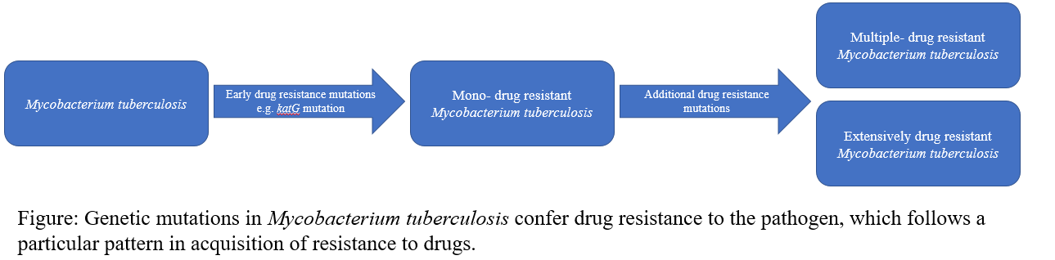

To explain the earlier emergence of isoniazid resistance compared to rifampicin resistance in *M. tuberculosis*, Cohen et al. proposed some possible mechanisms. According to them, isoniazid resistance in *M. tuberculosis* may develop due to any inactivating mutation in *katG*, whereas rifampicin resistance in this pathogen arises due to particular non-inactivating mutations in *rpoB*. Alternatively, they hypothesized that *katG* mutations preserve fitness factors in *M. tuberculosis* alongside conferring isoniazid resistance, leading to the acquisition of resistances to other drugs in the future. Furthermore, they suggested that pharmacokinetic effects and drug distribution in lesions may influence the order of drug resistance emergence. In current clinical practice, only isoniazid is administered to suspected TB patients; this may also play a role in the order of drug resistance acquisition in *M. tuberculosis*.

At present, the most widely applied molecular diagnostic approach for drug-resistant TB is the Xpert MTB/RIF assay, which detects mutations in the rifampicin resistance-determining region of *rpoB* in *M. tuberculosis.* However, drug resistance detection using this diagnostic approach has certain limitations, as it often does not detect drug resistance at the earliest stages. Alternative diagnostic tests capable of detecting isoniazid-resistant TB include Hain MTBDR plus and Hain MTBDRsl ver. 2.0 line probe assays.

Cohen et al. suggested that detection and adequate treatment of isoniazid mono-resistant strains may curtail the emergence of MDR and XDR strains. Efficient application of diagnostic tests, such as line-probe assay, to target rifampicin-susceptible strains that are resistant to other drugs is important for controlling the spread of MDR strains. Recent *de novo* evolution of MDR *M. tuberculosis* strains has significantly jeopardised the control of TB globally. Therefore, identification of common, early occurring pre-MDR mutations such as the *katG* mutation encoding p.Ser315Thr could be helpful in designing strategies for curbing the emergence of MDR *M. tuberculosis* strains.

**References:**

Cohen, K. et al. Genomic analysis of globally diverse Mycobacterium tuberculosis strains provides insights into the emergence and spread of multidrug resistance. Nature genetics, (2017).

Cohen, K. et al. Evolution of extensively drug-resistant tuberculosis over four decades revealed by whole-genome sequencing of Mycobacterium tuberculosis from KwaZulu-Natal, South Africa. PLoS Med. 12, e1001880 (2015).

Eldholm, V. et al. Four decades of transmission of a multidrug-resistant Mycobacterium tuberculosis outbreak strain. Nat. Commun. 6, 7119 (2015).