ORIGINAL TEXTS

TEXT 1 (ITALIAN)

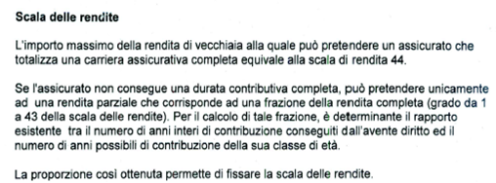

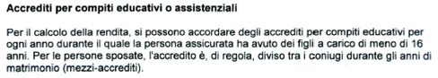

TEXT 2 (ENGLISH)

1. All the information you provide in this questionnaire will be considered in arriving at a final decision on your application.
2. Providing false or misleading information at ANY stage may affect your credibility and therefore disadvantage your claim.
3. If you wish to make a separate application on behalf of your minor children (or dependants), a separate application form for a declaration as a refugee must be completed for each minor child (or dependant). If not, your accompanying minor children (or dependants) will be included in your application and all decisions taken in relation to your asylum application will apply to them**.**