THE MUSEUM OF CHILDHOOD:

ART INTERVENTION AS A TOOL

FOR INTERPRETING HERITAGE AND HISTORY

MILICA PERIĆ

**Introduction**

Many modern and contemporary artists have been using museum collections or archival documents as fertile grounds from which a material, a relationship, or a frame of reference for their artistic creation is drawn. They have taken a wide-ranging approach to utilize found and appropriated objects and archival materials along with their attached history. In such a way, archiving and collecting became important contemporary art practices, and the dynamic relationship between academic disciplines such as ethnography or anthropology and contemporary art was established and developed.

In the post-Yugoslavian period, when official historical narratives are often blurred, changed, and manipulated, some artists have chosen to use collections, documents, and archival data and objects to create works that memorialize, question, or confront diverse aspects of this specific political and socio-cultural context. The material that artists appropriate and reconfigure is often intentionally displaced by institutions or individuals. Serbian contemporary artist Vladimir Perić frequently employs techniques of appropriation and recontextualization of discarded material with historical significance in his pluralistic practice. His preoccupation with discontinuity and the elusive nature of the past, history, memory, and identity reached its most complex approach and practice in the Museum of Childhood project.[1] He started this project after the completion of two earlier ten-year artistic phases. From 1986 to 1996, Perić worked under the pseudonym *Talent*,; he was a founder of the artistic group *Talent Factory* from 1996 to 2006.

Perić is very well known in the domestic context of contemporary art as a passionate collector of fragments from everyday culture which he transposes into an artistic perspective and artworks of sensible and witty data-driven visual and conceptual analysis. In the case of the Museum of Childhood, he sought objects that he could use in his artworks. These are objects which equally embodied appropriate aesthetic values but which inevitably held a historical background in relation with the context in which he grew up. The museum project slowly developed from Perić's artistic need to gather material for his artworks while at the same time he assembled artifacts which illustrated and interpreted the complex layers of childhood. The Museum of Childhood became a project which integrated different elements including the passionate collecting of discarded objects, mostly found at flea markets, information gathering, and research of narratives from both “macro” and “micro” historical perspective, and museum-like practices such as the organization and documentation of the large collection. The Museum of Childhood also employs art intervention as a tool to invent the “counter-narratives” and to generate new readings of the collected objects and archival material, playing with conventional notions in the artistic fusion of facts and fiction.

Both Elsner and Šola clearly describe the influences that explain why Perić used the term “museum” for this ambitious project. Elsner (1994, 1) writes about the impetuses to create permanence, “*…* desire and nostalgia, saving and loss, the urge to erect a permanent and complete system against the destructiveness of time.” Šola (2011, 133) also gives a clear opinion about one role of the museum, “More than a mechanism to establish, defend or impose certain identity, [the] Museum is rather a mechanism of confronting with oneself, a mechanism of introspection and interpretation.”

**The Collection of the Museum of Childhood**

The collection of the Museum of Childhood reflects the vibrancy and diversity of modern and recent history in the framework of youth. Childhood is a social phenomenon (Frønes 1994, 145); it is a socially constructed concept, culturally and ideologically transmitted and influenced by family and society (Zornado 2001, 139). The collection which seeks to illustrate childhood is, accordingly, heterogeneous and can hardly grasp all the complexities and contexts interconnected with the category of childhood.

Multiple and complex layers of the construction of childhood are present in the Museum of Childhood. The fusion of approaches, including the one which organizes the collection by means of the subjective experience, emotions, and memories of the collector on one hand and a more holistic understanding of childhood as a category that can be defined by various theories within the disciplines such as anthropology, sociology, ethnology, and history on the other, makes this concept and the museum's collection complex and broad. The objects in the collection are familiar and drawn from popular culture, even globally recognized, which insures that the public-at-large can identify them. Objects which are obscure and less familiar, drawn from highly personal knowledge and memory, are also included. They engage with memory that functions in several interwoven dimensions: individual, local, national, regional, international.

Certainly the collection could not be created and maintained as the concept of an “empty attic” which would be filled with all the childhood-related objects; it is too complex and, thus, a potentially endless topic. Instead, “boxes” were created and certain criteria were introduced to provide the definition of walls for the boxes. This introduction of systematization provided the artist and the author with a constant dilemma akin to that of a curator or archivist who works within institutional frameworks, who has to select, classify, and discard objects in order to create a collection or an archive with expected qualities.

Generally, the whole *fundus* of the Museum of Childhood has been organized into five major collections or topics with categories and subcategories that indicate specific themes within broader phenomena of childhood (Table 3.1). The research potential of the objects is inevitably present and significant. The museum's collections are being used as source material to study diverse phenomena of childhood as a category which functions as a narrative of society and history between individual, intimate, and wider contexts. However, the collection is not only defined through its historical and documentary context. The Museum of Childhood is considered a place for the creation and use of objects in scenarios alternative to ones which present objects as documents within historical narratives. Instead of being a disciplinary concept, the collection of the Museum of Childhood has become a source for artistic shaping and for constructing the meaning of objects and images.

**Art as a tool for interpreting the collection and history**

The Museum of Childhood tends to provide a parallel understanding of the value of objects within the collection. The study and research of the objects and the layers of history absorbed by the object, are engaged to produce certain knowledge. At the same time, experiments and surprises of contemporary art activities transpose the objects into dialectical constructs of historicity and fiction within an artistic context. The experiments discussed here are considered as the transformative process for the collection’s objects; this process introduces narratives based both on historical fact and subjective interpretation.

To carry a feeling about something or someone when leaving the museum, instead of a positive knowledge, can be a far more significant effect of visiting the museum(Šola 2011, 105)*.*

No activity and interpretation in the museum and similar collections-based institutions is objective or free of bias, or as Foster argues, “every archive is found yet constructed, factual yet fictive, public yet private” (Foster 2004, 9). In institutional museums, a guiding principle is to be as “objective” and factual as possible. Museums do present objects in new circumstances but they try to intertwine as little as possible and interpret them in a way that disseminates knowledge based on the proven methodologies of academic research. Use of heritage in museums for a wide range of purposes from educational to scientific is surely present, but it is not generally characteristic that an artistic or a more free approach is present in all phases of musealisation, from collecting to interpretation. Surely it is necessary for museums to continue as public places which attempt to make it possible for everyone to experience original material, but alongside this kind of public apparatus for the production of knowledge based on academically verifiable data, it is important that alternative scenarios exist.

It is important to find new ways of musealisation in today’s society; for the collection it is essential to preserve specific and individual approach[es] to the interpretation, so that visitor can identify him/herself with the collector based upon collector’s passion, emotion and ideal image of the world which collector himself had created (Bulatović 2011).[2]

Instead of using a solid methodology or approach, practice in the Museum of Childhood is quite a fuzzy field which combines various tactics. For example, the techniques of selection and arrangement employ organizing principles as in archival and museological practice. Museological and curatorial methods of systematization and documentation of the objects are applied to organize the collection and to govern its development in a proper quantitative and qualitative direction. Ethnographic approaches of “following the object” or “following the story” might also be drawn upon in an attempt to grasp the complexity of the contexts which were involved in the production, use, and discarding or donating of the object.

Collecting, accumulation, fragmentation, and interpretation, as artistic strategies, are employed to construct assemblages in which historical values of the used objects are fused with artistic sensibility and personal reflection toward them and toward the past and society. By putting diverse, abandoned objects and their narratives and discourses together, artistic interpretation surpasses explanatory modes or pressures of being “objective.” This kind of artistic interference can employ a wide range of interpretational techniques, from personalization to provocation. In this way, alternate understandings of present and past are potentially generated or a more vivid way of dealing with heritage is allowed.

It should be added also that a large number of the works in the Museum of Childhood are deeply rooted in the Yugoslavian social and cultural context. Appropriated objects serve as "found arks of lost moments in which the here-and-now of the work functions as a possible portal between an unfinished past and a reopened future"(Foster 2004, 15). However, the works attain a universal significance which is comprehensible without knowing the historical connotations. This opens a space for dialogue on the level of more common elements shared by many cultures, such as the categories of childhood, history, memories, identity, or loss.

**Contemporary artistic intervention as a new way of seeing/using the past:**

**Examples using collections and archival materials**

Several projects at the Museum of Childhood provide illustrative examples of the way artistic intervention has used objects and archival materials, primarily photographs, to produce narratives that blur boundaries between fact and fiction, artistic and museum ethnography/anthropology practice, and collective and personal memory. The first was a manipulation of well-loved childhood toys. The second were re-purposed historic photographs.

Within the large collection of toys of the Museum of Childhood is a Mickey Mouse rubber toy (Fig. 3.1). It is one of the eleven different models of rubber Mickey Mouse toys which were produced at the “Biserka” Factory in Zagreb (Fig. 3.2). The factory, established in 1956, specialized in the production of toys, games, and balls. As a result of the Civil War in the 1990s and post-war events, the factory has stopped working. Thus, the possibility of reconstructing relevant data, which would ideally come from the source itself, was inevitably made more difficult.

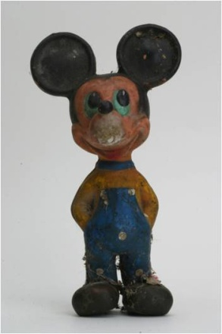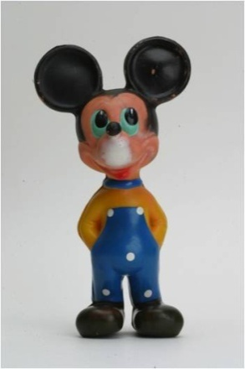 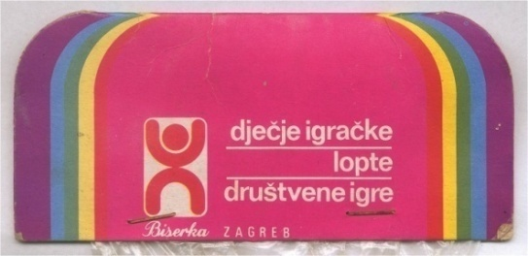

**Fig. 3.1.** Mickey Mouse rubber toy, on the left is the **Fig. 3.2.** One of several types of toy packaging

condition when found at the flea market. from the “Biserka” Factory.

Production: “Biserka” Factory, Zagreb, From the collection of the Museum of Childhood.

SFR Yugoslavia, 1968, product number 155.

From the Collection of the Museum of Childhood.

Based on the die-cast label on the back side of the Mickey Mouse’s ears, relevant production data can be identified such as the location and manufacturer ("Biserka" Factory, Zagreb, SFR Yugoslavia), the year (1968), and the article number (155), referring to the number of the product in the line of the entire toy production within the factory. In situations where the date of production is not indicated on the toy, this product or article number allows us to determine an approximate period of production. Also indicated is that production was done with a license from the Walt Disney Company. Marked on the back of the neck is the number of the mold, 4; numbering of molds was introduced in order to create a system which made it easier to extract and change molds which had some kind of error.

The “Biserka” Factory was the only Yugoslavian toy factory which had the official license from the Walt Disney Company. It is not known exactly when the license was obtained, but some conclusions could be drawn indirectly. The models of other rubber toys in the collection of the museum, which are marked with item number 58 and number 69, date from 1960. It can be concluded that during one year the factory produced about twelve different rubber models. The lowest model number of a Disney toy in the collection is 31, which means that this model probably dates from 1958. Therefore, the beginning of the official license could be dated to that year, but could also quite possibly date from the year when factory started operating.

Each Mickey Mouse toy in the collection of the Museum of Childhood is different. Not only because of the distinct conditions in which they were kept and used in their original context and where they were found after being abandoned by their owners, but also because of variations which originated during production. Such factors included the change of the workers who worked on the production line and who painted parts of the toys by hand. Another factor was the availability of regular colors, blue for pants and yellow for the t-shirt. Some toys were painted with colors that were not standard for the given model; such models are much less commonly circulated.

The toy was produced by casting rubber in a two-part mold. Different techniques were used for adding color, such as air gun, hand-painting with a brush, hand-painting with templates, and dipping the figure in paint. Use of the two-part mold was most likely abandoned in the early 1970s when it was replaced with the technique of expanded rubber. This model belongs to the “golden period” of production, when the factory had mastered the necessary technology. In the early models, certain primitiveness is noticeable. However, after 1970, changes in technology because of the need for a greater quantity of products led to a decreased quality and aesthetic aspect of the toys. The technology and design of the figure informs us about the industrial achievements of that time, and about values and aesthetic concepts which arrived in the post-war wave of globalization.

Disney characters were active factors of the popular culture of the twentieth century. The Disney brand was present in the Kingdom of Yugoslavia in the period before World War II, primarily in the field of publishing, in the form of comic books and magazines with stories of Disney characters (Zupan 1999). It was only after World War II, however, that the socialist transformation initiated rapid industrialization and liberalization and the policy of “balance between East and West” allowed greater impacts from the West. Globally recognized items, such as Disney products, increasingly began to influence the design of visual and popular culture, production, consumerism, and daily life. They existed in everyday culture and childhood as seen in comic books and newspapers, film and television, toys and literature, as well as in additional products intended for children such as notebooks, sticker albums, and more.

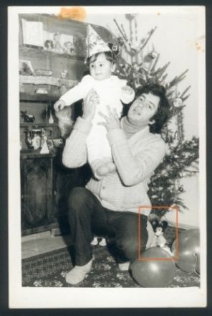 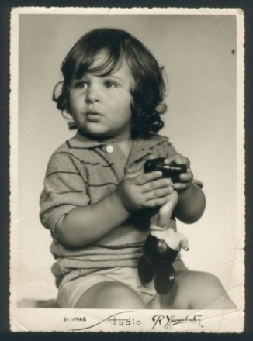

**Fig. 3. 3.** Children with rubber Mickey Mouse toys.

From the photo archive of the Museum of Childhood.

Rubber Mickey Mouse toys , as well as many other toys manufactured in the “Biserka” Factory, were part of childhood in post-war Yugoslavia, the most intensively from the 1960s to the late 1980s in the Socialist Federal Republic of Yugoslavia. These toys are an important testimony to private history, everyday life, childhood, and play (Fig. 3.3). They also serve as source material to explore the broader social context, the development and political position of industrialization, economics, and consumer culture in Yugoslavia. A particular theme for research and dialogue using the Mickey Mouse toy as embodiment of the *disneyfication* of childhood and society (Vučetić 2011, 186) could lead to revealing more of the prominent elements which framed the culture and society of that time. *Disneyfication* was certainly part of the context of ideological pluralism in socialist Yugoslavia, or rather a climate of balance “based on the idea of Yugoslavia as a meeting point of the East and the West, but belonging to neither” (Mihelj 2011, 27).

In the life of every collector, there is a dialectical tension between the poles of disorder and order (Benjamin 1968, 60)

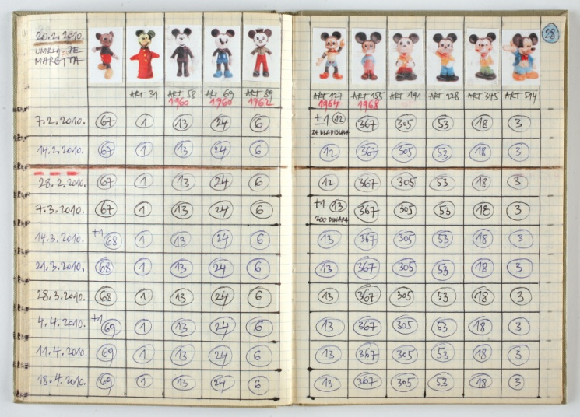

**Fig. 3.4.** Detail from the Mickey Mouse Journal.

From the collection of the Museum of Childhood.

The rubber Mickey Mouse toy in the collection of the Museum of Childhood is equally an historical document and an element for artistic creation. The author began to collect this Mickey Mouse figure at the beginning of the 21st century. Since 2004, he noted the dynamics of collecting of this and other Mickey Mouse rubber toys produced at the “Biserka” Factory in the *Journal of Mickey Mouse* (Fig. 3-4), in which he documents the ongoing ten-year practice of regular weekly visits to flea markets and the acquisition of Mickey Mouse rubber toys. Four hundred and sixty-three Mickey Mouse figures with article number 155 are currently in the collection of Museum of Childhood. Collected objects have been repurposed as artistic material, for the installation, *Three-dimensional Wallpaper for Children’s Room* (Fig. 3.5*).*

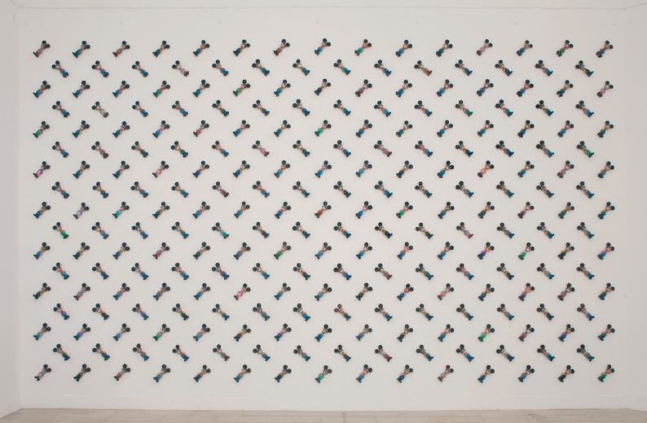

**Fig. 3.5.** *Three-dimensional Wallpaper for Children’s Room – pattern Mickey Mouse*. 2013.

“Nothing Between Us,” National Pavilion of Serbia, 55th Venice Biennale. From the

documentation of the Museum of Childhood

The accumulation of the same object leads us to consider the significance of the object to the author. A cheerful childhood cartoon hero found in the form of abandoned toys at the flea market represents evidence of the absence and destruction imposed by historical events for the author. These include the Civil War in Yugoslavia in the 1990s when massive degradation of human and existential rights and, hence, every other positive value took place. Also included is the post-war period, when an atmosphere of prolonged and encouraged individual losses, migrations, and conflicts, all of which had a destructive effect on collective cultural memory and identity. The artistic context of excessive accumulation and repetition gives a different kind of reading to these abandoned objects. They are returned to a public space as transformed material that unveils a personal response to the complex past, history, memory, and identity and commemorates loss while indicating a critical treatment of testimonies. Work with the Mickey Mouse figures is both mnemonic and allegorical, speaking of how the past is manifested in the present and how it influences an individual. It is built through contrasts in the formal features as well as in contextual dimensions.

The process of arranging these objects, embodiments of childhood innocence as well as of the destroyed state of innocence, beliefs, and a certain way of life, into precise mathematical patterns, reaches a metaphorical wholeness and harmony which failed to exist in reality. Personal response to loss is juxtaposed with clean exactness, grid formations which depend on repetition to produce patterns of cohesiveness, and variation of the same object to produce a visual dynamic. A synthesis between dialectical polarities such as chaos and order, or tumultuous experience and harmony, is attained in both visual and semantic dimensions, making this work simultaneously reveal and conceal the suspended memories and emotions related to the wartime and post-war experiences.

Pattern is used to deliberately drain us and to blur the contextual meaning and emotionally charged narratives of the figures. This ambiguity or “joyfully distressing” nature of the installation, as the artist often put it, is what engages our perception to involve both feeling and thorough intellectual inquiry into the history behind the charming imagery. This aesthetic engagement and pleasure can facilitate contemplation and deepen understanding (Bassnett 2009, 250) of the author and of the viewer.

Even though the objects hold personal and cultural resonance in the context of Yugoslavia, viewers who do not share these experiences are not excluded because universal dimensions such as identity, memory, nostalgia, and loss initiate a state of deep reflection about remembrance associated with sites in childhood and the past. In that way, viewers do not need to identify themselves with objects and their particular history in order to be moved emotionally. The engagement of viewers through affective response, as Bassnett argues, can be particularly important in relation to issues that are difficult to grasp (Bassnett 2009, 244). Also, by means of the globally recognized Mickey Mouse image, one can reflect on mutual and distinct elements of different cultures and contexts, as well as altered positioning and meaning of the same element in various cultural situations.

In this work, where “official,” forgotten, and “invented” history have come together, the artist managed to connect what cannot be connected in reality, in response to his own experience of loss. He also succeeded in associating objects that can be considered as historical or heritage artifacts into a constellation which is beyond the objective framework of interpretation. By introducing the personal and emotional context alongside the cultural, political, and social significance of the object, he provided a new lens for history and provoked a deeper understanding of multifaceted relation toward past.

**Two projects based on the photo archive of the Museum of Childhood**

*Memories Taken Over*

The project *Memories Taken Over* (2006 – ongoing) is a reflection on photography as one of the most important media for preserving, archiving, and forming personal and collective memory and history. Amateur photographs collected at flea markets are repurposed to show the conceptual preoccupation of the artist with collecting and arranging documented memories. An archive of childhood, everyday life, and private history is re-interpreted through processes that include the video *Sofia*, an intervention focused on a single disturbing narrative of an anonymous person; a photomontage composed of historical photographs, the video *Trio*; and an arrangement of photographs using thorough cataloguing methods akin to those employed by academic researchers and curators.

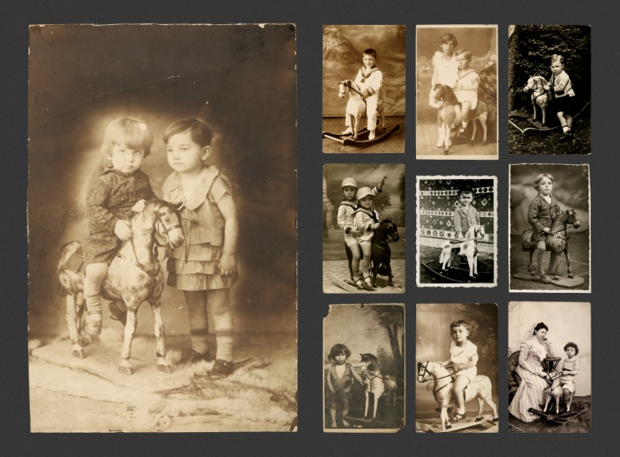

**Fig. 3.6.** Rocking horses. 2006. "Memories Taken Over."

From the collection of the Museum of Childhood

Appropriated photographs were assembled into groupings each representing a specific theme or motif (Fig. 3.6). By selecting and arranging several thousand photographs, approximately ninety universal motifs and situations emerged. Through this process, visible signs of commonality and parallels reinforced interconnection and dialogue between otherwise apparently disconnected histories. The artist was engaged more in a re-interpreting intervention than in invention.

(…) He rearranged found photographs in a way which resembles classification in family photo albums, but not with an aim to make a chronicle of connected history. Instead, he wanted to merge contexts which are among them unknown, through mutual moments, in order to build a total integration, never feasible in a diverse category of reality. It is a metaphorical album of childhood(s), a chronicle which at the same reconstructs, constructs and transforms the reality (Stojanov 2014, 2)

*Injured Parties*

In the multimedia installation, *Injured parties,* the artist incorporated found photographs with visible signs of deterioration. Carefully selected and cropped portraits of children were placed in a strict succession, which served as a visual apologia for disappearance and injuries the children on the photographs have endured in several situations (Fig. 3.7). These were times when the photographs became meaningless and no one preserved them as a personal memory. Then, a new layer of “injury” occurred in the form of physical deterioration of the abandoned material that took place in the surrounding of a flea market among other debris. In the gallery space, the artist, himself, added a new layer of injury to the image, through the intervention of scratching and physical damaging of the portraits, in order to emphasize the notion of destruction and oblivion.

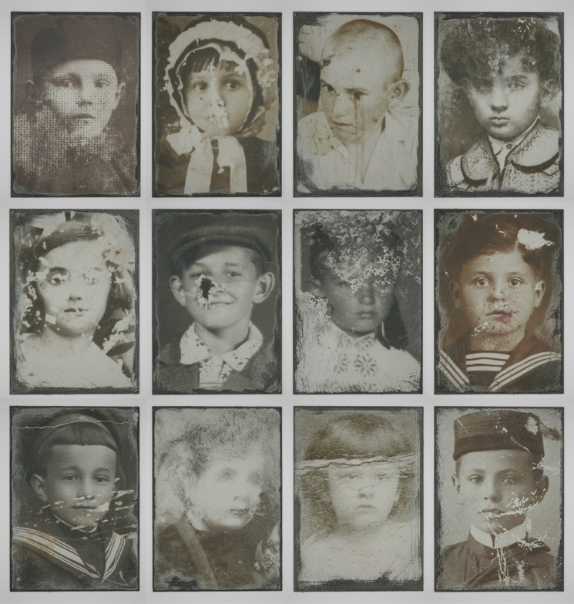

**Fig. 3.7.** Injured Parties. 2013, detail of the installation.

From the documentation of the Museum of Childhood.

The installation considered the relationship between appearance and disappearance, not just of photographs as documents of meaningful moments in history, but also the fracture of memories, concepts, and fragments of the past which had faded because of different reasons. In such a situation, where sites of discontinuity and voids in the archive and memory had been created, recollecting and rearticulating the abandoned documents otherwise disconnected from either private or collective historical narratives, creates a field of new historical configurations and manipulations.

Any archive is a product of the social processes and systems of its time, and reflects the position and exclusions of different groups or individuals within those systems (Breakell 2012, 5).

This installation was part of the exhibition “*History = Second-Hand Future*” which explored how the past informs the present and how the selected images support or alter the narratives of the past which we construct and embrace. Communicated in the exhibit was the concept of “truth” in history which is reconstructed based on selected fragments of the past, using criteria which often privilege certain kind of documents/objects. The exhibition commented on how objects and their involvement in historical narratives are shaped by their past and the path they have taken. How the actual need or capacity of the researcher, private collector, artist, society, or others can simultaneously and significantly influence or alter the very process of preservation or deterioration of the object/document was taken into consideration.

It can be argued that the whole concept of the Museum of Childhood raises the question of collective and individual relationships toward the preservation of certain parts of heritage. In the context of history which has been rewritten often, the Museum of Childhood rearticulated abandoned and discarded objects and experiences. Emphasis is placed on the question of what one society or an individual considers important enough to preserve and what is defined as insignificant, or unsuitable, in order to construct collective or personal historical narratives and memories.

**Concluding thoughts**

The practice at the Museum of Childhood is simultaneously *diagnostic*, that is valuing historicity, and *prognostic*,[3] bringing history to present. The museum collects abandoned and forgotten documents of the past, and puts them in the field of open interpretation. In such a context, the historical reading and artistic reconfiguration of the collection are in the state of constant flux and mutual influence.

Balance between historicity and the requirements of artistic creation demands an integrated approach to acquisition, collection organization, and interpretation which derives from both academic and artistic research. The Museum of Childhood is trying to maintain a fluctuating relationship between academic disciplines, rather than complying with compact and solidly demarcated approaches.

This hybrid model which mixes contemporary collecting, art, curatorial practice, and heritage can be discussed as defining a museological framework by which it can be described. This model is a manifested expression of critical museology, if we follow the definition that critical museology is crucial for developing new exhibitionary genres, telling untold stories, and rearticulating knowledge systems (Shelton 2013). It can also simply be taken as a lens for thinking about future trajectories of museums/collections and their cooperation with artists in order to challenge narratives and techniques of institutional presentation and authoritative concepts of interpretation.

Even if museums with collections of ethnographic/anthropological/historical value cannot allow such an extreme departure from their institutional integrity and disciplinary concept, the Museum of Childhood can provide a paradigm for the collaborative work between artists and museums. It can serve as a guide for other museums to embrace new possibilities of experimentation in visual representation, to employ some artistic strategies, and to cooperate with artists in order to provide a more vivid and enlightened interpretation. Multiple positioning of ethnographic/anthropological/historical objects with subjects and practices in the contemporary artistic field in this way, certainly goes beyond the authoritative and explanatory context of interpretation and the tendency toward entertainment and commerciality.

The Museum of Childhood provides a source for creating new relationships and shaping new cultural, historical, and social meanings of found objects onto which often personal and intimate emotions and experiences are projected. It is not a melancholic escape or a simple sentimentalization of the past; instead, manipulation is employed as a technique of investigation and confrontation of the past. The strength of this subjective reflexive position, integrated with artistic sensibility, is that it engages the author, as well as the viewer, in an interrogative mode. Both the context and the self are questioned in relationship with shifts and transformations that occur over time and changing history.

The Museum of Childhood, a space where art practice and cultural heritage has come together makes a significant contribution to innovation of museum practices. Work undertaken by the museum expands the discursive space of museum heritage and its use within museological practice, contemporary collecting, and contemporary art strategies. Several elements including numerous types of objects, passionate collecting, artistic and curatorial practices, and different institutional and architectural frameworks have been brought into relationship with each other, often without certain sense of how their fusion will appear at the end. Thus, in the Museum of Childhood the conceptual and operational boundaries between museological/curatorial and artistic categories are blurred; practices are exchanged and influenced by each other, demonstrating the potential of interdisciplinary dialogue and collaborative work, from which both academic and artistic field can benefit.

**Table 3.1.** Systematization of the Museum of Childhood collection

|  |  |
| --- | --- |
| **A CHILD CARE AND CHILD'S basic NEEDS** | |
| **A1 - Hygiene** | |
| Products – soaps and bath products, shampoos, cosmetics, toothpastes, washing powder for children’s fabrics | |
| Equipment and supplies: nappies, safety pins with children’s motifs, toothbrushes | |
| **A2 - Care about child’s physical health and development** | |
| Products: cough pastilles, medicines | |
| Equipment and supplies: inhaler, animal and children’s hero shaped hot therapeutic pillows, baby walker | |
| **A3 - Nourishment** | |
| Packaging and products | Meal: packaging for baby and children’s meals |
| Sweets: chocolate packaging and wrappers, ice-cream packaging, boxes and packaging for cookies and candies |
| Drinks: children’s juice packaging, milk and powder milk packaging |
| Utensils: plates, cups, cookware, cutlery with children’s motifs, lunch containers | |
| **A3 - Wear and footwear** | |
| Clothes: t-shirts, sweaters, pants, baby clothes, raincoats | |
| Uniforms: pioneer’s cap and scarf, ceremonial military uniform | |
| Accessories: applicable motifs for children's clothing, belts, sunglasses, umbrellas, hangers | |
| Footwear: shoes, sandals, boots | |
| **A5 - Writings and information** | |
| Books: *Children’s nourishment*, *Your child*, magazine: *Child and Parent* | |

|  |  |  |  |  |  |  |  |  |
| --- | --- | --- | --- | --- | --- | --- | --- | --- |
| **B SURROUNDING FOR CHILDREN** | | | | | | | | |
| **B1 - At home** | | | | | | | | |
| Interior | | | | | Furniture: table, chair, cradle | | | |
| Decoration: tapestries, needlepoint, table and wall clocks, lamps | | | |
| Exterior: movable property such as swings | | | | | | | | |
| **B2 - At school** | | | | | | | | |
| Furniture and equipment for school classrooms, gyms, laboratories, workshops: desks and chairs, chalkboards, large maps and educational posters for walls | | | | | | | | |
| **B3 - In public spaces (urban parks, shops, institutions…)** | | | | | | | | |
| Adapted shelves for children’s products, movable property from amusement parks… | | | | | | | | |
| **C EDUCATION AND CREATIVE ACTIVITY (within school classrooms and beyond)** | | | | | | | | |
| **C1 – Language, literacy and literature** | | | | | | | | |
| Writings* | | | Mother language learning: alphabet books, primers | | | | | |
| Foreign language learning: dictionaries, bilingual and multilingual books for language learning | | | | | |
| Picture books | | | | | |
| Pop-up books | | | | | |
| Stories and novels | | | | | |
| Fables | | | | | |
| Fairytales | | | | | |
| Poetry | | | | | |
| Brain teasers, tongue twisters, riddles | | | | | |
| Biographies and autobiographies | | | | | |
| Books with multiple contents | | | | | |
| Comics | | | | | |
| Made by children: essays, notebooks with content | | | | | | | | |
| **C2 - Art education and applied arts** | | | | | | | | |
| Writings | | | | | | | | |
| Children’s creativity | | | | Tools and equipment: brushes, paints, pyrography tools, hand loom, modeling materials, photo cameras | | | | |
| Template materials and kits: template samples (for cutting and folding) | | | | |
| Made by children: drawings, pictures, figures | | | | |
| **C3 - Music** | | | | | | | | |
| Writings | | | | | | | | |
| Equipment | Sound recording and reproducing devices | | | | | | | Gramophones |
| Tape recorders |
| Magnetophones |
| Receivers: Radios | | | | | | | |
| Children create and perform | Music instruments | | | | | | | |
| Products (sound storage media) | | | | | | Analog | Gramophone records (music, music and animation) |
| Compact cassettes |
| Tapes |
| Digital | |
| **C4 - Performing arts** | | | | | | | | |
| Writings | | | | | | | | |
| Children perform | | | | | | | Tools and equipment: masks, costumes | |
| Products: movies with children as actors | |
| **C5 – History and society** | | | | | | | | |
| Writings | | | | | | | | |
| Made by children: notebooks with content, albums (scrapbooks) | | | | | | | | |
| **C6 – Religious education** | | | | | | | | |
| Writings | | | | | | | | |
| Made by children: notebooks with content | | | | | | | | |
| **C7 - Geography and environment** | | | | | | | | |
| Writings | | | | | | | | |
| Made by children: notebooks with content, albums (scrapbooks) | | | | | | | | |
| **C8 - Biology** | | | | | | | | |
| Writings | | | | | | | | |
| Made by children: notebooks with content | | | | | | | | |
| **C9 - Physics** | | | | | | | | |
| Writings | | | | | | | | |
| Made by children: notebooks with content | | | | | | | | |
| **C10 - Chemistry** | | | | | | | | |
| Writings | | | | | | | | |
| Made by children: notebooks with content | | | | | | | | |
| **C11 - Mathematics** | | | | | | | | |
| Writings | | | | | | | | |
| Tools and equipment: abacus | | | | | | | | |
| Made by children: notebooks with content | | | | | | | | |
| **C12 - Technology and engineering** | | | | | | | | |
| Writings | | | | | | | | |
| Children creating | | | | | | Materials and tools: kits for working, kits for scale modeling, tools such as hacksaw, wood saw, hammer, pliers | | |
| Made by children: notebooks with content, products | | |
| **C13 - Domestic education and everyday life** | | | | | | | | |
| Writings | | | | | | | | |
| Made by children: notebooks with content | | | | | | | | |
| **C14 – Physical education and recreation** | | | | | | | | |
| Writings | | | | | | | | |
| Equipment: skis, bicycle, tricycle, scooter, balls, float, skates, slingshot | | | | | | | | |
| **C15 - General knowledge and culture** | | | | | | | | |
| Writings | | General (universal) encyclopedias end encyclopedic editions | | | | | | |
| Lexicons | | | | | | |
| Children’s magazines with diverse content | | | | | | |
| Made by children | | | | | | | | |
| **C16 - Pedagogical literature with diverse contents** | | | | | | | | |
| Writings | | | | | | | | |
| **C17 - Diverse multi-use tools and objects** | | | | | | | | |
| School bags, notebooks, sketchbooks, bags for notebooks, pencil cases, pens, pencils, compasses (drawing tools), rulers, chalk, small chalkboards for students | | | | | | | | |

*Writings include print publications (books, textbooks, additional educational resources such as maps and atlases) and educational and informational content on other media such as gramophone records and slide cards

|  |  |  |  |  |
| --- | --- | --- | --- | --- |
| **D PASTIME, HOBBYAND OTHER LEISURE ACTIVITIES** | | | | |
| **D1 - Play** | | | | |
| Writings | | | | |
| Toys and games | Mechanical (movement) toys: top, yo-yo, click-clack toy | | | |
| Optical toys: kaleidoscope | | | |
| Toy figures | | Animals (stuffed, rubber, metal, plastic animals) | |
| Dolls (textile, rubber, porcelain, plastic dolls) | |
| Children heroes | |
| Groups (such as Wild West) | |
| House and household: stove, iron, refrigerator, cooking utensils and cutlery, telephone | | | |
| Transport and vehicles | | Air | |
| Water | |
| Rail | |
| Road | |
| Working machines | |
| Services: the army and the war, police, firefighters, medicine | | | |
| Space and science (fiction): rockets, space weapons, robots | | | |
| Weapons: guns, sabers, swords | | | |
| Building, assembling, constructing: puzzles, construction kits | | | |
| Social games | | Board games: chess, monopoly | |
| Games with different tools and sets: pinball, playing cards | |
| Knowledge and learning: Quiz game, Educational kits | | | |
| Sound, rhythm, melody: rattles, music boxes, sleeping music toys | | | |
| Electronic toys: consoles, computer games | | | |
| **D2 - Watching movies, photographs and animation** | | | | |
| Equipment | Projectors | | | |
| Viewers | Mono viewers: Viewers in different shapes (animals, children’s heroes) | | |
| Stereo viewers | | |
| Film recordings | Analog | Film strips | | |
| Videotapes | | |
| Digital | | | |
| **D3 - Collecting and collectibles** | | | | |
| Albums with stickers | | | | |
| Stickers | | | | |
| Paper napkins | | | | |
| Collectibles with children motifs | Pins | | | |
| Philately | | | |
| Pendants | | | |
| **D4 - Children are saving and buying** | | | | |
| Money boxes | | | | |
| Wallets | | | | |
| **D5 - Celebrations** | | | | |
| Birthday: candles | | | | |
| New year: decoration objects | | | | |
| Religious holiday: bell for Lazarus Saturday | | | | |
| State holidays | | | | |
| **D6 - Journeys and excursions** | | | | |
| Equipment and objects: suitcases, drink and food thermos, pocket radios | | | | |
| **D7 Written communication and memory sharing** | | | | |
| Memory books | | | | |
| Postcards, greeting cards, letters | | | | |
| **E ARHIVAL MATERIALS** | | | | |
| **E1 - Photo-archive**: Photographs divided in thematic categories (such as Birth, In hospital, Bath, Prams, Play, Toys, Teddy bears, Dolls, Rocking horses etc) | | | | |
| **E2 - Grade reports** | | | | **E3 - Diplomas, certificates** |
| **E4 - Statutes, regulations** | | | | **E5 - Membership cards** |
| **E6 - Tickets** | | | | **E7 - Calendars** |
| **E8 - Posters** | | | | **E9 - Stickers** |

**Bibliography**

Bassnett, Sara. 2009. "Archive and Affect in Contemporary Photography." *Photography &*  *Culture,* 2(3): 241-252.

Benjamin, Walter. 1969. "Unpacking My Library, Talk about Book collecting." In  *Illumination*, ed. Benjamin Walter, 59-67. New York: Schocken Books.

Breakell, Sue. 2008. "Perspectives: Negotiating the Archive" *Tate’s Online Research*  *Journal*. http://www.tate.org.uk/research/publications/tate-papers/perspectives- negotiating-archive. (accessed 9 December 2014).

Bulatović, Prof. dr. Dragan. 2011. *Collection as a Passion*, Panel Discussion. Museum of African Art, Belgrade, Serbia.

Elsner, John & Cardinal, Roger. 1994. "Introduction." In *The Cultures of Collecting*, eds. John Elsner & Roger Cardinal, 1-6. Harvard University Press, Cambridge, Massachusetts.

Foster, Hal. 2004. An Archival Impulse, October 110, Fall, 3-22.

http://isites.harvard.edu/fs/docs/icb.topic837293.files/FosterArchivalImpulse.pdf. (accessed 9 December 2014).

Frønes, Iver. 1994. "Dimensions of Childhood." In *Childhood Matters: Social Theory,*  *Practice and Politics*, eds. Jens Qvortrup, *et al*., 145-165. Aldershot: Avebury.

Mihelj, Sabina. 2011. "Negotiating Cold War culture at the crossroads of East and West: uplifting the working people, entertaining the masses, cultivating the nation"  *Comparative Studies in Society and History* 53(3): 509-539.

Shelton, Anthony. 2013. "Critical Museology: A Manifesto," *Museum Worlds: Advances in*  *Research* 1(1): 7-23.

Stojanov, Milica. 2014. *Preuzete uspomene – Foto arhiva Muzeja detinjstva (Memories*  *Taken Over – Photo archive of the Museum of Childhood).* Novi Sad: City Museum of Novi Sad.

Šola, Tomislav. 2011. *Prema totalnom muzeju*. Centar za muzeologiju i heritologiju, Filozofski fakultet Univeziteta u Beogradu. Belgrade: Center for Museology and Heritology, Faculty of Philosophy.

Vučetić Radina. 2011. "Diznizacija detinjstva i mladosti u socijalističkoj Jugoslaviji" ("Disneyfication" Of The Childhood And Youth In Socialist Yugoslavia), *Istorija 20. veka (The History of The 20th Century)*:185-204. Institut za savremenu istoriju Beograd. Belgrade: Institute of Contemporary History.

Zornado, Joseph L. 2001. *Inventing the Child. Culture, Ideology, and the Story of Childhood.* New York: Garland Pub.

Zupan Zdravko. 1999. "Project Rastko." Library of Serbian culture online. http://www.rastko.rs/strip/zzupan- zlatnodoba.html. (accessed 9 December 2014).

1. The Museum of Childhood, located in Belgrade, Serbia, is an on-going project based on the large collection of childhood-related objects, mostly found at flea markets. It was initiated by the artist Vladimir Perić in 2006. I became involved in the project in 2011 and since then, the two of us developed the Museum of Childhood, fusing the approaches of museum-like practice and contemporary art. Our goal is to provide a permanent public space for the Museum of Childhood in the near future.
2. This was one of the conclusions and suggestions that prof. dr. Dragan Bulatović gave on the occasion of the panel discussion *Collection as a Passion*, held at the Museum of African Art, Belgrade, Serbia, 2011.
3. Terms were used by the curator Okwui Enwezor during the panel discussion relating to his exhibition 2008 "Archive Fever: Uses of the Document in Contemporary Art."