אוניברסיטת בן-גוריון בנגב

הפקולטה למדעי הבריאות

ביה"ס לרפואה ע"ש גולדמן

**נושא הצעת המחקר:**

**The association between the novel POCUS lung injury score and the severity of illness among COVID-19 respiratory patients**

הערכת הקשר בין POCUS Lung Injury Score (PLIS) לבין חומרת מצב החולה ב-COVID 19 הסובל מסימנים נשימתיים

**סטודנט מגיש:** יובל אולמן **ת.ז**: 208289892

**סוג העבודה**: עבודת מחקר קלינית

**מנחים:** ד"ר ליאור פוקס, רופא בכיר בפנימית ובטיפול נמרץ פנימי, המרכז הרפואי האוניברסיטאי סורוקה. מרצה בכיר, בית ספר למקצועות הבריאות, אוניברסיטת בן גוריון.

ד"ר יפתח שגיא, רופא בכיר במחלקה פנימית, המרכז הרפואי האוניברסיטאי סורוקה. דוקטורט בניהול מערכות בריאות, המחלקה לניהול מערכות בריאות, אוניברסיטת בן-גוריון בנגב.

**ייעוץ סטטיסטי**: ד"ר יפתח שגיא, רופא בכיר במחלקה פנימית, המרכז הרפואי האוניברסיטאי סורוקה. דוקטורט בניהול מערכות בריאות, המחלקה לניהול מערכות בריאות, אוניברסיטת בן-גוריון בנגב.

**Keywords**:

Ben-Gurion University of the Negev, Covid-19, intensive care unit, PLIS, point of care ultrasound, SOFA, Soroka University Medical Center

1. **Background**:

The coronavirus disease 2019 (COVID-19) epidemic began in December 2019 in China and rapidly spread around the world, leading the World Health Organization to officially declare it a public health emergency of international concern on January 30, 2020, and a pandemic on March 11, 2020. Data on hospital admissions during this time period found that approximately one third of patients hospitalized for COVID-19 presented with acute respiratory distress syndrome (ARDS) [1, 2].

Abnormal chest radiographs were reported in 95% of a different set of patientswith confirmed COVID-19 infection after being admitted to an intensive care unit (ICU). The most common findings on initial chest radiograph were bilateral reticular nodular opacities. Up to 67% of patients had evidence of ground-glass opacities. ARDS was observed in 15 of 15 patients (100%) requiring mechanical ventilation [source?].

Lung ultrasonography (LUS) can identify changes in the physical state of superficial lung tissue, which correlate with histopathology and can be identified in computerized tomography (CT) scans , but remain undetected in a large percentage of chest radiographs. In experimental models of ARDS, LUS has proved capable of detecting lung lesions before the development of hypoxemia. [4, 5, 7]

In the current COVID 19 pandemic there is a growing need for fast and safe methods of examining the lungs. A short, focused point-of-care ultrasound (POCUS) exam of the lung can reduce the number of healthcare professionals exposed to the virus during patient stratification [4, 6]

For these reasons, we developed a score for reporting the findings of lung ultrasound - the POCUS lung injury score, or PLIS. The PLIS is a novel score for that establishes nomenclature of LUS study among patients with a respiratory infection. It was developed during the COVID 19 outbreak as a method of communication between health care providers and different COVID units. The score provides a description of the pathological findings in the lungs as well as a number reflecting the severity of pathologies found, i.e., a summation of the findings.

We intend to investigate whether this score can serve each of two purposes: 1. **Description of lung pathologies** composed of a pulmonary congestion/edema score, as reflected in the number and severity of B lines, as well as the severity and extent of consolidations . 2. **A numerical score** that reflects the severity of the patient’s current situation.

As part of our assessment and validation of the PLIS, we thought to look at the association between the severity of lung disease, as reflected by the PLIS, and the severity of illness at the time the PLIS was given, as measured by the sequential organ failure assessment (SOFA) score. We also sought to evaluate the agreement between the description of the lung pathologies by the PLIS score and standard chest radiographs (CXR).

**The SOFA score:**

The SOFA score was developed in an attempt to provide a means of quantitatively and objectively describing the degree of organ failure over time in patients with sepsis. The SOFA score is part of the current clinical criteria for the definition of sepsis (sepsis 3). It measures organ dysfunction in six systems (respiratory, coagulation, hepatic, cardiovascular, renal and central nervous system), using a 5-point scale. A change in SOFA score of at least two points compared to the baseline SOFA score represents organ dysfunction. SOFA is well known within the critical care community and has a verified relationship to mortality risk [8, 9; Appendix 2].

**The PLIS protocol** can be found in Appendix 1.

1. **Study Hypothesis:**
2. PLIS score will reflect the severity of illness among COVID-19 patients.
3. PLIS score can reflect lung pathologies among COVID-19 patients with good agreement with CXR.
4. **Research goal:**

This study aims to assess the association between PLIS and the severity of illness as measured by the SOFA score.

1. **Secondary goals:**

This study aims to describe the agreement rate between the PLIS report and the formal CXR reading. The future goal is to prove that lung ultrasounds can replace CXR in the supervision of COVID-19 patients because CXR may needlessly endanger medical staff and other patients in the hospital.

1. **Materials and methods**
2. **Study design**

This study is a retrospective, pilot, double center, feasibility study to evaluate the PLIS on patients that presented with a respiratory infection, and will be carried out at the Soroka University Medical Center (SUMC) and Barzilai Medical Center (BMC). The Soroka Clinical Research Center will oversee and manage the study. We will analyze data collected from the treatment of COVID-19 patients during the 2020 outbreak, where the PLIS protocol (a novel lung ultrasound protocol) was used for patients scanning in both centers.



## Study population

Data was collected from patients admitted to SUMC or BMC corona wards and ICUs with a diagnosis of respiratory infection.

Since the first COVID-19 patients arrived at the ICU, we performed LUS by the PLIS protocol on all patients and during every morning round. The results were documented in all patient’s follow up notes. We then taught the physicians attending to non-ICU cover patients to collect PLIS results every day using LUS.

### Inclusion criteria (all should apply)

* Patients diagnosed with a COVID 19 infection and were hospitalized in one of the Corona units (ICU or medical ward) at SUMC and Barzilai Medical Center BMC during the COVID 19 outbreak.
* Patients requiring any method of respiratory support, such as a nasal cannula, non-invasive ventilation, oxygen mask or invasive mechanical ventilation.
* Patients physically capable of going through an ultrasound study.

### Exclusion Criteria

* Patients that refused ultrasound study.
* Patients with no respiratory abnormality or any respiratory support throughout hospital stay.
* Age < 18 years old

1. **Sample Size**

Based on previous studies, to achieve a power of 80% with p < 0.05, we will need 16 patients with ARDS and 16 patients without ARDS [10].

1. **Data Collection** 
   1. **Dependent variable**

The daily PLIS scores and data collected from CXR: B lines and description of consolidations.

* 1. **Independent variables**
* CXR formal reading, CT formal reading
* Demographic factors: age, gender, ethnicity
* Medical history: medications, diabetes mellitus, hypertension, systemic diseases, congestive heart failure, chronic obstructive pulmonary disease (COPD), height and weight, smoking status
* Clinical data:
  + Admission date, length of admission, hospital, unit, ICU admission and dates, comorbidity, mortality
  + Treatment: antibiotics prescribed, vasopressors, steroids, other COVID related experimental therapy
  + Vitals: heart rate, blood pressure, temperature, respiratory rate, cognitive assessment
* ARDS treatments: mechanical ventilation, dates on ventilation, positive end-expiratory pressure, nitric oxide, prone position
* Labs: PaO2/FIO2, white blood cells, platelets, creatine phosphokinase, troponin, D-dimer, brain natriuretic peptide, creatinine, bilirubin
* pleural effusion, urine output
* SOFA score, acute renal failure (calculated by RIFLE criteria)
  1. **Statistical Analysis**

Data will be analyzed using a SPSS 25.0. Data will be expressed as mean ± standard deviation (SD), median ± interquartile range (IQR), or number and percentage. The unit of analysis is a single test (US or XR) per patient. SOFA will be calculated for the same day per each imaging (US or XR) test. We will compare patient characteristics between those with ARDS vs. non-ARDS patients using the t-test, chi-square and non-parametric tests. We will calculate the correlation between each patient’s PLIS and SOFA scores using Spearman's rank correlation coefficient. We will compare patients’ characteristics stratified by PLIS score with CXR findings. We will calculate specificity, sensitivity, positive predictive value, negative predictive value and area under the curve for ARDS diagnosis based on PLIS score compared to SODA score and CXR. We will calculate the agreement between the two modalities using Cohen's kappa coefficient and will consider values greater than 0.8 as good agreement. We will also conduct multivariate logistic regression to test the association between ARDS and PLIS, SOFA and CXR variables. The final model will be selected based on plausible clinical explanation, statistical significance and goodness of fit using c-statistics.

1. **Research Limitations**

* A relatively small number of patients due to the fact that this epidemic just started in the south of Israel and we would like to further evaluate this score if our primary analysis will show benefit.
* There is wide variability in clinician experience regarding operating the LUS for the PLIS protocol. We have tried to establish a cohort of operators in the ICU and in the COVID-19 wards that have at least two years of LUS experience.
* We did not have CXR for every PLIS score, so our comparison is limited. We have many PLIS assessments and much fewer CXRs.
* As LUS is not yet considered the gold standard test to diagnose ARDS, it is hard to find the right comparison between the two modalities - the US and the CXR.

1. **Student responsibilities and schedule:**
2. Review literature and articles and study proposal (May 2020)
3. Conduct the study and data collection (June- July 2020)
4. Statistical analysis of the data (July 2020)
5. Review the conclusions of the study and summarize findings (August 2020)
6. Write the conclusions and study process as a scientific article (August 2020)
7. **References:**
8. Rodriguez-Morales AJ, Cardona-Ospina JA, Gutierrez-Ocampo E *et al*. Clinical, laboratory and imaging features of COVID-19: A systematic review and meta-analysis. *Travel Med Infect Dis* 2020;101623.
9. Guan WJ, Ni ZY, Hu Y, *et al*. Clinical Characteristics of Coronavirus Disease 2019 in China. *N Engl J Med* 2020; 382:1708-1720
10. Arentz M, Yim E, Klaff L, Lokhandwala S, Riedo FX, Chong M, Lee M. Characteristics and Outcomes of 21 Critically Ill Patients With COVID-19 in Washington State. *JAMA* 2020;323(16):1612-1614
11. Soldati G, Smargiassi A, Inchingolo R, *et al*. Is There a Role for Lung Ultrasound During the COVID-19 Pandemic? *J Ultrasound Med.* 2020;39:1459-1462
12. [M.J. Fiala](https://www.ncbi.nlm.nih.gov/pubmed/?term=Fiala%20M%5BAuthor%5D&cauthor=true&cauthor_uid=32331781). Ultrasound in COVID-19: a timeline of ultrasound findings in relation to CT. *Clinical Radiology*, 2020;
13. [D Buonsenso](https://pubmed.ncbi.nlm.nih.gov/?term=Buonsenso+D&cauthor_id=32196627) [1](https://pubmed.ncbi.nlm.nih.gov/32196627/#affiliation-1), [A Piano](https://pubmed.ncbi.nlm.nih.gov/?term=Piano+A&cauthor_id=32196627), [F Raffaelli](https://pubmed.ncbi.nlm.nih.gov/?term=Raffaelli+F&cauthor_id=32196627), [N Bonadia](https://pubmed.ncbi.nlm.nih.gov/?term=Bonadia+N&cauthor_id=32196627), [K de Gaetano Donati](https://pubmed.ncbi.nlm.nih.gov/?term=de+Gaetano+Donati+K&cauthor_id=32196627), [F Franceschi](https://pubmed.ncbi.nlm.nih.gov/?term=Franceschi+F&cauthor_id=32196627): Point-of-Care Lung Ultrasound Findings in Novel Coronavirus disease-19 Pnemoniae: A Case Report and Potential Applications During COVID-19 Outbreak. *European Review for Medical and Pharmacological Sciences*. 2020;24:2776-2780
14. Mallamaci F, Benedetto FA, Tripepi Ret al. Detection of pulmonary congestion by chest ultrasound in dialysis patients. *JACC Cardiovasc Imaging.* 2010; 3:586-94

1. [Moreno](https://www.sciencedirect.com/science/article/pii/B9780323048415500765" \l "!) RP, Metnitz, PGH, Parrillo JE, Dellinger RP. . [Severity scoring systems: Tools for the evaluation of patients and intensive care units](https://www.sciencedirect.com/science/article/pii/B9780323048415500765). **In:** [Critical Care Medicine. 2008, Third Edition. Philadelphia, PA, Mosby Elsevier, 1547-1565](https://www.sciencedirect.com/book/9780323048415)
2. Singer M, [Deutschman](https://jamanetwork.com/searchresults?author=Clifford+S.+Deutschman&q=Clifford+S.+Deutschman" \t "_blank) CS, [Seymour](https://jamanetwork.com/searchresults?author=Christopher+Warren+Seymour&q=Christopher+Warren+Seymour" \t "_blank) CW. The third international consensus definitions for sepsis and septic shock (Sepsis-3).

*JAMA*. 2016;315(8):801-810

1. Copetti R, Soldati G, Copetti P. Chest sonography: a useful tool to differentiate acute cardiogenic pulmonary edema from acute respiratory distress syndrome. *Cardiovascular Ultrasound* 2008, 6: 16
2. [Dietrich](https://www.ncbi.nlm.nih.gov/pubmed/?term=Dietrich%20CF%5BAuthor%5D&cauthor=true&cauthor_uid=27293860) CF, [Mathis](https://www.ncbi.nlm.nih.gov/pubmed/?term=Mathis%20G%5BAuthor%5D&cauthor=true&cauthor_uid=27293860) G, [Blaivas](https://www.ncbi.nlm.nih.gov/pubmed/?term=Blaivas%20M%5BAuthor%5D&cauthor=true&cauthor_uid=27293860) M et al.Lung B-line artefacts and their use.[*Journal of Thoracic Disease*](http://scholar.google.co.il/scholar?q=journal+of+thoracic+disease&hl=iw&as_sdt=0&as_vis=1&oi=scholart)**.** 2016:8(6),1356-1365
3. See KC, Ong V, Tan YL, Sahagun J, Taculod J. Chest radiography versus lung ultrasound for identification of acute respiratory distress syndrome: a retrospective observational study. *Critical Care* 2018;22:203

**APPENDIX**

* 1. **The PLIS protocol:**

The score provides a description of the pathological findings of the lungs as well as a number for the quantification of the severity of pathologies found.

The score is comprised of three fields described by A,B, and C.

**A score:** This is the only part of the score that is not related to the ultrasound study but to the severity of hypoxemia:

A0: Reflects minimal or no oxygen requirements to establish saturation > 90%. Patients on room air or nasal cannula will receive this score.

A1: Patient on higher oxygen supply (face mask) or non invasive ventilation (high flow, bipap cpap) or on invasive ventilation with p/f ration > 200.

A2: Patient on invasive ventilation with p/f ratio >100<200

A3: invasive ventilation p/f ratio< 100

**B score:** This is the part in the score that describes the severity of the interstitial syndrome or the gravity of lung congestion/edema in ARDS by checking for B lines in the lungs. B lines are defined as discrete laser-like vertical hyperechoic reverberation artefacts that arise from the pleural line and extend to the bottom of the screen without fading and move synchronously with lung sliding. Multiple B lines are associated with pulmonary edema and are proved to be a powerful diagnostic tool for ARDS [11, 12]. For this part, we will use the low frequency cardiac probe for the scanning of zone 1, i.e., the non-dependent, aerated part of the lungs, where pathology there has the highest specificity for interstitial lung syndrome. The number of B lines in the score corresponds to most B lines located in one cycle of breathing, in one intercostal space, in either lung.

B0: Up to 3 B lines in zone 1.

B1: 3-6 B lines in zone 1.

B2: More than 6 B lines in zone 1.

B3: Confluence of B lines in zone 1.

**C score:** This is the part of the score that describes the size and location of consolidations. We believe that lung pathology with consolidation concomitant to ARDS is more severe than ARDS with no consolidation, and that bilateral consolidations are worse than unilateral disease.

C0 : No lung consolidation detected by lung ultrasound.

C1: Unilateral small lung consolidation (small is defined as when the largest axis of measured consolidation is <4 cm).

C2: Small bilateral consolidation, or unilateral large consolidation.

C3: Bilateral consolidations where at least one is large.

The summation of A+B+C will define the score reported as a number, with scores ranging from 0 (lowest) to 9 (highest). The reporting of the score should specify each field and its numerical score: i.e., A1B2C2.

# Figure 1: The PLIS: respiratory infection ultrasound scoring.

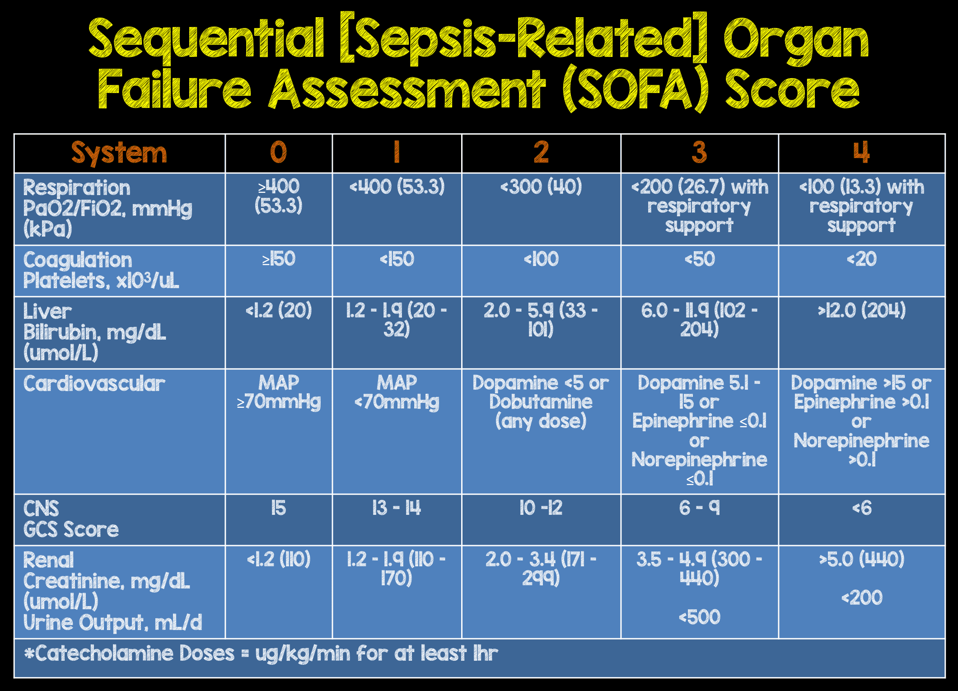

**Figure 2:** The SOFA score

* 1. **Statistics tables**:

**TABLE 1: Demographics and baseline characteristics**

|  |  |  |  |
| --- | --- | --- | --- |
| **Variable** | **ARDS** | **No ARDS** | **P value** |
| **Age (mean, SD)** |  |  |  |
| **Weight (mean, SD)** |  |  |  |
| **Males (n, %)** |  |  |  |
| **Hypertension (n, %)** |  |  |  |
| **COPD (n, %)** |  |  |  |
| **Cardiovascular disease (n, %)** |  |  |  |
| **Diabetes (n, %)** |  |  |  |
| **Malignancy (n, %)** |  |  |  |
| **Cerebrovascular disease (n, %)** |  |  |  |
| **Chronic kidney disease (n, %)** |  |  |  |
| **Mechanical ventilation (n, %)** |  |  |  |
| **PaO2/FIO2 (median, IQR)** |  |  |  |
| **WBC (mean, SD)** |  |  |  |
| **Platelets (mean, SD)** |  |  |  |
| **Bilirubin (mean, SD)** |  |  |  |
| **Creatinine (mean, SD)** |  |  |  |
| **Acute renal failure by RIFLE criteria - risk (n, %)** |  |  |  |
| **Acute renal failure by RIFLE criteria - injury (n, %)** |  |  |  |
| **Acute renal failure by RIFLE criteria - failure (n, %)** |  |  |  |
| **SOFA score (median, IQR)** |  |  |  |
| **PLIS (median, IQR)** |  |  |  |
| **XR - B lines (n, %) להוסיף שורה** |  |  |  |
| **XR - Consolidations (n, %)** |  |  |  |

**TABLE 2. Multivariate logistic regression on the association of ARDS, PLIS, SOFA and XR**

|  |  |  |  |  |
| --- | --- | --- | --- | --- |
| **Variable** | **P value** | **Odds ratio** | **95% confidence interval** | |
| **SOFA** |  |  |  |  |
| **PLIS** |  |  |  |  |
| **XR** |  |  |  |  |