Release and Deployment Management

The objective of release and deployment management is the scheduled rollout of changes to the IT infrastructure within the operating environment. A release is the logical grouping of all changes, whereas deployment is the actual implementation of these changes. In the course of the release or deployment process, changes are made to the current configuration of the IT infrastructure. Installing changes generally means that IT services are unavailable for the duration of the **deployment process**. Additionally, altering an operational configuration always carries the risk of disruption and limited availability due to unplanned effects. Figure 28 depicts the various stages of release and deployment management which are intended to minimise the risks of disruption after deployment and, by carefully selecting the date of deployment, should also ensure that users face minimal or no limitations.

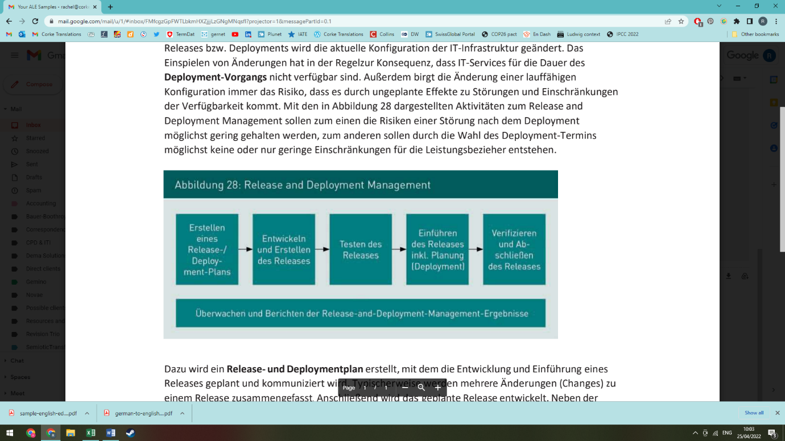

Figure 28: Release and Deployment Management

Monitor and report on the release and deployment management outcomes

Create a release/ deployment plan

Develop and build the release

Test the release

Install the release incl. planning (deployment)

Verify and close the release (release closure)

In addition, a **release and deployment plan** is created to design and communicate the development and introduction of a release. Usually a release groups together several changes. Following this, the planned release is developed. IT components must be enhanced and serviced and all documentation required for the development and operation must be produced. After the development work is complete, the release is tested. As well as reviewing the functionality of the release, checks are made to ensure the release’s rollback procedure can be successfully implemented. After the tests have been completed and approved, a detailed plan is made and then the release is installed via deployment. Alongside changes to software and hardware, this also involves carrying out all accompanying IT service management tasks. This includes updating the CMDB and the service catalogue (if required), implementing change management processes and monitoring activities, as well as amending contracts regarding the provision of IT services (where necessary).