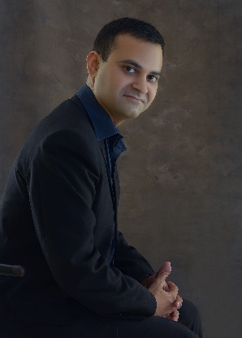

Senior Executive Copywriter in TechResource: My responsibility was to write blogs, video synopis and creative content until the company went bankrupt in Feb 2022 and I was laid off with other employees.

**PERSONAL SKILLS**

/ DEC 2021 – FEB 2022

/ NOV 2020 – NOV 2021

SENIOR EXECUTIVE COPYWRITER

CREATIVE

INNOVATE

HOBBIES

TEAM WORK

Senior Academic Writer in TheCircle5: My responsibility was to write MSc and PhD level dissertations, thesis and manage a team of writers.

SENIOR ACADEMIC WRITER

CYBER WARFARE

/ JAN 2013 - MAY 2014

RUSSIAN LANGUAGE

/ JUN 2018 – JAN 2020

BUSINESS DEVELOPMENT

/ FEB 2011 - DEC 2019

/ MAY 2016 – AUG 2016

/ AUG 2016 - MAY 2018

BUSINESS PLANS

1 H/S-2, Second Floor, P.E.C.H.S Block 6, Near Dehli Sweets, Karachi, Pakistan

An experienced professional having over 11 years of involvement in R&D, Project Management and Business Consultation, and academic writing. My professional experience through these years has been associated working with University Students, Private Corporations and Small Businesses.

The skillsets and abilities at my disposal make an impactful contribution with the people I work.

CREATIVE WRITING

BUSINESS INTEL

**CONTACT ME**



**PROFESSIONAL SKILLS**



DANIAL SAEED

PYTHON

ADOBE SUITE

MS OFFICE

Silver Wings Aviation Academy: I was trained for inflight cabin crew and their routines during flight.

Shaheen Aviation College: I was trained for passenger handling and Dangerous Goods Regulations of airport operations.

/ APR 2011 - JUN 2011

/ APR 2011 - JUN 2011

Cabin Crew Course

Ground Operations Course

Virtual University of Pakistan: I did my bachelor's in commerce and my favourite subjects were banking and principles of commerce.

/ MAY 2008 - MAY 2010

BACHELORES DEGREE

Russian Centre for Culture and Science: I have learned the Russian Language from this institution in my city.

**PROFICIENCY**

**EDUCATION**

Freelance Academic Writer: I have worked as a freelance academic writer for several organisations through third-party contracts.

HOD of business plans in Devisers: I was hired as head of the department of business plans in Devisers International Law and Immigration firm.

Business Development Coordinator in Akbar Ali & Sons: My responsibility was to prepare tender documents for clients and find them a suitable principal.

Researcher in M.M.Group of Companies: My responsibility was to research upon rice and increase its sales for the local and export markets.

RESEARCHER

WRITER

**WORK EXPERIENCE**

YOUTUBE

CRM

PROJECTS

ADMINISTRATION

dsaeed17@hotmail.com

https://www.linkedin.com/in/danial-saeed-a6435824/

+92 333 3509107

+92 333 2243432

**PROFILE**



Senior Academic Writer