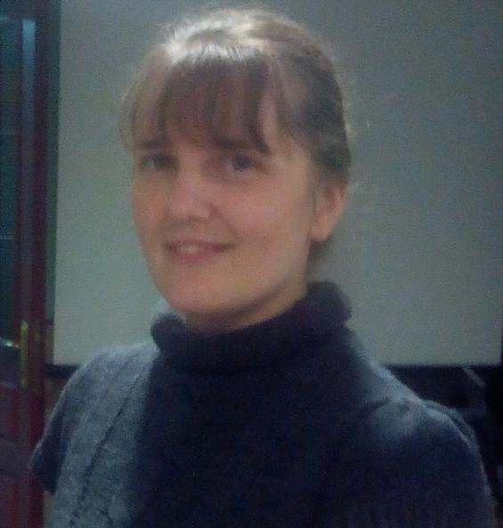
Irina Levchenko
Address: Zhitomir, Ukraine
Residence Ukraine
Contact tel. +38 0937517188 (mobile)

Education 2003 – 2008 Zhitomir State University, the Foreign Philology Faculty, the specialist of translation from English and Deutsch.

I specialize in the next fields of translation:
Medical documents (including PET-CT results, laboratory tests, etc), ICF for clinical trials, clinical evaluation reports, legal documents, agreements, POA, paystabs, financial reports, personal documents, diplomas, certificates, technical and software translation, insurance policies

Proficiency in a language
Ukrainian, Russian Native languages
English working language, reading skills – excellent, writing skills –
excellent, verbal skills – excellent
Hebrew working language, reading skills – excellent, writing skills –
excellent, verbal skills – excellent

Computer facilities: MS Word, MS Excel, Adobe Acrobat, Power Point.
CAT SDL Trados , Wordfast, SmartCAT, MemSource
Payment Via bank transfer, Moneybookers, PayPal, Webmoney

Rates 0.05-0.10 USD per a word, in dependence of translation complexity and urgency

Additional Education:
1996 - 1999 ORT Academic College for Technology in Jerusalem, software programming, bachelor
1995-1996 “Mekhina” Course of Jerusalem Hebrew University

Work experience
Since 2010 Cooperation with different translation agencies in USA, Germany, England
Israel, Russia and Latvia. Experience in He>Ru and En<>Ru, Ukr translation of legal documents (agreements, POA, heritage statements, insurance
policies ), medical documents (ICF for clinical trials, discharge summaries),
official documents (tender documentation for “GAZPROM
AVIA” (Ru>En), tender documentation for hotel construction in Netania
(He>Ru), court proceeding documents (affidavits, minutes),
memorandums of association, technical charts, method statements, financial reports
(En<>Ukr) and etc.

2008 - 2010 The collaboration with Christian Publish House “Tulip” (Odessa, Ukraine)
Translation of books and brochures.
  - The collaboration with Zhytomyr Regional Сenter of Mother and Infant Health Care. Translation of negotiations, letters, manuals of medical equipment
2001- 2009 The collaboration with the Board for Israel, Netherlands. Translation of seminars, books and brochures.
2000 - 2011 Translator and Assistant in the Charitable Foundation “House of Bread”.
Translation of correspondences, business meetings, account reports,
certificates, official letters for Customs Services
1998-2000 Software Engineer at Network at Tashilon (Internet Security), Tel – Aviv, Israel.

Don’t hesitate to contact with me by phone or by e-mail ira-levch@mail.ru
My profile in Internet: http://www.proz.com/profile/942781
The feedback from my clients: http://www.proz.com/wwa/942781

