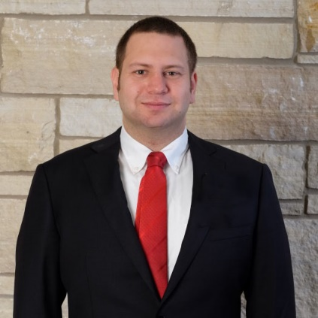**Steven Michael McGrath**

Phone: (cell) 319 430 9607

E-mail: steven@mcgrathtranslations.com

Website: www.mcgrathtranslations.com

**Educational Background:**

May 2017: Certification for Translation from Russian into English

American Translators Association (Certification # 533006)

December 2016: Chinese Proficiency Test (HSK 1), Shanghai, China

Summer 2014: Certificate of English Language Teaching to Adults (CELTA), Teaching House Chicago

May 2012: Master of Arts- History, M. V. Lomonosov Moscow State University, Faculty of History

2010: Certificate- Test of Russian as a Foreign Language, levels one and two, Philological Faculty,

M. V. Lomonosov Moscow State University

2008: Bachelor of Arts- History and Russian, University of Northern Iowa, Cedar Falls, IA

Graduated Cum Laude

Fall 2007-Spring 2008: Study Abroad, KORA Center for Russian Language in Vladimir

**Experience:**

2010-present: Freelance Russian to English translator and editor

Translations included: official documents for visa applications, websites, journalistic and literary work

Aug. 2016- Jan. 2017: English Teacher at China Rencai Finance-HR Management, Shanghai, China

Aug. 2015- Aug. 2016: English Teacher at Web International English, Shanghai, China

June 2014- June 2015: Assistant Director of Studies at Langwe Language School (formerly Prime School), Moscow, Russia. Led weekly teachers’ seminar, implemented Cambridge testing curriculum

Aug. 2012- June 2014: Teacher of English at Prime School Language Center, Moscow, Russia

May 2011- June 2012: Instructor at MBA City Learning Center, Moscow, Russia.

Fall 2010- May 2012: Instructor at Lomonosov Moscow State University, Department of Foreign Languages, Evening section, Moscow, Russia

June- August 2010: Intern at CIVIC (Council for International Visitors to Iowa Cities), Iowa City, IA

June- August 2009: Docent at Old Capitol Museum, Iowa City, IA

**Honors:**

2011-2012: Gave two presentations and published two papers at the XII and XIII International Conferences of Young Scholars of the Humanitarian Sciences at M.V. Lomonosov Moscow State University

2008: Inducted into Phi Alpha Theta (National History Honor Society) and Dobro Slovo (National Slavic

Honor Society) for meritorious scholarship

**Publications:**

* *The Biosphere and Civilization* V.I. Danilov Danil’yan and I.E. Reyf (Springer Nature, 2018, expected)
* "Social Life and Leisure of American Migrants in the USSR 1930-1935," *Relevant Problems of the Humanities in the 21st Century: Materials from the XIV International Conference of Young Scholars from the Humanities Departments at M.V. Lomonosov Moscow State University* (MAKS Press, Moscow, 2012)
* "On the Migration Process of American Citizens to the USSR at the Time of the First and Second Five-Year Plans," *Relevant Problems of the Humanities in the 21st Century: Materials from the XII and XIII International Conference of Young Scholars from the Humanities Departments at M.V. Lomonosov Moscow State University* (MAKS Press, Moscow, 2011)