**Abstract**

Ternary NiCo2Fex layered double hydroxides (LDH) [anchore](D:/%E6%9C%89%E9%81%93/Dict/8.10.3.0/resultui/html/index.html#/javascript:;)d on g-C3N4 nanocomposites were prepared for supercapacitors, in which the Fe provided an important role in enhancing the energy storage performance of NiCo2Fex-LDH. The density functional theory calculations of this material indicated that Fe improved the Fermi level of the NiCo2Fex-LDH and the g-C3N4 combined with the NiCo2Fex-LDHto form N-Ni bonds at heterostructure interface.The electrochemical test results for this material showed that the NiCo2Fe1.0-LDH@g-C3N4 electrode achieved an extremely high specific capacitance of 1550 F g-1 at a current density of 1 A g-1, which was far superior to that of the NiCo2-LDH@g-C3N4 electrode. An assembled NiCo2Fe1.0-LDH@g-C3N4//AC asymmetric supercapacitor device was found to deliver a specific capacitance of 129.64 F g-1 and the energy density of the device was as high as 35 Wh kg-1 at a corresponding power density of 701 W kg-1. This capacitor exhibited a capacitance retention of 92.7% over the course of 5000 cycles. The NiCo2Fe1.0-LDH@g-C3N4//AC asymmetric supercapacitor easily powered a blue LED. This work reveals a promising research path for reasonably constructing high-performance NiCo2-LDH-based nanostructured electrodes materials, which can be used in new energy storage devices.

1. **Introduction**

Over the past decade, supercapacitors (SCs) have proven to be a reliable energy storage technology, and have attracted increased attention because of their outstanding power density, long term sustainability, and fast charging-discharging rates. To meet the increasing demand for large-scale high-performance applications, intensive efforts are still underway to explore and develop corresponding high-energy electrode materials for SCs. Until now, layered double hydroxides (LDH) have been spotlighted for this purpose due to their significantly higher capacitance compared to monometallic hydroxides. The empirical formula for these LDH is generally expressed as [M1-xM’x(OH)2]x+An-x/n·mH2O, where divalent and trivalent metallic cations of M and M’ are located in brucite-like layers, and An- is an interlayer anion sandwiched between these brucite-like layers. NiCo2-LDH, is a typical binary hydroxide that has attracted increasing attention because the multistep oxidation of the metallic states of Co and Ni can improve the electrochemical activity if the material during the charging and discharging processes. Much work has been done to reveal that an interlayer in the NiCo2-LDH facilitates rapid ion transport yielding excellent rate capability and high specific capacitance. However, the cycling stability of this material is relatively poor. One effective way to address this challenging drawback is to identify other suitable trivalent metal ions as partial substitutes for the Co or Ni ions in NiCo2-LDH. For example, Fe3+ or Al3+ can be used to modify the material’s electronic structure and provide more active sites with rapid electron transfer. Furthermore, Fe3+ can be inserted into the nickel and cobalt hydroxide lattices. Consequently, the electrochemical performance of NiCo2-LDH electrodes can be improved through the contribution of the Fe3+/Fe2+ redox couple.

Moreover, graphitic carbon nitride (g-C3N4), a 2D nitrogen-doped graphite-like structured carbon material, has attracted extensive attention in the field of energy storage and conversion as a result of its fascinating electronic structure, thermal stability, and very low cost. Accordingly, g-C3N4 has garnered rising attention as a promising candidate for G and GO to construct high-performance hybrid electrode materials In particular, the ultra-high nitrogen content of g-C3N4 produces a strong chemical attraction with metal ions, thus improving the electron transfer between the active materials. Many studies have reported that the use of g-C3N4 in hybrid electrodes can efficiently improve energy storage performance. Some examples include, NiCo2O4/g-C3N4, CoS/g-C3N4, α-Fe2O3/g-C3N4, NiAl-LDH/g-C3N4 and Ni(OH)2/g-C3N4, TiO2/g-C3N4, RuO2/g-C3N4@graphene. This research inspired us to imagine a combination of NiCo2-LDH with g-C3N4 toproduce highly enhanced SCs. So far, there has been little work on the NiCo2Fex-LDH@g-C3N4 for the potential application in high-performance SCs.

Based on the previously detailed considerations, 3D hierarchical NiCo2Fex-LDH@g-C3N4 composite materials were successfully constructed. The detailed fabrication process is schematically illustrated in Fig. 1. The effect of different quantities of Fe on the morphologies and energy storage performance of the subject materials was then [explore](D:/%E6%9C%89%E9%81%93/Dict/8.10.3.0/resultui/html/index.html#/javascript:;)d. Benefiting from the favorable structure, it was found that the NiCo2Fe1.0-LDH@g-C3N4 delivered an unprecedented [gravimetric](D:/%E6%9C%89%E9%81%93/Dict/8.10.3.0/resultui/html/index.html#/javascript:;) capacitance of 1550 F g-1 at 1 A g-1. The NiCo2Fe1.0-LDH@g-C3N4//AC asymmetric supercapacitor produced an excellent energy density of 35 Wh kg-1 along with a power density of 701 W kg-1. The enhanced electrochemical performance of SCs was mainly attributed to the excellent electrical conductivity which greatly improved the electron mobility and the unique structure of the NiCo2Fex-LDH@g-C3N4 provided a large number of active sites for Faraday reactions. Moreover, the mechanism for the enhanced electrochemistry of the NiCo2Fex-LDH was further described using first-principles density function theory (DFT).

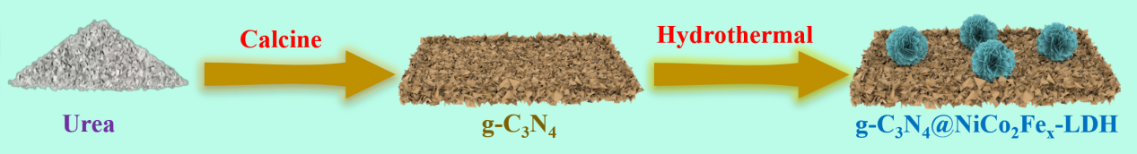

**Fig. 1** Fabrication route for NiCo2Fex-LDH@g-C3N4

1. **Experimental**
   1. **Materials**

All chemical reagents in this study were used as received without further purification. Urea was purchased from Liaoning Huajin Chemical Group, Ni(Cl)2·6H2O was obtained from Shanghai Zhenzhong Biotechnology Co., LTD, Co(Cl)2·6H2O was provided by Nanning Chemical Reagent Co., LTD and NH4F was obtained from Shandong Yusuo Chemical Co., LTD. The fabrication process of the NiCo2Fex-LDH@g-C3N4 is schematically illustrated in Fig. 1.

**2.2 Preparation of g-C3N4**

To prepare the g-C3N4 **,** 45 g of urea was placed into crucibles and heated to 550 °C at a heating rate of 5 ℃ min-1. Then, further heat treatment was performed at 500 ℃ for 4 h. After that, the material was cooled naturally to [ambient](D:/%E6%9C%89%E9%81%93/Dict/8.10.3.0/resultui/html/index.html#/javascript:;) [temperature](D:/%E6%9C%89%E9%81%93/Dict/8.10.3.0/resultui/html/index.html#/javascript:;), and the pale yellow powder was denoted as CN.

**2.3 Fabrication of NiCo2Fex-LDH@g-C3N4 (NFxC@CN)**

To prepare the final product, typically, 1.922 g of urea and 0.475 g of NiCl2•6H2O were dissolved into 30 mL deionized water. Simultaneously, three separate solutions were prepared with different Fe contents. In these, 0.951 g CoCl2•6H2O, x g (x represents 0.5 mmol, 1.0 mmol, 1.5 mmol) of FeCl3•6H2O and 0.593 g of NH4F were dissolved in 20 mL of deionized water. These solutions was separately poured into the three separate portions of the previous 30 mL solution with stirring until all the contents were completely dissolved. Subsequently, 0.2 g g-C3N4 was added into the separate mixtures. These three precursor solutions were sequentially transferred into a 100 mL autoclave and maintained at 120 ℃ for 5 h. The solid products were isolated, washed with water several times and dried for 6 h at 60 ℃ in a vacuum oven. The resulting samples were separately denoted as NiCo2Fe0.5-LDH@g-C3N4 (NF0.5C@CN), NiCo2Fe1.0-LDH@g-C3N4 (NF1.0C@CN), [NiCo](mailto:NiCo2Fe1.5-LDH@g-C3N4 (NF1.5C@CN) to reflect the relative quantities of FeCl3•6H2O that were 0.135, 0.270, 0.540 g. )[2](mailto:NiCo2Fe1.5-LDH@g-C3N4 (NF1.5C@CN) to reflect the relative quantities of FeCl3•6H2O that were 0.135, 0.270, 0.540 g. )[Fe](mailto:NiCo2Fe1.5-LDH@g-C3N4 (NF1.5C@CN) to reflect the relative quantities of FeCl3•6H2O that were 0.135, 0.270, 0.540 g. )[1.5](mailto:NiCo2Fe1.5-LDH@g-C3N4 (NF1.5C@CN) to reflect the relative quantities of FeCl3•6H2O that were 0.135, 0.270, 0.540 g. )[-LDH@g-C](mailto:NiCo2Fe1.5-LDH@g-C3N4 (NF1.5C@CN) to reflect the relative quantities of FeCl3•6H2O that were 0.135, 0.270, 0.540 g. )[3](mailto:NiCo2Fe1.5-LDH@g-C3N4 (NF1.5C@CN) to reflect the relative quantities of FeCl3•6H2O that were 0.135, 0.270, 0.540 g. )[N](mailto:NiCo2Fe1.5-LDH@g-C3N4 (NF1.5C@CN) to reflect the relative quantities of FeCl3•6H2O that were 0.135, 0.270, 0.540 g. )[4](mailto:NiCo2Fe1.5-LDH@g-C3N4 (NF1.5C@CN) to reflect the relative quantities of FeCl3•6H2O that were 0.135, 0.270, 0.540 g. ) [(NF](mailto:NiCo2Fe1.5-LDH@g-C3N4 (NF1.5C@CN) to reflect the relative quantities of FeCl3•6H2O that were 0.135, 0.270, 0.540 g. )[1.5](mailto:NiCo2Fe1.5-LDH@g-C3N4 (NF1.5C@CN) to reflect the relative quantities of FeCl3•6H2O that were 0.135, 0.270, 0.540 g. )[C@CN) to reflect the relative quantities of FeCl](mailto:NiCo2Fe1.5-LDH@g-C3N4 (NF1.5C@CN) to reflect the relative quantities of FeCl3•6H2O that were 0.135, 0.270, 0.540 g. )[3](mailto:NiCo2Fe1.5-LDH@g-C3N4 (NF1.5C@CN) to reflect the relative quantities of FeCl3•6H2O that were 0.135, 0.270, 0.540 g. )[•6H](mailto:NiCo2Fe1.5-LDH@g-C3N4 (NF1.5C@CN) to reflect the relative quantities of FeCl3•6H2O that were 0.135, 0.270, 0.540 g. )[2](mailto:NiCo2Fe1.5-LDH@g-C3N4 (NF1.5C@CN) to reflect the relative quantities of FeCl3•6H2O that were 0.135, 0.270, 0.540 g. )[O that were 0.135, 0.270, 0.540 g.](mailto:NiCo2Fe1.5-LDH@g-C3N4 (NF1.5C@CN) to reflect the relative quantities of FeCl3•6H2O that were 0.135, 0.270, 0.540 g. ) NiCo2-LDH@g-C3N4 was synthesized in the same way as the NFxC@CN without the addition of FeCl3•6H2O, and the product was denoted as NC@CN.

**2.4 Material characterization**

The microstructure and surface topography of the synthesized materials were analyzed using a SU8200 scanning electron microscope (SEM, Hitachi, SU8200, JAPAN). X-ray diffraction (Cu Kα, λ= 1.5406 Å, XRD) was employed to examine the structure and elementary composition of the experimental products. In addition, the binding energy and the chemical composition were further analyzed using X-ray photoelectron spectroscopy (XPS, Kratos Amicus spectrometer).

**2.5 Computational methods**

The details of the computational methods used in this study are presented in the supporting information.

**2.6 Electrochemical measurement**

Typically, the working electrode was prepared as follows. The active material, acetylene black and poly-tetrafluoroethylene binder with a mass ration of 8:1:1 were mixed and the resulting slurry was smeared onto a nickel foam (NF). The electrode was then dried overnight at 373 K. Cyclic voltammetry (CV), galvanostatic charge-discharge (GCD) and electrochemical impedance spectroscopy (EIS) were used to characterize the active material using an electrochemical analyzer (CHI660E, Chenhua, China) and the test cell contained 6 M KOH solution employing a three and two electrode configuration. The specific capacitance (C, F g-1) of the working electrode was evaluated using the following equation:

 (1)

where *I* (A) represented the galvanostatic current,  (s) represents the discharge time, *m* (g) is the mass loading of active materials, and  (V) refers to the discharging potential window.

**2.7 Fabrication of asymmetric supercapacitor (ASC)**

An ASC was assembled using the experimental materials which served as the positive and activated carbon was the negative electrode. The power density and energy density of the device were obtained using the formulas:

 (2)

 (3)

where P (W kg-1) represents the power density, E (Wh kg-1) refers to the energy density,  (s) is the total discharging time, and  (V) represents the operating discharge voltage.

1. **Results and Discussion**
   1. **Synthesis and Characterization**

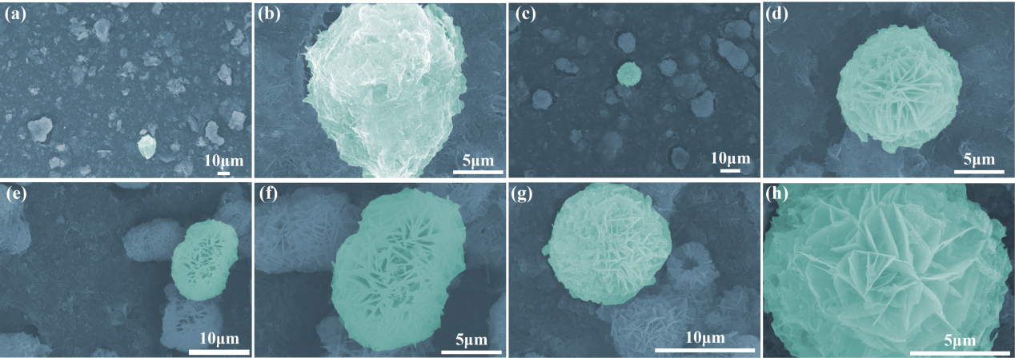

**Fig. 2** SEM images of NC@CN (a and b), NF0.5C@CN (c and d), NF1.0C@CN (e and f), and NF1.5C@CN (g and h)

The morphological characterization of the experimental products was accomplished using SEM. Fig. 2a and b show the images of the pristine NC@CN. As shown, it consisted of an irregular rock-like NiCo2-LDH with [rough](D:/%E6%9C%89%E9%81%93/Dict/8.9.6.0/resultui/html/index.html#/javascript:;)ness on the surface of the g-C3N4. However, the morphology changed significantly after the introduction of Fe into NiCo2-LDH (Fig. 2c and d). Notably, a few 3D flower-like NiCo2-LDH spheres that consisted of 2D nanosheets mixed with regular spheres were present on the NF0.5C@CN. As shown in Fig. 2e and f, the transition from a rock-like to flower-like morphology consisting of 2D nanosheets was clearly observed as Fe stoichiometry was increased. This indicated that the increased Fe content in the ternary NiCo2Fex-LDH promoted the growth of nanosheets. This nanostructure provided more electrochemically active sites for [electrochemical](D:/%E6%9C%89%E9%81%93/Dict/8.9.6.0/resultui/html/index.html#/javascript:;) [reaction](D:/%E6%9C%89%E9%81%93/Dict/8.9.6.0/resultui/html/index.html#/javascript:;)s. Interestingly, as the stoichiometric ratio of Fe reached 1.5, some of the spheres were damaged which was caused by the partial reduction of the flower-like spheres.

* 1. **Electrochemical properties**

The CV profiles of the various experimental electrodes at a scan rate of 5 mV s-1 are presented in Fig. 3a.

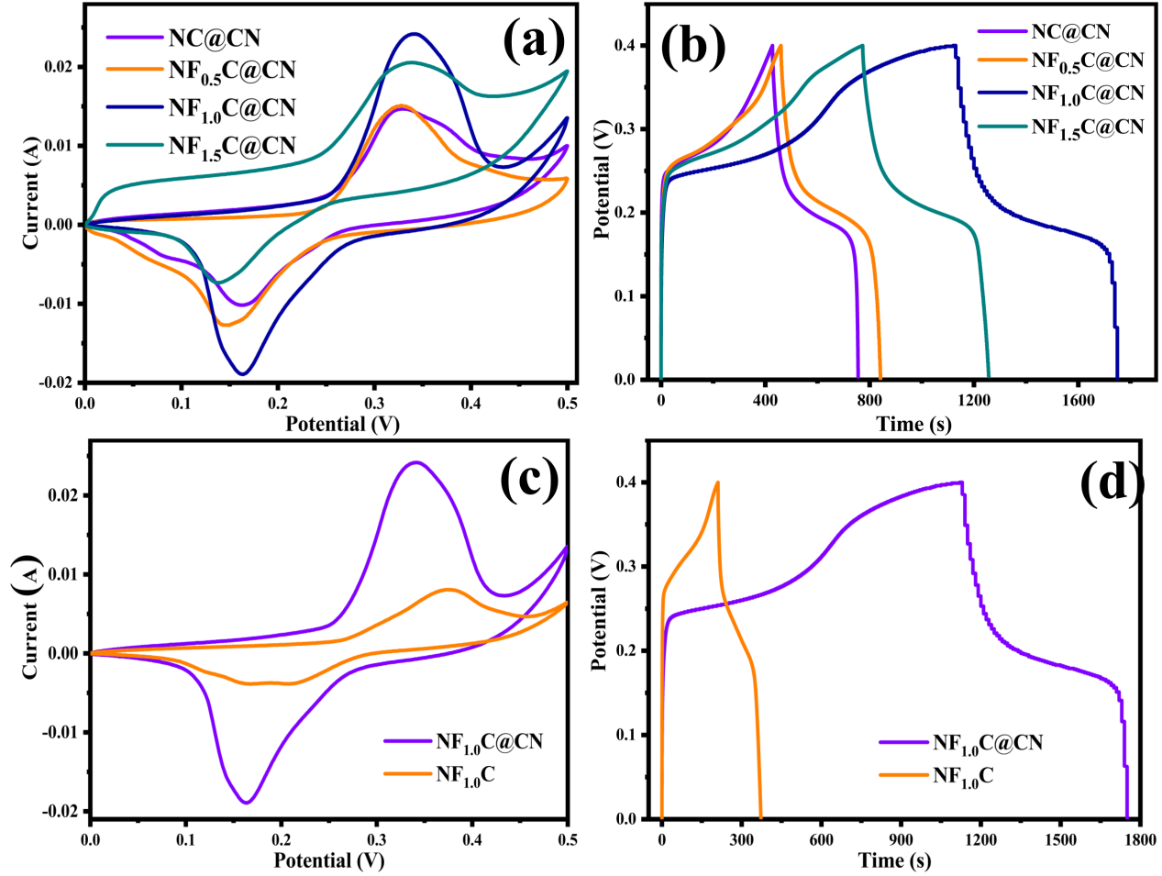**Fig. 3** CV curves (a) and GCD plots (b) of various electrode materials, CV curves (c)GCD graphs (d) of NF1.0C@CN and NFC

As can be seen from the CV results, a pair of redox peaks were observed in the voltage window of 0-0.5 V, which were attributed to the typical reversible faradaic reaction of the electrode materials. Moreover, the integral area of the CV curve for the NF1.0C@CN was larger than the NC@CN, NF0.5C@CN and NF1.5C@CN, suggesting that the NF1.0C@CN electrode possessed the highest energy storage capacity. A comparison of the GCD curves for NC@CN, NF0.5C@CN, NF1.0C@CN and NF1.5C@CN at 1 A g-1 is shown in Fig. 3b. The symmetrical GCD curves indicate that the material exhibited excellent redox reversibility. In addition, NF1.0C@CN electrode exhibited a longer charge-discharge time in the GCD curve than other electrodes. The corresponding capacitances of NC@CN, NF0.5C@CN, NF1.0C@CN and NF1.5C@CN were 821, 955, 1550and 1210 F g-1, respectively. Notably, the capacity of the NF1.5C@CN was smaller than that of NF1.0C@CN, indicating the capacitance of the materials was not completely proportional to the amount of Fe3+, This was credited to the excess of Fe3+ which possibly increased the charge transfer resistance of the electrode, and inhibited its electrochemical performance. The above results demonstrate that Fe had a significant effect on the increase in the [electrochemical](D:/%E6%9C%89%E9%81%93/Dict/8.10.3.0/resultui/html/index.html#/javascript:;) [energy](D:/%E6%9C%89%E9%81%93/Dict/8.10.3.0/resultui/html/index.html#/javascript:;) [storage](D:/%E6%9C%89%E9%81%93/Dict/8.10.3.0/resultui/html/index.html#/javascript:;) performance, including increased chemical adsorption of OH- and reinforcement of the electronic conductivity.

The CV and GCD curves of NF1.0C and NF1.0C@CN were further analyzed to ascertain the [synergy](D:/%E6%9C%89%E9%81%93/Dict/8.9.6.0/resultui/html/index.html#/javascript:;) of g-C3N4 in the composite materials, and these results are presented in Fig. 3c and d. As shown, the greater CV curve integral area and much longer charge-discharge time produced by that NF1.0C@CN suggested an improved capacitance over that of the NF1.0C. The specific capacitances of NF1.0C and NF1.0C@CN were 404and 1550 F g-1, respectively. This confirmed the electrochemical performance of the NF1.0C electrode material as a result of coupling it with g-C3N4. It seemed that the N-Ni bonds formed at the heterostructure interface [facilitate](D:/%E6%9C%89%E9%81%93/Dict/8.10.3.0/resultui/html/index.html#/javascript:;)d charge transfer, thus further reinforced capacitive storage capability.

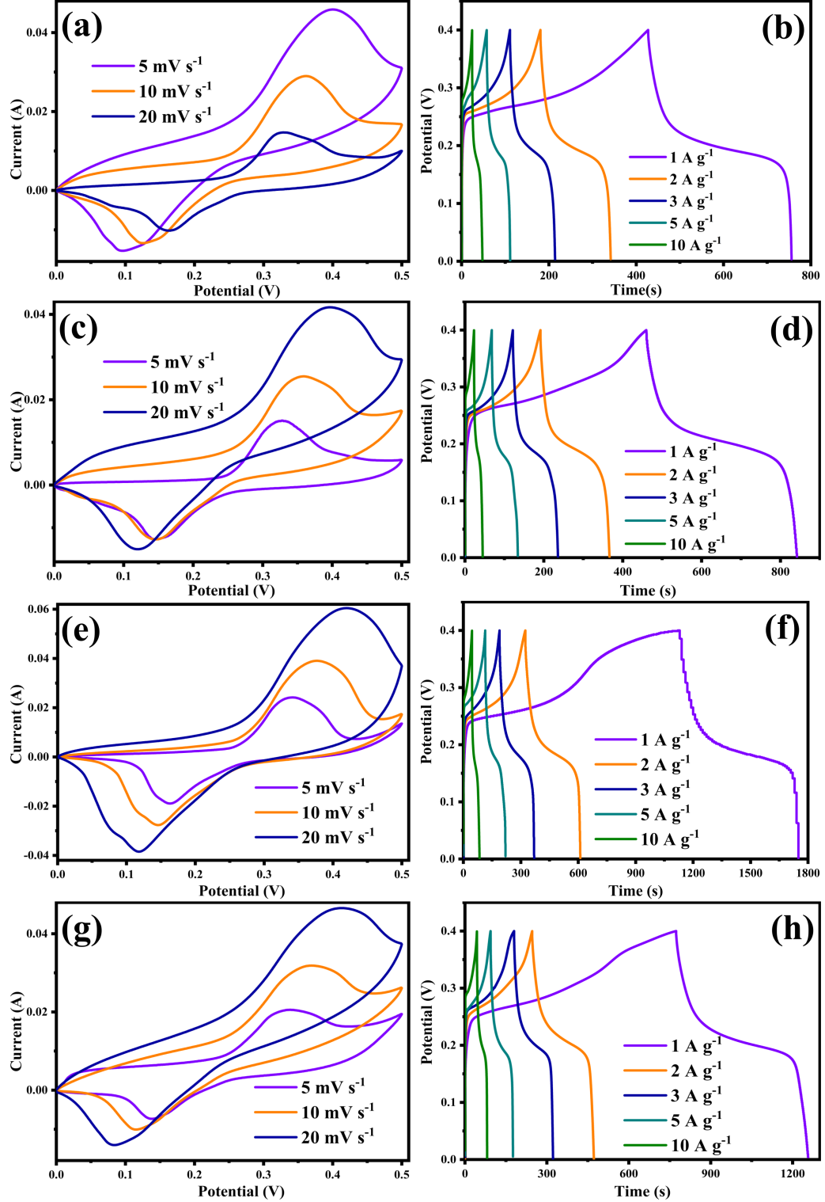

**Fig. 4** Cyclic voltammetric curves and constant current charge-discharge curves of NC@CN (a, b), NF0.5C@CN (c, d), NF1.0C@CN (e, f) and NF1.5C@CN (g, h) of respectively

Figs. 4 (a, c, e & g) depict the CV curves of NC@CN, NF0.5C@CN, NF1.0C@CN, NF1.5C@CN electrodes obtained at sweep rates of 5-20 mV s-1 in a potential window of 0-0.5 V. As shown, the NF1.0C@CN had the largest integrated area and current amplitude of all the samples, indicating a greatly improved specific capacitance. Moreover, the shapes of the CV cycle appear to be quite similar even at high sweep rates, indicating good reversibility in the charge/discharge process. For comparison, the GCD curves of NC@CN, NF0.5C@CN, NF1.0C@CN and NF1.5C@CN electrodes are displayed in Fig. 4 (b, d, f and h), [respectively](D:/%E6%9C%89%E9%81%93/Dict/8.9.6.0/resultui/html/index.html#/javascript:;). The good linear potential-time profile further demonstrated the excellent electrochemical performance of these materials. It was also found that the NF1.0C@CN electrode exhibited the longest discharge time of all the samples, suggesting that its electrochemical performance was effectively improved (see Fig. 4f). In addition, with 1 mmol Fe added, the specific capacity was as high as 1550 F g-1 at a [current](D:/%E6%9C%89%E9%81%93/Dict/8.10.3.0/resultui/html/index.html#/javascript:;) [density](D:/%E6%9C%89%E9%81%93/Dict/8.10.3.0/resultui/html/index.html#/javascript:;) of 1 A g-1. However, as displayed in Fig. 5h, when the Fe was present in excess, the specific capacitance of the material decreased, which suggests that an appropriate ratio of Fe is needed to enhance the specific capacitance of LDH. In conclusion, NF1.0C@CN had better electrochemical performance than the other composite electrode materials.

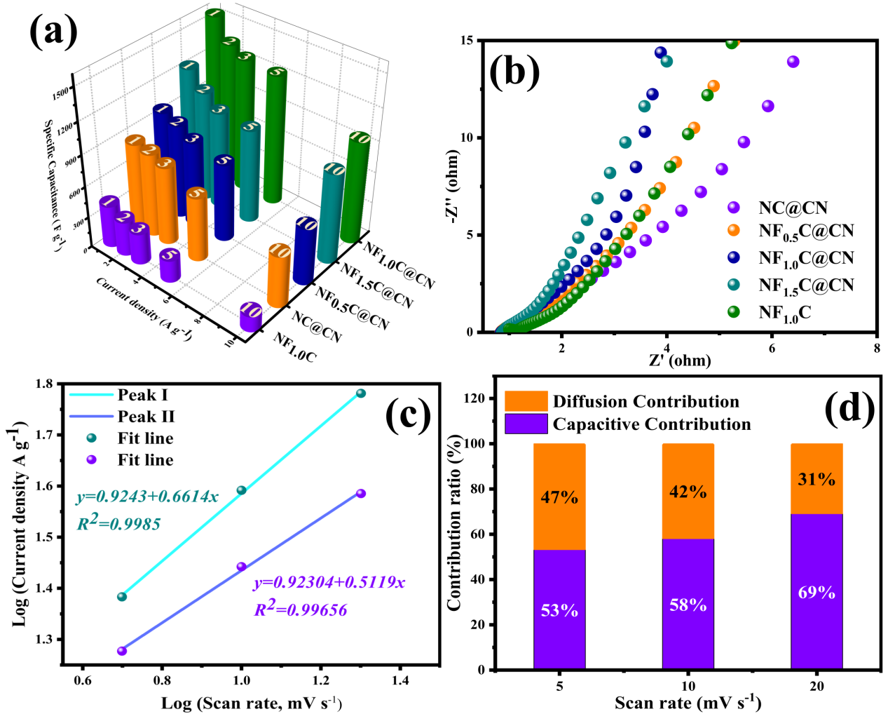

**Fig. 5** (a) Csp values and (b) EIS of all the electrodes, (c) relationships between peak currents and sweep rates for fitting b values, (d) contribution ratio of capacitance and diffusion control capacity at various can rates

The relationships between the calculated specific capacity and current density of all the composite electrodes is presented in Fig. 5a. The NF1.0C@CN electrode exhibited a high capacitance of 985 F g-1 evenat a higher current density of 10A g-1, which was much higher than the NF1.5C@CN (870 F g-1), NF0.5C@CN(550 F g-1), NC@CN (500 F g-1) and NF1.0C (150 F g-1) electrodes. These comparative results indicate that the composites possessed a good rate performance of about 65%.

Electrochemical Impedance Spectroscopy (EIS) analysis provided additional insights into the electrical conductivity of the electrodes. As depicted in Fig. 5b, in the EIS high-frequency band close to the origin of the coordinate system, the distance from the intersection point of the impedance diagram and the horizontal axis to the origin of the coordinate system represents the equivalent resistance (Rs) of the materials, and the semicircle at high frequency reflects charge transfer resistance (Rct) of the electrode. As observed, the similar Rs values suggest that the effect of the bulk resistance including electrolyte and internal resistance of the electrodes is relatively small. However, the NF1.0C@CN electrode showed a far smaller Rct than other electrodes, suggesting a stronger diffusion capability for the NF1.0C@CN.

To further investigate the energy storage mechanism of the NF1.0C@CN electrode, the relationship between the reaction current (i) and the scan rate (v) of the anode and cathode peaks was obtained using the CV diagram:

$i=a×v^{b}$ (4)

where a and b are constant, and b stands for the charge storage kinetics. *b* represents the slope of log(v) vs log(i). A value for b can be of 0.5 and 1.0, where b = 0.5 indicates a diffusion-controlled process, and b = 1.0 indicates capacitive-limited process. As shown in Fig. 5c, the b values of NF1.0C@CN for the anodic and cathodic peak current were calculated to be 0.6614 and 0.5119, respectively, which indicates that the charging and discharging process of NF1.0C@CN had both battery-type diffusion controlled and capacitive-type surface controlled kinetic behavior.

The contribution ratio of capacitive and diffusive behavior to the total charge storage could be calculated based on CV curves according to the following equation, in which, k1v stands for the capacitive controlled current and k1v1/2 represents a diffusion controlled process:

$i(V)=k_{1}v+k_{2}v^{1/2}$ (5)

To facilitate analysis, Eq. (5) can also be converted to:

$i(V)/v^{1/2}=k_{1}v^{1/2}+k_{2}$ (6)

As presented in Fig. 5d, the capacitive contribution of the NF1.0C@CN electrode gradually rises from 53.20% to 69.09% with the increase in the sweep rate.

In summary, the NF1.0C@CN electrode demonstrated the prominent merits of capacitive behavior caused by substitution of Co atoms with Fe in the NiCo2-LDH crystal lattice, thus generating more [active](D:/%E6%9C%89%E9%81%93/Dict/8.9.6.0/resultui/html/index.html#/javascript:;) [site](D:/%E6%9C%89%E9%81%93/Dict/8.9.6.0/resultui/html/index.html#/javascript:;)s and effective modulating the conductivity and electronic structure of the NF1.0C@CN. Moreover, the lattice matching caused by similar lattice parameters in the formation of heterojunction structure, the synergistic effect between NiCo2Fe1.0-LDH and g-C3N4 could be greatly improved, and thus the materials present remarkable energy storage performance.

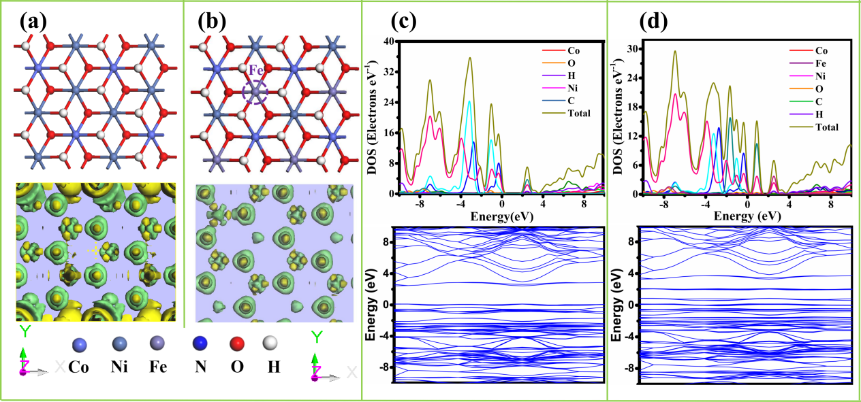

**Fig. 6** Atomic structure models and the differential charge density (a,b), the total density of state (DOS), and the band structures (c, d) of NiCo2-LDH with and without Fe incorporation

The DFT calculations were conducted on the experimental materials to ascertain the reason for the enhanced electrochemical activity of the NF1.0C@CN electrodes. Fig. 6a and b show atomic structure models and differential charge density of NiCo2-LDH before and after the incorporation of Fe. After importing Fe, the neighboring Ni and Co sites appear to have a stronger negative charge density due to the increased electron density between the bridged O and its [neighboring](D:/%E6%9C%89%E9%81%93/Dict/8.10.3.0/resultui/html/index.html" \l "/javascript:;) Co and Ni. In such an environment, the reducibility of Ni and Co [subsequent](D:/%E6%9C%89%E9%81%93/Dict/8.10.3.0/resultui/html/index.html#/javascript:;)ly improved as the corresponding affinity for electrons was enhanced. The total density of states (DOS) shown in Fig. 6c of the NC and NF1.0C were calculated to obtain more details into the depth of this effect The DOS plot of the NC showed it to be typical semiconductors, where the band gap was [estimate](D:/%E6%9C%89%E9%81%93/Dict/8.10.3.0/resultui/html/index.html#/javascript:;)d to be 1.98 eV. However, NF1.0C exhibited a lower band gap (0.50 eV) (Fig. 6d), which means the Fe impurity state could greatly enhance intrinsic electrical conductivity of NiCo2Fe1.0-LDH. After the incorporation of Fe, the improved DOS at the Fermi level allows more charge carriers to be injected into the conduction band of NiCo2Fe1.0-LDH, thus speeding up fast faradaic reactions. The above [analysis](D:/%E6%9C%89%E9%81%93/Dict/8.10.3.0/resultui/html/index.html#/javascript:;) is in good agreement with the EIS results. The color-filled charge density difference isosurface of NiCo2Fe1.0-LDH is present in Fig. S1. The result reveals N-Ni bonds may be formed as NiCo2Fe1.0-LDH combining with the g-C3N4. The [capacitance](D:/%E6%9C%89%E9%81%93/Dict/8.10.3.0/resultui/html/index.html#/javascript:;) and cycle stability of the electrode were greatly improved as the bonding interactions [accelerate](D:/%E6%9C%89%E9%81%93/Dict/8.10.3.0/resultui/html/index.html#/javascript:;) charge transfer which stabilizes the composites’ structure.

1. **Conclusions**

Concisely, by reasonably tailoring the amount of Fe3+ and introducing g-C3N4, the NF1.0C@CN material exhibits outstanding electrochemical performance compared to NC@CN. More strikingly, the assembled NF1.0C@CN//AC ASC cell produced a maximum energy density of 35 Wh kg-1 and a power density of 701 W kg-1. Most importantly, the significant enhancement in the electrochemical performance after the introduction of Fe into the NiCo2-LDH structure was directly investigated by theoretical calculation, and the results [indicate](D:/%E6%9C%89%E9%81%93/Dict/8.10.3.0/resultui/html/index.html#/javascript:;)d that the band gap of NiCo2-LDH becomes narrower after the incorporation of Fe, which enabled fast electron and ion transport In addition, a N-Ni bond could be formed by combining NiCo2Fex-LDH with g-C3N4  strengthened the structure of the composites. The present experimental findings suggest a new avenue for the design and understanding of a new type of LDH structured electrode material for energy storage applications.