Development of a small, covered yarn prototype

**Abstract:** The rapid development of the textile industry has led to the demand for more advanced textile equipment because the current covering yarn machines are large and expensive and have a large physical footprint. Also, the current technology is unsuitable for most laboratory research and small factory proofing. In this paper, the principle of forming covered yarn is analyzed and simplified into three systems: the unwinding system, covering system, and winding system. A small sample of low volume and better flexibility was developed, the production process and the primary structure of the covered yarn prototype was introduced, and the covering effect of the small prototype was debugged and analyzed.

**Key words:** covered yarn; small prototype; development

**1 Foreword**

Covered yarn is primarily used to wrap the outer cover yarn on the core yarn in a spiral winding manner to form a new yarn with better performance. The covered yarn produced by this new technology generally possesses a higher strength, richer appearance, and fluffier structure with less hairiness. Currently, production equipment for covered yarn is generally large-scale equipment. China's production includes FZZ031 type covering spinning machines manufactured by China Textile Academy, FZ008 type covered machines developed by Henan Textile Research Institute, SCB-1 carded woolen covered machines developed by Shanghai Textile Science Research Institute, and the GD171 type covered yarn machine developed by Zhejiang Titan Textile Machinery General Factory, etc. Foreign production includes the Parafil 2000 covered spinning machine from Sussen Company, IPC6000 covered spinning machine developed by Walker Company, and the GDS covered spinning machine developed by Gemill & Donsmore Company. These domestic and foreign covered spinning are large, expensive, and occupy a significant footprint, but are not suitable for small-scale fancy yarn proofing and laboratory research and development.

**2 Analysis of the principle of covered yarn**

Covered yarn is mainly composed of a filament or a twisted spun yarn as a core, and a novel composite yarn formed by spirally wrapping the filaments on the outside of the core yarn. The covering machine basically consists of three systems: a core yarn unwinding system, a covering system, and a winding system. The core yarn unwinding system is the process of passive unwinding of the core yarn on the bobbin by the drafting force. The winding system refers to rotating the hollow spindle when the motor is powered. The hollow spindle has a wire wrapped around the filament. When the hollow spindle rotates under motor action, it will also drive the covered yarn tube to rotate. When this occurs, the covered yarn tube will unwind and wrap around the core yarn unwound by the drafting force with the rotation of the hollow spindle. In the winding system, the motor drive induces rotation, and the yarn is evenly wound on the yarn drum by contact or non-contact. Ultimately, the covered yarn forms a well-defined bobbin.

By analyzing the various functions of the three systems described above, it can be assumed that the basic working principle of the small prototype is as follows: the core yarn is unwound on the bobbin under drafting force, uniformly unwound under the action of the tensioner, and the core yarn is subjected to uniform tension from the beginning to the end, so that it is in a relaxed state and the outer filaments can be easily wrapped. Before the core yarn passes through the hollow spindle, the outer filament in the covered yarn tube of the hollow spindle is unwound due to the driving of the motor and is spirally wrapped around the core yarn to form a fancy line as the hollow spindle rotates. The motor that drives the grooved drum to rotate not only provides the drafting force of the core yarn unwinding, but also provides the power for winding the finished, covered yarn. Due to the guiding effect of the groove on the surface of the grooved drum, the formed covered yarn forms a good bobbin.

**3** **Small, covered yarn prototype assembly and its debugging**

According to the formation principle of the covered yarn, the assembly of the small, covered yarn prototype occurs in two different ways, that is, the wrapping position of the covered yarn can be divided into two assembly forms: front unwinding of the covered yarn tube and back unwinding of the covered yarn tube, and the performances of the covered yarn produced by each, different assembly will provide different results.

**3.1 Small prototype of covered yarn with front unwinding of covered yarn tube**

The small prototype of the front unwinding of the covered yarn tube refers to the idea that the wrapping of the outer cover yarn to the core yarn is formed at the front end of the hollow spindle. Its mechanical structure sketch is as follows:

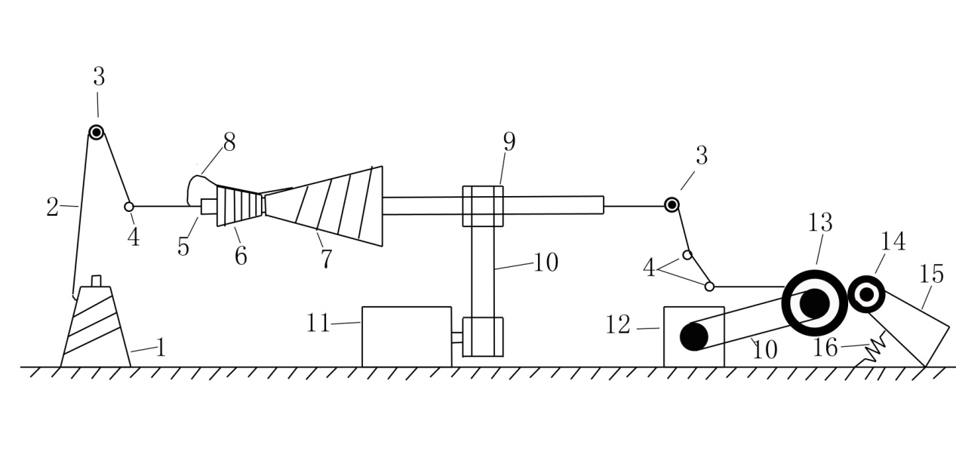1 Core yarn bobbin, 2 Core yarn, 3 Tensioner, 4 Yarn guide, 5 Hollow spindle, 6 Friction tensioner, 7 Covered yarn tube, 8 Outer cover yarn, 9 Gear, 10 Conveyor belt, 11 Motor 1, 12 Motor 2, 13 Grooved drum, 14 Fancy yarn tube, 15 Yarn frame, 16 Spring

Fig. 1 Mechanical structural diagram of small, covered yarn prototype with front unwinding of the covered yarn tube

The wrapping process of the small, covered yarn prototype with front unwinding of the covered yarn tube is as follows: due to the drafting action of motor 2, the core yarn is slowly unwound from the bobbin, and the core yarn is always passively unwound by constant tension due to the action of the front and rear yarn guides and the drafting action of the uniform motion of the motor 2, which participates in the work of the subsequent process. When the core yarn is at the front end of the hollow spindle, the hollow spindle driven by motor 1 rotates rapidly, and the rotation of the hollow spindle drives the rotation of the fixed covered yarn tube fixed. The rotation of the bobbin causes the wound outer cover yarn to rotate and unwind, and each time the hollow spindle rotates, the outer cover yarn is covered around the core yarn. By the functioning of the friction tensioner, the outer cover yarn will not be unwound and slough-off because of the centrifugal force produced by the rapid rotation of the yarn bobbin. It will only be actively fed into the outer cover yarn according to the amount of outer cover yarn necessary to cover the core yarn, and the outer cover yarn will be fed evenly and actively[6]. Finally, the fancy yarn formed by the wrapping passes through the hollow spindle and enters the winding system by way of the yarn guide. Then, motor 2 drives the rotation of the grooved drum. The groove on the groove drum enables the fancy yarn to be regularly covered on the fancy yarn tube and provides anti-overlapping functionality to facilitate the subsequent transportation, storage, and processing. The fancy yarn tube is fixed on the frame of the yarn because the tension provided by the spring attached to the frame forces the fancy yarn tube close to the groove and evenly rotates, ensuring a good package effect. In addition, it ensures that the core yarn can maintain a uniform speed and constant drafting force when unwinding, enabling a more uniform covering.

**3.2 Small prototype of covered yarn with back unwinding of covered yarn tube**

The small prototype of back unwinding of the covered yarn tube refers to the idea that the wrapping of the outer cover yarn to the core yarn is formed at the back end of the hollow spindle. Its mechanical sketch is as follows:

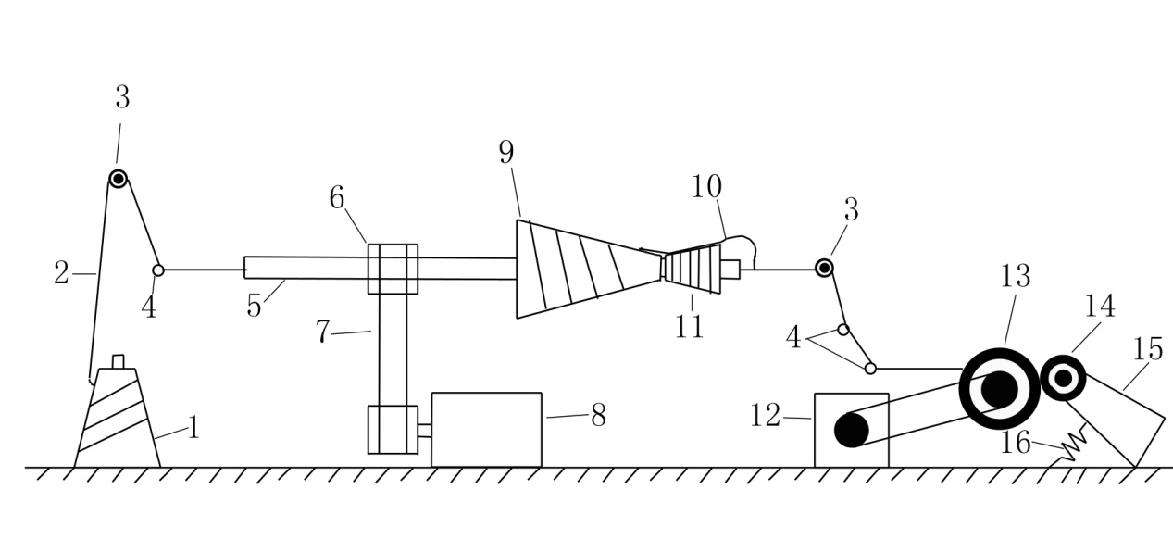

1 Core yarn bobbin, 2 Core yarn, 3 Tensioner, 4 Yarn guide, 5 Hollow spindle, 6 Gear, 7 Conveyor belt, 8 Motor 1, 9 Covered yarn tube, 10 Outer cover yarn, 11 Friction tensioner, 12 Motor 2, 13 Grooved drum, 14 Fancy yarn tube, 15 Yarn frame, 16 Spring

Fig. 2 Mechanical, structural diagram of small, covered yarn prototype with back unwinding of the covered yarn tube

The drawing system and winding system of the small, covered yarn prototype with back unwinding of the covered yarn tube are the same as that with front unwinding of the covered yarn tube, but the wrapping systems are different. When the core yarn passes through the hollow spindle, motor 1 drives the hollow spindle to rotate by the conveyor belt, and the hollow spindle drives the rotation of the fixed, covered yarn tube, so that the outer cover yarn of the core yarn is rotated and unwound. Then, every time the hollow spindle rotates, the outer cover yarn is also covered around the core yarn. Based on the functionality of the friction tensioner, the outer cover yarn will not be unwound and slough-off because of the centrifugal force of the rotation of the covered yarn tube but will be actively unwound according to the needs of the core yarn covering, so that the outer cover yarn can be evenly covered on the core yarn[7-8].

**4 Commissioning analysis of small, covered yarn** **prototype**

The parameters of motor 1 in the covered yarn small prototype are: 15 W, 0.12 A, 220 V, 50 Hz, 1.5 μF, and 1300 r/min. The parameters of motor 2 are: 6 W, 0.13 A, 220 V, 50/60 Hz, 0.8 μF, and 48 r/min. The rotational speed of motor 1 is much larger than the rotational speed of motor 2. Only when the rotational speed of motor 1 is greater than that of motor 2 can good winding be achieved. Moreover, in the case of the rotational speed of motor 2, if the rotational speed of the motor is too slow, significant core leakage may occur, and the formed fancy yarn effect is poor, but when the rotational speed of motor 2 is slow, the rotational speed of motor 1 is too fast, the outer cover yarn will be covered too tightly and the yarn will be folded. In this situation, the formed fancy yarn is hard and the outer cover yarn has overlapping particles, which affects the aesthetics and performance of the fancy yarn.

**4.1 Twist test**

The effects and performance of the covered yarn formed by different assembly methods are also different. After debugging and testing, the two different types of small, covered yarn prototypes can form a good, covered yarn when motor 1 rotates at 360 r/min and motor 2 rotates at 6 r/min. The different effects and properties of the covered yarn formed under these conditions are shown in Tables 1 and 2.

Table 1 Twist test data table

|  |  |  |
| --- | --- | --- |
| Twist (Twist/m) Assembly method  Experiment number | Small prototype for front unwinding of covered yarn tube | Small prototype for back unwinding of covered yarn tube |
| 1 | 483.6 | 363.3 |
| 2 | 470.0 | 349.6 |
| 3 | 475.2 | 360.4 |
| 4 | 463.0 | 358.0 |
| 5 | 486.4 | 358.4 |
| 6 | 483.2 | 362.0 |
| 7 | 467.6 | 361.6 |
| 8 | 476.0 | 369.2 |
| 9 | 468.8 | 364.0 |
| 10 | 454.4 | 368.8 |
| Average value | 472.82 | 361.53 |
| Standard deviation | 9.55 | 5.36 |

Yarn twist is one of the main performance indicators of covered yarn. It can be seen from Table 1 that under the same speed conditions, the twist of the covered yarn with front unwinding of the covered yarn tube is larger than that of the covered yarn with back unwinding of the covered yarn tube. It can be seen that the twisting efficiency of the front unwinding of the covered yarn tube is higher, the covered yarn is tighter, and the tension between yarns is larger. From the standard deviation in Table 1, it can be seen that the twist fluctuation of covered yarn of the small prototype with front unwinding of the covered yarn tube is greater than that of the small prototype with back unwinding of the covered yarn tube. It can be seen that the wrapping work of the small prototype is more stable and the covered yarn is more uniform with front unwinding of the covered yarn tube.

**4.2 Strength test**

Strength of the yarn is also one of the main performance indicators of the covered yarn. The test results of the covered yarn formed by the electronic single-yarn strength tester for the two assembly methods of small prototypes are shown in Table 2.

Table 2 Strength data sheet

|  |  |  |
| --- | --- | --- |
| Strength（cN） Assembly method  Experiment number | Small prototype for front unwinding of covered yarn tube | Small prototype for back unwinding of covered yarn tube |
| 1 | 1622 | 1561 |
| 2 | 1538 | 1596 |
| 3 | 1686 | 1588 |
| 4 | 1472 | 1656 |
| 5 | 1772 | 1576 |
| 6 | 1721 | 1634 |
| 7 | 1637 | 1652 |
| 8 | 1800 | 1507 |
| 9 | 1633 | 1696 |
| 10 | 1560 | 1486 |
| Average value | 1644.1 | 1595.2 |
| Standard deviation | 98.46 | 63.15 |

It can be seen from Table 2 that the strength of the covered yarn with front unwinding of the covered yarn tube is slightly higher than the strength of the covered yarn with back unwinding of the covered yarn tube. The strength fluctuation of the covered yarn of the small prototype with front unwinding of the covered yarn tube is greater than that of the small prototype with the back covered hollow spindle. Furthermore, it shows that the wrapping mode of the small prototype of the back unwinding of the covered yarn tube is more stable, and the wrapping effect of the covered yarn products is better.

**4 Conclusion**

Through the assembly and commissioning of the small, covered yarn prototype, it was shown that the development of a small, covered yarn prototype is achievable. The change in cover position and differences in motor speed directly affected the formation of covered yarn. The covering stability of the small prototype of the front unwinding mode of the covered yarn tube was less complete than that of the back unwinding mode of the covered yarn tube, but the efficiency of the covering was higher. The appropriate method can be selected based on the necessary efficiency and effects. The development of the small, covered yarn prototype will enable more refined and modular covered yarn processes, thereby reducing the complexity and cost of larger machines.