**Socio-Economic Impacts of Population Aging in Taiwan**

**Guang-Jong Fann, Yuan-Ho Hsu**

**Abstract**

Population aging is a global phenomenon in the 21st century. The phenomenon of an aging population structure will greatly impact the social system and living styles. The article will discuss the population aging phenomenon of Taiwan from these seven population indexes: population growth profile, structural changes of population age groups, population aging index, dependency support ratio, potential support ratio, parent support ratio and gender structure; To understand the underlying socio-economic issues that come as a result of an aging population in Taiwan. We will discuss the socio-economic challenges countered by an aging society, based on an awareness of an aging population structural change.

As a result of aging, it is necessary to establish a system that is flexible on the age of retirement to maintain balance in the labor market. The derivation of a new goods market and labor market based on the consumption dynamic of an aging population will thereby increase social resource allocation efficiency. A robust financial structure established through pension system and by means of stable asset price can ensure the living needs of the elderly people are met; And the reform in pension system can help with maintaining the wellness of government finance. By means of encouraging labor participation from elderly people and promoting technology advancement, it will be an effective policy route to boost growth in an economy consists of aging population. The provision of the necessary senior healthcare will be a serious challenge for the government in near future; And the establishment of a social support system through system of pension will be the immediate challenge and difficulty the government has yet to confront. (Taiwan Geriatrics Gerontology Magazine 2010; 5(3): 149-168)

**I. Preface**

Population aging is a global problem. Since the phenomenon of population aging appeared in western industrialized countries, this trend has spread to many newly industrialized countries in the recent decades. Taiwan, South Korea, Singapore and other countries have entered the ranks of aging countries in the past twenty years. It is expected that at the end of the 21st century, many countries that are now at the low development stage will transition to an aging society. Aging is the irreversible trend of human civilization development in the 21st century. The process has greatly impacted the global human social structure and lifestyle. The acceleration of aging has become the most important global challenge in adjusting future living structure.

An aging population is the result of decline in fertility-rates and medical advancement, in which the latter has reduced the number of death-rates and extended life expectancy. The aging in our population structure imply that we will face an unprecedented challenge. Longevity is the result of advancement in human civilization. However, as life expectancy are extended, there is an increase in the aging population while the young and heathy population shrinks. This development has produced conflict against the current social security system and the security of social welfare system, in which it has generated pressure to reform politics and society. In addition, the increase in aging population also brings tremendous pressure to the healthcare system. For example, the increase in the elderly population proportion is expected to raise the number of people struggling with mobility and chronic disease. This transition in population has posed a greater challenge on the integrity and sustainability of national health insurance and social security system.

On the other hand, the change in family structure is a result of an aging population and reduction in children. As education and urbanization moves forward, the traditional social life style and value system are challenged. It is difficult for young and married couples to take care of their elderly parents, while they are faced with the pressure of a competitive job market and raising children. Therefore, seeing three generations under the same roof will become less common; this will lead to dependency of elderly on family members, and an increasing reliance on the social system and government for life-care. In addition, the young labor force accompanying the aging population is relatively shrinking. The results will have adverse impacts on the future economic growth, which will lead to imbalance in supply and demand in the labor market, deterioration of trade terms, savings, and other economic impacts. How does our society support the life-care needs of the increasing aging population? How can the quality of life and dignity of the elderly people be maintained? How does one adjust to the relevant healthcare structure, social security structure and policies accordingly to the needs of aging? The urgency in dealing with relevant issues as such will surface quickly as aging in population aggravates.

As for the aging population in Taiwan, the elderly population over sixty-five years old proportioned about 6.2% of the total population in 1990, that is, one in every 16 people is an elderly person. However, the ratio of the aging population had climbed to 10.63% (one elderly person in every 9.4 people). According to the population estimation by the Council for Economic Planning and Development under the Executive Yuan, the proportion of aging population over 65 years old will reach 20.1% in the total population, i.e. one in every five people is an elderly person, and the proportion is expected to climb to 37.5% by 2056 [1].

According to World Health Organization, when a country’s aging population of 65 years old exceeds 7% of the total population, it is becoming an aging society; An aged society when it is over 14% of the total population, and a super-aged society if it is over 20% of the total population. In comparison, the U.S. and Japan had transitioned to an aging society in 1942 and 1970 respectively, and the same change happened in Taiwan and South Korea in 1993 and 2000. Judging from the aging rate, Taiwan’s population is aging faster than that of U.S. and Japan. The U.S. is expected to become an aged society in 2013, in which this transition already took place in Japan in 1994; While Taiwan and South Korea are expected to become an aged- society in 2017 and 2019 respectively (Table 1). However, it takes 72 years for U.S. to transition to an aged society from an aging society, but only 24 years for Japan and Taiwan, while South Korea only took 19 years. However, it takes Taiwan and South Korea 8 and 7 years respectively to move from an aged society into super-aged society, which is only about half of the time of U.S.

The impacts of rapid population aging are multi-faceted. The article discusses the potential challenges of the aging phenomenon on Taiwan’s society and economy, hoping to play a role of “attract jade by casting bricks”, and promoting public’s understanding of relevant issues. The second section of this article organizes and sorts out statistical results done at home and abroad, to illustrate changes in Taiwan’s population structure. Taiwan’s aging phenomenon can be discussed from seven population index: population growth profile, population age group structure change, aging population index, dependency ratio, potential support ratio, parental support ratio, and gender structure, as to understand the potential socio-economic problems posed by Taiwan’s population aging. In the third section, we will discuss the impacts and socio-economic challenges of an aging society, on the premise of understanding the structural change in an aging population, with reference to research articles at home and oversea, from these seven aspects; The labor market, consumer pattern, goods market, financial market, government finance, economic growth, healthcare and social support system. The fourth section is the conclusion.

*Chart 1: Comparison on population aging time of U.S.A., Japan, South Korea, and Taiwan.*

|  |  |  |  |  |
| --- | --- | --- | --- | --- |
|  | **Aging society**  (when aging population reach 7% of the total population) | **Aged society**  (When aging population reach 14% of the total population) | **Super-aged society**  (When aging population reach over 20% of the total population) | **The time (years) in becoming an aging population**  **Aging population**  7%-14% 14%-20%  72 16  24 12  24 8  19 7 |
| **United States** | 1942 | 2013 | 2028 |
| **Japan** | 1970 | 1994 | 2006 |
| **Taiwan** | 1993 | 2017 | 2025 |
| **South Korea** | 2000 | 2019 | 2026 |

*Source: Population Division, UN.*

*Website:* [*http://esa.un.org/unpp/index.asp?panel=2[2*](http://esa.un.org/unpp/index.asp?panel=2%5b2)*] National statistical data of population in static state by Executive Yuan; website:* [*http://www.dgbas.gov.tw/ct.asp?xItem=15408&CtNode=4594[3*](http://www.dgbas.gov.tw/ct.asp?xItem=15408&CtNode=4594%5b3)*]*

**II. Population Structure Dynamics in Taiwan**

1. *Taiwan’s population growth profile*

The expected residual life of Taiwanese men at age zero is 59.73 years old in 1957, increased to 75.59 years old in 2008; the expected residual life for women increased from 63.25 years old to 81.94 years old during the same period (Figure 1). The average residual life expectancy for those that are 60 years old were 12.89 more years for men in 1957 and increased to an additional 21.09 years in 2008; the residual life expectancy for women in the same period went from 15.82 years to 24.70 years (Figure 2). [4] The average residual life expectancy for both genders have greatly increased during the thirty years period. In addition, the average difference in residual life expectancy for both sexes from the age of zero had increased from 3.52 years in 1957 to 6.35 years in 2008. The average residual life expectancy for both sexes at 60 years old had climbed from 2.93 years in 1957 to 3.61 years in 2008. The gap of residual life expectancy in both sexes are widening. Therefore, we can forecast the results of Taiwan’s aging society, which also shows the feminization of aging.

The crude birth rate in Taiwan (*numbers of newborn in every thousand people each year*), is 27.18 per thousand in 1970, but it was only 8.3 per thousand in 2009; the crude death rate is 4.91 per thousand in 1970, but slowly climbed to 6.22 per thousand in 2009 (Figure 3). As the birth rate drops, the increase rate of the total population shows a downward trend. However, as the crude birth rate is greater than the crude death rate, even though the increase rate shows a downward trend, there will still be increase in the total population, however, the population structure will be moving toward aging development.

Figure 3 shows that since 1970 the crude death rate maintained an average of 5%, with a trend of subtle incline. Obviously, the incline in the average residual life in the past did not lower the crude death rate. The main reason is the proportion of the elderly population is increasing, while their mortality rate is relatively higher. As a matter of fact, if separate by age, the mortality rate of different age group has shown a significant downward trend in the past few decades (Table 2). From this, the improvement of medical standard has indeed increased the average residual life expectancy, while the average mortality rate is not likely to show a significant drop.

*Figure 1: Life expectancy of Taiwan’s population at age zero*

*---Average life expectancy for males at age zero*

*\*\*Average life expectancy for females at age zero*

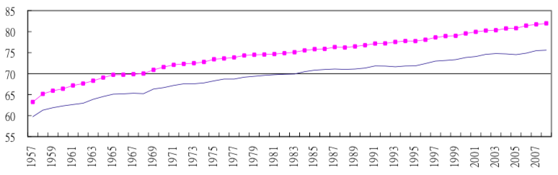

*Source: Department of Statistics under the Ministry of Interior, simplified life table; website:* [*http://sowf.moi.gov.tw/stat/year/y02-11.xls[4*](http://sowf.moi.gov.tw/stat/year/y02-11.xls%5b4)*]*

*Figure 2: Life expectancy of Taiwan’s population at age 60*

*---Average life expectancy for males at age 60*

*\*\*Average life expectancy for females at age 60*

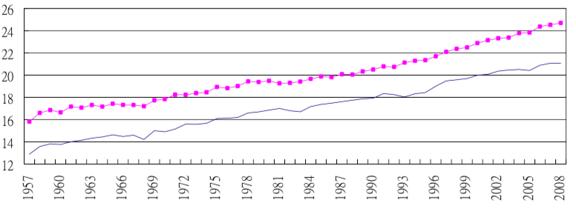

*Source: Department of Statistics under the Ministry of Interior, simplified life table; website:* [*http://sowf.moi.gov.tw/stat/year/y02-11.xls[4*](http://sowf.moi.gov.tw/stat/year/y02-11.xls%5b4)*]*

The total fertility rate showed a gradual yearly downward trend since 1970 and dropped to 2.06 population replacement threshold by 1984. Thereafter, the average total fertility rate was lower than the replacement rate, the total fertility rate of childbearing women was only 1.03 (Figure 4) by 2009. The above-mentioned dynamic changes in the population structure has caused the elderly population of Taiwan (population that are over sixty-five years old) to increase year by year in proportion of the total population. The proportion had reached 7.1% in 1973. Since then, Taiwan had officially become an aging society.