## **CHAPTER 2:**

## **Research methodology**

**Keywords:**

*Research position / Methodology / Empirical research / Methods / Critical qualitative research study / Inductive thematic analysis / Multiple case study Inclusive* educational *internationalisation.*

This research is a cross-national case study of inclusive educational internationalisation, with data collected from multiple perspectives, analysed with inductive thematic analysis. Data collection took place from mid-2014 through to the end of 2015. I have used three data sources: (1) documents that reveal my institution’s perspective on inclusive educational internationalisation; (2) my observations as participant observer; and (3) data (interviews & focus groups) collected at my instigation by external observers. From the beginning it was clear that I would need to write a case study. I had the enormous advantage of having total access to an IBC, but the limiting factor that it was only one IBC in a very specific context (place and time). As researcher I had the University of Applied Sciences policy position (which had strongly influenced my assumptions) and my access to the IBC and mother campus to go on. According to Braun and Clarke (2006), an inductive approach means that the identified themes are strongly linked to the data themselves (Patton, 1990). Repeated reading and (re-)organising on my data has led to my conclusions.

### Case Study

Robert Yin’s book *Case Study Research* (2nd ed., 1994) is the widely accepted ‘gold standard’ of case research and therefore I turn to it as a methodological starting point. Yin begins his text by arguing that case study is appropriate to answering ‘how’ and ‘why’ questions. For instance, issues of frequencies or incidence can better be approached via other methods. My question is: “How and why is or does inclusive internationalisation of higher education become inclusive?” Case history, according to Yin, is the appropriate research method when access is exceptional and contemporary events are at issue. While prescriptive texts do exist calling for ‘inclusive internationalisation of higher education’, there is (next to) no prior research ‘on the ground’ describing deans, faculty, administrators and students actually trying to implement it. As Dean, I had the opportunity to study the phenomena *in situ*. I could directly observe, acted as an observer-participant, had access to ample documents, and could extensively interview. Furthermore, and essential, I could arrange for focus groups and individual interviews conducted by external neutral researchers. In order to assess the success or failure of my effort, I thought that I needed to compare my impressions and participant observations, with more neutral and independent external data. Thus I arranged for the thorough individual and group interviewing of faculty, line administrators and students, at both the branch campus and the main campus, where I also held a senior position. I realised early on that as the Executive Dean of the branch campus, that interviews held directly by myself would inevitably be seriously influenced by my own position. Hence, I arranged for the interviews to be conducted by a neutral party under the directorship of the external thesis examiner of my Polytechnic who had no line responsibility or contact with the people with whom he was directing the interviews. As Yin warns, a case research takes a lot of time and energy to complete (Yin, 1994). I was in the field for more than a year (on and off); I spent at least one week out of three for more than a year at my university’s overseas branch campus (in the MENA region). In five different visits, the external researchers spent approximately a month in the MENA region. And data was collected at the main campus in the Netherlands; involving from the external researchers an additional approximately month of work.

As Yin states:

A case study is an empirical inquiry that (i) investigates a contemporary phenomenon within its real-life context, especially when, (ii) the boundaries between phenomena and context are not clearly evident. (Yin, 1994:13)

I started this project convinced that ‘inclusive educational internationalisation’ was: (i) ethically desired; (ii) that I knew from my context via policy documents and current academic literature what it was; and (iii) that my job in the MENA region was to actualise it in regards to the educational work floor (i.e. the faculty, line administrators and students). My assumption was that inclusive internationalisation of higher education had not yet been sufficiently implemented and that my appointment as acting Dean of my university’s branch campus in the MENA region would give me the opportunity to further its implementation. My concern in a sense was: ‘How and why can inclusive internationalisation of higher education (better) reach the faculty, line-administrators and students?’ And there was no research to be found that addressed my question. Thus my study was exploratory.

I knew from the start that I would need to address contextual conditions: How did branch campus faculty, administrators and students see their context and ‘internationalisation’ as a theme? I would also need to examine attitudes at the mother campus from the perspective of their relevance to the branch campus. The administrators at the mother campus have to address many issues concerning the branch campus - how did they see this? Faculty and students at the mother campus who had to work with their counterparts in the MENA region; how did they see that? And as students from the branch campus increasingly were required to come to Holland; how did all involved experience the interaction? Thus I wanted to know, in the relations on many levels, did inclusiveness flourish or not? Therefore my research was not experiment-directed at all, since the complex context was crucial and could not be simply controlled or restricted. In effect, the phenomena of inclusiveness and the context could not really be distinguished.

As Yin (1994:13) indicates: my research involves (i) a distinctive situation of many variables; (ii) relies on multiple sources of evidence which I triangulate to distil convergence of conclusions, and (iii) benefits from distinguishing early on how the literature (theory) defines ‘inclusive internationalization of higher education. Yin focuses on validity and reliability. ‘Construct validity’ is established by making sure that you are really studying what you say you are studying (Yin, 1994). In my case I set out to study inclusiveness in internationalisation of higher education: thus did differing hierarchical levels (senior management, line-management, lecturers, students) on different sites (in this case, the Netherlands and the MENA region) ‘walk the talk’. Were they ‘inclusive’ - i.e. open, respectful, unprejudiced, culturally sensitive, able to value difference, constructive, not judgmental, bigoted or racist - in their interactions? My external validity, i.e. the relationship to the literature (theory) commonly accepted in higher education policy in general and at my university in particular, was clear-cut. My university of applied sciences made ample use of the literature in its policy documents and had invited the crucial proponents of ‘inclusive educational internationalisation’ to speak on (the Dutch) campus. And I have respected ‘reliability’ by having data collected on all key issues not just via myself as observer-participant but also by qualified external researchers.

Yin (1994: 38-39) recommends single case studies when the case is extreme, unique and revelatory. My research has been done as a single case with two perspectives. My university have other branch campuses, but I did not have comparable access to them in terms of the amount of time I could spend there or the research facilities available. Furthermore, the branch campus in the MENA region was the university’s biggest branch campus and its identity formed a critical case for the university. The question of whether inclusive educational internationalisation really is realisable played itself out more in regards to IBCMENA than to the other branch campuses. When I started my project I did not anticipate that the case would be as extreme or revelatory as it became. At that time, the Dutch government changed the rules of degree accreditation whereby the branch campus students had to spend a full academic year in the Netherlands in order to get their degrees. Hereby was the relationship between the branch and the mother campuses much more intertwined than before. I was Dean when this decision had to be implemented for the first time, which put a lot of pressure on the relationship(s) and was extremely revelatory of attitudes and practices. The nature of the relationship came in for critical testing as enforced student movement (from the MENA region to the Netherlands) was implemented and the mother university had to play a role in whether or not to grant the BA degrees to branch campus students and how to deal with issues around exams (had all legally required exams been completed; had cheating occurred) in the branch campus.

Yin (1994: 56) stresses that the researcher(s) have to:

* Ask good questions;
* Be good listeners;
* Understand the issues at hand;
* Be unbiased.

I am confident that the research meets the first three criteria. By way of the fourth criteria, it is likely that the reader will discover whilst reading this research that my judgments about inclusiveness have changed quite dramatically through the research process. Thus insofar as I began the work with assumptions and a point-of-view (which I describe), I came to revise these on the basis of events and the research data.

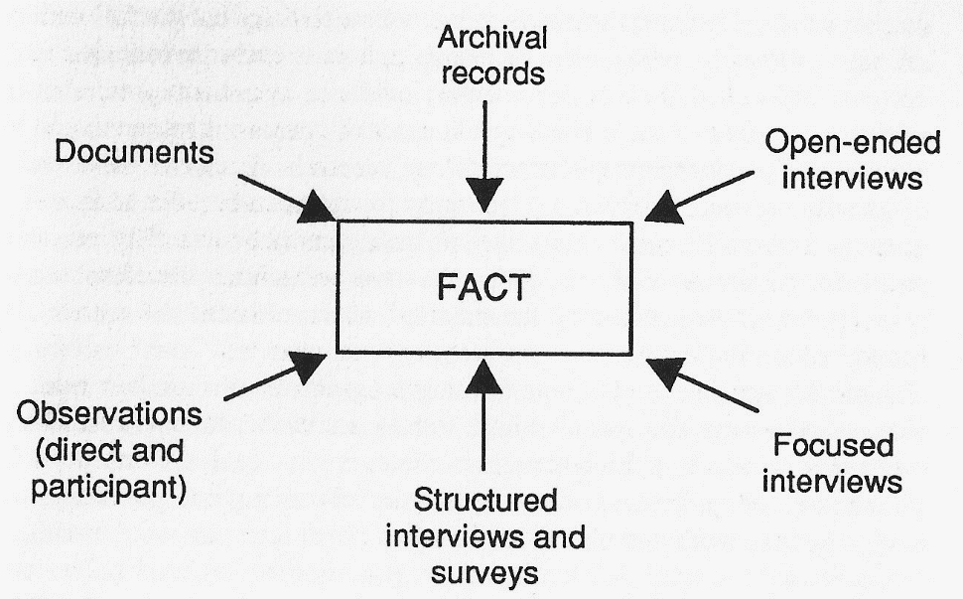Ultimately Yin presents case study research in a diagram:   
*Figure 1: Case study diagram (Yin, 1994:93)*

A good case examines its theme or issue from these perspectives. With the exception of the ‘Structured interviews and surveys’ in my research report you will find all of the above:

* Documents; i.e. policy documents, minutes of meetings, PR materials, etc. are all used.
* Archival records; in the sense of student or faculty records, they are only used in a generalised form; for privacy reasons it is not appropriate to quote individual records in a way that the person can be recognised.
* Open-ended interviews; the external interviewers began their interviews by asking “What does inclusive educational internationalisation mean to you and your work?” and proceeded with follow up questions from there.
* Observations; occurred as I was observer-participant and as the principal external interviewer wrote reflections on the research site and research that are included in the research report.
* Focused interviews were held by the external researchers.

Yin (1994:92) emphasises triangulation; here between myself as observer-participant; the concept (theory & policy) of inclusive educational internationalisation; and the data generated by external researchers. I am confident that I have met this requirement. Missing from Yin’s overview is research (self-)reflexivity. I believe that a case researcher should be aware of herself as part of the research case and should question her own feelings, sentiments and reactions. Reflexive awareness I believe is also a necessary quality in the criteria for case research.

In this thesis, I speak as a researcher who has the role of being an educational administrator. As you might expect of a Head of Department of an economics department, I am an educational practitioner and not a pedagogical academic. I started out in this research project motivated by pedagogical idealism. I found my university’s embrace of ‘inclusiveness’ something to champion. The university’s mission statements and the literature and expert meetings held to support the ‘inclusiveness’ position met with my enthusiasm. In the case you will see what happened to the faculty I managed as well as to myself when I set out to implement the university’s goals. Thus I was an idealist who set out to translate the ideals into practice. Thus I was an educational manager (a Head of Department) who will report here in my research on what happened. And as a researcher I investigated circumstances, change and events much more thoroughly than I would have ever done as a mere Head of Department. The thesis is a case study of the inclusive internationalisation of higher education in practice. As such, it is a thesis in the tradition of the educationalist (teacher)-as researcher. I am researching, here, my own practice as a Head of Department. And as the teacher-as-researcher movement would want (Carr & Kemmis, 2003) my appraisal of the pedagogy of inclusive educational internationalisation as well as my ideas about my own practice evolved (and changed) dramatically via the research process.