**About Me**

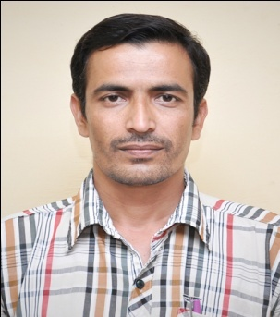

***Name*  - DR. SITARAM ADHIKARI**

***Father’s Name* - (L) Ramnath Adhikari**

***Permanent Address* - Koubru Laikha,**

**P.O- Motbung,**

**P.S – Sapermeina,**

**Dist – Senapati,**

**State – Manipur, India - 795107**

***D.O.B.***  *-***10-12-1977**

***Sex* - Male**

***Marital Status* - Married**

***Nationality* - Indian**

*Contact :*

E.mail I – [sitaramadhikaris@gmail.com](mailto:sitaramadhikaris@gmail.com)

Skype Id - sitaramadhikari1977

Mob – 7002840093 / 9508652365

***EDUCATIONAL QUALIFICATIONS :***

**M.A., Ph-D**

***SPECIAL QUALIFICATIONS :***

|  |  |  |  |
| --- | --- | --- | --- |
| ***1*** | SLET | NOV 2004, Roll No-4512069 | SLET Commission, NE Region, Guwahati |
| ***2*** | NET | DEC 2005, Roll No-H390514 | UGC, New Delhi |
| ***3*** | Ph-D | OCT 2008, Reg No – 2129/05 | Manipur University, Imphal |

***OTHER QUALIFICATIONS :***

1**.** Diploma in Assamese Language (North Eastern Regional Language Centre, Beltola, Guwahati) 2009-10.

***EXPERIENCES :***

1. Damdei Christian College, Taloulong, Manipur (2004- 2006)

2. Ph-D Research, Manipur University (2008)

3. Central Institute of Indian Languages, Mysore (2010-2012)

4. Freelance Translator (2013 - Till Date)

***LANGUAGE KNOWN :***

|  |  |  |  |
| --- | --- | --- | --- |
| **Language** | **Read** | **Write** | **Speak** |
| English | Yes | Yes | Yes |
| Manipuri | Yes | Yes | Yes |
| Assamese | Yes | Yes | Yes |

***COMPUTER KNOWLEDGE:***

1. Computer knowledge with Eng, Nepali, Manipuri and Assamese typing and Internet.

***TRANSLATON EXPERIENCE:***

Experience of 8 years dedicating service to many companies and individuals around the globe.

RATES OF TRANSLATIONS: (PER ENGLISH SOURCE WORD)

ENGLISH – MANIPURI 1.5 INR

ENGLISH – ASSAMESE 1.5 INR

RATES OF EDITING/PROOFREADING: (PER ENGLISH SOURCE WORD)

1. ENGLISH – MANIPURI 1 INR
2. ENGLISH – ASSAMESE 1 INR

RATES OF PROOFREADING (HOURLY RATE: (PER ENGLISH SOURCE WORD)

ALL LANGUAGES – 300 INR

***DECLARATION:***

I do hereby declare that the particulars of information and facts stated herein above are true, correct and complete to the best of my knowledge and belief.

Date: 22/08/2019 Sitaram Adhikari