SAKON NAKHON

## Executive summary

Located in Isan (อีสาน), Thailand’s largest region, and surrounded by lakes, rivers, wetlands, mountains and extensive farmland, the province of Sakon Nakhon is famous for its indigo-dyeing and textile-weaving production. Its capital city, also called Sakon Nakhon, was awarded the title of Craft City from the World Craft Council in 2017, and is gaining international recognition for its naturally dyed textiles.

This age-old craft, developed in close relationship with the land, was transmitted through the generations until modern production technologies of industrialisation overshadowed traditional practices. Thanks to a small number of pioneers, however, the craft was revived during the 1990s and has evolved since into a vibrant creative scene combining local wisdom with modern design influences. The renewed interest in traditional techniques, indigenous knowledge and environmental sustainability has instilled new energy into other sectors, such as agricultural production and sustainable farming.

In the past ten years, Sakon Nakhon has been developed on the basis of its agricultural resources. There has been a continuous increase in creative activities and businesses developed by citizens who moved back after working in other cities and regions. Since 2016, there has been rapid growth in creative networking and businesses around Sakon Nakhon and surrounding areas. Sakon Hed started out as a network of creative entrepreneurs involved in developing locally branded products that are modern, natural and sustainable. The network hosts the annual Sakon Hed festival (เทศกาลสกลเฮ็ด), which has now become the biggest creative event in Sakon Nakhon. The festival aims to promote local wisdom, products, services and brands as well as raise awareness of the growing creative activities in this region.

The uniqueness of Sakon Nakhon’s creative scene is in the somewhat disperse nature of its members. Traditional weaving communities are distributed across the province, while a growing base of returning talent gathers every year at the Sakon Hed festival, driven by an interest in crafts as well as a commitment to Sakon Nakhon and its traditions. Close relationships such as familial bonds and friendships are the drivers of fruitful collaborations: families and community groups can rely on shared resources to sustain their businesses, while a network of friends and volunteers can mobilise enough resources to create a yearly gathering during which ideas are exchanged and collaborations are arranged. As Sakon Nakhon gains prominence as a creative district in Thailand, the focus is on balancing environmental, economic and social sustainability.

## Background

Sakon Nakhon is one of the largest provinces in northeast Thailand, at 9,600 square kilometres. Its history can be traced back more than 2,000 years through fossil and archaeological records. During the tenth century, Sakon Nakhon was called Muang Nonghan Luang (เมืองหนองหารหลวง) and was a major city of the Khmer Empire, until a long drought led to its depopulation. It then became part of the Lan Xang Kingdom (อาณาจักรล้านช้าง) from the 14th century and had a close relationship with the city of Vientiane in Laos. During the time, Sakon Nakhon was known as Chiang Mai Nonghan (เชียงใหม่หนองหาร) and was influenced by Lao cultures and traditions. During the Rattanakosin period, King Rama I (who ruled from 1782 to 1809) renamed the city Sakon Tawapi (สกลทวาปี), which later changed to Sakon Nakhon (สกลนคร), meaning the City of Sakon.

The current population of Sakon Nakhon Province is around 1.1 million, and there are approximately 113,000 residents in the city centre. People here speak Isan, which is a Thai-Lao mixed language used around northeast Thailand. There are six different tribes in Sakon Nakhon – Saiyor (ไทรญ้อ), Taiyoy (ไทโย้ย), Taiso (ไทโส้), Taikaleang (ไทกะเลิง), Tai-Loa Isan (ไทลาวอีสาน) and Phutai (ภูไท), the last one being the largest and oldest tribe in the area. These tribes have their own dialects of Isan language and have been engaged in traditional weaving practices of both silk and cotton for generations. These traditions have very much shaped the creative and cultural fabric of the region.

Sakon Nakhon is known as a cultural and religious city. There are more than 400 Buddhist temples. Many of them are Dhammayuttika Nikaya (นิกายธรรมยุต) or Buddhist forest monasteries (วัดป่า), which focus only on scriptural study of the earliest existing Buddhist texts and meditation practices. Famous Buddhist forest monasteries include Wat Pa Sutthawas (วัดป่าสุทธาวาส), the temple of Buddhist master Mon (หลวงปู่มั่น), and Wat Pa Udomsompone (วัดป่าอุดมสมพร), where the relic of Fun (หลวงปู่ฝั้น) is kept. There are well-known annual Buddhist events supported by local government, such as the Wax Castle Festival (ประเพณีปราสาทผึ้ง) and the Boat Race (ประเพณีแข่งเรือ) at the end of Buddhist Lent Day (วันออกพรรษา). All of these events involve local artisans – for example, to create the beeswax castles and decorations on boats, and perform traditional dance and parades.

Sakon Nakhon is famous for indigo dyeing and textile weaving. Due to the abundance of the indigo plant along the Songkhram River (แม่น้ำสงคราม), which flows through the province, villagers have developed local wisdom and know-how to produce indigo-dyed textiles in a variety of patterns and styles. Indigo-dyed textile production declined in the Isan region during the mid-19th century due to synthetic dyes and industrialisation.[1]1 Farmers switched from growing indigo to more economically viable plantations such as rice, rubber, tapioca, cotton or sugar cane. Villagers, including women, started migrating to cities, reducing the number of agricultural labourers and weavers while swelling the ranks of factory workers. Without women to transmit or inherit the skills of dyeing and weaving, traditional indigo textile production gradually disappeared.[2]

However, since the 1990s the indigo industry has experienced a revival. During and after the economic crisis of 1997, various initiatives were introduced by the government to stimulate job creation in the rural sector and incentivise workers to return to their hometowns. In this period, the idea of ‘local wisdom’ emerged as a central concept for the revitalisation of many artisan sectors, including agriculture, food, traditional medicine and crafts. Many of the pioneers of the indigo craft revival discussed in the case study started operating in this decade, initiating a new era of indigo production that brings together tradition and innovation. Owing to this revival, the processes of planting, harvesting, fermenting, dyeing and weaving have been passed on over the centuries, and indigo has become the key cultural identity of Sakon Nakon. Indigo products embody traditional craft knowledge and practices, enabling relationships between different groups to be sustained – local community weavers and designers educated outside of the province, producers with a wealth of traditional knowledge and new consumers.

The communities’ close relationship with rich, fertile land and natural resources, and the valuing of local wisdom and indigenous knowledge, extend to sustainable agricultural practices in rice and beef. Small, family-run organic farms, such as Farm Hug, have increased in number in recent years, where traditional crafts and organic food production are brought together. This confluence of craft, culture and food makes Sakon Nakhon a unique creative district in Thailand.

## Typology of Sakon Nakhon’s creative and cultural district

#### Hard infrastructures

Sakon Nakhon is characterised by the relative remoteness of the region, its natural resources and its close proximity with other national borders and cultures. Lying on a flat plain on the bank of Nong Han Lake, it is surrounded by extensive farmland and national parks. North of Sakon Nakhon are the provinces of Bueng Kan (บึงกาฬ) and Nong Khai (หนองคาย), while Udon Thani (อุดรธานี), the prominent city of the Isan region and Isan Buddhism, is to the west. The south of Sakon Nakhon is connected to the provinces of Kalasin (กาฬสินธุ์) and Mukdahan (มุกดาหาร), and the nearest province is Nakhon Phanom (นครพนม), which is only 93km away. The region is close to the Laos border, where Vientiane is only 236km over the Thai-Lao Friendship Bridge (สะพานมิตรภาพไทยลาว).

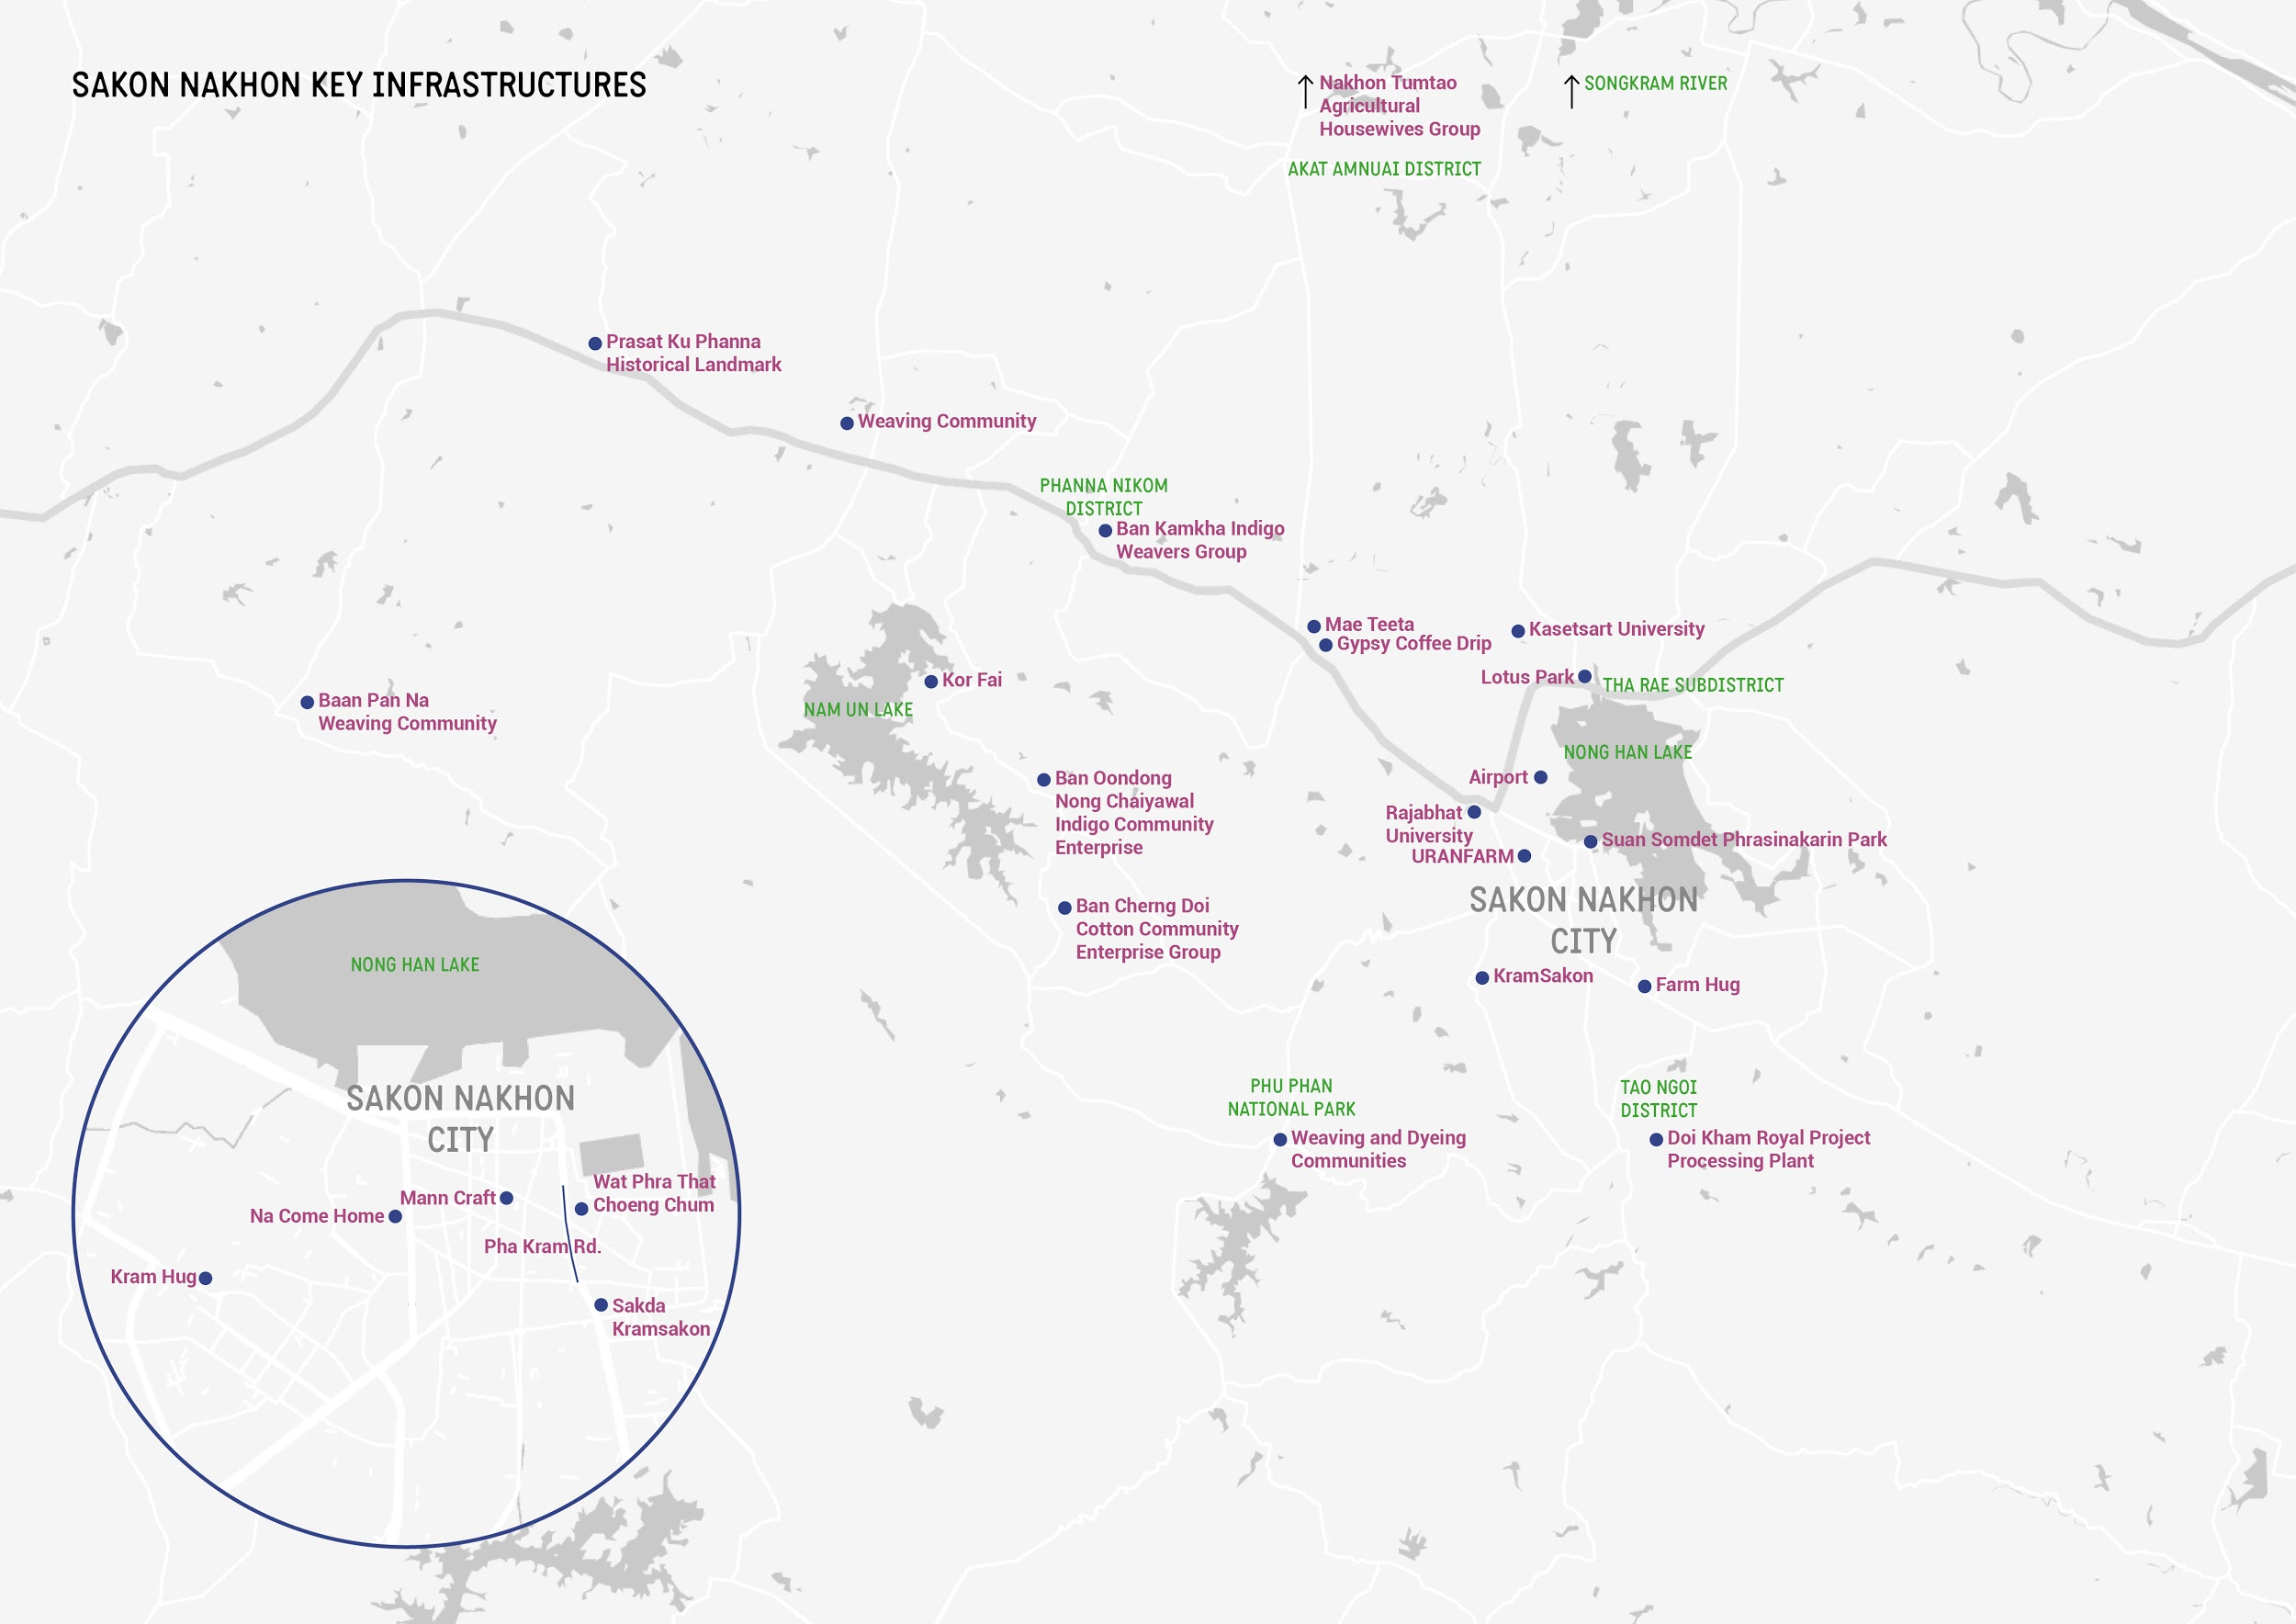

Figure 1. Key creative infrastructures of Sakon Nakhon

##### Natural resources

The abundance of water sources is an important natural infrastructure for the province because other surrounding provinces in northeast Thailand (such as Udon Thani) are dry regions. Sakon Nakhon Province is dominated by large bodies of water and mountains. **Nong Han Lake** (ทะเลสาบหนองหาร)is Thailand’s largest freshwater lake and the surrounding wetlands are important conservation areas. Nong Han Lake is fed by the Nam Pung River (ลำน้ำพุง) originating from the Phu Phan mountain region (เทือกเขาภูพาน), and draining through the Huai Nam Kan River (ห้วยน้ำก่ำ) into the Mekong River (แม่น้ำโขง). Other sources of water come from the Himalayas, where the Mekong River springs and flows through China, Myanmar, Laos, Thailand, Cambodia and Vietnam before flowing into the South China Sea. During its course, the Mekong River feeds the **Songkhram River** (แม่น้ำสงคราม) flowing through the northeast of Thailand, causing it to flood an area of more than 100 square kilometres every rainy season. This phenomenon sustains an aquatic and terrestrial ecology of countless wetlands; their biodiversity has high cultural and economic value in sustaining the communities for centuries.

**Phu Phan National Park** is one of the important natural resources in Sakon Nakhon. Located in the Phu Phan mountains, a range of hills dividing the Isan region into two basins, the park was established in 1972 to protect the flora and fauna of the area,[3] including the prized Siamese rosewood (ต้นพยุง). The indigofera tinctoria,known as the indigo plant or kram(คราม)in Thai, originates from the Phu Phan mountains. Indigo plants are widely grown in the area surrounding the Songkhram River, the very name of the river meaning ‘indigo forest’. The locals have found many uses for indigo over the centuries, calling it the ‘king of dyes’. It is most famous as a natural pigment yielding a distinctive, deep blue colour. However, other uses are common, such as a repellent for rice pests and a culture starter for edible mushrooms.

##### Public spaces

Public spaces are often a rare commodity in Thailand,[4] and can act as important hubs to enable civic, cultural and creative activities to happen. Lotus Park and the surrounding two parks located next to Nong Han Lake are considered the heart of Sakon Nakhon culture, supporting the recreational and cultural life of the residents. **Nong Han Chaloem Phrakiat Lotus Park** (อุทยานบัวเฉลิมพระเกียรติ) was created in 2009 by Kasetsart University Chalermphrakiat Sakon Nakhon Province Campus as part of a research project looking into the benefits of the royal lotus plant. Opened to the public in 2010, the park now features more than 100 varieties of lotuses and water flowers from around the world, with indoor and outdoor exhibition areas.

**Suan Somdet Phrasinakarin** and **Suan Somdet Galyani Vadhana Parks** (สวนสมเด็จพระศรีนครินทร์และสวนสมเด็จเจ้าฟ้ากัลยาณิวัฒนา กรมหลวงสงขลานครินทร์ หรือ สวนแม่สวนลูก)are located next to Nong Han Lake. Often described as the ‘lungs of the city’, they are the only large pedestrianised areas in Sakon Nakhon, kept cool by the large lake and the tall trees at the edge of the parks. They are prominent meeting points, hubs for recreational activities and places to gather for many public events.

##### Religious structures

Given the fact that there are more than 400 Buddhist temples, only the most significant have been noted here. Built around the first century, **Wat Phra That Choeng Chum** (วัดพระธาตุเชิงชุม)is one of the most important city temples of Sakon Nakhon. It was known as Phra That Nong Han (พระธาตุหนองหาร) during the time of the Lan Xang Kingdom. Wat Phra That Choeng Chum represents Lan Xang influences in Sakon Nakhon culture and traditions. Located next to Nong Han Lake, it is a popular destination among locals and tourists, who often visit to pay respect. Taking advantage of its popularity, local entrepreneurs have set up stalls selling indigo products around the entrance of the temple grounds. In front of Wat Phra That Choeng Chum is a walking street, hosting a creative weekend market called Thanon Pha Kram (ถนนผ้าคราม).

The **Archangel Michael Cathedral**, located in the subdistrict of Tha Rae (ท่าแร่), serves the largest Catholic community in Thailand. Its original structure was built by a community of Vietnamese descendants who settled in this province more than 130 years ago after fleeing persecution. The cathedral serves as a reminder of the rich cultural influences of the province.

##### Weaving and dyeing industries

Many indigenous groups live in Sakon Nakhon Province. These communities have an enduring tradition of weaving and dyeing cloth, and each group has devised specific techniques, patterns and styles that are regarded as a form of indigenous art and taught through the generations.[5] Mud mee (มัดหมี่), or ikat*,* isa technique of resist-dyeing to pattern textiles, such as tying or stitching. Weaving is traditionally considered a duty for Phu Tai women in the community.[6] In the past, textiles were woven for household products, such as clothes and bedding, as well as for important events and ceremonies such as weddings or Buddhist festivities. Dyeing and weaving industries rely on proximity to natural resources, so they are distributed throughout Sakon Nakhon Province. The map (fig. 1) shows traditional communities and pioneer revivalist groups located outside of Sakon Nakhon city.

More recently, shops selling indigo textiles and products have started opening closer to the city centre. Every afternoon on weekends and public holidays, Rop Mueang Road (ถนนรอบเมือง) in front of Wat Phra That Choeng Chum is transformed into **Thanon Pha Kram** **market** (ถนนผ้าคราม), taking advantage of a new commercial space that opened in 2016. Vendors sell raw indigo materials and end products such as clothes or accessories, so all generations of indigo enthusiasts can sell, buy and network. The market was an initiative of Kasetsart University, with support from local government, the Department of Creative Industry Development and the Department of Industry Promotion. Named as a ‘northeastern style flea market’, indigo-dyeing workshops are also held here. Others have opened permanent shops next to the market, such as **Thainiyom Kramsuay** (ไทยนิยมครามสวย), which occupies a 70-year-old, two-storey wooden house.

##### Educational institutions

Two universities in the city – **Kasetsart University** and **Sakon Nakhon Rajabhat University** (มหาวิทยาลัยราชภัฎ สกลนคร) – have been instrumental in reviving indigo-dyeing practices, bridging indigenous wisdom with modern science and technology.[7] Local schools provide indigo workshops for students, while the Indigo Centre at the Research and Development Institute of Sakon Nakhon Rajabhat University was set up to support people from the surrounding communities in developing their craft practices. Sakon Nakhon Rajabhat University was commissioned by the National Science and Technology Development Agency (NSTDA), owing to government policy introduced in 2000, to assist a community initiative in indigo craft revival. Researchers worked closely with villagers to understand and catalogue the traditional practices – traditions surrounding the craft include the belief that dye vats are inhabited by spirits that can favour the dyeing process[8]8 – and chemical processes of dyeing. What was once small scale and labour intensive with varying quality has transformed to meet an increasing demand for indigo textiles on the national and international market.[9] This new knowledge supported some of the indigo revival pioneers, such as **[Mr?]** Kamolrat’s development of a database system of Sakon Nakhon’s indigenous fabric stripes and patterns, which in turn contributed to the expansion of local craft knowledge.[10]10

##### Transportation hubs

Sakon Nakhon has a domestic airport with a daily bus service to Bangkok. It is connected to nearby cities such as Udon Thani and Nakhon Phanom. A planned upgrade by Airports of Thailand (AOT) for the airport to become an international hub in the coming years will undoubtedly improve connectivity.

### Soft infrastructures

#### Indigo communities and traditions

The recipes for indigo dye and the patterns and motifs created through weaving can vary from one community to the other. Weaving communities grow indigo plants using traditional methods[11] and make use of locally grown and spun cotton and silk yarns. A system of shared facilities keeps costs down, promotes collaboration and the circulation of resources and knowledge between communities. The weaving process is equally demanding and heavily reliant on the labour of women. Girls are socialised from a very young age, starting with cotton spinning and picking. Women learn to work together, where the younger and less experienced weavers can observe the proficient ones, learn their patterns and practise under supervision, with knowledge passed on from older women to younger girls.[12]12 This practice means the indigo-dyeing and weaving industry is managed 90 per cent by women. For example, in the Ban Cherng Doi cotton community enterprise group, men are in charge of growing indigo and making dye, while women weave cotton into traditional patterns and invent new ones. Men may also deal with matters outside the home, or even occupy positions of power in the public sector that enable them to support the dyeing and weaving industry through policy decisions.[13]

##### Pioneers of indigo production and community enterprise groups

To an untrained eye, indigo products may all look the same, but the expertise is embodied in the production process, the history of the practice, different techniques and additives used, and the quality of the woven materials. Some long established groups are distinct in the way they make, manage and develop their products.

**Nakhon Tumtao Agricultural Housewives Group** (บ้านนครถ้ำเต่า) was established in 2008 as a community-managed production network consisting of 372 indigo weavers from different villages, each member taking care of a specific part of the production process. The group is led by Mr Somkid Promchak (known as Mae Soom: แม่สุ่ม), who left to be educated elsewhere and returned in 1998. The group has collaborated with Kasetsart University and other agencies to research natural dyes and has developed its own recipe using lotus plants as an additive to the indigo dye.[14]

**Ban Kamkha Indigo Weavers Group** (บ้านคำข่า) has been running since 1994 as a community enterprise producing hand-printed cotton. Ms Pira Prasertkantong (คุณพิระ ประเสริฐก้านตง) is the local craft expert and instructor in a government-initiated project for local craft promotion (Support Arts and Crafts International Centre of Thailand – SACICT) and continues to innovate by introducing new patterns. The group’s goal is to grow its own cotton and create special recipe dyes incorporating mud and husks. Taking a different route to market, the **Ban Oondong Nong Chaiyawal Indigo Community Enterprise** (วิสาหกิจชุมชนทอผ้าฝ้ายย้อมครามบ้านเชิงดอย) distributes its unique weaved patterns from indigo-dyed, hand-spun cotton threads through an online channel. Led by indigo expert Ms Sunee Promkomol (คุณสุนีย์ พร้อมโกมล), it is supported by the Biodiversity-Based Economy Development Office (BEDO) under the Ministry of Natural Resources and Environment to develop sustainable natural products.

**Mae Teeta** (แม่ฑีตา) was the first indigo-dyed product brand in Sakon Nakhon, set up in 1992 by Ms Praphaiphan Deangchai. The brand paved the way for the resurgence of indigo craft in the province. ‘Mae’ is a respectful term meaning ‘mother’, named after the founder’s mother, Ms Teeta Chanpenphen. Mae Teeta is a family-run business involving the founder, her sister, her daughter and her nephew in the production of indigo-dyed textiles and clothes. Ms Teeta and her daughter were pioneers in reviving indigo farming in Sakon Nakhon, by introducing indigo seeds harvested from the surrounding forests into cultivation. A family-like relationship extends to the producers who plant and spin cotton with traditional spinners. Clients are also included in this extended family. Mae Teeta has a loyal base of returning customers that trust the brand and recommend its products to others. The younger generations of Mae Teeta’s family are fashion graduates who are developing clothing lines for younger customers and introducing the brand to an international market.

##### Contemporary indigo-related products and shops

A new generation of makers and producers are evolving indigo craft through a combination of experimental techniques, new marketing strategies and the creation of contemporary designs, as demonstrated by Mae Teeta’s example. Branding has become a key practice in the transformation of indigo-dyed textiles from objects of everyday, personal use to commodities available for local, national and international trade.[15] **KramSakon** is an umbrella brand for all the indigo merchandise produced by the indigo-dyed textile industry cluster.It is made up of 20 community enterprises and four SMEs. Members of KramSakon were among the first to establish the Phra Kram street market to sell their products through a dedicated store. One of the stores, **Kram Hug**, was started by a long established clothing producer, taking advantage of renewed interest in indigo products. It creates contemporary clothes, household items and accessories designed to appeal to a younger audience.

Dominating a busy crossroads with large windows and outdoor plants, **Kram Thong** (ครามทอง)and **Mann Craft** are owned by the same family and share premises. The stores are a key stopping point for important visitors such as the Thai fashion designer Princess Sirivannavari. The store displays traditional looms, books and signs explaining the process of indigo production. The two distinct brands target different audiences. While Kram Thong is the original brand that sells home decor items and textiles with vintage patterns, Mann Craft – the newer brand, developed by the next generation of the family, Praj ‘Mann’ Niyomkha – is all about innovation.[16] Lots of research and experimentation go into the discovery and adoption of different dyeing techniques that yield pastel-coloured textiles with intricate patterns, original tie-dye garments, and freehand-painted scarves, clothes and tapestries. This talent has been recognised internationally and has led the two brands to open shops in Sakon Nakhon Airport and Bangkok.

#### Social and sustainable creative endeavours

Alongside the indigo craft communities, there are new groups of returning creative entrepreneurs that are heavily influenced by sustainable living, and are actively contributing to the creative and cultural buzz of Sakon Nakhon. Many of these businesses are reconnecting with their strong cultural roots and illustrate the increasing diversity of Sakon Nakhon’s creative life.

**URANFARM** (อุฬารฟาร์ม) produces organic cacao, orchids, salad and palm oil. It is owned by Mr Narongdech Urankun (ณรงค์เดช อุฬารกุล), a local politician and farmer who is considered a pioneer of modern organic farming, introducing new crops and utilising different marketing and sales strategies by exporting to other regions. Mr Narongdech is a key member of the Sakon Hed network, which hosts the annual Sakon Hed festival. **Gypsy Coffee Drip** and **Gypsy Camp** are owned by Mr Gypsy Chanpengpen (ยิปซี จันทร์เพ็งเพ็ญ), another key member of the Sakon Hed network. Recognising an opportunity to service tourists interested in indigo products, he opened his cafe in 2014 next to the Mae Teeta shop. It is akin to a creative hub where local art and craft practitioners meet, including the Sakon Hed network. Like many others featured in this case study, Mr Gypsy returned after working as a researcher at Kasetsart University in Bangkok and witnessing the devastating 2011 floods.[17]

**Na Come Home** (นาคำหอม) is a brand of organic food including rice, fruit, vegetables and herbs. It is owned by Ms Ratikorn Tongsiri (รติกร ตงศิริ), another returnee who left behind a job in Bangkok’s media industry in 2011. Concerned with environmental issues and aiming to promote healthy living, she became an organic rice and vegetable farmer. Ms Ratikorn expanded her farm and opened an organic cafe, Come Home Sakon, at the end of 2011. The cafe sells desserts, drinks and locally sourced goods as well as showcasing local indigo products. Come Home Sakon is popular with locals, visitors and a network of young entrepreneurs that gather here. Profits from Na Come Home and the cafe are donated to local childcare centres and schools, reflecting other initiatives that are giving back to the community.

**Kor Fai** (ก็ฝ้าย) produces natural cotton products and promotes community tourism in Baan Na Chok. Community tourism shares the resources of a local community with visitors for the sustainable benefit of both the community and the natural environment. As a plateau and drought area of Sakon Nakhon Province, Baan Na Chok is used for buffalo grazing – Ms Saisunee Chiyahongsa (คุณสุนี ไชยหงษา) and Mr Sakai Chiyahongsa (คุณสะไก ไชยหงษา), leaders of the Baan Na Chuk Organic Dyeing Group, have used locally available resources such as buffalo manure creatively, to experiment with organic dyeing processes. They have developed both agricultural and community tourism, creating a successful complementary experience alongside their Kor Fai cotton products.

**Hoop Thame** (ฮูปแต้ม) specialises in Isan graphic design, prints, craft and book-making. Mr Aumnart Sunaprom (คุณอำนาจ สุนาพรม), a graphic design lecturer at Sakon Nakhon Rajabhat University, experiments with natural materials such as indigo dyeing on banana leaves, and offers hand-dyed textiles and hand-bound book-making workshops.

**Cha Ya Ta** is an experimental studio that combines eco-printmaking with local hand dyeing and weaving. Cha Ya Ta Incha (คุณชญตว์ อินทร์ชา) is an art educator at the School of Education, Roi Et Rajabhat University, and an expert in eco-printing. Her gelatin-printing techniques, which are sustainable and ecological, are taught through regular workshops at her studio.

**Phukarm** (ภูคราม) is known for working with communities in the Phu Phan mountains to create hand-made textiles and embroidered floral patterns. Ms Pirun Thaisuang (คุณปิลันธน์ ไทยสรวง) is a returning resident who worked as a community historian in Bangkok. Since 2016, she has trained and worked with ageing local women weavers to enable their traditional designs to become contemporary products for different markets.

#### Institutional collaborations and policy instruments

Thai central government has supported the indigo-dyeing sector through various entrepreneurial-based development strategies since 2001, during Prime Minister Thaksin Shinawatra’s first period in office. The Ministry of Industry established ‘entrepreneur development units’ to activate business, while the project One Tambon One Product (OTOP) aimed to stimulate entrepreneurial development in rural areas. In 2004, the Sakon Nakhon provincial governor designated indigo-dyed textiles as the official symbol of the province.

The Support Arts and Crafts International Centre of Thailand (SACICT) was established by royal decree in 2003 to ‘promote and support the integration of vocations leading to the creation of folk arts and crafts’.[18] It has introduced quality standards and supports local craftspeople and entrepreneurs with training, branding, marketing, internationalisation, intellectual property and blending technological development with traditional practices. These measures were put in place at a time when the market for indigo products was saturated and many entrepreneurs were pushed out of business by competition.[19] As a result indigo entrepreneurs began developing distinct brands that communicated authenticity and the careful design of their products.[20]

In 2008, Kenan Institute Asia (K.I.Asia) introduced community capability development programmes to resource indigo textile production in Sakon Nakhon, supported by BEDO. Since 2011, the development of small and medium-sized enterprises in the textile industry – grouped under the name of Cloth Industry Cluster of Sakon Nakhon (CIC-Sakon, โครงการพัฒนากลุ่มสิ่งทอผ้าย้อมครามจังหวัดสกลนคร) – has been supported by the Department of Industrial Promotion. The project is hosted by Kasetsart University. Since 2012, BEDO and K.I.Asia have collaborated with CIC-Sakon enterprises, implementing the Developing Indigo-Dyed Textile Industry Corporation Project within the indigo-dyed textile industry cluster, covering the full supply chain from indigo and cotton farming to marketing.[21] In 2017, with the support of Sakon Nakhon’s Chamber of Commerce, the local campuses of Rajabhat and Rajamangala universities, Silpakorn University and the Association of South East Asian Nations (ASEAN) Handicraft Promotion and Development Association (AHPADA), Sakon Nakhon successfully applied to be nominated as a Craft City by the World Craft Council.

#### Networks

As a geographically dispersed creative district, networks and community groups play an important role in Sakon Nakhon. The **Sakon Hed network** consists of locally born creative producers and innovators that come together once a year. The 18 founding members grew up locally but moved away to other cities. They reconnected four years ago with the idea of creating a platform for local creatives and craftspeople to reconnect again, and this resulted in the Sakon Hed festival, held annually since 2016. In recent years, the Sakon Hed network has increased awareness of arts, craft and creative enterprises to showcase their work. Their independent status, without affiliation with the government or corporations, allows them autonomy and freedom in curating the festival.

The **Young Entrepreneur Chamber of Commerce** (YEC) is a nationwide network with a local office in Sakon Nakhon that supports businesses participating in the Sakon Hed festival. YEC is a network of second generation business people who run mostly small businesses in the area. One notable initiative by YEC is an annual fundraising run in December to build and develop children’s centres in Sakon Nakhon.

#### Annual festivals

Festivals have become important temporary hubs to draw dispersed creatives and artisans to Sakon Nakhon to meet, share and network. Many people featured in this case study are young, returning talents, having studied or worked outside Sakon Nakhon city. The main **Sakon Hed festival** brings together a unique mix of indigo-dyeing and sustainable farming products across the province. ‘Sakon Hed’ means ‘Sakon Nakhon made’ in the Isan language. The festival has been held every year in December since 2016, to champion community-made, locally sourced products and services. The event offers workshops, talks and networking opportunities for artisans and visitors, attracting exhibitors and tourists from all around the province and the country. The festival is grassroots and volunteer-led, without significant funding support from one entity. Contributions come in different forms, from in-kind support by musicians to sourcing bamboo needed for stall structures. The festival has grown in popularity, attesting to the dedication of the organisers, and moved to a larger location for 2019. It coincides with Christmas to take advantage of the festive seasonal holiday, when many people are travelling back home**.**

Throughout the year, other cultural and religious festivities take place. Communities from around Sakon Nakhon Province construct large models of Buddhist temples out of beeswax. These impressive constructions are loaded onto trailers and driven through the city during the annual **Wax Castle parade** that concludes the Wax Castle Festival, taking place every year in October at the end of Buddhist lent. The Wax Castle parade is the biggest event of the year and it is supported by the local government, temples and other organisations.

### 2. Building social capital in Sakon Nakhon

Sakon Nakhon’s social capital owes much to the family-like bonds between groups and friends, underpinned by a strong sense of community. While geographically dispersed, the creative and cultural ecosystem of Sakon Nakhon is held together by shared values of respect for traditional wisdom, nature and sustainable development. Key actors such as the Sakon Hed network, creative indigo producers and sustainable farmers were identified with characteristics such as dedicated, generous, collaborative, innovative, experimental, heartfelt, flexible, good listener, team worker, open minded, kind, good advisor, good at problem solving, hardworking and the ability to say sorry.

[insert word cloud diagram]

#### Strong bonds for bridging

Close relationships and collaborations are key drivers of creative activity in Sakon Nakhon and are evident within the various communities in the province. Stemming from strong, intimate bonds, the indigo craft bridges different age groups and social identities. Skills are passed on between family members, and specific weaving patterns and dye recipes are developed within villages, which have an intimate relationship with the surrounding land, rivers, wetlands and mountains. Age-old bonds are seen in contemporary indigo brands such as Mae Teeta, Kram Thong and Mann Craft, discussed earlier. These family businesses have transformed indigo textiles from everyday, traditional products, bridging an emerging class of creatives looking to develop business in their hometown to reach a global market.

The Sakon Hed network offers the strongest example of family-like bonds that build bridging links. Sharing the same passion for returning home to reconnect, the founding members described their team as brothers, sisters and friends. The festival is an opportunity to expand the network and ‘make more friends’, turning strong bonds into bridging opportunities with other creative communities outside the province. Collaboration is based on respecting differences in taste and expertise, while carefully mediating and reaching consensus. Since they do not do business together, there are no conflicts of interest or competition between organisers. Instead the focus is on creating a welcoming environment for the growing number of visitors. The network has not relied on government funds or external influential partners to enable its growth. The success of the network and festival lies in this focus on collaborations and friendships, rather than just economic revenue. The organisers described the latter as a ‘social lubricant’, but not the main goal of Sakon Hed. What started as a family-like gathering has now become the largest independent festival in the province, where dispersed creative communities that live and work in bigger cities such as Chiang Mai or Bangkok come to meet, eat, drink and enjoy sustainable and creative activities.

The power of the Sakon Hed network to connect with a diversity of creative groups is remarkable. The festival draws talents to Sakon Nakhon temporarily to reconnect with fellow creatives, while also inviting friends from other provinces such as Surin (จังหวัดสุรินทร์) and Phrae (จังหวัดแพร่) to share and potentially collaborate. This maintains bridging relationships among mobile groups of creatives from different provinces and regions. Sial Sakon (เสี่ยวสกล), also known as the Friends of Sakon, is an extended network of friends involved in the organisation of the Sakon Hed festival. They travel from other regions in Thailand to join the festival as exhibitors and organisers. For example, Phrae Craft (แพร่คราฟท์), a creative network from Phrae province in the north of Thailand, are also members of Sial Sakon and exhibit traditional craft products at the event. This is an exchange, as the Sakon Hed network also joined Phrae Craft’s creative festival from 6 to 8 December 2019. Many other groups, such as Folkcharm from Loei Province (จังหวัดเลย), and Charm-Learn Studio and Ruenrom Organic Living (บ้านรื่นรมย์) from Surin Province, participate at these events to share organic products, new soil-dyed cotton, ceramics and award-winning bento designs.

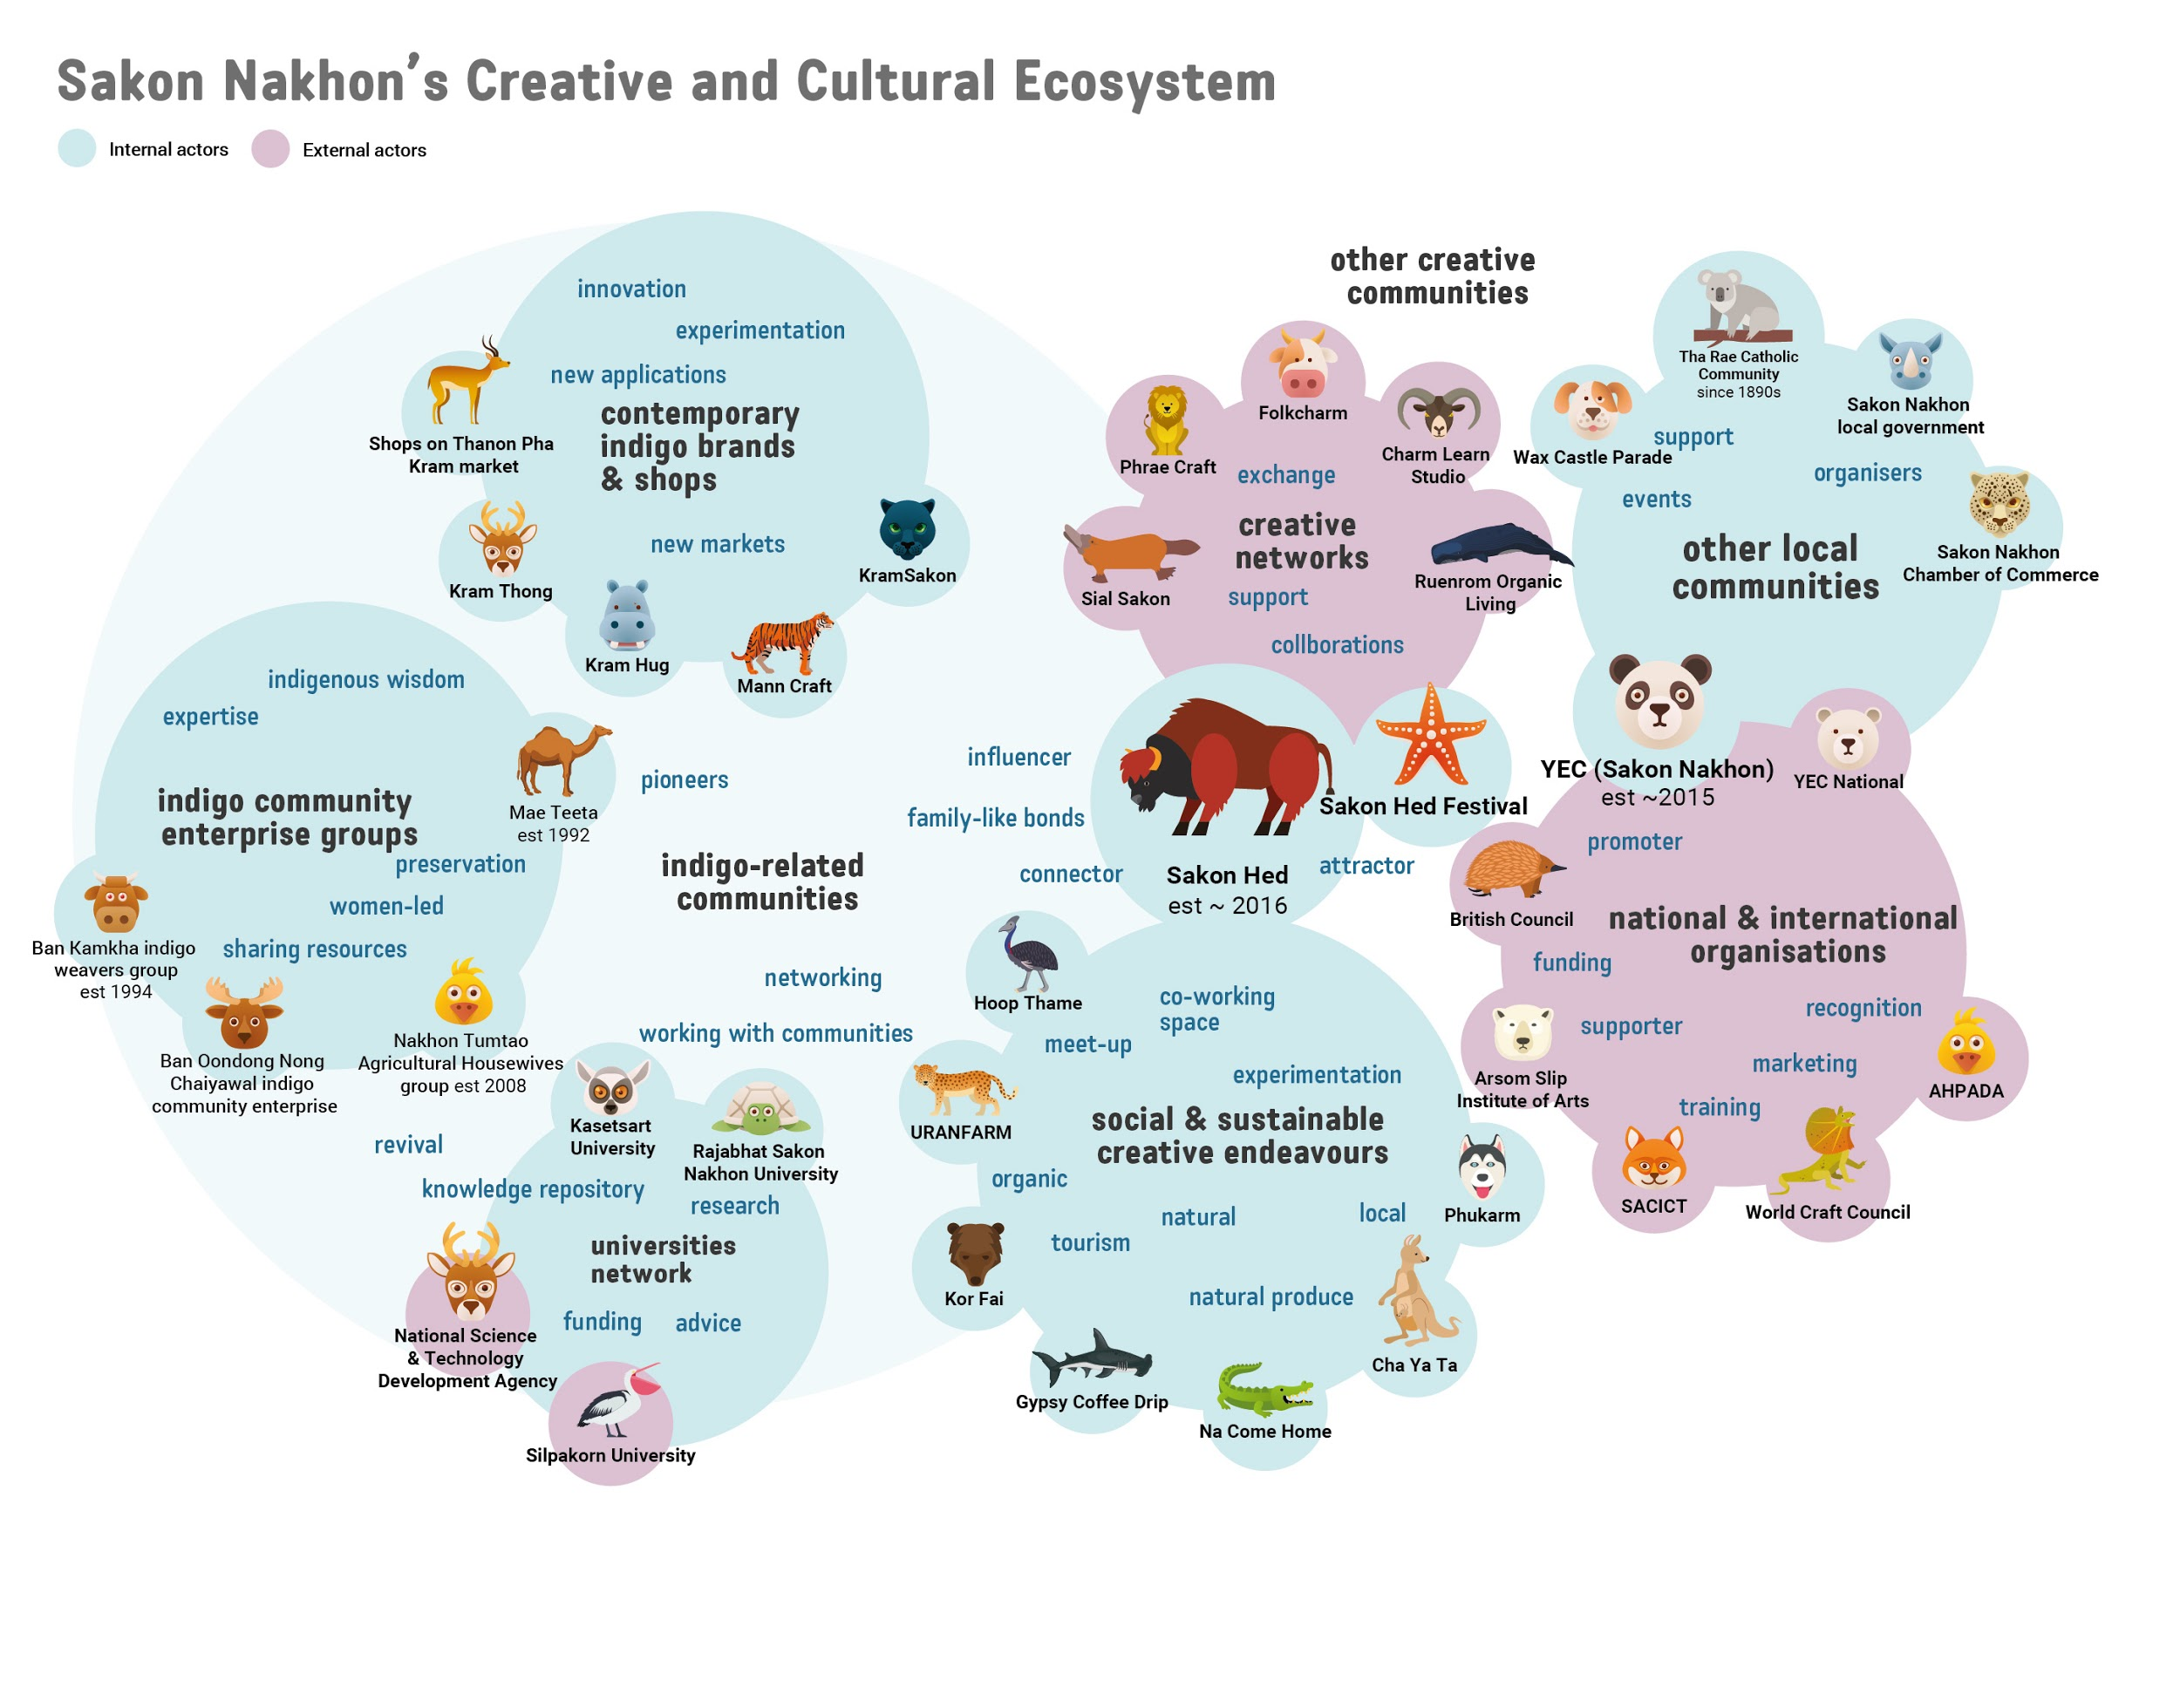

Figure 2. Sakon Nakhon’s Creative and Cultural Ecosystem

#### Linking to resources and national and international markets

Linking social capital can introduce the region’s indigo products to national and international markets. This provides new avenues for marketing and lowers the risk of failure for the dyeing and weaving entrepreneurs when local markets are saturated. Historically, the creative community in Sakon Nakhon had minimal access to local and central government resources. However, indigo craft revival in the early 2000s heralded a change in investment from Thai central government to help communities build greater business capacities and link to national and international actors. These contributions have been perceived as top-down and less flexible than local, self-organised efforts to nurture the creative community. A study by Chanorn identified OTOP as successful in stimulating local entrepreneurship, but also reported how local artisans felt it introduced divisiveness and promoted business models that were antagonistic to the cooperative nature of many community groups.[22]22

Educational institutions provide considerable links to resources and opportunities outside Sakon Nakhon. Kasetsart University Chalermphrakiat Sakon Nakhon Province Campus and Sakon Nakhon Rajabhat University have supported many projects that connect to public and private sectors, such as the example provided earlier where the NSTDA commissioned Rajabhat University to develop the local dyeing and weaving industry. Other examples include talks provided by experts during the Sakon Hed festival, such as Assistant Professor Tips Srisakunchaiyaruk (ผศ.ธิป ศรีสกุลไชยรัก) from Arsom Silp Institute of the Arts, on community development, and Ms Sirikun Lolpaikun (ดร.ศิริกุล เลากัยกุล) from Brand Being, who shared her vision on branding community products. Sakon Hed talks were supported by the British Council Thailand, which also provided funding for online media production during the festival.

## Key characteristics of Sakon Nakhon as a creative district

#### Nature as a driver of creative endeavours

Sakon Nakhon’s creativity draws upon the abundance of natural resources, attested by the indigo-dyeing and textile handweaving industry. Villages spread out in the Isan region cultivate this traditional craft. Many have made significant efforts to preserve the ancient craft, such as Mae Teeta, which rescued the seeds of two different varieties of indigo and grows them both to ensure their continuation. The revival of this craft in the 1990s, driven by renewed interest in organic and sustainable products worldwide, has also expanded the creative community to engage with agriculture and farming practices. The festival and network have given a platform for these industries in Sakon Nakhon to contribute to the creative and cultural richness of the area. This has expanded the scope of the cultural assets of the province to the forefront of contemporary life.

#### Sustaining and developing the dyeing and weaving craft

Indigo-dyed products have recently started to make their way into Sakon Nakhon city centre, where shops are catering directly to collectors and consumers. Support from local universities with technical know-how has been crucial in introducing innovation to this labour intensive craft. Opportunities to sell indigo-dyed textile products on a national and international scale is also emerging, sustained by efforts to establish quality standards and develop new modes of production, aided by branding, manufacturing and marketing support by various government initiatives. Newer indigo brands may communicate the indigo craft as a traditional practice as part of their message, but some, such as Mann Craft, focus on (re)discovering ways to extract pigments from different plants, creating new textile patterns produced artistically by weaving communities. However, natural dyes and textile weaving are labour intensive, which justifies the high price of the more elaborate items. As the market becomes increasingly competitive, the sector must find ways to preserve its authenticity without impacting on product prices and, therefore, labour retribution.

#### A dispersed creative network

The Sakon Hed festival illustrates how a dispersed network of creatives can come together and build creative capital through active collaborations and connections. This network is unique, in that it is still very much grounded by a commitment to the place and its tradition, and shows that the creative life of a place doesn’t necessarily need to be permanently situated to bring about a rich creative milieu. While there is an increasing number of creatives – particularly fashion designers – returning to open new indigo-related businesses in the city, there are also many more returning creatives who use the Sakon Hed festival as an opportunity to draw inspiration and bring new ideas back into the creative life of Sakon Nakhon. The festival is an example of a collaborative creative endeavour sustained by Sakon Nakhon’s creative diaspora.

#### d) Importance of family bonds and networks

Family bonds and family-like networks have been key to the revival of indigo-dyed products, and continue to sustain the creative ecosystem of Sakon Nakhon. Generational businesses such as Mae Teeta or Kram Thong and Mann Craft highlight the importance of not just drawing on traditional craft knowledge, but also joint family resources to support the development of new ideas. The Sakon Hed network is very much established and reliant on blood ties and family-like bonds. For example, Teeta Chanpenphen (of Mae Teeta) is the grandmother of Gypsy Chanpengpen, a key member of the network. Gypsy Coffee Drip is located next to the Mae Teeta shop in Dong Mafai village. Other members of Sakon Hed may not be related to each other but have nonetheless developed family-like bonds through years of childhood friendship. External visitors such as Chamroen Studio from Bangkok are connected through Mr Gypsy, who consider him as a ‘brother’. These family-like bonds explain the ability of the network to attract many external organisations to participate, calling on goodwill that only family-like relationships can rely on.

##### e) Diversifying a creative ecosystem

The indigo dyeing and weaving industry has been the dominant driver of Sakon Nakhon’s creative ecosystem. Prolonged investment and support from various government initiatives has undoubtedly helped revive it and contributed to its success. However, we have seen evidence of other creative activities emerging in the past few years that have diversified and strengthened Sakon Nakhon’s creative ecosystem. New creative businesses ranging from indigo-related products to sustainable agriculture and farm produce have illustrated how a creative district can continue to grow and evolve even without significant government support. Sakon Nakhon’s example shows how a creative district can build and extend on existing resources to achieve a more diversified and self-sustaining creative ecosystem.

**Links to infrastructures mentioned?**

1. 1 Chanorn, C. (2016). Self-transformation strategies of development: The emergence of indigo-dyed textile entrepreneurs in Sakon Nakhon, Thailand. *Thammasat Review, 19*(2), 1–21.
2. Chathiphot, P., & Phuraya, N. (2019). Indigo dyed community: A study on Phu Tai women’s wisdom to strengthening the community. *Phranakhon Rajabhat Research Journal (Humanities and Social Sciences), 14*(2), 1–19.
3. Department of National Parks, Wildlife and Plant Conservation (2015). *National parks in Thailand*. <http://park.dnp.go.th/file/NATIONALPARKS_Eng.pdf>
4. Thjaha, C. (2020). *Reorienting and sustaining design and social innovation: Insights from Asia-Pacific practices* [Unpublished doctoral dissertation]. Northumbria University.
5. Kamolrat, K. (2009). Development of the database system of Sakon Nakhon’s indigenous fabric stripes. *Warasan Samnakngan Khana Kammakan Wichai Haeng Chat (Witthayasat)*. **[volume and issue number? page numbers?]**
6. Chathiphot, P., & Phuraya, N. (2019). Indigo dyed community: A study on Phu Tai women’s wisdom to strengthening the community. *Phranakhon Rajabhat Research Journal (Humanities and Social Sciences), 14*(2), 1–19.
7. Tinnaluck, Y. (2005, June 21–24). *Improving indigo dyed textile: A community-oriented communication to success* [Conference presentation]. International Symposium on Public Communication of Science and Technology (PCST), Beijing, China.
8. 8 Chanorn, C. (2019). Dialectics of cultural production: Branding indigo-dyed textiles in Sakon Nakhon, Thailand. *Textile*, *17*(3), 312–326.
9. Tinnaluck, Y. (2005, June 21–24). *Improving indigo dyed textile: A community-oriented communication to success* [Conference presentation]. International Symposium on Public Communication of Science and Technology (PCST), Beijing, China.
10. 10 Kamolrat, K. (2009). Development of the database system of Sakon Nakhon’s indigenous fabric stripes. *Warasan Samnakngan Khana Kammakan Wichai Haeng Chat (Witthayasat)*. **[volume and issue number? page numbers?]**
11. The preparation of indigo paste and dye baths is lengthy, starting with the cultivation of indigo, planted in April. Whole stems and leaves are harvested in August and steeped over a few days to create a paste that can last one to two years. To make the dye bath, indigo paste is mixed with a homemade lye solution and left to ferment for 10 to 15 days, during which the pigment develops its distinctive blue colour. Additives such as tamarind paste or lime are sometimes added to make the dye more durable and balance its chemical composition. The yarn can then be dyed in this mixture, with repeated baths yielding a darker colour. The process is labour intensive and requires care and know-how: the dyeing mixture has to be stirred several times for days and its texture, colour and smell must be monitored to make sure the fermentation process is under control.
12. 12 Chathiphot, P., & Phuraya, N. (2019). Indigo dyed community: A study on Phu Tai women’s wisdom to strengthening the community. *Phranakhon Rajabhat Research Journal (Humanities and Social Sciences), 14*(2), 1–19.
13. Ibid.
14. Department of Industrial Promotion. (2017). *Unseen shopping districts 2017*. Bangkok Sakon Nakhon. <http://nec.dip.go.th/ebook/book8/book8.pdf>
15. Chanorn, C. (2019). Dialectics of cultural production: Branding indigo-dyed textiles in Sakon Nakhon, Thailand. *Textile*, *17*(3), 312–326.
16. At his farm and dyeing workshop, **Khun Mann [who is Khun Mann?]** experiments with different types of plants besides indigo: bellyache bush, the ebony tree (which attracts insects with which a red dye is made), and the oak tree (to produce iron gall ink) are all part of ongoing research to identify traditional plants used worldwide to make natural dyes. Mann practices a sustainable form of dyeing by not cutting down trees and plants to extract the dye. He has also developed new weaving techniques, with visionary products such as scarves woven with perfume-infused threads testifying to his commitment to creativity.
17. The 2011 disaster flooded huge swathes of the country and more than 13.6 million citizens were affected.
18. Support Arts and Crafts International Centre of Thailand. (2016). *Annual report 2015-2016*. <https://www.sacict.or.th/uploads/items/attachments/b9141aff1412dc76340b3822d9ea6c72/_c6a552c251ad7b0afd8913de68a44921.pdf>
19. Chanorn, C. (2019). Dialectics of cultural production: Branding indigo-dyed textiles in Sakon Nakhon, Thailand. *Textile 17*(3), 312–326.
20. Ibid.
21. Ibid.
22. 22 Chanorn, C. (2019). Dialectics of cultural production: Branding indigo-dyed textiles in Sakon Nakhon, Thailand. *Textile*, *17*(3), 312–326.