Social Justice in the EU – A Cross-national Comparison

Daniel Schraad-Tischler, Bertelsmann Stiftung

The concept of social justice
“Social justice” is a central constitutive element of the legitimacy and stability of any political community. Yet defining what social justice means and how best to achieve it is often subject to considerable controversy. The conceptual boundaries of social justice are continually in flux because the idea is a result of culturally and historically dependent value systems. Nevertheless, a modern concept of social justice that refers to the aim of realizing equal opportunities and life chances provides us a conceptual ideal able to garner the consensus needed for a sustainable social market economy. This paradigm suggests that establishing social justice depends less on compensating for exclusion than it does on investing in inclusion. Instead of an “equalizing” distributive justice or a simply formal equality of life chances in which the rules of the game and codes of procedure are applied equally, this concept of justice is concerned with guaranteeing each individual genuinely equal opportunities for self-realization through the targeted investment in the development of individual “capabilities”.

Thus, within the scope of his or her own personal freedom, every individual should be empowered to pursue a self-determined course of life, and to participate in society more broadly. Specific social backgrounds, such as membership in a particular social group or demographic category would not, according to this concept of social justice, be allowed to negatively affect one’s opportunities to succeed in life. By focusing on opportunities for self-realization, such a concept avoids the blind spots of an efficient market-driven, simply formal procedural justice on the one hand and a compensatory distributional justice on the other, and thus ultimately establishes a bridge between rival political ideologies. Government policies of redistribution function as an instrument of social justice and are conceived in terms of an investment rather than compensation. Within the conceptual framework of economic and social participation, redistributing resources within a community are a legitimate, if not essential, means of empowering all to take advantage of the opportunities around them. In
this sense, social justice can be understood as a guiding principle for a participatory society that activates and enables its members. A sustainable social market economy able to combine the principles of market efficiency with those of social justice requires the state to take on a role that goes beyond that of a “night watchman.” It requires a strong state led by actors who understand the need for social equity as a means of ensuring participation opportunities.

Approach – measuring social justice
The Social Justice Index presented here is informed by this paradigm and encompasses those areas of policy that are particularly important for developing individual capabilities and opportunities for participation in society. In addition to the fundamental issue of preventing poverty, the Social Justice Index explores areas related to an inclusive education system, labor market access, social cohesion and non-discrimination, health and intergenerational justice. The index is based on quantitative and qualitative data collected by the Bertelsmann Stiftung within the framework of its SGI project (www.sgi-network.org). The SGI survey (third edition published in April 2014), which draws on 140 indicators, provides a systematic comparison of sustainable governance in 41 OECD and EU member states. Individual SGI indicators have been selected and aggregated for use in the Social Justice Index following a tested procedure for measuring social justice.

As a cross-national survey, the Social Justice Index comprises 27 quantitative and eight qualitative indicators, each associated with one of the six dimensions of social justice. The data for the quantitative SGI indicators used in the Social Justice Index are derived primarily from Eurostat and the European Union Statistics on Income and Living Conditions (EU-SILC). The qualitative indicators reflect the evaluations provided by more than 100 experts responding to the SGI’s survey of the state of affairs in various policy areas throughout the OECD and EU (see www.sgi-network.org). For these indicators, the rating scale ranges from 1 (worst) to 10 (best). In order to ensure compatibility between the quantitative and qualitative indicators, all raw values for the quantitative indicators undergo linear transformation to give them a range of 1 to 10 as well. According to Merkel and Giebler (2009), the first three dimensions of poverty prevention, equitable education, and labor market access carry the most conceptual value, which is why they are each weighted more heavily in creating the index. For the purposes of comparison, in addition to the weighted Social Justice Index, a non-weighted ranking was created in which the six dimensions were treated equally. The findings discussed here derive from the weighted Social Justice Index.

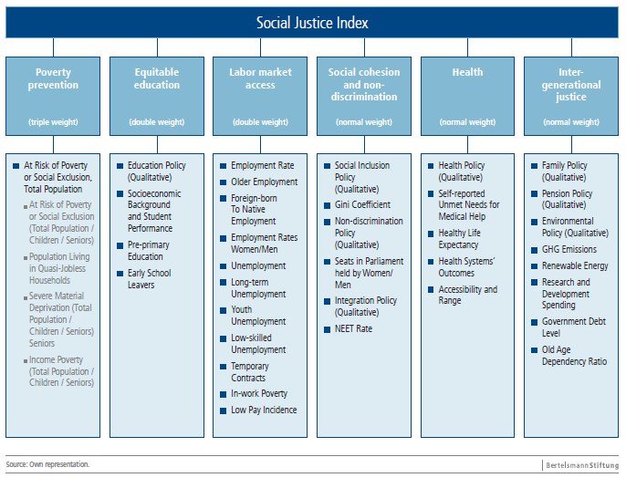

Results at a glance
The comparison of all 28 member states of the European Union (EU) clearly shows that the concept of social justice is realized to very different extents within the borders of the EU. In fact, EU countries vary considerably in their ability to create a truly inclusive society. Whereas the opportunities for every individual to engage in broad-ranging societal participation are best developed in the wealthy northern European countries of Sweden,
Finland, Denmark and the Netherlands, many other EU countries show what are at times massive deficiencies in this regard. Social injustice has once again clearly increased in recent years, most obviously in the crisis-battered southern European countries of Greece, Spain and Italy, as well as in Ireland and Hungary. However, a predominantly negative trend is also evident overall: In the majority of EU countries, the reach and scope of social justice has declined in the course of the crisis. Only three countries – Poland, Germany and Luxembourg – have proven able to improve significantly in comparison to the 2008 Social Justice Index.
In this context, it is worth noting that the crisis has had a different impact on the various generations. In comparing child and old-age poverty, for example, our analysis has shown that children and youth have been disproportionately more strongly affected and disadvantaged by the negative developments of recent years.

Figure: Social Justice Index 2014

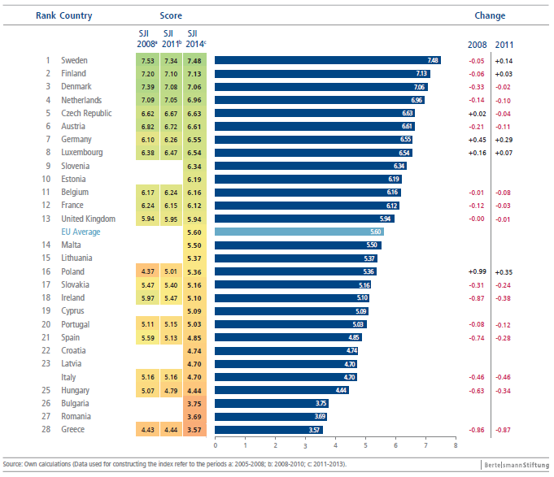

The Nordic countries of Sweden, Finland and Denmark, as well as the fourth-ranked Netherlands, score particularly well in the areas of poverty prevention, labor market access, social cohesion and non-discrimination. However, even these overall most successful countries within the EU demonstrate weaknesses in some areas; from the perspective of social justice, these should be more strongly addressed. For example, these countries show a distinct lack of labor market access opportunities for migrants. In addition, Sweden and Finland’s longtime efforts to combat relatively high rates of youth unemployment have not yet been successful. In Sweden, 23.5 percent of young people lacked employment according to recent figures, along with 19.9 percent in Finland.

The Czech Republic, which excels in the area of poverty prevention, as well as the three continental European welfare states of Austria, Germany and Luxembourg follow directly behind the top group. Germany’s social-justice improvements relative to the 2008 Social Justice Index are most striking. This has primarily been due to the country’s very robust labor market development during the crisis, which also had positive effects in the area of poverty prevention, for example. However, the strong employment statistics and very low rate of youth unemployment in cross-EU comparison should not obscure other justice deficits within the German labor market. In recent years, the emergence of a dual labor market has been increasingly evident, with poor vertical permeability from “atypical” employment relationships (enlarged low-wage sector, temporary employment) to “normal working conditions”. This is today a key problem, demanding further reform efforts. In addition, Germany and Austria show similar problems in the area of education. The influence of social background on students’ educational successes remains much too high in both countries.

Apart from first-ranked Czech Republic, two further post-communist welfare states, Slovenia
(9th) and Estonia (10th), performed at an above-average level in the overall index, even ranking above the three “old” EU member states of Belgium (11th), France (12th) and the United Kingdom (13th). While Estonia falls among the top-ranked EU states particularly in the areas of education access and intergenerational justice, Slovenia shows medium to good results in the areas of education, intergenerational justice as well as poverty prevention, in this latter respect leaving countries such as the United Kingdom behind. The United Kingdom is ranked only 15th in this area, and – like France – also shows a below-average performance on the issue of just educational opportunities.

Poland is another post-communist country that has been able to make significant improvements relative to the 2008 Social Justice Index, making a leap into the middle ranks. This was largely driven by its success in the reduction of poverty and social exclusion. However, the policies of the last two Tusk governments have also led to notable progress in all other areas of the Social Justice Index.

The bottom third of the social justice rankings, with the exception of Slovakia (17th place), Ireland (18th) and Latvia (23nd), is taken up exclusively by EU member states from southern and southeastern Europe. These countries show massive shortcomings in most areas of the Social Justice Index, in some cases worsening dramatically in recent years. Greece is at the bottom of the ranking with a youth unemployment rate of nearly 60 percent, a rapid increase in the risk of poverty particularly among children and youth, a health care system badly undermined by austerity measures, discrimination against minorities as a result of strengthened radical political forces, and an enormous mountain of debt that represents a mortgage on the future of coming generations. The resulting diminution of prospects for broad swathes of society represents a significant danger to the country’s political and social stability. These developments illustrate that the cuts induced by the crisis are not administered in a balanced way throughout the population.

In looking at the overall results across the Social Justice Index’s six dimensions, a very mixed picture emerges with regard to individual EU member states’ strengths and weaknesses.

Poverty prevention: About 25.4 percent of the people within the EU are at risk of poverty or social exclusion (2012, 2013) – a figure about 1.7 percentage points higher than that in 2009. The associated EU-wide rate for children and youth has risen as high as 28 percent. The EU remains far indeed from its self-declared goals in the areas of preventing poverty and social exclusion. The discrepancy between a poor south and southeast Europe on the one hand, and an affluent north on the other, is enormous. This unjust state of affairs must become a genuine European issue and take a much more prominent place on the political agenda. While non-monetary poverty – measured on the basis of the extent of serious material deprivation – does not represent a significant societal challenge in the Scandinavian countries, nearly 29 percent of Romanians and 46 percent of Bulgarians are affected by so-called material deprivation. Again, these figures are higher for children and youth. A rapid increase in poverty within this at-risk group was also evident in recent years, particularly in the crisis-struck countries. For those affected by severe material deprivation, the basic conditions enabling social participation and a self-determined life simply do not exist.

Figure: Poverty Prevention

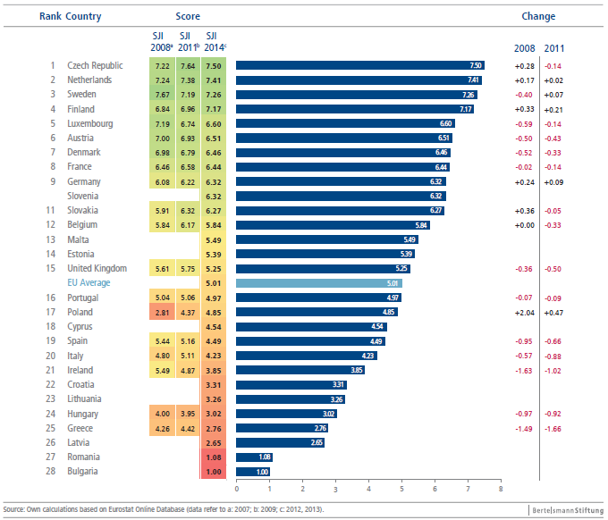

Equitable education: The question of whether a society can be deemed socially just depends significantly – in addition to the issue of poverty prevention – on the distribution and organization of educational opportunities. Sweden, Denmark, Lithuania, Estonia, Croatia and Finland are the top-ranking EU countries in this dimension. The influence of a student’s social background on his or her educational performance is in this regard least evident in Finland and Estonia. At the same time, these two countries attained the best results in the last PISA survey of learning achievement levels. This demonstrates that a high degree of social justice and a well-performing school and training system need not be incompatible goals. Notable in this context is the fact that the Finnish government, despite an already high degree of justice and quality, has again in its current 2011–2016 government education-policy program placed special focus on the prevention of poverty, inequality and exclusion.

Figure: Equitable Education

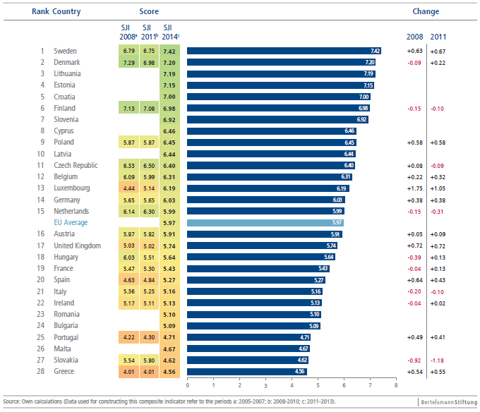

Labor market access: Overall, labor market access opportunities have deteriorated in the broad majority of EU member states over the course of the crisis. In the last several years, the EU has come no closer to the goal declared as a part of the Europe 2020 strategy, which aims to reach an employment rate of 75 percent. Indeed, this rate has even slightly declined from 66 percent in 2008 to 63.5 percent in 2013. In the overall comparison, Austria, Denmark and Germany, followed by the Nordic countries Finland and Sweden, offer the best labor market access opportunities, although the Scandinavian countries also clearly felt the effects of the crisis within their domestic labor markets. Denmark in particular, which at the beginning of the decade served as a model for labor market reform debates in other countries thanks to its flexicurity model, has since 2008 been forced to accept a significant increase in unemployment, from 3.5 percent to a recent 7.2 percent. Germany, which was able to buck the EU trend and show strong improvements, is instead increasingly being considered by other EU member states as a model for labor market policy reforms. This is also due
to Germany’s dual system of vocational training. The EU-wide problems with justice within the labor market are above all evident in the unequal distribution of access opportunities for various at-risk groups within society. Unemployment among youth and low-skilled individuals, for example, is a massive problem not only in the crisis-mired southern European countries, but also in countries such as Slovakia and Ireland. In these countries, this situation has additionally developed into an extremely high rate of long-term unemployment. This is particularly worrisome given that long-term unemployment figures among the greatest risk factors for poverty and social exclusion. Also problematic are distinct trends in almost all countries toward a dual labor market, with in some cases dramatic increases in atypical forms of employment with a low degree of vertical permeability. In Spain and Cyprus, for example, more than 90 percent of people with temporary work contracts are involuntarily in this kind of employment.

Figure: Labor Market Inclusiveness

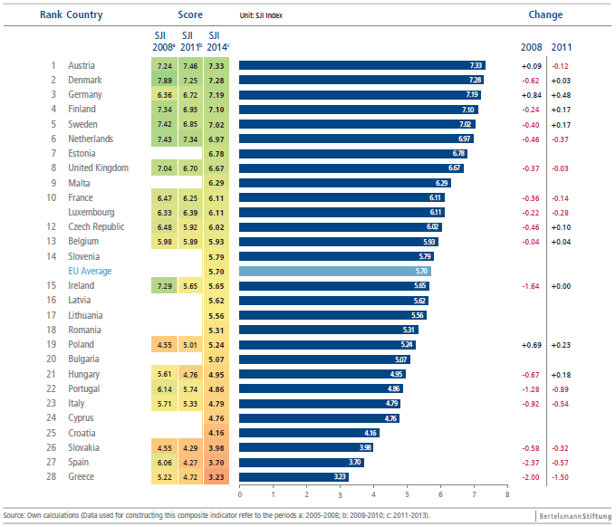
Social cohesion and non-discrimination: This dimension of the Social Justice Index assesses the degree to which tendencies toward social polarization, exclusion and discrimination against certain groups are successfully counteracted. Overall, Sweden, the Netherlands, Finland, Denmark, Luxembourg and Germany perform best in this category. Tendencies toward discrimination and polarization are effectively prevented in the still comparatively egalitarian societies of the Nordic countries. However, even in these small and homogeneous states, income polarization is increasing (except Finland); moreover, particularly for people of foreign origin, labor market and educational opportunities are narrower than for natives and people without an immigrant background. For this reason, the Nordic countries are not given top scores for their integration policies. Moreover, while all EU member states face the challenge of providing equal opportunities for participation to people with immigrant backgrounds, a number of EU countries also show very significant tendencies toward discrimination against specific minorities. This is particularly true with regard to the Roma, who are subject to significant restrictions and discrimination in Hungary, Romania, Bulgaria and Slovakia, among other nations. These population groups broadly lack equal opportunities for self-realization.

Figure: Social Cohesion and Non-discrimination

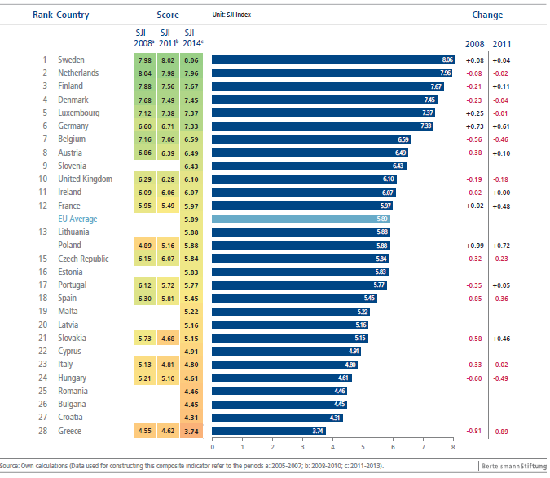

Health: In any assessment of social justice, the question of the greatest possible inclusiveness
in access to high-quality health care services must also be taken into consideration. Social participation can be significantly constrained as a result of poor health. Very good conditions in this respect prevail in Sweden, Luxembourg, the Netherlands and Belgium, while Romania and Latvia show the greatest shortcomings. The massive underfunding of the Romanian health care system, for example, leads to broad treatment inequalities and corruption. Problems in Greece have taken a similar course. There, harsh austerity measures have led to drastic cuts in the health care system. In addition, rising poverty has meant that many people are no longer in the position to undergo essential treatments.

Figure: Health

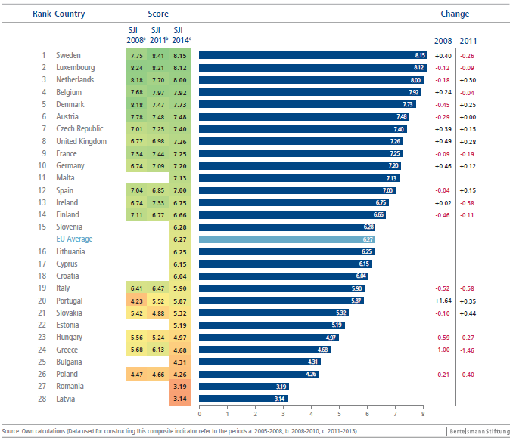

Intergenerational justice: Social justice is ultimately also a question of the allocation of participation opportunities between the young and the old. Current generations should not live at the expense of future generations. Unjust transfers of burdens and negative economic, social and environmental consequences should be avoided. In the overall assessment of this dimension, Sweden, Finland, Denmark and Estonia are clear leaders. Despite significant demographic pressures, these countries best succeed in investing in opportunities for young people and families. These countries also perform well with regard to the questions of environmental and fiscal sustainability and investment in research and development; thus, they are most likely to fulfill the complex, multidimensional demands of intergenerationally just policies. By contrast, the greatest shortcomings with regard to intergenerational justice are evident in the demographically “old” and highly indebted crisis states of Italy and Greece.

Figure: Intergenerational Justice

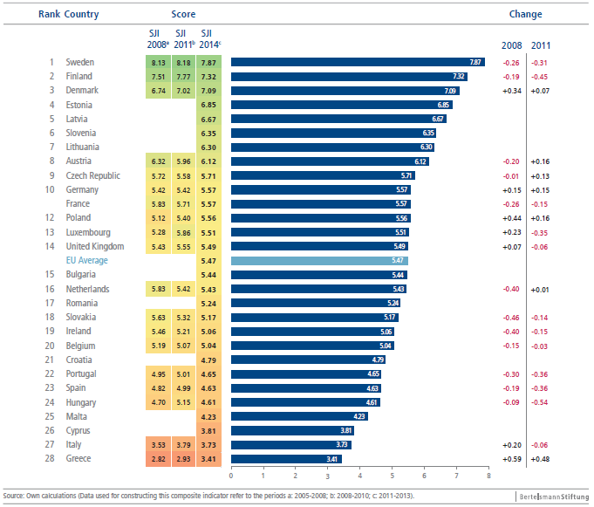

Conclusions

The results suggest that the rigid austerity policies pursued during the crisis and the structural reforms aimed at economic and budgetary stabilization have had, in most countries, negative effects with regard to social justice. Although there are at least mild signs of hope in the majority of EU countries that the worst economic woes have been overcome, core areas of social injustice remain mostly unaddressed, with no improvement in sight. On the contrary, social security systems have been badly undermined by austerity measures in many countries, as has the ability to invest in critical future-oriented policy areas such as education or research and development. Particularly in southern Europe, youth unemployment has climbed to ever-new record highs. The risk of poverty has also increased further as a result of the crisis. This applies especially to the younger generations, whereas poverty among older people has – from an EU-wide perspective – even been declining over the last years.

The gap between participation opportunities in the still-wealthy countries of northern Europe and in the crisis-struck southern nations has thus significantly increased. This is a highly explosive situation with regard to societal cohesion and social stability within the European Union. Should these social divisions persist for some time, or even worsen further, this will endanger the future viability of the entire European integration project. For this reason, a solution to this problem cannot be found solely within the national context. To be sure, it is primarily member-state governments that are being asked to steer the right course between the competing priorities of essential budgetary consolidation and equally essential investments in critical future-oriented policy areas. But the Europe-wide pressure of events demands action on the European level as well. This requires an EU-wide awareness of the problems of currently unsustainable and growing inequalities within the EU. In this context, the future socioeconomic strategy for the EU must be one that is not only concerned with the goal of budgetary consolidation and the resolution of the debt crisis, but also with the aim of combating social injustice within the Union. It ought to be a consistent and integrated strategy not only for economic progress but also for social justice.

Figure: Social Justice and Economic Performance

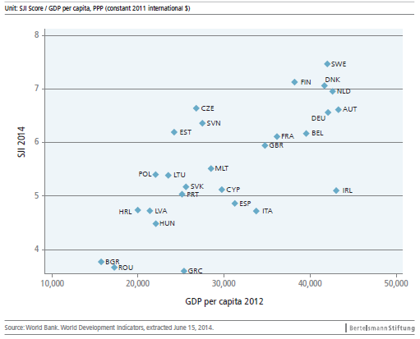

In this context, another interesting conclusion that can be drawn from our analysis is noteworthy. Economic strength does not automatically translate into greater social justice. To be sure, economic performance as measured on the basis of GDP is in fact positively associated with performance on the Social Justice Index. Countries with a higher economic performance level are on average also more socially just. However, a closer look reveals very interesting differences between countries with regard to their ability to enable all citizens to benefit from prosperity. This can be seen, for example, in the comparison of the Czech Re-public, Slovenia and Estonia on the one hand with Portugal, Spain, Greece, Italy and Ireland on the other.

The Czech Republic (rank 5), Slovenia (9) and Estonia (10) show that despite only having average economic performance levels, a comparably high degree of social justice is still possible. By contrast, Portugal, Greece, Spain and Italy have a comparably high GDP per capita, but perform far worse when it comes to social justice. The same holds true for Ireland. Despite its high GDP per capita, the country only performs below average in the Social Justice Index. Hence, countries such as the Czech Republic, Slovenia and Estonia illustrate the fact that social policy plays a critical role in achieving social justice. Estonia’s good performance is primarily driven by the areas of education and inter-generational justice, while the Czech Republic excels in poverty prevention.

Generally, it is very important to see that there is a close reciprocal relationship between the goal of social justice on the one hand and economic prosperity and performance on the other. This relationship should in no way be viewed as an automatic trade-off. On the contrary, investments in people’s participation opportunities – particularly with regard to education – are not only sensible for reasons of social justice; they are also essential from the perspective of economic growth and in maintaining and increasing a country’s potential for innovation.

Thus, for all EU member states, the establishment of equal participation opportunities is both an ethical and normative duty in the interests of societal solidarity and mutual responsibility, and a fundamental investment in the sustainability of society itself. A lack of opportunities for participation in areas such as education, the labor market or health care is economically dangerous, as are high levels of social exclusion that often result from them. Today’s social-policy failings, as well as short-sighted and ill-thought-out consolidation policies, could lead to costly consequences in the future; a post facto effort to compensate for and repair social exclusion is generally a considerably worse alternative than proactive and well-targeted investment in social participation.

References

Merkel, Wolfgang and Heiko Giebler (2009): “Measuring Social Justice and Sustainable Governance in the OECD.” In Sustainable Governance Indicators 2009, Policy Performance and Executive Capacity in the OECD, edited by the Bertelsmann Stiftung, 187-215. Gütersloh: Bertelsmann Stiftung.

Merkel, Wolfgang (2001): “Soziale Gerechtigkeit und die drei Welten des Wohlfahrtskapitalismus.” In Berliner Journal für Soziologie (2): 135-157.

Merkel, Wolfgang (2007): “Soziale Gerechtigkeit im OECD-Vergleich.” In Soziale Gerechtigkeit – eine Bestandsaufnahme, edited by Stefan Empter & Robert B. Vehrkamp, 233-257. Gütersloh: Bertelsmann Stiftung.

Schraad-Tischler, Daniel (2011): Social Justice in the OECD - How Do the Member States Compare? Sustainable Governance Indicators 2011, Bertelsmann Stiftung, Gütersloh. Available at: www.sgi-network.org.

Seelkopf, Laura & Daniel Schraad-Tischler (2014): Concept and Methodology. Sustainable
Governance Indicators 2014, Bertelsmann Stiftung, Gütersloh. Available at: www.sgi-network.org.

Sen, Amartya (1993): Capability and Well-Being. In The Quality of Life, edited by Amartya
Sen and Martha Nussbaum, 30-53. Cambridge, Mass: Harvard University Press.

Sen, Amartya (2009): The Idea of Justice. Cambridge, Mass: Harvard University Press.

Contact

Dr. Daniel Schraad-Tischler
Senior Project Manager
Sustainable Governance Indicators
Phone +49 5241 81-81240
daniel.schraad-tischler@bertelsmann-stiftung.de

Bertelsmann Stiftung
Carl-Bertelsmann-Straße 256
33311 Gütersloh
Germany

The full report “Social Justice in the EU – A Cross-national Comparison” can be downloaded at www.sgi-network.org. For a previous report on all OECD countries see Schraad-Tischler (2011).
See Sen (1993; 2009); Merkel (2001; 2007); Merkel/Giebler (2009), p. 192-194.
The methods of measuring social justice applied here are derived from those applied by Merkel (2001; 2007) and the approach and argument provided by Merkel/Giebler (2009). In contrast to Merkel/Giebler (2009), the index comprises six instead of seven dimensions to be measured. In addition, the weighting process and indicator set have been modified and supplemented.
In order to ensure comparability over time, we use the SGI’s method of fixed minimum and maximum values for each indicator. See Schraad-Tischler/Seelkopf (2014).

