Prospective Country Evaluation

**18 February 2019**

Guatemala

**Executive Summary**

**2019 ANNUAL COUNTRY REPORT**

**Commissioned by the Technical Evaluation Reference Group (TERG) of the Global Fund**



**DISCLAIMER**

Views expressed in this report are those of the authors. The authors have been commissioned by the Technical Evaluation Reference Group (TERG) of the Global Fund to Fight AIDS, Tuberculosis and Malaria (the Global Fund) to conduct an assessment to provide input into TERG’s recommendations or observations, where relevant and applicable, to the Global Fund. This assessment does not necessarily reflect the views of the Global Fund or the TERG.

This report shall not be duplicated, used, or disclosed – in whole or in part without proper attribution.

**Table of Contents**

Contents

Acronyms and abbreviations 4

Executive Summary - Introduction 7

Key Findings: Implementation of Global Fund Grants and Policies 10

# Acronyms and abbreviations

|  |  |
| --- | --- |
| AIDS | Acquired immunodeficiency syndrome |
| ART | Antiretroviral therapy |
| ARV | Antiretroviral drug |
| CAS | Colectivo Amigos contra el SIDA |
| CCM | Country Coordinating Mechanism |
| CDC | Centers for Disease Control and Prevention |
| CIESAR | Centro de Investigación Epidemiológica en Salud Sexual y Reproductiva |
| COMISCA | Council of Health Ministries of Central America and Dominican Republic |
| CSO | Civil society organization |
| CSW | Commercial sex worker |
| CT | Country team |
| DOTS | Directly observed therapy, short-course |
| EMMIE | Elimination of Malaria in Mesoamerica and Hispaniola Island |
| EQs | Evaluation questions |
| FUNDAMACO | Fundación Marco Antonio |
| GBD | Global Burden of Disease study |
| HIV | Human immunodeficiency virus |
| HIVOS | Humanist Institute for Cooperation with Developing Countries |
| HMIS | Health management information system |
| IDB | Inter-American Development Bank |
| IDEI | Asociación de Investigación Desarrollo y Educación Integral |
| IHME | Institute for Health Metrics and Evaluation |
| INCAP | Institute of Nutrition for Central America and Panama |
| IRS | Indoor residual spraying |
| KII | Key informant interview |
| KP | Key population in the context of the report refers to HIV stigmatized groups, including but not limited to men who have sex with men, transgender women and prison inmates |
| KVP | Key and vulnerable population in the context of the report refers to people with increased risk for malaria and TB based on a specific context or condition |
| LA | Legal advice |
| LFA | Local Fund Agent |
| LLIN | Long-lasting insecticide-treated net |
| LMI | Lower-Middle Income |
| M&E | Monitoring and evaluation |
| MANGUA | Sistema de registro electrónico de información clínica en VIH/Sida (Electronic Registry System for HIV Clinical information) |
| MDR TB | Multi-drug resistant tuberculosis |
| MIS | Modelo Integral de Salud (Integrated Model of Health) |
| MoH | Ministry of Health |
| MSM | Men who have sex with men |
| NASA | National Aids Spending Assessment |
| NGO | Non-governmental organization |
| NMS | National Malaria Subprogram |
| NSP | National Strategic Plan |
| NTP | National Tuberculosis Program |
| OMES | Organización Mujeres en Superación (Organization for Improvement of Women) |
| PAHO | Pan American Health Organization |
| PCE | Prospective Country Evaluation |
| PEC | Programa de Extensión de Cobertura (outreach health model) |
| PEPFAR | U.S. President’s Emergency Plan for AIDS Relief |
| PLHIV | People living with HIV |
| PR | Principal Recipient |
| PU/DR | Progress update and disbursement request |
| RCM | Regional Coordination Mechanism for Mesoamerica |
| RDT | Rapid diagnostic test |
| RMEI | Regional Malaria Elimination Initiative |
| RSSH | Resilient and sustainable systems for health |
| SEGEPLAN | Secretaría de Planificación y Programación de la Presidencia (Presidency Planning and Programming Secretariat) |
| SICOIN | Sistema de Contabilidad Integrada (Integrated Accounting System) |
| SIGPRO | Sistema Integral de Gestión de Proyectos (Project Management Integrated System) |
| SIGSA | Sistema de Información Gerencial de Salud (Health Management Information System – HMIS) |
| SR | Sub-recipient |
| STC | Sustainability, transition and co-financing |
| STI | Sexually transmitted infection |
| TB | Tuberculosis disease |
| TBNET | The Tuberculosis Network European Trials Group |
| TEPHINET | Training Programs in Epidemiology and Public Health Interventions Network |
| TERG | Technical Evaluation Reference Group |
| TRP | Technical Review Panel |
| TW | Transgender women |
| UAI | Unidades de Atención Integral (Integrated Care Units) |
| UMI | Upper-Middle Income |
| VfM | Value for money |
| VICITS | Vigilancia Centinela de las Infecciones de Transmisión Sexual (Sentinel Surveillance of Sexually Transmitted Infections Strategy) |
| WHO | World Health Organization |

# **Executive Summary - Introduction**

The Prospective Country Evaluation (PCE) is an independent evaluation of the Global Fund commissioned by the Global Fund’s Technical Evaluation Reference Group (TERG). The evaluation is assessing the Global Fund’s implementation effectiveness and impact in eight countries, including Guatemala. The PCE aims to assess the process and impact of the Global Fund business model in country and provide timely results and feedback to country stakeholders. Over the past decade, Guatemala has received over US$170 million in Global Fund grants. Guatemala brings a unique perspective to the PCE as a Central American country that has received significant investments across the three diseases and is projected to transition from Global Fund support for tuberculosis and malaria programs in 2020-2022.

Guatemala is classified as an Upper-Middle Income (UMI) country with high HIV and moderate malaria burden, and in 2018 shifted from moderate to low TB burden. Throughout the years, the Guatemalan government has increased its contribution for the national response towards HIV, TB, and malaria; nevertheless, the Global Fund still accounts for 20% of the total investment across the three diseases. Figure 1 shows the distribution of resources for each one of the three diseases by funding source.

**Figure 1. Funding landscape for TB, Malaria and HIV in 2018**

In 2018, Guatemala managed six Global Fund grants, including two grant extensions (HIV and malaria), three grants approved to start implementation in 2019 (HIV, TB, and malaria), and one grant that has been in implementation since 2016 (TB) (see Figure 2).

**Figure 2. Status of Global Fund Grants in Guatemala**



The PCE compiled and analyzed data on the implementation processes of national programs as well as grant investments, and country approaches to Global Fund strategic objectives and policies, for example Key Populations (KP) and Key and Vulnerable Populations (KVP)[1]. Findings were analyzed along the results chain, from inputs, to outputs and outcomes, and eventually, to impact. Figure 3 shows an overview of the results chain for TB. For the 2019 annual report, based on data collected during 2018, the PCE has focused on the TB grant in full implementation; during 2019, the PCE will assess the malaria and HIV grants in more as they initiate implementation.

**Figure 3. Results Chain for TB**

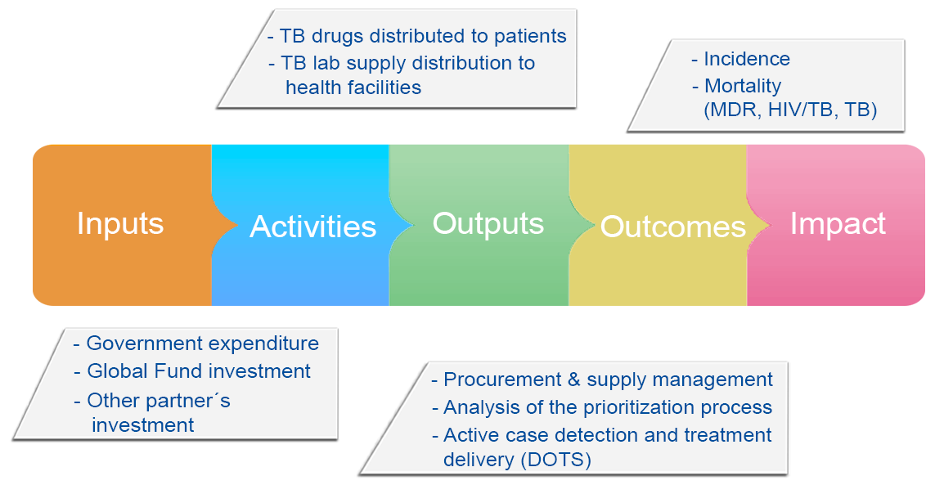

Guatemala has gone through adverse political events since 2015. Since then, several changes in leadership have taken place, including four changes of Ministry of Health (MoH) during the last three years. Shifts in government authorities, key staff and elaborate administrative controls have affected grant performance. Despite these factors, the PCE to date has independently confirmed significant advances for the three programs receiving Global Fund investment, while recognizing important challenges ahead.

# **Key Findings**: Implementation of Global Fund Grants and Policies

The Global Fund structures and policies that influence grant implementation were assessed, as well as the operationalization of Global Fund principles and strategic objectives. This section is organized by key findings identified by the PCE and include barriers and facilitators to implementation and their connection to the Global Fund business model or contextual factors.

**The strategic investments in TB, malaria, and HIV, made by the Global Fund have been successful in improving treatment and prevention objectives, but challenges still exist around case detection.**

Antiretroviral drug (ARV) coverage has tripled since the first Global Fund grant in 2004, but still only reaches 36% of those diagnosed, as reported by the National Cascade of Treatment Continuum 2016.

**Figure 4. National Cascade of Treatment Continuum, 2016**



The National TB Program (NTP) is nearing the World Health Organization (WHO) target in treatment success at 88% for 2018, but the rate has leveled off since 2012 with only incremental improvements during the last six years; outcomes for HIV-TB co-infection are lower (74% success).

**Figure 5. Success rate in treatment for TB**

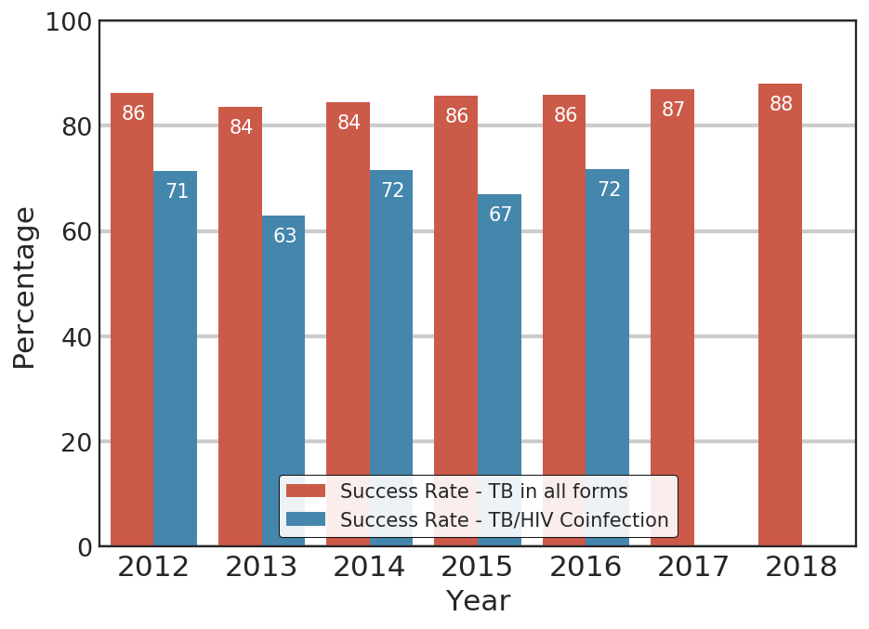

The National Malaria Subprogram (NMS) has succeeded in increasing the percentage of persons who receive a diagnosis and are treated within three days but is struggling with getting people to seek a test promptly when symptoms start. Even when there has been an improvement through the years from less than 20% in 2015 still only 40% of persons were tested within three days of experiencing symptoms in 2018 (see Figure 6).

**Figure 6. From experiencing symptoms to diagnosis and treatment for malaria**

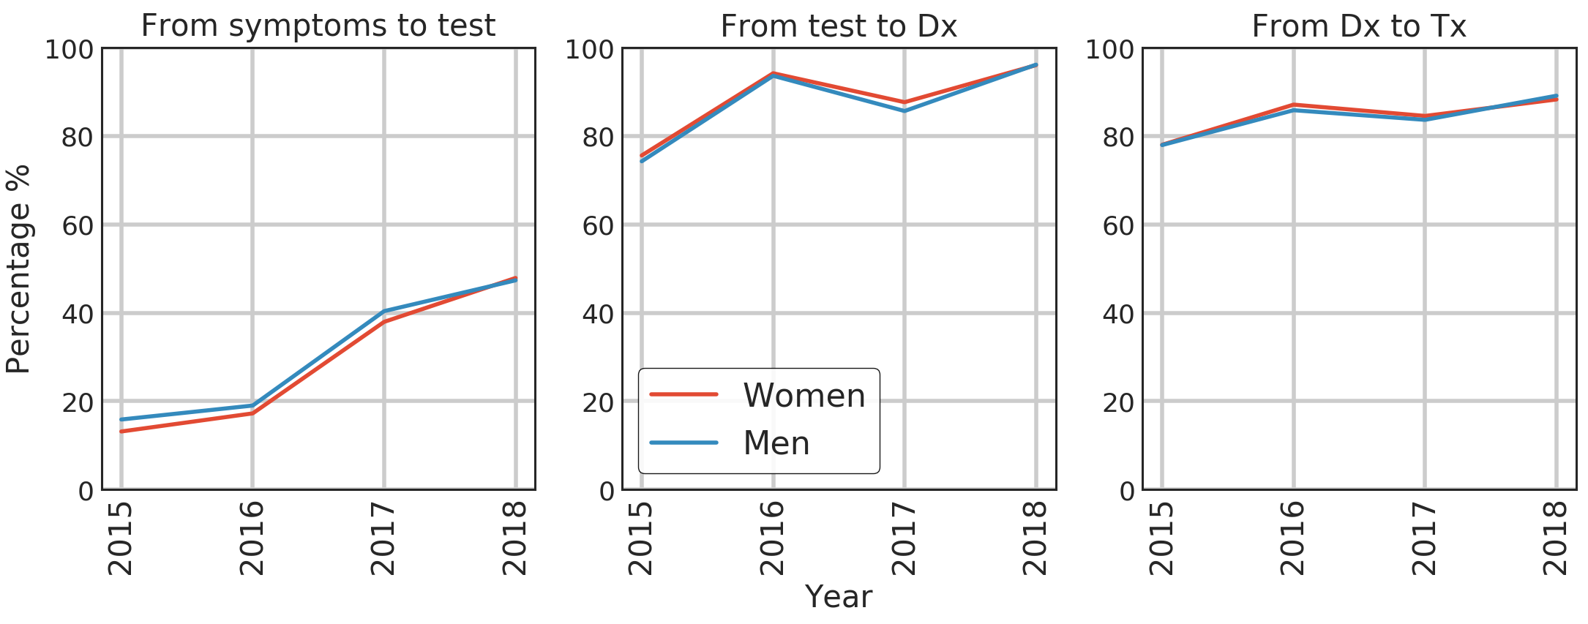

The three disease programs are underperforming in case detection, with the lowest levels of detection among HIV positive persons.

* The HIV national program and the new PR need to increase testing yields by better targeting of KP, particularly transgender women. According to reports by the former PR, HIVOS [Humanist Institute for Cooperation with Developing Countries], KPs are reached effectively, given the high coverage of prevention packages. Nevertheless, the number of new HIV cases detected among transgender women is suboptimal with a reactivity rate of 6% over a target of 10.5% in the period from January to November 2018 (last PU/DR available to PCE). For MSM, testing yields were reported at 5.8% for a target of 7% during the same period. The KP size estimates are extrapolated from national estimates, which have a margin of error and could account for low reactivity. In response to some of these issues, the new PR for HIV, INCAP, has revised and reduced targets for new cases as set forth in the 2018-2020 grant.
* Another area presenting low performance is linkage to care and treatment of diagnosed HIV cases, a persistent gap with consequences of high mortality rates.
* NTP is planning to overcome a 20% gap between WHO TB estimates and country notifications, for which there will be an increase in active case detection; for this purpose the number of person for outreach activities will grow substantially in the 2019-2022 grant (from 9 to 11 nurses and from 22 to 47 assistant nurses).
* NMS has performed a good job detecting the specific foci that produce 95% of the cases in the country; the challenge ahead is to carry out an effective foci management and improve management of cases in migrant agro workers

Figure 7. Comparison of Estimated and Reported TB incidence

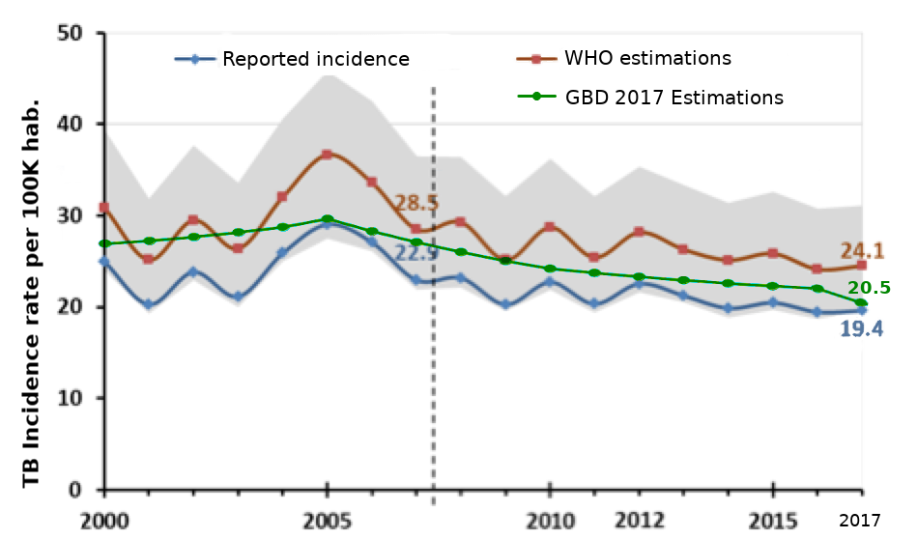

**Implementation of the STC Policy is at an early stage, but there is evidence of shifts towards programmatic sustainability through co-financing and transition preparedness.**

The NTP has made the most progress towards sustainability and transition planning through the development of a new and fully costed tuberculosis national strategic plan, which includes an embedded sustainability plan. The Global Fund is assisting in drafting a sustainability plan to be included as part of the HIV national strategic plan. The National Malaria Subprogram sustainability planning will advance, as more information on the Regional Malaria Elimination Initiative is made known to stakeholders.

Guatemala has met Willingness to Pay commitments for upcoming grants and has demonstrated good intentions as government allocations for the three diseases increased steadily since 2014 as shown in Table 1.

**Table 1. Structure and behavior of budget implementation of domestic funds for TB, HIV and malaria during 2011 - 2017**

|  |  |  |  |  |  |  |  |
| --- | --- | --- | --- | --- | --- | --- | --- |
| **All financial sources excluding donations** | | | | | | | |
| **Allocated Budget (millions USD)** | | | | | | | |
| **Program** | **2011** | **2012** | **2013** | **2014** | **2015** | **2016** | **2017** |
| Tuberculosis | 0.06 | 0.46 | 1.39 | 1.41 | 2.57 | 3.54 | 2.30 |
| HIV | 6.56 | 5.02 | 7.03 | 7.14 | 13.88 | 8.02 | 14.02 |
| Malaria | 0.02 | 0.32 | 1.43 | 1.46 | 3.78 | 2.24 | 5.75 |
|  |  |  |  |  |  |  |  |
| **Current Operational Budget (millions USD)** | | | | | | | |
| **Program** | **2011** | **2012** | **2013** | **2014** | **2015** | **2016** | **2017** |
| Tuberculosis | 0.06 | 0.23 | 1.34 | 1.28 | 2.64 | 2.27 | 2.24 |
| HIV | 6.42 | 5.15 | 6.80 | 13.25 | 13.88 | 11.93 | 16.10 |
| Malaria | 0.01 | 0.45 | 1.39 | 2.81 | 2.72 | 3.44 | 5.48 |
|  |  |  |  |  |  |  |  |
| **Expenditures (millions USD)** | | | | | | | |
| **Programa** | **2011** | **2012** | **2013** | **2014** | **2015** | **2016** | **2017** |
| Tuberculosis | 0.06 | 0.23 | 1.23 | 1.06 | 2.39 | 1.86 | 1.77 |
| HIV | 6.33 | 5.12 | 6.30 | 11.26 | 8.20 | 10.33 | 13.22 |
| Malaria | 0.01 | 0.45 | 1.16 | 2.34 | 2.24 | 2.95 | 3.37 |

Note: Numbers in light blue correspond to classification as activities. For TB and HIV, a change to program classification took place in 2012 but malaria continues to be classified as an activity of the larger program,

Vector-transmitted diseases.

Source: SICOIN

Nevertheless, challenges with low budget execution must be overcome. Unfortunately, this situation is directly influenced by political instability. As shown In figure 8, the proportion of budget execution was higher during 2011 to 2013 in comparison with 2014 to 2017, which can be explained due to changes in the General Budget Law. Among other modifications, this law issued the cancellation of the Programa de Extensión de Cobertura (PEC), an outreach program that contracted out services from NGOs. After this change, all budget transfers to NGOs stopped abruptly in 2014 even though it was originally planned to decrease over a course of three years when the MoH had replaced the PEC with another suitable model.

In the aftermath of 2015 political crisis, government expenditures fell to 84%, but recovered to 93% a year later when a new government was elected. The increase in expenditures was not due to better administration, but as result of catch up of delayed payment of contracts during the crisis.

The trend observed during the first year of the current government was not sustained as expenditures fell to 86% in 2017 when MoH underwent several changes in the Minister of Health which were accentuated by changes to the General Law of Procurement of Goods and Services. Failure to train financial and administrative staff at the Ministry of Finance led to a stalling of procurement in the MoH. A gradual recovery was observed during 2018, likely as a result of staff becoming more knowledgeable in the procurement processes. Guatemala’s unstable political context directly affects budget implementation, which poses a potential obstacle for sustainability and transition.

**Figure 8. Implementation of f Budget execution**

Value for Money: Maximizing the impact and outcomes of Global Fund investments through economy, efficiency, effectiveness, equity, and sustainability

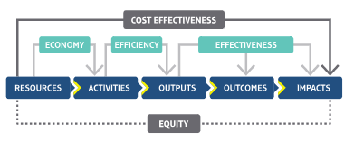

* The 2019 malaria grant will adopt the foci strategy aligned with WHO guidance to be effective in achieving elimination.
* The NTP developed a new prioritization process utilizing epidemiological and socio-demographic variables to be more inclusive of populations that harbor higher risk.
* The HIV program has prioritized areas based on HIV notifications of cases and presence of KP to go “where the virus is.”

**The PCE has identified positive examples of program design and implementation related to Value for Money.**

Stakeholders reported efficiency gains in the grant extension with PR HIVOS by reducing the number of sub-recipients (SRs), and by prioritizing their mix of interventions geographically. National programs made strides in the four pillars of VfM (equity, efficiency, effectiveness and economy) by better prioritizing and focalizing their interventions.

A main VfM issue identified by the PCE is the challenges around the MoH processes to efficiently procure goods and services, which results in underutilization of budget and overall low expenditures of domestic funds in the three diseases.

The TB program has executed less than 50% of its allocated budget in past years (2015-2017). Budget execution data for 2018 will be officially released in April 2019 and added to the current analysis.

**Figure 9. Budget implementation, NTP 2016-2017**

As the country unexpectedly faced two iteration reviews for the HIV and the malaria funding requests, the CT promoted a restructuring of the CCM. It underwent a successful reform and transitioned to a more balanced, streamlined CCM, which is anticipated to be more efficient and representative of stakeholders. Guatemala is now participating in the CCM Evolution and is expected to further improve technical and leadership skills through this process.

**The Country Coordinating Mechanism (CCM) underwent a reform in the past year and has shown improvements around coordination and leadership capacities.**

**The PCE and numerous stakeholders have asserted some efficiency loss due to parallel reporting systems, both in monitoring and evaluation (M&E) and in logistics related to supply management. However, there is an encouraging trend in upcoming funding requests to include RSSH investments, but there are issues around the lack of indicators included in grant performance frameworks.**

The Guatemala HIV grant has allocated 4.1% of the budget to RSSH activities but does not include RSSH specific performance indicators. The funding request for malaria does include one specific indicator on RSSH related to coverage.

RSSH – Data Systems

* There are examples of parallel program information systems presenting inconsistencies due to the lack of interoperability (i.e. HIV and TB notifications cannot be linked with treatment outcomes). Additionally, there are cases of lost information due to data aggregation in different databases. Some information is only registered in physical records and not readily available outside of the paper format, and sometimes data is not disaggregated by demographic variables such as gender, age, and ethnicity.
* The upcoming Global Fund grants include financing to improve health management information systems (HMIS) as requested by the country, particularly for the new HIV PR, INCAP, which will receive technical assistance from MEASURE Evaluation.

**To address KVP, a key strategic objective of the Global Fund, grants have progressively concentrated on the most affected populations**

For example, the new 2018-2020 HIV grant decreased interventions for female sex workers due to the evidence showing declining HIV incidence among this population. In contrast, investment in activities for transgender women has increased substantially, reflecting the high HIV prevalence of this population. Likewise, the TB grants have continued to prioritize vulnerable populations. Beyond targeting areas with known high TB incidence, the NTP carried out a broader prioritization using socio-demographic variables. The rationale was to improve case detection in areas that have higher vulnerability but are reporting few cases. The PCE team revised the prioritization and provided feedback to the NTP, which resulted in the addition of departments not previously included. The NTP will also scale up interventions directed at the highly vulnerable prison inmates. The NMS has prioritized elimination actions to very specific foci in three departments that report 95% of cases.

**Considering the above evidence, findings, and implications, several strategic considerations emerge that may be relevant to the national programs, in-country Global Fund stakeholders, and the Global Fund.**

**Strategic Considerations for National Programs**

1. The PCE considers it necessary to review the methodology for estimating Key Population sizes for HIV at subnational sites. Current data for KP site estimates (and expected number of PLHIV) at the municipality level are extrapolated from national estimates, which are not representative and are outdated.
2. The NTP has identified incarcerated individuals as a KP. To define the burden of the disease in prisons, a better estimate of incidence should be implemented by screening detainees at admission. Initially it could be conducted as a pilot in selected detention centers. The costs of this endeavor could be covered by unused funds from the present TB budget.
3. The revised geographic prioritization proposed by the PCE, reviewed and implemented by the NTP, could improve the effectiveness of interventions by increasing TB case detection.
4. Inclusion of the Planning Unit of the MoH *(Unidad de Planificación - UPE)* into CCM discussions on STC and meet with the CT when considered relevant.
5. The three programs may consider reviewing budget allocations for human rights and advocacy since there is a mismatch between the discourses over the importance human rights and allocated funding.

**Strategic Considerations for Stakeholders**

1. In the topic of human rights it is of concern that a sound intervention on human rights in HIV was changed to a modality that could potentially setback the gains achieved and has funding only for the first year of the grant period.

**Strategic Considerations for Government Authorities**

1. The Minister of Finance must implement a continuous training program for MoH financial units in the use of the Law of Procurement of Goods and Services (*Ley de Compras y Contrataciones*) given the inefficiency observed in budget execution.
2. The Presidency Planning and Programming Secretariat (SEGEPLAN) should focus on building capacity in the MoH for an adequate **management by results** (GpR) given deficiencies found in operative planning (POA) and failure to link expected results and budget implementation at all levels of the MoH.

1. Key population in the context of the report refers to HIV stigmatized groups, including but not limited to men who have sex with men, transgender women; it also refers to prison inmates. Key and vulnerable population in the context of the report refers to people with increased risk for malaria and TB based on a specific context or condition.