**Profiling the Organelle-Specific Proteome during Aging**

**Abstract:**

Aging is characterized by the loss of physiological integrity, accumulation of pathological protein aggregates, and the development of age-related diseases. The dysregulation of protein degradation and ubiquitination pathways contribute to organelle dysfunction and age-associated disorders. This study aims to investigate the impact of protein localization on organelle function and age-related diseases, enhancing our understanding of the intricate organellar proteome. At the cellular level, this research focuses on morphological, compositional, and functional changes in organelles during aging and age-related diseases. Advanced techniques for intact organelle purification enable the study of changes in organelle content and protein–protein interactions. At the tissue level, the investigation explores cell-type-specific metabolic modifications and their relationship with organ dysfunction and organismal lifespan through intercellular communication. Furthermore, the study examines the organelles’ spatiotemporal regulation during aging under nutritional fluctuations. Deciphering the molecular mechanisms underlying aging, identifying strategies for healthy aging, and mitigating age-related diseases is crucial for addressing the healthcare challenges of an aging population.

**Section a. State-of-the-art and objectives**

**Background:**

Aging is the progressive loss of physiological integrity and accumulation of pathological protein aggregates; this deterioration is the primary risk factor for major human diseases. Thus, the effect of aging on physiological integrity may lead to the development of various metabolic, cardiovascular, oncological, and neurodegenerative disorders. The prevalence of neurodegenerative disorders, including Huntington’s disease, Parkinson’s disease, Alzheimer’s disease, and amyotrophic lateral sclerosis, has become a prominent global public health concern in the 21st century (López-Otín et al., 2013). These disorders share a common characteristic wherein proteins undergo abnormal folding processes instead of assuming their native three-dimensional structures. Consequently, a significant degree of protein misfolding and aggregation occurs, especially during aging. These events are particularly prominent in neurodegenerative diseases like Alzheimer’s and Parkinson’s, resulting in protein accumulation, ultimately leading to cell death (Lindner & Demarez, 2009).

The dysregulation of ubiquitination or impairment in the degradation pathways can lead to the accumulation of protein aggregates, contributing to organelle dysfunction and the various diseases associated with protein misfolding and aggregation. Therefore, progress in this field requires a comprehensive understanding of the signals and processes that link chronic protein aggregation to cellular and tissue dysfunction. Furthermore, protein degradation and ubiquitination can regulate protein subcellular localization (Liao et al., 2022). A key aspect of organelle communication and inter-organelle interactions is their role in regulating protein homeostasis, encompassing protein folding, degradation, and clearance mechanisms. The specific roles of organelles can be identified by deciphering the complex organelle dynamics and relationships, unveiling common aging signatures (Ross et al., 2015). Beyond changes in the total levels of individual proteins, we hypothesize that age-related alterations in protein subcellular localization also influence the aging process. However, the relationship between ubiquitination, organelle-specific mislocalization, and organelle dysfunction remains largely unknown. Therefore, to better understand the total complexity of the organellar proteome, this proposal aims to investigate, in mechanical detail, the impact of specific protein localization on organelle function and age-related diseases.

**Aim 1**

At the cellular level, we will investigate the morphological, compositional, and functional changes in organelles that occur during aging and age-related diseases. We will also explore cross-talk mechanisms between organelles and their relation to proteostasis alterations. Quantitative and high-resolution mapping of the changes in the protein composition of organelles during aging has not been feasible due to the need for sophisticated isolation procedures, which provide limited specificity and low protein quantities for proteomics (Rhee et al., 2018; Castro et al., 2021). Recently, methods for purifying intact organelles have been developed (Samaddar et al., 2021; Ray et al., 2020). These methods are based on tagging proteins specific to the organelle of interest, followed by rapid immune purification under conditions that preserve the intact organelle (Organelle IP). These approaches were initially developed and validated in cell lines (Ray et al., 2020) and are currently being translated into animal models (Bayraktar et al., 2019). The recent development of technologies that facilitate studying the impact of aging and interventions on the content of organelles across tissues, such as BioID and TurboID, which enables the study of protein–protein interactions in situ, are also currently being translated to model organisms (Spence et al., 2019; Xiong et al., 2021). These approaches could complement Organelle IP strategies by revealing, for example, changes in organelle contact sites or assembly of protein complexes that might occur during aging (Castro et al., 2021; Rhee et al., 2013).

**Aim 2**

We will examine cell-type-specific metabolic modifications at the tissue level and how they are interconnected with organ dysfunction and organismal lifespan through intercellular and inter-organ communication mechanisms.

**Aim 3**

This study also aims to determine how organelles are spatiotemporally regulated during aging under nutritional fluctuations such as fasting and feeding. Understanding the molecular mechanisms underlying aging and identifying pathways that can delay the aging process and the onset of multiple diseases is crucial in addressing the healthcare needs of an aging society (Cohen & Dilin, 2008).

**For this purpose**

**Section b. Methodology**

**Aim 1 - Determining the impact of organelle-specific proteomics mapping during aging** (Months 1–36).

Even if the total levels of a protein remain similar with age, slight perturbations to their subcellular localization could trigger severe changes in cellular homeostasis, activity, and function (Nemes, 2021). Organelles are one of the smallest structural units that influence the morphological, functional, and biochemical characteristics of eukaryotic cells. Functional alterations in organelles such as the mitochondria, ER, lysosome, and nucleus have been associated with the aging process and age-related diseases (Beyenbach & Wieczorek, 2006; Chondrogianni et al., 2015; Magalhães et al., 2019). Therefore, defining age-related changes in protein subcellular localization and their effects on organelle function can lead to discovering novel aging modifiers. However, there is a lack of quantitative and high-resolution mapping of protein changes in organelle composition during aging. Recent innovations such as TurboID rely on the t biotin ligase enzyme that utilizes ATP to convert biotin into a reactive intermediate called biotin-AMP. This intermediate allows for the covalent labeling of proteins near the TurboID enzyme (Larochelle et al., 2019; Cho et al., 2020).

Compared to the hours required by BioID and BioID2, TurboID labeling occurs within 10 minutes or less and enables rapid protein biotinylation within minutes. This faster labeling method may enable the combination of TurboID with PDB assays to study dynamic protein–protein interactions (Branon et al., 2018). Moreover, these enzymes retain their catalytic activity below 37°C, making them suitable for use in *Caenorhabditis elegans*. TurboID is the more active enzyme, albeit larger (35 kD), while miniTurbo is smaller (28 kD) but exhibits a lower affinity for biotin. This lower affinity requires higher concentrations of exogenous biotin for effective labeling (Sanchez et al., 2021).

TurboID-dependent biotinylated proteins can be affinity purified using streptavidin-coated beads. Therefore, we will employ affinity purification using streptavidin-coated beads to efficiently capture TurboID-dependent biotinylated proteins, enabling their extraction and enrichment. As a result, biotinylated proteins can be easily extracted and enriched using the streptavidin system, followed by quantitative proteomics. In this case, we will apply the TurboID system in *C. elegans* to characterize the age-related alterations in the protein composition of distinct subcellular compartments and the contact sites between organelles.

**Aim 2 - Investigating how organelle-specific is regulated in different tissue in physiology or aging** (Months 1–24).

Next, we will generate constructs that express *C. elegans* codon-optimized Turbo-ID fused with specific target sequences, directing the subcellular localization and retention of proteins within the mitochondrial matrix, ER lumen, nucleus, or cytosol (Table 1). These target peptides will be selected based on validated sequences for specific subcellular localization in *C. elegans*. Additionally, TurboID will be fused with a fluorescent tag (mCherry) to confirm subcellular localization using compartment-specific dyes like MitoTracker or ER-Tracker.



Table 1. List of constructs for TurboID localization in specific subcellular compartments.

To establish precise transgene integration, we will apply MosSCI technology, enabling single-copy transgene insertion into a well-defined location in the *C. elegans* genome. Then, subcellular-specific proximity labeling experiments will be performed in *C. elegans* at different stages of its life cycle (days 1, 5, 10, and 15), representing young, middle age, and old animals. After that, quantitative proteomics will be employed to analyze the resulting data. Furthermore, data integration from different subcellular compartments will enable the identification of specific proteins associated with each organelle in young animals and proteins that exhibit changes in subcellular localization with age. Quantitative proteomics of the total protein levels will be conducted simultaneously to differentiate between changes in subcellular localization resulting from dysregulated localization and alterations in total protein abundance.

In addition, bioinformatic tools will be used to classify age-related changes in the protein composition within each subcellular compartment based on various criteria, including biological processes and tissue-specific expression. Moreover, the TurboID strains will be crossed with long-lived genetic models characterized by dietary restriction and reduced insulin signaling. Therefore, integrating subcellular-specific data from age-matched wild-type and long-lived animals will enable the assessment of whether longevity paradigms can prevent age-related alterations in the protein composition of organelles.

**Aim 3 - Spatiotemporal Regulation of Organelles during Aging under Conditions including Cold Exposure, Fasting, and Feeding** (Months 1–12).

Alterations in energy or nutrient balance influence the age-related dynamics of the changes in organelle function (Gottschling & Nyström, 2017). In this study, we aim to investigate how various circumstances affect organelle dynamics in organisms over time by conducting experiments under different nutritional conditions or cold exposure. By utilizing controlled cold environments that have previously been discovered to affect protein age progression, we will monitor any changes in organelle distribution or movement throughout the specified time period. Additionally, this study aims to analyze how nutrient deprivation and environmental stimuli followed by feeding periods affect organelle regulation throughout an organism’s lifespan.

**Anticipated Difficulties for Data Collection, High-Risk and High-Gain Balance, Feasibility, and Contingencies:**

This project involves performing high-risk tasks and lesser-risk tasks that still hold promise for producing outstanding outcomes. One of the major technical challenges is mapping organelle-specific proteomics during aging (Aim 1); however, the potential rewards are significant. It has the high return potential of generating robust datasets that can be an invaluable resource for other researchers investigating cell biology and aging. We plan to disseminate all datasets via public repositories and complement them with interactive Shiny Web applications (Koyuncu et al., 2021). In Aim 2, we will use these datasets to identify ubiquitination modifications that can be targeted to slow down organelle dysfunction during aging and prevent multiple diseases. Aim 2 could also be considered a high-risk task, as changes in the ubiquitination of a protein might not influence its subcellular localization. If we fail to identify ubiquitination sites involved in protein localization, we will perform quantitative phosphoproteomics to define age-related phosphorylation changes throughout the proteome. Furthermore, we will conduct the phosphoproteomics experiments and analysis in collaboration with the CECAD Proteomics Facility, which boasts extensive experience in this technique. Once the phosphorylation changes in dysregulated organelle components have been identified, we will perform a functional analysis by generating phospho-site mutants via CRISPR-Cas9 and assess the effects on organelle function and aging.

**Timeline for research study:**

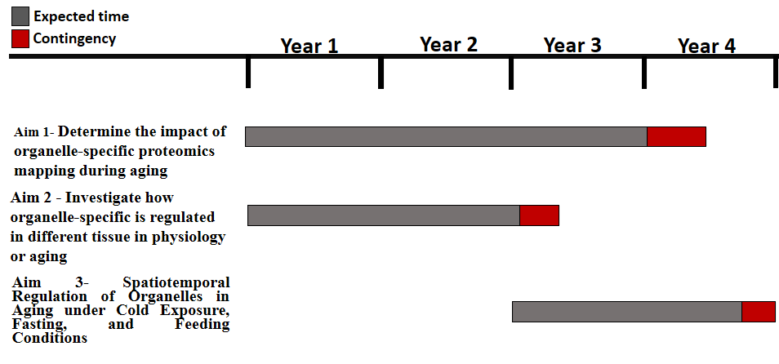

**Timeline**