ZeroDivisionError

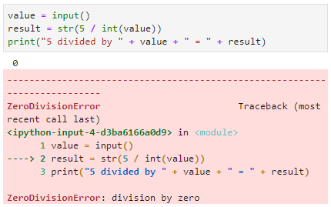

You can see in the image above that when the user enters zero for the input, the application crashes. The error provided by the interpreter is the ZeroDivisionError exception. That exception name gives us some idea as to why this crashed—it implies that the program attempted to divide something by zero. If you ever come across an error that you don’t understand, you can simply search for that error on the internet to find some great help resources on that error.

Let’s look at a few other things in this error message. At the bottom of the error, you see a cleaner description of the error. In this case, that description says “division by zero,” which may further clarify things if you were confused. Next, just as it does with syntax errors, the interpreter provides an arrow pointing to the place in the code at which the error occurred. In this case, we can see that in line 2 we are dividing by a variable and, when that variable equals zero, we are going to have this error.

Let’s look at another exception example:

Opening and Reading a File

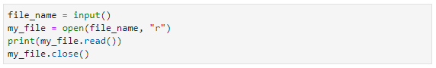

In the code above, the user is prompted to enter a value, which we store in a variable called “file_name.” Then, we open a file with the name stored in file_name. The second argument in the open function, *“*r,*”* indicates that we’re opening the file for reading. We then read the file and print out the resulting data before closing the file.

If you run this code and enter a valid filename, the result should be that the contents of the file will be printed to the screen. However, if you enter an invalid file name, an exception will occur.