Introduction

Walter Richard Sickert (1860~1942) was a painter in London who painted scenes that remind us life during his age. The period of his career from 1905 to 1914, which is called the Camden Town Period because of the Camden Town Murder Series that was composed in that period, are generally considered especially representative works.

However, his works were not realist paintings, which merely illustrate the daily life of their time. In *‘Questions of Artistic Identity, Self-Fashioning and Social Referencing in the Work of the Camden Town Group’*, Andrew Stephenson said;

By remembering at all times, as Sickert stressed, the importance of that imaginative ‘somewhere’ over who was being depicted, the collapse of artistry into the reportage style of the ethnographic investigator, or the danger of invoking the moralized and religious sentiments of urban social reformers, could be avoided. (1)

Stephenson stressed that Sickert painted the view of an imaginative somewhere and he did not paint scenes and incidents which existed in reality. In *‘Walter Sickert’*, David Peters Corbett said that Sickert was a ‘dispassionate observer’ of modern life and his works in the Camden Town Period help us to understand the subject as a ‘modern experience.’ However, he treated the models and situations of his paintings as symbolic factors of ‘modern experience’ rather than as individuals.(2) According to these statements, it is possible to say that Sickert painted imaginative perspectives which are not based on reality but that he succeeded nevertheless in representing modern experience. At a glance, painting ‘the imaginative views’ and ‘modern experience’ are inconsistent objectives. However, in Sickert’s paintings, both of these were compatible and necessary for his subject.

In addition, scholarship like Lisa Tickner’s ‘Walter Sickert: The Camden Town Murder and Tabloid Crime’ (3), argues in many ways that the narrativity in Sickert’s works is an important constituent part. According to ‘*Ennui c.1914 by Walter Richard Sickert catalogue entry’*, Nicola Moorby referred to the narrativity of Sickert’s paintings and the peculiarity of *Ennui* [figure.1], which is one of the representative works in Sickert’s late Camden Town Period. He said;

Sickert had previously explored the tensions apparent in the domestic arena in works such as *Off to the Pub* c.1912 (Tate), *Sunday Afternoon* c.1912–13 (The Beaverbrook Art gallery) and *Jack Ashore* c.1912–13 (Pallant House Gallery), but none of these portray a situation as explicitly dysfunctional as *Ennui*. ...Although the descriptive, realist nature of Sickert’s painting allows scope for narrative interpretation, the ambiguity of the scene ultimately discourages the development of a story. (4)

In this description, the remarkable point is the more dysfunctional characteristics of *Ennui* than other pictures. Moorby said this characteristic disturbs the audience to create a sense of narrativity. However, I believe that narrativity plays distinctive roles in Sickert’s works to represent the subject which reminds us the life of that time in London, which Corbett called ‘modern experience’. (5)

In this treatise, by treating *Ennui* I will analyze how narrativity relates to ‘modern experience’ in Sickert’s works. In addition, I state about the mean which painting the imaginative views and modern experience are consistent. First, I explain the background and the details of *Ennui*. Second, I indicate the meaning and the aim of constituent parts of *Ennui*. Third, I explain the significance of narrativity in *Ennui*. Finally, I conclude this treatise.

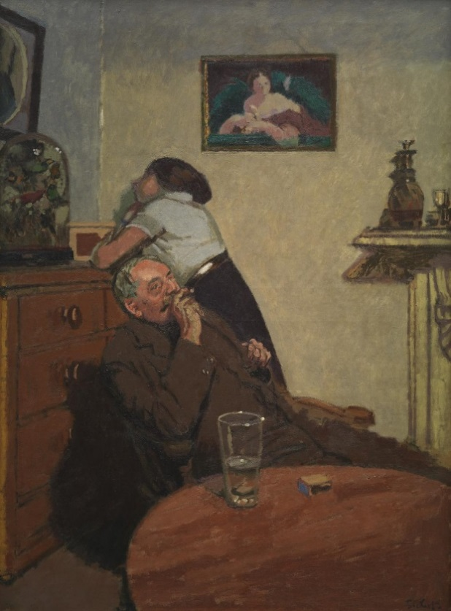 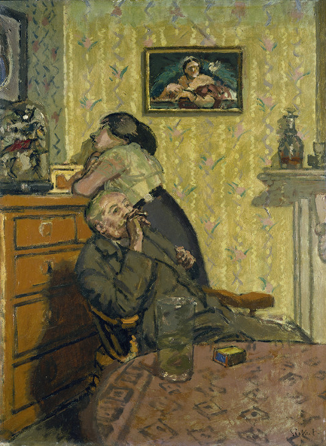

[figure.2] Walter Richard Sickert, *Ennui*, 1917-1918, Oil paint on canvas, 76cm×56cm

The Ashmolean Museum, Oxford

[figure.1] Walter Richard Sickert, *Ennui*,

c.1914, Oil paint on canvas, 152.4cm x 112.4cm,

frame: 174.1cm x 134.0cm x 11.0cm, Tate

1.Summary of *Ennui*

First, I summarize the information about *Ennui*. *Ennui* is a representative work in Sickert’s Camden Town Period, though it is not included in the Camden town murder series. There are four esquisses of *Ennui* which have the same title and the same subject. There are also many sketches and three etching plates in various sizes. In addition, according to Moorby (6), it is said that Sickert changed some details of the contents for each version of *Ennui*. For example, comparing the *Ennui* in the Tate and *Ennui* 1917–18 (Ashmolean Museum, Oxford) [figure.2], one would notice that the Tate’s version is almost twice the size and the picture’s style looks more realistic than the Ashmore’s version, whereas Sickert used brighter colors in the later and he painted patterns on the walls and table. According to the figure of works which have the same title and the same subject and various transitions of the details by the painter which seem as Sickert’s trial and error, it is possible that Sickert was obsessed with this subject and he paid elaborate attention to setting the scene of *Ennui*.

2. The contents of *Ennui*

I describe about the contents and the subject matter of *Ennui*. Preceding studies have considered the title, *Ennui*, an important element of this painting. Moorby explained the meaning of the word ‘ennui’ by quoting from *The Demon of Noontide: Ennui in Western Literature,* written by Reinhard Kuhn. According to Moorby:

Ennui is a state signifying hatred or disinterest in life itself, a ‘state of emptiness that the soul feels when it is deprived of interest in action, life and the world, a condition that is the immediate consequence of the encounter with nothingness, and has an immediate effect, a disaffection with reality’’. (7)

In addition, the word ‘ennui’ is referenced prominently within French literature of the nineteenth century, for instance the works of Baudelaire. The contents of the painting *Ennui* correspond to the meaning of the word. Furthermore, the painting has an important relationship to the literary fashions of the nineteenth century. In this chapter, I describe the details of them.

According to Moorby, the two people who were depicted in this picture are referred to as Hubby and Marie Hayes. The man, Habby, is Sickert’s old friend, but his true name is unknown. He was employed by Sickert as a servant and a sitter in 1911. He appeared in many of Sickert’s paintings from 1911 to 1914, including *Off to the Pub* (Tate) [figure.3] and *Sunday Afternoon.* (Beaverbrook Art Gallery) [figure.4] On the other hand, Marie Hayes was a cleaning woman in Sickert’s house. (8)

In *Ennui* and other pictures including Hubby and Marie Hayes in this period, the pair were depicted as husband and wife, parent and child, or lovers. However, they were none of these things.

The room depicted in *Ennui* was Sickert’s studio, which was located in Granby Street in Camden Town. In the center of the painting, Hubby and Marry Hayes are depicted as protagonists and some furniture is placed around them. These objects were also the property of Sickert, and some of them appeared in other of his paintings in that same period. At a glance, the interior looks unremarkable, but Sickert composed this view closely. The two people in this painting are depicted as not facing each other even though they are in a tight space, as if they do not have any interest in each other at all. On the left side, Mary Hayes is depicted as one of the protagonists and she gazes at a bell jar as if she is lost in thought, and stuffed birds are confined in the jar. The bell jar is a Victorian taste object, which is domed by glass with some ornaments confined in it. The woman’s feelings are implied by the constituent of this painting. Moorby claimed that stuffed birds in the bell jar represent the woman’s feelings. The dead birds trapped in the bell jar imply that the woman is also confined in the room like them. At the same time, it makes us imagine the woman’s feeling of entrapment. Mary Hayes and Hubby are depicted surrounded by furniture in the corner of the room. Moorby compared the composition of the interior to the stuffed birds in the bell jar, implying that the situation of the couples is similar to that of the birds. (9)

Moreover, in *Millais, Manet, modernity*, Paul Barlow elaborated on the meaning of birds in Victorian arts, by studying *The Ruling Passion (The ornithologist),* which was painted by John Everett Millais in the Victorian era. According to Barlow, in Victorian art caged birds were used to imply taming nature and guiltless in commonly. However, in *The Ruling Passion (The ornithologist),* all birds are stuffed. In short, there are many dead bodies of birds in the domestic scene. Barlow said using the dead bodies of birds for ornaments was an issue which was debated in the 1880s. In the end, birds in paintings were a typical subject in the Victorian era, and Millais’s work alludes the problematic side of the convention. (10) Return and see *Ennui* with this information. The bell jar and stuffed birds are also Victorian taste. They imply and remind spectators of Victorian art’s convention of using birds as a subject. At the same time, they also imply the dark side of the previous culture.

Furthermore, Sickert distorted the perspective in this picture. We can see the table in the foreground is painted as if it inclines a little to the front. Nevertheless, the glass and the matchbox on the table are depicted in their correct size and perspective. This effect is not remarkable in this picture, and this technique reminds us of still life paintings by Paul Cézanne, but Sickert used this effect for a particular aim. According to David Peters Corbett, this is intended to give an unsettling effect to the picture and a sense of discomfort to spectators. About this, in *Walter Sickert* Corbett said,

It is Sickert’s capacity to encapsulate stark horror in the banal and the familiar which defines much of his work at this period, relentlessly bearing down on the suburban horrors of alienation and unhappiness dramatized in an ordinary sitting room. (11)

From this description, it is possible to say that Sickert had the ability to casually create something disquietingly in an ordinary view, and *Ennui* was one of those indoor paintings in this period which are painted by the ability of the painter. Sickert did not distort the view in an extreme way, but the casualness of his depiction gave an impression which is strange and discomforting to the ordinary view. Therefore, his technique enhances the sense that there is something disquieting.

On the upper side of the wall in the background, a picture is hanging, but the detail is not painted clearly. According to Moorby, this painting of a bare shouldered woman is a portrait of Queen Victoria, and it also appeared in other of Sickert’s works, for instance, *Degas at New Orleans* (private collection) and *Telling the Tale* (private collection). (12) In the period when *Ennui* was painted, Queen Victoria had already passed away. Therefore, it is possible to imagine that the painting out of date. In this painting, the bell jar on the left side is a Victorian taste object and it is also obsolete, like the portrait of deceased queen. These objects seem to make the spectators of former days think the interior is stale, but the painter’s aim was more complicated. Sickert painted these old-fashioned ornaments to deliberately enhance the decadent atmosphere.

According to Moorby, the title of this work, *Ennui*, was a significant theme among influential writers and poets of the nineteenth century, and Sickert was familiar with these works and authors. In addition, in the late nineteenth century, the term ‘decadence,’ which is related to the notion of ‘ennui,’ was used to describe literature and the arts. (13) From the title, *Ennui*, it is plausible that Sickert wanted to remind spectators the tendency in the French literary works of the nineteenth century which regarded ‘ennui’ and ‘decadence’ as important themes. The two old fashioned objects in this picture which I mentioned, the bell jar and the portrait of Queen Victoria, were also painted to evoke the decadent culture of the nineteenth century. With the title and these objects, Sickert urged spectators to remember the nineteen-century culture of *Ennui*, especially that of the Victorian era. For a twentieth century audience, it likely that the objects intended to create a decadent atmosphere in this painting evoked a more real sense of the old-fashioned, because the nineteenth century and its decadence were the immediate past for them. Finally, these constituents which remind spectators of the previous century give us a static impression, as if inhabitants of this room were not concerned about fashion or freshness and did not rearrange the room for years. In short, they suggest ‘decadence’. Sickert not only made spectators remember the tendency of nineteenth century but also created a decadent impression in the room.

By combining these elements of *Ennui*, it is possible to say that Sickert made a ‘disquieting atmosphere’. Actually, in this room, there are no specific events which articulate any disquieting stories. However, the constituent elements were precisely designed by the painter to make spectators feel something disquieting. This painting does not indicate any extraordinary events or any specific stories, but the title, the protagonists, the object, and the composition, were all intended to show a disquieting atmosphere in the domestic scene, as I mentioned. Furthermore, the atmosphere in this painting has the function of allowing spectators to imagine some disquieting narrativity in the scene. All of the protagonists and the constituents which I mentioned are full of a decadent taste and suggestive of some gloomy stories and we are urged by them to imagine some narrativity.

However, as Moorby mentioned, a specific narrative is ultimately not formed in this scene. (14) The situation of this view is ambiguous because the protagonists do not behave in a special way and they are just present in the room. The constituent parts are no more than an allusion to something disquieting, because they do not indicate any specific stories. In *Ennui*, there is just a disquieting atmosphere, and the narrativity which we are led to imagine by the painting are ultimately just our surmises.

3. The significance of narrativity in *Ennui*

I described the effects of the constituent elements of *Ennui*. In this chapter, I analyze the function of narrativity which is made to be ambiguous by these factors in the painting.

In *Walter Sickert*, Richard Shone referred to Sickert’s series of paintings in the Camden Town Period that depict men and women in interiors. He said:

A slight adjustment in the relation of two figures, a different fall of light, and the whole psychological potential of the picture changes. But how discreet Sickert is, how unrhetorical. There is none of that meretricious chiaroscuro of the ‘subject’ picture nor the piquant highlights of fashionable portraits. (15)

From this account, we can conclude that Sickert was able to design a particular atmosphere and he achieved it not only in *Ennui* but also in other paintings. These other paintings have a similar subject delicately depicted by their characters and interiors, without indicating a specific story or real incidents.

The atmosphere Sickert created without telling a specific story makes spectators imagine some narrativity, but in *Ennui,* all that we actually have is a disquieting atmosphere. Ultimately, specific stories are not formed in the picture. In *Ennui*, there is just an atmosphere which alludes to disquieting stories. However, spectators are made to imagine a story to this picture. This fact means that each spectator can experience ‘the disquieting narrativity’ through their imagination and notion of modern life. I mentioned that Sickert painted scenes that remind us of life in London during his time, but they were imaginative scenes. This means that the scenes Sickert painted in Camden Town Period were ‘the conceptual images’ of modern life in London. In other words, Sickert painted scenes that appealed to spectators’ memories, experiences, and imaginations to remind them of abstract ideas about modern life in London. The constituent parts of his paintings in the same period— for instance, obscure interiors, nudes of prostitutes, and anonymous men and women—were fragments of an abstract contemporary image that call modern life in London to the spectator’s mind, what David Peters Corbett called ‘modern experience’. (16) His method was not to illustrate real life, but to create views that remind us of scenes of daily life in London. He did this with models in his studio who were directed closely by himself, indicating the contrived intention of his paintings. In this way, Sickert’s painting came to have an ambiguity that alludes to stories in modern life, because he painted abstract fragments of modern life. Especially in *Ennui*, by combining the ambiguity and the constituent parts which I mentioned in the previous section, the painting alluded to some narrativity, and it appears as if a ‘the disquieting atmosphere’ is in front of us. The disquieting atmosphere in *Ennui* stimulates our imaginations to recall notions or tales about modern life from our memories, experiences or imaginations. Actually, it is impossible to specify a particular story in *Ennui,* because the painting is too ambiguous, as Moorby mentioned. (17) In addition, we all naturally imagine different ideas about modern life in London. However, the narrativity of *Ennui* does not belong to a specific someone or a specific real-life story. Simultaneously, it is also possibly to say that we can share the disquieting narrativity of *Ennui* through the concept of “modern experience” which Sickert indicated by creating the disquieting atmosphere in the picture.

Paintings that illustrate specific stories, for example religious and historical paintings, cannot have the same effect That is because, if a picture show specificity, their stories obtain inherent characters which exist outside of our imagination.

In short, by making stories in paintings ambiguous, the stories no longer belong to anyone in particular. At the same time, the paintings obtain a conceptual abstraction which makes us imagine narrativity. In the case of *Ennui*, this narrativity is composed of some disquieting stories of modern life in the London of Sickert’s time.

Moreover, *Ennui* can be conceived as one of Sickert’s experiments to find a new mode of expression. In ’Seeing into modernity: Walter Sickert’s music-hall scenes, c.1887-1907’, David Peters Corbett explained why Sickert problematised the relationship between appearance and content in his works for the investigation. Treating Sickert’s works depicting the scenes of music-halls in London, Corbett said;

These are strategies designed to problematise the visual surfaces of these scenes. A mere description of contemporary life will not do. Not only the project of Impressionism to transcribe the surface appearance of modern life, but also the capacity of paint to image a deep, interior, reading of the material is explored here. (18)

In *Ennui*, as I mentioned, Sickert depicted a disquieting atmosphere which makes us imagine some narrativity, and it created ambiguity in the image. That is to say, the ambiguity and disquieting atmosphere were ways to problematise the relationship between the appearance and contents of paintings so Sickert could explore the capacity of painting, as Corbett said. (19) In addition, as Corbett said, in the music hall paintings that preceded *Ennui*, Sickert problematised the superficial expression as if he wanted to baffle spectators. For instance, he painted the composition of the view more complicated. In *Ennui*, Sickert distorted the perspective, which was another way for Sickert to problematise the investigation. Sickert did not, however, make it difficult to understand what is depicted in *Ennui*. However, in *Ennui*, Sickert problematised not only the composition of surface but also the concept of the painting. Sickert left an enigma about the narrativity of this painting, and a definite answer cannot be found. It is possible this was a way of problematising the painting to investigate the capacity of painting. Based on these facts, in the later part of the Camden Town Period when Sickert painted *Ennui*, we can say that he tried to achieve a more complicated and deeper contrivance than in his past works. In addition, this means that during that time the conceptual characteristics of Sickert’s paintings were enhanced and departed from ‘the mere depiction of contemporary life’. (20)

Sickert depicted an image that makes us imagine modern life of his time in London. In *Ennui*, however, there are no specific stories. There is just ‘a disquieting atmosphere’, which was deliberately constructed by the painter. In this painting, Sickert tried to depict modern life as not a mere illustration but as a conceptual existence. Then, this conceptual image without specific stories embodied the modern experience not as a view of someone’s daily life but as something shared by spectators through their imagination.

Conclusion

In *Ennui*, Sickert achieved a disquieting atmosphere without plainly indicating specific stories or situations in someone’s life. However, he did not eliminate narrativity from his work at all. The disquieting atmosphere is an important factor to make spectators imagine a narrative. Thus, the narrativity in *Ennui* does not belong to anyone in particular, but is to be held in common by spectators as facilitated by their imagination. In addition, this method was part of an investigation by the painter to experiment the capacity of paintings. In Sickert’s works, modern experience is not a view of reality but something people can share, like narrativity without specific stories.