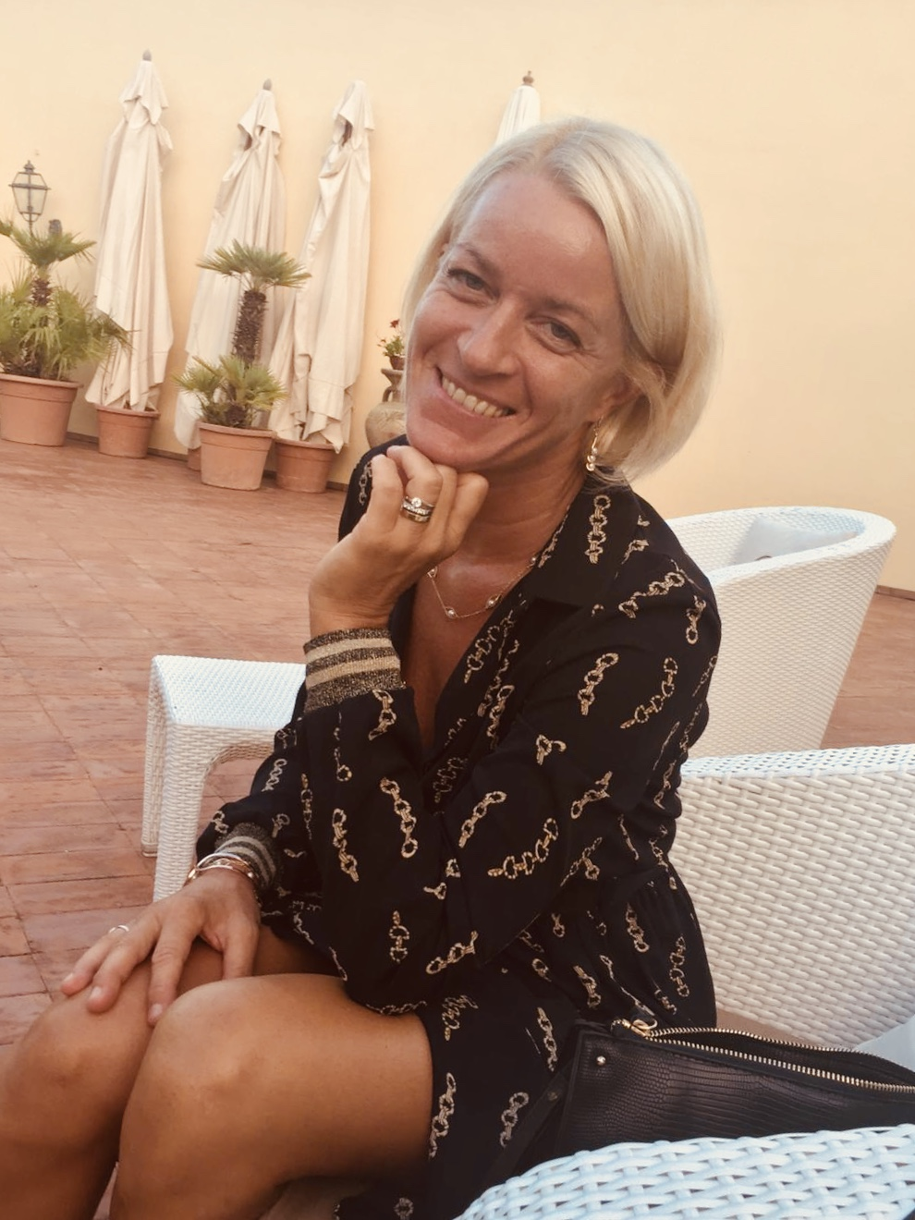

**Vanessa DI STEFANO**

Cell: +39 338 2007 111 Ø

[quilps.translations@gmail.com](mailto:quilps.translations@gmail.com)

ProZ.com: <http://www.proz.com/translator/1474906>

LinkedIn: <http://www.linkedin.com/pub/vanessa-di-stefano/3b/880/41>

Professional Affiliate *of* the *Institute of Translation & Interpreting (ITI*)

**HIGH QUALITY TRANSLATIONS**

*References available on request*

**ITALIAN>ENGLISH**

Average daily production: 2,500 - 3,500 words

Rate for translations (indicative): €0.11 - €0.13 to the word of origin

*The fee depends on the content and type of text, specialization, urgency etc.*

**AREAS OF SPECIALISATION**

History, philosophy, popular science, journalistic writing, literature, culture (in particular, Sicilian).

*Sub-specialisation*: mountaineering, tourism and travel, general documents.

**PROFESSIONAL PRESENTATION**

Translator with years of experience of several books, articles, thesis and more. She is highly motivated and scrupulous, with a particular interest in history, philosophy, literature, culture, travel and journalism. She pays particular attention to style and sense of text, to details, and has excellent literary, organizational, administrative, interpersonal and communicative skills.

**Work experience** in the following sectors: translation, journalism, marketing, public relations, art, tourism, hotels, administration, teaching and event management; has lived in Belgium, France, Argentina, Kenya, United Kingdom and Italy.

**Languages** English Mother tongue

Italian Very good knowledge (CEFR level C2 - experienced operator)

French Good knowledge (CEFR level B1 - freelance operator)

**Qualifications** 2011 – 2013 Master in Translation, Highest Grade-Unv. of Bristol-ISCED 7.2

2007 – 2009 Certificate in Law and Society - Kent University - ISCED 5.2

Labour law; criminal law; public law, legal procedures; critical introduction to the law.

2007 - 2008 Certificate in Social Sciences - Open University - ISCED 5.1

1991 - 1994 Degree in Journalism - London College of Printing - ISCED 6.1

2003 Cambridge CELTA - ISCED 4.2

**Specialized Translations:**

**Historical texts:**

**Essays translated:**

* "Performativity and Revolutionary Semantics in Gramsci and Togliatti's Texts"   
  An analytical essay on the language used by communists in Italy during the first half of the 20th century, which will be part of the book *Words of Power, The Power of Words. The Twentieth Century Communist Discourse in an International Perspective*, edited by Giulia Bassi.

Author: Giulia Bassi, University of Trieste

*To be published*

* “Grammar and historical materialism. Linguistic education in Italian Communist Party schools (1947-1977)”

An essay on the language training of cadres in post-warcommunist party schools, which will be part of the book *Words of Power, The Power of Words. The Twentieth Century Communist Discourse in an International Perspective*, edited by Giulia Bassi

Author: Anna Tonelli, Professor of Contemporary History, University of Urbino Carlo Bo

* The chapter on Italy, a collection of original historical documents, of the book entitled  
  *Societies under German Occupation - Experiences and Everyday Life in World War II*  
  A book on societies under German occupation, and the experiences and daily life in World War II

Edited by: Prof. Peter Haslinger and others

Editor-in-Chief: Francis Ipgrave, Herder Istitut

*To be published*

*Project details: http://www.societies-under-german-occupation.com/#project-description*

* "Political tropes of the ICP in party discourse and historiography: The case of ‘Progressive Democracy’”"   
  Author: Giulia Bassi, University of Trieste
* “The Nanjing massacre memorial hall and the historical identity of China in Asian and global history”  
  An analytical essay on the Nanjing massacre

Author: Guido Abbattista, Professor of Modern History, University of Trieste

* “The Italian anti-fascist community in Moscow: the activity of communist women and the example of Teresa Noce”

*For a conference in Moscow*

Author: Anna Tonelli, Professor of Contemporary History, University of Urbino Carlo Bo

* “Rebellious walls: Graffiti in Italy during the Cold War (1948-1955)”

*For a conference in Moscow*

Author: Enrico Mannari, Professor at the Luiss School of Government

**Book translated:**

* *Segesta: The Elymi Paradise*

Author: Giusi Incammisa

Publishing house: Anselmo Editore

Published: 2004

ASIN: B0040DHP5Q

ISBN: None

(ISBN of the Italian version: 9788888216010)

**Revisions:**

* “Globsearoutes: An historical geodatabase of global navigations”

A proposal on a global navigation geodatabase project

Author: Guido Abbattista, Professor of Modern History, University of Trieste

* “Staged for what? Living human exhibitions as entertainment, science and education”

A presentation on exhibitions of human beings from exotic countries, practiced in the ninth century

Author: Guido Abbattista, Professor of Modern History, University of Trieste

* “Sericulture in Italy and Japan”

For the book “Global perpectives in modern Italian culture: Knowledge and representation of the world in Italy (16th-19th centuries)”, ed. by Guido Abbattista, Professor of Modern History, University of Trieste

Author: Claudio Zanier, Professor of Industrial Archaeology, University of Pisa

* “Voices in China in early 19th century Italian culture (1800-1850)”

Author: Guido Abbattista, Professor of Modern History, University of Trieste

* “Karl Marx and the global history of the civil war: The slave movement, working-class struggle and the American State within the world market”

Author: Matteo Battistini, Researcher, University of Bologna

* “The missing middle class: American progressivism’s search for order”

Author: Matteo Battistini, Researcher, University of Bologna

* “‘Breaking the Bamboo Curtain’ or ‘Appeasing Deng Xiaoping’? Anglo-American public opinion and diplomacy during the Tiananmen crackdown of 1989”

Author: Mireno Berrettini, Professor of Political Science, Università Cattolica del Sacro Cuore

* “Neither war nor peace: A genealogy of the meanings of the term ‘Cold War’””

Author: Mireno Berrettini, Professor of Political Science, Università Cattolica del Sacro Cuore

**Philosophical texts**

**Books translated:**

* *Nietzsche’s Death of God and Italian Philosophy*

(English version: "Nietzsche. Beyond the Abyss")

Author: Emilio Carlo Corriero, Professor of Philosophy, University of Turin

Publisher: Rowman & Littlefield International

Published: September 2016

ISBN-10: 1783488123 / ISBN-13: 978-1783488124

*http://www.rowmaninternational.com/books/nietzsches-death-of-god-and-italian-philosophy*

* *The Absolute and the Event: Schelling after Heidegger*

Author: Emilio Carlo Corriero, Professor of Philosophy, University of Turin

Publisher: Bloomsbury

Published: April 2020

https://www.bloomsbury.com/uk/the-absolute-and-the-event-9781350111431/

**Essays translated:**

* "Schelling's Dante"

Author: Massimo Cacciari, philosopher, academic, Italian politician and former mayor of Venice.

*To be published*

* “Acting the Absolute: Theoretical premises of Schelling’s ethics”

Author: Emilio Carlo Corriero, Professor of Philosophy, University of Turin

*To be published*

* “About *Dartsellung des Naturprocesses*: ‘The philosophy of nature as a positive philosophy’”

Author: Emilio Carlo Corriero, Professor of Philosophy, University of Turin

*A version of the adapted essay was published in the new magazine "Kabiri" (no.1), edited by Jason Wireh, with the title "The Ungrounded Nature of Being: Grounding a Dynamic Ontology from Nature-Philosophy to Positive Philosophy".*

*https://journals.library.mun.ca/ojs/index.php/kabiri/article/view/1942/1513*

* Part of the essay: “Schelling's Ungrounded Nature of Being: Grounding of a Dynamic Ontology”

Author: Emilio Carlo Corriero, Professor of Philosophy, University of Turin

*To be published in the book “World soul and other writings of a philosophical nature by Schelling,” edited by Iain Hamilton-Grant*

* Various entries for a book on new morphology by different authors

Ed. by: Federico Vercellone, Professor of Aesthetics, University of Turin

**Revisions:**

* Revision of various essays and texts for Germana Pareti, professor of educational science in the

Department of History of Philosophy, University of Turin

**Book in translation:**

* *Zarathustra’s Gift*

Author: Emilio Carlo Corriero, Professor of Philosophy, University of Turin

**Literary texts:**

For Giunti

* Various excerpts of literary texts for the sale of international Italian book rights for possible publication abroad

**Chronicle texts:**

**Book due to be published:**

For Kogan Page

* *No Job for the Old*

Author: Riccardo Pozzoli (The Blonde Salad; Foorban)

**Scientific texts:**

**Translated books (**for Giunti):

* *Men Who Love Plants*

Author: Stefano Mancuso

*Not published?*

* *The Revolutionary Genius of Plants*

Author: Stefano Mancuso

*http://www.simonandschuster.com/books/The-Revolutionary-Genius-of-Plants/Stefano-Mancuso/9781501187858*

* *Einstein and the time machine*

Publisher: Chicago Review Press

Published: June 2017

ISBN 9781613738658

*https://www.chicagoreviewpress.com/einstein-and-the-time-machine-products-9781613738658.php*

* *Newton and the anti-gravity formula*

Publisher: Chicago Review Press

Published: June 2017

ISBN 9781613738610

*https://www.chicagoreviewpress.com/newton-and-the-antigravity-formula-products-9781613738610.php?page_id=21*

* *Tracing our ancestors*

*To be published*

* *The story of life*

*To be published*

**Cultural and historical texts:**

* **Magazine:**

Only translator since 2013 for the bilingual magazine *Piacere Sicilia*. The magazine of about 25,000 words contains articles on Sicilian culture, history and gastronomy. Annual edition.

* **Internet pages:**

Translator since 2017 for Liberty Lines of various pages of their website and various documents, including legal documents.

**Art texts:**

* Translator of art criticism in a catalogue by Franco Mineo, a well-known Sicilian painter.

Author: Franco Mineo

Published by: Regional Province of Trapani

Published: 2010 (no ISBN)

**Various texts:**

* Menu translator for Filippo La Mantia, famous Sicilian chef
* Essay entitled “The experience of common assets in Italy”  
  Author: Antonio Vercellone, PhD Fellow, Bocconi University

**Translations** since 2004Freelance translator (UK and Italy)

**Generic** 2003 - 2004 Translator at the British Institute (Italy)

**Experience** as of 2014 Text Revisions (Doublestruck, UK)

**Professional** 1994 – 1998Editor/ deputy editor/ deputy designer (Forward Publishing, UK)

**Relevant** 1991, 1993 Chronicler (Evening Argus, Press Association, UK)

**More** 2007 – 2010Vice Director of Art Gallery (Rye Art Gallery, UK)

**Experiences** 2007 – 2008Personal transcriber for Justin Dukes, the former general manager of a  
**Working**  television network and financial newspaper with national circulation

(Channel 4 & Financial Times Group, UK)

2006 – 2009 Representative and agency owner of marriage organization agency and special events (Pelsham Weddings, UK)

2004 - 2005 Hotel manager (Chantmarle Manor House, UK)

2002 Researcher (foreign trade) for a data processing company (IMAR Service, Italy)

2002 Hotel receptionist and employee (Hotel Capo San Vito, Italy)

2000 - 2002 Head of Department, Borders Books (UK)

2000 Director of publications and public relations assistant for

a plastics company (Tower GRP, UK)

1992 +1993 Transaction brokerage agent for the German market in the

bonds (Bund) (L.I.F.F.E. , UK)

1990 – 1991 Deputy director and accountant, responsible for foreign activities

for a market research company (Sandpiper Field, UK and Spain)

1989 - 1990 Assistant librarian and receptionist (American Express, UK)

1988 - 1989 Employee 'Waivers and Loans' (Legal & General, UK)

**Experience** 1998 - 2000 Secretary and Deputy Director of a health development programme,

**Volunteering** educational and social in a deprived neighborhood of Nairobi

(Mukuru Promotion Centre, Kenya)

**Education** 1978 – 1987 Elementary and secondary - Roedean School (UK)

**ScolasticA** Baccalaureate: English, French, Political Science, Law

1975 – 1972 Elementare – British School of Paris (Francia), International School of

Brussels (Belgium), West Dean School (UK)

**Skills** CAT tools MemSource

**Techniques** Computer Apple OS X, Microsoft Office

**Interests** History, writing, philosophy, languages, literature, politics, travel, new technologies, cultural movements, art, music, theatre, cinema, photography, nature, animal world, theology, hiking, mountain trekking.