**Generalized Potenciada Uniform Distribution**

**Abstract**

We introduce here a new uniform distribution model called Generalized Potenciada Uniform Distribution (GPUD), which is based on introducing the parameter $k$ into the probability density function associated with the power of random variable values and includes an operator we call the Potenciada Mean. From this new model we can derive the shape properties, the higher-order moments, the moment generating function, the model that simulates the GPUD, and other important statistics. This approach has made it possible to generalize the distribution of Jayakumar & Sankaran (2016) through a new distribution called GPUD(J-S). Two sets of real data related to Covid-19 and to bladder cancer were tested to demonstrate this proposal's potential. The maximum likelihood method was used to calculate the parameter estimators applying the maxLik package in R-language. The results show that this new model is more flexible and useful than other comparable models.

**Key words:** Generalized Uniform Distribution, maximum likelihood estimation, Covid-19

1. **Introduction**

In the last years, several researchers have proposed different generalizations of new distribution functions of continuous random variables to model more broadly different behaviors related to survival analysis, such as the useful life of a computer. Doing so also allows the study of hazard functions to determine the reliability of devices subject to use and deterioration. Additionally, these extended distributions provide greater flexibility in modeling various real-life problems (Nassar et al., 2018; Sankaran and Jayakumar, 2016; Torabi et al., 2018).

Our research described here follows the approach presented originally in the seminal article of Marshall and Olkin (1997), and continued afterwards by other authors including Alshangiti et al. (2014); Jayakumar and Sankaran (2016); and Jose and Krishna (2011), where the results of the Marshall-Olkin extended uniform distribution demonstrates different approaches and generates a new model family.

Uniform distribution is closely related to the rest of the distribution functions. To demonstrate, we can take the distribution function as a random variable; we can easily see that this random variable is uniformly distributed as the $U(1,0)$, which is the basis on the inverse transform method. The uniform distribution function defined on the closed interval [0,1] is of fundamental importance for the generation of random numbers in simulation processes that allows the numerical evaluation of the behavior of statistical models (Law, 2007).

Previously reported results, like Rondero-Guerrero et al. (2020), motivated us to consider that statistical distributions are frequently applied to models of real-world phenomena in diverse areas such as medical sciences, finance, engineering, and economics, where the analysis of risk and survival functions is included due to their relevance in modeling data from various systems. Therefore, we decided to extend our work and apply it to real world data, too; however, we did so in such a way that our enhanced model presents a better data fit and that creates a tool that can potentially be used by many areas, the design of public health policies being just one example.

Based on our approach, we propose a new branch of the uniform distribution function family, based on something new that we call the Potenciada Mean. Our generalization is based on the incorporation of a new parameter $k$, that appears in the power of the values taken by the continuous random variable (Rondero-Guerrero et al., 2020). Furthermore, this proposal generalizes the work of Jayakumar and Sankaran (2016) and by allowing us to generalize Jayakumar’s model, has broaden our perspective.

The article is structured as follows. In Section 2, the general conditions of the new family of the Generalized Potenciada Uniform Distribution are defined and discussed. Section 3 shows some interesting properties of the $GPUD$, such as hazard function, survival function, moment generator function, moments, and statistics as: quantile, median, asymmetry, and kurtosis. Section 4 uses the $GPUD$ approach to generalize the work of Jayakumar and Sankaran (2016), allowing another family of distributions to be generated. This new family contains the parameter $k$ as the power of the values of the random variable, which provides greater flexibility to this and other models. Section 4 also discusses expressions for estimating the parameters of the new generalization, and presents a simulation study to determine the performance of maximum likelihood estimators for specific sample sizes. The usefulness of $GPUD$ by Jayakumar and Sankaran (2016) generalization is shown in Section 5, where two real data sets are used to fit the proposed model, and we demonstrate empirically that the $GPUD$ is more appropriate than other competitive models, such as the Weibull, the Exponentiated Weibull (Pal et al., 2006), New Marshall-Olkin Weibull (Cui et al., 2020), and Marshall-Olkin Exponentiated (García et al., 2020). Finally, conclusions are presented in Section 6.

Motivados por los resultados reportados previamente, Rondero-Guerrero et al. (2020) y considerando que las distribuciones estadísticas se aplican frecuentemente para modelar fenómenos reales en diferentes áreas como ciencias médicas, finanzas, ingeniería y economía, donde se incluye el análisis de las funciones de riesgo y sobrevivencia por su relevancia en el modelado de datos de diversos sistemas. Cabe señalar que nuestro modelo presenta un mejor ajuste de datos, lo que permite contar con una herramienta que potencialmente puede usarse, por ejemplo, para el diseño de políticas públicas de salud.

1. **A new family of the Uniform Distribution Function**

Based out of our research (see Rondero-Guerrero et al. (2020)), we are introducing a new family of distribution functions we call Generalized Potenciada Uniform Distribution (GPUD) with a continuous random variable $X$. The respective Probability Density Function (PDF), is defined as follows,

|  |  |  |
| --- | --- | --- |
| $$f_{X^{k}}\left(x\right)=\left\{\begin{aligned}\frac{x^{k}}{\left(b-a\right)M_{k}(a, b)} \\ \\ 0 \\ \end{aligned}{\begin{aligned}a≤x≤b \\ \end{aligned} k=0, 1, 2,…, n. \atop x<a;x>b }\right.$$ | (1) |  |

The term $M_{k}\left(a, b\right)$, defined as an operator herein named Potenciada Mean is expressed as,

|  |  |
| --- | --- |
| $$M_{k}\left(a, b\right)=\frac{\sum_{j=0}^{k}{ a^{k-j}b^{j}}}{k+1}$$ | (2) |

Understanding that for the case, $k=0$, $M_{0}\left(a, b\right)=1$, we then recover the usual uniform distribution. It is easy to show that Equation (1) is a well-defined PDF where the mean is $μ=\frac{a+b}{2}$.

The Distribution Function (DF) corresponding to Equation (1) is given as,

|  |  |  |
| --- | --- | --- |
| $$F_{X^{k}}\left(x\right)=P\left(X≤x\right)=\left\{\begin{aligned}0 x<a \\ \\ \frac{x^{k+1}-a^{k+1}}{b^{k+1}-a^{k+1}} a≤x≤b \\ \\ 1 x>b \end{aligned}\right. k=0, 1, 2,…, n.$$ | (3) |  |

It should be noted that Equations (1 and 3) represent any member of a new family of probability density and distribution functions for different values of the $k$ parameter. These results show that there are many polynomial functions satisfying the conditions of a PDF and DF respectively, that is, $F_{X^{k}}^{'}\left(x\right)=f_{X^{k}}(x)$, which belongs to the new $GPUD$.

When $a=0$ y $b=1$, the $GPUD$ takes the form,

|  |  |
| --- | --- |
| $F_{X^{k}}\left(x\right)=x^{k+1}$; for $k=0, 1, 2, 3,..., n.$ | (4) |

It is important to note that this last expression will be used in Section 3 when we introduce the survival function defined as,

|  |  |
| --- | --- |
| ${\overline{F}}_{X^{k}}\left(x\right)=1-F_{X^{k}}\left(x\right)=1-x^{k+1}$. | (5) |

The corresponding graphs of $f_{X^{k}}(x)$ and $F_{X^{k}}(x)$ are shown in Figures 1 and 2, respectively, for different values of $k$. The results in Figure 1 show that the PDF skews to the right as the value of the parameter, $k$, increases. Graphical properties are of great importance because they allow researchers and professional users of statistical methods to see if any of these distributions fit the data set of an application.

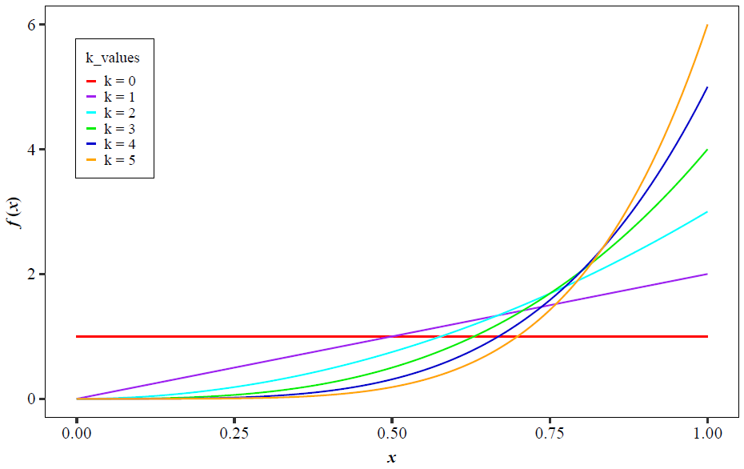

Figure 1. $f_{X^{k}}(x)$ for $k=0, 1, 2, 3, 4, \text{and}$ 5

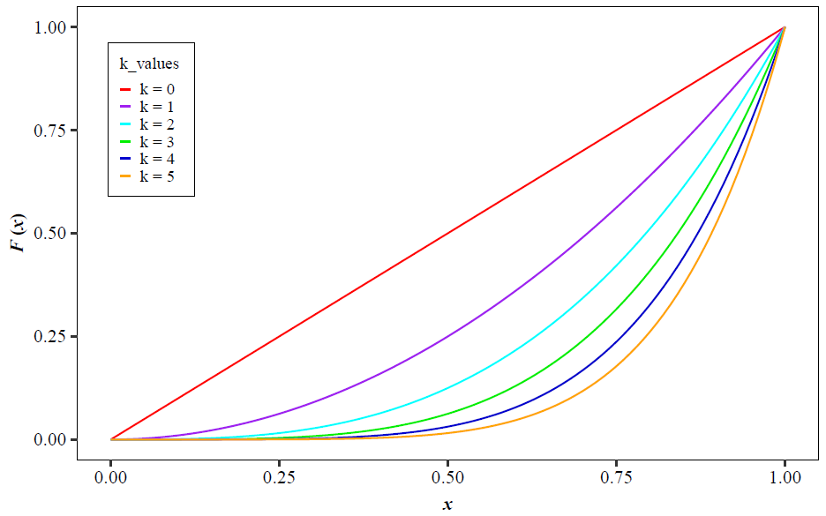

Figure 2. $F_{X^{k}}(x)$ for $k=0, 1, 2, 3, 4, \text{and} 5$

1. **General properties of the GPUD**

In this section, we examine general properties of the GPUD to show the flexibility of this new family of distributions, which will allow the development of a generalization of the model proposed by Jayakumar and Sankaran (2016) studied in section 4.

* 1. **Hazard function and survival function**

From Equations (1) and (3), the hazard function and survival function, respectively, can be obtained, as shown below:

|  |  |
| --- | --- |
| $$h_{X^{k}}\left(x\right)=\frac{f(x)}{{\overline{F}}_{X^{k}}\left(x\right)}=\frac{(k+1)x^{k}}{1-x^{k+1}} for a=0, b=1, and k=0, 1, 2,…, n.$$ | (6) |

In what follows, we will use the more common notation for the survival function $S_{X^{k}}\left(x\right)={\overline{F}}_{X^{k}}\left(x\right)$. Where,

|  |  |
| --- | --- |
| $$S_{X^{k}}\left(x\right)=1-F_{X^{k}}\left(x\right)=1-x^{k+1},$$ | (7) |

for, $a=0$, $b=1$, and $k=0, 1, 2,…, n$.

Survival analysis is a topic of great importance for researchers in many disciplines. Both the hazard and survival function deals with a non-negative continuous or discrete random variable $X$, which is related to data from lifetime, and allows the formulation of statistical models in areas such as medicine, engineering, and biology. For example, in biomedical research, survival analysis is applied to a random variable related to the time that elapses from the onset of a disease until the patient either recovers or dies noting specific key interventions along the way.

When working with the hazard function, researchers are interested in the graphs' properties, as they are useful in identifying whether the distribution can model increasing or decreasing failure rates. Figure 3 and 4 shows the shape of $h_{X^{k}}\left(x\right)$ and $S_{X^{k}}\left(x\right)$ respectively, for different *k*-values.

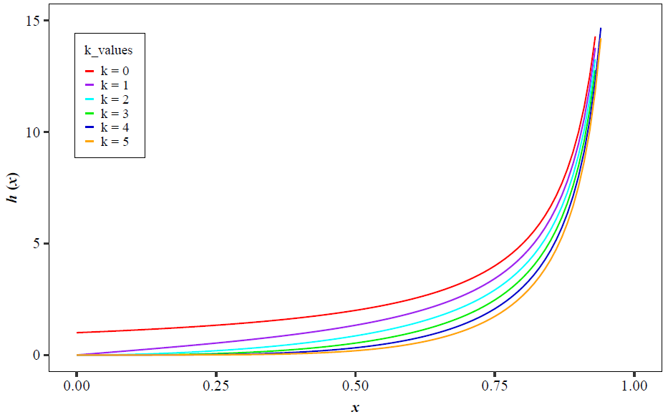

Figure 3. $h_{X^{k}}(x)$ for different values of *k*

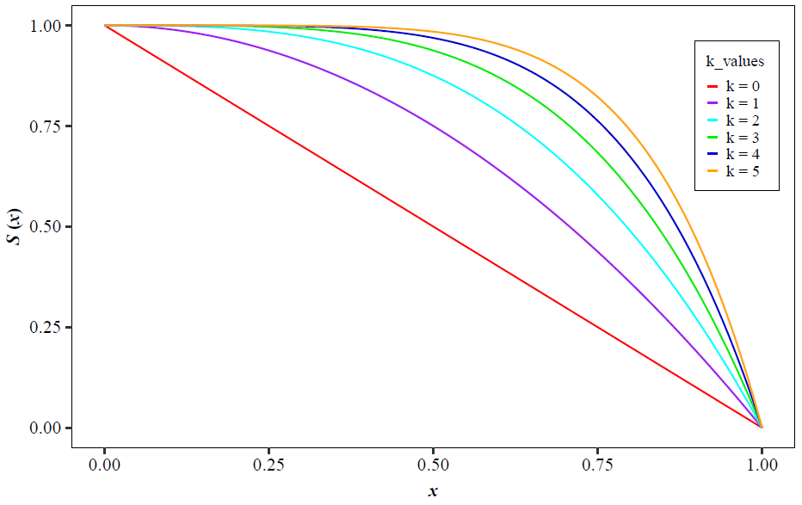

Figure 4. $S_{X^{k}}(x)$ for different values of *k*

* 1. **Moment generating function**

A function of great importance in the calculation of higher order moments is the moment generating function. We will see that, once again, we can obtain a compact expression of it in terms of the Potenciada Mean.

**Theorem 1.** The moment generating function of the PDF, is given as,

|  |  |
| --- | --- |
| $$φ_{X^{k}}\left(t\right)=\sum_{l=0}^{∞}{\frac{t^{l}}{l!}∙\frac{M_{k+l}}{M_{k}}}$$ | (8) |

**Proof:** The moment generating function $φ_{x}\left(t\right)$ is defined by,

|  |  |
| --- | --- |
| $$φ_{X^{k}}\left(t\right)=E\left[e^{tx}\right]=\int_{-∞}^{∞}{e^{tx}f_{X^{k}}\left(x\right)dx}=\frac{1}{\left(b-a\right)M_{k}(a, b)}\int_{a}^{b}{e^{tx}x^{k}dx},$$ | (9) |

and expanding $e^{tx}$ in a Taylor series,

|  |  |
| --- | --- |
| $$φ_{X^{k}}\left(t\right)=E\left[e^{tx}\right]=\frac{1}{\left(b-a\right)M_{k}(a, b)}\int_{a}^{b}{\left[1+\frac{tx}{1!}+\frac{{\left(tx\right)}^{2}}{2!}+\frac{{\left(tx\right)}^{3}}{3!}+…\right]}x^{k}dx,$$ | (10) |

obtaining,

|  |  |
| --- | --- |
| $$φ_{X^{k}}\left(t\right)=1+\frac{t}{1!}∙\frac{M_{k+1}\left(a, b\right)}{M_{k}\left(a, b\right)}+\frac{t^{2}}{2!}∙\frac{M_{k+2}\left(a, b\right)}{M_{k}\left(a, b\right)}+\frac{t^{3}}{3!}∙\frac{M_{k+3}\left(a, b\right)}{M_{k}\left(a, b\right)}+…,$$ | (11) |

or in terms of the series,

|  |  |
| --- | --- |
| $$φ_{x}\left(t\right)=\sum_{l=0}^{∞}{\frac{t^{l}}{l!}∙\frac{M_{k+l}}{M_{k}}}.$$ | (12) |

From this expression it is possible to obtain all the moments .

* 1. **Moments**

Next, we show the calculation of the higher order moments for the $GPUD$, that we are proposing, which allow us to determine the mean and variance, among others.

**Theorem 2.** The $r^{th}$ moment of the PDF is given as,

|  |  |
| --- | --- |
| $$μ_{k}^{r}=E_{k}\left[x^{r}\right]=\frac{M_{k+r}(a, b)}{M_{k}(a, b)}.$$ | (13) |

**Proof:** We can write the $r^{th}$ moment as,

|  |  |
| --- | --- |
| $${μ_{k}^{r}=E}_{k}\left[x^{r}\right]=\int_{-∞}^{∞}{x^{r}f_{X^{k}}\left(x\right)dx}=\int_{a}^{b}{x^{r}\left[\frac{x^{k}}{\left(b-a\right)M_{k}(a, b)}\right]}dx,$$ | (14) |

from which results,

|  |  |
| --- | --- |
|  |  |

|  |  |
| --- | --- |
|  | (15) |

therefore,

|  |  |
| --- | --- |
| $$μ_{k}^{r}=E_{k}\left[x^{r}\right]=\frac{M_{k+r}(a, b)}{M_{k}(a, b)}.$$ | (16) |

It is worthwhile noticing the advantage of the last Equation. For the case $a=0$ and $b=1$ it is expressed as,

|  |  |
| --- | --- |
| $$μ_{k}^{r}\left(0,1\right)=\frac{M_{k+r}\left(0,1\right)}{M_{k}\left(0,1\right)}= \frac{k+1}{k+r+1}.$$ | (17) |

Of course, for the usual uniform distribution $k=0$, so that for the first moment $r=1$, the mean is, $μ\left(0,1\right)=1/2.$ From the previous result we can calculate the corresponding variance for $k=0, 1, 2,..., n$,

|  |  |
| --- | --- |
| $$σ_{k}^{2}=μ_{k}^{2}-{\left[μ_{k}^{1}\right]}^{2},$$ | (18) |

and can rewrite the previous result,

|  |  |
| --- | --- |
| $$σ_{k}^{2}=\frac{M_{k+2}}{M_{k}}-{\left[\frac{M_{k+1}}{M_{k}}\right]}^{2}.$$ | (19) |

We emphasize that the higher order moments with respect to the mean, such that $E_{k}\left[{(x-μ_{k}^{1})}^{r}\right]$, necessarily involve expressions that are given in terms of the Potenciada Mean operator, which shows its relevance and in addition, achieves a great economy of calculation.

For the skewness and kurtosis coefficients, we have

|  |  |
| --- | --- |
| $$γ_{3_{k}}=E\left[{\left(\frac{x-μ}{σ}\right)}^{3}\right]=\frac{1}{σ^{3}}\left[E\left(x^{3}\right)-3μE\left(x^{2}\right)+2μ^{3}\right],$$ | (20) |

|  |  |
| --- | --- |
|  | (21) |

To demonstrate the flexibility of the $GPUD$ properties, Table 1 shows the corresponding calculations for $μ_{k}$, $σ_{k}^{2}$, $γ_{3_{k}}$, and $γ_{4_{k}}$, for $a=0$, $b=1$, and different values of $k$. The data in the table indicates that the $GPUD$ has a negative bias for values of $k≥1$. Furthermore, $GPUD$ is a leptokurtic family.

**Table 1.** Mean, variance, coefficients of skewness and kurtosis for GPUD

|  |  |  |  |  |
| --- | --- | --- | --- | --- |
| $$(a, b, k)$$ | mean | variance | skewness | kurtosis |
| (0, 1 , 0) | 0.5 | 0.08333 | 0 | -1.2 |
| (0, 1 , 1) | 0.66667 | 0.05556 | -0.56569 | -0.6 |
| (0, 1 , 2) | 0.75 | 0.03750 | -0.86066 | 0.095 |
| (0, 1 , 3) | 0.8 | 0.02667 | -1.04978 | 0.696 |
| (0, 1 , 4) | 0.83333 | 0.01984 | -1.18322 | 1.2 |
| (0, 1 , 5) | 0.85714 | 0.01531 | -1.28300 | 1.62 |

* 1. **Simulation, quantiles and median**

Using Equation (3), the random variable $X$ of the $GPUD(a, b, k)$ can be simulated as

|  |  |
| --- | --- |
| $$x={\left(a^{k+1}+\left(b^{k+1}-a^{k+1}\right)u\right)}^{1/(k+1)},$$ | (22) |

where $u$ is the standard uniform distribution. In addition, the *qth* quantile of the GPUD $(a, b, k)$ is given as,

|  |  |
| --- | --- |
| $$x={\left(a^{k+1}+\left(b^{k+1}-a^{k+1}\right)q\right)}^{1/(k+1)}.$$ | (23) |

Table 2 shows the median of the GPUD distribution for different values of the parameter $k$.

**Table 2.** Median of the GPUD distribution

|  |  |  |  |
| --- | --- | --- | --- |
| $$a$$ | $$b$$ | $$k$$ | Median |
| 0 | 1 | 0 | 0.5 |
| 0 | 1 | 1 | 0.70711 |
| 0 | 1 | 2 | 0.79370 |
| 0 | 1 | 3 | 0.84090 |
| 0 | 1 | 4 | 0.87055 |
| 0 | 1 | 5 | 0.89090 |

1. **Generalization of Jayakumar and Sankaran (2016) distribution using the GPUDapproach**

After showing the characteristics of the $GPUD$ family, we will see below how this new approach provides greater versatility in modeling specific statistical applications and data analysis, which has allowed us to generalize the results obtained by Jayakumar and Sankaran (2016). These authors introduce what they call Generalized Uniform Distribution (GUD), where the parameters $(α, θ)$ are considered. The survival function reported by the same authors is based on the truncated negative binomial distribution, which allowed generalizing the Marshall and Olkin (1997) model as shown below,

|  |  |
| --- | --- |
| $\overline{G}\left(x;α, θ\right)=\frac{α^{θ}}{1-α^{θ}}\left[{\left[F(x)+α\overline{F}(x)\right]}^{-θ}-1\right],$ for $θ>0, α>0 \text{and} x∈R.$ | (24) |

The theta parameter allows greater amplitude and flexibility to the Marshall and Olkin (1997) model, whose survival function is given as,

|  |  |
| --- | --- |
| $\overline{G}\left(x;α\right)=\frac{α\overline{F}(x)}{1-(1-α)\overline{F}(x)}$, $α>0 \text{and} x∈R.$ | (25) |

Note that if $θ=1$, Equation (24) is reduced to the model (25).

Jayakumar and Sankaran (2016) consider the DF as $F(x)=x$, and to the survival function as $\overline{F}(x)= 1- x$, which come from the usual uniform distribution, and substituting in Equation (24), results in,

|  |  |
| --- | --- |
| $$\overline{G}\left(x;α, θ\right)=\frac{α^{θ}}{1-α^{θ}}\left[{\left[x\left(1-α\right)+α\right]}^{-θ}-1\right], θ>0, 0<α<1,$$ | (26) |

the corresponding DF is,

|  |  |
| --- | --- |
| $$G\left(x;α, θ\right)=\frac{1-α^{θ}{\left[x\left(1-α\right)+α\right]}^{-θ}}{1-α^{θ}},$$ | (27) |

and the PDF is given as,

|  |  |
| --- | --- |
|  | (28) |

* 1. **GPUD approach**

Using the GPUD approach, we now introduce $F_{X^{k}}\left(x\right)= x^{k+1}$, and $S_{X^{k}}\left(x\right)={\overline{F}}_{X^{k}}\left(x\right)= 1- F_{X^{k}}\left(x\right)=1-x^{k+1}$, for $k=0,1,2,..,n$; $0<x<1$, where we obtain a new family of distributions with three parameters $\left(α, θ, k\right)$, which will be defined as ${GPUD}_{(J-S)}$. How we developed our generalization is presented below, where the survival function is expressed as,

|  |  |
| --- | --- |
| $${\overline{G}}_{(J-S)}\left(x;α, θ, k\right)=\frac{α^{θ}}{1-α^{θ}}\left[{\left[x^{k+1}\left(1-α\right)+α\right]}^{-θ}-1\right],$$ | (29) |

for $θ>0, 0<α<1$, and $k=0, 1, 2, 3,…, n$

Therefore, the DF of this new ${GPUD}_{(J-S)}$ family is given as,

|  |  |
| --- | --- |
| $$G_{(J-S)}\left(x;α, θ, k\right)=\frac{{1-α}^{θ}{\left[x^{k+1}\left(1-α\right)+α\right]}^{-θ}}{1-α^{θ}}$$ | (30) |

In turn, the corresponding PDF is given as,

|  |  |
| --- | --- |
| $$g_{(J-S)}\left(x;α, θ, k\right)=\frac{α^{θ}}{1-α^{θ}}*\frac{θ\left(k+1\right)\left(1-α\right)x^{k}}{{\left[\left(1-α\right)x^{k+1}+α\right]}^{θ+1}}.$$ | (31) |

Note: If $k=0$ and $θ>1$, with $θ≠1$, the GUD is obtained as given by Jayakumar and Sankaran (2016). Below are the Figures 5 and 6, for the values of $k=3$, leaving the value of $θ=5$ fixed and considering several values of $α$.

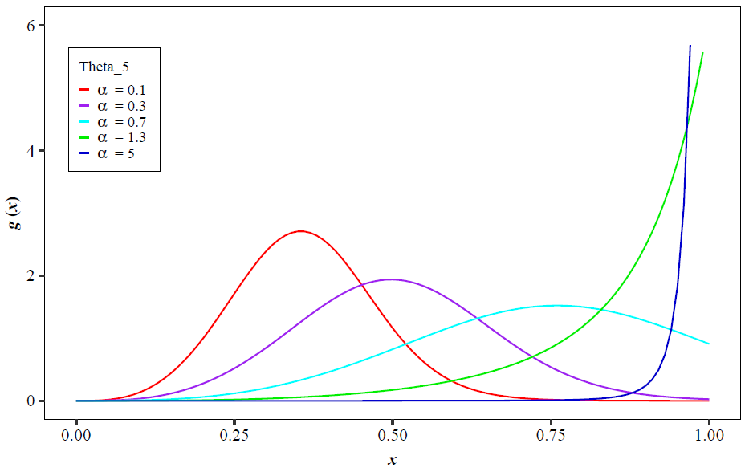

Figure 5. $g_{\left(J-S\right)}(x)$ for $k=3$

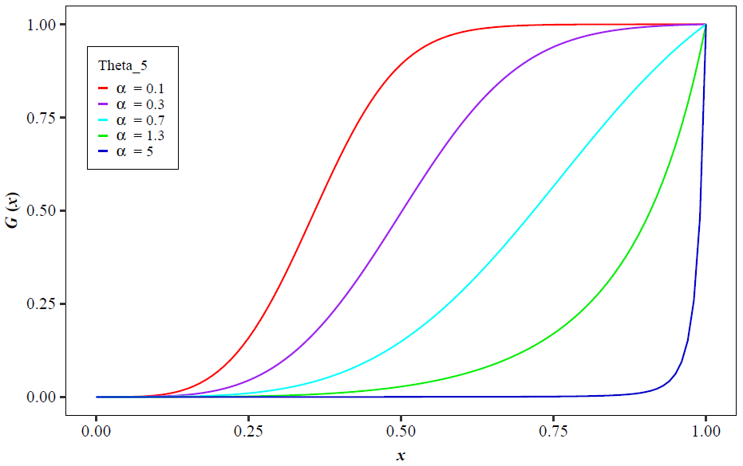

Figure 6. for

* 1. **Hazard and survival functions of the ${GPUD}_{(J-S)}$**

Our generalization is important because it makes possible the creation of a wide range of different hazard functions which can be applied to various analyses about survival or reliability studies in diverse areas such as medicine, engineering, economics, and others. Generally, we work with a one-dimensional and continuous random variable defined in [0, ∞) unless otherwise indicated, which measures the time between events.

The hazard function given by Jayakumar and Sankaran (2016) is,

|  |  |
| --- | --- |
| $$h\left(x\right)=\frac{g(x)}{\overline{G}(x)}=\frac{θ(1-α)}{\left[x\left(1-α\right)+α\right]\left[1-{\left(x\left(1-α\right)+α\right)}^{θ}\right]},$$ | (32) |

in our case, using the ${GPUD}_{(J-S)}$, where $\overline{F}(x)= 1- x^{k+1}$, we obtain a new family of hazard functions given in terms of the parameter $k$,

|  |  |
| --- | --- |
| $$h_{\left(J-S\right)}\left(x;α, θ, k\right)=\frac{θ\left(1-α\right)(k+1)x^{k}}{\left[α+\left(1-α\right)x^{k+1}\right]\left[1-{\left[α+\left(1-α\right)x^{k+1}\right]}^{θ}\right]}.$$ | (33) |

In Figure 7, the behavior of the hazard function $h_{\left(J-S\right)}(x)$ is shown, referred to the ${GPUD}_{(J-S)}$ for different values of $(α,θ,k)$. It should be noted that if we substitute the value of $k=1$ in Equation (33) we obtain the same results reported by the cited authors.

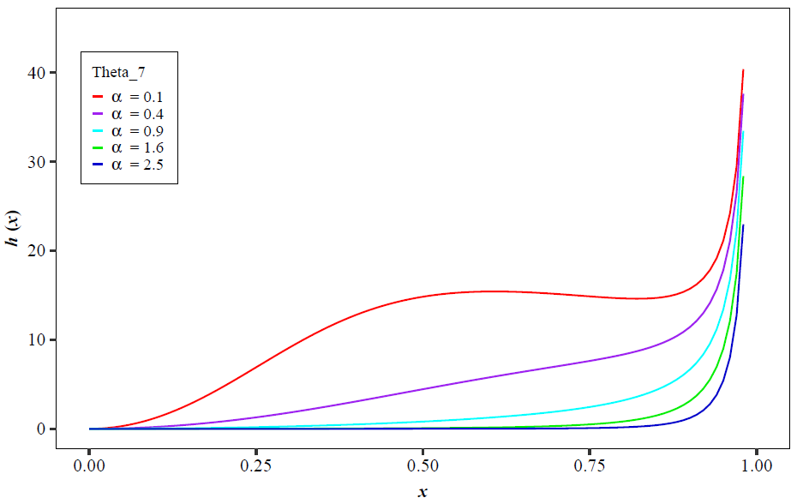

Figure 7. $h_{\left(J-S\right)}(x)$ for $k=2$

Here, in Figure 8, the behavior of the survival function $S_{\left(J-S\right)}(x)$ is shown, referring to the ${GPUD}_{(J-S)}$ for different values of $(α,θ,k)$.

|  |  |
| --- | --- |
| $$S_{\left(J-S\right)}\left(x;α, θ, k\right)=1-\left[\frac{{1-α}^{θ}{\left[x^{k+1}\left(1-α\right)+α\right]}^{-θ}}{1-α^{θ}}\right].$$ | (34) |

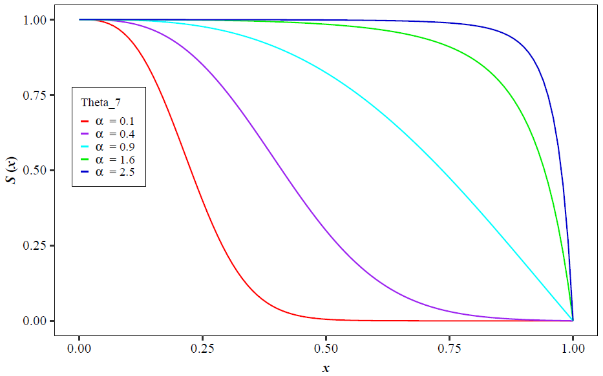

Figure 8. $S_{\left(J-S\right)}(x)$ for $k=2$

Our model notably provides greater versatility, since in this proposal a parameter $k$ is added, which intervenes as an exponent in the random variable's values, as is shown in the previous graphs (7 and 8).

* 1. **Parameters’ estimation of the ${GPUD}_{(J-S)}$**

Consider the estimation of unknown parameters using the maximum likelihood method (Okasha and Kayid, 2016; Torabi et al., 2018). For a sample of the random variable $(x_{1, }{ x}_{2, }{…,x}_{n })$, starting from Equation (31), in which an additional parameter $k$ was introduced which has been working on the generalizations proposed throughout this article. The log-likelihood function is given as,

|  |  |
| --- | --- |
| $$L\left(x;α, θ, k\right)=\prod_{i=1}^{n}{g_{(J-S)}\left(x_{i};α, θ, k\right)},$$ | (35) |

which from our proposal is expressed as,

|  |  |
| --- | --- |
| $$L\left(x;α, θ, k\right)={\left[\frac{α^{θ}θ(k+1)(1-α)}{1-α^{θ}}\right]}^{n}∙\prod_{i=1}^{n}{{x_{i}^{k}\left[\left(1-α\right)x_{i}^{k+1}+α\right]}^{-\left(θ+1\right)}}.$$ | (36) |

Note the relevance of the parameter $k$ in the previous expression, which comes from the generalization of the work of Jayakumar and Sankaran (2016), where only the parameters $α$ and $θ$ appear.

The corresponding maximum likelihood function is given as,

|  |  |
| --- | --- |
| $$lnL\left(x;α, θ, k\right)=n*ln\left(\frac{α^{θ}θ\left(k+1\right)\left(1-α\right)}{1-α^{θ}}\right)-\left(θ+1\right)\sum_{i=1}^{n}{ln\left[\left(1-α\right)x_{i}^{k+1}+α\right]}+k\sum_{i=1}^{n}{ln\left(x_{i}\right)}.$$ | (37) |

To obtain the covariance matrix $I^{-1}\left(β\right)$ and the corresponding estimators, the partial derivatives of the log-likelihood function were calculated and are given as,

|  |  |
| --- | --- |
| $$\frac{∂lnL}{∂α}=-\frac{n}{1-α}+\frac{nθ}{α}+\frac{nα^{θ-1}θ}{1-α^{θ}}-\left(θ+1\right)\sum_{i=1}^{n}{\frac{\left(1-x_{i}^{k+1}\right)}{x_{i}^{k+1}\left(1-α\right)+α}},$$ | (38) |

|  |  |
| --- | --- |
|  | (39) |

|  |  |
| --- | --- |
|  | (40) |

The maximum likelihood estimators can be obtained numerically by solving the equations, $\frac{∂lnL}{∂α}=0$, $\frac{∂lnL}{∂θ}=0$, and $\frac{∂lnL}{∂k}=0$.

On the other hand, the second derivatives of the log-likelihood function of ${GPUD}_{(J-S)}$ with respect to $α$, $θ$ and $k$ are given as,

|  |  |
| --- | --- |
| $$\frac{∂^{2}lnL}{∂α^{2}}=-\frac{n}{{\left(1-α\right)}^{2}}-\frac{nθ}{α^{2}}+n\frac{α^{θ}θ^{2}-α^{θ}θ{+α}^{2θ}θ}{{α^{2}\left(1-α^{θ}\right)}^{2}}-\left(θ+1\right)\sum_{i=1}^{n}{-\frac{{\left(1-x_{i}^{k+1}\right)}^{2}}{{\left[x_{i}^{k+1}\left(1-α\right)+α\right]}^{2}}},$$ | (41) |

|  |  |
| --- | --- |
|  | (42) |

|  |  |
| --- | --- |
|  | (43) |

|  |  |
| --- | --- |
|  | (44) |

|  |  |
| --- | --- |
|  |  |

|  |  |
| --- | --- |
|  | (45) |

|  |  |
| --- | --- |
|  | (46) |

The matrix of the maximum likelihood estimators of $β=(α,θ,k)$ for $\hat{β}=(\hat{α},\hat{θ},\hat{k})$, is given as,

|  |  |
| --- | --- |
| $$I\left(β\right)=-E\left[\begin{matrix}\frac{∂^{2}lnL}{∂α^{2}} & \frac{∂^{2}lnL}{∂α ∂θ} & \frac{∂^{2}lnL}{∂α ∂k} \\ \frac{∂^{2}lnL}{∂α ∂θ} & \frac{∂^{2}lnL}{∂θ^{2}} & \frac{∂^{2}lnL}{∂θ ∂k} \\ \frac{∂^{2}lnL}{∂α ∂k} & \frac{∂^{2}lnL}{∂θ ∂k} & \frac{∂^{2}lnL}{∂k^{2}}\end{matrix}\right].$$ | (47) |

Therefore, the covariance matrix will be $I^{-1}\left(β\right)$. The approximate confidence intervals $q$ to the $\left(1-δ\right)100\%$ for the parameters $α$, $θ$, and $k$ will be $\hat{α}±Z_{δ/2}\sqrt{V(\hat{α})}$, $\hat{θ}±Z_{δ/2}\sqrt{V(\hat{θ})}$, and $\hat{k}±Z_{δ/2}\sqrt{V(\hat{k})}$ respectively, where $V\left(\hat{α}\right)$, $V\left(\hat{θ}\right)$, and $V\left(\hat{k}\right)$ are the variances of $\hat{α}$, $\hat{θ}$, and $\hat{k}$ which are represented by elements of the principal diagonal of the matrix $I^{-1}\left(β\right)$ and $Z_{δ/2}$ is the $δ/2$ upper percentile of the standard normal distribution.

* 1. **Simulation, quantiles and median of the ${GPUD}_{(J-S)}$**

In this work we follow the approach proposed by several authors to calculate the inverse function of the DF where a known simulation mechanism generates random numbers. It follows that to obtain the model that simulates random numbers that have a $G_{(J-S)}\left(x; α, θ, k\right)$ behavior (Equation 30), the inverse function is expressed as,

|  |  |
| --- | --- |
| $$X=\sqrt[k+1]{\frac{α}{1-α}\left({\left[1-Y(1-α^{θ})\right]}^{-1/θ}-1\right)},$$ | (48) |

where $Y∼U(0,1)$ and $k=1, 2,…, n$.

For the particular case of $k=0$, the result reported by Jayakumar and Sankaran (2016) is obtained,

|  |  |
| --- | --- |
| $$X=\frac{α}{1-α}\left({\left[1-Y(1-α^{θ})\right]}^{-1/θ}-1\right).$$ |  |

On the other hand, it is interesting to calculate the *qth* quartile from the perspective of this research generalization, because it gives us information about the usual parameters of the distribution,

|  |  |
| --- | --- |
| $$x_{q}=\sqrt[k+1]{\frac{α}{1-α}\left[\frac{1}{{\left[1-q(1-α^{θ})\right]}^{1/θ}}-1\right]}.$$ | (49) |

In particular, we obtain the Median by putting $q=1/2$ in Equation (49).

Like in Equation (48), for $k=0$, in Equation (49), the result reported by Jayakumar and Sankaran (2016) is obtained,

|  |  |
| --- | --- |
| $$x_{q}=\frac{α}{1-α}\left[\frac{1}{{\left[1-q(1-α^{θ})\right]}^{1/θ}}-1\right]$$ |  |

In Table 3 we show the calculation of the medians to show one of the advantages of our model for different values of the parameters $(α,θ,k)$.

**Table 3.** Median of the ${GPUD}_{(J-S)}$ distribution

|  |  |  |  |
| --- | --- | --- | --- |
| $$α$$ | $$θ$$ | $$k$$ | Median |
| 0.999 | 1 | 0 | 0.500 |
| 0.1 | 5 | 1 | 0.017 |
| 0.5 | 2.9 | 2 | 0.465 |
| 0.2 | 3.5 | 3 | 0.379 |
| 0.3 | 4.5 | 4 | 0.516 |
| 0.4 | 6 | 5 | 0.605 |

Conversely, a simulation study was conducted to verify the MLE's performance for different sample sizes and different parameter values for the ${GPUD}_{(J-S)}$. Equation (48) was used to generate a random sample of the ${GPUD}_{(J-S)}$ with parameters $(α,θ,k)$. The different sample sizes considered in the simulation are $n=50, 100, 500$, and $1000$. In the simulation, we have used the maxLik package in R-language to find the parameter estimates. The process was replicated 1000 times for each sample size, and we reported the average parameter estimate and the associated mean square errors. The results are reported in Table 4. As the sample size increases, the mean bias and mean square errors decrease, indicating the consistency property of the MLE.

**Table 4**. Simulation results for some different values of the parameters $α,θ$, and $k$.

|  |  |  |  |
| --- | --- | --- | --- |
| Parameters | $$n=50$$ | | |
| $$(α,θ,k)$$ | $$\hat{α}\left(\hat{S}E\left(\hat{α}\right)\right)$$ | $$\hat{θ}\left(\hat{S}E\left(\hat{θ}\right)\right)$$ | $$\hat{k}\left(\hat{S}E\left(\hat{k}\right)\right)$$ |
| $$0.1, 5.0, 1$$ | 0.1824(0.0381) | 6.5601(1.1336) | 0.8977(0.0264) |
| $$0.3,4. 5, 4$$ | 0.3118(0.0749) | 4.5536(1.1644) | 3.9607(0.1424) |
| $$0.5, 2.9, 2$$ | 0.5727(0.1364) | 3.5358(1.8380) | 1.9710(0.0836) |
| $$0.2, 3.5, 3$$ | 0.2401(0.2787) | 3.9706(1.2449) | 3.3686(0.1351) |
| $$0.4, 6.0, 5$$ | 0.4813(0.3773) | 6.4273(1.5653) | 5.3987(0.3607) |
|  | $$n=100$$ | | |
| $$0.1, 5.0, 1$$ | 0.0942(0.0091) | 4.9550(0.31965) | 1.0153(0.0131) |
| $$0.3,4. 5, 4$$ | 0.2894(0.0243) | 4.3186(0.5959) | 4.0191(0.0601) |
| $$0.5, 2.9, 2$$ | 0.5353(0.0399) | 3.2871(0.4759) | 1.9783(0.0351) |
| $$0.2, 3.5, 3$$ | 0.2237(0.0246) | 3.8212(0.3720) | 2.9831(0.0465) |
| $$0.4, 6.0, 5$$ | 0.4135(0.1233) | 6.3185(0.4801) | 5.0704(0.0643) |
|  | $$n=500$$ | | |
| $$0.1, 5.0, 1$$ | 0.1059(0.0046) | 5.2748(0.1395) | 1.0024(0.0083) |
| $$0.3,4. 5, 4$$ | 0.3176(0.0153) | 4.5384(0.2283) | 3.9159(0.0384) |
| $$0.5, 2.9, 2$$ | 0.5077(0.0325) | 2.9661(0.4098) | 2.0083(0.0286) |
| $$0.2, 3.5, 3$$ | 0.2116(0.0137) | 3.6814(0.1843) | 2.9787(0.0445) |
| $$0.4, 6.0, 5$$ | 0.4057(0.0710) | 6.1182(0.2961) | 5.0090(0.0462) |
|  | $$n=1000$$ | | |
| $$0.1, 5.0, 1$$ | 0.10584(0.0037) | 5.1328(0.1187) | 0.9977(0.0064) |
| $$0.3,4. 5, 4$$ | 0.3059(0.0108) | 4.5210(0.1629) | 3.9930(0.0311) |
| $$0.5, 2.9, 2$$ | 0.5034(0.0195) | 2.9958(0.13785 | 2.0009(0.0158) |
| $$0.2, 3.5, 3$$ | 0.20877(0.0097) | 3.5549(0.0931) | 2.9905(0.0250) |
| $$0.4, 6.0, 5$$ | 0.3992(0.0134) | 6.0348(0.0253) | 5.0038(0.0191) |

1. **Application to real data**

In this section, we present the GPUD(J-S) family's practical utility through the analysis of two sets of real data to show the potential of the new family of distributions. The first set of data is related to the global health problem currently being experienced by the pandemic caused by a new strain of coronavirus (COVID-19), which has infected more than 187 million people around the world and has caused the death of more than 4 million people as of June 31, 2021. The data correspond to people who died from COVID-19 and also had diabetes. The time span from onset of symptoms to patient’s death was analyzed. The data is collected from Mexico, specifically it was obtained from the Secretary of Health of the Government of Mexico (<https://www.gob.mx/salud/documentos/datos-abiertos-bases-historicas-direccion-general-de-epidemiologia>). The data correspond from February 27 (first person infected with COVID in Mexico and had diabetes) to April 20, 2020. A total of 1113 data was obtained up to that date.

It should be clarified that the information of the referred source is available in days (dates). However, it was necessary for compatible calculation purposes to divide each data by the longest life span of the infected persons (76.1 days) to obtain values of the study variable in the interval $0<x<1$, as this is a requirement of our model.

The second set of data refers to the remission times (in months) of a sample of 128 patients with bladder cancer presented by Shakhatreh (2018):

0.08, 0.20, 0.40, 0.50, 0.51, 0.81, 0.90, 1.05, 1.19, 1.26, 1.35, 1.40, 1.46, 1.76, 2.02, 2.02, 2.07, 2.09, 2.23, 2.26, 2.46, 2.54, 2.62, 2.64, 2.69, 2.69, 2.75, 2.83, 2.87, 3.02, 3.25, 3.31, 3.36, 3.36, 3.48, 3.52, 3.57, 3.64, 3.70, 3.82, 3.88, 4.18, 4.23, 4.26, 4.33, 4.34, 4.40, 4.50, 4.51, 4.87, 4.98, 5.06, 5.09, 5.17, 5.32, 5.32, 5.34, 5.41, 5.41, 5.49, 5.62, 5.71, 5.85, 6.25, 6.54, 6.76, 6.93, 6.94, 6.97, 7.09, 7.26, 7.28, 7.32, 7.39, 7.59, 7.62, 7.63, 7.66, 7.87, 7.93, 8.26, 8.37, 8.53, 8.65, 8.66, 9.02, 9.22, 9.47, 9.74, 10.06, 10.34, 10.66, 10.75, 11.25, 11.64, 11.79, 11.98, 12.02, 12.03, 12.07, 12.63, 13.11, 13.29, 13.80, 14.24, 14.76, 14.77, 14.83, 15.96, 16.62, 17.12, 17.14, 17.36, 18.10, 19.13, 20.28, 21.73, 22.69, 23.63, 25.74, 25.82, 26.31, 32.15, 34.26, 36.66, 43.01, 46.12, 79.05.

In this case, a similar procedure was performed to the COVID-19 dataset. For this second set, each data was divided by 79.051 to obtain values of the study variable in the interval $0<x<1$.

The fit of the ${GPUD}_{(J-S)}$ distribution is compared with the following lifetime distributions for a continuous variable $X$:

1. Weibull distribution having PDF
$$g\left(x; λ, β\right)=\frac{λ}{β^{λ}}\left(x^{λ-1}\right)e^{-{\left(\frac{x}{β}\right)}^{λ}}; λ, β>0.$$

2. Exponentiated Weibull (EW) distribution (Pal et al., 2006) having PDF
$$g\left(x;α, λ, γ\right)=αγλ^{γ}\left(x^{γ-1}\right){\left(1-e^{-{\left(λx\right)}^{γ}}\right)}^{α-1}\left(e^{-{\left(λx\right)}^{γ}}\right); α, λ, γ>0.$$

3. New Marshall-Olkin Weibull (NMOW) distribution (Cui et al., 2020) having PDF
$$g\left(x;θ, λ, β\right)=\frac{θλβ\left(x^{β-1}\right)\left(e^{-{\left(λx\right)}^{β}}\right)}{{\left(θ+\left(θ-1\right)e^{-{\left(λx\right)}^{β}}\right)}^{2}}; θ, λ, β>0.$$

4. Kumaraswamy exponential-Weibull (KwEW) distribution (Cordeiro et al. 2016) having PDF
$$g\left(x;α,γ, k, β,λ\right)=αγ\left(λ+kβx^{k-1}\right)e^{-λx-βx^{k}}{\left(1-e^{-λx-βx^{k}}\right)}^{-1+α}$$

$$*{\left[1-{\left(1-e^{-λx-βx^{k}}\right)}^{α}\right]}^{-1+γ}1_{R_{+}}(x); α,γ, k, β,λ>0.$$

5. Alpha power transformed Weibull (APTW) distribution (Dey et al. 2017) having PDF
$$g\left(x;α, β,λ\right)=\frac{logα}{α-1}βλx^{λ-1}e^{-βx^{λ}}α^{\left(1-e^{-βx^{λ}}\right)}; β, λ>0, \text{and }α≠0$$

6. Extended Exponentiated Weibull (EEW) distribution (Bidram et al. 2015) having PDF

$$g\left(x;λ, α, β, γ\right)=\frac{γαβλ^{β}x^{β-1}e^{-{\left(λx\right)}^{β}}{\left(1-e^{-{\left(λx\right)}^{β}}\right)}^{α-1}}{{\left[1-\left(1-γ\right)\left(1-{\left(1-e^{-{\left(λx\right)}^{β}}\right)}^{α}\right)\right]}^{2}}; λ, α, β, γ>0.$$

Tables 5 and 6 present the calculations obtained from the seven distributions for the values of the estimators, log-likelihood (–log L), Akaike Information Criterion (AIC) and Bayesian Information Criterion (BIC). According to Jayakumar and Sankaran (2019), $AIC=-2logL+2k$ y $BIC=-2logL+klog(n)$. $L$ is the likelihood function evaluated in the maximum likelihood estimates, $k$ is the number of parameters, and $n$ is the sample (data set). Additionally, the Crammer-von Mises (W*), Anderson-Darling (A*), and Kolmogorov-Smirnov (K-S) statistics and their corresponding $p$-value are calculated in order to test the goodness of fit and have other criteria. That allows identifying which of these distributions best fits the data set. Usually, the smaller the K-S, W*, and A* statistics' values, we find that the fit to the data is better.

Note that in Table 5, the K-S statistic of the ${GPUD}_{(J-S)}$ distribution is the smallest compared to the other distributions, and therefore the value corresponding to the $p$-value is the highest, which shows that this new proposal produces the best fit for the COVID-19 dataset. On the other hand, referring to Table 6 corresponding to those for bladder cancer, something similar occurs with the ${GPUD}_{(J-S)}$, where the calculated values of K-S and the $p$-value show the best fit of the data.

**Table 5.** Parameter estimates and goodness-of-fit statistics for COVID-19 data.

|  |  |  |  |  |  |  |  |  |
| --- | --- | --- | --- | --- | --- | --- | --- | --- |
| **Model** | **MLEs** | **−log L** | **AIC** | **BIC** | **W\*** | **A\*** | **K−S** | ***p*-value** |
| $${GPUD}_{(J-S)}$$ | $$\hat{θ}=1.3820$$ $$\hat{α}=0.0171$$ $$\hat{k}=1.3556$$ | $$996.80$$ | $$1987.6$$ | $$1972.55$$ | $$0.040$$ | $$0.286$$ | $$0.015$$ | $$0.938$$ |
| Weibull | $$\hat{λ}=1.5267$$ $$\hat{β}=0.2010$$ | $$1049.43$$ | $$2102.87$$ | $$2112.90$$ | $$1.215$$ | $$7.836$$ | $$0.063$$ | $$0.000$$ |
| EW | $$\hat{α}=4.6592$$ $$\hat{λ}=15.684$$ $$\hat{γ}=0.8000$$ | $$1009.16$$ | $$2024.32$$ | $$2039.37$$ | $$0.109$$ | $$0.842$$ | $$0.024$$ | $$0.539$$ |
| NMOW | $$\hat{θ}=23.594$$ $$\hat{λ}=4.7847$$ $$\hat{β}=2.4901$$ | $$1012.29$$ | $$2030.59$$ | $$2045.63$$ | $$0.062$$ | $$0.433$$ | $$0.017$$ | $$0.892$$ |
| KwEW | $$\hat{α}=5.1356$$ $$\hat{γ}=0.8671$$ $$\hat{k}=0.7149$$ $$\hat{β}=5.9909$$ $$\hat{λ}=4.4400$$ | $$1008.85$$ | $$2027.70$$ | $$2052.78$$ | $$0.115$$ | $$0.883$$ | $$0.024$$ | $$0.507$$ |
| APTW | $$\hat{α}=0.0081$$ $$\hat{β}=5.3347$$ $$\hat{λ}=1.8937$$ | $$998.913$$ | $$2003.82$$ | $$2018.87$$ | $$0.371$$ | $$2.432$$ | $$0.031$$ | $$0.222$$ |
| EEW | $$\hat{λ}=5.5779$$ $$\hat{α}=2.6910$$ $$\hat{β}=1.1188$$ $$\hat{γ}=0.2539$$ | $$1010.26$$ | $$2028.53$$ | $$2048.58$$ | $$0.121$$ | $$0.804$$ | $$0.020$$ | $$0.728$$ |

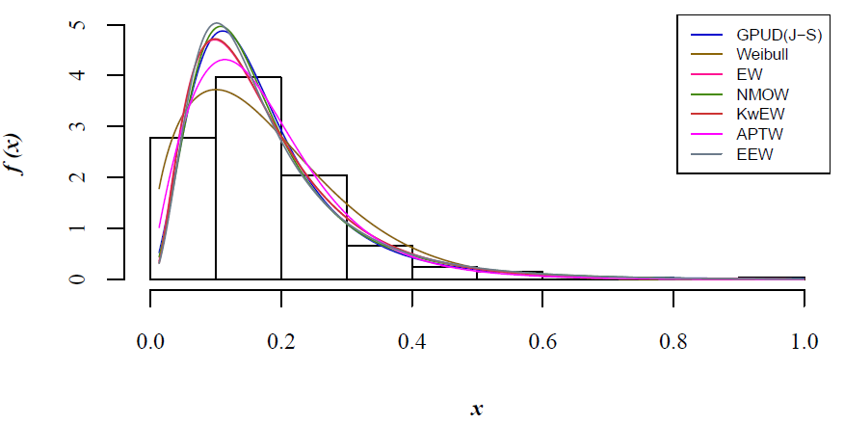

Figure 9. The fitted PDFs of the ${GPUD}_{(J-S)}$, W, EW, NMOW, KwEE, APTW, and EEW for Covid-19 data.

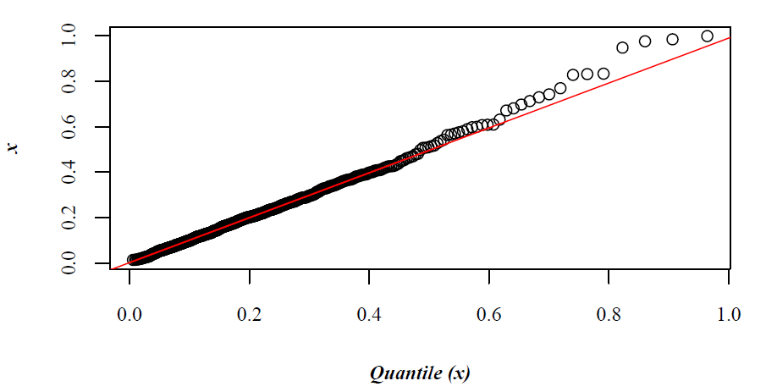

Figure 10. Q-Q plot for the ${GPUD}_{(J-S)}$ distribution for the COVID-19 data set.

**Table 6.** Parameter estimates and goodness-of-fit statistics for cancer data.

|  |  |  |  |  |  |  |  |  |
| --- | --- | --- | --- | --- | --- | --- | --- | --- |
| **Model** | **MLEs** | **−log L** | **AIC** | **BIC** | **W\*** | **A\*** | **K−S** | ***p*-value** |
| $${GPUD}_{(J-S)}$$ | $$\hat{θ}=1.5927$$ $$\hat{α}=0.0380$$ $$\hat{k}=0.5148$$ | $$150.15$$ | $$294.30$$ | $$285.74$$ | $$0.052$$ | $$0.409$$ | $$0.029$$ | $$0.999$$ |
| Weibull | $$\hat{λ}=1.0465$$ $$\hat{β}=0.1212$$ | $$145.28$$ | $$294.56$$ | $$300.27$$ | $$0.130$$ | $$0.783$$ | $$0.070$$ | $$0.541$$ |
| EW | $$\hat{α}=2.1044$$ $$\hat{λ}=16.732$$ $$\hat{γ}=0.7325$$ | $$148.42$$ | $$302.84$$ | $$311.40$$ | $$0.052$$ | $$0.329$$ | $$0.055$$ | $$0.820$$ |
| NMOW | $$\hat{θ}=11.957$$ $$\hat{λ}=4.5675$$ $$\hat{β}=1.5857$$ | $$149.21$$ | $$304.42$$ | $$312.98$$ | $$0.028$$ | $$0.205$$ | $$0.031$$ | $$0.999$$ |
| KwEW | $$\hat{α}=2.9478$$ $$\hat{γ}=0.9958$$ $$\hat{k}=0.5311$$ $$\hat{β}=4.5388$$ $$\hat{λ}=4.3906$$ | $$148.26$$ | $$306.52$$ | $$320.78$$ | $$0.058$$ | $$0.368$$ | $$0.050$$ | $$0.897$$ |
| APTW | $$\hat{α}=0.0500$$ $$\hat{β}=5.5405$$ $$\hat{λ}=1.2415$$ | $$148.81$$ | $$303.62$$ | $$312.18$$ | $$0.044$$ | $$0.273$$ | $$0.055$$ | $$0.832$$ |
| EEW | $$\hat{λ}=2.6368$$ $$\hat{α}=1.0580$$ $$\hat{β}=1.5018$$ $$\hat{γ}=0.0808$$ | $$149.22$$ | $$306.44$$ | $$317.85$$ | $$0.029$$ | $$0.211$$ | $$0.040$$ | $$0.984$$ |

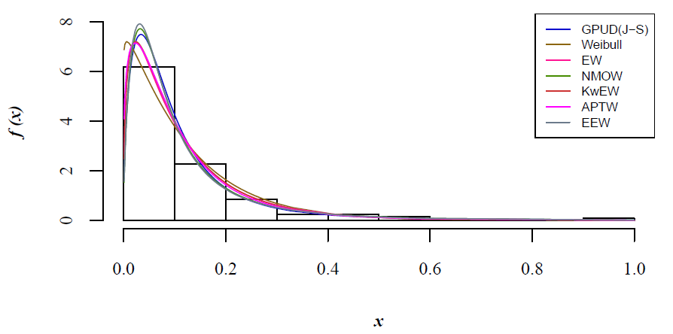

Figure 11. The fitted PDFs of the ${GPUD}_{(J-S)}$, W, EW, NMOW, KwEE, APTW, and EEW for bladder cancer data.

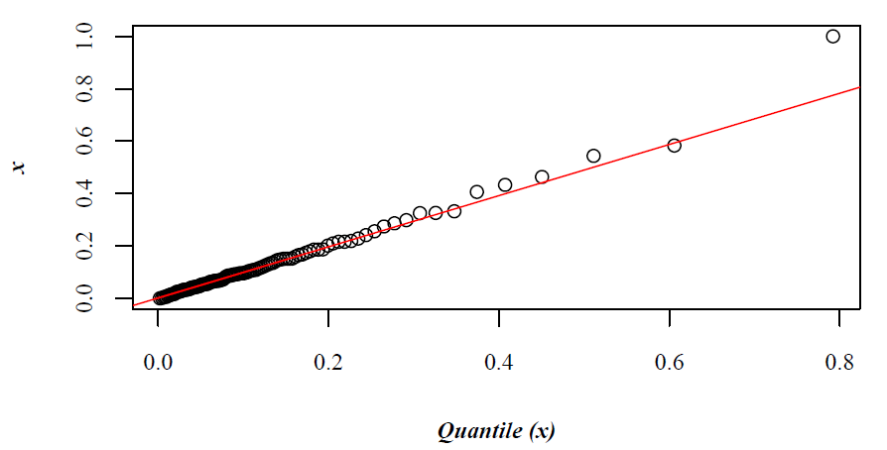

Figure 12. Q-Q plot for the ${GPUD}_{(J-S)}$ distribution for bladder cancer data.

Figures 9 and 11 show the fit of the different distributions contrasted with the ${GPUD}_{(J-S)}$. As can be seen in the figures, our model presents excellent flexibility, and it is competitive with other widely accepted distributions in use such as the Weibull distribution or the Exponentiated Weibull, among others.

1. **Conclusions**

This article introduced a new family of the usual uniform distribution with three parameters $(a,b,k)$, called Generalized Potenciada Uniform Distribution $(GPUD).$ The method used in this proposal incorporates a parameter $k$ as the power of the values of the continuous random variable favoring a greater diversity of the probability density and survival and hazard functions. Furthermore, some properties are derived from the new distribution.

Motivated by these findings, we deepened our research approach which allowed us to generalize the model presented in Jayakumar and Sankaran (2016). Doing so made it possible to generate a new family of distributions, called ${GPUD}_{(J-S)}$ which presents excellent flexibility in the cumulative distribution function due to the presence of the parameter $k$. To clarify our GPUD approach allows us to generalize other models, too, such as that of Jose and Krishna (2011), which is research in process. To demonstrate the effectiveness of the model, two sets of real data related to COVID-19 and bladder cancer were adapted, and the maxLik package in R-language was used to find the estimators of the parameters.

The results obtained show that the ${GPUD}_{(J-S)}$ is a valid alternative to other known distributions, such as the Weibull, Exponentiated Weibull, New Marshall-Olkin Weibull distributions, among others, with the added advantage that it provides the versatility of working with the parameter $k$ in the values of the random variable.

**Acknowledgements**

The authors acknowledge partial support from PRODEP and CONACyT, MEXICO.

**References**

Alshangiti, A. M., Kayid, M., & Alarfaj, B. (2014). A new family of Marshall-Olkin extended distributions. *Journal of Computational and Applied Mathematics*, 271, 369–379.

Bidram, H., Alamatsaz, M. H., & Nekoukhou, V. (2015). On an extension of the exponentiated weibull distribution. *Communications in Statistics: Simulation and Computation*, 44(6), 1389–1404.

Cordeiro, G. M., Saboory, A., Khanz, M. N., Ozel, Gamze., & Pascoa, M. A. R. (2016). The Kumaraswamy exponential-Weibull distribution: theory and applications. *Hacettepe Journal of Mathematics and Statistics*. 45(4), 1203-1229

Cui, W., Yan, Z., & Peng, X. (2020). A New Marshall Olkin Weibull Distribution. *Engineering Letters*, 28(1), 63–68.

Dey, S., Sharma, V. K., & Mesfioui, M. (2017). A New Extension of Weibull Distribution with Application to Lifetime Data. *Annals of Data Science*, 4(1), 31–61.

García, V., Martel-Escobar, M., & Vázquez-Polo, F. J. (2020). Generalising Exponential Distributions Using an Extended Marshall-Olkin Procedure. *Symmetry*, 12(3), 464.

Jayakumar, K., & Sankaran, K. K. (2019). Discrete Linnik Weibull distribution. *Communications in Statistics: Simulation and Computation*, 48(10), 3092–3117.

Jayakumar, K., & Sankaran, K. K. (2016). On a generalisation of uniform distribution and its properties. *Statistica*, 76(1), 83–91.

Jose, K. K., & Krishna, E. (2011). Marshall-Olkin extended uniform distribution. *ProbStat Forum*, 4(October), 78–88.

Law, A. M. (2007). Simultion Modeling and Analysis. McGraw-Hill International.

Marshall, A. W., & Olkin, I. (1997). A new method for adding a parameter to a family of distributions with application to the exponential and Weibull families. *Biometrika*, 84(3), 641–652.

Nassar, M., Afify, A. Z., Dey, S., & Kumar, D. (2018). A new extension of Weibull distribution: Properties and different methods of estimation. *Journal of Computational and Applied Mathematics*, 336, 439–457.

Okasha, H. M., & Kayid, M. (2016). A new family of Marshall-Olkin extended generalized linear exponential distribution. *Journal of Computational and Applied Mathematics*, 296, 576–592.

Pal, M., Ali, M. M., & Woo, J. (2006). Exponentiated Weibull distribution. *STATISTICA*, 66(2), 139–147.

Rondero-Guerrero, C., González-Hernández, I., & Soto-Campos, C. (2020). On a generalized uniform distribution. *Advances and Applications in Statistics*, 60(1), 93–103.

Sankaran, K. K., & Jayakumar, K. (2016). A New Extended Uniform Distribution. *International Journal of Statistical Distributions and Applications*, 2(3), 35–41.

Shakhatreh, M. K. (2018). A new three-parameter extension of the log-logistic distribution with applications to survival data. *Communications in Statistics - Theory and Methods*, 47(21), 5205–5226.

Torabi, H., Bagheri, F. L., & Mahmoudi, E. (2018). Estimation of parameters for the Marshall–Olkin generalized exponential distribution based on complete data. *Mathematics and Computers in Simulation*, 146, 177–185.