Table 1 Sociodemographic characteristics of the study population by number of children (N = 894,608 women)
P-value | Women with ≥ 3 children  n = 426,627  (47.6%) | Women with 1–2 children  n = 284,841  (31.8%) | Women with no children  n = 183,500  (20.5%) |  | Variable
< 0.001 | 38.70 (5.95) | 38.63(5.42) | 39.95 (5.65) |  | Mean age, years, at the beginning of the study (SD)
< 0.001 | 75.6 | 95.1 | 86.2 | Non-Haredi Jewish | Ethno-religious group
 | 6.2 | 1.6 | 0.9 | Haredi Jewish
 | 18.2 | 3.3 | 12.9 | Arab
< 0.001 | 27.2 | 21.4 | 50.9 | 0–8 | Education (years)
 | 39.9 | 28.8 | 15.2 | 9–12
 | 32.8 | 49.8 | 33.9 | ≥ 13
< 0.001 | 23.2 | 62.6 | 55.7 | Europe/America | Country of origin
 | 38.1 | 18.6 | 20.0 | Asia/Africa
 | 38.5 | 18.8 | 24.3 | Israel
< 0.001 | 24.4 | 10.8 | 15.7 | Small | Size of locality of residence
 | 75.6 | 89.2 | 84.3 | Large
SD, standard deviation

Table 2 Breast cancer mortality rates by sociodemographic characteristics among the total population (N = 894,608 women)
P-value | Age-adjusted hazard ratio (99% CI) | Mortality rate per 10,000 during the study period
 | 1.00 | 86.61 | 0 | Number of children
< 0.001 | 1.375 (1.270–1.487) | 111.75 | 1–2
< 0.001 | 1.213 (1.125–1.308) | 99.47 | ≥ 3
 | 1.00 | 106.49 | Non-Haredi Jewish | Ethno-religious group
< 0.001 | 0.812 (0.690–0.956) | 81.11 | Haredi Jewish
< 0.001 | 0.871 (0.793–0.956) | 85.40 | Arab
 | 1.00 | 85.51 | 0–8 | Education (years)
< 0.001 | 1.483(1.382–1.592) | 110.21 | 9–12
< 0.001 | 1.402(1.310–1.501) | 107.25 | ≥ 13
 | 1.00 | 96.99 | Asia/Africa | Country of origin
0.013 | 1.071 (0.997–1.143) | 105.25 | Israel
< 0.001 | 1.109 (1.031–1.192) | 107.60 | Europe/America
 | 1.00 | 84.30 | Small | Size of locality of residence
< 0.001 | 1.212(1.125-1.306) | 105.10 | Large
CI, confidence interval
Table 3 Breast cancer mortality rates by number of children in the total population and by age-based follow-up groups (30–49, 50–64, and 65–80 years)
65-80 years age-based follow-up group | 50-64 years age-based follow-up group | 30–49 years age-based follow-up group | Total population | Number of children
136,152 | 173,100 | 175,033 | 183,500 | 0 | Number of women
234,494 | 274,290 | 277,462 | 284,841 | 1–2
382,312 | 409,714 | 413,665 | 426,267 | ≥ 3
851,776 | 2,480,704 | 1,817,985 | 5,150,465 | 0 | Cumulative follow-up person-years
1,159,285 | 3,888,177 | 3,196,267 | 8,243,729 | 1–2
1,842,596 | 5,810, 580 | 4,766,571 | 12,419,747 | ≥ 3
31.07 | 48.18 | 14.00 | 86.61 | 0 | Breast cancer mortality rate per 10,000 in the follow-up period
32.11 | 58.55 | 24.36 | 111.75 | 1–2
25.21 | 52.57 | 22.51 | 99.47 | ≥ 3
49.66 | 33.62 | 13.48 | 29.29 | 0 | Breast cancer mortality rate per 100,000 person-years
64.95 | 41.30 | 21.15 | 36.81 | 1–2
52.32 | 37.07 | 19.53 | 32.75 | ≥ 3
1.00 | 1.00 | 1.00 | 1.00 | 0 | Aged-adjusted hazard ratio for breast cancer mortality
1.351 (1.155–1.581)** | 1.273 (1.140–1.421)** | 1.195 (1.092–1.307)** | 1.375 (1.270–1.487)* | 1–2
1.082 (0.931–1.258)** | 1.141 (1.027–1.267)** | 1.140 (1.114–1.166)** | 1.213 (1.125–1.308)* | ≥ 3
*Adjusted for age at the beginning of the study
**Adjusted for entry year in the aged follow-up period

Table 4 Results of multivariable Cox models for predicting breast cancer mortality rates by number of children and sociodemographic variables (hazard ratio) in the total population and by age-based follow-up groups (30–49, 50–64, and 65–80 years)
**Model D  65–80 years age-based follow-up group | **Model C  50–64 years age-based follow-up group | Model B**  30–49 years age-based follow-up group | *Model A  total population
752,958 | 857,104 | 866,160 | 894,608 |  | N
1.00 | 1.00 | 1.00 | 1.00 | 0 | Number of children
1.237 (1.045–1.466) | 1.071 (0.949–1.209) | 1.656 (1.349–2.033) | 1.216 (1.117–1.324) | 1–2
0.989 (0.834–1.173) | 0.935 (0.830–1.054) | 1.551 (1.271–1.893) | 1.056 (0.970–1.149) | ≥ 3
1.00 | 1.00 | 1.00 | 1.00 | Non-Haredi Jewish | Ethno-religious group
0.711 (0.54–0.935) | 0.873 (0.703–1.084) | 0.720 (0.623–0.865) | 0.776 (0.658–0.915) | Haredi Jewish
0.825 (0.648–1.051) | 1.079 (0.922–1.263) | 0.784 (0.601–0.962) | 0.852 (0.715–0.911) | Arab
1.00 | 1.00 | 1.00 | 1.00 | 0–8 | Education (years)
1.478 (1.263–1.665) | 1.558 (1.392–1.745) | 1. | 1.471 (1.361–1.589) | 9–12
1.422 (1.263–1.729) | 1.598 (1.428–1.788) | 0.965 (0.886–1.051) | 1.388 (1.283–1.501) | ≥ 13
1.00 | 1.00 | 1.00 | 1.00 | Asia/Africa | Country of origin
0.977 (0.836–1.142) | 0.950 (0.855–1.055) | 1.028 (0.873–1.210) | 0.994 (0.923–1.072) | Israel
1.019 (0.963–1.203) | 1.088 (0.974–1.215) | 1.254 (1.059–1.487) | 1.136 (1.050–1.230) | Europe/America
1.00 | 1.00 | 1.00 | 1.00 | Small | Size of locality of residence
1.278 (1.077–1.516) | 1.123 (1.007–1.251) | 1.298 (1.094–1.541) | 1.205 (1.113–1.304) | Large
* Adjusted for age at the beginning of study
** Adjusted for entry year in the aged follow-up period

Fig. 1 Analysis of breast cancer mortality rates by number of children, adjusted for age at the beginning of the follow-up period, level of education, ethno-religious group, country of origin, and size of locality of residence in the total population and by age-based follow-up groups (30–49, 50–64, and 65–80 years)

Entire study period | 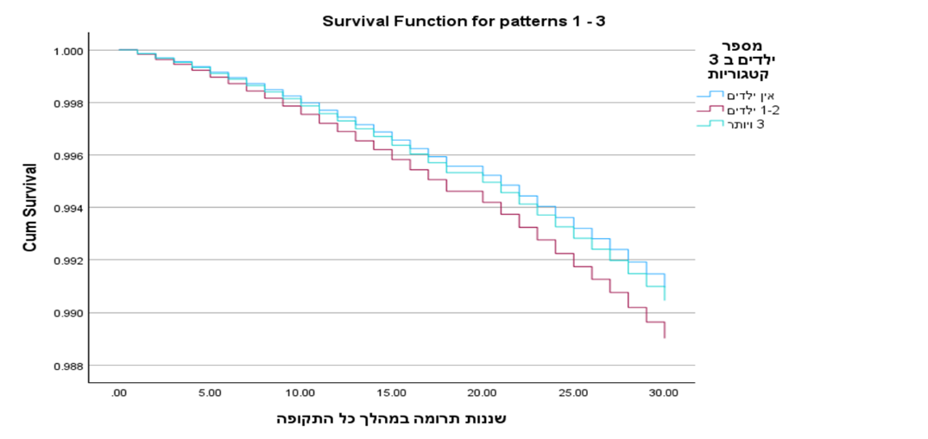
30–49 years age-based study period | 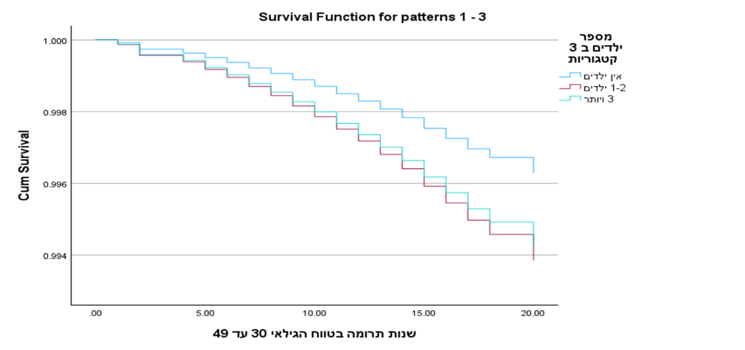
50–64 years age-based study period | 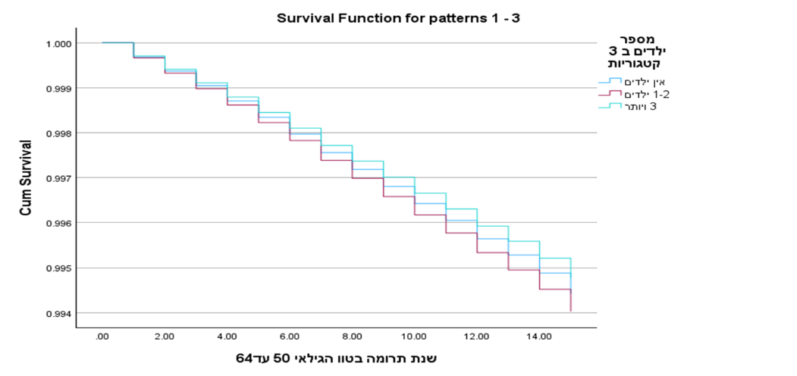
65–80 years age-based study period | 