**Health Perception and Anxiety Among Displaced and General Populations: The Mediating Role of Emotional Well-Being and Functioning**

**Authors: Orly toren1; Zipora novosler1; Dalia selig1; Maayan baron1; Galit Madar1**

**1 Ono Academic College, Academic Boulevard, Kiriat Ono**

Abstract

**Background:**  
Forced displacement is a significant public health challenge associated with deteriorated mental and physical health outcomes. Following the 2023 Israel's "Iron of sward" war started on October 7th), over 250,000 Israeli citizens were evacuated from their homes. Previous research has consistently documented elevated anxiety and poor health perception among displaced populations; however, the extent to which displacement itself contributes to anxiety has not been directly examined or established.

**Objective:**  
To compare levels of anxiety and health perception between displaced and non-displaced Israeli adults and to examine the mediating roles of emotional well-being and emotional functioning in the relationship between displacement status and anxiety.

**Methods:**  
A cross-sectional, comparative quantitative study was conducted using validated self-report questionnaires to assess health perception (SF-36) and anxiety (GAD-7). The study sample comprised 98 adults, including 46 displaced individuals and 52 participants from the general population. Differences in health dimensions and anxiety levels were analyzed using t-tests, correlation analyses, and regression models. To advance understanding beyond previous research, mediation analysis based on the Conservation of Resources (COR) theory was employed, enabling identification of the psychological mechanisms through which displacement influences anxiety.

**Results:**  
Displaced participants reported significantly lower scores across all SF-36 dimensions and significantly higher anxiety levels compared to the general population. Regression analyses indicated that emotional well-being and emotional functioning were significant predictors of anxiety, whereas displacement status alone was not a direct predictor once mediators were included. Mediation analysis further demonstrated that both emotional well-being and emotional functioning fully mediated the relationship between displacement and anxiety

**Conclusion:**  
Forced displacement has lasting negative effects on mental health, with internally displaced persons (IDPs) showing persistently high anxiety even one year after the war. These outcomes are driven primarily by erosion of emotional and functional resources. Strengthening psychological resilience and ensuring continuity of care should therefore be central goals for clinical practice and public health policy.

Introduction

Internal displacement, as defined by the United Nations Guiding Principles, refers to situations in which individuals or groups are forced to flee their homes due to conflict, violence, persecution, or disasters. Unlike refugees, internally displaced people (IDPs) remain within the borders of their own country1.

As of 2021, there were approximately 48 million people worldwide who had fled or were forced to leave their homes in areas affected by conflict or war, relocating to other parts of their own countries2. The largest internally displaced population since World War II has been observed in Ukraine, with 6.5 million IDPs and 6.3 million refugees3.

Internal displacement is closely linked to widespread impacts on both the mental and physical health of affected populations. Recent studies indicate a high prevalence of medical problems among IDPs, including respiratory infections, chronic pain, sleep disorders, and reduced functioning, alongside elevated rates of anxiety, depression, and Post Traumatic Stress Disorder. A recent study found that approximately 45% of IDPs reported poor physical health, 14% reported anxiety, and 18% reported depression4.

In Israel, the “Iron Swords” war, which erupted on October 7, 2023, led to the evacuation of hundreds of thousands of Israeli citizens from their homes. According to data collected by the Knesset Research and Information Center, approximately 253,000 Israelis were forced to flee and evacuate their homes in the first days following the surprise attack carried out by the Hamas terrorist organization on communities near the Gaza border on October 7, 20235. As of September 2024, about 143,000 citizens still remain displaced from their homes6.

This situation poses a unique challenge for Israel’s healthcare system due to its physical and mental health implications. Various communities from both the north and the south were evacuated to hotels across the country, where they resided for many months. In some of these communities, there are signs of social disconnection and weakening community ties6, a reality that further exacerbates the health-related—both physical and mental—challenges.

**Anxiety** – following displacement and extended periods of living away from home in temporary housing—often marked by overcrowding, lack of privacy, and, at times, the absence of educational and employment opportunities—IDPs are at increased risk of developing conditions such as depression, anxiety, loneliness, and other mental health problems . Numerous studies report a high prevalence of mental disorders, particularly anxiety, among displaced populations. Key risk factors identified include heightened exposure to trauma and increased psychological distress in the aftermath of displacement8.

A longitudinal study conducted in Israel after October 7th found that forced displacement had a strong and lasting impact on anxiety levels among study participants—an effect that persisted for at least 90 days and remained statistically significant9. Participants who experienced forced displacement showed significantly higher levels of anxiety (GAD-7) at all three measurement points compared to participants who were not displaced. Five months after October 7, 32% exceeded the moderate anxiety threshold (GAD-7 score ≥ 10), 30 days later 29% remained above this threshold, and three months later 24% reported moderate anxiety. Nevertheless, some participants experienced a slight but insufficient decrease in anxiety levels over time. Overall, 75% of participants reported at least one symptom of anxiety, depression, or PTSD on day 1, a rate that slightly declined to 69% on day 30 and to 67% on day 90.

Ulke et al. 8 found that the effects of forced displacement on mental health—particularly anxiety—can endure for many years and may even emerge in later life. Their article reviewed research examining a population displaced during World War II in both West and East Germany. The findings showed that, even in older age, displaced individuals reported a significantly higher prevalence of anxiety attacks compared to those who were not displaced. In East Germany, 13.2% of displaced individuals reported experiencing anxiety attacks in the four weeks prior to the survey, compared to 5.9% among non-displaced individuals. In West Germany, the corresponding rates were 11.1% and 7.2%, respectively. These differences remained statistically significant after controlling for age and gender. Notably, displaced women—particularly in East Germany—were at greater risk of developing anxiety symptoms, highlighting the need for targeted support for vulnerable subgroups within displaced populations.

A recent systematic review and meta-analysis, conducted to update the World Health Organization’s estimates, reported that the point prevalence of mental disorders—including depression, anxiety, PTSD, bipolar disorder, and schizophrenia—among conflict-affected populations is 22.1% 10.

In Israel, surveys conducted on physical and mental health during the COVID-19 pandemic exist; however, the most recent national survey prior to the pandemic estimated a lifetime prevalence of anxiety disorders at 5.2%, within a broader lifetime rate of 17.6% for mood and anxiety disorders11.

**Perceived health** – illness and mortality rates among internally displaced persons (IDPs) are consistently higher than the national averages in their host countries2. Displacement, regardless of its cause, often exposes evacuees to harsh physical conditions. Many are forced to reside in refugee camps or temporary shelters with limited access to healthcare services, clean water, and adequate nutrition. These conditions increase vulnerability to infectious diseases, untreated malnutrition, and chronic illnesses—such as diabetes, hypertension, and cardiovascular disease—which may further deteriorate due to difficulties in adhering to prescribed treatment regimens.

A systematic literature review on disaster-driven evacuation and health outcomes among individuals with chronic conditions. The review found that evacuation often led to medication loss, lack of access to essential medical equipment, and disrupted follow-up care, all of which contributed to the deterioration of evacuees’ health12. These findings underscore the critical importance of ensuring continuity of care and access to medications in disaster preparedness and response for displaced populations.

Following the 2011 Fukushima nuclear disaster, evacuees experienced not only the immediate dangers of the event but also significant post-evacuation health declines. Many evacuees faced harsh living conditions and limited access to medical care, which contributed to increased post-evacuation mortality—particularly among elderly populations. Additionally, lifestyle-related health risks escalated substantially among evacuees: the proportion of overweight individuals rose notably, and there was a marked uptick in hypertension, diabetes, dyslipidemia, polycythemia, and atrial fibrillation13.

Health is a multidimensional construct encompassing biological, psychological, and social dimensions. It can be assessed using perceived or self-rated health, which reflects factors related to the maintenance, decline, or improvement of overall health14. The advantages of self-rated health lie in its ability to capture multiple domains of well-being and to integrate these with short-term changes that contribute to an overall appraisal of health status. It also offers insights into health-related behaviors and is influenced by socioeconomic status as well as the psychological resources individuals perceive themselves to have for coping with health challenges. Nonetheless, self-rated health has limitations, as it is shaped by gender and cultural contexts.

The SF-36 questionnaire15 is one of the most widely used instruments for assessing health. It is a valid and reliable tool for measuring perceived health, developed through extensive cross-cultural and multi-national research, and validated across diverse populations. The questionnaire consists of eight subscales that capture both physical and mental health dimensions. In the general population, SF-36 scores are commonly used to evaluate overall health, with studies in most countries demonstrating a strong correlation between self-rated health and objective medical indicators16.

War and the forced displacement of populations from their homes create a volatile situation that exposes displaced persons to mental health disorders—one of the most challenging conditions for the mental well-being of any citizen17. Mental health problems are a common phenomenon, particularly among displaced populations compared to the general public18. Research indicates that the SF-36 enables comparisons between displaced populations and general populations, revealing clear disparities in both health components, especially in mental health. Among displaced persons, sharp declines are observed in mental health scores due to trauma, anxiety, and depression, as well as reductions in physical health scores as a result of physical limitations and lack of access to healthcare services4,16. The questionnaire is considered reliable as it reflects personal health perception and allows for monitoring changes over time..

**Theoretical Model** – This study is based on Hobfoll’s Conservation of Resources (COR) model19-20. The model was developed to explain how the loss of, or threat to, personal, social and material resources leads to stress and psychological responses such as anxiety and depression.

According to this model, stress arises from the loss or threat to personal resources (e.g., health, self-esteem), social resources (e.g., family support), and material resources (e.g., home, livelihood). Among populations affected by displacement or war, damage to these resources leads to increased anxiety, depression, and impaired sleep quality, thereby also affecting physical health through psycho-physiological mechanisms10. Integrating the assessment of physical and mental health (e.g., using the SF-36) makes it possible to examine how resource loss mediates the relationship between traumatic events and anxiety levels.

Recent studies indicate that difficulties in emotion regulation serve as a significant mediating mechanism between exposure to traumatic events and harsh living conditions, and the development of anxiety among displaced and refugee populations. Exposure to resource loss and displacement impairs the ability to regulate emotions and increases the risk of anxiety and depressio4. A systematic review found that the use of maladaptive emotion regulation strategies, such as expressive suppression, is consistently associated with higher levels of anxiety and psychological distress among refugees21. Similar findings have been demonstrated in trauma-exposed populations, where emotion dysregulation has been identified as a direct mediator between trauma exposure and symptoms of anxiety and depression22-23.

Figure 1 – the COR Model for Predicting Anxiety

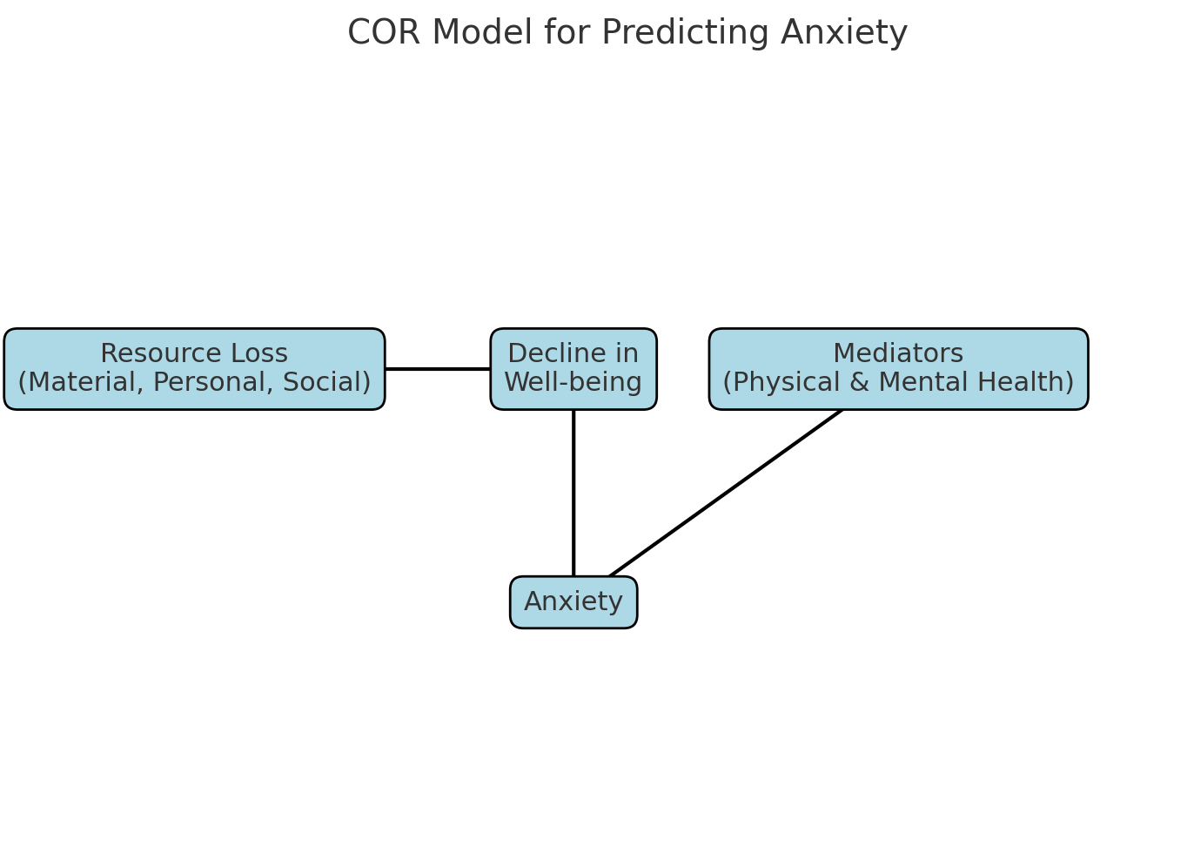

**Purpose**

The purpose of this study is to examine the impact of displacement on mental and physical health by comparing levels of anxiety, perceived health, and mental well-being between displaced persons and the general population in Israel, and to assess the role of health (both physical and mental) as mediating factors in this relationship.

Accordingly, the study investigated whether differences exist in anxiety levels and perceived health between the displaced population in Israel and the general population, and whether perceived physical health, mental well-being, and emotional functioning mediate the relationship between displacement status and anxiety levels.

**Method**

A comparative quantitative cross-sectional study was conducted using self-report questionnaires. The study included 98 men and women over the age of 18, comprising (1) evacuees from the south or northern parts of Israel who had not returned to their homes at the time of data collection (2) individuals from the general population who had not been evacuated from this homes. To maintain a similar proportion between the two groups, approximately half of the study participants who completed the questionnaire were sampled from the general population (52 individuals, representing 53.1% of all respondents), and the other half from the displaced population (46 individuals, representing 46.9% of all respondents). Inclusion criteria encompassed all adults in Israel who can read and write in Hebrew.

**Table 1.** Socio-demographic characteristics of the IDPs compared to the general population

| IDP ((N=46 | | | |  | General population (N=51) | | | | |
| --- | --- | --- | --- | --- | --- | --- | --- | --- | --- |
| **Variable** | **Categories** | **N** | **%** |  | **Variable** | **Categories** | **N** | **%** | **Significance** |
| **Gender** | Male | 14 | 30.4 |  | **Gender** | Male | 20 | 38.5 |  |
| Female | 32 | 69.9 |  | Female | 32 | 61.5 | N. S |
| **Education** | High school | 9 | 19.6 |  | **Education** | High school | 9 | 17.3 | N .S |
| Vocational | 9 | 19.6 |  | Vocational | 11 | 21.2 |
| Academic | 28 | 60.9 |  | Academic | 32 | 61.5 |
|  | **Mean** | **S.D.** |  |  |  | **Mean** | **S.D.** |  |  |
| **Age** | 38.33  Range(19-81) | 1.15 |  |  | **Age** | 35.75  (טווח 21-74) | 1.35 |  | N. S |
| **No. of Children** | 1.15  Range( 0-4) | 1.46 |  |  | **No. of Children** | 1.35  טווח (0-7) | 1.68 |  | N. S |

The majority of respondents were women and held an academic degree. The mean age in the IDP group was 38.33 years (SD = 14.93), compared to 35.75 years (SD = 15.41) in the general population group, with no statistically significant difference between the two. Likewise, no significant differences were observed between the groups in the other demographic variables, including marital status, level of religiosity, and economic status.

**Research tools**

**Part A** – Perceived Health: Measured using the SF-36 questionnaire15. The questionnaire is designed for self-administration among both healthy and ill populations, as it is sensitive to deterioration in health status. It is suitable for all ages and contexts and has been validated in diverse cultural populations. The SF-36 consists of 36 items measuring eight health domains. The items are multiple-choice, and the response scales vary depending on the question. Higher scores indicate higher self-perceived health.

The SF-36 has demonstrated strong reliability reliability across diverse populations. Cronbach’s α values typically range from 0.76 to 0.95 across subscales, with overall scores around 0.8724-26. Test–retest reliability is also high, for both physical and mental component summaries26. These findings affirm the SF-36's robust psychometric performance across different demographic and clinical groups.

The health domains assessed and the reliability coefficients for each subscale are presented below**:**

**Dimensions related to the physical health:**

* Physical Functioning: 10 items assessing limitations in daily activities due to health status. Example: *“To what extent does your health limit you in lifting or carrying groceries?”* Reliability (Cronbach’s Alpha) = 0.95.
* Role Limitations due to Physical Health: 4 items assessing the impact of physical limitations on work or daily activities during the past month. Example: *“During the past month, have you cut down the amount of time you spent on work or other activities?”* Reliability (Cronbach’s Alpha) = 0.85.
* Bodily Pain: 2 items assessing the respondent’s physical functioning in relation to pain. Example: *“How much bodily pain have you had during the past four weeks?”* Reliability (Cronbach’s Alpha) = 0.91.
* General Health: 5 items assessing the respondent’s overall physical functioning. Example: *“*In general, would you say your health is *…?”* Reliability (Cronbach’s Alpha) = 0.85.

**Dimensions related to the emotional health:**

* Role Limitations due to Emotional Problems: 3 items assessing mental functioning over the past month. Example: *“During the past month, have you accomplished less than you would like as a result of any emotional problems?”* Reliability (Cronbach’s Alpha) = 0.87.
* Energy/Fatigue: 4 items assessing feelings and how things have been going during the past month. Example: *“Did you feel full of pep?”* Reliability (Cronbach’s Alpha) = 0.92.
* Emotional Well-Being: 5 items assessing feelings and general mental state over the past month. Example: *“Have you felt so down in the dumps that nothing could cheer you up?”* Reliability (Cronbach’s Alpha) = 0.88.
* Social Functioning: 2 items assessing the extent to which physical or emotional health has interfered with normal social activities during the past month. Example: *“During the past four weeks, to what extent has your physical health or emotional problems interfered with your normal social activities (like bisiting with friends, relatives etc.?”* Reliability (Cronbach’s Alpha) = 0.84.

**Part B** – Generalized Anxiety Perception – Generalized anxiety was measured using the self-report GAD-7 questionnaire27. The questionnaire consists of seven items describing symptoms of generalized anxiety, rated on a four-point Likert scale (0 – *not at all*, 3 – *nearly every day*). Example: *"over the last two weeks how often have you been bothered by feeling nervous, anxious, or on the edge*". Higher scores indicate higher levels of anxiety. The GAD-7 is widely used for both research and clinical purposes to screen for anxiety symptoms in the general population and in clinical populations. It has strong psychometric properties, including high internal consistency (Cronbach’s alpha = 0.89) and high validity indices28-29. In the present study, the questionnaire demonstrated excellent reliability (Cronbach’s alpha = 0.96).

**Part C** – Demographic Questionnaire including personal details such as gender, age, country of birth, education, etc.

**Sampling**

A convenience sample combined with the snowball sampling method was used. Participants received anonymous self-report questionnaires via Google Forms, distributed in relevant WhatsApp and Facebook groups targeting the study populations. They were asked to forward the online link to additional acquaintances for completion. The questionnaires were completed online by the study participants, accessed either through their mobile phones or personal computers.

**Statistical analysis**

Descriptive statistics were employed to summarize the participants' sociodemographic characteristics, including the distribution of key research variables both overall and across relevant background factors (e.g., sex, age, education). Additionally, correlations between various variables were calculated.

Internal reliability the SF-36 subscales and for the Gad-7 questionnair was assessed using Cronbach's alpha. Differences between the groups were examined using t-tests for independent groups, and multivariate regression analyses examining the combined effect of all predictors on anxiety. A mediation model30-31 was tested to estimate the total and indirect effects of the emotional variables on anxiety levels, specifically assessing their contribution to explaining the relationship between IDPs status and anxiety.

**Ethical Considerations**

Ethical approval was obtained from the Ethics Committee of the Research Authority at Ono Academic College. In Israel, the regulations for human subject research distinguish between interventional studies and studies based on existing data and questionnaires. This type of research is defined, among other things, as: 'A prospective study in which health data is collected from individuals through direct contact with them.' Such studies do not require signed informed consent )https://www.gov.il/blobFolder/guide/protocol-of-medical-research-involving-human-subjects/he/clinical\_trials\_cth\_GLOSSARY.pdf).

Since this study is survey-based rather than interventional, the research questionnaire provided participants with a clear explanation of the study and the significance of their participation. Each participant had the option to decline participation or withdraw at any time. To safeguard participant rights, all participants were informed about the study details, including the estimated time required to complete the questionnaires. Furthermore, all collected data remained entirely anonymous and confidential. Completion of the questionnaire was considered as consent to participate.

**Results**

Table 2 shows that across all eight dimensions assessing physical and mental health, the IDPs had significantly lower scores than the general population. In contrast, for anxiety, the displaced group scored significantly higher.

**Table 2. Comparison of health measures and anxiety between the IDPs and the general population**

|  |  |  |  |  |  |
| --- | --- | --- | --- | --- | --- |
| **Health Categories** | | **N** | **Mean** | **SD** | **t scores** |
| Physical Functioning | IDPs | 46 | 74.56 | 29.18 | t (76.21)=2.76\*\*\* |
| General Population | 52 | 88.55 | 19.20 |
| Physical Role Limitation | IDPs | 46 | 38.04 | 41.075 | t (96)=3.86\*\*\* |
| General Population | 52 | 68.26 | 36.41 |
| Emotional Role Limitation | IDPs | 46 | 7.24 | 20.97 | t (76.05)=6.69 \*\* |
| General Population | 52 | 53.84 | 42.85 |
| Energy/Fatigue | IDPs | 46 | 28.36 | 14.94 | t (96)=6.18\*\*\* |
| General Population | 52 | 48.17 | 16.86 |
| Emotional Well Being | IDPs | 46 | 33.73 | 18.86 | t (96)=6.20 \*\*\* |
| General Population | 52 | 55.92 | 16.51 |
| Social Functioning | IDPs | 46 | 39.40 | 23.85 | t (96)=4.68\*\*\* |
| General Population | 52 | 60.81 | 21.44 |
| Bodily Pain | IDPs | 46 | 66.03 | 25.09 | t (96)=4.33 \*\*\* |
| General Population | 52 | 85.28 | 18.70 |
| General Health | IDPs | 46 | 53.47 | 24.33 | t (96)=2.83\*\*\* |
| General Population | 52 | 66.25 | 20.26 |
| Anxiety | IDPs | 46 | 14.93 | 6.08 | t (96)=7.15\*\*\* |
| לא מפונים | 52 | 6.59 | 5.44 |
|  | לא מפונים | 52 | 7.31 | 3.3 |

p<0.001\*\*\*

Table 3 presents significant differences between the IDPs and the general population, with IDPs showing a substantially higher proportion of high anxiety scores (χ²(1) = 27.7, p < .001). Specifically, 36.7% of the displaced group reported high anxiety levels (total score > 11), compared to 13.3% of the general population.

**Table 3.** Differences between the groups in the prevalence of moderate and high anxiety levels

|  |  |  |  |  |  |  |
| --- | --- | --- | --- | --- | --- | --- |
|  | IDPs | | General Pupolation | |  |  |
| Anxiety level | N (46=) | % | N(52=) | % | χ2 | |
| Up to score 10 | 10 | 10.2 | 39 | 39.8 | χ2(1)=27.7, p<0.001 | |
| Above score 11 | 36 | 36.7 | 13 | 13.3 |

Table 4 indicates that among IDPs, all dimensions of perceived health were significantly and negatively correlated with anxiety, except for physical role limitations. A similar pattern was found in the general population, though no correlation was observed between physical functioning and anxiety.

In both groups, strong negative correlations were evident between role limitations due to emotional problems, emotional well-being, and social functioning, and anxiety. In other words, lower emotional role functioning, poorer emotional well-being, and reduced social functioning were all associated with

**Table 4**. Pearson correlations between health perception and Anxiety among displaced and general population

|  |  |  |  |  |  |  |  |  |
| --- | --- | --- | --- | --- | --- | --- | --- | --- |
|  | Physical Functioning | Physical Role Limitation | Emotional Role Limitation | Energy/Fatigue | Emotional Well Being | Social Functioning | Bodily Pain | General Health |
| IDPs ( N=46) |  |  |  |  |  |  |  |  |
| Anxiety | **-.299\*** | -0.287 | **-.646\*\*** | **-.576\*\*** | **-.759\*\*** | **-.661\*\*** | **-.418\*\*** | **-.416\*\*** |
|  |  |  |  |  |  |  |  |  |
| General Population (N=52) |  |  |  |  |  |  |  |  |
| Anxiety | 0.002 | **-.568\*\*** | **-.633\*\*** | **-.569\*\*** | **-.632\*\*** | **-.602\*\*** | **-.302\*** | **-.391\*\*** |

P<0.05\*, p<0.01\*\*

To predict the dependent variable anxiety, a multiple regression analysis was performed, incorporating all study variables along with group affiliation (displaced population vs. general population) (Table 4). The variable pain was excluded due to high multicollinearity with other variables, and social functioning was omitted as it did not align with the theoretical framework underlying the study.

**Table 5. Multiple regression analysis for predicting anxiety**

|  |  |  |  |  |  |
| --- | --- | --- | --- | --- | --- |
| **Model** | |  | |  | **t** |
| **B** | **Std. Error** | **Beta** |
|  | (Constant) | 14.09 | 2.35 |  | 10.66 |
| Group (IDPs =1) | 1.348 | 1.047 | 0.095 | 1.288 |
| Physical Functioning | 0.008 | 0.022 | 0.028 | 0.383 |
| Physical Role Limitation | -0.026 | 0.013 | -0.149 | -1.914 |
| Emotional Role Limitation | -0.060 | 0.014 | -0.351 | -4.380\*\* |
| Energy/Fatigue | -0.064 | 0.03 | -0.17 | 1.95 |
| Emotional Well being | -0.202 | 0.042 | -0.360 | -4.769\*\* |
| General Health | 0.012 | 0.027 | 0.038 | 0.445 |

Preliminary analyses showed that the variable *group* (general population vs. IDPs) explained 34% of the variance in anxiety levels. However, when perceived health variables were added to the model (table 4), the effect of the group became non-significant. In contrast, two variables—emotional role functioning (β = 0.351, p < .01) and emotional well-being (β = 0.36, p < .01)—were significant predictors of anxiety levels. The expanded model was statistically significant [F(7, 89) = 33.82, p < .01], accounting for 72.7% of the variance in anxiety.

Given these findings, and the identification of emotional well-being and emotional role functioning as significant predictors, a mediation model 30-31 was tested to assess the total and indirect effects of these variables on anxiety, with particular focus on their role in explaining the relation

nship between evacuation status and anxiety.

**Figure 2**. Mediation Model to predict anxiety

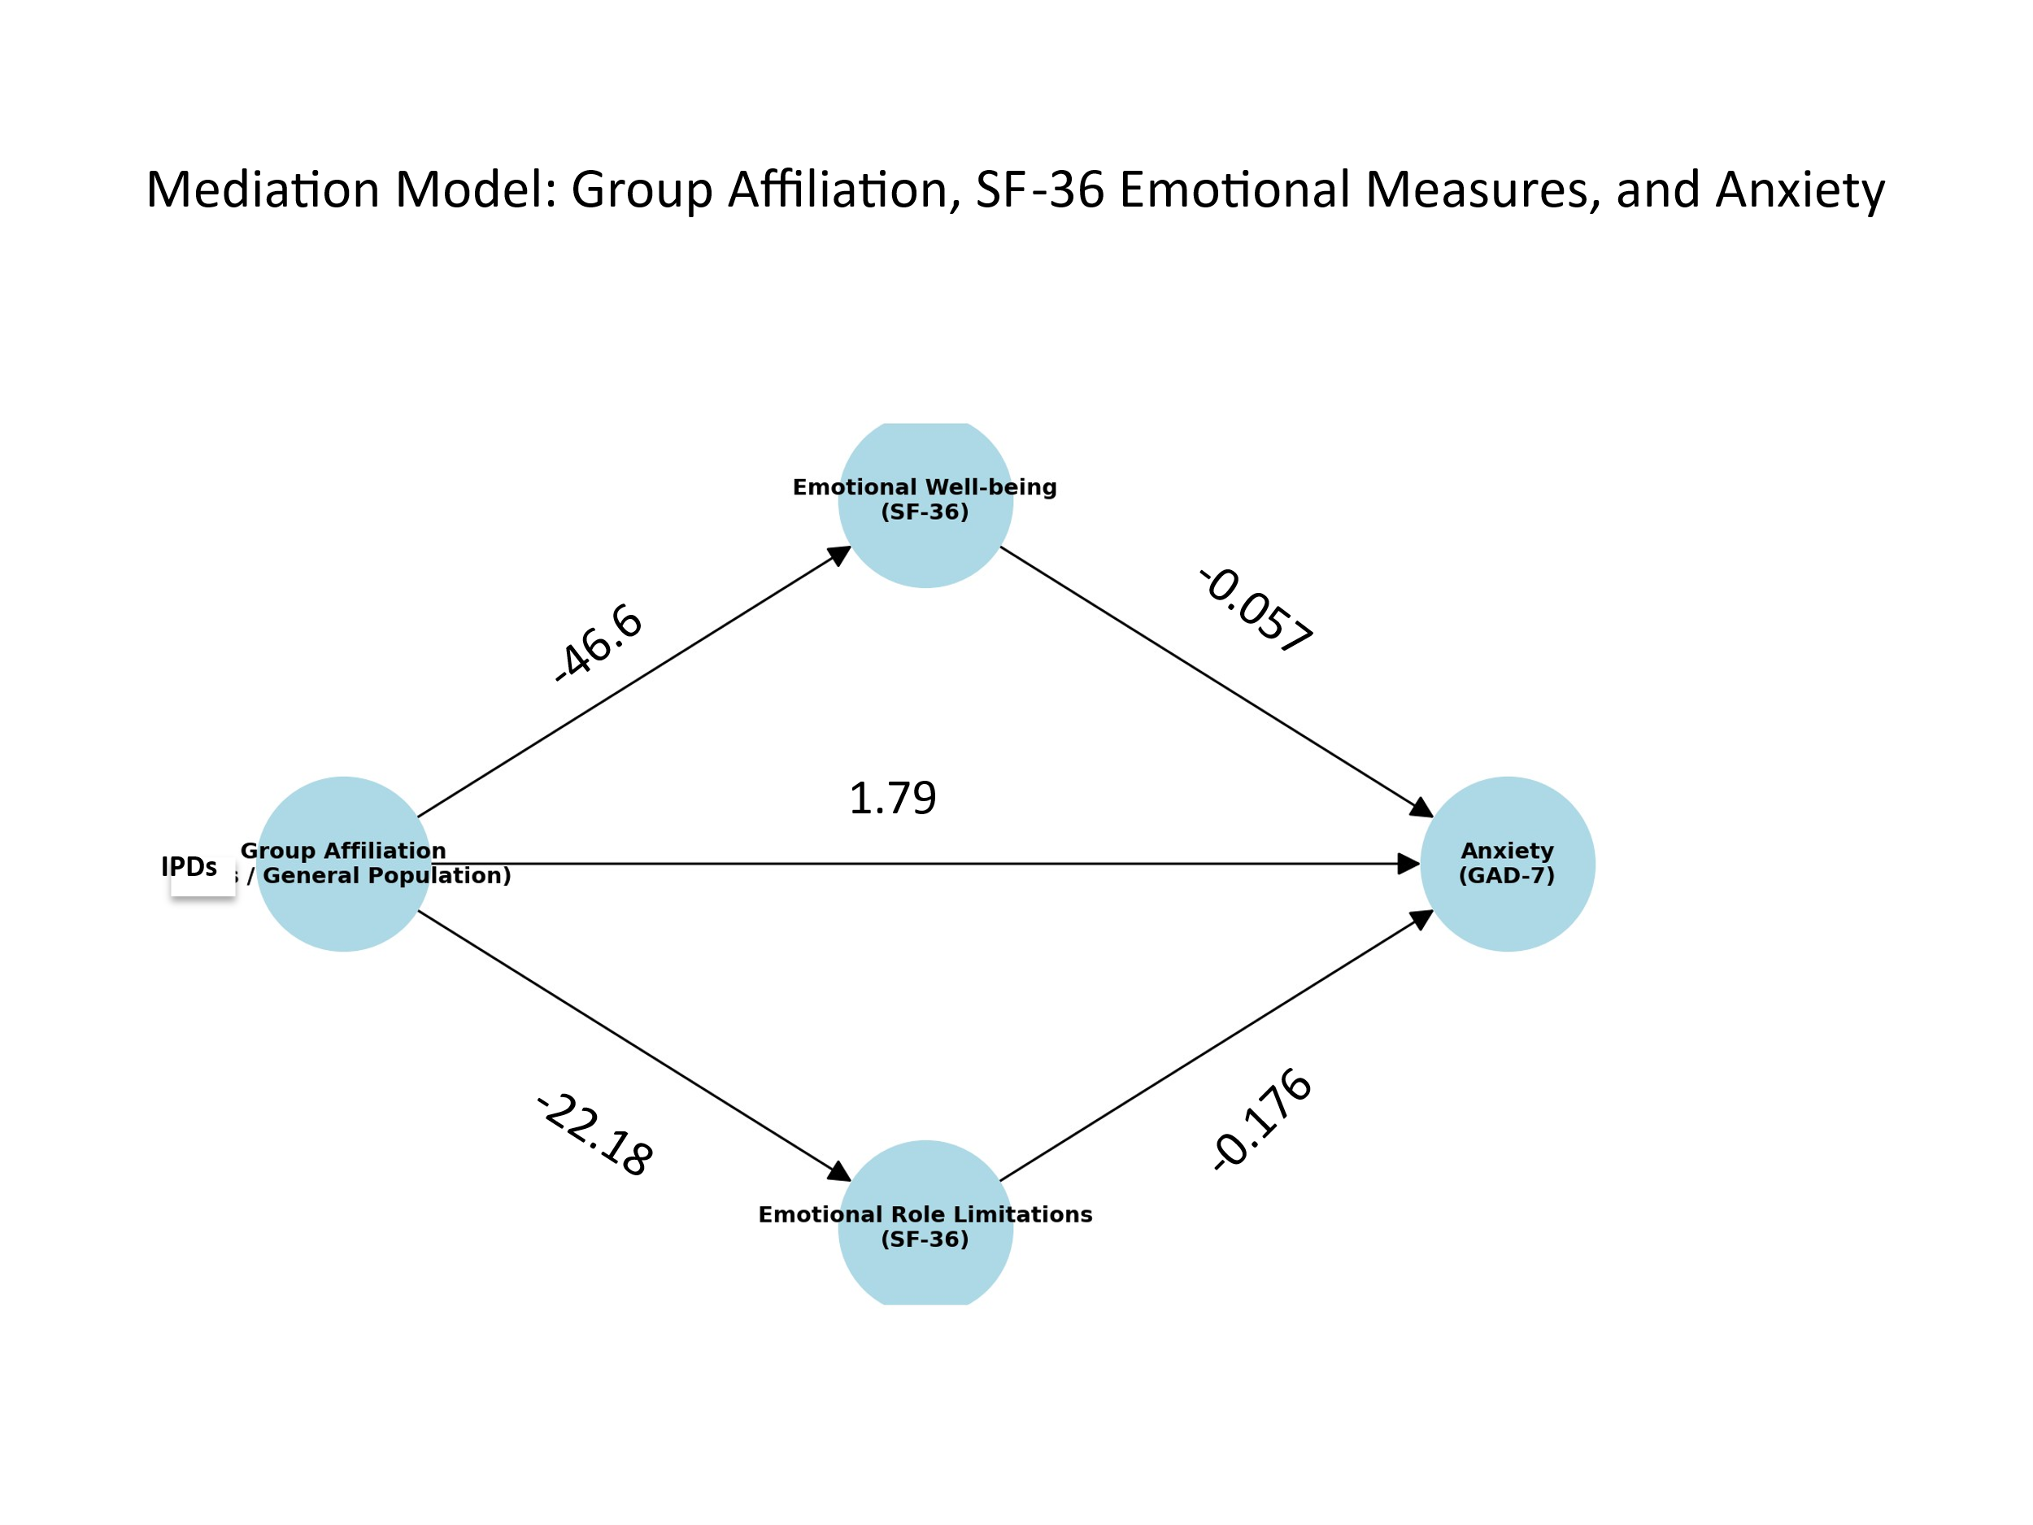

As presented in Figure 2, Regression and mediation analyses revealed that the IDPs scored significantly lower than the general population in Emotional Well-being (t(96) = 6.21, p < .001, β = -1.07; MΔ = -22.18) and Emotional Role Limitations (t(96) = 6.70, p < .001, β = -1.12; MΔ = -46.6). Both variables were strong negative predictors of anxiety, with Emotional Well-being showing a large effect (t(94) = 7.12, p < .001, β = -0.517) and Emotional Role Limitations a moderate effect (t(94) = 4.45, p < .001, β = -0.331). Initially, group affiliation predicted an 8.34-point higher anxiety score among the IDPs (t(96) = 7.156, p < .001), but this effect became non-significant (1.79 points) after including the mediators. Bootstrap analyses confirmed significant indirect effects for both Emotional Well-being (3.91 points, 95% CI [2.49, 5.50]) and Emotional Role Limitations (2.64 points, 95% CI [1.26, 4.28]). Together, these mediators accounted for 6.55 points of the group–anxiety relationship, indicating that nearly all of the difference in anxiety levels between groups was explained by reduced Emotional Well-being and Emotional Role Limitations due to Emotional Problems among the displace.

This finding suggests that the difference in anxiety scores between the IDPs and the general population is almost entirely accounted for by the two mediators, both reflecting aspects of emotional status.

**Discussion**

This study demonstrates the profound impact of forced evacuation in Israel on both physical and mental health. Evacuees reported significantly poorer outcomes across all SF-36 domains—including physical functioning, pain, vitality, social functioning, emotional well-being, and general health perception—alongside higher anxiety levels compared to the general population. Poor self-rated health, widely recognized as a predictor of morbidity, increased healthcare utilization, and premature mortality, was notably prevalent among evacuees16. Consistent with prior research on displaced populations 4,10,13, these findings underscore the long-term vulnerability associated with loss of stability, poor living conditions, and weakened social support. One year after the war, over a third (36%) of evacuees reported high anxiety levels, markedly higher than both the general population and rates reported nine months after displacement9. Taken together, displaced populations should be recognized as a high-risk group requiring targeted clinical interventions to alleviate anxiety, enhance emotional resources, and prevent the escalation of psychological distress. At the health policy level, comprehensive strategies are needed to ensure continuity of care, strengthen resilience, and promote sustainable psychological recovery.

status and psychological vulnerability in populations exposed to war and displacement. Among internally displaced persons, stress and depletion of personal resources were found to predict heightened anxiety32. Longitudinal evidence from Israeli war veterans showed that loneliness and poor subjective physical health reinforce each other over time, with physical health problems both reflecting and aggravating symptoms of PTSD and anxiety33. More recently, the health and environmental consequences of the Gaza conflict highlighted the profound physical and psychological toll of prolonged exposure to insecurity and instability, reinforcing the notion that deteriorated physical health and weakened resilience serve as significant predictors of long-term psychological distress34. Collectively, these studies strengthen the interpretation that poor perceived health is not only a subjective reflection of adversity but also a key marker of depleted resilience and social resources, underscoring the need for comprehensive interventions to mitigate long-term mental health

A key and innovative finding of this study is the identification of emotional well-being and emotional role limitation as mediators in the relationship between displacement and anxiety. While most studies have conceptualized evacuation as a direct cause of heightened anxiety 8,35 and longitudinal evidence from Israel following October 7 demonstrated persistently elevated anxiety levels among evacuees months after displacement9, the present findings suggest that this effect is not direct but operates primarily through these mediating factors. In fact, anxiety is explained almost entirely through the erosion of psychological resources—diminished sense of control, weakened social belonging, and impaired emotional coping capacity.

This interpretation is consistent with Hobfoll’s19 Conservation of Resources model, which conceptualizes stress as the outcome of an actual or anticipated loss of personal, emotional, and social resources. Among displaced populations, these resources are profoundly disrupted: social networks are severed, sense of control is diminished, and living conditions are altered—together impairing emotional functioning and overall well-being. Recent studies further underscore the mediating role of difficulties in emotion regulation in the relationship between trauma and anxiety among displaced populations21,23.

The significance of these findings lies in clarifying the mechanisms underlying anxiety among displaced populations and emphasizing the need for interventions that strengthen emotional resources to prevent long-term distress. Public policy and psychosocial programs should therefore focus not only on material support but also on enhancing resilience, coping capacity, and daily functioning to safeguard overall well-being.

In contrast to prior studies reporting greater psychological vulnerability among women after forced evacuation8, gender was not a significant predictor of anxiety in the present study. This may reflect sample characteristics or the context of ongoing war, where men and women were similarly exposed to negative experiences. Nevertheless, examining gender differences remains essential to ensure that interventions are tailored to diverse needs.

The limitations of this study should be acknowledged, including the reliance on a small convenience sample and a cross-sectional design that precludes causal inference. Still, the consistency and robustness of the findings point to clear trends that are supported by theoretical models and previous research.

To summarize, this study highlights the adverse mental health consequences of forced displacement and identifies mediating factors that represent key targets for prevention and intervention. Enhancing emotional capacities and psychological functioning may be critical in mitigating these long-term effects

# References

1. **United Nations High Commissioner for Refugees (UNHCR). Global Trends: Forced Displacement in 2024. Geneva: UNHCR; 2025. Available from: https://www.unhcr.org/sites/default/files/2025-06/global-trends-report-2024.pdf**
2. Cantor D, Swartz J, Roberts B, Abbara A, Ager A, Bhutta ZA, et al. Understanding the health needs of internally displaced persons: A scoping review. J Migr Health. 2021;4:100071.
3. **Tay AK. The mental health needs of displaced people exposed to armed conflict. Lancet Public Health. 2022 May;7(5):e398–e399.**

**doi:10.1016/S2468-2667(22)00088-3** [pubmed.ncbi.nlm.nih.gov](https://pubmed.ncbi.nlm.nih.gov/35487226/?utm_source=chatgpt.com)

1. Ali AMA, et al. Prevalence of physical and mental health problems among internally displaced persons in White Nile state, Sudan 2023: A cross-sectional study. BMC Public Health. 2024;24:3448.
2. Almagor LO. Population evacuation programs – Part B: Since the outbreak of the “Iron Swords” war. Knesset Research and Information Center; 2023.
3. **Florsheim Institute for Policy Studies. One year of “Swords of Iron”: Data from the Knowledge and Information Center. Tel Aviv: FFI; October 2024. Available from:** [https://ffi.org.il/wp-content/uploads/2024/01/שנה-לחרבות-ברזל-נתוני-מרכז-מידע-וידע-241006.pdf](https://ffi.org.il/wp-content/uploads/2024/01/%D7%A9%D7%A0%D7%94-%D7%9C%D7%97%D7%A8%D7%91%D7%95%D7%AA-%D7%91%D7%A8%D7%96%D7%9C-%D7%A0%D7%AA%D7%95%D7%A0%D7%99-%D7%9E%D7%A8%D7%9B%D7%96-%D7%9E%D7%99%D7%93%D7%A2-%D7%95%D7%99%D7%93%D7%A2-241006.pdf)
4. Wollach R, Amsalem D. Forced displacement and anxiety: Evidence from Israel. Health Policy Res. 2025;12(3):210-8.
5. Ulke H, Bozkurt A, Gül E. Gender and psychological vulnerability in displaced populations: Evidence from Turkey. Int J Ment Health Syst. 2021;15:101.
6. Amsalem D, Haim-Nachum S, Lazarov A, Levi-Belz Y, Markowitz JC, Bergman M, et al. The effects of war-related experiences on mental health symptoms of individuals living in conflict zones: A longitudinal study. Sci Rep. 2025;15(1):889. doi:10.1038/s41598-024-84410-3
7. Charlson F, et al. New WHO prevalence estimates of mental disorders in conflict settings: A systematic review and meta-analysis. Lancet. 2019;394(10194):240-8.
8. **Levinson D, Zilber N, Lerner Y, Grinshpoon A, Levav I. Prevalence of mood and anxiety disorders in the community: Results from the Israel National Health Survey. Isr J Psychiatry Relat Sci. 2007;44(2):94–103.**
9. Ochi S, Hodgson S, Landeg O, Mayner L, Murray V. Disaster-driven evacuation and medication loss: a systematic literature review. PLoS Curr. 2014 Jul 18;Edition 1. doi:10.1371/currents.dis.fa417630b566a0c7dfdbf945910edd96.
10. Hasegawa A, Ohira T, Maeda M, Yasumura S, Tanigawa K. Emergency responses and health consequences after the Fukushima accident: Evacuation and relocation. Clin Oncol. 2016;28(4):e-8. doi:10.1016/j.clon.2016.01.002.
11. Tinajero-Chávez LI, Mora-Romo JF, Bravo-Doddoli A, Cruz-Narciso BV, Calleja N, Toledano-Toledano F. Design, development, and validation of the Self-Perceived Health Scale (SPHS). Healthcare. 2023 Jul 12;11(14):2007. doi:10.3390/healthcare11142007.
12. Ware JE, Sherbourne CD. The MOS 36-item short-form health survey (SF-36): I. Conceptual framework and item selection. Med Care. 1992;30(6):473-83.
13. Hajian-Tilaki K. Health-related quality of life and its socio-demographic determinants among Iranian elderly. Iran J Public Health. 2020;49(6):1200-7.
14. Carpiniello B. The mental health costs of armed conflicts—a review of systematic reviews conducted on refugees, asylum-seekers and people living in war zones. Int J Environ Res Public Health. 2023;20(4):2840.
15. Bedaso A, Duko B. Epidemiology of depression among displaced people: a systematic review and meta-analysis. Psychiatry Res. 2022;311:114493.
16. Hobfoll SE. Conservation of resources: A new attempt at conceptualizing stress. Am Psychol. 1989;44(3):513-24. doi:10.1037/0003-066X.44.3.513
17. Hobfoll SE, Halbesleben JRB, Neveu JP, Westman M. Conservation of resources in the organizational context: The reality of resources and their consequences. Annu Rev Organ Psychol Organ Behav. 2018;5:103-28.
18. Köhler T, Müller M, Maercker A. Emotion regulation and mental health in refugees: A systematic review. Eur J Psychotraumatol.2023;14(1):2180200.
19. Chen S, Yang L, Guo W. Emotion dysregulation mediates the relationship between trauma exposure and mental health problems among conflict-affected youth. Front Psychol. 2020;11:1782.
20. Papies EK, Aarts H. Emotion regulation strategies and vulnerability to anxiety in displaced populations. Anxiety Stress Coping. 2021;34(4):401-16.
21. Wu Q, et al. Reliability, validity, and sensitivity of the Short‑Form 36 Health Survey (SF‑36) in patients with sick sinus syndrome. PLoS Curr Disasters. 2023;Edition 1. doi:10.1371/currents.dis.fa417630b566a0c7dfdbf945910edd96. [PMC+1](https://pmc.ncbi.nlm.nih.gov/articles/PMC10270486/?utm_source=chatgpt.com" \t "_blank)
22. Gandek B, Ware JE Jr, Sinclair SJ, Kosinski M. Psychometric evaluation of the SF‑36 Health Survey in older and disabled populations: Data from the Medicare Health Outcomes Survey. Health Care Financing Review. 2004 Summer;25(4):5‑25. [PMC+15cms.gov+15jpmph.org+15](https://www.cms.gov/files/document/04summerpg5pdf?utm_source=chatgpt.com)
23. Saruarov Y, et al. Analysis of the SF‑36 Questionnaire and Validation of the Kazakh SF‑36 v2 Health Survey. SR Health and Behavior. 2024;
24. Spitzer RL, Kroenke K, Williams JB, Lowe B. A brief measure for assessing generalized anxiety disorder: The GAD-7. Arch Intern Med. 2006;166(10):1092-7.
25. **Löwe B, Decker O, Müller S, Brähler E, Schellberg D, Herzog W, Herzberg PY. Validation and standardization of the Generalized Anxiety Disorder Screener (GAD-7) in the general population. Med Care. 2008;46(3):266-74.**
26. Kliem S, Sachser C, Lohmann A, Baier D, Brähler E, Fegert JM, et al. Psychometric evaluation and community norms of the GAD-7, based on a representative German sample. Front Psychol. 2025;16:1526181.
27. Preacher KJ, Hayes AF. SPSS and SAS procedures for estimating indirect effects in simple mediation models. Behav Res Methods Instrum Comput. 2004;36(4):717-31.
28. Rucker DD, Preacher KJ, Tormala ZL, Petty RE. Mediation analysis in social psychology: Current practices and new recommendations. Soc Personal Psychol Compass. 2011;5(6):359-71.
29. Boiko DI, et al. Stress coping and anxiety among internally displaced persons affected by the Russian–Ukrainian war: A pilot study. Front Psychol. 2024;15:1347865. doi:10.3389/fpsyg.2024.1347865
30. Tsur N, Stein JY, Levin Y, Siegel A, Solomon Z. Loneliness and subjective physical health among war veterans: Long-term reciprocal effects. *Soc Sci Med*. 2019 Aug;234:112373. doi:10.1016/j.socscimed.2019.112373.
31. Dardona Z, Amane M, Dardona A, Boussaa S. Health and environmental impacts of Gaza conflict (2023–2024): A review. One Health Bull. 2025;5(1):1-12. doi:10.4103/ohbl.ohbl\_42\_24
32. Wollach R. Displaced in their own land: How to support evacuated communities? Taub Center, Policy Paper No. 11.202. Jerusalem; 2023.

**Declarations**

**Author Contributions:**

All authors beside GM contributed to the conceptualization and methodology of the study. GM and OT handled software development and validation, with GM also conducting the formal analysis. OT led the investigation, visualization, and supervision. DS, MB, ZN, and OT provided resources, while DS, MB, and ZN managed data curation. OT was responsible for writing the original draft, and GM handled the review and editing. No external project administration or funding acquisition was involved.

Authorship contribution in **CRediT taxonomy** format:

**Conceptualization:** DS, MB, ZN, OT; **Methodology:** DS, MB, ZN, OT; **Software:** GM, OT; **Validation:** GM, OT; **Formal analysis:** GM; **Investigation:** OT; **Resources:** DS, MB, ZN, OT; **Data curation:** DS, MB, ZN; **Writing – original draft:** OT; **Writing – review & editing:** GM; **Visualization:** OT; **Supervision:** OT; **Project administration:** Not applicable; **Funding acquisition:** Not applicable

All authors have read and agreed to the published version of the manuscript.

**Funding:**

This research received no funding

**Informed Consent Statement** :

See also the section of ethical consideration in the paper. In Israel, the regulations for human subject research distinguish between interventional studies and studies based on existing data and questionnaires. This type of research is defined, among other things, as: 'A prospective study in which health data is collected from individuals through direct contact with them.' Such studies do not require signed informed consent). https://www.gov.il/blobFolder/guide/protocol-of-medical-research-involving-human-subjects/he/clinical\_trials\_cth\_GLOSSARY.pdf).

As this was a survey-based study rather than an interventional one, the online questionnaire included a clear explanation of the study’s purpose and the significance of participation. Prior to accessing the questionnaire, participants were required to indicate their agreement by selecting the consent box. They were informed of their right to decline participation or withdraw at any time. Only those who provided consent were granted access to the survey. All dada was anonymously collected.

**Ethics approval and consent to participate:**

Ethical approval **No. 202467ono** was obtained from the Ethics Committee of the Research Authority at Ono Academic College, July 2024.

**Data Availability Statement:**

The datasets used and/or analyzed during the current study are available from the corresponding author on reasonable request. Data is stored at the statistician (GM) personal computer .

**Acknowledgments:**

During the preparation of this manuscript, the authors used ChatGPT (4o) to create the figures and review the translations. The authors have reviewed and edited the output and take full responsibility for the content of this publication.

**Consent for publication**

Not applicable.

**Availability of data and materials**

The datasets used and/or analyzed during the current study are available from the corresponding author on reasonable request.

**Competing interests**

The authors declare that they have no conflict of interests.

**Acknowledgments**

Not applicable.

**Authors' information (optional)**

Not applicable.

Abbreviations

Internally displaced persons (IDPs)