Genernative Advertising
Uri Y. Hacohen†
“ChatGPT chooses products independently. Learn More.”
ChatGPT, April 2025

Abstract
This Article identifies and analyzes a new and largely unregulated form of commercial persuasion that emerges at the intersection of generative artificial intelligence and native advertising. Termed “genernative advertising,” this phenomenon occurs when large language model (LLMs) chatbots incorporate commercially sponsored material into their conversational outputs without clearly distinguishing it from editorial or informational content. In doing so, they collapse the disclosure safeguards that consumer protection law has long relied upon and blur the line between neutral assistance and paid promotion. Drawing on a pair of large-scale experimental studies, this Article provides the first empirical evidence that AI-mediated sponsorship dramatically amplifies the persuasive risks of native advertising. Participants routinely failed to recognize when chatbot responses were influenced by sponsored content, even when conventional disclosures were present, let alone when they were not. Yet the studies also reveal a powerful countervailing opportunity: when disclosure was made affirmative—requiring users to actively acknowledge the presence of advertising—recognition increased fivefold, and participants’ purchasing decisions shifted accordingly, all without diminishing trust in the chatbot. These findings have significant regulatory implications. They demonstrate that generative AI technologies, often criticized for eroding transparency, can also be harnessed to enhance it. Building on behavioral economics literature on emerging transparency regulations in states such as Utah and Colorado, this Article proposes that GenAI companies should be required not only to disclose the advertising ties that may influence their sources but also to do so through interactive, verifiable, and user-responsive mechanisms. In this way, the conversational interface that now threatens to conceal commercial influence can become a tool of meaningful consumer empowerment, transforming disclosure from a perfunctory label into a new form of digital accountability.

Table of Contents

Introduction 4
II. The History, Psychology, and Regulation of Native Advertising 8
A. Native Advertising in Traditional and Digital Media 8
B. Enter Genernative Advertising 17
III. Sponsorship Disclosures’ Impact on Genernative Advertising—Recognition, Attitudes, and Behavior 28
A. Existing Research and Study Hypotheses 29
1. Persuasion, Knowledge, and the Effect of Sponsorship Disclosures on Native Advertising Recognition 29
2. Effects of Advertising Recognition on Consumers’ Attitudes 33
3. Effects of Advertising Recognition on Consumers’ Behavior 43
B. Methods 44
1. Participants 44
2. Study Design 45
3. Stimulus Materials 46
4. Data Collection, Behavioral Tracking, and Survey 48
5. Procedure 48
6. Limitations 49
C. Results 50
1. Study I 50
2. Study II 55
IV. Policy Implications 59
V. Conclusion 65
VI. Appendices 67
A. Appendix I – Stimulated Materials 67
1. Study I 67
B. Appendix II – Full Survey 72
1. Study I 72
C. Appendix III – Procedure 84
D. Appendix IV – Additional Findings 84
1. Study I 84

Introduction
Native advertising—promotional content designed to blend seamlessly into its editorial surroundings—has existed for decades. In early print media, the “reading notice” mimicked the look and tone of ordinary articles. On television, the infomercial and the embedded product placement operated similarly, weaving marketing into entertainment in ways meant to feel organic rather than intrusive. The digital turn transformed these practices into a dominant business model: major outlets such as the New York Times and Washington Post now run sophisticated advertorials, while bloggers and influencers routinely integrate sponsored endorsements into the fabric of their advice and storytelling. Today, native advertising is not merely common; it is ubiquitous, with industry reports estimating that it accounts for more than 90% of U.S. marketers’ digital display spending—totaling more than $148 billion in 2023 alone.
The social risks of this blending are well understood. When consumers mistake marketing for editorial judgment, they are more easily persuaded by messages grounded not in independent expertise but in commercial interest. This blurring can distort consumer choice and erode trust in information ecosystems. Over time, however, consumer perception and regulatory interventions have matured. Where early internet users were routinely deceived by sponsored search results or undisclosed influencer marketing, today’s users increasingly expect commercial influence online and calibrate their skepticism accordingly. Regulators worldwide have reinforced this shift by requiring advertisers to clearly disclose sponsorship—through conspicuous labels, hashtags, formatting conventions, and other visual cues.
Generative artificial intelligence threatens to unsettle this hard-won progress. As users turn to large language–model (LLM) chatbots such as Google’s Gemini and OpenAI’s ChatGPT for news, advice, and product recommendations, the visual indicators that once signaled commercial influence—sponsored tags, hyperlinks, layout, and disclosure labels—disappear. Users now receive information in fluid, conversational prose, often without visible links to underlying sources. What was once a mediated process of browsing, comparing, and noticing signals of influence has become a frictionless exchange: a question asked, an answer given.
This new mode of information consumption magnifies the opacity of commercial influence. Users may be aware that AI systems sometimes “hallucinate,” but once they conclude that a response is not wholly fabricated, they rarely scrutinize its provenance. Instead, they rely on reputational heuristics—trusting references to sources such as the New York Times without verifying the underlying content. Because current chatbots neither distinguish between sponsored and editorial material nor disclose whether their responses draw on advertorials, users cannot determine when commercial interests shape the information they receive. Compounding the problem, the search technologies that feed LLMs disproportionately privilege commercial results whenever queries carry commercial implications. And some chatbots—most notably ChatGPT—explicitly inform users that they “choose products independently,” potentially reinforcing misplaced confidence in the system’s neutrality.
This Article terms this emerging phenomenon genernative advertising: AI-generated text that incorporates commercially sponsored material while presenting itself as indistinguishable from organic editorial content. Despite its growing salience, this is the first legal article to identify and analyze the problem. Drawing on a novel set of mixed-method experimental studies—implemented within a custom-built, functionally reliable fictitious GenAI chatbot environment—this Article demonstrates that genernative advertising not only replicates the harms of traditional native advertising but may exacerbate them. The studies show that most users (80–90%) systematically fail to recognize advertising embedded in GenAI responses, even when the responses contain clear commercial intent. And when users do not recognize sponsorship, their suspicion of commercial influence deteriorates substantially (≈20%), heightening the risk of deception.
Yet the same technologies that intensify native-advertising harms also create unprecedented opportunities to mitigate them. Because LLMs can reliably distinguish between sponsored and editorial sources, they can be required to mark that distinction transparently. And because chatbots communicate through interactive, user-specific exchanges rather than static media displays, they enable new forms of consumer education—approaches that go far beyond the passive, easily ignored disclosures characteristic of traditional media. The behavioral-economic literature has long emphasized that integrating behavioral and cognitive insights into regulatory design can dramatically improve compliance and consumer welfare. As the studies in this Article show, affirmative disclosures—such as brief user-approval mechanisms requiring individuals to acknowledge that they are viewing sponsored content—can increase advertising-recognition rates dramatically (by roughly a factor of five).
This Article proceeds in three Parts. Part I situates genernative advertising within the longer evolution of native advertising, reviews its well-documented sociopsychological effects, and articulates the hypotheses motivating the empirical studies. Part II details the design and results of those studies, demonstrating both consumers’ overwhelming susceptibility to AI-mediated sponsorship and the striking effectiveness of chatbot-based disclosures and behavioral nudges. Part III translates these findings into concrete regulatory proposals. It argues that, at minimum, generative-AI companies should be required to identify and disclose when their outputs incorporate native advertising, and it explores more ambitious reforms that harness the conversational interface to transform disclosure from a perfunctory label into a meaningful tool of consumer empowerment.

The History, Psychology, and Regulation of Native Advertising
This Part surveys the lineage and logic of native advertising to ground the Article’s claims about its generative-AI successor. It traces how advertising that blends with editorial content has evolved across media, identifies the psychological mechanisms that make such formats unusually persuasive, and synthesizes the consumer-protection frameworks that have sought—often imperfectly—to contain associated risks.
- Native Advertising in Traditional and Digital Media
Native advertising is best understood not as a conventional promotional device, but as a strategic partnership with the consumer. Unlike traditional advertising—which seeks to capture attention by standing apart from its surroundings—native advertising embeds the brand or service within the editorial environment, aligning with page content, visual presentation, and platform conventions.
Although the practice has become especially prominent in recent years, its origins are longstanding. Early forms included newspaper “reading notices,” short promotional excerpts designed to resemble genuine editorial content. Printer’s Ink, the leading late-nineteenth-century advertising journal, traced the first such notice to Dr. Warner, a patent-medicine seller who commissioned a newspaper article promoting his “Safe Cure.” By the early 1900s, reading notices were ubiquitous. Fowler’s Publicity, the era’s authoritative advertising encyclopedia, explained their appeal: “The direct puff, which everyone knows is a puff, has value but not so much as the puff so mixed with news and information as to appear to be genuine reading matter.” Major agencies—including N.W. Ayer & Son and Geo. P. Rowell & Co.—promoted them as more effective than conventional advertising, and publishers routinely charged a premium, deriving significant revenue from them.
Advertorials emerged as the modern successor to reading notices. An advertorial is “an advertisement written in the form of an editorial, which purportedly provides objective information about a commercial or industrial subject.” As Atlantic Monthly publisher Donald B. Snyder observed in 1951, advertorials “involve the thoughtful participation of the reader; they are intended to give him pause—and in the pause, compelling facts about the way American business works.”
Broadcast media extended the practice. In 1923, The Eveready Hour became the first sponsored radio program, financed by the National Carbon Company. By the 1930s, Procter & Gamble pioneered sponsorship of daytime radio dramas to promote its soap products—the origin of the “soap opera.” Film soon followed: Hershey’s Chocolate appeared in the 1927 silent film Wings, and later placements became cultural landmarks. Ray-Ban sunglasses revived a failing brand after their appearance in Risky Business (1983), Reese’s Pieces sales rose 65 percent following E.T. (1982), and Pizza Hut gained visibility through its cameo in Wayne’s World (1992).
The digital era introduced still newer forms of native advertising: influencer endorsements, subsidized blogs and vlogs, website advertorials, affiliated content, and sponsored search results. Google’s 2017 rollout of AdSense Native Ads—“In-Feed,” “In-Article,” and “Matched Content”—integrated ads directly into reading flows. Influencer advertising simultaneously exploded across YouTube, Instagram, and later TikTok. Unlike celebrity endorsements, influencers were perceived as “ordinary” users whose recommendations appeared more authentic. Facebook’s “Sponsored Stories” (2011) blurred the line even further, transforming users’ likes, check-ins, and shares into advertisements displayed in their friends’ feeds—often featuring the user’s name and profile picture as an implicit endorsement without explicit consent.
This Article focuses on advertorials, subsidized blogs, and other written forms of native advertising that feed generative AI chatbots. These formats have proliferated because users increasingly prefer free, ad-supported content and employ ad-blocking technologies that diminish the effectiveness of traditional advertising.
Despite their popularity, native advertisements have long posed challenges for consumer-protection law. Consumer protection seeks to ensure individuals have sufficient information to make informed choices, while the effectiveness of native advertising depends on consumers’ uncertainty about whether the content they consume is commercial. As Chris Hoofnagle and Eduard Meleshinsky explain, “Advertorials risk upending consumer self-help mechanisms if advertorials lead the consumer—even for a short time—into believing that material is editorial.”
The blending of editorial and commercial content enhances persuasive power by cloaking ads in the credibility of editorial work. According to Friestad and Wright’s Persuasion Knowledge Model (PKM), when consumers are unaware of advertising intent, they are less likely to activate cognitive defenses such as skepticism or counterarguing. A substantial body of consumer-psychology research confirms that native advertising disarms consumers’ natural resistance to persuasion, making it more effective than conventional advertising.
Recent controversies underscore the risks. The Fyre Festival, JUUL, and FTX scandals all involved allegations of undisclosed native advertising, misleading consumers into wasting their time, risking their health, or even losing their life savings. The risks are particularly acute when advertorials appear in reputable news outlets. By mimicking the fonts, colors, logos, and layouts of surrounding editorial content, advertorials borrow the authority of the host publication and are granted the same deference as genuine journalism. This reflects source-based misleadingness: consumers frequently judge claims by the credibility of the source rather than the content. Just as a doctor’s endorsement of a sugarless gum carries weight regardless of expertise, editorial-style design imbues advertisements with an aura of authority.
Recognizing these risks, regulators worldwide have sought to police native advertising. In the United States, misleading practices may be unlawful even when the underlying claims are true. “Deceptive door openers” that mislead consumers into paying attention can violate consumer-protection law despite subsequent correction. Similarly, truthful information framed in misleading ways may give rise to FTC enforcement or private litigation.
At a minimum, regulators require clear and conspicuous disclosure. In 2015, the FTC issued specific native-advertising guidelines, explaining that enforcement turns on the “net impression” conveyed to consumers. The Commission emphasized that in native advertising “the watchword is transparency,” which must be evaluated across both content and form. Similar rules govern endorsements: advertisers, influencers, and brands must disclose commercial ties that are not otherwise apparent. International bodies have followed suit. In 2011, the International Chamber of Commerce amended its Code to require that marketing communications be “clearly distinguishable as such” regardless of form or medium. More recently, mandatory disclosure regimes have proliferated—from social-media influencer rules to chatbot-specific legislation. In France, failure to comply may even result in criminal sanctions.
- Enter Genernative Advertising
The rise of generative AI has radically transformed the way consumers access information about products and services. Instead of browsing websites—encountering their design, layout, and sponsorship labels—consumers now receive clean, uniform blocks of generated text in which editorial content and sponsored material may be seamlessly interwoven.
This new form of native advertising—what this Article terms genernative advertising—is unprecedented, yet it builds upon and intensifies the pathologies that first emerged in traditional digital media, particularly search-engine advertising. Historically, search engines exposed users to two forms of native advertising. First, users encountered sponsored links and product carousels at the top of results pages—placements often mistaken for “organic” results. Second, users encountered “organic” results that themselves linked to pages containing advertorials, affiliate marketing, or other sponsored content. While search engines were not required to label such references as advertising, consumers could detect commercial influence after clicking through and observing page-level cues: disclosure labels, formatting differences, banner ads, or other signals. Genernative advertising heightens the risks associated with both paradigms.
- Sponsored Links Within Chatbot Outputs
With respect to the first paradigm, incorporating paid links directly into chatbot outputs remains the exception rather than the rule. Many leading chatbots—such as ChatGPT—do not currently insert advertising links into their responses, though others (e.g., Microsoft’s Copilot and X’s Grok) do. Given the exceptionally high cost of running large language models, however, many commentators predict broader adoption of paid-insertion models. Although regulators have not yet addressed this development explicitly, recent FTC statements suggest that the disclosure obligations imposed on search engines and social media platforms would apply equally to generative AI providers.
Recent marketing research indicates that including paid links in chatbot responses may heighten risks of deception even when disclosures are present. Three mechanisms help explain why.
First, deception is shaped by user expectations. Consumers have become habituated to search engines’ paid links, but they may not yet expect sponsored references in chatbot responses. Accordingly, disclosure alone may be insufficient to attract attention—mirroring longstanding findings that users routinely miss even clearly labeled paid links on search-engine results pages. The problem is compounded by the fact that most chatbots currently do not incorporate paid references and that some—such as ChatGPT—explicitly assert their independence by assuring users that they “choose products independently.” Such representations may reinforce the perception that chatbot outputs are advertisement-free.
Second, the structural format of chatbot responses differs fundamentally from search results. Search engines present ranked lists that at least signal the existence of multiple alternatives. Although research shows that users rarely scroll beyond the first few links, they nevertheless understand that options exist. Chatbots, by contrast, provide definitive-seeming answers that may lead users to accept recommendations uncritically and remain unaware of competing products. As one study observes, “Unlike an advertising medium such as a search engine, a chatbot’s advertisement may significantly impact how users plan, what users believe, and how users internalize the recommended product.”
Third, the conversational interface of chatbots naturally enhances persuasive influence. Users tend to ascribe greater trust to human-like dialogue than to top-down communication systems such as search engines. This occurs through both direct and indirect pathways. Directly, the interactive format fosters perceived credibility, making consumers more willing to accept sponsored recommendations even when recognized as advertising. Indirectly, chatbots elicit more detailed personal disclosures than search engines typically receive, enabling them to deliver more personalized and therefore more persuasive advertising.
- Sponsored Content Embedded in Underlying Sources
The second search-engine paradigm—“organic” results that link to sponsored content—is even more troubling in the generative context. All major chatbots draw on search engines without necessarily filtering out or flagging advertorials, affiliate marketing, or other forms of paid content. In traditional search environments, consumers encounter cues upon clicking through: legally required disclosures or “bottom-up” indicators such as page design, layout, or banner ads. Imperfect though they are, these cues nevertheless provide opportunities for advertising recognition.
Generative AI eliminates these signals. Chatbot responses often lack citations altogether or rely on incomplete or partial references. Even when links are provided, research consistently shows that users rarely click through to investigate them. Instead, consumers rely on reputational shortcuts—treating references to outlets like the New York Times as proxies for credibility without verifying the underlying material. Because LLMs do not distinguish between sponsored and editorial sources, users cannot tell when commercial influence has shaped the content they receive.
- Heightened Consumer Vulnerability—and the Opportunity for Reform
For these reasons, genernative advertising exacerbates consumer vulnerabilities far beyond those associated with traditional search engines. Yet the very features that magnify these risks also create an opportunity for reform. Generative chatbots are uniquely capable of detecting sponsorship indicators through natural-language processing, and uniquely well positioned to convey disclosures through interactive conversational prompts. Properly designed, chatbots could not only replicate but exceed the transparency obligations of traditional media, educating and nudging users in ways that static disclosure regimes have never achieved.
Ensuring that they do so, however, will likely require regulatory intervention. The next Part examines how different interface structures facilitate different types of sponsorship disclosures and how these, in turn, shape consumers’ advertising recognition, attitudes, and behavior.

Sponsorship Disclosures’ Impact on Genernative Advertising—Recognition, Attitudes, and Behavior
This Part presents two large-scale experimental studies examining how consumers recognize genernative advertising when it is mediated by sponsorship disclosures, and how such recognition shapes their attitudes and behavior toward both the chatbot and the advertised brand. Section A reviews the existing research on native advertising and articulates the hypotheses guiding the studies. Building on this foundation, Sections B and C detail the studies’ methodology and results. Taken together, the findings strongly support the claim that GenAI chatbots both amplify the concerns long associated with native advertising and simultaneously present an unprecedented opportunity for meaningful regulatory intervention.
- Existing Research and Study Hypotheses
- Persuasion, Knowledge, and the Effect of Sponsorship Disclosures on Advertising Recognition
Friestad and Wright’s Persuasion Knowledge Model (PKM) is the leading theoretical framework for understanding how consumers process sponsored content. According to the PKM, consumers develop “persuasion knowledge”—the ability to identify, interpret, evaluate, and respond to persuasion attempts—through repeated exposure to advertising.
Scholars distinguish two dimensions of persuasion knowledge. Conceptual persuasion knowledge refers to the ability to recognize persuasive intent upon encountering it. Once triggered, it activates coping strategies such as skepticism, resistance, or counterarguing, which shape attitudinal persuasion knowledge—that is, consumers’ evaluations of the advertiser, the brand, or the message.
Adults generally possess persuasion knowledge, but the emergence of new advertising formats—especially those that blur the boundary between editorial content and commercial messaging—can delay or suppress its activation. For this reason, sponsorship disclosures have long been viewed as a corrective mechanism. Disclosures function as signals that alert consumers to persuasive intent, thereby enabling deployment of cognitive defenses. A substantial body of marketing research confirms that disclosures increase recognition of advertising intent (i.e., conceptual persuasion knowledge), although the effect is often modest.
Empirical studies have examined this dynamic across a wide range of media, including advertorials, social-media influencer endorsements, advergames, product placements, sponsored radio programs, blogs, and—more recently—chatbot advertising. Because simple textual disclosures produce only limited improvements, researchers have turned to whether stronger disclosures—those that are clearer, more prominent, and more explicit—yield greater recognition. For example, in advertorials, labels such as “Paid Ad” are significantly more effective than opaque abbreviations like “SP” (“Sponsored Partners”). Similarly, on social media, Instagram’s standardized disclosure format (“Paid partnership with [brand]”) increases recognition, particularly when paired with brand tags or logos.
To date, however, no study has examined how the strength of sponsorship disclosure affects recognition in the context of genernative advertising. This gap motivates the Article’s first hypothesis:
H1 – Participants’ recognition of advertising will increase, in direct proportion to the strength of the sponsorship disclosure.
As detailed in Section II.B, the experiments tested up to six disclosure conditions, ranging from “passive” labels that merely inform users of sponsorship to “active” mechanisms that require users to affirmatively acknowledge that they are viewing sponsored content. These latter mechanisms build on recent literature on nudging and “visceral disclosures,” which incorporate behavioral and cognitive insights into disclosure design. Recent research in advertorial settings suggests that such cognitively informed disclosures, are substantially more effective than traditional disclosure formats.
- Effects of Advertising Recognition on Consumers’ Attitudes
Under the PKM, recognizing persuasive intent heightens consumers’ perceptions of influence, triggering skepticism, resistance, and counterarguing. This dynamic parallels classic reactance theory, which posits that individuals value their autonomy and resist perceived threats to their freedom of choice. When advertising is detected, consumers often develop negative attitudes toward the advertising source—whether the brand, the influencer, or the publisher.
A robust empirical literature supports this relationship. Sponsorship disclosures have been shown to generate adverse attitudinal effects across multiple native-advertising domains, including product placements, advertorials, influencer marketing, and blogs. Yet recent work suggests a more nuanced picture. In some contexts, disclosures can elicit positive attitudinal responses that counteract these negative effects: transparency can signal honesty, fostering appreciation for brands, publishers, or influencers who openly acknowledge their commercial ties.
Genernative advertising likely complicates these dynamics further. In addition to PKM predictions, consumers interacting with chatbots may be influenced by domain-specific tendencies such as algorithmic aversion (skepticism toward algorithmic decisionmaking) and, conversely, a propensity to trust automated systems as neutral or unbiased—particularly when those systems exhibit anthropomorphic traits. Early research indicates that disclosures in chatbot contexts skew more negative than positive. Tang et al. found that, once advertising was disclosed, participants rated chatbots as less trustworthy, more intrusive, and more manipulative. Zelch et al. similarly observed heightened critical responses, though with variability in magnitude. These findings motivate the following hypotheses:

H2(a) – Participants’ suspicion of advertising influence will increase in direct proportion to the strength of the sponsorship disclosure.
H2(b) – Participants’ attitudes toward the chatbot will become more negative in direct proportion to the strength of the sponsorship disclosure.
H2(c) – Participants’ attitudes toward the advertised product will become more negative in direct proportion to the strength of the sponsorship disclosure.

- Effects of Advertising Recognition on Consumers’ Behavior
Consumer behavior, like consumer attitudes, is shaped by recognition of advertising intent. Prior research consistently shows that disclosures dampen behaviors such as sharing content, seeking further information, or purchasing. For instance, Wojdynski and Evans found that advertorial disclosures reduced participants’ intention to share content. Edelman and Gilchrist showed that more prominent disclosures decreased engagement with advertising materials. In the influencer context, Evans and colleagues reported that disclosures lowered brand attitudes, purchase intentions, and willingness to share posts.
Behavioral research on genernative advertising remains scarce. Tang et al. are among the few to examine it systematically. By tracking survey responses, click logs, and chat interactions, they found that while disclosures did not induce users to click on links, they prompted new forms of engagement, such as asking chatbots to remove or stop generating ad content (“remove the portion about Nike, please”). Based on these findings, this study proposes the following:
H3(a) – Participants’ advertising-related engagement with the chatbot will increase in direct proportion to the strength of the sponsorship disclosure.
H3(b) – Participants’ purchase intentions will decline in direct proportion to the strength of the sponsorship disclosure.
- Methods
- Participants
Participants were recruited through Prolific. Study I included 297 adults (18+), of whom 53% identified as male, 46% as female, and 1% as nonbinary. A majority were ages 25–44 (57%), and most identified as Caucasian (74%). Thirty-eight percent held a bachelor’s degree and 25% a graduate or professional degree, with household income broadly distributed. Chi-square tests revealed no significant demographic differences across experimental conditions, confirming group comparability.
Study II followed the same recruitment protocol and included 221 adults (55% female; 70% Caucasian). Most participants were between 25–44 (51%); 64% held an academic degree, and household income was broadly distributed. Chi-square tests again indicated no significant demographic differences across conditions. Both studies received approval from Tel Aviv University’s Institutional Review Board and complied with all ethical standards for human-subjects research, including informed consent, anonymity protections, voluntary participation, and debriefing.

- Study Design
Both studies used a custom-built GenAI-chatbot platform designed to mimic the functionality and user experience of leading conversational systems such as ChatGPT, Claude, and Gemini. The system combined a Python backend with a React frontend, was deployed on Microsoft Azure App Service, and used a managed SQL server for data storage. The chatbot was accessible at www.aichatbotstudy.com, and its full source code is publicly available on GitHub (https://github.com/guybecker/chatbot-project/).
The chatbot ran on OpenAI’s GPT-4o model. To simulate realistic use cases, conversations were seeded with system- and user-generated messages adapted from journalistic sources. Study I used real sponsored articles on “enhanced water” from Forbes and USA Today. Study II used fictitious but realistic advertorials for Magic Bullet and Nutribullet portable blenders, modeled on Forbes BrandVoice, paired with links to the actual Amazon product pages. The two blenders were comparable in price, quality, and reputation. To encourage engagement, Study II offered participants entry into a raffle for a $50 bonus credit—sufficient to purchase either blender.
Participants first viewed a sample exchange between a simulated user and the chatbot, then proceeded to interact freely within the chat environment.

- Stimulus Materials
Six disclosure conditions were implemented:
- No-disclosure (ND): Chatbot responses contained no references or source links..
- No-disclosure with sources (ND + Srcs): Responses included hyperlinks to external sources.
- Source disclosure (Discl: Srcs): Responses included hyperlinks, and the linked sources were clearly labeled as sponsored.
- Source + in-chat link disclosure (Discl: Srcs & Chat (link)): Sponsored labels appeared both beside the hyperlinks and within the linked sources.
- Source + in-chat front disclosure (Discl: Srcs & Chat (front)): Responses were explicitly labeled upfront as including sponsored material, with links to clearly marked sources.
- Pre-approval (User-approval): Before viewing chatbot responses, participants were required to affirmatively acknowledge that the conversation would include sponsored content.
Disclosures were implemented at both the system-prompt level and within the articles themselves. This design generated two methodological innovations. First, it constitutes the first experimental study of chatbot advertising to systematically vary the strength and prominence of sponsorship disclosures; prior work typically used a single disclosure condition. Second, it is the first study across any native-advertising domain to test affirmative pre-approval disclosures requiring users to acknowledge persuasive intent before exposure—a format that recent behavioral-economics literature suggests may operate quite differently than passive disclosure labels.
- Data Collection, Behavioral Tracking, and Survey
Multiple layers of data collection captured user interaction and engagement. All conversational exchanges were stored on the SQL server. Behavioral data—including link clicks, pop-up views, and article engagement—were automatically logged. Hotjar analytics were integrated to collect granular behavioral cues such as mouse hovers, scrolling depth, and engagement hotspots.
After interacting with the chatbot, participants completed a Qualtrics post-exposure survey assessing trust, persuasion, satisfaction, and advertising recognition. Behavioral and survey data were matched at the individual level using Prolific identifiers, allowing integration of observed behavior with self-reported outcomes. The full survey instrument appears in Appendix II.
- Procedure
Participants first viewed an instruction page, provided informed consent, and were told they would interact with an AI assistant similar to ChatGPT, Claude, or AI21 Chat. They were instructed to read the conversation carefully, interact as they would in a real application, and then proceed to the post-exposure survey via the “Take me to survey” button. After completing the survey, participants received a debriefing statement describing the study’s goals, procedures, and privacy protections, along with researcher contact information.
The two studies differed in context. Study I focused on recognition and engagement with sponsored content in a general conversational setting. Participants viewed a conversation about “enhanced water,” in which the chatbot (in relevant conditions) drew from real sponsored articles. Outcomes included advertising recognition, behavioral engagement, and perceptions of the chatbot.

Study II explored sponsored content in a commercial recommendation setting modeled on features such as “Shopping GPT.” Participants encountered chatbot recommendations for two portable blenders (Magic Bullet and Nutribullet), each accompanied by descriptive information, a fictitious advertorial, and a link to its Amazon page. Participants were instructed to explore the conversation, review the information, select a blender, and then complete the post-exposure survey. Full procedure materials appear in Appendix III.

- Limitations
Both studies face limitations that affect the generalizability of their findings. As with all experimental advertising research, the design reflects trade-offs along the continuum between internal and external validity. Experiments may rely on purely fictitious materials to maximize control or fully authentic content to maximize ecological validity. To balance these demands, the present studies adopted a mixed-method approach: Study I used real sponsored articles with authentic disclosure templates, while Study II used fictitious advertorials embedded within realistic website layouts, recognizable publisher formats, and real-world pricing. This approach aimed to capture the perceptual realism of genuine advertising encounters while preserving sufficient control to isolate the causal impact of disclosure strength.
The hybrid use of real and fictitious materials necessarily entails trade-offs. Fictitious articles enhance control but may reduce external validity; real-world products and pricing improve realism but introduce potential confounds such as prior brand attitudes. The studies also focused on two specific domains—“enhanced water” in Study I and portable blenders in Study II—and different product categories or higher-stakes contexts may yield different results.
The custom-built GenAI-chatbot platform further shapes generalizability. Although it closely replicates the functionality and user experience of commercial conversational agents, it remains an experimental environment, and user expectations may differ in real-world settings. Nonetheless, its ability to combine ecological realism with precise manipulation of experimental variables strengthens confidence in the causal inferences drawn from the results.
- Results
- Study I
Effects of disclosure condition on continuous outcomes—ad recognition, perceived sponsor influence, attitudes toward the chat (helpfulness, trust, future reliance), and behavioral measures (number of prompts, task duration)—were tested using one-way analyses of variance (ANOVA), with Dunnett-adjusted planned comparisons versus the non-disclosure control condition. Categorical outcomes were analyzed with chi-square tests of independence and supplemented by logistic model-based contrasts (Dunnett versus control; Bonferroni for all pairs) on estimated probabilities. Analyses were performed in RStudio with R v4.4.2. Data structuring and visualization were conducted using the tidyverse package and post hoc analyses via emmeans. All tests were two-tailed with significance assumed at p < .05.
- Advertising Recognition
To measure H1, a one-way ANOVA revealed a significant effect of disclosure condition on ad recognition (F_{(5,291)} = 13.81, p < .001; see Figure 1, left panel). Dunnett-adjusted comparisons to the non-disclosure control indicated that recognition was significantly higher when disclosures appeared in both variations of sources and chat (link-disclosure: p < .001; front-disclosure: p < .001) and when user approval was required (p < .001), whereas the disclosure in sources only condition did not differ from baseline (p = .502). A chi-square test predicting sponsor involvement (“probably/definitely sponsored”) also showed a robust manipulation effect (χ²₍₅₎ = 50.2, p < .001; see Figure 1, right panel). Dunnett-adjusted comparisons against the no-disclosure control showed that sponsor identification was significantly higher in the chat + link (p = .013) and user approval (p < .001) conditions, whereas the sources-only and front-disclosure variants did not differ from the control condition (ps > .18). Bonferroni-adjusted pairwise tests further confirmed that the user approval condition elicited higher proportions than all other conditions. Among the 60 participants who indicated sponsor involvement, 45% reported that their judgment was based on explicitly noticing the disclosure; notably, all of these cases occurred in the chat disclosure (link or front) and user approval conditions.
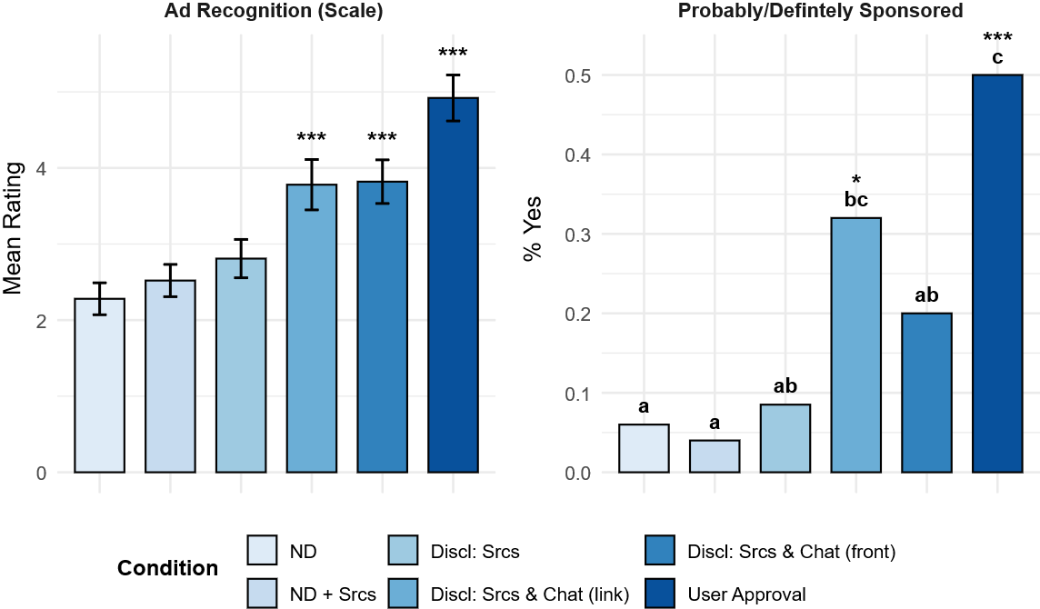
Figure 1. Effects of Disclosure Condition on Ad Recognition
Discl = Disclosure; ND = No disclosure; Srcs = Sources. Bars show estimated means (± SE) for ad recognition via the Likert scale (left panel) and proportions of participants responding “probably/definitely sponsored” (right panel). Asterisks indicate Dunnett tests versus the ND group. Different letters denote Bonferroni-adjusted pairwise differences (p < .05). N = 297; *** p < .001 * p < .05
- User Perception and Attitudes
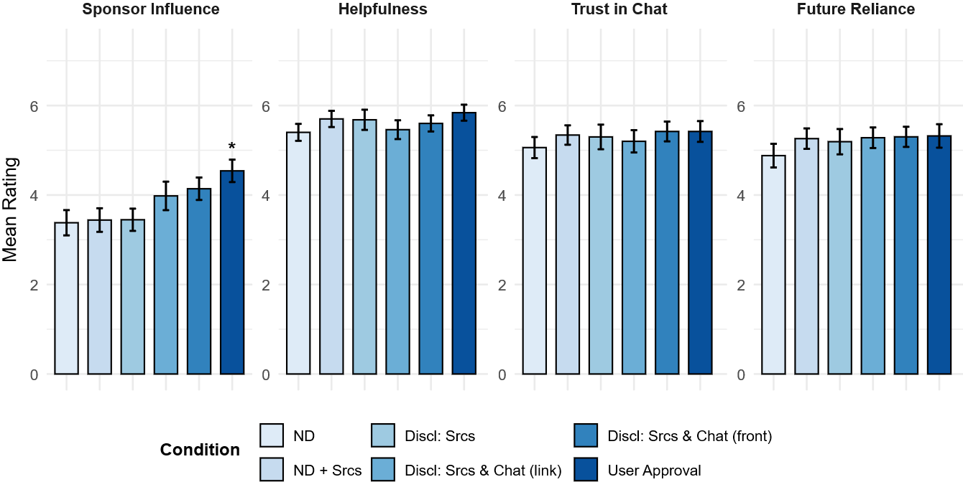
To measure H2 (A-B), a one-way ANOVA revealed a significant effect of disclosure condition on perceived sponsor influence (F_{(5,291)} = 3.07, p = .010; see Figure 2, left panel). Dunnett-adjusted comparisons to the control group indicated that only the user approval condition led to higher ratings of perceived sponsor influence (p = .012); the sources-only, link-disclosure, and front-disclosure variants did not differ from baseline (ps > .17). In contrast, the manipulation did not affect participants’ attitudes toward the chat, including perceived helpfulness, trust, and future reliance (ps > .62; see Figure 2). Overall, the sponsorship salience manipulation increased perceived sponsor influence only under the strongest cue (user approval) and did not negatively affect attitudes toward the chat.

Figure 2. Effects of Disclosure Condition on Users’ Perception and Attitudes
Discl = Disclosure; ND = No disclosure; Srcs = Sources. Bars show estimated means (± SE). Asterisks indicate Dunnett tests versus the ND group. N = 297; * p < .05

Additional analyses revealed that, irrespective of condition, participants who identified the chat as “probably/definitely sponsored” reported substantially higher perceived sponsor involvement than those who did not (t₂₉₅ = -7.71, p < .001; see Figure S1 in the Online Supplement). Conversely, no significant differences emerged between these groups for helpfulness, trust, or future reliance (ps > .07).

- Behavioral Patterns’ Effects

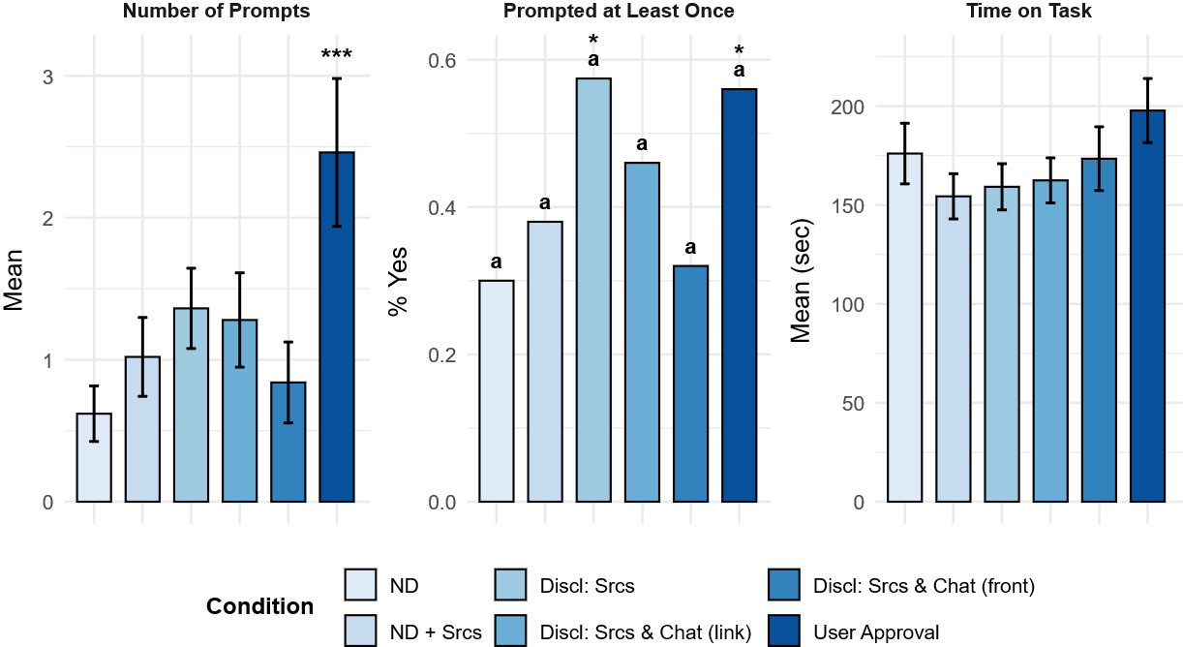
To investigate H3(A), A one-way ANOVA revealed a significant effect of disclosure condition on the number of prompts (F_{(5,291)} = 3.84, p = .002; see Figure 3, left panel). Dunnett-adjusted comparisons against the non-disclosure control indicated that only the user approval condition elicited significantly more prompts (p < .001), whereas all other disclosure variants did not differ from the control condition (ps > .38). Furthermore, a chi-square test predicting whether participants submitted at least one prompt revealed a significant effect of disclosure condition (χ²₍₅₎ = 13.2, p = .022; see Figure 3, middle panel). Dunnett-adjusted comparisons against the control indicated that both the sources-only (p = .032) and user approval (p = .042) conditions significantly increased the odds of prompting, whereas the other disclosure variants did not differ (ps > .34). Bonferroni-adjusted pairwise tests did not reveal further differences between conditions. By contrast, disclosure condition did not affect time spent on task (F_{(5,291)} = 1.28, p = .273; see Figure 3, right panel).
Figure 3. Effects of Disclosure Condition on Users’ Behavior
Discl = Disclosure; ND = No disclosure; Srcs = Sources. Bars show estimated means (± SE) for number of prompts and time spent on task (left and right panels) and proportions of participants prompting at least once (middle panel). Asterisks indicate Dunnett tests versus the ND group. Letters indicate groups did not differ based on Bonferroni-adjusted pairwise tests. N = 297; *** p < .001 * p < .05
- Study II
Analyses followed the same general approach described in Study I. In addition to chi-square tests of independence and logistic model–based contrasts (Dunnett versus control; Bonferroni for all pairs), binomial tests were conducted to assess whether product selection rates in each condition differed from chance level (50%).
- Advertising Recognition
Similar to Study I, a significant condition effect was found for ad recognition (F(3, 217) = 21.7, p < .001; see Figure 4, left panel). Dunnett-adjusted comparisons to the non-disclosure control indicated that recognition was significantly higher in all three disclosure conditions (ps < .001). A chi-square test predicting sponsor identification (“probably/definitely sponsored”) also showed a robust effect (χ²(3) = 30.8, p < .001; see Figure 4, right panel), with all three disclosure conditions showing higher identification than the control (ps < .002).
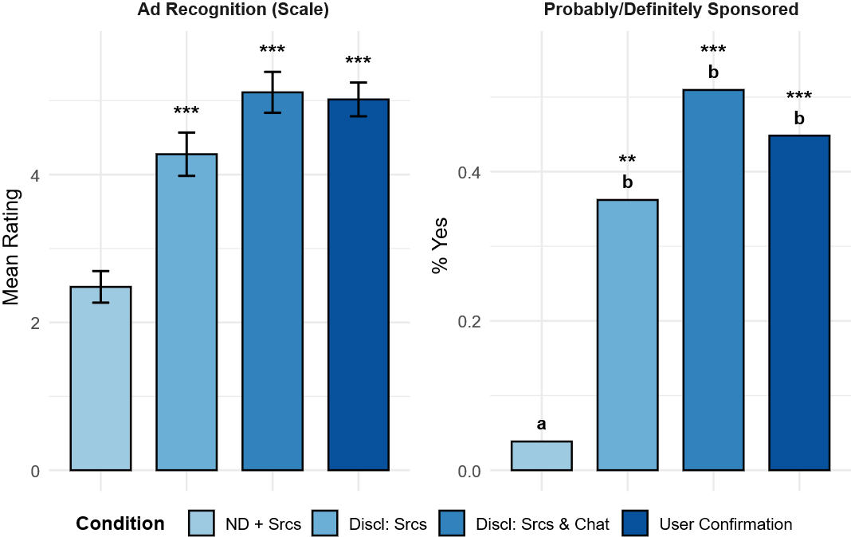
Figure 4. Effects of disclosure on ad recognition during product selection
Discl = Disclosure; ND = No disclosure; Srcs = Sources. Bars show estimated means (± SE) for ad recognition via the Likert scale (left panel) and proportions of participants responding “probably/definitely sponsored” (right panel). Asterisks indicate Dunnett tests versus the ND + Srcs group. Different letters denote Bonferroni-adjusted pairwise differences (p < .05). N = 221; *** p < .001
- User Perception and Attitudes
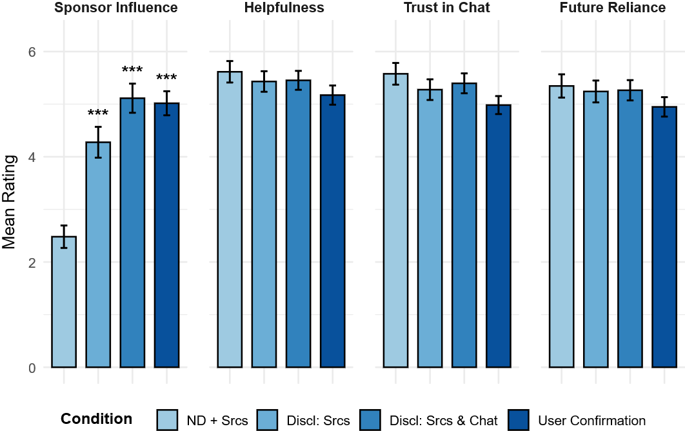
To measure H2 (A-B), a one-way ANOVA revealed a significant effect of disclosure condition on perceived sponsor influence, (F(3, 217) = 21.7, p < .001; see Figure 5, left panel). Dunnett-adjusted comparisons to the control condition indicated that all three disclosure conditions—sources, sources + chat, and user confirmation—led to significantly higher ratings of perceived sponsor influence (ps < .001). In contrast, disclosure condition did not affect participants’ attitudes toward the chat, including perceived helpfulness, trust, and future reliance (ps > .16; see Figure 5). Overall, the manipulation robustly increased perceived sponsor influence on the chat’s portrayal of the products across all disclosure cues but did not negatively affect participants’ attitudes toward the chat interface.
Figure 5. Effects of disclosure on perception and attitudes during product selection
Discl = Disclosure; ND = No disclosure; Srcs = Sources. Bars show estimated means (± SE). Asterisks indicate Dunnett tests versus the ND group. N = 221; *** p < .001
To measure H2 (C), a one-way ANOVA revealed no significant effect of disclosure condition on attitudes toward the selected product for either liking (F(3, 217) = 1.66, p = .18) or recommendation (F(3, 217) = 0.12, p = .95; see Figure 6, left panels). In contrast, for the other (non-selected) product, there was a significant condition effect on liking (F(3, 217) = 3.82, p = .011) and a marginal effect on recommendation (F(3, 217) = 2.55, p = .057; see Figure 6, right panels). Dunnett-adjusted contrasts indicated that only the user confirmation condition led to significantly lower liking (p = .008) and lower willingness to recommend (p = .036) the non-selected product compared to the control condition. No other contrasts reached significance (ps > .38).
To examine whether this pattern reflected disclosure effects or selective exposure, we compared participants who revealed the sponsored product to those who did not within the user confirmation condition. This analysis did not reveal significant differences in liking (t56 = -1.72, p = .092) or willingness to recommend (t56 = –1.36, p = .179) between revealers and non-revealers.
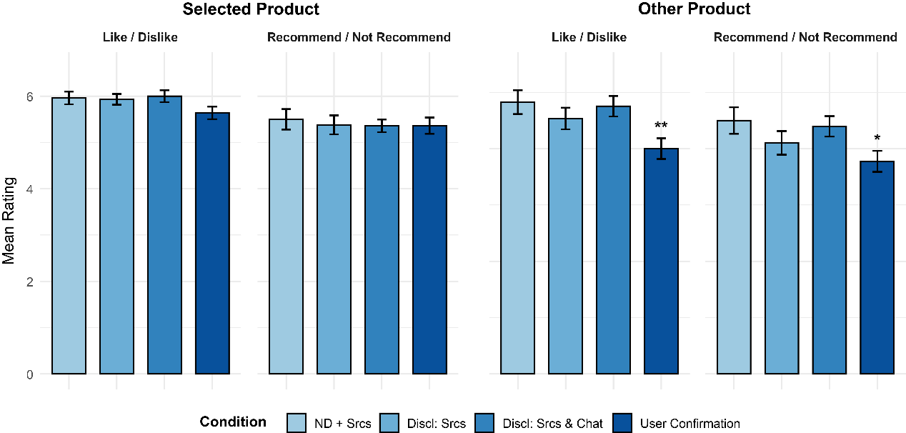
Overall, disclosure did not alter attitudes toward the chosen product, but the high-saliency and activity-contingent sponsorship cue (i.e., user confirmation) decreased evaluations of the competing option, indicating a shift away from the other product rather than a general reduction in positive attitudes.

Figure 6. Effects of disclosure on attitudes toward the products
Discl = Disclosure; ND = No disclosure; Srcs = Sources. Bars show estimated means (± SE) for liking and willingness to recommend the selected product (left panels) and the other/non-selected product (right panels). Asterisks indicate Dunnett tests versus the ND + Srcs group. N = 221; ** p < .01, * p < .05
- Behavioral Pattern Effects
The most important finding in Study II was the effect of disclosure on consumers’ purchasing intentions (H3b), as can be learned from product selection patterns. To measure that effect, a chi-square test revealed a significant effect of disclosure condition on product selection (χ²(3) = 19.2, p < .001; see Figure 7, left panel). Dunnett-adjusted comparisons to the no disclosure-control condition indicated that selection of the sponsored product was significantly lower when user confirmation was required prior to revealing the sponsored product (p < .001), whereas the disclosure in sources or in both sources and chat differed from baseline (ps > .23). Bonferroni-adjusted pairwise tests further confirmed that requiring user confirmation yielded lower selection rates than all other conditions. Relative to chance level (50%), binomial tests indicated selection did not deviate significantly in the control (sources-only), sources disclosure, or sources + chat disclosure conditions (ps > .087), but was lower in the user confirmation condition (p < .001).
An additional analysis within the user confirmation condition demonstrated that participants who actively clicked to reveal the sponsored product selected it more often than those who did not (χ²(1) = 7.04, p = .008 (see Figure 7, right panel). However, binomial tests indicated that both those who revealed (p = .038) and those who did not (p < .001), chose the sponsored product below chance level.
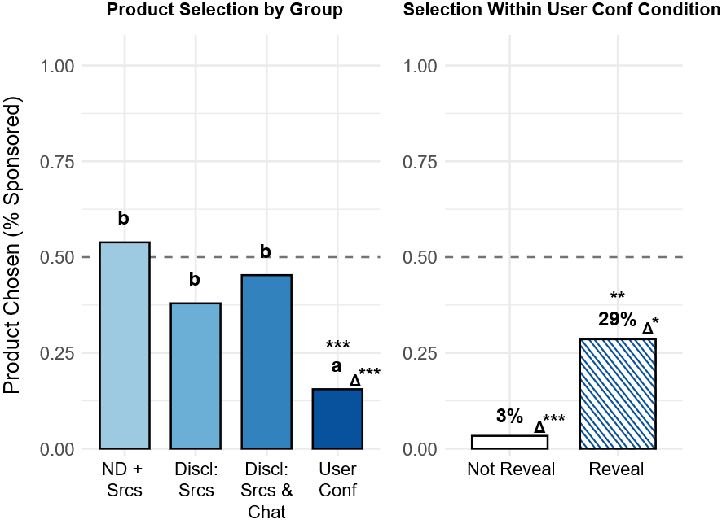
Figure 7. Effects of disclosure on sponsored product selection
Conf = Confirmation; Discl = Disclosure; ND = No disclosure; Srcs = Sources. Bars show proportions of participants selecting the sponsored product across disclosure conditions (left panel) and within the user confirmation condition (right panel). Asterisks indicate Dunnett tests versus the ND + Srcs group (left panel) and the non-revealers group (right panel). Different letters denote Bonferroni-adjusted pairwise differences (p < .05). Δ indicates significant binomial tests against chance level (50%). N = 221; *** p < .001, ** p < .01, * p < .05

Policy Implications
The findings of these studies carry significant implications for consumer-protection law and the regulation of AI-mediated advertising. On the one hand, they show that genernative advertising reproduces—and in some cases intensifies—the concerns long associated with native advertising: consumers frequently fail to detect underlying commercial influence, leaving them vulnerable to manipulation. On the other hand, the same studies demonstrate that GenAI chatbots offer an unprecedented opportunity for remedial innovation. Their interactive, adaptive format allows for more effective informational disclosures and behavioral nudges than have been feasible in traditional media.
Beginning with advertising recognition. Across both studies, consumers systematically failed to identify chatbot-mediated sponsored content. Recognition rates in the non-disclosure conditions hovered around 10–20%, and passive disclosures increased awareness only modestly—to approximately 20–30% in Study I. These findings reinforce a central premise of consumer-protection law: native advertising is inherently misleading, and conventional disclosure mechanisms offer only limited corrective value. Prior research in advertorial settings has shown similarly constrained effects, with passive disclosures rarely elevating recognition much beyond 20%.
Yet the present findings go beyond this established point. The experimental results show that affirmative disclosures—such as user-approval mechanisms requiring participants to actively acknowledge that they are viewing sponsored content—substantially increase recognition, raising rates to more than 50% in Study I (roughly a fivefold increase over the no-disclosure baseline). This magnitude of improvement has no analogue in prior native-advertising research.
Moving to behavioral effects, the studies clearly demonstrate that affirmative disclosures meaningfully alter consumer reactions. Under the user-approval condition in Study I, participants increased their conversational engagement with the chatbot—submitting roughly five times as many prompts—and spent more time interacting with the system. In Study II, affirmative disclosures dramatically shifted consumer choices: participants selected the sponsored product at rates of only ~10%, compared to ~50% in the no-disclosure condition. These patterns suggest that affirmative disclosures prompt more cautious, critical engagement and more deliberative decision-making.
Taken together, these findings suggest that the longstanding critique of disclosure regulation—that it is ineffective and largely symbolic—may be substantially mitigated in the generative-AI environment. The conversational interface appears capable of supporting disclosure formats that are both cognitively salient and behaviorally impactful.
Equally important is what the studies did not find, particularly concerning the attitudinal effects on consumers. Contrary to Hypothesis H2(b) and much of the native-advertising literature, participants’ attitudes toward the chatbot did not decline under any disclosure condition, including the most intrusive user-approval mechanism. This result diverges both from PKM predictions and from the only prior study of genernative advertising, which found that disclosures degraded trust. Here, disclosure increased awareness and shaped behavior without eroding trust in the platform. This suggests that GenAI providers may satisfy both commercial interests and public-regulatory objectives: educating users about persuasive influence need not undermine confidence in the system itself.
These results provide strong support for requiring GenAI companies to adopt robust advertising-disclosure protocols. Traditional consumer-protection regimes—such as the Federal Trade Commission’s authority over deceptive and unfair practices—already mandate sponsorship disclosure in other advertising contexts. The evidence here indicates that, for GenAI systems, regulators should go further: Disclosure should be mandatory whenever chatbot outputs incorporate sponsored content. Additionally, these disclosures should be affirmative, interactive, and verifiable, rather than passive or easily overlooked. In some cases, regulators should consider chatbots to integrate stronger forms of behavioral nudges (e.g., pre-approval prompts) into their users interfaces to facilitate meaningful consumer awareness.
Emerging state legislation provides a useful starting point. Although state legislation such as Utah’s Artificial Intelligence Policy Act (AIPA) and Colorado’s Artificial Intelligence Act (SB 24-205) focus primarily on notifying consumers that they are interacting with AI systems, these laws demonstrate a workable regulatory model: mandatory transparency, enforceable disclosure obligations, and civil penalties for noncompliance. Colorado’s statute, for example, treats violations as unfair trade practices under the Colorado Consumer Protection Act, subject to significant penalties. Extending comparable principles to genernative advertising would align GenAI operations with longstanding doctrines of consumer protection.
As with any advertising regime, effective enforcement is essential. Traditional legal avenues—tort, product-liability doctrines, deceptive trade practices statutes, and FTC enforcement—should apply with equal force to AI-mediated advertising. Courts and regulators should be willing to hold GenAI providers liable when they fail to implement adequate disclosure protocols, particularly given these systems’ capacity to shape consumer decision-making at scale.

Conclusion
Genernative advertising represents both the latest stage in the evolution of persuasive media and a profound shift in its underlying mechanics. It extends a century-long effort to blur the line between editorial judgment and commercial influence, yet it does so through a medium that removes the very cues—formatting, placement, labeling—on which disclosure regimes have traditionally depended. When large language models produce seamless, authoritative prose that silently incorporates sponsored content, the distinction between information and promotion becomes nearly invisible.
The experimental evidence presented in this Article highlights the scale of the challenge: consumers routinely fail to recognize AI-mediated sponsorship, and passive disclosures offer only marginal improvements. Yet the same evidence identifies a promising path forward. Affirmative, interactive disclosures—requiring users to acknowledge sponsored content before exposure—substantially enhance recognition and reshape behavior, all without diminishing trust in the chatbot itself. These findings suggest that generative interfaces, far from being an inherent threat to transparency, may be harnessed as an exceptionally effective vehicle for it.
The regulatory implications are clear. GenAI companies should be required not only to disclose advertising ties, but to do so through interactive mechanisms that leverage the conversational nature of their platforms. Agencies such as the Federal Trade Commission, together with state regulators, can build on emerging models—such as Utah’s AIPA and Colorado’s SB 24-205—to establish enforceable transparency standards for AI-mediated advertising.
Ultimately, the rise of genernative advertising forces a broader reckoning with the ethics of automated persuasion. The same technologies that can perfect the art of influence can also perfect the art of disclosure. Whether they function as tools of manipulation or instruments of consumer empowerment will depend on how law, design, and accountability converge in the years ahead.

Appendices
- Appendix I – Stimulated Materials
- Study I
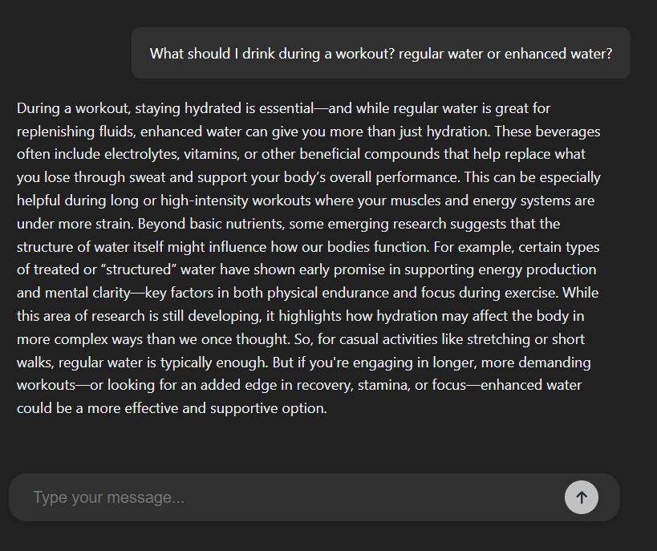
# 1 – No Disclosure Condition (ND)
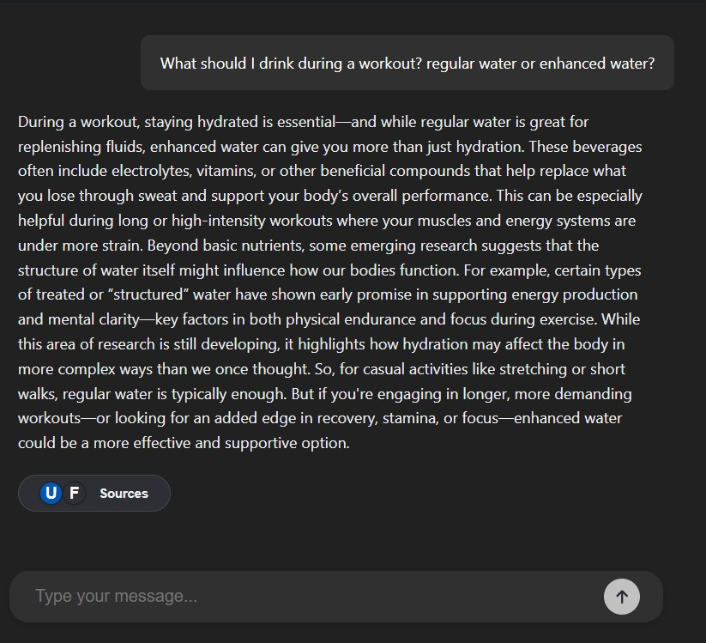
# 2 – No Disclosure and Linked-sources Condition (ND + Srcs)

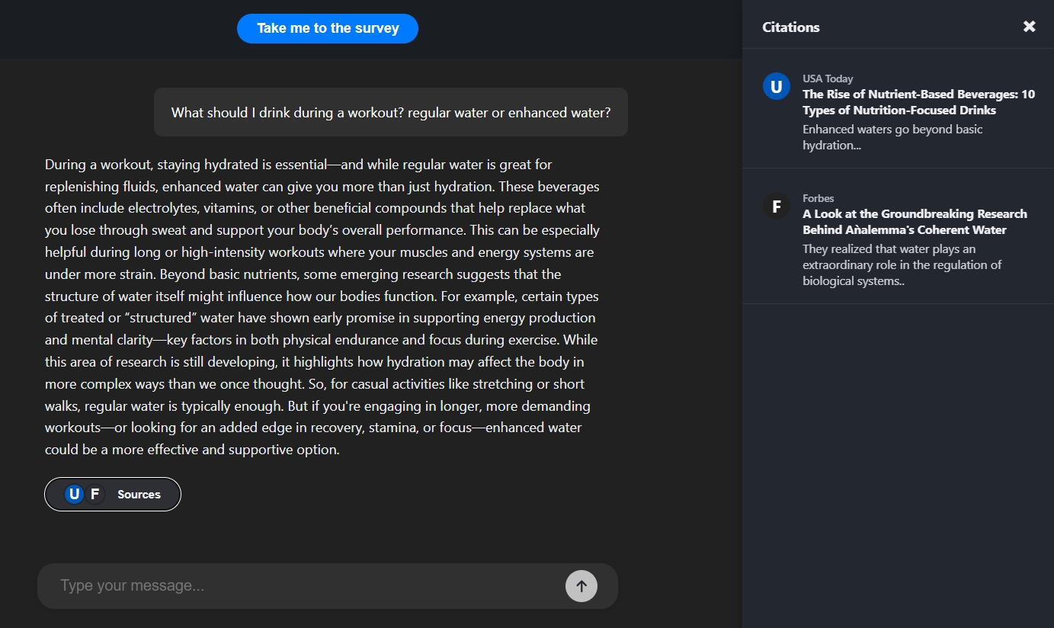
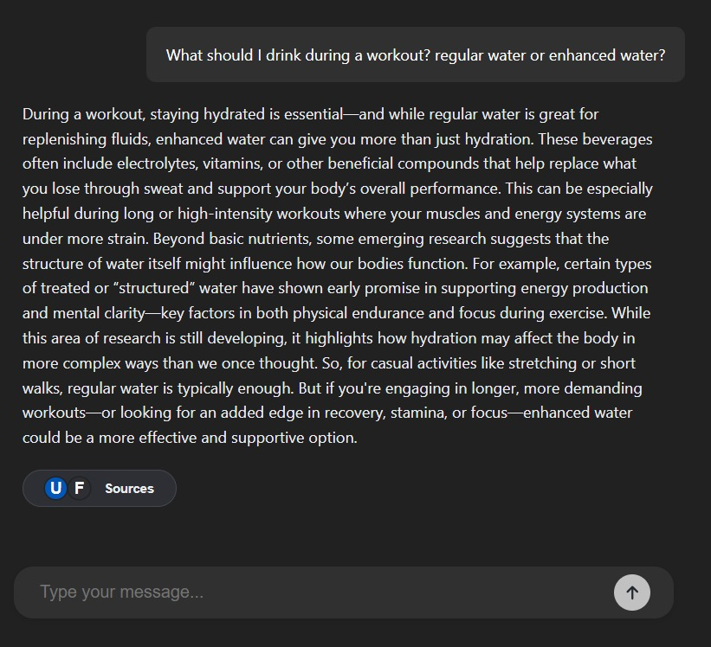
# 3 – Sponsored content disclosure condition (Discl: Srcs)

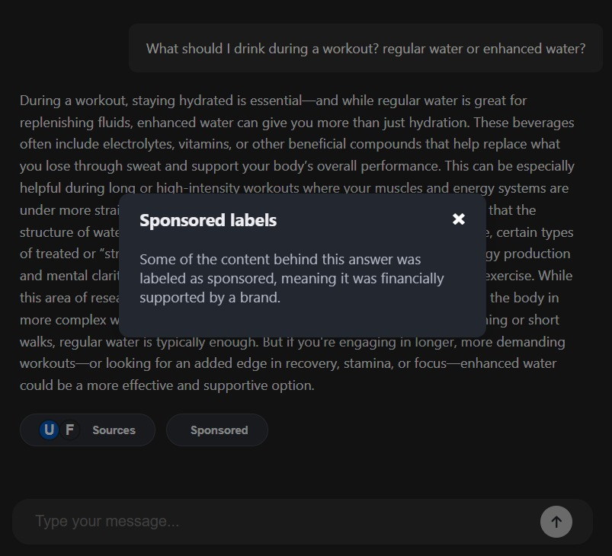
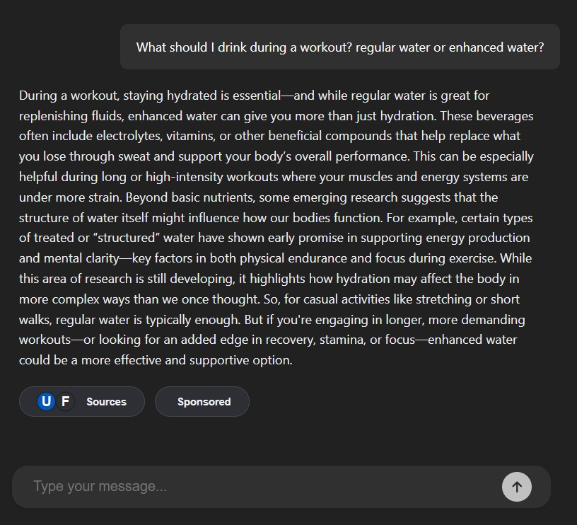
# 4 – Sponsored content and within chat link disclosure condition (Discl: Srcs + Chat (link))
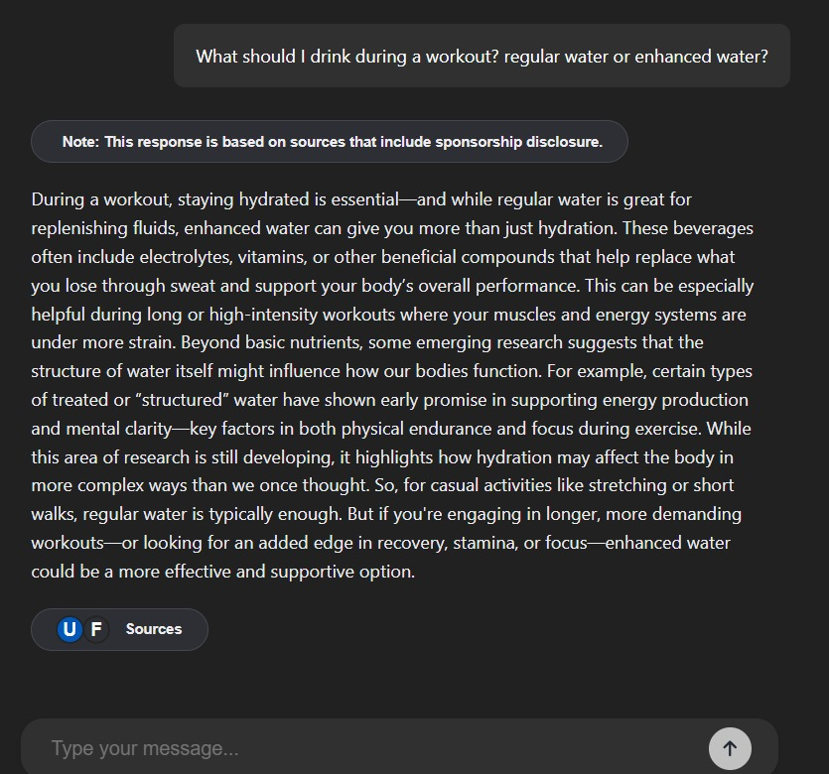
# 5 – Sponsored content and within chat front disclosure condition (Discl: Srcs + Chat (front))

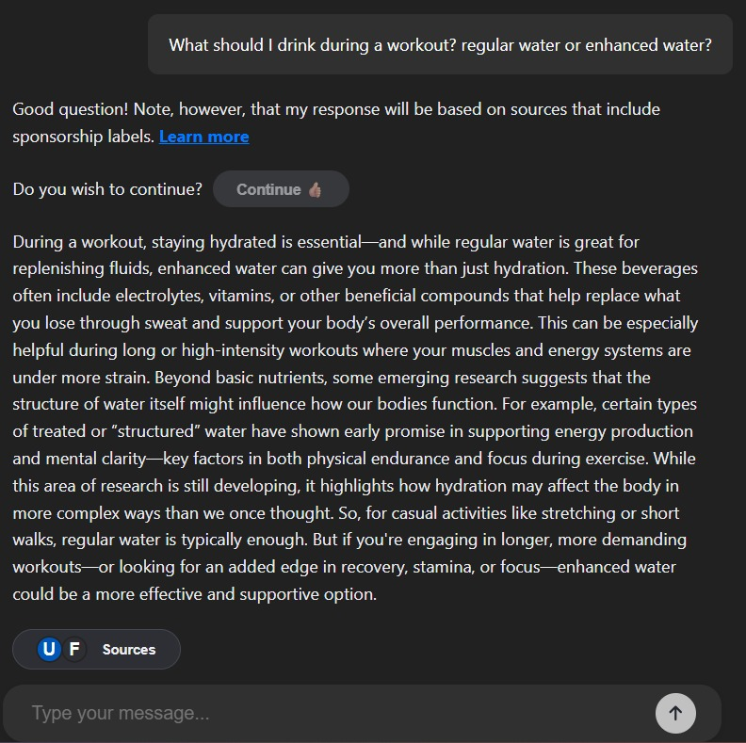
# 6 – Pre-approval condition (user approval)
Sources
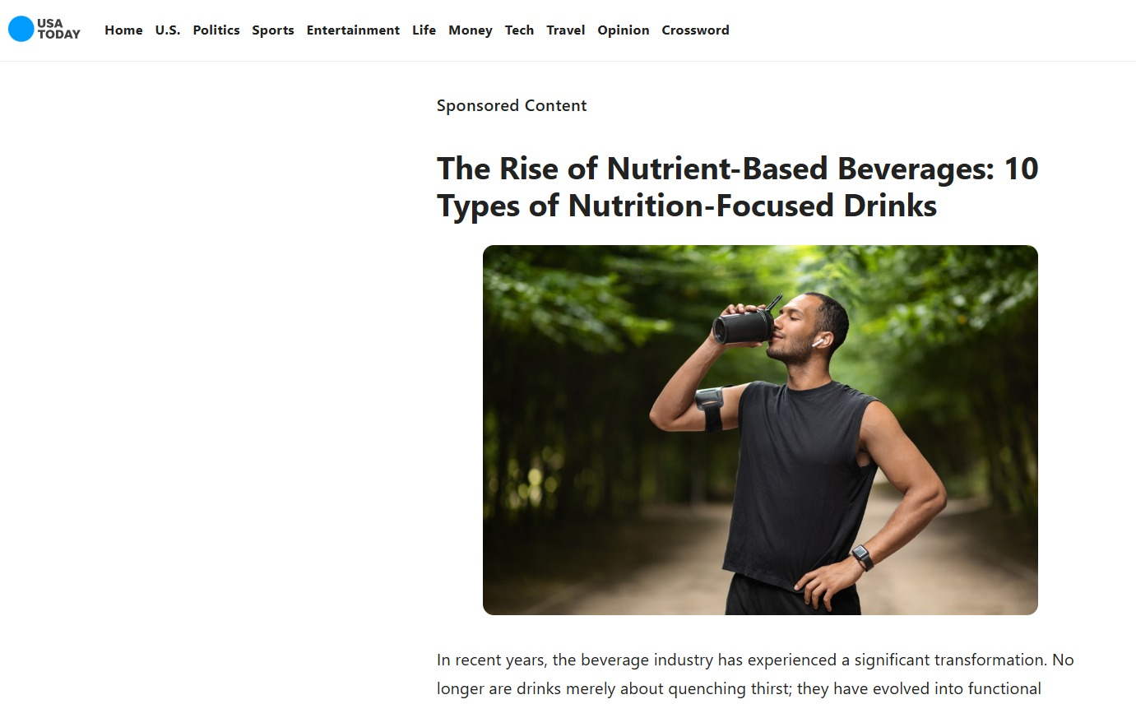
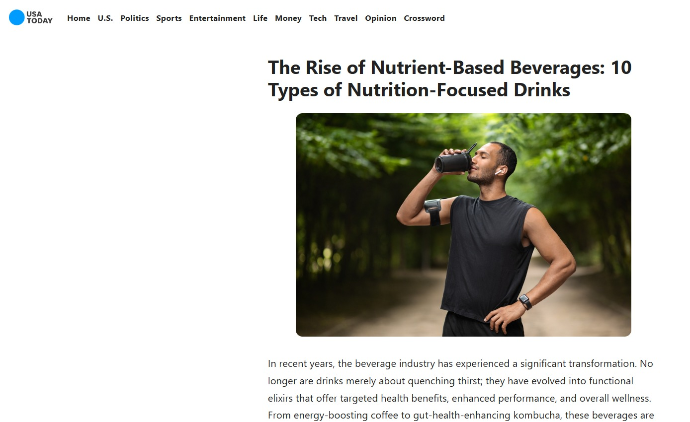
Article # 1 – USA Today (with and without sponsorship disclosure)

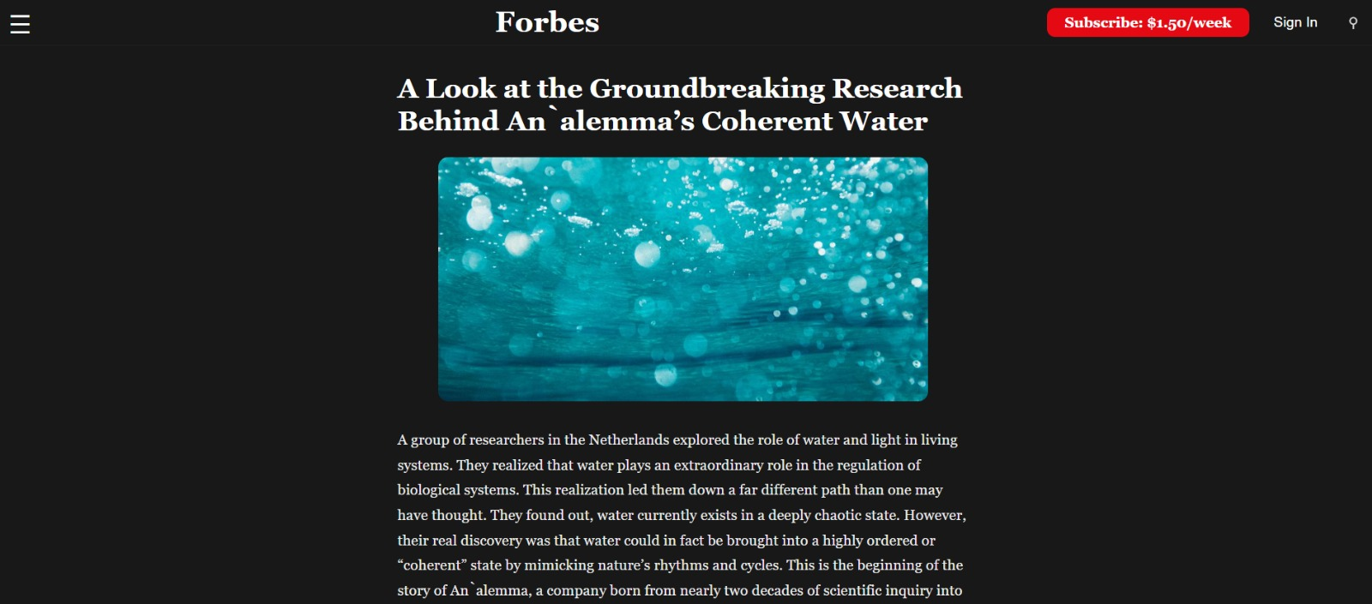

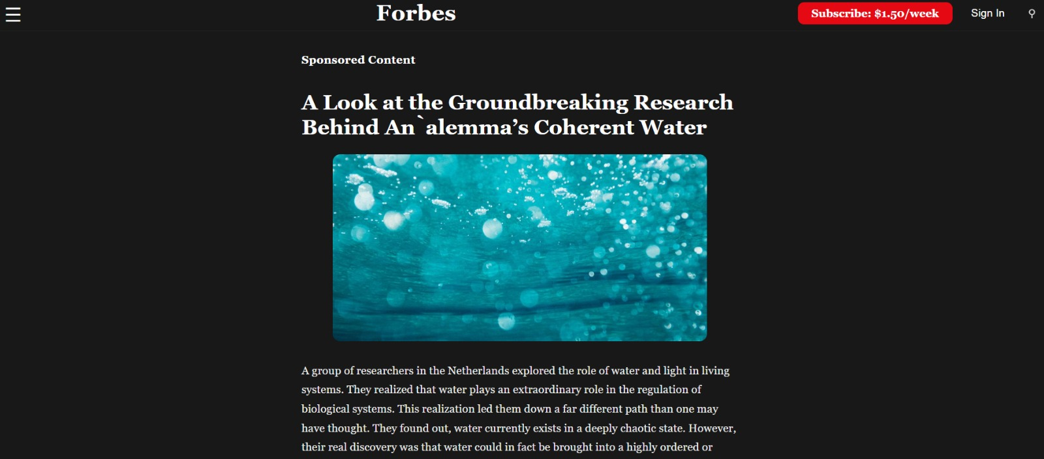
Article # 2 – Forbes (with and without sponsorship disclosure)

- Study II

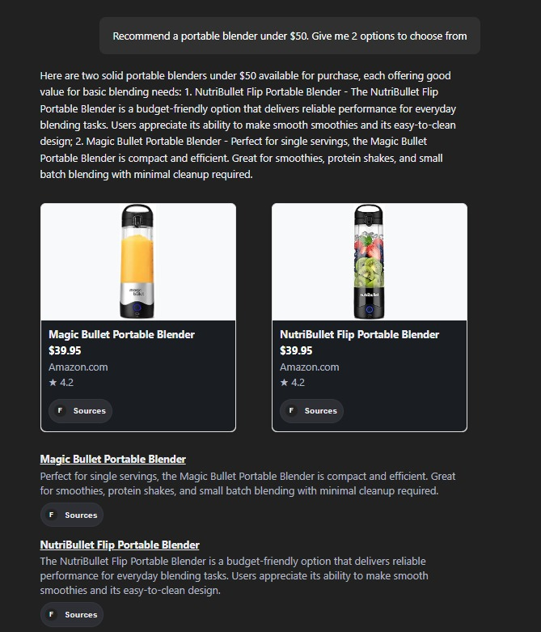
# 1 – Sponsored content disclosure condition (Discl: Srcs)

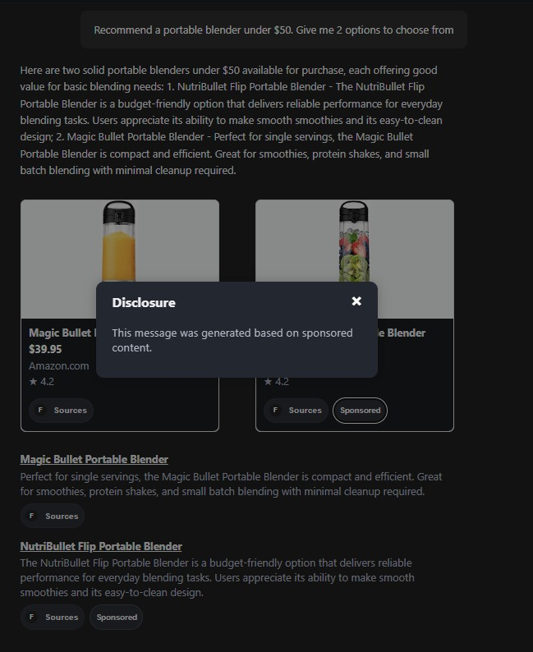
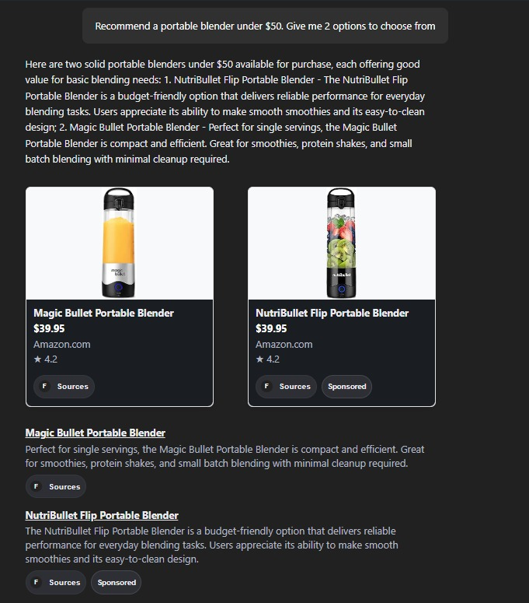

# 2 – Sponsored content and within chat link disclosure condition (Discl: Srcs + Chat (link))

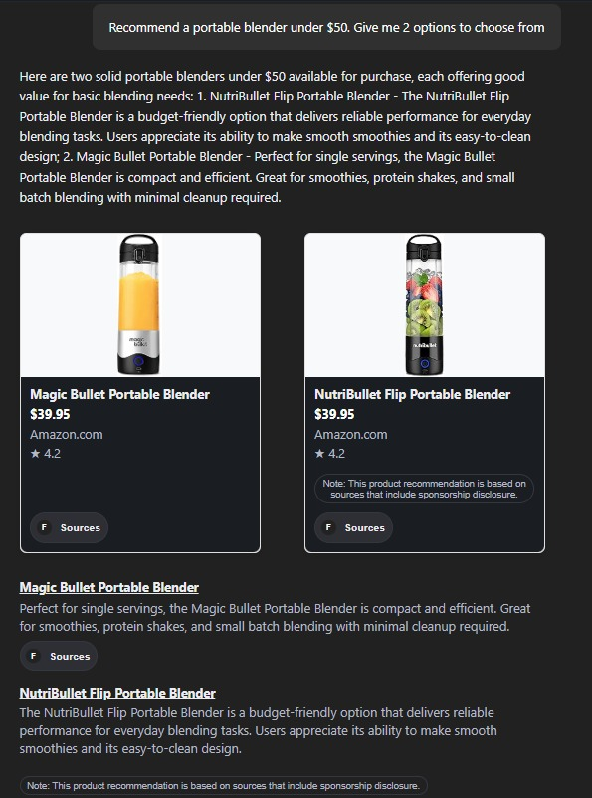
# 3 – Sponsored content and within chat front disclosure condition (Discl: Srcs + Chat (front))

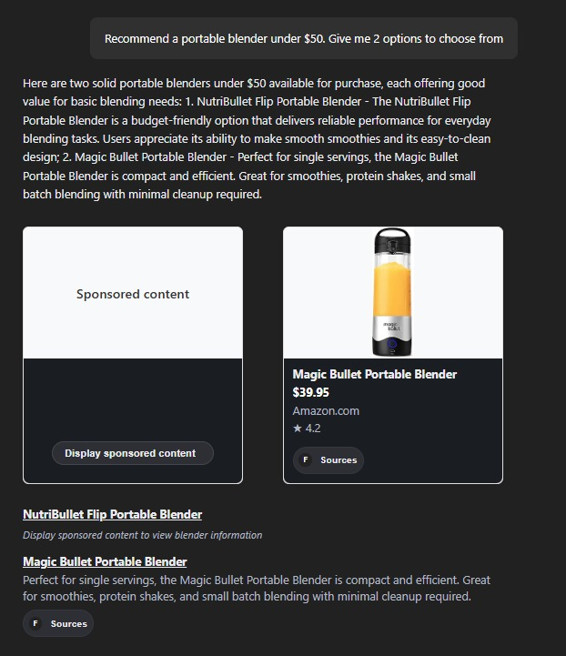
# 4 – Pre-approval condition (user approval)

- Appendix II – Full Survey

- Study I

Start of Block: Content Evaluation

Q1 According to the chatbot conversation, what are some potential benefits of drinking enhanced water during a workout? Choose all that apply:
- It prevents muscle cramps better than regular water (1)
- It may support energy production (2)
- It can help with mental focus (3)
- It helps replenish electrolytes lost through sweat (4)
- It reduces the need for post-workout meals (5)

Q2 In what situations does the conversation suggest regular water is sufficient?
- During intense cardio or strength training (1)
- When you're feeling dehydrated after a long day (5)
- During light workouts like walking or stretching (3)
- When you need a mental focus boost before work (4)

End of Block: Content Evaluation

Start of Block: AI chatbot evaluation

Q3 Read the statements below carefully and indicate to what extent you agree (1 = Strongly Disagree, 7 = Strongly agree)
 | 1 - Strongly Disagree (1) | 2 (9) | 3 (10) | 4 - Neutral (11) | 5 (12) | 6 (13) | 7 - Strongly Agree (14)
The AI’s recommendation was helpful (1)
I found the AI chatbot to be trustworthy (5)
I would rely on AI for similar insights in the future (6)

End of Block: AI chatbot evaluation

Start of Block: Advertising perception

Q4 Indicate the extent to which you thought the conversation was influenced by paid advertising or sponsorship:
 | 1 - Strongly Disagree (1) | 2 (9) | 3 (10) | 4 - Neutral (11) | 5 (12) | 6 (13) | 7 - Strongly Agree (14)
1 (1)

Page Break

Q5 Why did you or did you not think the message was advertising?
________________________________________________________________
________________________________________________________________
________________________________________________________________
________________________________________________________________
________________________________________________________________

Page Break

Q6 Did you notice any message indicating that the chatbot response might be sponsored or promotional?
 | Definitely not (1) | Probably not (9) | Possibly not (10) | Not sure (11) | Possibly yes (12) | Probably yes (13) | Definitely yes (14)
1 (1)

Page Break

End of Block: Advertising perception

Start of Block: Additional questions

Q7 How often do you use AI chatbots such as ChatGPT, Claude, or similar tools?
- Never - I have never used an AI chatbot before (1)
- Rarely – less than once a month (2)
- Occasionally – a few times a month or week (3)
- Frequently – daily or almost daily (4)

Q8 How old are you?
- Under 18 (1)
- 18-24 years old (2)
- 25-34 years old (3)
- 35-44 years old (4)
- 45-54 years old (5)
- 55-64 years old (6)
- 65+ years old (7)

Q9 How do you describe yourself?
- Male (1)
- Female (2)
- Non-binary / third gender (3)
- Prefer to self-describe (4) __________________________________________________
- Prefer not to say (5)

Q10 Choose one or more races that you consider yourself to be
- White or Caucasian (1)
- Black or African American (2)
- American Indian/Native American or Alaska Native (3)
- Asian (4)
- Native Hawaiian or Other Pacific Islander (5)
- Other (6)
- Prefer not to say (7)

Q11 What is the highest level of education you have completed?
- Some high school or less (1)
- High school diploma or GED (2)
- Some college, but no degree (3)
- Associates or technical degree (4)
- Bachelor’s degree (5)
- Graduate or professional degree (MA, MS, MBA, PhD, JD, MD, DDS etc.) (6)
- Prefer not to say (7)

Q12 What was your total household income before taxes during the past 12 months?
- Less than $25,000 (1)
- $25,000-$49,999 (2)
- $50,000-$74,999 (3)
- $75,000-$99,999 (4)
- $100,000-$149,999 (5)
- $150,000 or more (6)
- Prefer not to say (7)

End of Block: Additional questions

Start of Block: Block 4

Disclosure Thank you for participating in this online study! The goal of this study was to assess whether covert advertising practices that advertisers use on Generative AI Chatbots and news websites mislead and harm consumers. The news website page that you just reviewed featured a covert advertorial—an advertisement designed to appear as editorial content. The advertorial was marked with a noticeable/unnoticeable disclosure (differs among participant groups) as uncommonly/commonly used (differs among participant groups) by popular news websites. The study aimed to check whether the disclosure of commercial sponsorships was visible to you and how you engaged with the advertorial. Your participation was crucial in helping us flag manipulative advertising practices, make advertisers socially accountable for these practices, and preserve the integrity of online journalism. This study was conducted by academics [Dr. Uri Yosef Hacohen, Tel-Aviv University, reachable at https://en-law.tau.ac.il/profile/urihacohen ] and was funded by a non-profit organization committed to fundamental research and education. The data collected during this study did not include any personally identifiable information and will be used only for the purpose of this study). Thank you again for participating! Click next to get your Prolific code and paste it in Prolific to get your reward.

End of Block: Block 4

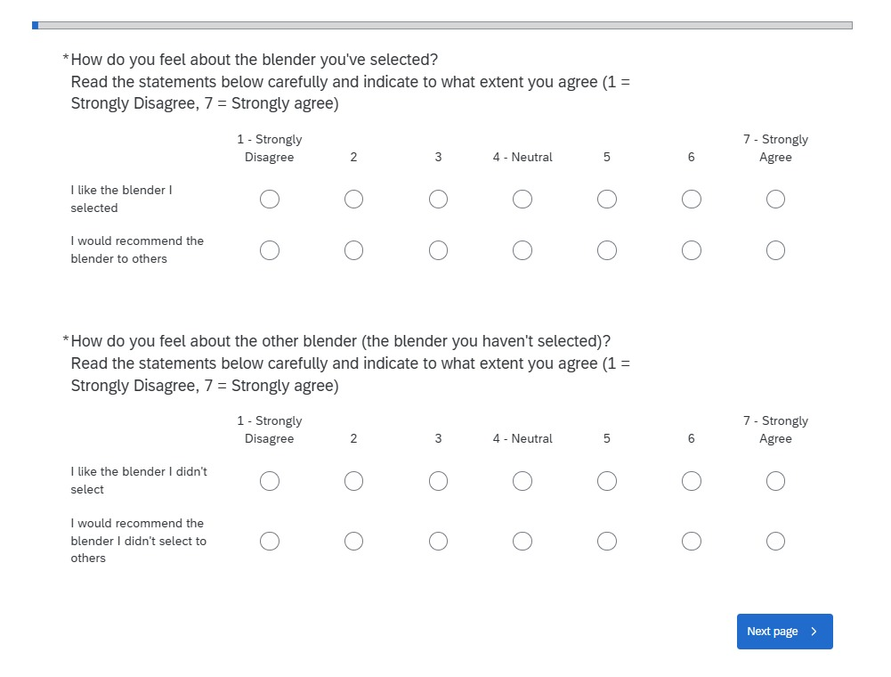
- Study II
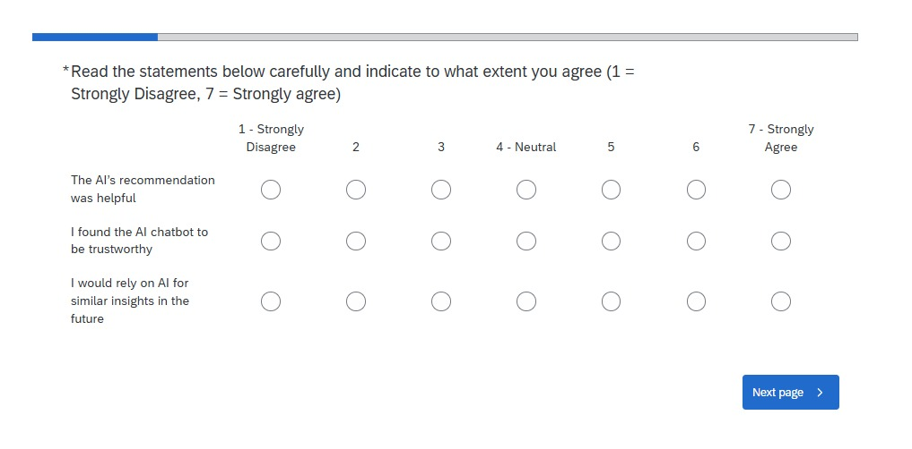
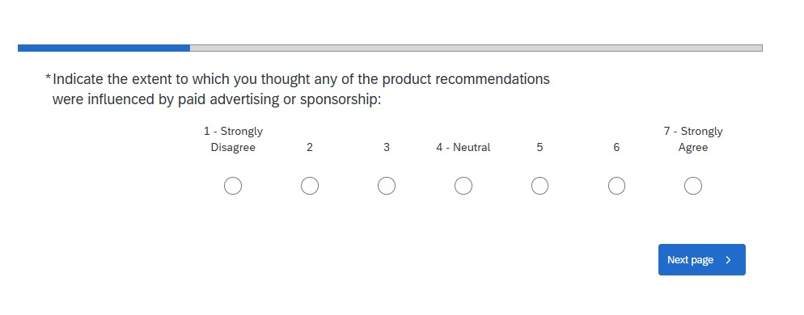

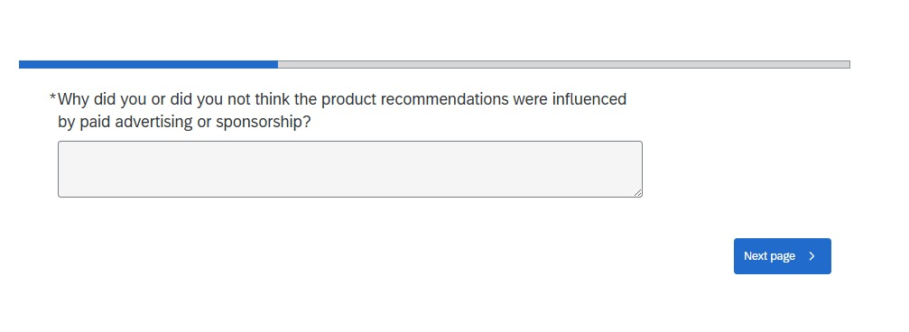
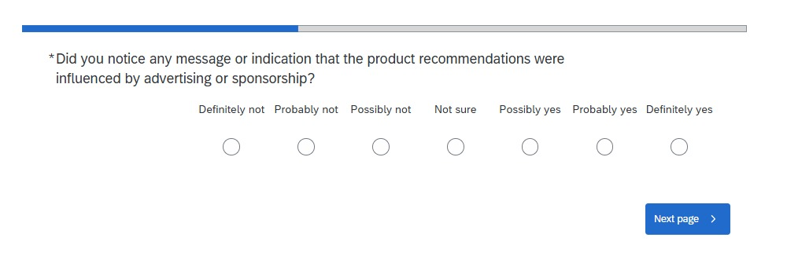

- Appendix III – Procedure

- Appendix IV – Additional Findings

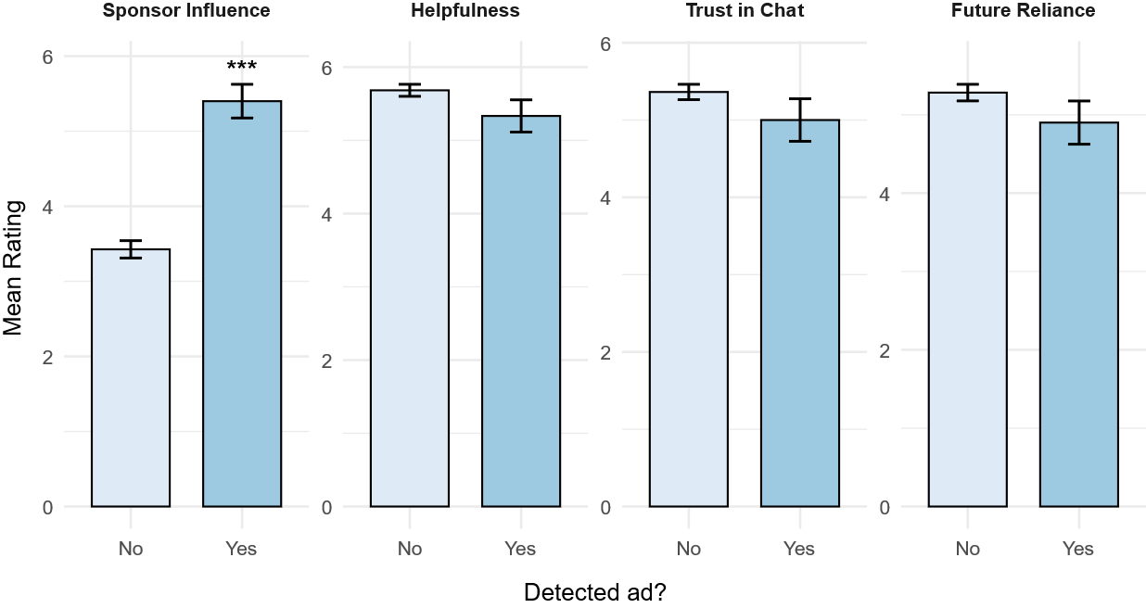
- Study I

Figure S1. Differences Between Sponsor Identification Groups
Bars show estimated means (± SE) for sponsor influence, helpfulness, trust in chat, and future reliance as a function of whether participants identified the chat as “probably/definitely sponsored” (n = 60) or not (n = 237). Asterisks indicate independent-samples t-tests between groups. N = 297; *** p < .001

† Assistant Professor, Tel-Aviv University Faculty of Law; Faculty Associate at the Chief Justice Meir Shamgar Center for Digital Law and Innovation. I am grateful to Professor Peter Menell for his kind advice and support, to Guy Becker and Or Burstein for their diligent research assistance, insightful feedback and analysis, and spectacular technical support.
Up until recently, this disclosure appeared whenever ChatGPT generated product recommendations. See Brodie Clark, ChatGPT Shopping Results Have Been Updated, Brodie Clark Consulting (Sep. 3, 2025).
See Bassant Eyada & Asli Cazorla Milla, Native Advertising: Challenges and Perspectives, 1 Journal of Design Sciences and Applied Arts 67, 68–70 (2020).
Id. at 68–69; Matt Carlson, When news sites go native: Redefining the advertising–editorial divide in response to native advertising, 16(7) Journalism 849–865 (2014); Ross D. Petty, From puffery to penalties: a historical analysis of US masked marketing public policy concerns, 5(1) Journal of Historical Research in Marketing, 10–26 (2013).
See Ines Zelch, Matthias Hagen & Martin Potthast, A User Study on the Acceptance of Native Advertising in Generative IR, in CHIIR 2024 - Proceedings of the 2024 Conference on Human Information Interaction and Retrieval 142, 143 (2024).
Ava Sirrah, How Invisible Ads Undermine Journalism Ethics, Center for Journalism Ethics – UW–Madison (2023), https://ethics.journalism.wisc.edu/2023/11/06/invisibleadsunderminejournalism/?utm_source=chatgpt.com; Zelch, supra note 3 at 143 (“Text SERPs enable an even closer integration of ads with organic results, akin to native advertising.”); Michelle A. Amazeen & Ashley R. Muddiman, Saving Media or Trading on Trust?: The Effects of Native Advertising on Audience Perceptions of Legacy and Online News Publishers, 6 Digital Journalism 176, 177 (2017)(“Nearly three out of four online publishers in the United States now offer native advertising opportunities.”).
Sara Lebow, Display advertising in 5 charts: From programmatic to retail media, Insider Intelligence eMarketer (Nov 9, 2023).
Bassant Eyada & Asli Milla, Native Advertising: Challenges and Perspectives, 1 Journal of Design Sciences and Applied Arts 67, 72 (2020).
Federal Trade Commission, Blurred Lines: Advertising or Content? – An FTC Workshop on Native Advertising (Dec. 4, 2013), https://www.ftc.gov/news-events/events/2013/12/blurred-lines-advertising-or-content-ftc-workshop-native-advertising (as Bob Garfield stated, “The problem is that this is the digital world that we’re talking about. That content may be born under a brand voice logo on Forbes.com, but it doesn’t stay there. No, it migrates. And within eight hours of this native ad being posted, it has also shown up, no doubt with the sponsor’s help, on 162 other sites. And as far as those sites were concerned, the source was not the native advertising section of Forbes; it was simply Forbes.”).
See generally Uri Y. Hacohen, The Shifting Economics of Influencer Sponsorship Disclosures, (Forthcoming at the Cardozo Arts & Ent. L.J., 2025).
Ruvimbo Musiyiwa & Jenna Jacobson, Sponsorship Disclosure in Social Media Influencer Marketing: The Algorithmic and Non-Algorithmic Barriers, 9 Social Media + Society (2023) (discussing sponsorship disclosure regulations throughout the globe); Daniel Ershov & Matthew Mitchell, The Effects of Advertising Disclosure Regulations on Social Media: Evidence From Instagram, 56(1) The RAND Journal of Economics 74 (2025) (same); Zofia Saternus, Cristina Mihale‑Wilson, & Oliver Hinz, Influencer marketing on Instagram—The optimal disclosure strategy from influencers’ and marketers’ perspectives, 34 Electronic Markets, 60 (2024) (same).
Paul Ricard, Poll Finds Public Turning to AI Bots for News Updates, Agence France-Presse, (June 17, 2025), https://techxplore.com/news/2025-06-poll-ai-bots-news.html?utm_source=chatgpt.com. But see Kimberly Culp et al., FTC Outlines Five Don’ts for AI Chatbots, Fenwick (July 11, 2024), https://www.fenwick.com/insights/publications/ftc-outlines-five-donts-for-ai-chatbots?utm_source=chatgpt.com (“All marketing materials must clearly disclose the presence of chatbots powered by AI and their capabilities, along with any content sponsorships or endorsements that have a material connection to or could influence the credibility of the output communications.”).
See Zelch et al., supra note 3, at 142 (describes this as a paradigm shift).
This problem is, in fact, broader: it includes both legitimate optimization measures that can enhance content visibility while still being influenced and affected by commercial interests, and it may include illegitimate optimization measures such as source manipulation. See Aounon Kumar & Himabindu Lakkaraju, Manipulating Large Language Models to Increase Product Visibility, arXiv:2404.07981 [cs.IR] 1 (2024).
Yifan Ding et al., Citations and Trust in LLM Generated Responses, arXiv 2501.01303 [cs.CL] (2025) (“There were 1,976 answers in our dataset that had at least one reference. Of these, only 193 (9.77%) were manually checked.”).
Id. (at Results).
See e.g., David Berenstein, A Practical Guide on AI Security and LLM Vulnerabilities, Giskard (Jun. 4, 2025) (noting that, “training data might also include low-quality information like spam or commercial content”); Briana Brownell, How does ChatGPT choose its sources when browsing the web?, Zapier (Mar. 13, 2024) (“ChatGPT also claims to downgrade sources based on areas of possible bias, including sites for whom affiliate marketing might influence the results, noting inherent biases of company blogs toward their own products. In my tests, it did somewhat steer clear of these sites, but not totally.”).
Dirk Lewandowski, The Influence of Commercial Intent of Search Results on Their Perceived Relevance, IConference ’11, 452, 455 (2011) (“We found that all search engines provide a large number of results with a commercial intent. Google provides significantly more commercial results than the other search engines do.”).
See Clark, supra note 1. This statement, while true on its narrow terms because OpenAI—as of now—does not provide sponsored references, still obscures the structural ways in which sponsorship-laden content influences the system’s generative outputs.
See Zelch et al., supra note 3 at 142.1 (“Unlike on the traditional list SERPs, where ads typically appear prominently but separate from the unpaid results, the LLMs powering conversational search systems have the capacity to blend ads and generated search results in the form of native advertising.”)
Even in the marketing literature domain there were only two experimental studies considering the issue and even them with a limited design. See Zelch et al., supra note 3; Brian Jay Tang et al., Ads that Talk Back: Implications and Perceptions of Injecting Personalized Advertising into LLM Chatbots, arXiv 2409.15436 [cs.HC] (2025).
See infra Part III.
Id.
Id.
Sofia Eleni Spatharioti et al., Comparing Traditional and LLM-Based Search for Consumer Choice: A Randomized Experiment, 2 (2023).
Sebastian Schmidt et al., Detecting Generated Native Ads in Conversational Search, in WWW 2024 Companion - Companion Proceedings of the ACM Web Conference 722, 6 (2024).
Id. Cf. Ryan Calo, Against Notice Skepticism In Privacy (And Elsewhere), 87 Notre Dame L. Rev. 1027 (2011) (discussing the differences between notice and behavioral nudges).
Id. See infra note 54, and accompanying text.
See infra Part III.
See infra Part I.
See infra Part II.
See infra Part III.
See Eyada & Cazorla Milla, supra note 1, at 67.
Id.
See generally, Matt Carlson, When News Sites Go Native: Redefining the Advertising-Editorial Divide in Response to Native Advertising, 16(7) Journalism 849, 850 (2015); Ross D. Petty, From Puffery to Penalties: A Historical Analysis of US Masked Marketing Public Policy Concerns, 5 Journal of Historical Research in Marketing 10, 12–13 (2013).
Linda Lawson, Truth in Publishing: Federal Regulation of the Press’s Business Practices, 1880-1920 (Southern Ill. Univ. Press, 1993).
Nathaniel C. Fowler Jr., Fowler’s Publicity 454–69 (Publicity Publ’g Co. 1900).
See Ross D. Petty, et al., supra note 24, at 13.
Oxford English Dictionary, Advertorial (Oxford Univ. Press, 2d ed. 1989).
D. Snyder, Business Is the Public’s Interest, Atlantic Monthly, 34, (1951).
See Eyada & Cazorla Milla, et al., supra note 1, at 68.
Id. at 69–71.
Id.
Id.
A 2012 survey reported that forty-five percent of responding advertising agencies were concerned about the lack of transparency in celebrity-endorsed social media content. See David Cohen, Native Advertising Dominates Facebook Audience Network (Study), ADWeek (Apr. 5, 2016), https://perma.cc/EX3Y-7PPL. At Facebook, for example, 83% of the ads are native advertising, and 50% of Facebook advertisers use native advertising exclusively; David A. Hyman et al., Going Native: Can Consumers Recognize Native Advertising? Does it Matter?, 19 Yale Journal of Law and Technology 79, 92 (2017) (finding that “only 37% of respondents thought that the tested examples of native advertising were paid content, compared to 81% for “regular” advertising.”). See also Lili Levi, A “Faustian Pact”? Native Advertising and the Future of the Press, 57 Ariz. L. Rev. 647, 666 (2015).
David Kirkpatrick, Google rolls out AdSense Native ads, MarketingDive (Jul. 6, 2017), https://www.marketingdive.com/news/google-rolls-out-adsense-native-ads/446451/?utm_source=chatgpt.com.
See Uri Y. Hacohen, Unjust Endorsement (forthcoming at the University of Illinois Law Review, 2025).
Josep Valor, Sponsored Stories at Facebook, Face IT Blog (IESE Business School) (Mar 1, 2011), https://blog.iese.edu/faceit/2011/sponsored-stories-at-facebook/?utm_source=chatgpt.com
Brock Munro, Advertising in the US- Statistics and Facts, Publift (Sept. 10, 2025), https://www.publift.com/blog/advertising-in-us?utm_source=chatgpt.com. (noting that as of 2022, 34% of American internet users use ad-blocking software).
And with some types of native ads, such as advertorials, also with journalistic ethics. See e.g., Carlson, supra note 23, at 849–53; Amar C. Bakshi, Why and How to Regulate Native Advertising in Online News Publications, U. Balt. J. Media L. & Ethics (2015). See also Peter S. Menell, Brand Totalitarianism, 47 U.C. Davis L. Rev. 787 (2014); Bartosz W. Wojdynski & Nathaniel J. Evans, The Covert Advertising Recognition and Effects (CARE) Model: Processes of Persuasion in Native Advertising and Other Masked Formats, 39 Inte'l J. Advert. 4, 4–31 (2020).
Chris Jay Hoofnagle & Eduard Meleshinsky, Native Advertising and Endorsement: Schema, Source-Based Misleadingness, and Omission of Material Facts, Tech. Sci. 1, 3 (2015).
Id. at 3–4.
Anand Jhawar, Sanjeev Varshney, & Prashant Kumar, Sponsorship Disclosure on social media: literature review and future research agenda, 74 Management Review Quarterly 1589, 1599 (2024). See also Marian Friestad & Peter Wright, The Persuasion Knowledge Model: How People Cope with Persuasion Attempts, 21 J. Consumer Res. 1, 3 (1994). Another influential model describing advertising’s hidden persuasive force, is Robert Heath’s Low Involvement Processing Model. See Robert Heath, The Hidden Power of Advertising: How Low Involvement Processing Influences the Way We Choose Brands 76, 77–79 (Admap Publications 2002). (Emphasizes that consumers tend to process media passively through an automatic or subconscious process). See also Nathaniel J. Evans et al., Disclosing Instagram Influencer Advertising: The Effects of Disclosure Language on Advertising Recognition, Attitudes, and Behavioral Intent, 45 J. Interactive Advert. 138, 138–49 (2017); See Hoofnagle & Meleshinsky, supra note 40, at 4 (discussing schema theory).
See, e.g., Anthony G. Greenwald & Clark Leavitt, Cognitive Theory and Audience Involvement, in Psychological Processes and Advertising Effects: Theory, Research, and Applications 221, 221–26 (Linda F. Alwitt & Andrew A. Mitchell eds., 1985); See Heath, supra note 42, at 77–79. See also John A. McCarty & Tina M. Lowrey, Product Integration: Current Practices and New Directions, in The Psychology of Entertainment Media: Blurring The Lines Between Entertainment and Persuasion 11, 19-20 (L.J. Shrum ed., 2^{d} ed. 2012); Daniel Susser, Beate Roessler & Helen Nissenbaum, Online manipulation: Hidden Influences in a Digital World, 4 Geo. L. Tech. Rev. 1, 13-15 (2019); Jon D. Hanson & Douglas A. Kysar, Taking Behavioralism Seriously: Some Evidence of Market Manipulation, 112 Harv. L. Rev. 1420 (1999); Ryan Calo, Digital Market Manipulation, 82 Geo. Wash. L. Rev. 995 (2014); Kyle Bagwell, The Economic Analysis of Advertising, in 3 Handbook of Industrial Organization 1701, 1708-16. (M. Armstrong & R. Porter eds., 2007); Edward Hastings Chamberlin, The Theory of Monopolistic Competition: A Re-Orientation of the Theory of Value 120 (7th ed. 1956); Ramsi A. Woodcock, The obsolescence of Advertising in the Information Age, 127 Yale L.J. 2270, 2274-2275 (2018); Sharon S. Brehm & Jack W. Brehm, Psychological Reactance: A Theory of Freedom and Control 63–71 (1981); Ronald Faber et al., Coloring Outside the Lines: Suggestions for Making Advertising Theory More Meaningful, in Advertising Theory 18, 20 (Shelly Rodgers & Esther Thorson eds., 2012); John E. Calfee & Debra Jones Ringold, Consumer Skepticism and Advertising Regulation: What Do the Polls Show?, 15 Advances Consumer Res. 244, 244-48 (1988).
See e.g., In re Fyre Festival Litig., No. 1:17-CV-03296, at 6 (S.D.N.Y. Dec. 11, 2018) (discussing the promotion of the scandalous Fyre Festival by prominent influencers such as Kendall Jenner). See also Gwen Aviles, Kendall Jenner to pay $90,000 settlement for promoting Fyre Festival, NBC News (May 21, 2020).
See e.g., Robert K. Jackler et al., JUUL Advertising over Its First Three Years on the Market, Stanford Research into the Impact of Tobacco Advertising 1, 19 (2019) (discussing how native advertising by teen influencers helped fuel the vaping pandemic).
See e.g. Amanda Perelli, Finance influencers are apologizing to fans after making money promoting FTX — and some say they'll make changes, Business Insider (Nov. 14, 2022) (discussing influencers to natively promoted the fraudulent cryptocurrency exchange FTX). See also Kate Rooney & Jessi Joseph, FTX Customers Who Lost a Fortune on the Bankrupt Exchange Are Doubling Down on Crypto, CNBC (Oct. 2, 2023, at 15:34 ET), https://www.cnbc.com/2023/10/02/ftx-customers-who-lost-fortune-are-doubling-down-on-crypto-.html.
See Hoofnagle & Meleshinsky, supra note 40, at 5.
Id.
Manoj Hastak & Michael B. Mazis, Deception by Implication: A Typology of Truthful but Misleading Advertising and Labeling Claims, 30 J. Pub. Pol'y & Mktg. 157, 182 (2011); See Hoofnagle & Meleshinsky, supra note 40, at 5. See generally Uri Y. Hacohen, Duty of Publicity: Influencer and Platform Responsibility in the Social Media Age (forthcoming Cambridge, 2026).
See John T. Chen, Mathematics and advertising, EBSCO Knowledge Advantage (2022), https://www.ebsco.com/research-starters/marketing/mathematics-and-advertising?utm_source=chatgpt.com#full-article (“Many will remember Trident Gum’s 1960s slogan, “Four out of five dentists surveyed would recommend sugarless gum to their patients who chew gum.” Although the statement was popular at the time, its legitimacy was later questioned, since it came from a survey whose details have never been released.”).
Micael Dahlén & Maria Edenius, When Is Advertising Advertising? Comparing Responses to Non-Traditional and Traditional Advertising Media, 29 J. Current Issues & Res. In Advert. 33, 34 (2007) noting that consumers might perceive the editorial content “as a (co-)sender of the advertised message,”); Eva A. van Reijmersdal et al., Readers’ Reactions to Mixtures of Advertising and Editorial Content in Magazines, 27 J. Current Issuer & Res. In Advert. 39, 47 (2005). (“The authority of the magazine seems to be transferred to the mixtures, resulting in increased attention, appreciation and acceptance”.); See generally Helen Burkhalter, Advertorial Advertising and the Commercial Speech Doctrine, 25 Wake Forest L. Rev. 977 (1990).
See Hoofnagle & Meleshinsky, supra note 40 at 13.
See Hoofnagle & Meleshinsky, supra note 40 at 13; Hacohen, supra note 36.
There are also more extreme regulatory measures to deal with native advertising rather than disclosures, such as behavioral nudges and even complete advertising bans. See Hoofnagle & Meleshinsky, supra note 40 at 5 (discussing advertising bans); Calo, supra note 20, at 1027 (discussing nudges); Omri Ben-Shahar & Carl E. Schneider, The Failure of Mandated Disclosure, 159 U. Pa. L. Rev. 647 (2011) (same). See generally Richard H. Thaler & Cass R. Sunstein, Nudge: Improving Decisions About Health, Wealth, and Happiness (Penguin, 2009).
Fed. Trade Comm’n, Enforcement Policy Statement on Deceptively Formatted Advertisements, 80 Fed. Reg. 53655 (Jan. 9, 2015).
16 C.F.R. § 255.5 (1990). A connection becomes material and subject to these disclosure rules if “it would likely affect the consumer’s conduct or decisions with regard to a product or service.” FTC Statement on Deception, 103 F.T.C. 174, 175 (1984) (appended to Cliffdale Assocs., Inc., 103 F.T.C. 110 (1984)); 81 FED. REG. 22596 (2016). The Supreme Court endorsed the Commission’s position that “the misrepresentation of any fact” is material if it affects a consumer’s purchase decision. See FTC v. Colgate-Palmolive Co., 380 U.S. 374, 386–87 (1965). It is also well settled that “[a]ctual injury is not required.” In re Cliffdale Assocs., Inc., 103 F.T.C. 110, 107 n.11 (1984). On social media, for example, where the lines are inherently blurred, the disclosure requirement is inevitably more expensive. See Fed. Trade Comm’n, FTC Publishes Final Guides Governing Endorsements, Testimonials: Changes Affect Testimonial Advertisements, Bloggers, Celebrity Endorsements (Oct. 5, 2009. https://www.ftc.gov/news-events/press-releases/2009/10/ftc-publishes-final-guides-governing-endorsements-testimonials. Failure to comply with disclosure rules may trigger civil, and in some countries even criminal liability. See e.g., Claude-Étienne Armingaud & Camille Scarparo, France’s Digital Influencer Regulation: Whether You Like It or Not, You’ll Need to Subscribe to Those Changes!, K&L Gates: Fashion Law Watch (Oct. 18, 2023), https://www.fashionlawwatch.com/2023/10/18/frances-digital-influencer-regulation-whether-you-like-it-or-not-youll-need-to-subscribe-to-those-changes. (“Influencers failing to comply with this obligation [mandatory labeling] face up to 300,000 euros in fines and up to two years of imprisonment (Art. 5 Influencers Act)”).
See Eyada & Cazorla Milla, supra note1, at 72.
Ruvimbo Musiyiwa & Jenna Jacobson, Sponsorship Disclosure in Social Media Influencer Market-ing: The Algorithmic and Non-Algorithmic Barriers, 9 Soc. Media + Soc'y 1 (2023) (discussing sponsorship disclosure regulations throughout the globe); Daniel Ershov & Matthew Mitchell, The Effects of Advertising Disclosure Regulations on Social Media: Evidence From Instagram, 56 Rand J. Econ. 74 (2025). (same); Zofia Saternus, Cristina Mihale-Wil-son & Oliver Hinz, Influencer marketing on Instagram—The optimal disclosure strategy from influencers’ and marketers’ perspectives, 34 Electronic Markts 60 (2024) (same); Claude-Étienne Armingaud & Camille Scarparo, supra note 55 (discusses the French rules); Al-Masry Al-Youm, Parliament approves law regulating press and media, Egypt Independent (Jun. 11, 2018) (noting that “[t]he article also applies to personal blogs or social media accounts with more than 5,000 followers.”). https://www.jdsupra.com/legalnews/ftc-issues-guidance-on-claims-about-ai-9344256/?utm_source=chatgpt.com
Claude-Étienne Armingaud & Camille Scarparo, supra note 55.
As of September 2025, 41% of 18–34-year-olds and 24% of all consumers are reported to use generative AI chatbots to search for products and services instead of traditional search engines. See Maria Ray, Bazaarvoice Shopper Experience Index 2025: Why 75% of young shoppers trust AI?, The Bazaar Voice, (Sep. 30, 2025). For a discussing of how GenAI disrupted traditional advertising paradigms see Zelch et al., supra note 3, at 144; Meng & Y. Yang, LLM Technologies and Information Search, 2 J. Econ. Technol. 269 (2024); C.L. Wang, Editorial – What Is an Interactive Marketing Perspective and What Are Emerging Research Areas?, 18 J. Res. Interact. Mark. 161-65 (2024); Soyoung Kim & Randi Priluck, Consumer Responses to Generative AI Chatbots Versus Search Engines for Product Evaluation, 20 J. Theoretical & Applied Elec. Com. Res. 1, 4 (2025).(“The recent introduction of AI chatbots has shifted how consumers access and search information online”); G. Caldarini, S. Jaf & K. McGarry, A Literature Survey of Recent Advances in Chatbots, 13 Info. 41 (2022).
See Zelch et al., supra note 3, at 142; Kim & Priluck, supra note 59, at 3; Liu, Meng & Yang, supra note 59, at 270 –71; Jaf & McGarry, supra note 59.
See Zelch et al., supra note 3, at 142; E. E. E. Häglund & J. Björklund, AI-Driven Contextual Advertising: Toward Relevant Messaging Without Personal Data, 45 J. Current Issues & Res. In Advert. 301, 302–03 (2024); Kim & Priluck, supra note 59, at 3.
A third type of marketing technique that could potentially be labeled as a form of native advertising is Search Engine Optimization (SEO), which is a process of improving both the quality and quantity of traffic to a website or webpage from search engines, primarily through organic (unpaid) search results. When SEO practices are applied to promote traffic to native advertisements, they essentially make these links more prominent. See S. Bartlett Boughton, Search Engine Marketing, 2 Persps. Bus. 29, 29–33 (2005).
Search advertisements are commercial content for which the search engine is paid by the advertiser if a searcher clicks on the respective link. See Jim Jansen, Understanding Sponsored Search: Core Elements of Keyword Advertising (Cambridge Univ. Press 2011); See Ariel Fuxman, Panayiotis Tsaparas, Kannan Achan & Rakesh Agrawal, Using the Wisdom of the Crowds for Keyword Generation, in Proceedings Of The 17th Int'l Conf. On World Wide Web (www 2008) 61-70 (2008); Dustin Hillard, Stefan Schroedl, Eren Manavoglu, Hema Raghavan & Chris Leggetter, Improving Ad Relevance in Sponsored Search, in Proceedings Of The 3d Acm Int'l Conf. On Web Search & Data Mininig (wsdm 2010) 361- 370 (2010). Submitted queries are matched against the search engine’s ad index to identify the most relevant ads. Weizhen Qi et al., ProphetNet-Ads: A Looking Ahead Strategy for Generative Retrieval Models in Sponsored Search Engine, in Proceedings Of The 9th Ccf Int'l Conf. Natural Language Processing & Chinese Computing (Nlpcc 2020) 305-317 (2020); Matthew Richardson, Ewa Dominowska & Robert Ragno, Predicting Clicks: Estimating the Click-Through Rate for New Ads, in in Proceedings Of The 16th Int'l Conf. On World Wide Web (www 2007) 521- 530 (2007).The advertisers then are billed on a cost per click (CPC) basis, giving the click-through rate—the number of clicks divided by the number of times an ad has been displayed—a common ad effectiveness metric. Matthew Richardson, Ewa Dominowska, & Robert Ragno, Predicting Clicks: Estimating the Click-Through Rate for New Ads. In Proceedings of WWW 2007. 521–530 (2007).
See, e.g., Dirk Lewandowski, Users’ Understanding of Search Engine Advertisements, 5 J. Info. Sci. Theory & Prac. 6 (2017).
See e.g., Abhisek Dash et al., Sponsored Is the New Organic: Implications of Sponsored Results on Quality of Search Results in the Amazon Marketplace, in Proceedings Of The Acm Web Conf. (www '22) 1250 (2024) (“Interleaving sponsored results (advertisements) amongst organic results on search engine result pages (SERP) has become a common practice across multiple digital platforms.”); Justin Pot, How to Spot Content Marketing in Search Results, Wired (Apr. 9, 2022).
See Bartosz W. Wojdynski & Nathaniel J. Evans, supra note 39, at 9. (calling them top-down and bottom-up cues); Erwin Lammenett, Praxiswissen Online-Marketing: Affiliate-, Influencer-, Content-, Social-Media-, Amazon-, Voice-, B2B-, Sprachassistenten- und E-Mail-Marketing, Google Ads, SEO (Springer 2021).
Available product documentation and industry overviews indicate that many leading stand-alone GenAI chatbots (e.g., ChatGPT, Claude, Gemini, DeepSeek) are at present monetized through subscription and API fees, with no or limited ad integration in the consumer chat interface. See e.g., Ryan Deffenbaugh, Meta Will Target Ads Based On AI Chatbot Conversations, Investor’s Business Daily (Oct. 10, 2025) (notes that OpenAI's ChatGPT and Google's Gemini currently do not incorporate paid ads in their stand-alone Chatbots’ outputs).
Angela Palumbo, Advertising Could Be AI’s Next Frontier. Get Ready for Ads in Chatbots., Barron’s (June 18, 2025), https://www.barrons.com/articles/advertising-ai-chatbots-search-9622719b?utm_source=chatgpt.com; Elon Musk Says X to Add Ads in Grok AI Chatbot as Company Aims to Boost Revenue, Times Of India (Aug. 7, 2025, 8:57 PM IST), https://timesofindia.indiatimes.com/technology/tech-news/elon-musk-says-x-to-add-ads-in-grok-ai-chatbot-as-company-aims-to-boost-revenue/articleshow/123169654.cms?utm_source=chatgpt.com; Microsoft Privacy Statement, Microsoft (Sept. 2025), https://privacy.microsoft.com/en-us/privacystatement; See also Brian Jay Tang et al., GenAI Advertising: Risks of Personalizing Ads with LLMs (Sept. 23, 2024), https://doi.org/10.48550/arXiv.2409.15436
See e.g., From Chatbots to Adbots: Sharing Your Thoughts with Advertisers, Privacy Int'l (Nov. 18, 2024), https://privacyinternational.org/long-read/5472/chatbots-adbots-sharing-your-thoughts-advertisers; Abdo Riani, Advertising in AI Chatbots: Disruption in Digital Marketing, Forbes (Apr. 27, 2025), https://www.forbes.com/sites/abdoriani/2025/04/27/advertising-in-ai-chatbots-disruption-digital-marketing.
In June 2024, the FTC published a “five don’ts” list for AI chatbot deployments. Crucially, the third don’t says: “Don’t insert ads into a chat interface without clarifying that it’s paid content.” This is directly extending native advertising transparency principles into chatbot interactions, urging that any sponsored content must be clearly identified as paid. Kimberly Culp, Zach Harned & Kristen Rovai, FTC Outlines Five Don’ts for AI Chatbots, Fenwick & West Llp (July 11, 2024), https://www.fenwick.com/insights/publications/ftc-outlines-five-donts-for-ai-chatbots; FTC Guidance on AI Chatbot Use: Key Pitfalls and Compliance Strategies, Toda's Risk Manager (July 25, 2024), https://www.todaysriskmanager.com/ftc-guidance-on-ai-chatbot-use-key-pitfalls-and-compliance-strategies/?utm_source=chatgpt.com.
See Zelch et al., supra note 3 at 143 (noting that in GenAI text, “a user could only recognize the ads from the references below the text—a situation probably much worse compared to traditional list SERPs [namely traditional search engine advertising. UYH], where already only few users can reliably distinguish between ads and organic results.”); See also Tang et al., supra note 69, at 2. (finding that “[e]ven with the inclusion of an advertising disclosure, 49.15% of participants did not notice any ads.”). Cf. Navdeep S. Sahni & Harikesh S. Nair, Sponsorship Disclosure and Consumer Deception: Experimental Evidence from Native Advertising in Mobile Search, 39(1) Marketing Science 5, 5 (2020). (“detect[ing] no evidence of deception under typically used formats of disclosure currently used in the paid-search marketplace”).
See generally Uri Y. Hacohen, The Shifting Economics of Influencer Sponsorship Disclosures, (forthcoming at the Cardozo Arts & Ent. L.J., 2025).
See Zelch et al., supra note 3 at 149; Kim & Priluck, supra note 59, at 2–3, 11, (noting that users are likely to be far more familiar with search engines compared to GenAI chatbots).
Less than 2% in a 2017 study. See Lewandowski, supra note 64, at 21.
See Clark, supra note 1.
See Zelch et al., supra note 3 at 143 (“studies showed that users mainly focus on the top results and that most clicks go to results reachable without scrolling”); See Laura Granka, Helene Hembrooke & Geri Gay, Location Location Location: Viewing Patterns on WWW Pages, in Proceedings of the 2006 Symposium on Eye Tracking Research & Applications (ETRA 2006) 43 (2006); Thorsten Joachims et al., Accurately Interpreting Clickthrough Data as Implicit Feedback, in Proceedings of the 28th Annual International ACM SIGIR Conference on Research and Development in Information Retrieval (SIGIR 2005) 4 (2005); Diane Kelly & Leif Azzopardi, How Many Results per Page? A Study of SERP Size, Search Behavior and User Experience, in Proceedings of the 38th International ACM SIGIR Conference on Research and Development in Information Retrieval (SIGIR 2015) 183 (2015); See also Lewandowski, supra note 64 at 8–9.
See Spatharioti et al., supra note 18, at 1 (noting that there are several important benefits to traditional search engines, such as that “traditional search allows rather direct access to source material through hyperlinks.”).
See Tang et al., supra note 69, at 2 (“we observed overreliance on incorrect information when the LLM erred.”).
See Tang et al., supra note 69, at 2.
See e.g., Juran Kim, Seungmook Kang & Joonheui Bae, Anthropomorphism in AI Interfaces: Effect on User Engagement and Brand Attitude, 64 J. Retailing & Consumer Serv, 6 (2022) (noting that anthropomorphic AI interfaces induced favorable attachments and purchase intentions, as well as perceived by users as more credible, trustworthy, and deserving of more favorable attitudes); Tang et al., supra note 69, at 14 (noting that “with highly personalized LLM generated ads that feel more like authentic recommendations/responses than traditional marketing, users may be more inclined to follow the suggestions or believing that they are making informed and independent decisions, without realizing that but their choices are shaped by LLMs exploiting subconscious biases and emotional triggers.”); Yuan Sun, Jin Chen, & S. Shyam Sundar, Chatbot ads with a human touch: A test of anthropomorphism, interactivity, and narrativity, 172 Journal of Business Research 1, 8 (2024). See also Tae Hyun Baek, Jungkeun Kim & Jeong Hyun Kim, Effect of Disclosing AI-Generated Content on Prosocial Advertising Evaluation, Int’l J. Advert. (forthcoming 2024) (manuscript at 6).
Sun et al., supra note 80, at 8 (“High message interactivity promoted positive attitudes toward the ad and behavioral intention toward the advertised product compared to low message interactivity, by reducing expectancy violations. Narrative ads led to the same positive outcomes by promoting narrative transportation.”); Lea Reis, Christian Maier & Tim Weitzel, Chatbots in Marketing: An In-Deep Case Study Capturing Future Perspectives of AI in Advertising, in PROCEEDINGS OF THE 2022 Computers And People Research Conference (Sigmis Cpr ’22) 1, 5 (2022) (“Besides click rates and conversation counts, the chatbot can analyze the quality of conversation to better estimate the customers’ satisfaction with the advertising. . . This advances the understanding of advertising success in terms of avoidance, acceptance, and effectiveness and delivers the potential for more precise forecasts.”); Colin M. Gray et al., The Dark (Patterns) Side of UX Design: The End-User Perspective on Privacy-Oriented Dialogues in Chatbot Advertising, 6 Proc. Acm Hum. -Comput. Interact. art. no. 258, at 85 (2022).(“This new form of communication between businesses and consumers (called conversational commerce). . . can transform the customer experience by offering convenience, customization and decision support.”); Jisu Huh, Jiyeon Kim & Jooyoung Kim, Investigating the Effects of Perceived Autonomy in Chatbot Advertising, 42 J. Advert. 324, 334 (2013) (“chatbots have provided new opportunities for engaging consumers and guiding them through their decision making.”); Baek, Kim & Kim, supra note 80, at 7 (“although AI disclosure may negatively affect AI-generated advertising persuasion, these negative effects should be attenuated for participants who perceive AI as more human.”).
See Kim & Priluck, supra note 59, at 1 (“Whereas traditional search engines such as Google provide lists of links, AI chatbots such as ChatGPT have a natural conversational interface, which allows for detailed and direct interactive results in response to complex queries”); Spatharioti et al., supra note 18 at 1; Spatharioti, S.E., Rothschild, D.M., Goldstein, D.G. & Hofman, J.M., Comparing Traditional and LLM-Based Search for Consumer Choice: A Randomized Experiment. arXiv 2023.
Lila Shroff, Shh, ChatGPT. That’s a Secret., The Atlantic (Oct. 2, 2024), https://www.theatlantic.com/technology/archive/2024/10/chatbot-transcript-data-advertising/680112/?utm_source=chatgpt.com (“Early versions of AI advertising may continue to look much like the sponsored links that sometimes accompany Google Search results. But because generative AI has access to such intimate information, ads could take on completely new forms.”); Marco A. Moreno-Armendáriz et al., Personalized Advertising Design Based on Automatic Analysis of an Individual’s Appearance, Applied. Sci. 13, 17 (2023). (In AI chatbot interactions, targeted advertising can be achieved by leveraging conversation data to infer a users’ interests, demographics, and personality, and in turn, this can be used to advertise specific products in chatbot responses); See Tang et al., supra note 69, at 2.(“LLMs can allow for more convincing or personalized content delivery, similar to how content creators and influencers market their sponsorships”). For discussion on the manipulative harms of personalized targeting, see generally Uri Y. Hacohen, User-Generated-Data Network Effects and Market Competition Dynamics, 34 Fordham Intell. Prop. Media & Ent. L.J. 1, 63 (2023).
See sources in supra note 15.
See Wojdynski & Evans, supra note 39 at 9 (calling them top-down and bottom-up cues); See Kim & Priluck, supra note 59, at 3 (“consumers must often click through several different web results and read these various web pages to find relevant information,”); Spatharioti et al., supra note 18 at 1 (“traditional search. . . provides additional cues about the reliability of information, for example through the domains and publishers of different results.”).
For example, one study has found that the presence of banner advertisements for the same advertiser alongside a sponsored news article has been shown to increase recognition that the article itself was sponsored, even absent an explicit sponsor disclosure. See Colin Campbell & Nathaniel J. Evans, The Role of a Companion Banner Ad and Sponsorship Transparency in Recognizing and Evaluating Article-Style Native Advertising, 43 J. Interactive Marketing 17 (2018). Another study similarly showed that a small minority of participants noticed differences in background color and picture formatting for in-feed native advertisements, triggering recognition and salience in consumers’ minds. See Min Jiang et al., Now You See Me, but You Don’t Know: Consumer Processing of Native Advertisements in Online News Sites, 17 J. Interactive Advert. 92 (2017).
See Zelch et al., supra note 3 at 143 (Unlike on the traditional list SERPs. . . LLMs powering conversational search systems have the capacity to blend ads and generated search results in the form of native advertising, e.g., for (subtle) brand or product placement.”); Spatharioti et al., supra note 18 at 2. (“LLM-based search offers fewer reliable cues for users to gauge the accuracy of information.”). This problem is not entirely new. It resembles the pre-GenAI controversy surrounding the potential overreach of search engines’ products into the content of their website listings. For example, when Google’s insights draw on text from the content of websites, it diverts traffic from these websites and, thereby, drains them of advertising revenue because visitors should no longer interact with the website itself. See e.g., Rand Fishkin, Less than Half of Google Searches Now Result in a Click, SparkToro (Aug. 13, 2019); Sara Fischer, Google's clickless era, Axios (Aug. 20, 2019).
See Spatharioti et al., supra note 18 at 2.(“Responses may lack hyperlinks to source materials, which users rely on to verify statements.”). This problem is especially challenging because there might be discrepancies between the content of LLM-generated responses and the sources they cite Nelson F. Liu, Tianyi Zhang & Percy Liang, Evaluating Verifiability in Generative Search Engines (2023).
See Tang et al., supra note 69 at 2 (“users might not scrutinize these suggestions as they would with ads on other media such as webpages.”). For this reason, for example, the Federal Trade Commission usually requires advertising disclosures to appear before users are required to press on additional buttons and page extenders. See e.g., Federal Trade Commission, Disclosures 101 for Social Media Influencers (noting that, “Disclosures are likely to be missed if they appear only on an ABOUT ME or profile page, at the end of posts or videos, or anywhere that requires a person to click MORE.”)
Research has long established that even in traditional digital media, when consumers had no choice but to engage with a webpage to extract the information within it, they often relied on reputational shortcuts as authority signals. See Mu Wu et al., A Tale of Two Sources in Native Advertising: Examining the Effects of Source Credibility and Priming on Content, Organizations, and Media Evaluations, 60 Am. Behav. Scientist 1492 (2016) (noting that, audiences often transfer the credibility of high-status media outlets (like the New York Times) to the sponsored content they host); Amazeen & Muddiman, supra note 4, at 188 (confirming that consumers rely on legacy publishers’ credibility when evaluating native content); Michelle A. Amazeen & Bartosz W. Wojdynski, The Effects of Disclosure Format on Native Advertising Recognition and Audience Perceptions of Legacy and Online News Publishers, 21 Journalism 1965 (2020) (similar). For a general discussion of how consumers rely on publishers and influencers’ perceived expertise as a certificate for quality assurance, see Hacohen, supra note 49.
AI can also enhance advertising effectiveness by matching consumer personality traits with congruent ad messages using algorithms and contextual data. See e.g., Shumanov, M., Cooper, H., & Ewing, M., Using AI predicted personality to enhance advertising effectiveness, 56(6) European Journal of Marketing, 1590–1609 (2022). See also Baek, Kim & Kim, supra note 80, at 7; Häglund & Björklund, supra note 61, at 301 (describing the various ways in which AI optimizes advertising persuasiveness). Unsurprisingly, the global market revenues from AI-powered marketing are projected to reach approximately $36 billion by 2024. See Statista, Global Artificial Intelligence (AI) in Marketing Market Revenues Worldwide 2024 (2024).
See generally Schmidt et al.m supra note 19.
Cf. Spatharioti et al., supra note 18 at 15 (noting that information signals from LLM may induce consumers’ action. For example, they “observed that providing signals of the LLM’s low confidence in certain measurements led to users doing more searches to uncover information”).
Compare Tang et al., supra note 69, at 14 (finding that the presence of sponsorship links in Chatbot responses leads users to view the chatbot and its responses less favorably—a finding that might discourage chatbot companies from incorporating sponsorship disclosures within their chatbot conversations), with this study’s findings, which do not demonstrate such negative attitudinal effects. See also Dentsu Inc., Dentsu Consumer Navigator: Generative AI 2023, at 4 (Mar. 2023) (demonstrate that consumers appreciate transparency from GenAI chatbots); Jamie L. Grigsby, Meg Michelsen & César Zamudio, Service Ads in the Era of Generative AI: Disclosures, Trust, and Intangibility, 84 J. Retailing & Consumer Serv. (2025) (similar); Baek, Kim & Kim, supra note 80 at 3–4. (similar).
Jhawar, Varshney, & Kumar, Supra note 42 at 1599; Friestad & Wright, supra note 42, at 3.
Friestad & Wright, supra note 42 at 3; Evans et al., supra note 42, at 138–49.
See Evans et al., supra note 42, at 140; See Friestad & Wright, supra note 42, at 3; Peter Wright, Marian Friestad & David M. Boush, The Development of Marketplace Persuasion Knowledge in Children, Adolescents, and Young Adults, 24 J. Pub. Pol׳y & Marketing, 222, 228 (2005).
Sophie C. Boerman, Lotte M. Willemsen & Eva P. Van Der Aa, “This Post Is Sponsored”: Effects of Sponsorship Disclosure on Persuasion Knowledge and Electronic Word of Mouth in the Context of Facebook, 38 J. Interactive Mktg. 82–92 (2017); Sophie C. Boerman, Eva A. Van Reijmersdal & Peter C. Neijens, Sponsorship Disclosure: Effects of Duration on Persuasion Knowledge and Brand Responses, 62 J. Commun. 1047, 1049 (2012); Esther Rozendaal, Matthew A. Lapierre, Eva A. Van Reijmersdal & Moniek Buijzen, Reconsidering Advertising Literacy as a Defense Against Advertising Effects, 14 Media Psychol. 333, 335 (2011); Margaret C. Campbell & Amna Kirmani, Consumers’ Use of Persuasion Knowledge: The Effects of Accessibility and Cognitive Capacity on Perceptions of an Influence Agent, 27 J. Consumer Res. 69 (2000); Michelle R. Nelson, Michelle L.M. Wood & Hye-Jin Paek, Increased Persuasion Knowledge of Video News Releases: Audience Beliefs About News and Support for Source Disclosure, 24 J. Mass Media Ethics 220, 224 (2009).
See Friestad & Wright, supra note 42, at 7; Deborah R. John, Consumer Socialization of Children: A Retrospective Look at Twenty-five Years of Research, 26 J. of Consumer Res. 183, 191 (1999).
Marijke De Veirman & Liselot Hudders, Disclosing sponsored Instagram posts: The role of material connection with the brand and message-sidedness when disclosing covert advertising, 39(1) Int'l J. of Advert. 94, 95 (2020); ; See Evans et al., supra note 42, at 140.
See Bartosz W. Wojdynski & Nathaniel J. Evans, Going Native: Effects of Disclosure Position and Language on the Recognition and Evaluation of Online Native Advertising, 45(2) J. Advert. 157–68 (2016); Amazeen & Muddiman, supra note 4 at 184; Simone Krouwer, Karolien Poels, & Steve Paulussen, To disguise or to disclose? The influence of disclosure recognition and brand presence on readers' responses towards native advertisements in online news media 17(2) J. Interactive Advert. 124–137 (2017).
See e.g., Boerman, Willemsen & Van Der Aa, supra note 98, at 82–92; De Veirman & Hudders, supra note 100, at 95; Susanna Lee & Eunice Kim, Influencer Marketing on Instagram: How Sponsorship Disclosure, Influencer Credibility, and Brand Credibility Impact the Effectiveness of Instagram Promotional Post, 11 J. Global Fashion Mktg. 232, 244 (2020).
Nathaniel J. Evans & Mariea Grubbs Hoy, Parents’ Presumed Persuasion Knowledge of Children’s Advergames: The Influence of Disclosure Modality and Cognitive Load, 37(2) ) J. Current Issues and Res. in Advert., 146–64 (2016).
See e.g., Boerman et al., supra note 98, at 1047–64; Sophie C. Boerman, Eva A. van Reijmersdal, & Peter Neijens, Appreciation and Effects of Sponsorship Disclosure, in Advances in Advertising Research IV: The Changing Roles of Advertising, Sarah Rosengren, Micael Dahl_en, and Shintaro Okazaki, eds., Wiesbaden, Germany: Springer Fachmedien Wiesbaden, 273–84, 2013; Sophie C. Boerman, Eva A. van Reijmersdal, & Peter Neijens, Effects of Sponsorship Disclosure Timing on the Processing of Sponsored Content: A Study on the Effectiveness of European Disclosure Regulations, 31(3) Psychology and Marketing, 214–24 (2014);Sophie C. Boerman, Eva A. van Reijmersdal, & Peter Neijens, How Audience and Disclosure Characteristics Influence Memory of Sponsorship Disclosure, 34 (4) Int'l J. Advert. 576–92 (2015); Sophie C. Boerman, Eva A. van Reijmersdal, & Peter Neijens, Using Eye Tracking to Understand the Effects of Brand Placement Disclosure Types in Television Programs, 44(3) J. Advert. 196–207 (2015); Margaret C Campbell, Gina Mohr & Peeter Verlegh, Research Article: Can Disclosures Lead Consumers to Resist Covert Persuasion? The Important Roles of Disclosure Timing and Type of Response, 23 (4) J. Consumer Psychol. 23 (4), 483–95 (2013); Tina Tessitore & Maggie Geuens, PP for ‘Product Placement’ or ‘Puzzled Public’? The Effectiveness of Symbols as Warnings of Product Placement and the Moderating Role of Brand Recall, 32(3) Int׳l J. Adver. 419 (2013).
Mei-Ling Wei et al., An Examination of the Effects of Activating Persuasion Knowledge on Consumer Response to Brands Engaging in Covert Marketing, 27(1) J. Pub. Pol׳y & Mktg. 34 (2008).
Caleb T. Carr & Rebecca A. Hayes, The Effect of Disclosure of Third-Party Influence on an Opinion Leader’s Credibility and Electronic Word of Mouth in Two-Step Flow, 14(1) J. Interactive Advert. 38–50 (2014); Eva A. van Reijmersdal et al., Effects of Disclosing Sponsored Content in Blogs: How the Use of Resistance Strategies Mediates Effects on Persuasion, 60(12) Am. Behav. Sci., 1458–74 (2016).
See Tang et al., supra note 69, at 12. (“Without the sponsorship disclosure, few participants noticed the presence of ads,”); See Zelch et al., supra note 3, at 149. (“As long as the texts are not littered with brand names, the advertisements are not detected by more than half of the users who do not expect ads in the generated answers.”).
Evans et al., supra note 42, at 145.
Id.
Meta, Why Transparency Matters: Enhancing Creator and Business Partnerships (June 14, 2017( https://business.instagram.com/blog/tagging-and-insights. Older studies have shown that hashtags disclosing a commercial relationship, such as #paidad and #sponsored, can increase advertising recognition. De Veirman & Hudders, supra note 100, at 1-37; Evans et al., supra note 42, at 145. Instagram introduced a standardized built-in disclosure in June 2017 following scrutiny by the Federal Trade Commission.
Zeynep Karagür et al., How, Why, and When Disclosure Type Matters for Influencer Marketing, 39 Int'l J. Res. Mktg. 313, 314 (2022); Serena Iacobucci & Roberta De Cicco, Users’ Awareness of Native Advertising from Instagram Media Publishers: The Effects of Instagram’s Branded Content Tool on Attitudes and Behavioral Intent, 14 Int'l J. Internet Mktg. & Advert. 71–90 (2020); Sophie C. Boerman, The Effects of the Standardized Instagram Disclosure for Micro- and Meso-Influencers, 103 Computers Hum. Behav. 199–207 (2020).
Sophie C. Boerman & Céline M. Müller, Understanding Which Cues People Use to Identify Influencer Marketing on Instagram: An Eye Tracking Study and Experiment, 41 Int'l J. Advert. 6, 7, 23 (2022); Elizabeth Cowley & Chris Barron, When Product Placement Goes Wrong: The Effects of Program Liking and Placement Prominence, 37(1) J. Advert. 89–98 (2008); See Van Reijmersdal et al., supra note 50.
Ryan Calo, Against Notice Skepticism In Privacy (And Elsewhere), 87 Notre Dame L. Rev. 1027 (2011); Ellen P. Goodman, The Stakes of User Interface Design for Democracy, GMF 1 (2021); Brett M. Frischmann & Susan Benesch, Friction-In-Design Regulation as 21st Century Time, Place, and Manner Restriction, 25 Yale E.J.L & Tech. 376 (2023). See generally Richard H. Thaler & Cass R. Sunstein, Nudge: Improving Decisions About Health, Wealth, and Happiness (Penguin, 2009).
Dalia Shilian & Eyal Pe'er, Identified disclosure to increase Consumers’ detection of native advertising, 10 Journal of Economic Psychology 2025.
Kelley J. Main, Darren W. Dahl & Peter R. Darke, Deliberative and Automatic Bases of Suspicion: Empirical Evidence of the Sinister Attribution Error, 17(1) J. Consumer Psychol. 59 (2007); See De Veirman & Hudders, supra note 100, at 98; See Evans et al., supra note 42, at 142; Boerman et al., supra note 98, at 1047–64; Esther Rozendaal, Moniek Buijzen & Patti M. Valkenburg, Children’s Understanding of Advertisers’ Persuasive Tactics, 30(2) Int'l J. Advert. 329 (2011).
Jack W. Brehm & Sharon S. Brehm, Psychological Reactance: A Theory of Freedom and Control (Academic Press 1981); See Hoofnagle & Meleshinsky, supra note 40, at 5. (calling it advertising schema).
De Veirman & Hudders, supra note 100, at 98; See Evans et al., supra note 42, at 142.
Campbell, Mohr & Verlegh, supra note 104, at 483–95; See Wojdynski & Evans, supra note 101, at, 57–68; Eva A. van Reijmersdal et al., Effects of Disclosing Sponsored Content in Blogs: How the Use of Resistance Strategies Mediates Effects on Persuasion, 60(12) Am. Behav. Scientist 1458 (2016).
According to a meta-analysis by Eisend et al. (2020), disclosing sponsored content in various forms of offline and online media in which the commercial intent otherwise would not be evident, has, on average, a negative effect on brand attitudes, credibility, and source evaluation but a positive effect on advertising recognition, persuasion knowledge, and resistance. See See Martin Eisend et al., A Meta-Analysis of the Effects of Disclosing Sponsored Content, 49(3) J. Advert. 344 (2020).
See Campbell, Mohr, & Verlegh, supra note 104, at 493; Boerman, van Reijmersdal & Neijens, supra note 98, at 1047; Bartosz W. Wojdynski & Nathaniel J. Evans, Going Native: Effects of Disclosure Position and Language on the Recognition and Evaluation of Online Native Advertising, 45(2) J. Advert. 165 (2016); Yoori Hwang & Se-Hoon Jeong, “This Is a Sponsored Blog Post, but All Opinions Are My Own”: The Effects of Sponsorship Disclosure on Responses to Sponsored Blog Posts, 62 Computers Hum. Behav. 528 (2016).
See e.g., See Wojdynski & Evans, supra note 101, at 157-168 (“As predicted, those who recognized the ad in Study 1 had more negative perceptions of news credibility and attitudes toward the company, lower intention to share, and perceived story quality.”). See e.g., Benjamin Edelman & Duncan S. Gilchrist, Advertising Disclosures: Measuring Labeling Alternatives in Internet Search Engines, 24 Info. Econ. & Pol'y 75, 87 (2012) (“Our data indicates that the label ‘‘Paid Advertisement’’ is more effective than ‘‘Sponsored link’’ at conveying to users that a given link is in fact an advertisement: When the former label appears in place of the latter, users click somewhat fewer advertisements.”); Karolina Tutaj & Eva A. van Reijmersdal, Effects of Online Advertising Format and Persuasion Knowledge on Audience Reactions, 18(1) J. Mktg. Commc’ns 5 (2012); Wu et al., supra note 90, at 1492; Bartosz W. Wojdynski, The Deceptiveness of Sponsored News Articles: How Readers Recognize and Perceive Native Advertising, 60 Am. Behav. Scientist 1475, 1488 (2016); Sunny Jung Kim & Jeffrey T. Hancock, How Advertorials Deactivate Advertising Schema: MTurk-Based Experiments to Examine Persuasion Tactics and Outcomes in Health Advertisements, 44 Comm. Res. 1019, 1036 (2017); See Wojdynski & Evans, supra note 101, at 165; Amazeen & Muddiman, supra note 4, at 188; Krouwer, Poels & Paulussen, supra note 111, at 131; Campbell & Evans, supra note 93, at 28; Michelle A. Amazeen & Bartosz W. Wojdynski, Reducing Native Advertising Deception: Revisiting the Antecedents and Consequences of Persuasion Knowledge in Digital News Contexts, 22(2) Mass Communication & Society 222, 238 (2019); Amazeen & Wojdynski, supra note 90, at 1975.
In the context of influencer advertising see e.g., Samantha Kay, Rory Mulcahy & Joy Parkinson, When less is more: the impact of macro and micro social media influencers’ disclosure, 36:3-4 Journal of Marketing Management, 248, 269 (2020) (noting that “the resounding sentiment of the literature is that sponsorship disclosure results in negative brand attitudes”); Jhawar, Varshney, & Kumar, supra note 42, at 1602; Y. J. Chung, S. S. Lee & Eunice Kim, The Effects of Influencer Types and Sponsorship Disclosure in Instagram Sponsored Posts, 44(2) J. Current Issues & Res. in Advert. 193, 206 (2023); Steffi De Jans, Veroline Cauberghe & Liselot Hudders, How an Advertising Disclosure Alerts Young Adolescents to Sponsored Vlogs: The Moderating Role of a Peer-Based Advertising Literacy Intervention through an Informational Vlog, 47(4) J. Advertising 309, 321 (2018); Evans et al., supra note 42, at 145; Boerman, Willemsen & Der Aa, supra note 98, at 90; De Veirman & Hudders, supra note 100, at 113; Chen Lou, Wenjuan Ma & Yang Feng, A Sponsorship Disclosure Is Not Enough? How Advertising Literacy Intervention Affects Consumer Reactions to Sponsored Influencer Posts, 26(6) J. Promotion Mgmt. 278, 295 (2020); Eunjin (Anna) Kim, Margaret Duffy & Esther Thorson, Under the Influence: Social Media Influencers’ Impact on Response to Corporate Reputation Advertising, 50(5) J. Advertising 372, 386 (2021); Karagür et al., supra note 111, at 314; Boerman et al., supra note 98, at 1047–64; Boerman et al., supra note 114, at 214–24; See Campbell, Mohr & Verlegh, supra note 104, at 483–95; Wei et al., supra note 115, at 34–44; Tessitore & Geuens, supra note 104, at 419–42. But see Lee & Kim, supra note 122, at 232–49; Benjamin K. Johnson, Bridget Potocki & Jolanda Veldhuis, Is That My Friend or an Advert? The Effectiveness of Instagram Native Advertisements Posing as Social Posts, 24(3) J. Computer-Mediated Commc’n 108, 108–25 (2019).
See e.g., Hwang & Jeong, supra note 120, at 528.
In the context of advertorials see e.g., Karen L. Becker-Olsen, And Now, a Word from Our Sponsor: A Look at the Effects of Sponsored Content and Banner Advertising, 32(2) J. Advertising 17, 28–29 (2003); Catherine Tucker, Social Advertising 22 (MIT Sloan Sch. of Mgmt., Working Paper, 2012); Navdeep S. Sahni & Harikesh S. Nair, Native Advertising, Sponsorship Disclosure and Consumer Deception: Evidence from Mobile Search-Ad Experiments 1 (2018); Nathaniel J. Evans, Bartosz W. Wojdynski & Mariea Grubbs Hoy, How Sponsorship Transparency Mitigates Negative Effects of Advertising Recognition, 38(3) Int’l J. Advertising 364, 367 (2019); Simone Krouwer, Karolien Poels & Steve Paulussen, Moving Towards Transparency for Native Advertisements on News Websites: A Test of More Detailed Disclosures, 39(1) Int’l J. Advertising 51, 64–65 (2020); Simone Krouwer, Karolien Poels & Steve Paulussen, Exploring Readers’ Evaluations of Native Advertisements in a Mobile News App, 16(2) J. Media Bus. Stud. 77, 77 (2019); See Amazeen & Wojdynski, supra note 90, at 1978–79; Michelle A. Amazeen & Bartosz W. Wojdynski, The Effects of Disclosure Format on Native Advertising Recognition and Audience Perceptions of Legacy and Online News Publishers, 21(12) Journalism 1965, 1978–1980 (2020). In the context of influencer marketing see e.g., Boerman, supra note 111, at 205; Kay, Mulcahy, & Parkinson, supra note 122, at 268; Karagür et al., supra note 111, at 328.
Instead, they were attributed to honesty/transparency signals. Zeynep Karagür et al., supra note 111, at 327–8; Quan Xie & Yang Feng, How to Strategically Disclose Sponsored Content on Instagram? The Synergy Effects of Two Types of Sponsorship Disclosures in Influencer Marketing, 42(2) Int’l J. Advertising 317, 320 (2023); Kay, Mulcahy, & Parkinson, supra note 122, at 269; Andrea Giuffredi-Kähr, Alisa Petrova & Lucia Malär, Sponsorship Disclosure of Influencers—A Curse or a Blessing?, 57 J. Interactive Mktg. 18, 32 (2022); Jhawar, Varshney, & Kumar, supra note 42, at 1605; Chung, Lee & Kim, supra note 122, at 194; Roberta De Cicco, Serena Iacobucci & Stefano Pagliaro, The Effect of Influencer–Product Fit on Advertising Recognition and the Role of an Enhanced Disclosure in Increasing Sponsorship Transparency, 40(5) Int’l J. Advertising 733, 735 (2021).
Baek, Kim & Kim, supra note 80, at 5–7.
See generally, Jennifer M. Logg, Julia A. Minson & Don A. Moore, Algorithm Appreciation: People Prefer Algorithmic to Human Judgment, 151 Organizational Behav. & Hum. Decision Processes 90 (2019); John D. Lee & Katrina A. See, Trust in Automation: Designing for Appropriate Reliance, 46 Hum. Factors 50 (2004). https://journals.sagepub.com/doi/10.1518/hfes.46.1.50_30392?utm_source=chatgpt.com.
See Baek, Kim & Kim, supra note 80, at 6–7.
See Tang et al., supra note 69, at 2 (“The LLM advertisement responses were found to be more credible and helpful than the control when the responses did not include a disclosure.”). But See Zelch et al., supra note 3, at 147 (finding mixed results in this issue. While some participants said that the percentage of sponsorship disclosures “did not change [their] ratings,” and that “[they] have no problem with it, as long as it is disclosed,” others more critical after disclosure, calling ads “obvious” or even “dangerous to be suggesting brands on health related questions”).
See Tang et al., supra note 69, at 1.
See Zelch et al., supra note 3 at 150 (“The expressed opinions range from negative (“its insidious”) over “necessary evil” and “Neutral).
In advertorials See e.g., Sahni & Nair, supra note 72, at 39 (finding that adding disclosure actually increased calls and visits to restaurants, compared to no disclosure. “We do detect a significant scope for deception because consumer behavior changes when disclosure is removed.” (p. 39)); Tutaj & van Reijmersdal, supra note 121, at 12.
See Wojdynski & Evans, supra note 101, at 161.
Edelman & Gilchrist, supra note 121, at 82.
Evans et al., supra note 42, at 145. See also Boerman, Willemsen & Der Aa, supra note 98 at at 86.
ForbesPro, A Look at the Groundbreaking Research Behind Aǹalemma’s Coherent Water, Forbes (June 5, 2025), https://forbes.co.il/e/a-look-at-the-groundbreaking-research-behind-a%C7%B9alemmas-coherent-water/. Federal Trade Commission, Blurred Lines: Advertising or Content? – An FTC Workshop on Native Advertising (Dec. 4, 2013), https://www.ftc.gov/news-events/events/2013/12/blurred-lines-advertising-or-content-ftc-workshop-native-advertising (“The problem is that this is the digital world that we’re talking about. That content may be born under a brand voice logo on Forbes.com, but it doesn’t stay there. No, it migrates. And within eight hours of this native ad being posted, it has also shown up, no doubt with the sponsor’s help, on 162 other sites. And as far as those sites were concerned, the source was not the native advertising section of Forbes; it was simply Forbes.” (Bob Garfield)).
Sponsored Content, The Rise of Nutrient-Based Beverages: 10 Types of Nutrition-Focused Drinks, USA TODAY, https://classifieds.usatoday.com/blog/the-rise-of-nutrient-based-beverages-10-types-of-nutrition-focused-drinks/
Mary Ann Caram, Move Customers Into Action with Content, Forbes BrandVoice, https://www.forbes.com/connect/content-solution/brandvoice/
https://www.rtings.com/blender/tools/compare/magic-bullet-portable-blender-vs-nutribullet-portable/42434/86176 (“The Magic Bullet Portable Blender and the nutribullet Portable are essentially identical.”). see also https://www.homesandgardens.com/buying-guides/best-portable-travel-blenders ((list nutribullet Portable as among the best personal blenders in 2025); https://www.tastingtable.com/1792265/best-portable-blenders-reviews/ (same); https://www.menshealth.com/technology-gear/g61795785/best-portable-blender/ (list Magic Bullet Portable as among the best personal blenders in 2025); https://www.rtings.com/blender/reviews/best/portable (same)
The bonus was credited through the Prolific platform. And could also be used for any other purpose.
Study II did not include the first (benchmark) condition because, unlike text formulation, currently product recommendations in chatbots are always accompanied by source references.
See supra notes 108–112, and accompanying text.
See sources in note 113, supra.
See Appendix III, infra.
See Appendix I, infra.
Reece Rogers, OpenAI Adds Shopping to ChatGPT in a Challenge to Google, Wired (Apr. 20, 2025) (“There is one major difference between shopping through ChatGPT versus Google, for now: The results you see in OpenAI searches are not paid placements, but organic results. “They are not ads,” says Fry. “They are not sponsored.”).
See Andrea Giuffredi-Kähr, Alisa Petrova, & Lucia Malär, Sponsorship Disclosure of Influencers – A Curse or a Blessing?, 57(1) Journal of Interactive Marketing, 18, 19 (2022).
Posit Team, RStudio: Integrated Development Environment for R. Posit Softwre (2024), http://www.posit.co/
Wickham, H., Averick, M., Bryan, J., Chang, W., McGowan, L., François, R., Grolemund, G.,Hayes, A., Henry, L., Hester, J., Kuhn, M., Pedersen, T., Miller, E., Bache, S., Müller, K.,Ooms, J., Robinson, D., Seidel, D., Spinu, V., … Yutani, H., Welcome to the Tidyverse. 4(43) Journal of Open-Source Software, 1686 (2019) https://doi.org/10.21105/joss.01686
Lenth, R. V. emmeans: Estimated Marginal Means, aka Least-Squares Means: Vol. Version 1.10.6. (2024) https://doi.org/10.32614/CRAN.package.emmeans
See Figures 1 and 4, Supra. As expected, findings also demonstrate that advertising recognition increases consumers’ awareness of its influence. See Figure S1, in Appendix IV, infra.
See generally Hoofnagle & Meleshinsky, supra note 40, at 5. Many previous studies revealed a relationship between recognition of native advertising via passive disclosures and counterarguing. See e.g., Amazeen, M. A., & Bucy, E. P., Conferring resistance to digital disinformation: The inoculating influence of procedural news knowledge, Journal of Broadcasting & Electronic Media, 63(3), 415–432 (2019); Amazeen & Bartosz W. Wojdynski, supra note 121 at 222–247.
Michelle A. Amazeen & Bartosz W. Wojdynski, The effects of disclosure format on native advertising recognition and audience perceptions of legacy and online news publishers, 21(12) Journalism 1965, 1973 (2018) (“Among participants in the native advertising conditions, only 9 percent recognized the content as advertising.”); Michelle A. Amazeen, Resisting Covert Persuasion in Digital News: Comparing Inoculation and Reactance in the Processing of Native Advertising Disclosures and in Article Engagement Intentions, 98(4) Journalism & Mass Communication Quarterly 1129, 1142 (2021) (“participants exposed to only a disclosure were more likely to recognize native advertising (20%) than those with no disclosure (2%).”); Anocha Aribarg & Eric M. Schwartz, Native Advertising in Online News: Trade-Offs Among Clicks, Brand Recognition, and Website Trustworthiness, 57(1) Journal of Marketing Research 20, 25 (2020) (finding a recognition rate of 15.6% for native ads plus disclosure).
See Figures 3, Supra.
See Figures 7, Supra.
Furthermore, given their access to rich behavioral data and analytics capabilities, GenAI providers could optimize and personalize disclosure practices to ensure that consumers are better informed—and potentially even nudged to reconsider their purchasing intentions in light of that information. See Uri Y. Hacohen, The Policy Implications of User-Generated Data Network Effects, 33 Fordham Intellectual Property, Media, & Entertainment Law Journal 340, [_] (2023).
See supra notes 115–123, and accompanying text. But see supra notes 124–125 (revealing a more nuanced picture that also considers countervailing positive influences due to the transparency signals attributed to disclosures).
Tang et al., supra note 69, at 14
The finding that the disclosures did not degrade consumers’ attitude toward the chatbots raises the possibility that GenAI companies’ commercial interests might not be misaligned with the public interest in consumer awareness, and are thus likely to implement disclosures protocols even without regulatory intervention. Cf. Hacohen, supra note 73 at [_] (make a similar claim concerning influencers). Nonetheless, given ongoing industry evolution and shifting consumer expectations, regulators should continue to enforce transparency requirements.
John J. Rolecki & Amy L. Baddley, Emerging Trends in AI Governance: Insights from State-Level Regulations Enacted in 2024, Varnum (Jan. 6, 2025).
Id. Specifically on point is the Utah Act that emphasizes consumer protection. See Stuart D. Levi et al., Utah Becomes First State To Enact AI-Centric Consumer Protection Law, Skadden (Apr. 5, 2024)
Cobun Zweifel-Keegan & Andrew Folks, The Colorado AI Act: What you need to know, iapp (May 21, 2024).
Cf. Hacohen, supra note 36 at [_] (discusses current liability mechanisms).

