Drivers of inequality on YouTube: Deconstructing the occupational group of content creators

Word count
79,567 characters

Keywords
computational social science; web-scraping data; content creators; YouTube; occupational composition; social inequality

Abstract (229 words)
Over the past decades, content creation has emerged as a new occupational group within the platform economy. Although the field is characterized by low entry barriers, research has highlighted substantial digital hurdles and precarious working conditions that reinforce new social inequalities. This study analyzes the composition of content creation along three different mechanisms and their contribution to success: individual performance, platform embedding, and socio-demographic characteristics. We combine web-scraped data with a manual annotation that supplements variables such as age, gender, and race. Drawing on a dataset of 783 YouTube channels in German-speaking countries, we apply cluster analysis and multiple regression models to deconstruct this field of work. Our results reveal three groups: The top earners, who accumulate over one million subscribers on average and high revenues on the platform; the established mid-tiers, consisting of experienced channels active in more niche thematic areas and modest reach; and a third cluster, called engaging diversifiers manage to sustain themselves despite limited reach by relying on alternative monetization strategies and stable audiences. Regression analysis shows how algorithmic affordances structure success and reach on the platform compared to individual efforts of the creators. The socio-demographic composition reveals stratification primarily by creators’ age but not along gender or race. This study illustrates the methodological potential of integrating web-scraped data into sociological analysis and highlights how platform-based creative labor can be examined from an inequality perspective.
Drivers of inequality on YouTube: Deconstructing the occupational group of content creators
- Introduction
The rise of content creation as an occupational group is part of a social media-driven digital transformation that has reshaped communication, labor markets, and related economic processes (Hou 2019). As an emerging form of labor, content creation is rapidly expanding in market volume (Goldman Sachs 2023) and has been described as the new ‘gold rush’ phenomenon (Johnson/Woodcock 2019). This economy “allows individuals to create content, grow an audience, and monetize it by generating some sort of revenues” (Peres et al. 2024: 404) and serves not only as means of self-expression but also as a pathway toward occupational opportunities. Career autonomy, possibilities for creativity, and perceived prospects of rapid success associated with this profession – combined with low entry barriers, such as the absence of formal educational requirements or technical prerequisites – make this field of work particularly attractive to adolescents (Arriagada/Ibáñez 2020; He et al. 2023). In addition, diverse monetization strategies allow content creators to commercialize their work even within highly specialized topics (Kolo et al. 2023; Rieder et al. 2023a). Despite its widespread popularity, attention and success are highly concentrated: a small number of individuals capture a disproportionate share of visibility (Franck 2019) and generate the majority of economic revenue (Bertoni 2025; Duffy 2020; Verwiebe et al. 2025). These dynamics are fundamentally shaped by the requirement of advanced digital skills and a thorough understanding of algorithmic processes needed for navigating their functionality and achieving success (Bishop 2019; Duffy/Meisner 2023). Moreover, empirical evidence suggests that these abilities are unevenly distributed across socio-demographic characteristics such as age, gender, and education (Lythreatis et al. 2022; Ragnedda et al. 2022), thereby reproducing broader patterns of social inequality.

Computational social science (CSS) offers a powerful framework to study this group by opening access to novel data sources and variables while enabling their analysis with innovative methodological approaches (Edelmann et al. 2020). These allow researchers to examine digital environments without relying exclusively on self-reported data from surveys or interviews, instead drawing on granular digital trace data (Keusch/Kreuter 2021). This article seeks to advance a systematic understanding of the dynamics shaping the occupational field of content creation, while maintaining a broad analytical scope rather than narrowing the focus to selected groups of interest (Miller/Hogg 2023). We examine three interrelated mechanisms that structure this field and contribute to platform success: individual performance, platform embeddedness, and socio-demographic characteristics. To do so, we started our sampling procedure by a random draw of 5,000 channels from a full coverage of content creators active on YouTube across Germany, Austria, and Switzerland (115,976 channels). For this sample, detailed metadata were collected via the YouTube API including channel-level, video-level and comment-level information belonging to a channel. Given the absence of socio-demographic variables in platform-generated data, these were supplemented with manual annotations of age, gender, and race (Seewann et al. 2022). Through this process, we not only enrich the dataset but also extend CSS methodologies by demonstrating how computational tools can be adapted to capture dimensions of inequality that are central to sociological analysis. Combining these different data sources, we are able to assess several indicators for individual performance, broader contextual patterns of platform embeddedness, while allowing the analysis to account for relevant socio-demographic characteristics.

As the study focuses on independent content creators, we excluded media, promotional channels and corporate accounts, reducing the sample to 4,361 cases. We further restricted the sample to creators enrolled in the YouTube partner program (N=823), as enrollment serves as an operational indicator for economic integration into the platform. After excluding incomplete cases, a third gender category, and statistical outliers, the final dataset comprises 783 YouTube channels. This dataset enables an empirical examination of the structural composition of this occupational group and the conditions under which success and reach are distributed within the creator economy. Following, the present study pursues the following research questions: Which factors and mechanisms shape the stratification of content creators within an increasingly differentiated occupational field? More specifically, how do performance metrics and platform embeddedness influence the distribution of success and reach, and how are these patterns further structured by socio-demographic characteristics?

- State of the art
Scholars have made various attempts to conceptualize the group of content creators, frequently drawing on creators’ self-descriptions to inform broader theoretical understandings of labor in the creator economy – most notably framing it as a new form of entrepreneurship or self-employment (Cunningham/Craig 2019; Poell et al. 2021). Given the vast number of individuals being active on social media platforms (Bobzien et al. 2025; Meltwater 2025), distinguishing between those who mainly post for personal joy and creative self-expression and those pursuing a straightforward professional career as content creators remains challenging. This difficulty is further compounded by the absence of institutionalized entry requirements for content creators as well as the observation that content creation rarely follows linear career trajectories (Edeling/Wies 2024). In this light, the existing body of research can be broadly categorized into three major strands, each focusing on distinct facets of the content creation phenomenon. (1) A substantial number of studies examine small channels, particularly in relation to the precarious working conditions they often face. (2) Another line of research focuses on superstar channels and the winner-takes-all dynamics that characterize the creator economy. (3) A final strand investigates professional creators who occupy an intermediate position between precarity and superstar status.

The first body of literature often describes the relational tension between present activities and future-oriented ambitions of creators, particularly in terms of potential economic returns. For instance, Duffy introduces the notion of aspirational labor, defined as work “that hold the promise of social and economic capital” (Duffy 2016: 443), a concept that simultaneously underscores the inequalities embedded in this occupational group. This perspective is situated within wider debates on the neoliberal, meritocratic narratives propagated by industries operating in the platform economy (Fuchs 2015; Kopf 2020; Schor et al. 2020). Similarly, Kuehn and Corrigan describe this form of work as hope labor, which “functions because it is largely not experienced as exploitation or alienation, despite the commodification processes inherent to digital and cultural production.” (Kuehn/Corrigan 2013: 12) Several studies show how especially these creators are surrounded by complex platform-driven constraints and precarious working conditions leading to discrimination and health issues (Duffy 2020; Glatt 2022). Especially marginalized groups, particularly PoC or LGBTQIA+ creators, frequently encounter discrimination through account suspensions and content violations to informal punishments such as shadow-banning (Duffy/Meisner 2023; Harris et al. 2023; Kojah et al. 2025). In addition, quantitative research shows the share of these small channels who are trying to succeed in this economy. For example, Kolo et al. (2023) used a non-representative online survey with nearly 50,000 creators from Europe and the U.S. across different social media platforms and topics. Their sample was composed of approximately 85% women, with 72% of respondents reporting fewer than 1,000 followers (Kolo et al. 2023: 61). Rieder et al. (2020) offered a complementary perspective by mapping the structural distribution of platform metrics among content creators on YouTube, including subscribers, video uploads, and likes. By stratifying channels by subscriber count, the authors linked these patterns to the theoretical concept of hope labor, showing that Lifestyle and Gaming channels dominate the long tail of creators with fewer than 1,000 subscribers. Furthermore, they also identified that “many abandoned channels in the YouTube ‘cemetery’ are from gaming” (Rieder et al. 2020: 19) reflecting the intense competition and volatility of success compared to more niche-oriented content in topics such as the heterogeneous category Lifestyle. This skewed distribution along reach is in turn reflected by the broad research on micro influencers (Chen et al. 2024; Park et al. 2021).

The analysis by Rieder and colleagues (2020) illustrates the high concentration of attention and success at the upper end of the distribution: just 4% of channels surpassed one million subscribers, yet they collectively accounted for one-third of all subscribers and views on the platform. This accumulation highlights structural inequalities within this occupational field that resemble a winner-takes-all market (Rosen 1981). Building on this, Verwiebe and colleagues (2025), using web-scraping data, recently estimate AdSense revenues from YouTube and reveal an extremely skewed earning distribution, with a Gini coefficient of 0.89. Findings from Strauss et al. (2025) investigating power-law distributions across multiple social media platforms, suggest that platforms characterized by higher competition and greater market value – such as YouTube and Instagram – exhibit more unequal algorithmic systems compared to platforms such as Patreon, thereby reinforcing rich-get-richer dynamics. Beyond quantitative approaches, a number of studies have adopted a case-study design, focusing on single prominent superstar creators – such as PewDiePie, Charli D’Amelio, and MrBeast – as exemplary instances through which to examine the ‘winners’ in this economy (Boffone 2022; Hokka 2021; Miller/Hogg 2023). These studies often concentrate either on particularly high-reach content formats employed by such representatives of winner-takes-all markets or on their broader online and offline marketing strategies and even their philanthropic activities (Davies 2024; Lea/Gomez 2024). In doing so, they highlight how these creators leverage their status on social media platforms to establish a presence within other (established) cultural industries, including film, television, literature, and streaming (Tilton 2025). In Brooks’ et al. (2021: 543) view the specific role of these social media superstars is driven by a process they term “influencer celebrification”: These influencers are able to acquire a vast amount of “celebrity capital within an interconnected social media advertising ecosystem” (Brooks et al. 2021: 543). Such capital accumulation is enabled through practices that produce “community-oriented synergistic effects”, “audience portability”, and “content traversal” (Brooks et al. 2021: 543)

Lastly, research also covers creators within this gap showing broader dynamics and patterns in this distribution – which often involves a specialization on more niche-oriented content (Kolo et al. 2023). Qualitative research shows how creators along different levels of success struggle to navigate opaque algorithmic systems, which act as powerful yet non-transparent gatekeepers in the platform–creator relationship producing also disparities along socio-demographic characteristics (Duffy 2020; Kingsley et al. 2022). Additionally, the integration of novel data sources with computational methods enables highly fine-grained analyses and affords a more comprehensive understanding of this field. Building on Verwiebe et al. (2025), who investigate quantitatively creators across the full success spectrum, a central finding is the pronounced pay gap that systematically disadvantages women and older creators within YouTube's monetization ecosystem (Weißmann/Bobzien 2026). Gender represents a general dimension of structural disadvantages on social media, whereby this third group provides one focal point for analyzing these disparities. Research highlights the underrepresentation of women on YouTube (Döring/Mohseni 2019; Wotanis/McMillan 2014) with men especially dominating the early adopters of content production on social media (Gioia/Morabito 2025). Using computational methods, Rieder and colleagues (2023a) demonstrate that monetization practices vary considerably across levels of success, with creators drawing on a diverse range of revenue streams beyond YouTube's internal programs. Their findings show structural differences along the dimensions of channel size and content topic in the use of strategies such as crowdfunding, affiliate marketing, and cross-platform promotion in the creator economy (Frank/Cook 2013; Gaenssle/Budzinski 2021; Hua et al. 2022). The platformized and algorithm-dependent nature of the creator economy introduces new forms of digital inequality that are systematically structured along socio-demographic characteristics (Ragnedda et al. 2022; Wu et al. 2019). For example, generational differences in digital literacy and platform participation are well documented across social media platforms, with younger users consistently demonstrating higher levels of digital literacy and engagement rates (Bobzien et al. 2025). Given creators' visibility to large audiences, scholarly inquiry has increasingly attended to this middle-positioned group's exposure to negative sentiment, offensive language, and hate speech (Philipp et al. 2026). While creators often seek to cultivate positive relationships with their audiences (Weißmann et al. 2026), research presents mixed findings: women face high levels of sexist commentary (Amarasekara/Grant 2019; McCarthy 2022; Alichie 2023) yet some studies also show that they can sustain comparatively positive overall tone from their audience (Weißmann et al. 2025).

While scholars have provided valuable conceptual and empirical insights into digital creative labor, much of it has focused either on cultural framings (Poell et al. 2021), on specific subgroups of creators (Hokka 2021; Tilton 2025), or on a narrow set of variables (Rieder et al. 2023b). Quantitative studies have frequently relied on self-reported surveys with limited representativeness (Kolo et al. 2023), whereas qualitative research has illuminated working conditions without capturing structural distributions at scale (Duffy et al. 2021). Despite growing scholarly attention, empirical work has yet to systematically examined the mechanisms and logics underlying platform success. Specifically, research has not adequately disentangled the respective contributions of individual effort, platform-structural embeddedness, and socio-demographic characteristics in shaping differential outcomes – processes that both reflect and reproduce broader patterns of digital inequality.

Addressing this gap, we focus on three interrelated mechanisms which are highlighted in various studies concerning content creators on social media (see Figure 1). First, individual performance influences creators’ reach and prospects for success on the platform (Arriagada/Ibáñez 2020; Ferchaud et al. 2018; Gräve 2019). Previous findings suggest that the creator economy operates as a highly skewed market in which economic success accumulate among a small elite (Rieder et al. 2023b; Verwiebe et al. 2025). We therefore expect performance indicators in our sample to display strong right-skewed distributions and high levels of inequality across channels. Second, content production is embedded within the marketized and algorithmic logics of the platform (Duffy/Meisner 2023; Hödl/Myrach 2023; Kingsley et al. 2022; Kopf 2020). If success on YouTube depends on the ability to align with these logics, creators who exhibit stronger forms of platform embeddedness – for example in specific thematic areas, or through audience engagement strategies – should on average achieve higher performance outcomes (Arriagada/Ibáñez 2020). We therefore expect a positive association between indicators of platform embeddedness and measures of success and reach. Third, the literature indicates that opportunities and risks in platform-based creative work are structured along socio-demographic characteristics, reproducing broader patterns of social inequality (Döring/Mohseni 2019; Harris et al. 2023; Ragnedda et al. 2022). We therefore expect systematic differences in the success across socio-demographic groups, with younger, male and white content creators more likely to perform better regarding the reach within the creator economy.

about here Figure 1

Building on these mechanisms and our conceptualization of content creators, we see our approach as paralleling new facets in the broader stratification literature, in which a key innovation of the past two decades has been the introduction of the analytical concept of micro-classes (Weeden/Grusky 2005; 2012). Weeden and Grusky (2012) argue that conventional approaches to inequality research have remained predominantly focused on broad occupational classes, aggregating heterogeneous occupations into large categories and thereby obscuring finer-grained patterns of inequality. Their micro-class framework addresses this limitation by disaggregating occupations into smaller units of analysis, enabling a more precise examination of stratification processes. In this article, we adopt key elements of this framework to a certain extent in order to investigate the internal differentiation of content creation as an occupational group. Specifically, we trace patterns of inequality within this occupation rather than treating it as a homogeneous whole.

- Research design
Data
To empirically investigate these mechanisms, we concentrate on German-speaking YouTube channels based in Germany, Austria, and Switzerland (Alsaleh et al. 2019). In the first step, we compiled a full coverage of these content creators by collecting all channels with a minimum of ten uploaded videos, obtained from the website Channelcrawler in December 2022. This dataset comprised 115,976 channels, from which we drew a random sample of N=5,000. In a second step, using the YouTube Data API v3, we gathered all publicly available information for these creators between January and June 2023, including channel-level metrics such as thematic area, subscriber counts, video uploads, and descriptions. Leveraging computational social science approaches allowed us to scale this process considerably: in addition to channel metadata, we scraped approximately 1.2 million videos and nearly 55 million user comments, providing an unprecedented dataset for examining both performance metrics and platform-mediated processes. In a third step, we additionally conducted a manual annotation of socio-demographic characteristics for each channel. These included age, gender, and race of the channel host, which were systematically coded using information obtained from videos, channel descriptions, and other publicly available sources (e.g. personal websites and other social media platforms). Finally, because our focus is on the occupational group of content creators, we only include channels that are enrolled in the YouTube partner program, which signals a recognizable degree of professionalization and demonstrate a certain level of invested effort and accumulated experience on the platform. Additionally, we exclude media organizations and company-operated accounts in order to concentrate specifically on independent content creators. After removing the third gender category due to the small number of cases (n = 10), incomplete cases and four extreme outliers with over 2.5 million subscribers, the final dataset consists of 783 content creators and includes 383,987 videos and 32,014,906 comments (see Figure 2 for the sampling procedure).

about here Figure 2

Variables
Based on the multiple data sources we distinguish between three different feature-sets of variables which are used in our further analysis (see Figure 1).

The first set comprises channels’ performance metrics, which provide information about the individual effort that creators invest in their work. Given the measurement challenges of creative labor (Pitts 2022), we operationalize several proxy indicators from our data. These include the number of monetization strategies, the degree of professionalization, an interaction rate, the productivity, the number of active months on YouTube, and the time elapsed since the last upload. We use the channel and video descriptions to identify different monetization strategies by extracting and categorizing external links and promotional references (such as an online store, sponsorship or affiliate links) (Rieder et al. 2023b). This approach allows us to capture a dimension central to digital self-employment: fragmented income streams (Johnson et al. 2022). The degree of professionalization is operationalized by detecting the presence of a legal notice within the channel description using natural language processing techniques. Since social media platforms are fundamentally social environments where communication takes place with every video or comment, content creators have a vested interest in maintaining audience engagement over time (Ferchaud et al. 2018). By defining an interaction rate as the mean number of comments creators post under their videos, we capture the individual effort to build relationships with their community. Productivity is operationalized through two distinct metrics: first, as the aggregate count of uploaded videos (Hödl/Myrach 2023; Liu et al. 2024) and second, as the mean duration across all videos on a given channel (Song et al. 2025). To calculate the number of active months, we compute the difference between the first and most recent video upload. To account for the current activity status, we constructed a measure capturing the interval in days between the data collection date and the timestamp of the last uploaded video.

In addition to these performance metrics, we developed a second set of web-scraped variables that capture the broader conditions of content creation, which depend not only on creators’ agency but also on algorithmic and structural dynamics of the platform. These measures include the subscriber count, AdSense Earnings, channel topic, community strength, and channel sentiment. Since our web-scraped data indicate which creators participate in the YouTube Partner Program, we are able to estimate their monthly platform-based earnings. The channel topic inherently brings together several indicators – such as competition within the genre, potential market or sponsorship interest, and audience composition (Rieder et al. 2020). The platform's algorithmic infrastructure governs the sorting, ranking, and recommendation of content across typical categories, structuring reach in ways that reflect YouTube's business interests and audience preference signals (Matamoros-Fernández et al. 2021; Verwiebe et al. 2024). We further operationalize community strength as the ratio of recurring commenters (commentators who at least commented twice on the channel) to the total number of commentators on a channel. This measure ranges from 0 to 1, with higher values indicating a denser community of recurring commenters and thus capturing the relational intensity between creators and their audiences (Villegas-Simón et al. 2023). Using computational methods, we conceptualize the overall sentiment expressed on a channel as an proxy for audience responses and the degree of negativity directed toward the content creator (Chung 2015). Capturing this dimension is essential, as interaction with the audience constitutes a central aspect of creators’ working environment and a key source of their success and reach (Gräve 2019). Sentiment was measured using a supervised machine-learning–based approach. We applied the XGBoost algorithm, which achieved the highest F1-score (60.79) compared to alternative classifiers such as random forests and support vector machines, to all German and English comments posted under creators’ videos (see Table A1 for the detailed performance metrics). Each comment was assigned a sentiment value – positive (1), neutral (0), or negative (−1) (Liu 2022). In a subsequent step, we calculated the average sentiment score for each creator with a resulting variable ranging from -1, when all comments on a channel have a negative sentiment to 1, indicating exclusively positive comments (Weißmann et al. 2025). Together, these measures extend beyond raw platform metrics by accounting for structural inequalities in creators’ opportunities and working environments.

Lastly, we implemented a standardized annotation procedure to manually code creators’ age, gender, and race. Annotations were based on information from channel descriptions, the most recent video, and additional web searches. Members of the research team entered the coded information and their justifications into a standardized online form, ensuring traceability of sources and a higher degree of coding reliability. While such annotations inevitably involve interpretive judgments, they reflect social reality – namely, how creators are perceived by their potential audiences. Since each creator was classified only once by a single human coder, we assessed intercoder reliability on a random sample of 200 channels. Krippendorff’s alpha values were 0.71 for age, 0.90 for gender, and 0.83 for race, indicating that the annotation scheme demonstrates acceptable to high reliability and is comparable to alternative demographic inference approaches used for social media profiles (Lockhart et al. 2023; Wang et al. 2019). Given the variability in information content creators disclose on their channels, we assigned the category "unknown" when insufficient information was available for classification. Channels were classified as "mixed" when they featured multiple individuals with differing demographic characteristics. This step extends the conventional workflow of web-scraping by enriching existing data sources with additional information for sociological research. In doing so, it enhances the analytical capacity to examine structural patterns of inequality within the creator economy. In Table A2 we summarized the sample composition regarding all variables.

Empirical strategy
The empirical strategy proceeds in two steps. First, we apply a hierarchical cluster analysis based on all metric variables to identify distinct groups of creators. This unsupervised method enables us to map the heterogeneity of the occupational field without imposing predefined categories. For the hierarchical clustering we’re using Ward’s method and Euclidean distances (Ward 1963) to account for the nested structure of channels within different niches and topical areas of the platform. To reduce dimensionality of correlated variables (see Figure A1) we apply a principal component analysis to metric variables which have been standardized due to differing measurement scales. By including only principal components with an eigenvalue greater than 1, we retained four components, which were used for clustering. By using the mean values of metric variables, the clusters are characterized by their differences regarding their centroids and are tested against the overall mean in the full sample. For the categorical variables (socio-demographic characteristics, channel topics and professionalization) χ²-tests are employed to determine whether the cluster composition regarding the categories differs statistically from the full sample (Lê et al. 2008).

Second, we analyze the stratification in this economy using multiple regression models with the subscriber count as dependent variable and indicator of success and reach (Gräve 2019). For each of the three proposed mechanisms (see Figure 1), we estimate a separate regression model to assess their respective predictive power and to examine how these factors relate to the channel’s reach. Variables such as AdSense earnings and alternative monetization strategies are excluded from the regression analyses as they are more appropriately conceptualized as outcomes of reach rather than antecedents. This design allows us to assess how social stratification intersects with individual performance and contextual embedding, thereby linking platform dynamics with broader patterns of inequality.
- Results
In a first step we determined the optimal number of clusters for our hierarchical cluster analysis. This approach identified three distinct groups within the occupational field of content creators on YouTube (see Figure A3 & Figure A4) which we label top earners, established mid-tiers, and engaging diversifiers. These groups differ significantly in their levels of earnings from the YouTube AdSense program, number of alternative monetization strategies, subscriber count, mean video duration and their interaction as well as community strength, thereby highlighting the stratified nature of the creator economy (see Figure 3).

about here Figure 3

The smallest but most visible group is made up of top earners (N = 17). These channels have accumulated very large subscriber bases (min. of 396,000) and generate substantial revenues through YouTube AdSense and the additional use of alternative monetization strategies. With a range between $2,100 and $11,200, this group earns on average around $5,900 per month only through distributions by the platform. Figure 3 visualizes how skewed even this group is with regard to their success and reach, showing the winner-takes-all dynamics in this economy (Strauss et al. 2025; Verwiebe et al. 2025). Their operations are marked by a high degree of professionalization, often resembling small media enterprises. In terms of thematic content, top earners demonstrate a slightly higher concentration in the Gaming category compared to the overall sample (see Table 1 for the cluster characterization along influential variables). Their position at the peak of the field reflects the extreme concentration of economic rewards within the platform ecosystem and dominates the public perceptions of content creation (Bertoni 2025). However, despite their reach with more than one million subscribers on average, these channels also display a more negative sentiment on their channel compared to the overall sample. This highlights the ambivalent social dynamics of success on the platform (Duffy 2020) and shows how controversial or even hateful content spreads on social media (Bertaglia et al. 2024; Mathew et al. 2019; Philipp et al. 2026).

about here Table 1

The second group, referred to as established mid-tiers, consists of highly experienced channels that have endured over longer periods despite achieving only modest levels of success (N = 555). These creators exhibit partly extended inactivity since their last upload, suggesting that these creators may have exited content production on YouTube – a pattern similar to the “YouTube cemetery” identified by Rieder et al (2020: 19). In contrast to top earners, these creators predominantly operate in more specialized or niche content areas, such as Science & Technology, where competition is comparatively low but special expertise necessary (Kolo et al. 2023). This reduced pressure may account for their lower productivity metrics and diminished video duration, as differentiation from competitors becomes less impactful. Additionally, this cluster exhibits higher representation in the Music category, which likely contributes to lower video lengths given that music videos tend to be substantially shorter than content in other thematic categories (smallest mean duration of videos is 34 sec. in this cluster). With an average subscriber count of 64,000, these creators generate approximately $240 monthly through the YouTube AdSense program – a substantial disparity relative to top earners that underscores platform-driven earning inequality in economic compensation (Verwiebe et al. 2025). Regarding the socio-demographic composition, creators aged 21-30 are overrepresented among established mid-tier channels compared to the overall sample, yet no significant deviations emerge with respect to gender or race (see Table A4 for the socio-demographic composition along the 3 clusters).

The third cluster consists of creators who can be described as engaging diversifiers (N = 211). These channels typically have the smallest average number of subscribers of the threefold structure and are comparatively new and inexperienced. Although they demonstrate high levels of productivity and invest with long videos, their efforts do not (yet) translate into proportional audience growth. This finding follows the debates about precarity in the creator economy (Schor et al. 2020), where self-exploitation is justified with the believe in future rewards (Duffy et al. 2021; Kuehn/Corrigan 2013). With a mean of 32,000 subscribers, these creators rely heavily on alternative monetization strategies beyond the YouTube AdSense program, which generates approximately $150 per month on average. Such strategies include affiliate marketing, sponsorships, and cross-platform activities, with 45% of the creators in this cluster employing at least two of these approaches to secure economic returns from their work (Rieder et al. 2023b). This approach seems sustainable because they cultivate stable and loyal audiences who consistently consume and support their content, indicated by a high community strength (Ladhari et al. 2020; Weißmann et al. 2025). The reliance on such diversified revenue models suggests an adaptive response to platform constraints and the unequal distribution of attention (Franck 2019), allowing these creators to maintain their presence and viability despite limited scale. This group thus illustrates how persistence and strategic adaptation can enable sustained participation in the creator economy, even without mass audience success (Edeling/Wies 2024). Regarding their thematic focus the creators are primarily situated in the category Gaming, which is characterized by low entry barriers but also by high levels of competition and oversaturation (Rieder et al. 2020).

Altogether these results demonstrate the multiple pathways and constraints that shape creator careers. They not only reflect inequalities in reach and monetization but also reveal how experience, thematic embedding, and adaptive strategies interact to produce distinct occupational positions within the creator economy (Kolo et al. 2023). The distribution of cluster sizes underscores the deeply asymmetric nature of this economy, wherein 17 creators – constituting roughly 2 percent of the sample – dominate the upper tail, while the distribution is already top-truncated. Gaming content creators particularly illustrate this stratification: while some creators occupy elite positions at the summit of the economic hierarchy, others who failed to achieve breakthrough success pursue diversification strategies as an alternative pathway to sustainability.

Regression analysis
To examine the stratifying mechanisms within the creator economy more rigorously, we employ regression analyses with the (logarithmized) subscriber count as the dependent variable – serving as a proxy for success and reach. Each mechanism is tested through separate regressions, followed by a full model incorporating all three mechanisms simultaneously (Figure 1). This analytical strategy enables us to assess explanations for digital success: whether reach stems primarily from creator labor practices (Model 1), platform-structured affordances and algorithmic curation (Model 2), structural inequalities rooted in demographic characteristics (Model 3), or an intersection of these mechanisms (Model 4).

about here Figure 4

Model 1 examined with channel performance metrics the individual efforts, operationalized through behavioral engagement patterns (adjusted R² = 5.56%). Interaction rate demonstrated a significant positive association with success and reach (β = 0.094, p < .001), consistent with platform imperative toward participatory labor. Similarly, the video count exhibited a significant positive relationship (β = 0.115, p < .001), reflecting a payoff when content production is consistent. Conversely, mean video duration yielded a significant negative coefficient (β = –0.099, p < .001), reflecting a broader digital trend toward shorter content – one actively promoted by platforms such as Instagram and TikTok. Understood within the framework of the attention economy as postulated by Franck (2019), this finding offers further evidence that the production of short-form video is rewarded when competition for attention is intensified by the sheer volume of content circulating within the field. The experience on the platform interestingly showed no significant association. On the other side the small but significant positive coefficient for time since last upload (β = 0.074, p < .01) presents a result indicating a bias towards established channels who can afford posting rather irregularly.

Model 2 introduced platform-mediated variables, shifting analytical focus from individual efforts to structural algorithmic and platform affordances. Community strength demonstrated no significant relationship, complicating narratives about the effects of the audience on the success of content creators. Channel sentiment emerged as a strong negative predictor (β = –0.238, p < .001), a striking finding that contradicts conventional assumptions about positive affect driving engagement. This result potentially reflects algorithmic amplification of controversial or emotionally polarizing content (Cotter 2019). The content category effects reveal the platformized stratification of cultural production: HowTo & Style channels showed significantly higher subscriber counts relative to the reference category of Autos & Vehicles (β = 0.401, p < .001), which not only yields one of the highest CPM rates in the AdSense program (Google 2025) but also offers multiple opportunities for alternative monetization strategies (Schwemmer/Ziewiecki 2018). The substantially improved adjusted R² (11.95%) indicates that platform-structured variables (Model 2) explain considerably more variance than creator practices (Model 1), underscoring the primacy of algorithmic mediation over individual agency in determining reach outcomes – a key insight for theories of platform power (Duffy/Meisner 2023; Verwiebe et al. 2024).

Model 3 examined socio-demographic characteristics to assess whether offline inequalities are reproduced in visibility logics of social media platforms (adjusted R² = 7.88%). Age emerged as the sole significant demographic predictor, with creators aged 21–30 accumulating significantly more subscribers than those under 20 (β = 0.588, p < .001). This pattern may reflect both life course positioning – where young adults possess greater specific cultural capital, production resources, and temporal flexibility for content creation (Bobzien et al. 2025). Older age cohorts (31–40 and 40+) showed no significant differences from the youngest group, potentially indicating either a leveling effect or the increasing invisibility of middle-aged creators within youth-oriented platform cultures. Critically, neither gender nor race demonstrated significant associations with subscriber counts. Although existing research highlights the persistence of gender disparities (Weißmann et al. 2025; Weißmann/Bobzien 2026) and the marginalization of creators of color (Williams et al. 2025) in terms of economic outcomes and exposure to harassment, these dynamics do not appear to systematically shape success or reach on YouTube.

The full model (Model 4) incorporated all web-scraped and manual annotated predictor variables, yielding substantially improved explanatory power (adjusted R² = 24.33%) and revealing how creator agency, platform structures, and social positioning intersect in producing reach outcomes. Most performance metrics retained significance: interaction rate (β = 0.140, p < .001) and video count (β = 0.118, p < .001) remained positive predictors, reinforcing the disciplining effects of creator labor practices. The mean video duration maintained its negative association (β = –0.065, p < .01), suggesting that the platform continues to disadvantage longer productions even when controlling for demographic and categorical factors. The active time on the platform becomes a significant positive predictor in the full specification (β = 0.068, p < .01), indicating that more experience is associated with greater reach – a finding that aligns with early adopter narratives in the creator economy literature (Gioia/Morabito 2025). Channel sentiment remained strongly negative (β = –0.222, p < .001), while community strength achieved marginal significance (β = –0.068, p < .05), complicating assumptions about audience loyalty translating into growth. This indicates that reach is not primarily generated by strong, recurring and loyal viewers but more through virality and new viewers. Among thematic areas, Comedy (β = 0.423, p < .05) and HowTo & Style (β = 0.313, p < .05) demonstrated significant advantages, suggesting certain genres have a high demand on the platform. The persistent age effect for creators aged 21–30 (β = 0.489, p < .001), indicates that life course positioning retains explanatory power even when accounting for behavioral and platform factors. The coefficients for gender and race remained not significant.

- Discussion
Computational social science opens new possibilities for studying emerging social phenomena by granting access to novel, large-scale data sources. The digital trace data generated by social media platforms are particularly valuable in this regard: they are fine-grained and naturally embedded in the social structures they reflect. This study advances a methodological approach that moves beyond platform-native metrics by integrating web-scraped performance indicators – including productivity and professionalization proxies – with contextual variables capturing platform logics, and, critically, with manually annotated socio-demographic data on creators' age, gender, and race. This integration is not merely technical; it reflects a substantive contribution to inequality research, which requires that the social positions behind digital labor remain analytically visible and can be systematically examined through the mechanisms of individual performance, platform embeddedness and socio-demographic characteristics. In doing so, this study contributes to an emerging methodological agenda at the intersection of platform labor research and digital inequality scholarship.

Following our conceptualization of content creators, we included only channels that demonstrate a measurable degree of investment in effort and time on their YouTube activity – operationalized through their participation in the YouTube partner program. As a result, not all channels in our sample correspond to creators earning full-time income from their activities, but this approach allows us to capture a broader spectrum of creators who exhibit sustained engagement and professionalizing practices on the platform. The findings of this study underline that content creators cannot be understood as a homogeneous occupational group (Weeden/Grusky 2012). Instead, it constitutes a fragmented field shaped by unequal distributions of reach, earnings, and opportunities for professionalization (Verwiebe/Hagemann 2025). Our cluster analysis highlights this fragmentation in three distinct segments dependent on the individual performance but also the contextual embedding on the platform: The top earners exemplify the high-reward but extremely exclusive segment of professionalized creators highlighting winner-takes-all dynamics in this field of work. This group comprises only 17 creators and nonetheless shows a pronounced variation in the number of subscribers and earnings, underscoring considerable heterogeneity even within this subfield. The second group, called established mid-tiers, focuses on more specialized niche content such as Science & Technology, where competition is not as high as in other thematic areas. Despite their extensive experience, these creators maintain a relatively limited audience reach, making exclusive reliance on platform-generated earnings an insufficient basis for economic sustainability (Rieder et al. 2023b). While our analysis includes only those creators that exhibit a minimum level of activity on the platform it is nevertheless possible that some creators pursue their work without economic intention, engaging in it as a leisure practice (Edeling/Wies 2024). The third group, engaging diversifiers is characterized by a high productivity and a close audience relationship. Yet this does not translate into broad reach or economic success. This result provides important conceptual linkages to Duffy’s (2016) and Kuehn and Corrigan’s (2013) theoretical frameworks on professionalization and the future-oriented disposition that facilitates self-exploitation. This threefold structure expands the image of the creator economy as either a space of precarious aspirants or highly successful elites by showing how some creators carve out sustainable positions through adaptive strategies outside the core logics of platform monetization (Kolo et al. 2023). Embedded in the logic of micro-classes (Weeden/Grusky 2005; 2012) this shows how inequality along several working outcomes is present even in narrow definitions of occupational groups.

The regression analysis further demonstrates that this occupational field is stratified along the three proposed mechanisms with the contextual platform embedding being the biggest driver for reach and success on the platform. Thereby, a channel’s sentiment as well as the channel topic are strong predictors for the number of subscribers of a YouTube channels. Looking at the individual effort of a creator a high video count and strong interaction with the audience can be seen as strong indicators for success on the platform. From the socio-demographic characteristics the age of the content creator is the only variable showing significant results with creators between 21 and 30 predicting a higher number of subscribers. These findings resonate with existing debates on inequality in the platform economy, suggesting that opportunities for digital careers are unevenly distributed and mirror broader structures of advantage and disadvantage (Lythreatis et al. 2022; Salganik et al. 2022). We do not observe significant effects of gender or race on platform success and reach. On a theoretical level, this seems to indicate, that individual labor practices as well as their platform embeddedness play a more important role than socio-demographic characteristics for the explanation of inequalities within the group under study. However, this result should not be taken to imply that dynamics along gender and race are absent from the platform economy altogether as inequalities may manifest in other dimensions of creative labor – such as genre specialization, resource access, or exposure to other platform-specific risks such as hate speech – that are not captured by our framework (Thomas et al. 2022; Weißmann et al. 2025; Williams et al. 2025; Wotanis/McMillan 2014). For instance, women or creators of color may self-select into specific topics where their content elicits a more favourable audience (Hoose/Rosenbohm 2024; Wegener et al. 2023). These findings of the cluster analysis and the regression models reveal that the creator economy, often celebrated as an open and meritocratic field (Bishop 2019; Levy 2023), is not only dependent on the individual efforts but also partly structured by social inequalities that shape labor markets more broadly, only here mediated through the logics of platforms and algorithms (Duffy et al. 2021). Future research should investigate whether these outcomes are specific to YouTube’s algorithmic governance, monetization system, and content hierarchies, or whether they reflect structural dynamics across platforms more generally.

Limitations
This study also faces several limitations. First, the analysis relies exclusively on accessible web-scraping data, which restricts the scope of observable variables and raises the possibility of omitted variable bias (Sen et al. 2021). Important aspects such as creators’ real income or wages (including distinctions between multiple income streams), working hours, educational attainment, or the role of social and professional networks cannot be captured within this dataset, even though they are central to a comprehensive understanding of occupational structures. We also were unable to include a third gender category due to the small sample size, which itself points to the underrepresentation of diverse gender identities within the platform economy (Döring/Mohseni 2019; Kingsley et al. 2022). Furthermore, some of our indicators – such as those used to approximate the degree of professionalization or productivity – are proxies which may reduce precision. Second, by limiting our sample to channels enrolled in the YouTube Partner Program, our analysis is effectively aligned with the platform’s internal classification and governance structures, excluding creators who fail to meet thresholds and community guidelines (Chen et al. 2024) or who are affected by moderation practices such as shadow banning (Savolainen 2022). Third, the analysis is limited to cross-sectional data and the case of German-speaking countries and therefore cannot account for longitudinal dynamics, such as how creators transition between clusters over time. Given the winner-takes-all structure of the platform, creators follow diverse trajectories, making it particularly important to examine which individuals eventually exit the platform (Edeling/Wies 2024). Fourth, beyond the visible figure of the creator, additional workers often operate in the background under precarious conditions, as exemplified by the case of video editors employed by one of Germany’s most prominent gamers, Papaplatte (Bieker 2025). Finally, the platform’s algorithmic governance remains a black box, meaning that we cannot directly assess how recommendation systems, monetization rules, or content moderation practices intervene in shaping stratification. These limitations underline the need for future studies that combine large-scale platform data in order to better capture the complexity of digital labor markets.

References
Alichie, Bridget (2023): “You don’t talk like a woman”: the influence of gender identity in the constructions of online misogyny. Feminist Media Studies 23 (4): 1409–1428.
Alsaleh, Dhoha A., Elliott, Michael T., Fu, Frank Q. & Thakur, Ramendra (2019): Cross-cultural differences in the adoption of social media. Journal of Research in Interactive Marketing 13 (1): 119–140.
Amarasekara, Inoka & Grant, Will J (2019): Exploring the YouTube science communication gender gap: A sentiment analysis. Public Understanding of Science 28 (1): 68–84.
Arriagada, Arturo & Ibáñez, Francisco (2020): “You need at least one picture daily, if not, you’re dead”: content creators and platform evolution in the social media ecology. Social Media+ Society 6 (3): 2056305120944624.
Bertaglia, Thales, Goanta, Catalina & Iamnitchi, Adriana (2024): The Monetisation of Toxicity: Analysing YouTube Content Creators and Controversy-Driven Engagement, in: Proceedings of the 4th International Workshop on Open Challenges in Online Social Networks. New York, NY, USA: Association for Computing Machinery. 1–9, accessible on: https://dl.acm.org/doi/10.1145/3677117.3685005, date of access: 11.3.2026.
Bertoni, Steven (2025): Forbes Top Creators 2025 - Instagramers, YouTubers & Other Digital Creators. Forbes., accessible on: https://www.forbes.com/sites/stevenbertoni/2025/06/16/forbes-top-creators-2025/, date of access: 20.8.2025.
Bieker, Bastian (2025): Wie viel darf ein Angestellter beim größten Streamer Deutschlands verdienen? Frankfurter Allgemeine Zeitung., accessible on: https://www.faz.net/aktuell/gesellschaft/menschen/twitch-streamer-papaplatte-streit-um-gehalt-mit-seinem-cutter-eskaliert-110642833.html, date of access: 29.9.2025.
Bishop, Sophie (2019): Managing visibility on YouTube through algorithmic gossip. New Media & Society 21 (11–12): 2589–2606.
Bobzien, Licia, Verwiebe, Roland & Kalleitner, Fabian (2025): Visualizing Age-Specific Digital Platform Usage in Germany. Socius 11: 23780231251319360.
Boffone, Trevor (2022): The D’Amelio Effect: TikTok, Charli D’Amelio, and the Construction of Whiteness, in: Trevor Boffone (Ed.), TikTok Cultures in the United States. London: Routledge. 17–27.
Brooks, Gillian, Drenten, Jenna & Piskorski, Mikolaj Jan (2021): Influencer Celebrification: How Social Media Influencers Acquire Celebrity Capital. Journal of Advertising 50 (5): 528–547.
Chen, Jie, Zhang, Yangting, Cai, Han, Liu, Lu, Liao, Miyan & Fang, Jiaming (2024): A Comprehensive Overview of Micro-Influencer Marketing: Decoding the Current Landscape, Impacts, and Trends. Behavioral Sciences 14 (3): 243.
Chung, Jae Eun (2015): Antismoking campaign videos on YouTube and audience response: Application of social media assessment metrics. Computers in Human Behavior 51: 114–121.
Cunningham, Stuart & Craig, David (2019): Social Media Entertainment: The New Intersection of Hollywood and Silicon Valley. New York: NYU Press.
Davies, Rhodri (2024): Good intent, or just good content? Assessing MrBeast’s philanthropy. Journal of Philanthropy and Marketing 29 (2): e1858.
Döring, Nicola & Mohseni, M. Rohangis (2019): Male dominance and sexism on YouTube: results of three content analyses. Feminist Media Studies 19 (4): 512–524.
Duffy, Brooke Erin (2016): The romance of work: Gender and aspirational labour in the digital culture industries. International Journal of Cultural Studies 19 (4): 441–457.
Duffy, Brooke Erin (2020): Algorithmic precarity in cultural work. Communication and the Public 5 (3–4): 103–107.
Duffy, Brooke Erin & Meisner, Colten (2023): Platform governance at the margins: Social media creators’ experiences with algorithmic (in)visibility. Media, Culture & Society 45 (2): 285–304.
Duffy, Brooke Erin, Pinch, Annika, Sannon, Shruti & Sawey, Megan (2021): The Nested Precarities of Creative Labor on Social Media. Social Media + Society 7 (2).
Edeling, Alexander & Wies, Simone (2024): Embracing entrepreneurship in the creator economy: The rise of creatrepreneurs. International Journal of Research in Marketing 41 (3): 436–454.
Edelmann, Achim, Wolff, Tom, Montagne, Danielle & Bail, Christopher A. (2020): Computational Social Science and Sociology. Annual Review of Sociology 46 (Volume 46, 2020): 61–81.
Ferchaud, Arienne, Grzeslo, Jenna, Orme, Stephanie & LaGroue, Jared (2018): Parasocial attributes and YouTube personalities: Exploring content trends across the most subscribed YouTube channels. Computers in Human Behavior 80: 88–96.
Franck, Georg (2019): The economy of attention. Journal of Sociology 55 (1): 8–19.
Frank, Robert H. & Cook, Philip J. (2013): Winner-Take-All Markets. Studies in Microeconomics 1 (2): 131–154.
Fuchs, Christian (2015): Culture and Economy in the Age of Social Media. New York: Routledge.
Gaenssle, Sophia & Budzinski, Oliver (2021): Stars in social media: new light through old windows? Journal of Media Business Studies 18 (2): 79–105.
Gioia, Francesca & Morabito, Leo (2025): Behind the Screen: Gender Differences in the Creator Economy, IZA Discussion Paper. Rochester, NY: Social Science Research Network, accessible on: https://papers.ssrn.com/abstract=5133994, date of access: 8.10.2025.
Glatt, Zoe (2022): We’re all told not to put our eggs in one basket" uncertainty, precarity and cross-platform labor in the online video influencer industry. International Journal of Communication 16: 3853–3871.
Goldman Sachs (2023): The creator economy could approach half-a-trillion dollars by 2027. accessible on: https://www.goldmansachs.com/insights/articles/the-creator-economy-could-approach-half-a-trillion-dollars-by-2027, date of access: 9.9.2025.
Google (2025): Google AdSense – Website monetarisieren und Einnahmen erzielen. Google AdSense., accessible on: https://adsense.google.com/intl/de_de/start/, date of access: 12.9.2025.
Gräve, Jan-Frederik (2019): What KPIs Are Key? Evaluating Performance Metrics for Social Media Influencers. Social Media + Society 5 (3): 2056305119865475.
Häfner, Nathanael (2021): Youtube: Christoph Krachten beteiligt sich an “Fairtube.” Süddeutsche.de., accessible on: https://www.sueddeutsche.de/wirtschaft/youtube-fairtube-1.5257083, date of access: 10.3.2026.
Harris, Camille, Johnson, Amber Gayle, Palmer, Sadie, Yang, Diyi & Bruckman, Amy (2023): “Honestly, I Think TikTok has a Vendetta Against Black Creators”: Understanding Black Content Creator Experiences on TikTok. Proc. ACM Hum.-Comput. Interact. 7 (CSCW2): 1–31.
He, Amy, Zink, Nicki, Roeschke, Lindsey, Tassin, Claire, Tran, Kevin & Moquin, Emily (2023): Report: Influencer Marketing Trends for Brands. Morning Consult Pro., accessible on: https://pro.morningconsult.com/analyst-reports/influencer-marketing-trends-report, date of access: 9.9.2025.
Hödl, Tatjana & Myrach, Thomas (2023): Content Creators Between Platform Control and User Autonomy. Business & Information Systems Engineering 65 (5): 497–519.
Hokka, Jenni (2021): PewDiePie, racism and Youtube’s neoliberalist interpretation of freedom of speech. Convergence 27 (1): 142–160.
Hoose, Fabian & Rosenbohm, Sophie (2024): Self-representation as platform work: Stories about working as social media content creators. Convergence 30 (1): 625–641.
Hou, Mingyi (2019): Social media celebrity and the institutionalization of YouTube. Convergence 25 (3): 534–553.
Hua, Yiqing, Horta Ribeiro, Manoel, Ristenpart, Thomas, West, Robert & Naaman, Mor (2022): Characterizing Alternative Monetization Strategies on YouTube. Proc. ACM Hum.-Comput. Interact. 6 (CSCW2): 1–30.
Johnson, Mark R. & Woodcock, Jamie (2019): ‘It’s like the gold rush’: the lives and careers of professional video game streamers on Twitch.tv. Information, Communication & Society 22 (3): 336–351.
Johnson, Nicholas E., Short, Jeremy C., Chandler, Jeffrey A. & Jordan, Samantha L. (2022): Introducing the contentpreneur: Making the case for research on content creation-based online platforms. Journal of Business Venturing Insights 18: e00328.
Keusch, Florian & Kreuter, Frauke (2021): Digital trace data, in: Uwe Engel, Anabel Quan-Haase, Sunny Xun Liu & Lars Lyberg (Eds.), Handbook of Computational Social Science, Volume 1. London: Taylor & Francis. 99–118.
Kingsley, Sara, Sinha, Proteeti, Wang, Clara, Eslami, Motahhare & Hong, Jason I. (2022): “Give Everybody [..] a Little Bit More Equity”: Content Creator Perspectives and Responses to the Algorithmic Demonetization of Content Associated with Disadvantaged Groups. Proc. ACM Hum.-Comput. Interact. 6 (CSCW2): 1–37.
Kojah, Sena A., Zhang, Ben Zefeng, Are, Carolina, Delmonaco, Daniel & Haimson, Oliver L. (2025): “Dialing it Back:” Shadowbanning, Invisible Digital Labor, and how Marginalized Content Creators Attempt to Mitigate the Impacts of Opaque Platform Governance. Proc. ACM Hum.-Comput. Interact. 9 (1): 1–22.
Kolo, Castulus, Roth, Alexander & Haumer, Florian (2023): Social media influencers as content creators in the creative economy. Journal of Creative Industries and Cultural Studies: JOCIS (11): 52–82.
Kopf, Susanne (2020): “Rewarding Good Creators”: Corporate Social Media Discourse on Monetization Schemes for Content Creators. Social Media + Society 6 (4): 2056305120969877.
Kuehn, Kathleen & Corrigan, Thomas F. (2013): Hope Labor: The Role of Employment Prospects in Online Social Production. The Political Economy of Communication 1 (1).
Ladhari, Riadh, Massa, Elodie & Skandrani, Hamida (2020): YouTube vloggers’ popularity and influence: The roles of homophily, emotional attachment, and expertise. Journal of Retailing and Consumer Services 54: 102027.
Lê, Sébastien, Josse, Julie & Husson, François (2008): FactoMineR: An R Package for Multivariate Analysis. Journal of Statistical Software 25: 1–18.
Lea, Monica & Gomez, Lucia (2024): Digital stunt philanthropy: Mechanisms, impact, and ethics of using social media influencing for the greater good, in: Giuseppe Ugazio & Milos Maricic (Eds.), The Routledge Handbook of Artificial Intelligence and Philanthropy. London: Routledge. 287–306.
Levy, Tara Walpert (2023): The New American Dream: YouTube Creators chart their own path to success, one video at a time. YouTube Official Blog., accessible on: https://blog.youtube/news-and-events/2022-youtube-creator-economy-impact-report/, date of access: 2.10.2025.
Liu, Bing (2022): Sentiment Analysis and Opinion Mining. Springer Nature.
Liu, Jing, Ye, Qing, Wu, Hong, Ma, Rongyang, Guo, Shanshan & Long, Han (2024): How do health content creators perform well? An integration research of short video and livestream behaviors. Frontiers in Public Health 12., accessible on: https://www.frontiersin.org/journals/public-health/articles/10.3389/fpubh.2024.1446247/full, date of access: 1.3.2026.
Lockhart, Jeffrey W., King, Molly M. & Munsch, Christin (2023): Name-based demographic inference and the unequal distribution of misrecognition. Nature Human Behaviour 7: 1084–1095.
Lythreatis, Sophie, Singh, Sanjay Kumar & El-Kassar, Abdul-Nasser (2022): The digital divide: A review and future research agenda. Technological Forecasting and Social Change 175: 121359.
Matamoros-Fernández, Ariadna, Gray, Joanne E., Bartolo, Louisa, Burgess, Jean & Suzor, Nicolas (2021): What’s “Up Next”? Investigating Algorithmic Recommendations on YouTube Across Issues and Over Time. Media and Communication 9 (4): 234–249.
Mathew, Binny, Dutt, Ritam, Goyal, Pawan & Mukherjee, Animesh (2019): Spread of Hate Speech in Online Social Media, in: Proceedings of the 10th ACM Conference on Web Science. New York, NY, USA: Association for Computing Machinery. 173–182, accessible on: https://dl.acm.org/doi/10.1145/3292522.3326034, date of access: 11.3.2026.
McCarthy, Brigid (2022): ‘Who unlocked the kitchen?’: Online misogyny, YouTube comments and women’s professional street skateboarding. International Review for the Sociology of Sport 57 (3): 362–380.
Meltwater (2025): Digital 2025: Global Overview Report. DataReportal – Global Digital Insights., accessible on: https://datareportal.com/reports/digital-2025-global-overview-report, date of access: 12.9.2025.
Miller, Vincent & Hogg, Eddy (2023): ‘If you press this, I’ll pay’: MrBeast, YouTube, and the mobilisation of the audience commodity in the name of charity. Convergence 29 (4): 997–1014.
Neumann University (2026): BA in Media Content Creation. accessible on: https://www.neumann.edu/academics/undergrad/ba-in-media-content-creation, date of access: 10.3.2026.
Park, Jiwoon, Lee, Ji Min, Xiong, Vikki Yiqi, Septianto, Felix & Seo, Yuri (2021): David and Goliath: When and Why Micro-Influencers Are More Persuasive Than Mega-Influencers. Journal of Advertising 50 (5): 584–602.
Peres, Renana, Schreier, Martin, Schweidel, David A. & Sorescu, Alina (2024): The creator economy: An introduction and a call for scholarly research. International Journal of Research in Marketing 41 (3): 403–410.
Philipp, Aaron, Auerswald, Dajana & Gottstein, Joana (2026): „So, du bist jetzt auf der Block-Liste – Herzlich willkommen“. Coping von Content Creator:innen auf YouTube mit negativen Kommentaren. SCM – Studies in Communication and Media.
Pitts, Frederick Harry (2022): Measuring and managing creative labour: Value struggles and billable hours in the creative industries. Organization 29 (6): 1081–1098.
Poell, Thomas, Nieborg, David B. & Duffy, Brooke Erin (2021): Platforms and Cultural Production. Cambridge: Polity.
Ragnedda, Massimo, Ruiu, Maria Laura & Addeo, Felice (2022): The self-reinforcing effect of digital and social exclusion: The inequality loop. Telematics and Informatics 72: 101852.
Rieder, Bernhard, Borra, Erik, Coromina, Òscar & Matamoros-Fernández, Ariadna (2023a): Making a Living in the Creator Economy: A Large-Scale Study of Linking on YouTube. Social Media + Society 9 (2): 20563051231180628.
Rieder, Bernhard, Borra, Erik, Coromina, Òscar & Matamoros-Fernández, Ariadna (2023b): Making a Living in the Creator Economy: A Large-Scale Study of Linking on YouTube. Social Media + Society 9 (2): 20563051231180628.
Rieder, Bernhard, Coromina, Oscar & Matamoros-Fernandez, Ariadna (2020): Mapping YouTube: A quantitative exploration of a platformed media system. First Monday 25 (8): 10667.
Rosen, Sherwin (1981): The Economics of Superstars. The American Economic Review 71 (5): 845–858.
Salganik, Matthew J., Dodds, Peter Sheridan & Watts, Duncan J. (2022): Experimental study of inequality and unpredictability in an artificial cultural market, in: Klarita Gërxhani, Nan de Graaf & Werner Raub (Eds.), Handbook of Sociological Science. Cheltenham: Edward Elgar Publishing. 443–445.
Savolainen, Laura (2022): The shadow banning controversy: perceived governance and algorithmic folklore. Media, Culture & Society 44 (6): 1091–1109.
Schor, Juliet B., Attwood-Charles, William, Cansoy, Mehmet, Ladegaard, Isak & Wengronowitz, Robert (2020): Dependence and precarity in the platform economy. Theory and Society 49 (5): 833–861.
Schwemmer, Carsten & Ziewiecki, Sandra (2018): Social Media Sellout: The Increasing Role of Product Promotion on YouTube. Social Media + Society 4 (3): 2056305118786720.
Seewann, Lena, Verwiebe, Roland, Buder, Claudia & Fritsch, Nina-Sophie (2022): “Broadcast your gender.” A comparison of four text-based classification methods of German YouTube channels. Frontiers in Big Data 5., accessible on: https://www.frontiersin.org/journals/big-data/articles/10.3389/fdata.2022.908636/full, date of access: 10.3.2026.
Sen, Indira, Flöck, Fabian, Weller, Katrin, Weiß, Bernd & Wagner, Claudia (2021): A Total Error Framework for Digital Traces of Human Behavior on Online Platforms. Public Opinion Quarterly 85 (S1): 399–422.
Shi, Congming, Wei, Bingtao, Wei, Shoulin, Wang, Wen, Liu, Hai & Liu, Jialei (2021): A quantitative discriminant method of elbow point for the optimal number of clusters in clustering algorithm. EURASIP Journal on Wireless Communications and Networking 2021: 31.
Song, Feifei, Zhang, Wenchang, Jiang, Shenyang & Moon, Ken (2025): When Workloads Are Emotional Labor: An Empirical Study of Livestreaming Productivity. accessible on: https://papers.ssrn.com/abstract=5198270, date of access: 1.3.2026.
Strauss, Ilan, Yang, Jangho & Mazzucato, Mariana (2025): “Rich-Get-Richer”? Analyzing Content Creator Earnings Across Large Social Media Platforms. accessible on: https://papers.ssrn.com/abstract=5253032, date of access: 10.3.2026.
Studio71 (2026): Studio71 - Next Level Influencer Marketing & Digital Content. Studio71., accessible on: https://www.studio71.de/, date of access: 10.3.2026.
Thomas, Kurt, Kelley, Patrick Gage, Consolvo, Sunny, Samermit, Patrawat & Bursztein, Elie (2022): “It’s common and a part of being a content creator”: Understanding How Creators Experience and Cope with Hate and Harassment Online, in: Proceedings of the 2022 CHI Conference on Human Factors in Computing Systems. New York, NY, USA: Association for Computing Machinery. 1–15, accessible on: https://dl.acm.org/doi/10.1145/3491102.3501879, date of access: 9.9.2025.
Tilton, Shane (2025): The Novelty of Platform Superstars, in: Shane Tilton (Ed.), Digital Culture in the Platform Era: Studying Celebrity, Influence, and Superstars Online. Cham: Springer Nature Switzerland. 51–67, accessible on: https://doi.org/10.1007/978-3-031-92014-1_4, date of access: 26.3.2026.
Verwiebe, Roland, Buder, Claudia, Weissmann, Sarah, Osorio-Krauter, Chiara & Philipp, Aaron (2024): “The algorithm is like a mercurial god”: Exploring content creators’ perception of algorithmic agency on YouTube. New Media & Society: 14614448241307931.
Verwiebe, Roland & Hagemann, Steffen (2025): Bourdieu revisited: new forms of digital capital – emergence, reproduction, inequality of distribution. Information, Communication & Society 28 (11): 1861–1883.
Verwiebe, Roland, Osorio-Krauter, Chiara, Fritsch, Nina-Sophie, Weißmann, Sarah, Philipp, Aaron & Buder, Claudia (2025): Working on an algorithm-controlled platform as a content creator: What explains unequal earnings on YouTube? European Societies 0 (0): 1–29.
Villegas-Simón, Isabel, Anglada-Pujol, Ona, Lloveras, María Castellví & Oliva, Mercè (2023): “I’m Not Just a Content Creator”: Digital Cultural Communicators Dealing With Celebrity Capital and Online Communities. International Journal of Communication 17: 19–19.
Wang, Zijian, Hale, Scott, Adelani, David Ifeoluwa, Grabowicz, Przemyslaw, Hartman, Timo, Flöck, Fabian & Jurgens, David (2019): Demographic Inference and Representative Population Estimates from Multilingual Social Media Data, in: The World Wide Web Conference, WWW ’19: The World Wide Web Conference. New York, NY, USA: Association for Computing Machinery. 2056–2067, accessible on: https://dl.acm.org/doi/10.1145/3308558.3313684, date of access: 12.1.2026.
Ward, Joe H. (1963): Hierarchical Grouping to Optimize an Objective Function. Journal of the American Statistical Association 58 (301): 236–244.
Weeden, Kim A. & Grusky, David B. (2012): The Three Worlds of Inequality. American Journal of Sociology 117 (6): 1723–1785.
Weeden, Kim A. (2002): Why Do Some Occupations Pay More than Others? Social Closure and Earnings Inequality in the United States. American Journal of Sociology 108 (1): 55–101.
Weeden, Kim A. & Grusky, David B. (2005): The Case for a New Class Map. American Journal of Sociology 111 (1): 141–212.
Wegener, Claudia, Jage-D’Aprile, Friederike & Plumeier, Lisa (2023): Motherhood in social media: phenomena and consequences of the professionalization of mothers and their media (self-)representation. Feminist Media Studies 23 (7): 3222–3238.
Weißmann, Sarah & Bobzien, Licia (2026): Gender Gaps on YouTube: Unpacking Gender Inequality in Content Creator Earnings. Soziale Welt.
Weißmann, Sarah, Graw, Luise, Rißmann, Samira, Schmidt, Inken Rabea & Wagner, Laura (2026): „Ich gehe vor die Kamera und ich muss jetzt mich selber spielen“ – Authentische Darstellung von Content Creator:innen auf YouTube. Österreichische Zeitschrift für Soziologie 51 (1): 4.
Weißmann, Sarah, Philipp, Aaron, Verwiebe, Roland, Krauter, Chiara Osorio, Fritsch, Nina-Sophie & Buder, Claudia (2025): Clicks, comments, consequences: Are content creators’ socio-structural and platform characteristics shaping the exposure to negative sentiment, offensive language, and hate speech on YouTube?, accessible on: http://arxiv.org/abs/2504.07676, date of access: 13.9.2025.
Williams, Gianna, Chen, Natalie, DeVito, Michael Ann & To, Alexandra (2025): Why Can’t Black Women Just Be?: Black Femme Content Creators Navigating Algorithmic Monoliths, in: Proceedings of the 2025 CHI Conference on Human Factors in Computing Systems. New York, NY, USA: Association for Computing Machinery. 1–14, accessible on: https://dl.acm.org/doi/10.1145/3706598.3713842, date of access: 26.3.2026.
Wotanis, Lindsey & McMillan, Laurie (2014): Performing Gender on YouTube. Feminist Media Studies 14 (6): 912–928.
Wu, Eva Yiwei, Pedersen, Emily & Salehi, Niloufar (2019): Agent, Gatekeeper, Drug Dealer: How Content Creators Craft Algorithmic Personas. Proc. ACM Hum.-Comput. Interact. 3 (CSCW): 1–27.
YouTube (2025a): YouTube Partner Program: Eligibility, Benefits & Application. YouTube Creators., accessible on: https://www.youtube.com/intl/en_us/creators/partner-program/, date of access: 17.9.2025.
YouTube (2025b): YouTube’s Impact on the Creator Economy. YouTube’s 2024 Impact Report., accessible on: https://www.youtube.com/howyoutubeworks/youtubes-impact/, date of access: 20.8.2025.

Figures & Tables
Figure 1: Framework of three mechanism driving the stratification in the creator economy
individual performance  metrics |  | platform-mediated  variables |  | socio-demographic  characteristics
Monetization strategies |  | Subscriber count |  | Age
Professionalization |  | AdSense Earnings |  | Gender
Interaction rate |  | Channel topic |  | Race
Productivity |  | Community strength
Active months |  | Channel sentiment
Time since last upload

Figure 2: Sampling process including the sample size (left) and a description of the inclusion criteria (right)

Figure 3: Visualization of the cluster analysis along influential variables
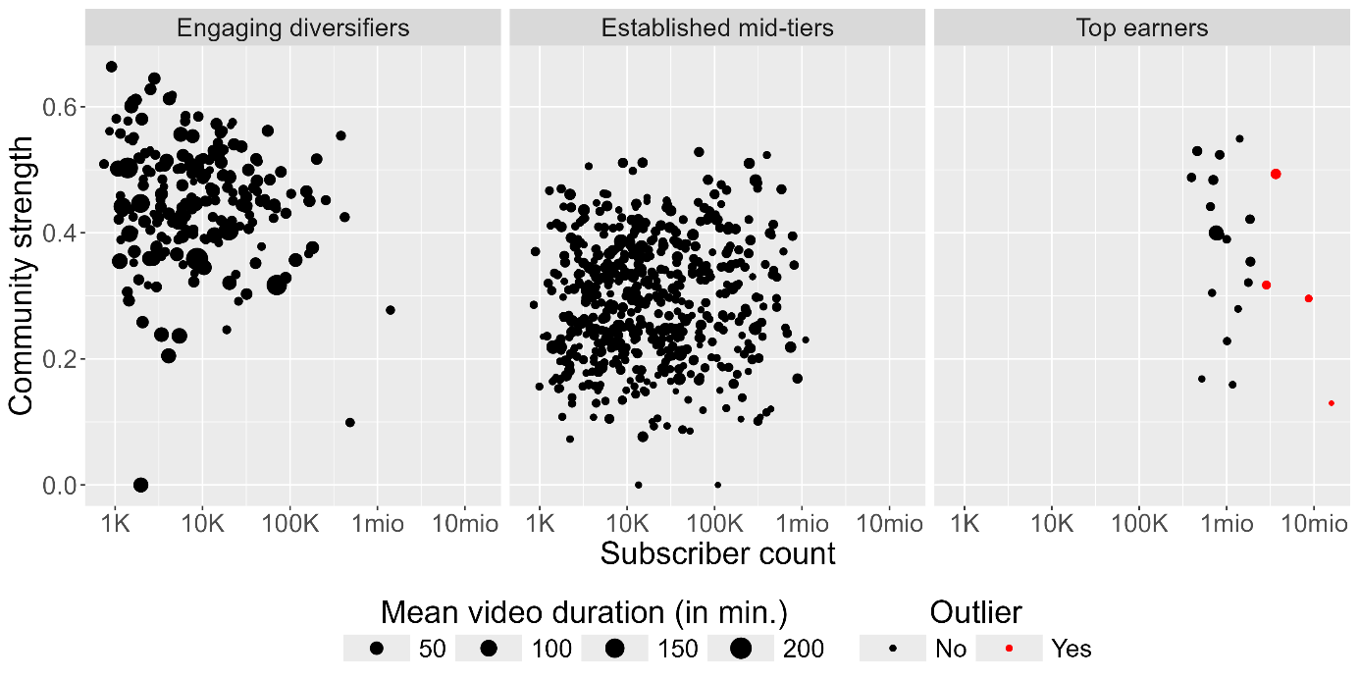
Note: data based on 783 content creators

Table 1: Cluster characterization using test statistics for derivations from overall sample means and frequencies
 |  | Engaging Diversifiers | Established Mid-Tiers | Top Earners
Metric variables | Active months | -4,99 | 4,22 | 2,06
Metric variables | Monthly AdSense Earnings | -3,14 | -4,25 | 22,8
Metric variables | Monetization strategies | 1,94 | -2,62 | 2,26
Metric variables | Time since last upload | -5,03 | 5,22 | -0,981
Metric variables | Mean video duration | 12,7 | -12,3 | -0,395
Metric variables | Interaction rate | 6,14 | -5,84 | -0,5
Metric variables | Community strength | 16,5 | -16,6 | 1,48
Metric variables | Channel sentiment | 7,82 | -6,76 | -2,74
Metric variables | Subscriber count | -3,78 | -2,61 | 19,6
Metric variables | Productivity | 6,78 | -8,64 | 6,27
Categorical variables | Age=21 - 30 yrs | -4,52 | 3,49 | 2,41
Categorical variables | Age=40+ yrs | 3,35 | -2,51 | -2,75
Categorical variables | Topic=Gaming | 5,03 | -5,78 | 2,42
Categorical variables | Topic=Music | -3,31 | 3,06 | 0,44
Categorical variables | Topic=Science & Technology | -2,11 | 2,39 | -0,814
Categorical variables | Professionalization=yes | -0,3 | -0,837 | 3,01
Note: Values represent test statistics, where ± 1.96 corresponds to a p-value less than .05. For metric variables, cluster means are compared to the overall sample mean using t-tests. For categorical variables, within-cluster frequencies are compared to overall sample frequencies using χ²-tests.

Figure 4: Visualization of standardized regression coefficients for the most influential predictors across four model specifications (with 95% confidence intervals)
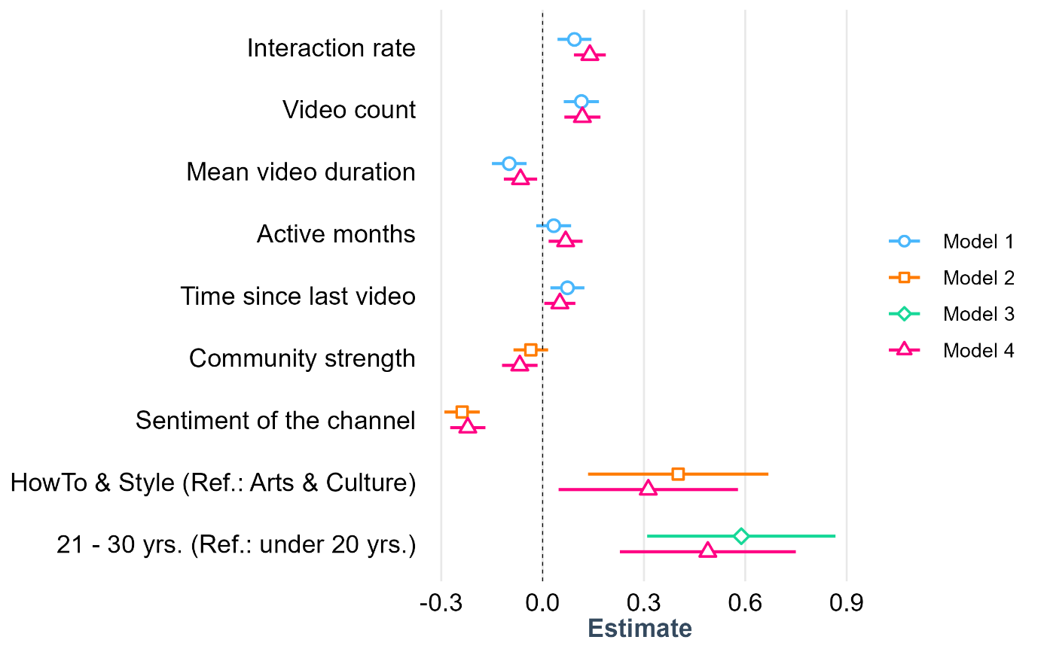
Note: N=783; Model 1 includes only channel performance metrics; Model 2 includes only platform-mediated variables; Model 3 includes only socio-demographic characteristics; Model 4 includes all variables

Appendix
Table A1: Performance metrics of the sentiment prediction using XGBoost
 | Balanced Acc. | Sensitivity | Specificity | F1 (macro weighted)
Negative | 68.61 | 52.64 | 84.58 | 55.15
Neutral | 66.00 | 63.16 | 68.84 | 57.62
Positive | 75.71 | 64.43 | 86.98 | 68.54
All | 70.20 | 60.08 | 80.14 | 60.79

Table A2: Sample composition regarding the frequency of categorical variables and the mean of metric variables
Categorical variables | N | Metric variables (Mean) | N
Age |  | Subscriber count | 76,283
under 20 yrs. | 28 | Video count | 475
21 – 30 yrs. | 199 | Monthly AdSense earnings [in US-$] | 339.7
31 – 40 yrs. | 213 | Monetization strategies | 1.35
40+ yrs. | 202 | Community strength (ratio of recurring commentators) | 0.34
Mixed | 27 | Interaction rate (own comments per video) | 8.2
Unknown | 114 | Channel sentiment | 0.14
Gender |  | Mean video duration [in minutes] | 16.3
male | 516 | Active months | 80.2
female | 184 | Time since last video [in days] | 167.5
Mixed | 41
Unknown | 42
Race
PoC | 133
white | 503
Mixed | 8
Unknown | 139
Professionalization (Legacy notice)
Yes | 124
No | 659
Channel Topic
Autos & Vehicles | 54
Comedy | 11
Education | 43
Entertainment | 151
Film & Animation | 17
Gaming | 129
Howto & Style | 49
Music | 71
News & Politics | 5
Nonprofits & Activism | 5
People & Blogs | 128
Pets & Animals | 17
Science & Technology | 39
Sports | 31
Travel & Events | 33

Figure A1: Correlation matrix of metric variables used for the principal component analysis
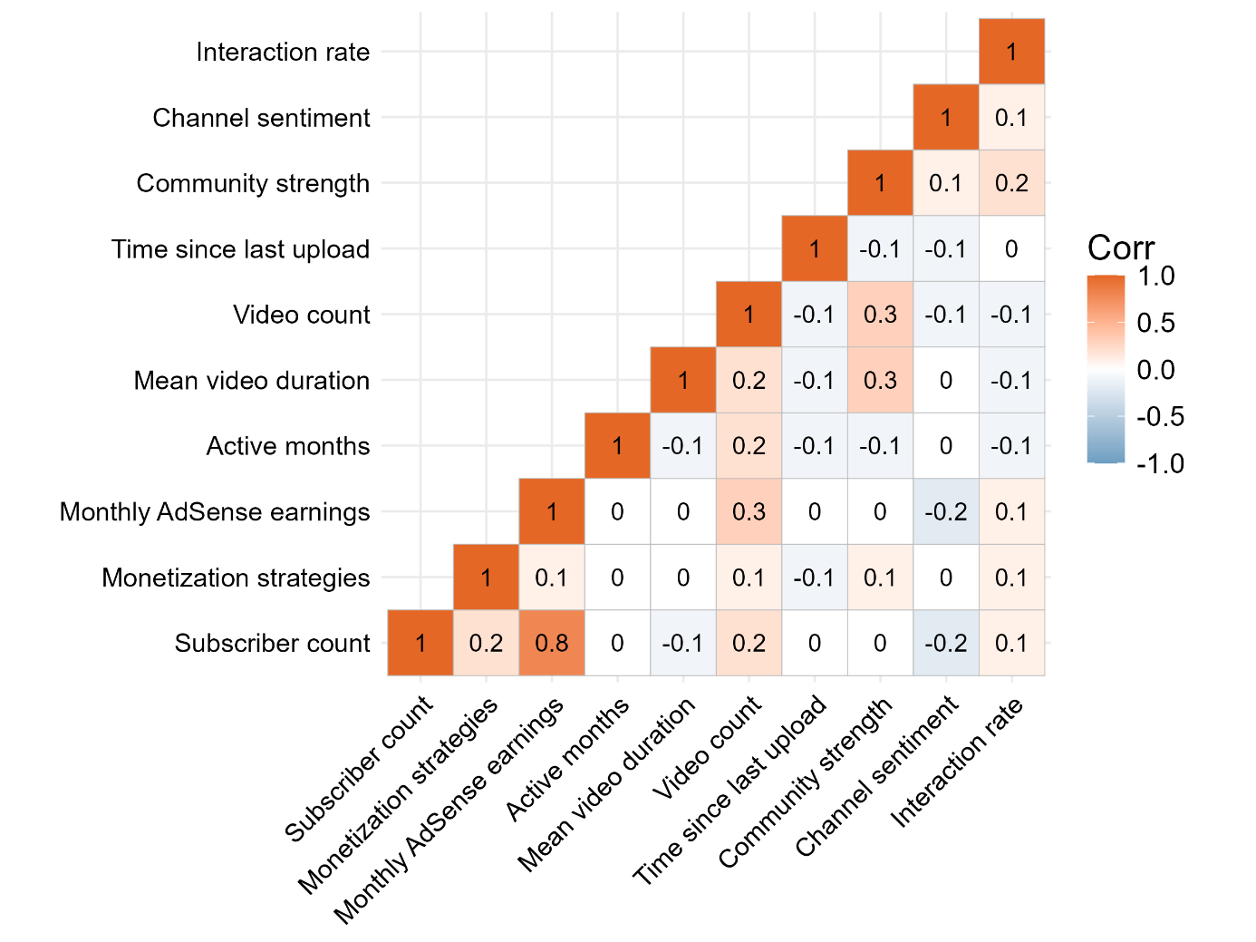

Figure A2: Contribution of the metric variables to the four remained principal components
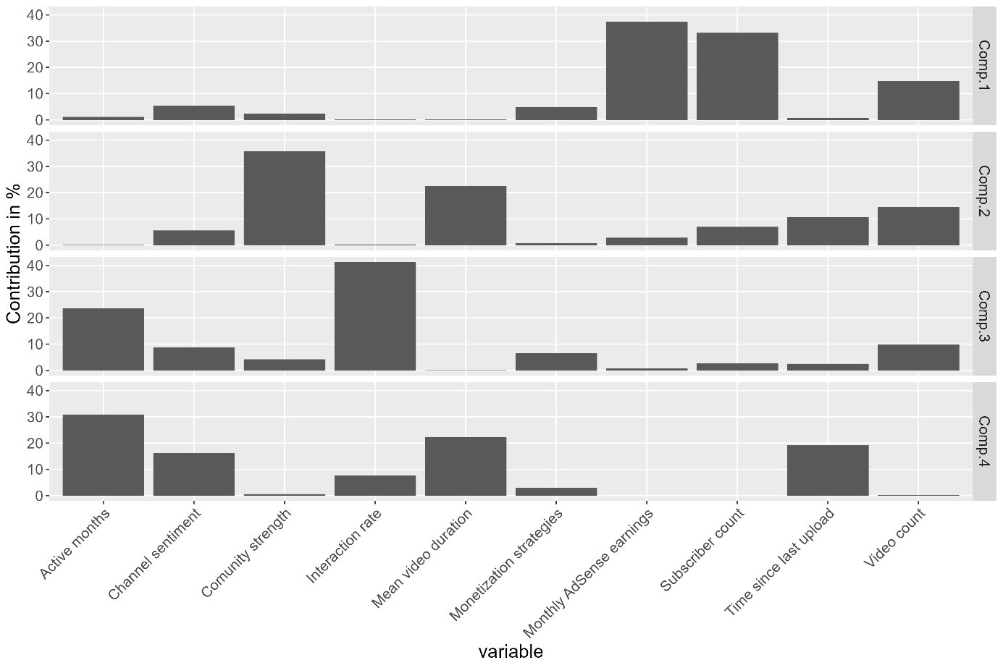
Figure A3: Elbow Plot for determining the number of clusters
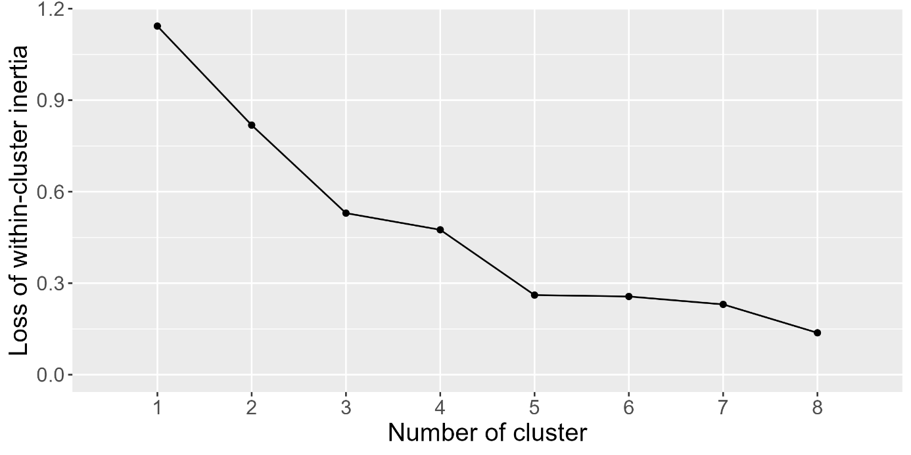

Figure A4: Silhouette plot for determining the optimal number of clusters
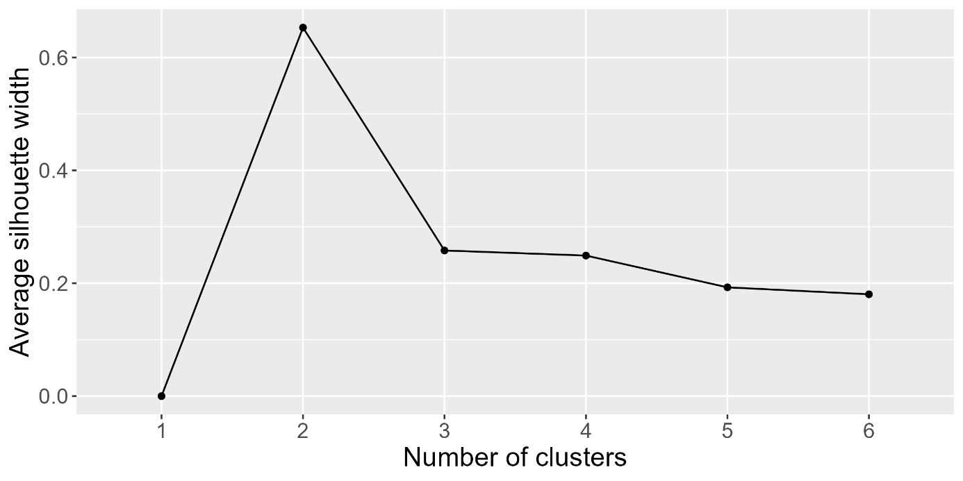

Table A3: Detailed variable description
Variable | Description | Scale
Subscriber count | Number of subscribers | Metric
AdSense Earnings | Average monthly revenue in US-$ the content creator generates through the YouTube AdSense program (see Verwiebe et al. (Shi et al. 2021) for detailed calculation) | Metric
Monetization strategies | Number of alternative monetization strategies found on the YouTube channel (YouTube membership; affiliate links; sponsorship; donation websites such as Patreon or Ko-Fi; has an online store; part of public broadcasting; published content such as books or music; brand cooperation; has another job) | Metric
Professionalization | Does the YouTube channel have a legal notice in the channel description (No; Yes) | Binary
Active months | Time difference between first and last video in months | Metric
Productivity | Sum of uploaded videos by the creator | Metric
 | Mean video length in minutes of all uploads | Metric
Time since last upload | Time difference between last video and data collection timestamp in days | Metric
Channel sentiment | Mean sentiment of all foreign comments under the videos from the content creator (sentiment was classified as negative, neutral or positive) | Metric
Community strength | Number of recurring commentators (left a minimum of two comments on the channel) divided by the total number of commentators | Metric
Interaction rate | Mean number of comments posted by the creator under their own videos | Metric
Channel topic | Channel topic (Autos & Vehicles; Comedy; Education; Entertainment; Film & Animation; Gaming; Howto & Style; Music; News & Politics; Nonprofits & Activism; People & Blogs; Pets & Animals; Science & Technology; Sports; Travel & Events) | nominal
Age | Age in years of the content creators manually annotated with our annotation survey (under 20 yrs.; 21-30 yrs.; 31-40 yrs.; 40+ yrs.; mixed; unknown) | ordinal
Gender | Gender of the content creators manually annotated with our annotation survey (male; female; mixed; unknown) | Binary
Race | Race of the content creators manually annotated with our annotation survey (PoC; white; mixed; unknown) | Binary

Table A4: Socio-demographic composition along the 3 identified clusters
 | Engaging Diversifiers |  | Established Mid-Tiers |  | Top Earners
Age
under 20 yrs. | 10 | (4.7 %) | 18 | (3.2 %) | 0 | (0.0 %)
21 – 30 yrs. | 30 | (14.2 %) | 160 | (28.8 %) | 9 | (52.9 %)
31 – 40 yrs. | 63 | (29.9 %) | 143 | (25.8 %) | 7 | (41.2 %)
40+ yrs. | 73 | (34.6 %) | 129 | (23.2 %) | 0 | (0.0 %)
Mixed | 10 | (4.8 %) | 17 | (3.1 %) | 0 | (0.0 %)
Unknown | 25 | (11.8 %) | 88 | (15.9 %) | 1 | (5.9 %)
Gender
male | 132 | (62.6 %) | 371 | (66.8 %) | 13 | (76.6 %)
female | 56 | (26.5 %) | 126 | (22.7 %) | 2 | (11.8 %)
Mixed | 16 | (7.6 %) | 23 | (4.2 %) | 2 | (11.8 %)
Unknown | 7 | (3.3 %) | 35 | (6.3 %) | 0 | (0.0 %)
Race
PoC | 29 | (13.7 %) | 100 | (18.0 %) | 4 | (23.5 %)
white | 146 | (69.2 %) | 347 | (62.5 %) | 10 | (58.8 %)
Mixed | 2 | (1.0 %) | 5 | (0.9 %) | 1 | (5.9 %)
Unknown | 34 | (16.1 %) | 103 | (18.6 %) | 2 | (11.8 %)
N | 211 |  | 555 |  | 17
Note: Values indicate the absolute number of channels and corresponding proportions within the respective cluster
Table A5: Regression results with the (logarithmized) subscriber count as dependent variable using our sample of N = 783 content creators
 | Model 1 with channel performance metrics |  | Model 2 with platform-mediated variables
 | Coefficient | Std. Error | Coefficient | Std. Error
Intercept | 4.205 *** | 0.025 | 4.124 *** | 0.093
Interaction rate | 0.094 *** | 0.026
Video count | 0.115 *** | 0.027
Mean video duration | – 0.099 *** | 0.026
Active months | 0.033 | 0.026
Time since last upload | 0.074 ** | 0.026
Community strength |  |  | – 0.035 | 0.026
Sentiment of the channel |  |  | – 0.238 *** | 0.027
Channel Topic [Ref.: Autos & Vehicles]
Comedy |  |  | 0.380 | 0.227
Education |  |  | 0.161 | 0.139
Entertainment |  |  | 0.174 | 0.108
Film & Animation |  |  | 0.276 | 0.190
Gaming |  |  | – 0.010 | 0.112
HowTo & Style |  |  | 0.401 *** | 0.136
Music |  |  | – 0.022 | 0.124
News & Politics |  |  | 0.123 | 0.320
Nonprofits & Activism |  |  | – 0.038 | 0.320
People & Blogs |  |  | 0.080 | 0.111
Pets & Animals |  |  | – 0.116 | 0.190
Science & Technology |  |  | – 0.087 | 0.144
Sports |  |  | 0.126 | 0.154
Travel & Events |  |  | – 0.127 | 0.152
Age [Ref.: under 20 yrs.]
21 – 30 yrs.
31 – 40 yrs.
40+ yrs.
Gender [Ref.: male]
Female
Race [Ref.: PoC]
White
Adjusted R² | 0.0556 |  | 0.1195
Note: *p < .05, **p < .01; ***p < .001; all metric coefficients are standardized; coefficients for the categories mixed and unknown in socio-demographic characteristics are not displayed
Table A5 (continued): Regression results with the (logarithmized) subscriber count as dependent variable using our sample of N = 783 content creators
 | Model 3 with socio-demographic characteristics |  | Model 4 with all variables
 | Coefficient | Std. Error | Coefficient | Std. Error
Intercept | 4.024 *** | 0.146 | 3.956 *** | 0.163
Interaction rate |  |  | 0.140 *** | 0.024
Video count |  |  | 0.118 *** | 0.027
Mean video duration |  |  | – 0.065 ** | 0.025
Active months |  |  | 0.068 ** | 0.026
Time since last upload |  |  | 0.051 * | 0.023
Community strength |  |  | – 0.068 * | 0.027
Sentiment of the channel |  |  | – 0.222 *** | 0.027
Channel Topic [Ref.: Autos & Vehicles]
Comedy |  |  | 0.423 * | 0.215
Education |  |  | 0.187 | 0.133
Entertainment |  |  | – 0.083 | 0.288
Film & Animation |  |  | 0.315 | 0.180
Gaming |  |  | 0.027 | 0.113
HowTo & Style |  |  | 0.313 * | 0.135
Music |  |  | – 0.012 | 0.118
News & Politics |  |  | 0.037 | 0.301
Nonprofits & Activism |  |  | 0.046 | 0.301
People & Blogs |  |  | 0.014 | 0.109
Pets & Animals |  |  | – 0.137 | 0.180
Science & Technology |  |  | – 0.090 | 0.135
Sports |  |  | 0.100 | 0.144
Travel & Events |  |  | – 0.225 | 0.150
Age [Ref.: under 20 yrs.]
21 – 30 yrs. | 0.588 *** | 0.142 | 0.489 *** | 0.133
31 – 40 yrs. | 0.239 | 0.142 | 0.205 | 0.134
40+ yrs. | 0.080 | 0.142 | 0.149 | 0.136
Gender [Ref.: male]
Female | – 0.045 | 0.061 | 0.091 | 0.066
Race [Ref.: PoC]
White | – 0.098 | 0.069 | – 0.107 | 0.066
Adjusted R² | 0.0788 |  | 0.2433
Note: *p < .05, **p < .01; ***p < .001; all metric coefficients are standardized; coefficients for the categories mixed and unknown in socio-demographic characteristics are not displayed
Figure A5: Residuals vs. fitted values plot for the regression model 4 (full model)
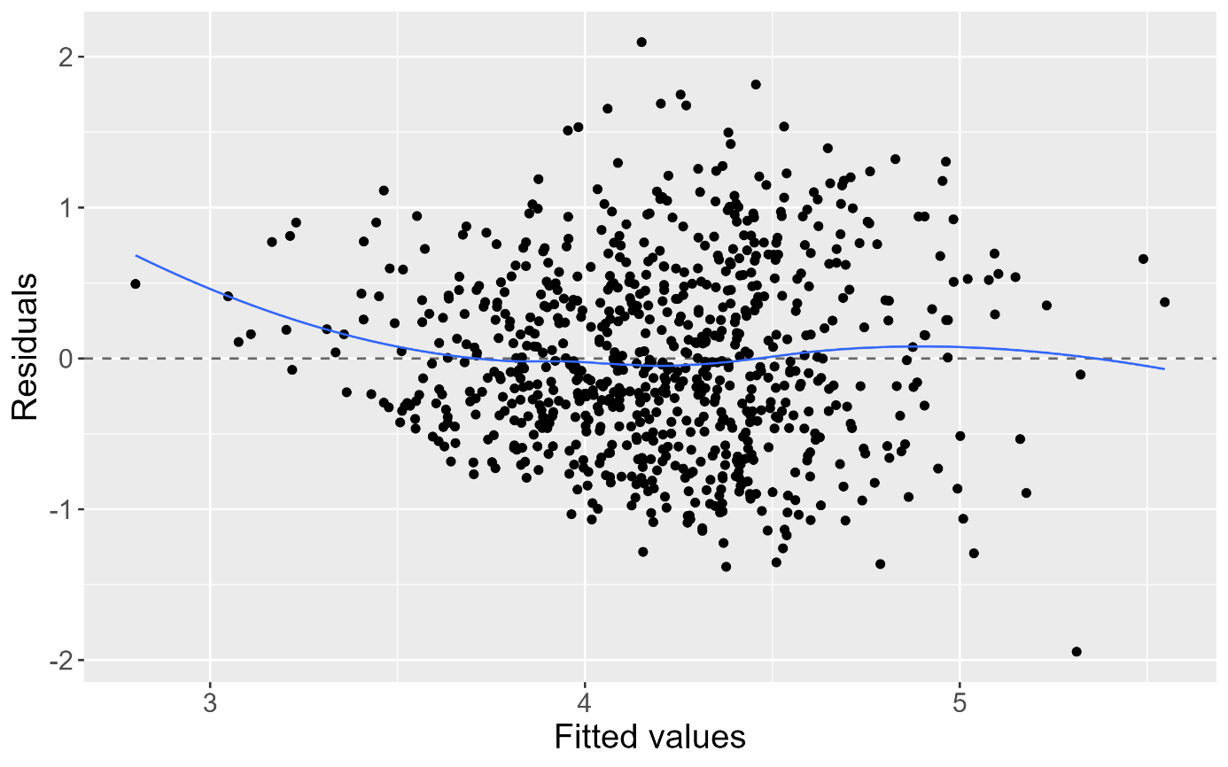
Figure A6: QQ-plot of residuals for the regression model 4 (full model)
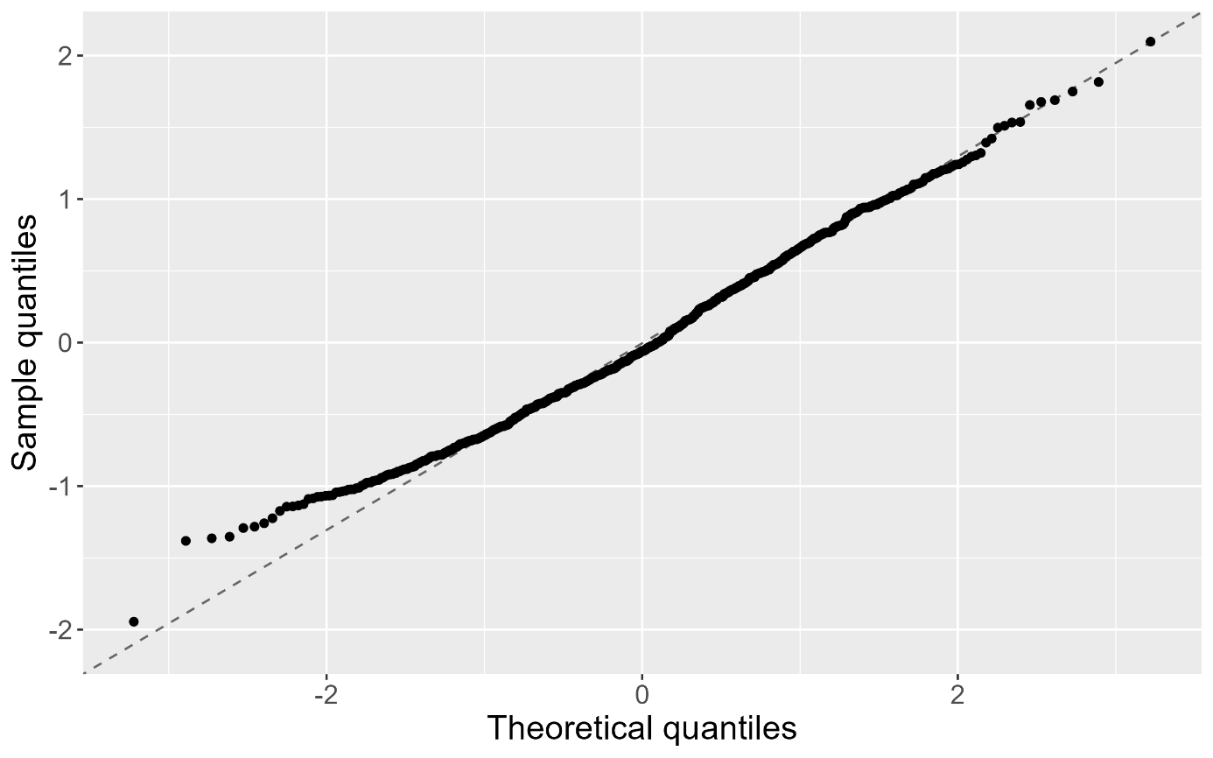

YouTube (2025b) itself states their “creative ecosystem contributed over $55 billion to the U.S. GDP in 2024 [and] supported more than 490,000 full-time jobs in the US.
YouTube, owned by Google, integrates the AdSense program, allowing creators to earn revenue from advertisements displayed within their videos. Additionally, YouTube offers monetization features such as channel memberships and paid messages in livestreams, which enable them to earn income directly through the platform. Access to these features, however, is contingent upon meeting specific eligibility thresholds, such as minimum subscribers or accumulated watch hours (Google 2025; YouTube 2025a)
However, content creation is becoming somewhat formalized, as evidenced by the integration of associated skills – such as e-commerce and digital marketing – into university curricula or even dedicated programs at private universities (Neumann University 2026). At the organizational level, the emergence of creator agencies (Studio71 2026) and unions (Häfner 2021) points to a growing advocacy among professional creators.
A somewhat different emphasis is offered by Edeling and Wies (2024), who propose a typology of content creators that acknowledges motivations and trajectories beyond economic gain. This includes, for instance, the hobby model, which foregrounds personal enjoyment and creative self-expression. At the same time, the authors identify creators who pursue alternative pathways to success, as captured in the ephemeral opportunity model, in which success in the creator economy depends less on sustained audience-building and more on external activities or fleeting moments of prominence (Edeling/Wies 2024).
By encompassing a diverse range of platforms and creators, this sample challenges previous findings that portray YouTube as a predominantly male space (Döring/Mohseni 2019).
Since content creation is a relatively young field of work, having emerged only around two decades ago, the processes associated with more established occupational groups has also certain limitations. In particular, mechanisms of social and institutional closure that sustain, for example, higher pay levels have not yet developed to the same extent (Weeden 2002).
The Python scripts used for web scraping are publicly available at: [link anonymized]
The full annotation survey can be found at: [link anonymized]
This information was obtained by scraping the channels’ source code, where monetization status was indicated by the values “true” and “false” under “is_monetization_enabled”; however, this field was removed from the source code in 2024.
The decision for the selection of this cutoff was to maintain a single, consistent sample for the analysis, as retaining these outliers would introduce bias into the subsequent regression models. These four cases mark the highest 0.5% in the distribution of the subscriber count.
For a detailed explanation of all variables see Table A3 in the appendix.
We retrieved the cost per mille (CPM) – a metric indicating the price of placing advertisements – for the region of Europe and the different channel topics from the AdSense Program (Google 2025). Given that YouTube shares 55% of advertising revenue with creators, we calculate the estimated average monthly earnings by linking these CPM rates to the age of the channel and its cumulative view count (Verwiebe et al. 2025).
During pre-processing, we retained emojis in addition to text, as they are widely used in social media communication to express emotions. The training data consist of 7,500 German- and English-language YouTube comments that were manually annotated for sentiment by human coders following a strict classification guideline.
Because YouTube is a predominantly visual platform, we chose to capture creators’ race as a visible social marker rather than migration background, which is more common in sociological analysis but not directly measurable in this context.
Accordingly, these four components are retained for the subsequent cluster analysis in place of the original ten variables (see Figure A2 for the variables contributing most to each component).
To ensure transparency and reproducibility, the dataset and R-scripts used for the statistical analysis are publicly accessible at: [link anonymized]
Using the elbow criterion (Figure A3) we see a peak for a 3 and 5 cluster solution. By including the silhouette score criterion we find the highest score for 2 and 3 clusters and since the score has a tendency to two clusters (Shi et al. 2021), we decided to use 3 clusters.
Robustness checks restricted to channels that uploaded at least one video within the past year, or to channels older than two years, yielded similar results with three clusters.
The exclusion of four extreme outliers results in a conservative estimate of the cluster mean – manual reintegration of these cases would yield an average of $41,000 (in terms of content, these outliers are distributed across the categories of Sports, Music, Comedy, and How-To & Style). The top earner is even making $725,000 per month from the AdSense program.

