Proof of Concept grant 2026
Demonstrate that the idea funded by the original ERC grant has innovation potential and significant economic or societal benefits
Size of the grant: €150 000 (lump sum)
Duration: 18 months
Submission due: 17 September 2026

From Cave to Gallery: Recreating Stone Age Tools for the Modern Era

Omry Barzilai

Abstract
Prehistoric stone tools are among the earliest and most significant technological innovations in human history. Although countless numbers of such artifacts are curated in museums and academic research collections, they remain largely inaccessible for the public. Existing replicas produced from synthetic polymers, or experimental flintknapping cannot faithfully reproduce both the morphology and material properties of specific archaeological artifacts.
This project aims to develop an innovative methodology for producing highly accurate replicas of prehistoric stone tools by combining high-resolution 3D documentation with advanced materials engineering. Building on the extensive digital database generated within the ERC Synergy project LAST NEANDERTHALS (Grant No. 101118565), we will develop protocols to recreate authentic stone materials for making prehistoric replicas that bear the exact morphology and physical properties of the original stone tools.
The project represents a high-risk, high-gain initiative, requiring the development of entirely new methods for replicating archaeological stone tools. If successful, it will establish a novel platform for producing authentic replicas for museums, education, experimental archaeology, and public outreach, making some of humanity's earliest technological innovations accessible to researchers and the wider public while promoting cultural heritage and social innovation.

Background and rationale
Stone tools represent the earliest technological innovation in human evolution and the longest-lasting technology in human history. First appearing approximately three million years ago in East Africa, they became fundamental to human survival and played a central role in the cultural and biological evolution of our ancestors (Harmand et al. 2015; Shea 2016). Throughout prehistory, stone tools were used for hunting, butchery, food processing, woodworking, hide preparation, and many other daily activities. As technology evolved, increasingly sophisticated production systems emerged, culminating in highly standardized methods such as the Levallois technique, which characterized Neanderthal populations for more than 300,000 years (Romagnoli et al. 2020). Experimental archaeology, together with use-wear and residue analyses, has demonstrated that these tools formed a versatile technological system that underpinned virtually every aspect of Neanderthal life.
Millions of prehistoric stone tools have been recovered from archaeological sites across the Eurasia, the vast majority of which are now housed in museums and research collections. Within the ERC Synergy project LAST NEANDERTHALS: The Physical, Cultural and Bio-Genetic Landscape of the Last Neanderthals (Grant No. 101118565), led by Prof. Omry Barzilai, Prof. Stefano Benazzi, and Prof. Francesco Berna, thousands of diagnostic artifacts from dozens of archaeological sites are being documented using standardized technological analyses, raw-material characterization, high-resolution 3D recording, and use-wear studies.
Despite their scientific and cultural importance, these prehistoric stone tools remain largely inaccessible to the public. Most artifacts are permanently stored in museums, universities, or private collections, where access is generally restricted to researchers. Even when on public display, these artifacts are exhibited behind protective glass, preventing visitors from experiencing their weight, texture, and physical properties firsthand. Consequently, the public is unable to experience their weight, texture, sharpness, and other physical properties that are essential for understanding prehistoric technology.
Several approaches have attempted to overcome this limitation. Traditional museum replicas, produced using plaster or synthetic polymers, reproduce only the external appearance of archaeological artifacts and fail to capture the feel and material properties of the original stone (e.g. Olson et al. 2014). Experimental flintknappers can produce functional replicas using traditional techniques, but these are modern reconstructions rather than faithful copies of specific archaeological artifacts (e.g. Wilke and Quintero 1994). Their accuracy depends on the skill of the knapper, and the reduction strategy employed, resulting in replicas that inevitably differ from the original tools in morphology, manufacturing details, and raw-material characteristics.

Project objectives
The proposed project aims to overcome the limited public accessibility of prehistoric stone tools by developing an innovative methodology for producing highly accurate replicas through the integration of high-resolution 3D documentation and advanced materials engineering. The objective is to reproduce archaeological artifacts not only in their morphology and dimensions but also, as closely as possible, in their mineralogical composition and mechanical properties.
Unlike the original archaeological artifacts, these replicas will be freely accessible to museums, educational institutions, visitor centers, researchers, and the general public. They will serve as hands-on educational resources, museum exhibits, outreach tools, and commercial products for museum shops, allowing visitors to physically experience prehistoric technology in ways that are impossible with the original archaeological material. By making these unique artifacts accessible, the project represents a genuine form of social innovation that will promote public engagement with prehistoric archaeology and foster a greater appreciation of early human technological achievements.

Scientific foundation
The proposed research builds directly upon the extensive digital and analytical database generated by the ERC Synergy project LAST NEANDERTHALS. The project investigates the environmental, cultural, and biological processes associated with the disappearance of the Neanderthals and the dispersal of modern humans across Eurasia between approximately 60,000 and 40,000 years ago https://www.erc-lastneanderthals.eu/.
Within the ERC project, the applicant leads the Cultural Landscape Work Package 3, which investigates prehistoric material culture through integrated techno-typological analysis, raw-material studies, high-resolution 3D documentation, use-wear and residue analysis, and experimental archaeology. This unique collection of digital models and raw-material data provides an extraordinary foundation for developing accurate physical replicas of prehistoric artifacts.
Innovation and high-risk/high-gain potential
The proposed research is highly innovative because it combines state-of-the-art 3D documentation with materials engineering to produce faithful replicas of prehistoric stone tools that reproduce not only the original morphology but also, as closely as possible, their mineralogical composition and mechanical properties. Although high-resolution digital models of archaeological artifacts are increasingly available, no established methodology currently exists for transforming these digital records into physically accurate replicas manufactured from materials that closely resemble the original rocks.
The project therefore represents a genuine high-risk, high-gain initiative. Its principal challenge is the development of laboratory protocols capable of recreating different prehistoric raw materials (including volcanic and metamorphic rocks, chert, and quartzite) manufacturing replicas using molds derived from high-resolution 3D scans. While reproducing some lithologies such as volcanic rocks may prove relatively straightforward, replicating fine-grained sedimentary rocks such as chert or coarse-grained high-pressure metamorphic mineral assemblages presents a significant scientific challenge. Through iterative experimentation involving mineralogical characterization, materials engineering, and mechanical testing, we aim to establish novel manufacturing protocols for producing realistic prehistoric stone-tool replicas.
If successful, the project will establish an entirely new methodology for replicating archaeological artifacts with extraordinary fidelity. Beyond its scientific significance, the resulting technology will have broad applications in museums, education, cultural heritage, conservation, experimental archaeology, and public engagement, making one of humanity's earliest technological innovations accessible to researchers, educators, and the wider public in ways that have not previously been possible.

Approach and methodology
This project will employ two independent methods for creating highly accurate replicated stone tools (Figs. 1-2).
Methodology 1 - High-Resolution 3D Documentation and Digital Replica Production
This method will employ high-resolution three-dimensional (3D) documentation to create accurate digital models of diagnostically important prehistoric stone tools produced by Neanderthals and their contemporary human populations. The selected artifacts including: spear points, knives, scrapers, Levallois flakes, and other characteristic implements, will serve as the basis for producing precise replicas.
Lithic artifacts will be digitized using scanners available at the Material Culture PaleoLab, at the University of Haifa: structured-light portable scanners (EinScan Pro HD, Revopoint MetroX), and high-resolution stationary scanner (Artec Micro II). When appropriate, photogrammetry will complement the scanning workflow. These methods generate highly accurate 3D models that capture the complete morphology of each artifact at sub-millimeter resolution.
The digital models will undergo standardized post-processing, including mesh optimization, and orientation according to technological conventions. The resulting models will constitute a permanent digital archive while simultaneously serving as the templates for manufacturing physical replicas.
Selected artifacts representing different technological groups will initially be reproduced using high-resolution 3D printer designed for polymer materials. These printed models will serve as master templates for producing high-precision casting gypsum molds. The molds will subsequently be used to cast the synthetic stone materials developed in Methodology 2, enabling the production of faithful replicas that accurately reproduce the morphology and dimensions of the original archaeological artifacts. This approach guarantees that every replica faithfully reproduces the morphology and dimensions of the original archaeological specimen while allowing repeated manufacture without further handling of the original artifacts. The digital archive will also provide a valuable resource for future research, museum exhibitions, virtual collections, and educational applications.
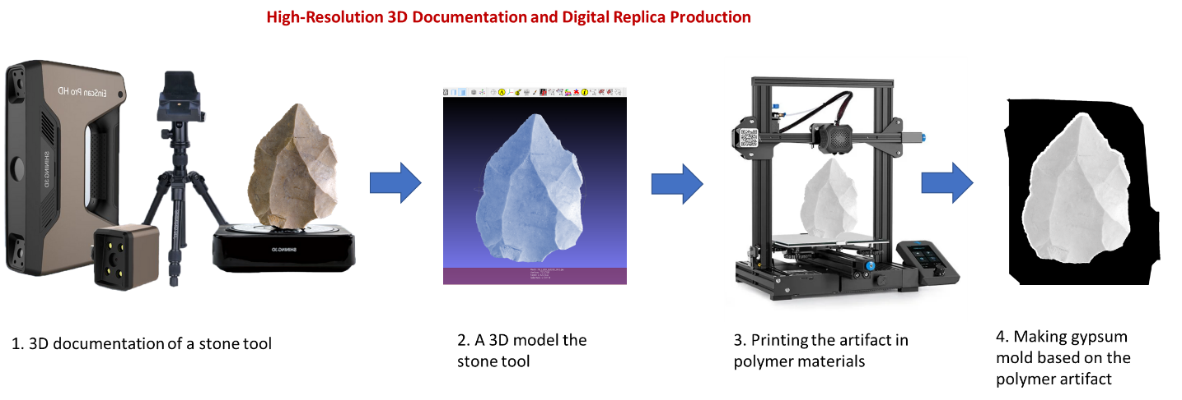

Figure 1. Workflow illustrating the 3D documentation and production of smelting mold

Methodology 2: Recreating Prehistoric Raw Materials
The second methodology focuses on recreating the original stone materials from which the archaeological artifacts were manufactured. Following high-resolution 3D documentation, the selected artifacts will undergo detailed raw material characterization integrating macroscopic, mesoscopic, and petrographic analyses, non-destructive geochemical characterization, and experimental archaeology protocols routinely employed by the Material Culture PaleoLab and collaborating laboratories within the ERC Synergy project LAST NEANDERTHALS. These analyses will determine the lithology, mineralogical composition, geochemical signature, and relevant physical properties of each artifact. The study will encompass the full range of prehistoric raw materials represented in the project, including chert, quartz, quartzite, volcanic rocks, and metamorphic rocks.
Based on these analyses, experimental materials engineering will be carried out by Prof. Ronit Kessel at the Experimental Laboratory of the Institute of Earth Sciences, the Hebrew University of Jerusalem. The objective is to develop laboratory protocols capable of reproducing synthetic stone materials that closely match the mineralogical composition and mechanical properties of the original archaeological rocks. The synthesized materials will subsequently be cast into high-precision molds produced from the 3D models generated in Methodology 1, resulting in faithful replicas that reproduce not only the morphology and dimensions of the original prehistoric artifacts but also, as closely as possible, their physical and mechanical properties.
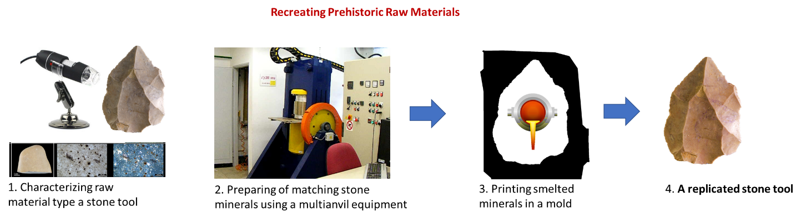
Figure 2. Workflow illustrating the recreating stone raw materials
Experiments will be performed in a gas-mixing 1-atm furnace. The first attempt will be to reproduce the stone tools made of volcanic material. Volcanic rocks of similar compositions will be placed in a container inside the vertical furnace and exposed to high temperature and specific atmosphere. After reaching equilibrium, the material will be cooled and poured into the relevant cast prepared in the first stage. The texture and mineralogy of the produced material will be examined via optical microscopy and electron microprobe analyzer. Experiments will be carried out at a range of temperatures and cooling rates in order to find the best conditions reproducing the grain size and textures in the natural tools. Changing the atmosphere in the furnace (by mixing various gases, such as CO₂-H₂) is important to impose the correct conditions leading to mineral assemblage similar to the those in the natural samples.
More challenging is the attempt to produce stone tools similar to those made of metamorphic and sedimentary material. Metamorphic rocks were formed under high-pressure and high temperature. For each stone tool, the mineral assemblage will be characterized and order to evaluate the P-T conditions of formation. For small tools, capsules shaped as a tool can be placed inside the high-pressure apparatus. For larger-sized tools, several experiments at a given P-T can be performed and the parts will be annealed at high temperature to produce the desired shape of the tool.
The most challenging part is to produce tools made of sedimentary rocks as chert. Any heating changes its mineralogy and texture. Experiments in the 1-atm furnace will be performed where crushed chert will be placed in a pre-shaped capsule and heated. A wide range of temperatures will be examined to find possible conditions where the crushed material annealed without changing the mineralogy.

Summary
By integrating high-resolution 3D documentation with innovative mineral-based manufacturing, this project aims to produce prehistoric stone tool replicas that faithfully reproduce not only the morphology and dimensions of the original artefacts but also, as closely as possible, their appearance, texture, weight, and mechanical properties. The resulting replicas will provide an unprecedented level of authenticity, creating new opportunities for museum exhibitions, education, experimental archaeology, and public engagement, while ensuring the long-term preservation of the original archaeological artifacts.
Importantly, if successful, the methodology developed in this project will be applicable to stone tools from any prehistoric period and geographical region. Its impact will therefore extend far beyond the archaeological collections investigated here, providing museums, researchers, educators, and cultural institutions worldwide with a reliable approach for producing highly accurate replicas of prehistoric artefacts. By making these objects accessible for handling and interactive learning, the project will enhance public understanding of prehistoric technologies and offer new insights into the daily lives, skills, and ingenuity of our Stone Age ancestors.

References
Harmand, Sonia, Jason E. Lewis, Craig S. Feibel, Christopher J. Lepre, Sandrine Prat, Arnaud Lenoble, Xavier Boës et al. 2015. 3.3-million-year-old stone tools from Lomekwi 3, West Turkana, Kenya. Nature 521, no. 7552: 310-315.
Olson, Brandon R., Jody M. Gordon, Curtis Runnels, and Steve Chomyszak. 2014. Experimental three-dimensional printing of a lower Palaeolithic handaxe: an assessment of the technology and analytical value. Lithic Technology 39/3: 162-172.
Romagnoli, Francesca, Florent Rivals, and Stefano Benazzi, eds. 2022. Updating Neanderthals: understanding behavioural complexity in the late Middle Palaeolithic. Academic Press,
Shea, J.J. 2016. Stone Tools in Human Evolution: Behavioral Differences among Technological Primates. New York and Cambridge, Cambridge University Press
Wilke, P. J. and L. A. Quintero. 1994. Naviform Core-and-Blade Technology:
Assemblage Character as Determined by Experiments. In Neolithic
Chipped Stone Industries of the Fertile Crescent. SENEPSE 1. Edited by
H. G. K. Gebel and S. K. Kozlowski, pp. 33–60. Berlin: ex oriente.

- Principal Investigator - strategic lead and project management (max. 1 page)

The project will be led by Prof. Omry Barzilai, an expert in Paleolithic archaeology, lithic technology, and interdisciplinary archaeological research. As Principal Investigator, Prof. Barzilai will provide the overall scientific vision, strategic leadership, and administrative management required to ensure the successful completion of the project and the translation of its outcomes into practical applications.
Prof. Barzilai currently leads the Material Culture PaleoLab at the University of Haifa and serves as one of the Principal Investigators of the ERC Synergy project LAST NEANDERTHALS: The Physical, Cultural and Bio-Genetic Landscape of the Last Neanderthals (Grant No. 101118565). Through these roles, he has extensive experience coordinating large international research collaborations involving dozens of researchers and institutions across Europe and Asia, managing complex research infrastructures, overseeing project budgets, coordinating fieldwork, and integrating multidisciplinary datasets.
Within the proposed project, Prof. Barzilai will be responsible for defining the scientific priorities, coordinating the research activities, and ensuring effective collaboration between the archaeological and materials engineering teams. He will supervise the selection of archaeological artefacts for replication, oversee the 3D documentation and raw material characterization workflows, and coordinate the integration of the different methodological components into a unified production pipeline. Particular emphasis will be placed on maintaining high scientific standards, ensuring the reproducibility of the developed protocols, and monitoring progress toward the project's milestones and deliverables.
Project management will follow a structured framework consisting of clearly defined work packages, milestones, and regular progress evaluations. Frequent coordination meetings with all project partners will ensure efficient communication, rapid identification of technical challenges, and timely implementation of solutions. The interdisciplinary nature of the project requires close interaction between archaeology, digital documentation, Earth sciences, and materials engineering, and the PI will facilitate this integration through continuous scientific coordination and shared decision-making.
Prof. Barzilai will also oversee risk management and dissemination activities. Technical risks associated with the development of printable mineral-based materials will be continuously evaluated together with project partners, allowing experimental protocols to be adapted as required. At the same time, the PI will coordinate the dissemination of project outcomes through scientific publications, international conferences, museum collaborations, public outreach initiatives, and engagement with cultural heritage institutions to maximize the scientific, educational, and societal impact of the project.
By combining proven experience in managing large interdisciplinary research programmes with expertise in prehistoric material culture and international collaboration, Prof. Barzilai will provide the strategic leadership necessary to deliver the project's scientific objectives while ensuring its long-term sustainability and broad societal impact.

- Supplementary documents (e.g., Host Institution Support Letter: Letters of support or Letters of intent)

