Proactive Excavation: Is It Just a Scientific Dig? A Closer Look at the Tel Burna Excavation Season from Perspectives Not Based on Archaeological Research

Abstract
Tel Burna, inhabited from the Bronze Age until the end of the second millennium bce, was excavated for more than a decade with an open policy that allowed the public – including students, volunteers, children, and adults from Israel and abroad – to participate. During the 2023 four-week excavation season, the team conducted a quasi-experimental study examining how the experiences of regular, day, and occasional participants shaped qualities, abilities, and emotions related to learning and mental well-being, using a mixed-methods approach (questionnaires, interviews, and observations), The findings demonstrate that participation in the excavation enhanced interest, enjoyment, curiosity, identity, belonging, and a sense of community. These results indicate that public engagement in archaeological excavations can contribute to interdisciplinary and experiential learning while reinforcing values and relationships essential for improving well-being. The article presents insights that deepen our understanding of the interrelationships between archaeology, learning, and well-being.
Keywords: community archaeology excavation, educational, alternative learning experiences, cultural heritage, mental well-being

Introduction
The Antiquities Law enacted by the Knesset of Israel stipulates that entities conducting excavations at antiquities sites are responsible for safeguarding the sites and preserving the artefacts uncovered. The law further states that the Authority will promote and encourage educational and outreach activities in the field of archaeology. Thus, preserving the memory of the past for future generations requires not only disseminating knowledge but also educating the public about the physical preservation of sites and artefacts. Archaeological excavations are often conducted by academic institutions for research purposes. Intrinsically, these projects are dictated by methodological and analytical research questions. In such cases, the question arises whether the directors of academic excavations, alongside their responsibility for scientific investigation, should also bear responsibility for public participation in excavation as a mechanism for the production and exchange of knowledge.
This article examines the effects of integrating community- and education-based approaches into an academic excavation by actively engaging members of the public as participants. The study focuses on the Tel Burna excavations in Israel, a 15-year academic project that has recently completed its final field season. Our research investigates the ongoing participation of university students, volunteers, and school-aged youth in fieldwork, exploring the educational impact of their involvement in cultural heritage and their perceived connections to ancient cultures. Data collection began in 2023 during the thirteenth excavation season and focused on the educational dimensions of archaeology. By combining archaeological research with educational practice – an approach known as educational archaeology (Cohen-Tavor, et al. 2021: 105) – the excavation aimed to provide a holistic experience that extended beyond the transmission of historical knowledge to contribute to participant empowerment and community engagement.
Educational archaeology has the ability to use this field of knowledge as a tool for supporting education, serving as a springboard to other related fields of knowledge by virtue of being a multidisciplinary subject, and promoting critical thinking and extended learning (McNeill, 2011). The general nature of constructivist learning is that learners should be involved and empowered through appropriate communication. In archaeological activities, learners are involved in fieldwork and discussion of the findings, and with the assistance of professional archaeologists, this facilitates active learning (Henson 2011). The Israel Antiquities Authority, within the framework of the Community and Education Centers, which were established in 2015, began working in schools and community centres to integrate this field of knowledge into them and make archaeology accessible to the public (Ambar-Armon, 2024).
This article examines the effects of integrating community- and education-based approaches in an academic excavation by actively involving members of the public. The study focuses on the Tel Burna excavations in Israel, a 15-year academic project that recently completed its final field season. Our research explores the participation of university students, volunteers, and school-aged youth and investigates the educational impact of their engagement with cultural heritage and their perceived connections to ancient cultures within the context of a defined academic research excavation.

Archaeology and the Holy Land
David Ben-Gurion, Israel’s first Prime Minister, said in his speech at the sixth Conference for the Study of the Land of Israel in 1949 that archaeology would occupy a worthy place in the story of the country’s past. According to him, life today in the country is a continuation of life in the past, and archaeology has significance in connecting modern Israel with its historical past.
Connecting the past to the present for the sake of the future, Ben-Gurion’s statement emphasizes the role of archaeology in uncovering ancient roots underground and using it to strengthen and cultivate identity and create symbols of belonging (Feiga, 2009: 167; Geva, 1992: 93).
Archaeology plays an important role in building connections between people and the land they live in, connecting them to past cultures. In practice, it engages the public in uncovering the past and contributes to the creation of a national ethos that expresses identity and roots. Research by Sayer has demonstrated that community access to and active engagement with heritage, and more specifically archaeological sites, can provide an important mechanism in supporting individuals’ sense of identity, belonging, and connection to people and places (2024: 147). By strengthening people’s sense of belonging, national, regional, and cultural identity, and connection, heritage sites can, through their narratives, improve participants’ and visitors’ mental well-being, including their personal happiness and sense of peace and calm (Sayer, 2024: 148). Community participation in archaeological excavations, for example, at Shoreditch Park, has demonstrated that direct contact with archaeological finds and remains can develop a connection to the past of the place and the people who lived there. Direct physical contact with objects and their stories can trigger personal memories and reminiscences to support the development of contemporary connections that enable historical empathy and activate emotions (Simpson, 2011). The Stanwell Motherhood community archaeology project demonstrated how participation in excavation empowered young women, improving their connection to the environment and contributing to a sense of civic pride, self-confidence, and the development of shared community values (Cole, 2011).

Community and educational activities integrating archaeology
Archaeological excavations, long-term excavations, are mostly conducted by academic institutions for research purposes and are guided by methodological and analytical research questions. The need for precision in excavation and the exposure of findings in the various soil layers raises an important question: Should directors of academic excavations, in addition to their scientific responsibility, also bear responsibility and allow the participation of adults and youth from the community and the education system as a way to bring participants closer to the country and its past? Is there a responsibility for directors of these excavations to involve those lacking knowledge in the field in the excavation for the sake of belonging and community and for the benefit of youth and young adults learning about the past in a different way? To what extent is this possible?
The concept of community archaeology incorporates site and artefact research and preservation while involving local participants. Isherwood (2011) argues that community archaeology projects are complex arenas in which the practice of field archaeology and the process of ‘building’ communities and developing the relationship between people and places intersect. Yet, in these complex arenas where professional and public knowledge about the past converge, and social interactions affect community dynamics, a range of tensions can arise. Various effects were observed during archaeological activity in the community in studies from the early 2000s (Sayer, 2022: 249–50). Within the framework of these studies, the main advantage of strengthening heritage and its preservation was evident while transferring responsibility to the local population for the management of these sites. A variety of social and value advantages were also discovered, such as teamwork, taking responsibility, accepting others in society, a connection to the place, and cultivating a sense of community.
However, not all the community archaeology projects examined were successful. As Sayer has indicated, community archaeology projects can also have negative impacts on communities, can result in frustration between individuals, fail to generate community interest, increase community divisions, heighten tensions, and result in disagreement between professionals and community members (2022: 248–66).
Community archaeology, driven primarily by the desire to learn about the past, to understand it, and to act in it and with it, has been gaining global momentum since the beginning of the twenty-first century. This insight stems primarily from the fact that the public has an absolute right to experience archaeology in their own neighbourhood/country and even to take an active part in this activity. People’s desire to know about the past and to touch it, the human nature to touch people, is an active multi-generational experience (Moshenska & Dhanjal, 2011: 5).
Community archaeological activity is often founded on three key relationships:
The first connection to community activity at an archaeological site is the connection between "the communities living in the physical space" and "the archaeological sites that exist in that space.". Does the archaeological site and the historical story that accompany it connect a local population through a choice for joint activity? Through joint activity, the community is created and strengthened. Or perhaps the community as a group is created and strengthened from their activity at the archaeological site. As a result of the activity, a community is created.
The second connection concerns defining the goals of the project and how the place is seen at the end of the activity. What is the community’s involvement in these decisions? Community archaeology initially served as a tool for obtaining funding for projects, but this goal was soon changed, and archaeological activity was given the ability to realize potential community benefits and respond to unemployment problems. Isherwood argues that community involvement in archaeological activity is the basis for the meaning and values that the community will relate to (2011: 12–14).
The third connection concerns the interaction between archaeologists and the community throughout the activity. Sometimes, this may take place as early as the initial planning stage of the excavation. Integrating community members within the archaeological processes can give them a better understanding of the past, strengthen the community’s relationship with the site and its environment, while also supporting the archaeologists during their research (Marshall, 2002: 211–19; Tully, 2007: 155–87). Community archaeology enables interaction between archaeologists and communities. Communities can be self-defined or externally defined. They can be based on location, status, interests, ethnicity, hobbies, language, sexuality, and any number or combination of other factors (Marshall, 2002: 211–19). Community archaeology assumes that better archaeology can be achieved when more diverse voices are involved in interpreting the past. This is not a relinquishment of the scientific nature of archaeology but simply understanding how research fits in with the community involved. Community archaeology is also relevant to the process of social cohesion, through their connection to their local heritage, but also as a vital step for the continuity of archaeology as a discipline in the future (Tully, 2007: 155–87).
Community archaeological activity is structured around three interrelated aspects:
The connection between communities and place, including archaeological sites located there, examines how places (sites) and the narratives associated with them encourage collective engagement, and can strengthen an existing community. How through active participation in archaeological activity can lead to the existence / empowerment of a community. In both cases, joint interaction with the site plays a central role in shaping community identity. For this, it is important to work towards joint decision-making. In defining the research questions, and with them the goals of the community project. How the requirements of the site are ultimately understood or represented. Of course, the degree of community involvement in shaping all the goals significantly affects both the results of the project and the meanings attributed to the site and the broader community values ​​​​connected to the site. This calls for cooperation between archaeologists and communities, including the entire archaeological process, starting from the planning stage.
Understanding buthat integrating community members into archaeological practice can deepen understanding of the past, strengthen relationships between people and place, and provide valuable support for archaeological research (Sayer, 2022: 248–66). While maintaining scientific rigour, this approach recognizes that incorporating diverse perspectives can lead to richer interpretations of the past and contributes to social cohesion and the long-term sustainability of archaeology as a discipline.
Many archaeologists see the inclusion of people from the immediate community as those who can take part and help, but also as those who will preserve the sites after the activity is over. The fact that more and more archaeologists see people from the community as partners in archaeological activity is the reason for the increase in the number of community archaeological activities that are taking place (Tripp, 2011: 28–9). Gradually, excavations and site preservation projects have increasingly involved communities and, in many countries, are often considered essential for archaeology’s survival as a discipline (Feige, 2009: 179). One of the central concerns has been the role of laypeople, those without relevant qualifications in archaeology, and often regarded as ‘non-experts’ in archaeological projects (La Salle & Hutchings, 2016: 164–80; Sayer, 2014: 55–73).
As the State of Israel is characterized by a number of diverse populations with rich historical pasts, archaeology provides a unique mechanism to connect people to their past and to each other. Community participation in archaeological excavations could provide a means to strengthen community relationships and trust through an inclusive means to increase community awareness of the diverse history of the country and of past cultures, supporting communities to connect through the exploration of shared pasts.
Education is an integral part of community archaeology as it incorporates hands-on learning activities. Educational archaeology is often considered a branch of community archaeology, including educational programmes, lectures, field trips, as well as practical fieldwork and post-excavation analyses (Shavit, 2022: 163–73). Integrating archaeological activity into the education system can be a link that connects the adult community to the site and its antiquities. Experiential learning by the children who live in the vicinity of the site can lead to their parents becoming familiar with it. Adults will be exposed to the site through the children’s activities there. Archaeology today is a multidisciplinary and interdisciplinary field, integrating fields such as geography, geology, history, sociology and anthropology, environment, engineering and architecture, and biblical studies. The multidisciplinary nature of archaeology can support participants’ engagement in a broader learning experience. For example, findings and sites can be used to discuss and bring to life important contemporary issues (Henson, 2016: 45).
Educational activities combine several skills which can be tested in different learning models. For example, if the practice of archaeological excavation is considered within the context of Bloom’s educational model (Bloom, et al., 1956: 6–9; Krathwohl, 2002: 213–15), activities support cognitive (thinking), emotional (feeling), and psychomotor (doing).
Henson (2016: 46; see also Krathwohl, 2002: 212–18) identifies four main aspects of learning through community and school participation in archaeology:
- Studying the past: presenting evidence of human behaviour and its changes over time.
- Studying human life and cultural expression: understanding cultural behaviour reflected in findings.
- Human–environment relations: learning about nature’s influence on human settlement and agriculture, and vice versa.
- Learning about ourselves: understanding past human behaviour and applying insights to our own lives.
According to Henson, learning about the environment and the past through archaeology contributes to one’s feeling of belonging to a place, while participation in an excavation empowers and encourages greater community involvement beyond the excavation (2011: 125).
Furthermore, organized community participation in an archaeological activity enables broader participation in the discovery and learning processes.
Students who study in elementary and secondary educational institutions, which are part of a community, and are given the opportunity to participate in archaeological excavations, will experience a process that includes learning and connection to the place where they live. Participation in the excavation and the labour that goes with it sometimes includes the discovery and excitement of the discovery, and sometimes also excavation without any finds (since this too has an important learning product). Involving school students in the excavation project at Tel Barkat created motivation in them. At the end of two excavation seasons, most of the students testified to being satisfied with their participation. The students noted that every piece of pottery they found was significant. The joy of discovery, accompanied by explanations from the archaeologists, led to great enthusiasm, and as a result, many requests were made to participate in future excavations during vacations and in the afternoons outside the formal school day (Paz, 2010: 34–47).
Pupils from primary and secondary schools, as members of the local community, participated in excavations that provided experiential learning and strengthened connections to their place of residence. Excavation work involved both moments of discovery and periods with no material finds, each offering valuable educational outcomes.

The Tel Burna excavations
Tel Burna is located in the Guvrin Valley, in an area known as the Judean Shephelah (the lowlands between the Mediterranean coastal plain and the Judean Mountain range). It is a multi-period site occupied from the third millennium bce, reaching its peak in the late second millennium bce (Late Bronze Age). Excavations began over a decade ago (Shai, 2021; Shai & McKinny, 2020: 1–17; Shai & Uziel, 2016: 57–69), combining scientific research with an open-door policy for community members of all ages. Although primarily an academic excavation with clear scientific goals, the researchers maintained an open, inclusive policy: anyone could join without long-term commitment, and no age limits were set. This created interaction between professionals, students, amateurs, young and old, locals and visitors (Shai & Uziel, 2016: 67). Emphasizing the role of archaeology in cultural heritage and its relevance to the study of the human past enables a better understanding of one’s existence and place within the larger fabric of human society, nature, and the environment.
It is important to note that the primary purpose of the project has been first and foremost as an academic excavation, directed by clear scientific questions. The Tel Burna Archaeological Project was primarily designed to explore the nature and dynamics of ancient borders in the southern Levant, particularly in the Shephelah region during the Bronze and Iron Ages. The project examines how political, cultural, and economic boundaries were formed, negotiated, and transformed over time in this frontier zone between different regional entities.
In addition to this central question, the project also addresses several related issues:
- Economic hinterland and subsistence strategies: investigating the agricultural landscape, resource exploitation, and the economic infrastructure that supported settlement at Tel Burna during the Bronze and Iron Ages.
- Regional and interregional trade: examining evidence for trade networks and exchange systems that connected the site to neighbouring regions and wider Mediterranean and Near Eastern spheres.
- Settlement dynamics in a border zone: understanding how settlement organization, material culture, and local economies reflect the site’s position within a contested or transitional frontier landscape.
This is demonstrated by the multitude of scientific publications the project has produced through the years. Nonetheless, the educational–community facet of the project has been maintained since the outset.
During the summer 2023 excavation season, the team conducted research that accompanied the excavation undertaken by researchers, students, volunteers, and temporary guests from Israel and abroad. The universities leading the excavation and the research were the Institute of Archaeology at Ariel University (Prof. Itzik Shai), Lipscomb University (Prof. Steve Ortiz), and Colorado Christian University (Dr Seth Rodriguez).

Methodology
During 2023, the team conducted participant surveys (n=88), which included professionals, students, and volunteers from Israel and abroad. The participants answered questionnaires and were interviewed in the field (the vast majority of whom came to participate in the excavation for over three days). Five adults and six youth under the age of 18 came for activities lasting from several hours to a single day. The definition of an adult is someone over the age of 18, and children were defined in this study as those 18 and under, that is, still pupils in the formal education system. The participants were asked to answer questionnaires before and after their participation in the excavation. Field observations were conducted, interviews were conducted, and videos and photos were taken during the excavation and the subsequent activities following the excavation (washing potsherds, sorting, and learning in the field).
The data collected from the different groups of participants were analyzed and compared to assess the impact of their participation in an academic excavation project on their values ​​and behaviors related to learning, education, and well-being. The information in this type of study is partly explicit, that is, immediately visible to the participants and heard in their voices, and partly implicit, revealed in the discourse that takes place at the end of the activity and expressed in the questionnaires filled out at the end of the activity, in which we see the difference from the opinions at the beginning of the participation. The behavior of visitors to the archaeological site and their feelings about this participation in community and educational activities are the subject of the study. The goal is to assess the extent to which their participation in an academic excavation project has an impact on their values ​​and behaviors related to learning, education, and mental well-being.
The team hypothesized that participation in an archaeological excavation had the ability to contribute to empowering individuals to effectively learn about the past and its impact on the present and support wider social values, including improving attributes linked to well-being.
In Israel, these areas have hardly been examined and little has been written about the integration of archaeological activity into community and educational activity, despite the extensive activity that has taken place in the last decade within the framework of the Israel Antiquities Authority’s community and educational activities. (Ambar-Armon, 2024: 91–119)

Results
A total of 88 participants completed both the pre- and post-excavation questionnaires. Respondents included archaeologists, university students, and volunteers of all ages from Israel and abroad. Approximately half were Israeli (48%) and half international (52%). Students constituted the largest group (40%), representing archaeology, biblical studies, and unrelated disciplines. Long-term volunteers were predominantly foreign (70%), motivated by a strong interest in archaeology, while local volunteers, including children and adults, were primarily motivated by curiosity and a desire to connect with the past. The results corresponded to six thematic axes: curiosity and interest, experiential learning, multidisciplinary learning, learning about the place, sense of belonging, responsibility and cooperation.

Curiosity and interest
Participants demonstrated a marked increase in curiosity and interest as the excavation progressed (Figure 1). This increase was supported by conversations with the excavation team and participants. Hands-on engagement with new architectural features and artifacts that were discovered increased enjoyment and sparked a desire for deeper learning. As one volunteer noted, “As more and more parts of the structure were discovered, I became curious about finding tools and parts of tools.” The manager of an excavation site where large, almost complete storage jars were discovered noted, “As more things, artifacts, or installations are discovered, the participants’ interest increases and is expressed in their questions to me and their desire to work as much as possible and discover more things. ”The explanations given to me throughout the fieldwork helped me understand what was here but also made me want to know more’ (voulontier).
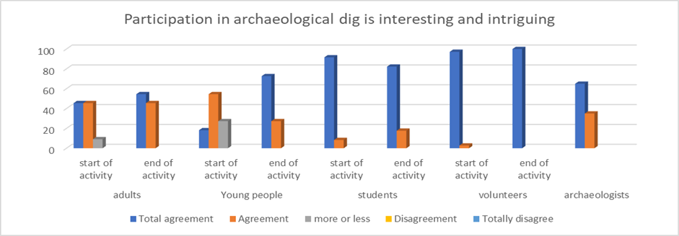
Figure 1
Participants frequently described the excavation as an ‘enriching and exciting experience’, particularly during moments of discovery, which were repeatedly cited as ‘emotionally powerful’ and ‘motivational’ (Image 1-3). Community participants indicated that excavation provided an enriching and exciting experience, which was stimulated during specific moments of discovery, and participants were ‘curious to discover something new and to be taught about it’ (VP). Participation in excavation was an experiential activity, which encouraged the acquisition of knowledge that supported individuals to learn, itw as noted by Some of the adult participants (students and volunteers). ‘adults are as curious as children and they also enjoy what they do if it leads to knowledge and something that will meet their needs’ (voulontier). The qualitative and quantitative results indicated that direct engagement with archaeological materials was a strong catalyst for intellectual stimulation and learning.

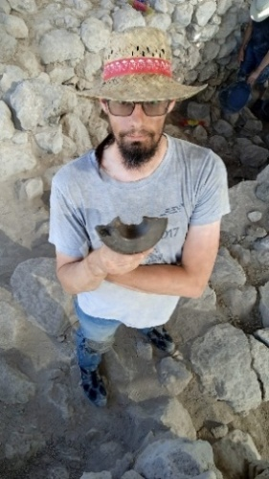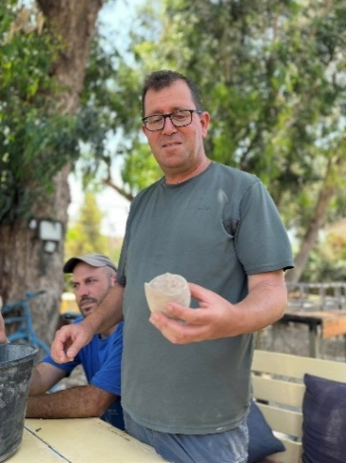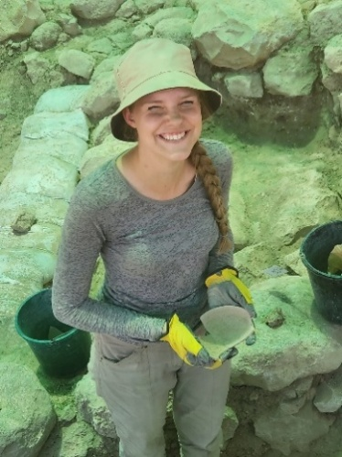
Images 1–3 The moments of discovery in the excavation and the look full of satisfaction

Experiential learning
The excavation was perceived by participants as offering a ‘different [type of] learning’, an informal education that was distinct from formal education. The quantitative results demonstrated that excavation was often understood as a unique and effective learning environment (Figure 2). Commentary indicated that this practical ‘experimental’ learning environment generated enjoyment, a sense of achievement, and a strengthened connection to the places’ historical and cultural layers. Participation in the archaeological excavation was perceived as a tool for learning that contrasted with those experiences in formal ‘school’ learning environments and classrooms, creating ‘an experience and fun in learning’ (IV) that supported participants to comprehend and potentially retain knowledge.(Figure 2).
Participants emphasized the emotional impact of discovery, ‘there is no more powerful experience than the moment when you discover a find that testifies to life here thousands of years ago’(VP). The degree of pleasure and feeling of happiness as expressed in the questionnaires reinforces this statement that links the experience to the mental feeling.
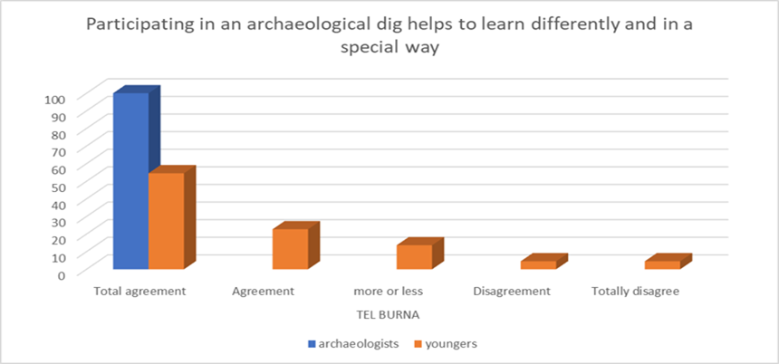
Figure 2

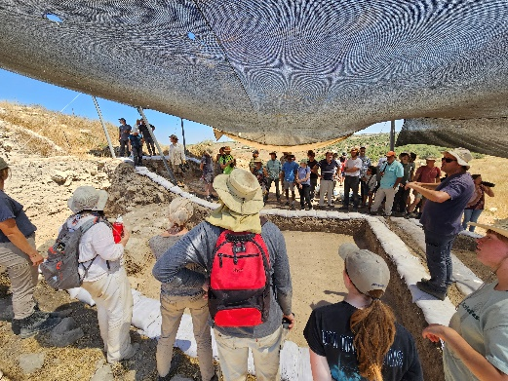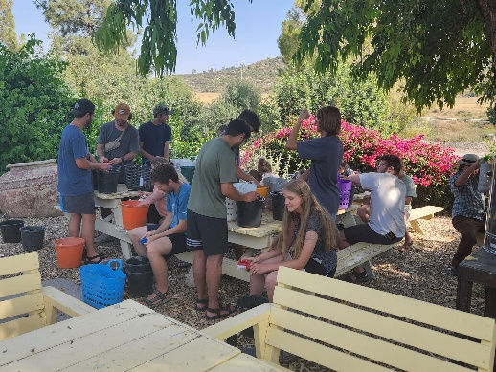
Images 4–5 Collaborative learning

Multidisciplinary learning
Participants, especially students, initially associated archaeology primarily with history and biblical studies. However, engagement in excavation altered this singularity, and quantitative data indicated a substantial expansion in the range of disciplines participants identified as relevant and associated with archaeological excavation (Figure 3). These subjects included geography, heritage studies, language, agriculture, art, and mathematics. Commentary correlated quantitative results ‘here they will learn many subjects through work and research in a more interesting way than inside the classroom at school’ (VP), and ‘history and Bible are the obvious subjects. However, there are touches on many other areas, such as language, mathematics, art, and daily life, which can easily be expressed in certain learning on the site. It is possible that every subject in one way or another will be connected to archaeology activities’ (VP).
This shift in perceptions of disciplinary boundaries demonstrated that through involvement in excavation, participants understood archaeology as an inherently multidisciplinary and interdisciplinary field, integrating scientific, environmental, historical, and cultural knowledge.

.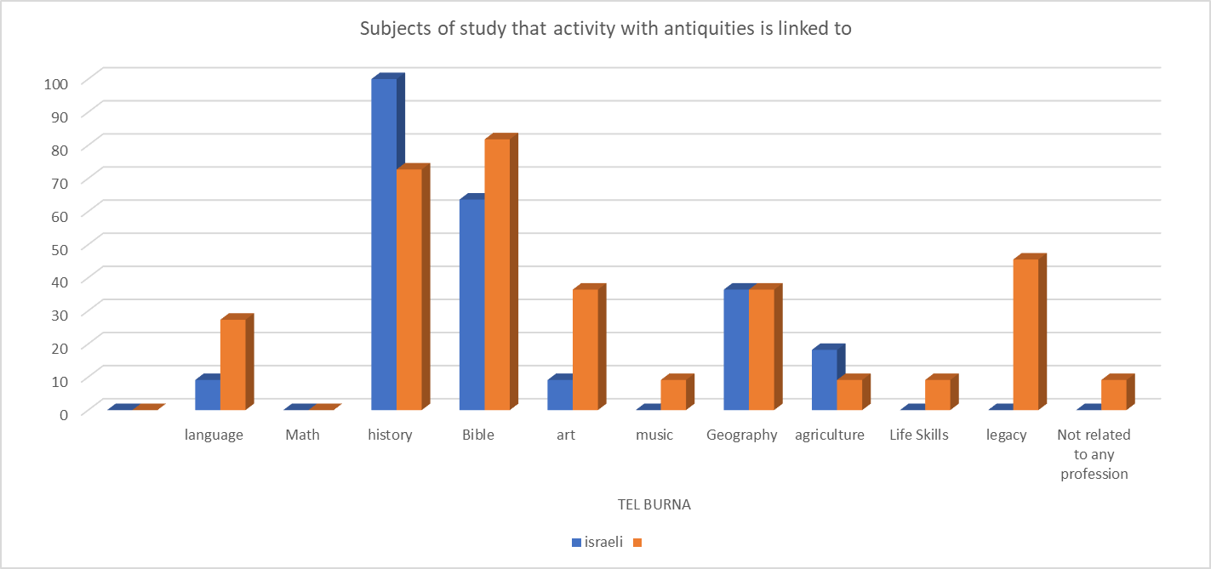
Figure 3

Learning about the place
Participants reported in conversations with them during the excavation and on tours of the site each week, as well as throughout the discussions during the workdays with the excavation leaders, a deeper understanding of the local environment and the broader historical landscape. Learning is made effective through direct involvement in site activities: "During the site tours at the end of a day of activity or during the weekly summary, we get an overall picture of what was discovered and the connection to the space, so that the picture that emerges is broad and comprehensive" (student from the US). International students emphasized the importance of excavations in an area rich in religious and historical significance: "When I dig here and share in the discoveries that come to the surface, I feel like I am learning in a special way about the place that I know from the Holy Books, but I am also a participant in the discovery itself, and it is an exciting experience" (a volunteer from the United States), while local participants emphasized the connection between the excavation and their communities: "Standing here with my daughters and telling them about this place that I know from my childhood and uncovering the history underground with them is exciting, and of course, later we tell about it at home and to friends on the kibbutz. I am sure that they will also come here in the future to see what we told about it" (a site visitor who lives in a community adjacent to the site).
During the excavation, the participants, who came to participate in the excavation from outside the country, noted that they learned about the past and present, often linking them to the country's past, noteing that “The curriculum fascinated me: the subject, the Holy Land, all the sites from different periods".
Participant observations, survey results and commentary indicated the excavation and post-excavation experience supported continuous learning, and supported the participant to connect the finds to both the places history and gain wider temporal awareness. The hands-on activities on site served as a bridge between theoretical knowledge and tangible experience, reinforcing learning through physical interaction with the past. "All of this created an understanding that learning would be interesting and enrich me with knowledge. After many years, I realized that I was right and that the interest in archaeology in Israel is full of learning and understanding of the past but also provides many experiences.’ (XX)

Sense of belonging
Quantitative data indicated a significant increase in participants’ sense of belonging to the land after active engagement in excavation (Figure 4). Interviews and informal conversations indicated that it was the practical engagement that played a central role in strengthening participants’ sense of belonging. Local participants often articulated this connection in terms of place-based continuity and intergenerational responsibility, commenting that they had visited with children so ‘they know what used to be here, next to where they live today’, emphasizing the role of the excavation in linking everyday life to local historical narratives.

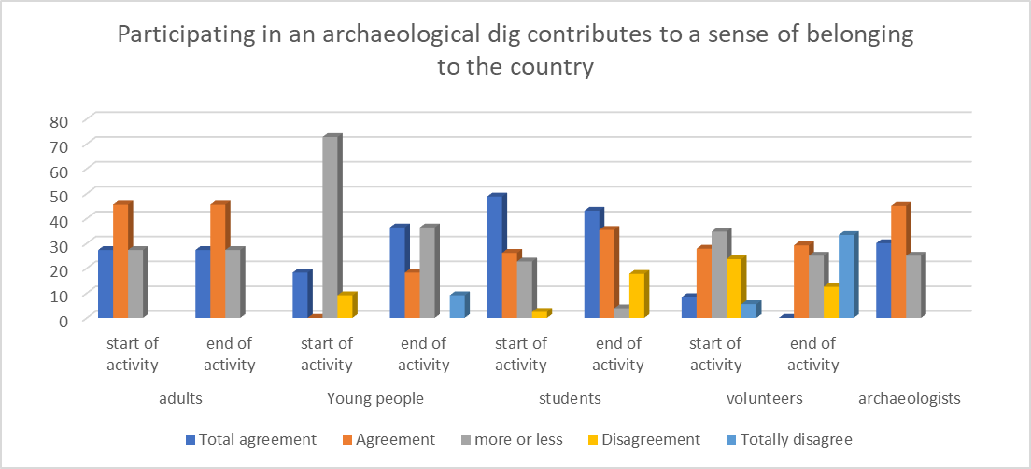
Figure 4

The trend of connection to place as a result of engagement with excavation was consistent across all groups examined, although qualitative data indicated that this was expressed differently amongst different demographics. Local participants described a connection to place and belonging in terms of physicality, continuity, and intergenerational responsibility, with parents stating that they wanted their children to ‘know what used to be here near where they live today’ (XX). Whilst International participants expressed symbolic, historical, and religious forms of belonging, often describing the excavation as a way to feel and to see the history through the eyes and the hands, they noted ‘here in the Land of Israel is the entire historical story of religions . . . discovering history underground connects and strengthens a connection to the country’ (XX)
International volunteers expressed a broader and symbolic-religious connection to the place through embodied involvement in its archaeological past, ‘to dig in the Holy Land and discover the past known from the Holy Books’ (FVP) and described it as an opportunity to break away from daily routine, to physically engage with history, and to experience the discovery of history firsthand. The discovery of remains from the distant past fostered local and transnational forms of belonging, ‘strengthens the connection to the land’ (xx) and mediated by direct interaction with the material past.

Responsibility and cooperation
The community excavation was grounded in supporting participants to understand and to take responsibility and ownerships for specific excavation area: this resulted in all participants reporting a heightened sense of responsibility during the excavation (Figure 5). In commentary participants emphasized the feeling of responsibility to ‘bring[ing] the past to the surface’ (SP) for future generations and noted ‘‘we have a responsibility to bring to the surface the past that we know from written history’ (SP).. This growing awareness of the responsibility was associated learning through experience about the need for careful, and precise work to avoid damaging artefacts or architectural features ‘the work must be carried out slowly and responsibly, since we do not know what is in the ground and the fear that it will be destroyed when the ground is exposed requires extreme caution’ (SP)
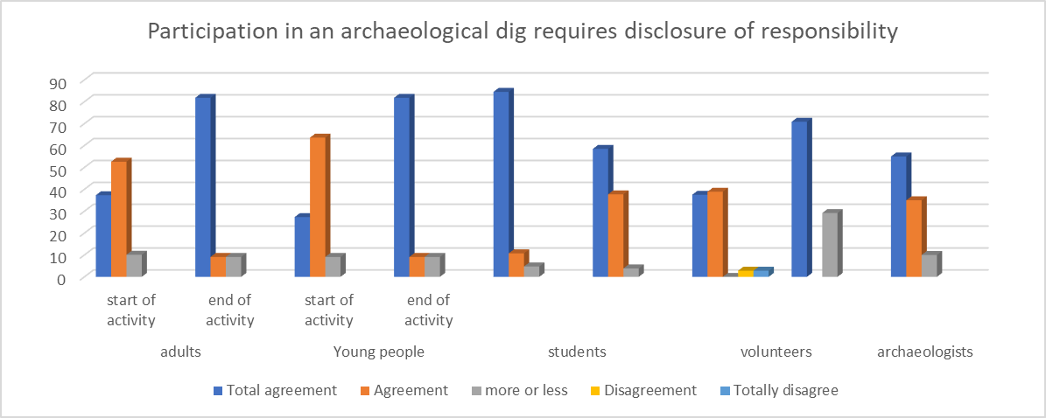

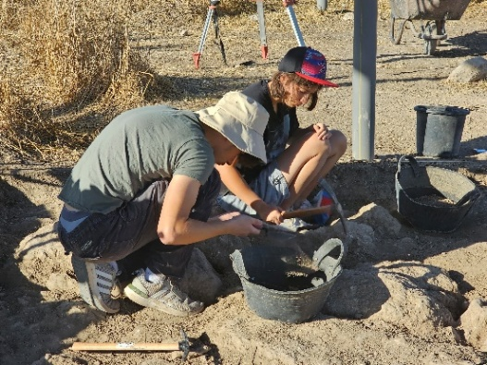
Image 6: Careful work with tools
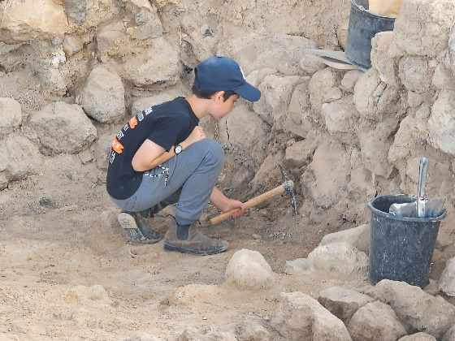

Image 7: Carefully uncovering a finding
The archaeological excavation activity required participants to work and act together responsibly as a team, forming a social unit that worked towards a common goal. The shared physical space of the excavation squares fostered dialogue, teamwork, and the formation of new social connections. Participants highlighted how they had learned the importance of cooperation and the value of careful collaborative work (Image 6). "During the excavation, I work with partners in the activity, whom I did not know before, from Israel and abroad. Throughout the days of excavation and the excitement of the activity and discoveries, we become partners in a laborious experience that requires joint work. It is impossible to carry out the activity in the small excavation pit alone. Another benefit is that from the shared conversations throughout the working hours, we get to know each other better" (volunteer from Israel).

Discussion
The findings, emerging from the research we conducted, show that archaeological excavations that integrate a community have the potential to provide powerful educational and social activity.
- Experiential learning: experiential learning emphasizes the importance of practical experiences and emotional processes in learning. John Dewey, in his model, argues that learning is a social process that develops from experiences. He emphasizes the need for inquiry and reflection. Kolb, in his model, describes the stages of learning (experience, reflection, theoretical elaboration, and practical training) and highlights the importance of practical experiences.
- Sociological constructivism: this theory argues that learning occurs in social contexts, where knowledge is constructed through interaction with others. For example, collaborative learning promotes deeper understanding.
- Heritage engagement: this concept concerns the connection between learners and their cultural and historical heritage. Place-based learning strengthens the connection between learners and the places where they live, encouraging exploration of local history and heritage. This experiential and exploratory learning is achieved through shared activities among participants, such as community projects or field research, thereby strengthening their connection to heritage and influencing their identities.

Experiential learning as a driver of engagement

According to constructivist models (e.g., Henson, 2016; McNeill, 2011), participation in an archaeological dig transformed learning from passive knowledge acquisition to active knowledge construction. The “moment of discovery,” or the process of exposure as repeatedly described by participants, serves as a catalyst for knowledge acquisition through emotional engagement, which facilitates and leads to the formation of long-term memory. “I come to the digs and enjoy the conversation with the participants and the researchers. I gained most of my knowledge in archaeology from participating in the various digs and conferences in the field” (volunteer from Israel). The experience of moments of discovery is a spurring trigger for learning about what is discovered and how it is discovered, about the period and what is happening in it. "Participants who come to the excavation as a volunteer come to it out of the experience. The acquaintance with the other participants and the interest and curiosity to discover and learn something new. In the moments when they sit and wash the potsherds and an instructive discourse takes place, that is where the acquisition of knowledge that is the result of the experiential activity in the excavation area comes into play" (field manager). The significant increase in curiosity scores (Figure 1) supports the claim that sensory and embodied learning environments improve motivation and cognitive absorption.

Archaeology as a multidisciplinary learning platform
The shift from a narrow disciplinary connection to a broad recognition of the multidisciplinary nature of archaeology demonstrates the field’s ability to integrate diverse fields of knowledge (Figure 3). This finding is consistent with broader research emphasizing archaeology’s role in connecting environmental, historical, cultural, and scientific perspectives. The science of archaeology is also inherently multidisciplinary as a result of the wide range of materials that archaeologists collect and analyze (Peter J. Cobbi Elvan Cobbii, Hayk Azizbekyan, 2022). Such integration is of great value in 21st century education, where multidisciplinary thinking and flexible application of knowledge are essential. As adults working in their environment, there is a need to integrate thinking and action across many fields of knowledge. The activities that students perform at historical and archaeological sites touch on diverse fields of knowledge (archaeology as a multidisciplinary field), and studying at these sites is a way to acquire tools and knowledge for adulthood.
Strengthening sense of belonging and identity
Research indicate that archaeology influences people's sense of belonging to a place and community, through knowledge of history. From looking at Figure 4, we see that the strenuous activity that took place in the field during the excavation and the discoveries therein provide experiences that increase the sense of belonging. These activities and discoveries strengthen both physical and social-spiritual connections. Local participants experienced a deep sense of belonging achieved through continuity and proximity to place, while international participants emphasized symbolic and religious connections. This duality exemplifies Sayer’s (2024) position that heritage sites are not only physical places but also spaces that foster personal and collective well-being. They can establish connections between people and meaningful narratives that shape their identities and experiences. The excavation also served as a social bridge, creating shared experiences among diverse participants – Israelis and foreigners, adults and children – thereby reinforcing community cohesion. Sayer (2024) in her article shows that the activity of individuals as a group in community activities helps to reduce anxiety (helping with mental well-being). The occupation of group members distracted and allowed patients to temporarily forget about their mental health problems. This conclusion is also consistent with the model of Holt (2023) which presents the idea of ​​community activity as a way to improve mental health.
Development of twenty-first-century skillsThe excavation environment naturally fostered key skills such as teamwork, responsibility, problem-solving, and investigative thinking. Involving diverse community participants in an excavation requires the application of these skills at some basic level. Figure 5 illustrates the strong sense of responsibility developed by the participants, reflecting the precision and care required in archaeological work. These findings are consistent with the skills required of scholars in the 21st century, which emphasize active, collaborative, and inquiry-based learning as essential for modern learners.

Implications for archaeology and education in Israel
Despite extensive activities by the Israel Antiquities Authority, there remains a notable gap in empirical research on the long-term educational and social impacts of community archaeology. This study demonstrates that archaeological excavations can serve not merely as enrichment activities but as robust pedagogical models that foster curiosity, identity, and social engagement. The results indicate that integrating archaeological fieldwork into educational curricula can significantly improve learning outcomes and strengthen awareness of cultural heritage. Going out for extracurricular learning that incorporates activity in an archaeological excavation will be an experience for learners, will lead to interest and a desire to know, and can serve as a basis for learning. Also, the laborious activity in the field will strengthen the participants' connection to heritage through the stories of the past and the findings that will be discovered.Conclusion
This research provides insights into how community-based archaeological excavations in Israel offer significant educational, social, and emotional benefits. The findings reveal several critical insights into the role of archaeology in education and community engagement. Experiential learning significantly enhances knowledge acquisition, as direct engagement with archaeological materials transforms learning into an active and memorable process. This hands-on approach not only deepens understanding but also fosters a lasting connection to the subject matter. Additionally, archaeology cultivates essential twenty-first-century skills. Participants practised teamwork, responsibility, inquiry, and problem-solving within an authentic research environment, equipping them with competencies vital for modern society. Furthermore, participation in archaeological projects strengthens identity and fosters a sense of belonging. Both local and international participants reported an intensified connection to the land, though this connection was expressed through distinct cultural lenses, highlighting the diverse ways in which heritage can resonate. Moreover, archaeology serves as a bridge between communities, as the shared experience of discovery fosters meaningful social bonds across age, nationality, and background.

dHowever, it is crucial to acknowledge that this study is only a starting point. More research is needed in Israel to explore the long-term impacts of such participatory experiences on individuals and the conservation of heritage. The findings underscore the importance of further investigation into these areas to fully understand the benefits and implications of archaeological engagement. Community archaeology should be recognized not only as an outreach activity but also as a comprehensive pedagogical model capable of fostering independent, curious, and socially connected learning. Community archaeology offers unique opportunities for active audience engagement, allowing participants to directly experience the exploration of their history and heritage. This model is not only a means of transmitting information but a platform for creating deep connections between people, promoting critical thinking, and encouraging intellectual curiosity. Through direct experiences in the field, participants develop not only a deeper understanding of the archaeological findings but also important social ties that connect different communities. Thus, community archaeology contributes not only to the preservation of history but also to the building of a more engaged and connected society, in which learning is a shared, diverse, and dynamic process.

Bibliography
‘Ubiquitous Learning: The Future of Education’ [accessed 2 July 2024]. Available at: <https://www.linkedin.com/pulse/ubiquitous-learning-future-education-smowl-1guef?trk=article-ssr-frontend-pulse_more-articles_related-content-card>.
Alon, Y. [accessed 26 September 2021]. Available at: <https://www.youtube.com/watch?v=CUpwFIvOaW8>.
Alon, Y. 1959. A Screen of Sand: Israel and the Arabs between War and Peace. Tel Aviv: Kibbutz Hameuhad, Hapoalim Library. [Hebrew].
Ambar-Armon, E. 2024. A New Approach to Community Archaeology in the Israel Antiquities Authority: A View from the Northern Region. In: R. Bonnie, M. Lorenzon, & Suzie Thomas, eds. Living Communities and Their Archaeologies in the Middle East. Helsinki: Helsinki University Press, pp. 91–119.
Barshad, D., ‘Inheritance Procedure’, Procedure Files at the Israel Antiquities Authority, effective date 10/31/2018, Israel Antiquities Authority. [Hebrew].
Bloom, B. S., Engelhart, M. D., Furst, E. J., Hill, W. H., & Krathwohl, D. R. 1956. Taxonomy of Educational Objectives: The Classification of Educational Goals. Handbook I: Cognitive Domain. New York: David McKay Company.
Chen, A. [accessed 2 April 2024]. Available at: <https://anatchn.wordpress.com/2014/04/12/%D7%9C%D7%9E%D7%94-%D7%94%D7%AA%D7%9B%D7%95%D7%95%D7%9F-%D7%A7%D7%95%D7%A0%D7%A4%D7%95%D7%A6%D7%99%D7%95%D7%A1-%D7%9B%D7%A9%D7%90%D7%9E%D7%A8-%D7%AA%D7%9E%D7%95%D7%A0%D7%94-%D7%90%D7%97%D7%AA-%D7%A9/>.
Cinnamon, G. 2008. The Archaeological Site as a Constituent of Local Identity: A Case Study of the Neighborhood Community of Ir Ganim and Kiryat Menachem. Jerusalem. In: M. Feiga and T. Shiloni, eds. A Spade to Dig Into: Archaeology and Nationalism in the Land of Israel. Jerusalem: Ben-Gurion Institute Press, pp. 187–206. [Hebrew].
Cobb, P. J., Cobb, E., and Azizbekyan, H. (2022). Interdisciplinary Learning in an Intercultural Setting during Archaeological Fieldwork. Academic Praxis, 2: 1-18.
Cohen-Tavor, A., Lavanda, A., Rothschild, M., Zichlinsky, A., & Ben-Shlomo, D. 2021. Educational Archaeological Excavations in the Barkan Githes. Judea and Samaria Studies, 1(1): 91–125. [Hebrew].
Cole, T. 2011. The Stanwell Mothers Project: Reaching Archaeologists and Communities. In: G. Moshenska & S. Dhanjal, eds. Community Archaeology: Themes, Methods and Practices. Oxford: Oxbow Books, pp. 71–9.
Document of the recommendations of the ministerial committee for the promotion of values ​​education, their implementation and assimilation [accessed 1 July 2024]. Available at: http://education.academy.ac.il/SystemFiles/values%20in%20the%20heart%20of%20education.pdf.
Doron, Y. 2018. Everything a Child Needs: From the Diary of an Educator. Jonathan Doron Publishing [Hebrew].
Edwards, Clifford H. 1982. Responsibility in Learning. Peabody Journal of Education, 59: 145–52.
Efthymia N., Laure, B., & Thilo, R. 2022. Archaeological Science Classroom Activities: A Free Multi-lingual Pedagogical Resource in Archaeological Science. Journal of Archaeological Science: Reports 45.
Feiga, M. 1998. Archaeology, Anthropology and Development Towns: The Design of the Israeli Place. In Zion 63(4): 441–459 [Hebrew]. , 3rd, 4th, pp. 441–59.
Feiga, M. 2009. Archaeology’s Imagined Communities: On Nationalism, Otherness, and the Surface. Democratic Culture, 72: 167–205. [Hebrew].
Feiga, M., & Shiloni, T. 2008. A Spade to Dig with: Archaeology and Nationalism in the Land of Israel. Jerusalem: Ben-Gurion Institute Press. [Hebrew].
Geva, S. 1992. Here in the Land of the Ancestral Delight: Israeli Biblical Archaeology at the Beginning of Its Journey. Zmanim: A Quarterly History, 42: 92–102. [Hebrew].
Ghattas J. S. 2010. Palestinian Archaeology: Knowledge, Awareness and Cultural Heritage. Present Pasts, 2: 58–71.
Giorgis, D., & Peterson, B. 1996. Teachers and Librarians Collaborate to Create a Community of Learners. Language Arts, 73: 477–82.
Goldschmidt, G. 1994. The Loss of Childhood – The Loss of Education: Education Today: Reflection – or Preparation for Modern Reality? Studies in Education, 59/60: 75–63. [Hebrew].
Gonen, S. 2010. Responsibility towards Self and Responsibility towards Others and What Lies between Them. Da’at – A Journal of Philosophy, 70: 131–97. [Hebrew].
Griffin, P. 2014. Performance Assessment of Higher Order Thinking. Journal of Applied Measurement, 15(1): 1–16.
Günter, M., & Marc, D. 2017. From Text to Image: Shaping a Visual Grounded Theory Methodology. Historical Social Research, 42: 280–300.
Hawtrey, K. 2007. Using Experiential Learning Techniques. Journal of Economic Education, 38: 143–52.
Henson, D. 2011. The Educational Purpose of Archaeology: A Kingdom View from the United Kingdom. In: Katsuyuki Okamura & Akira Matsuda, eds. New Perspectives in Global Public Archaeology. London: Springer, pp. 217–26.
Henson, D. 2016. Archaeology and education in the UK: Key Concepts. In: G. Moshenska, ed. Public Archaeology. London: UCL Press, pp. 43–59.
Hesse, F., Care, E., Buder, J., Sassenberg, K., & Griffin, P. 2015. A Framework for Teachable Collaborative Problem Solving Skills. In: P. Griffin and E. Care, eds. Assessment and Teaching of 21st Century Skills. Dordrecht: Springer, pp. 35–56.
Heyink, J. W., & Tymstra, TJ. 1993. The Function of Qualitative Research. Social Indicators Research, 29(3): 291–305.
Hill, A. 2013. The Place of Experience and the Experience of Place: Intersections Between Sustainability Education and Outdoor Learning. Australian Journal of Environmental Education, 29: 18–32.
Holt, N. (2023). 'The impact of remote arts on prescription: Changes in mood, attention and lone liness during art workshops as mechanisms for wellbeing change'. Nordic Journal of Arts, Culture and Health, 5(1), 1–13. https://doi.org/10.18261/njach.5.1.1
Huff Sisson, J., & Lash, M. 2017. Outdoor Learning Experiences Connecting Children to Nature: Perspectives from Australia and the United States. YC Young Children, 72(4): 8–16.
Isherwood, R. 2011. Community Archaeology: Conceptual and Political Issues. In: G. Moshenska & S. Dhanjal, eds. Community Archaeology: Themes, Methods and Practices. Oxford: Oxbow Books, pp. 6–17.
Israel Antiquities Authority website [accessed 12 January 2019]. Available at: <http://www.antiquities.org.il/>.
Jones, S. 2015. Archaeology and the Construction of Archaeology and the Construction of Community Identities. In: Michael Nevell & Norman Redhead, eds. Archaeology for All. Cambridge: Cambridge University Press, vol. 2, pp. 3–14.
Kakunda-Moalem, H. 2020. Mental Well-being and Significant Stressful Events as Risk Factors for Negative Attitudes towards Life among Jewish, Christian and Muslim adolescents and Young Adults. Educational–Social Work Meeting, Special Issue on Suicide Prevention, 75–100. [Hebrew].
Katz, H. 2011. Man Does Not Live on Pottery Alone. Haifa: Pardes Publishing. [Hebrew].
Katz, H. 2015. Archaeology Above and Archaeology Below: The Attitude of Religious Zionist Society to Archaeology 1948–1967. Kathedra, 160: 106–22 [Hebrew].
Krathwohl, D. R. 2002. A Revision of Bloom’s Taxonomy: An Overview. Theory into Practice, 41: 212–18.
La Salle, M., & Hutchings, R. 2016. What Makes Us Squirm: A Critical Assessment of Community-Oriented Archaeology. Canadian Journal of Archaeology/Journal Canadien d’Archéologie, 40: 164–80.
Marshall, Y. 2002. What Is Community Archaeology? World Archaeology, 34(2): 211–19.
May, V. 2011. Self, Belonging and Social Change. Sociology, 45: 363–78.
McKinny, C., Tavger, A., Cassuto, D., Sharp, S., Suriano, J. M., Ortiz, M. S., & Shai, I. 2020. Tel Burna after a Decade of Work: The Late Bronze and Iron Ages. Near Eastern Archaeology, 83(1): 4–15.
McMullin, E. 1996. Enlarging Imagination. Tijdschrift voor Filosofie, 227–60.
McNeill, H. 2011. The Use of Archaeology as Alternative Education. In: G. Moshenska & S. Dhanjal, eds. Community Archaeology: Themes, Methods and Practices. Oxford: Oxbow Books, pp. 80–9.
Micho-Tal H., Sena, Y., & Medzini, A. 2015. Training Teachers to Use Mobile Technologies in Extracurricular Learning: A Case Study. Horizons in Geography, 87: 112–25. [Hebrew].
Ministry of Education. Leading Values [accessed 22 January 2024]. Available at: <https://meyda.education.gov.il/files/noar/movilimarachim.pdf>.
Ministry of Education. Portal for Teaching Staff in the Field of Land of Israel Studies and Archaeology [accessed 22 January 2024]. Available at: <https://pop.education.gov.il/tchumey_daat/israel-studies-archeology/high-school/israel-studies-archeology-pedagogy/curriculum/>.
Mittelberg, D., & Valron, D. 2013. ‘Diaspora Jews Are Our Brothers’: Issues of Jewish Identity and Community among Young Israelis. Studies in Education, 7/8: 76–9. [Hebrew].
Moshenska, G., & Dhanjal, S. 2011. Introduction: Thinking about, Talking about, and Doing Community Archaeology. In: G. Moshenska & S. Dhanjal, eds. Community Archaeology: Themes, Methods and Practices. Oxford: Oxbow Books, pp. 1–5.
Moshenska, G., & Dhanjal, S. eds. 2011. Community Archaeology: Themes, Methods and Practices. Oxford: Oxbow Books.
Paz, Y. 2010. Community Archaeology in Proto-Historical Tel Bareqet, Israel: School Children and Agency for Active Public Engagement in Cultural Heritage Projects. Public Archaeology, 9: 34–47.
Saif, A. 1983. The Seven Dimensions of Education for Future Life. Studies in Education, 83: 196–205. [Hebrew].
Sayer, F. 2014. Politics and the Development of Community Archaeology in the UK. Historic Environment, 5(1): 55–73.
Sayer, F. 2022. Hard Roads to Travel: Lessons Learnt from Practising Community. Journal of Community Archaeology & Heritage, 9(4): 248–66.
Sayer, F. 2024. Heritage and Wellbeing: The Impact of Heritage Places on Visitors’ Wellbeing. Oxford: Oxford University Press.
Sayer, F, Leyva, R, Luck, A, Lidbetter, N & Smithson, D (2024), 'Testing The Potential Therapeutic Effects of An Online Creative Arts-Based Intervention For People With Anxiety', Arts and Health. https://doi.org/10.1080/17533015.2024.2364595 Luck, A & Sayer, F 2023, 'Dig
Shai, I. 2021. Tel Burna. [Accessed 23 December 2025] Available at: <https://www.hadashot-esi.org.il/Report_Detail_eng.aspx?print=all&id=25985&mag_id=133>.
Shai, I., & McKinny, C. 2020. Canaanite Votive Offerings and Their Significance within Their Context at Tel Burna. Israel Exploration Journal, 70(1): 1–17.
Shai, I., & Uziel, J. 2016. All for Archaeology and Archaeology for All: The Tel Burna Archaeology Project’s Approach to Community Archaeology. Journal of Community Archaeology & Heritage, 3: 57–69.
Sharan, S. 1989. Cooperative Learning in Small Groups: A Review of Research Methods. Studies in Education, 51/52: 114–87. [Hebrew].
Shavit, A. 2022. The Devil Walks in the City of God: The Archaeological–Community Project in the City of Lod. Rechovot: Discoveries Publishing House-Israel Institute of Archaeology. [Hebrew].
Simpson, F. 2011. Shoreditch Park Community Excavation: A Case Study. In: G. Moshenska & S. Dhanjal, eds. Community Archaeology: Themes, Methods and Practices. Oxford: Oxbow Books, pp. 115–19.
Sommer, U. 2017. Archaeology and nationalism. In: Gabriel Moshenska, ed. Key Concepts in Public Archaeology. London: UCL Press, pp. 166–86.
Tadmor, Y. 2014. Meaning Is a Serious Matter. Studies in Education, 12: 139–46 [Hebrew]..
Tripp, John C. 2011. Why Community Archaeology. In: G. Moshenska & S. Dhanjal, eds. Community Archaeology: Themes, Methods and Practices. Oxford: Oxbow Books, pp. 28–9.
Tully, G. 2007. Community Archaeology: General Methods and Standards of Practice. Public Archaeology, 6(3), 155–87.‏
Tully, G. 2015. Community Archaeology in Sudan: Discovering Mograt Island together. Aus der Archäologie: Der Antike Sudan, 26: 201–4.
Tzabar, B., N. 1999. Ethical Research in Teaching and Learning. Tel Aviv: Modan Publishing. [Hebrew].
Tzur, A., & Izikovitz, R. 2011. My Ideal School: A Look at Students’ School Experience from a Physical Environment Perspective. Studies in Education, 4: 144–70. [Hebrew].
UNESCO. 1998. Learning to Live Together in Peace and Harmony: Values Education for Peace, Human Rights, Democracy and Sustainable Development for the Asia-Pacific Region. Bangkok: UNESCO PROAP.
Yamarik, S. 2007. Does Cooperative Learning Improve Student Learning Outcomes? Journal of Economic Education, 38: 259–77.

Notes Antiquities Law, 1978 [accessed 29 August 2022]. Available at: <https://www.nevo.co.il/law_html/law01/p186_001.htm>.
Under the direction of Prof. Izhaq Shai and the auspices of the Institute of Archaeology, Ariel University.
The Sixth National Conference on the Knowledge of the Land, Yedioth, 15 (1949), p. 125.
No age limit was placed on the participants, so that interaction was created between professionals (i.e., experienced archaeologists and students, and laymen), between young people and adults, and between locals and foreigners. Young children had to be accompanied by their parents at all times. Parents and children shared in the work, further adding to their overall experience.

