Features of Digital Tools Utilized in Mathematical Modeling Process
Abstract
The modeling approach is used to prepare students to become responsible citizens and face the challenges and demands of modern times, mainly when they engage in modeling activities using digital tools. This study investigates the features of digital tools used in modeling processes among prospective teachers. Thirty-two prospective mathematics teachers participated in this study, and data were collected from video recordings of their participation in three modeling activities involving digital tools. The study’s findings show that in the first activity, most of the groups of participants used digital tools in the mathematical aspect of the modeling processes. However, in the final activity, participants used digital tools throughout most of the modeling processes. The findings also show that the level of digital tool utilization was neither dependent on time nor a specific activity. However, the average level of utilization of digital tools illustrates that changes did indeed occur between the first and the last activities in most of the modeling phases/actions. These changes in the utilization of digital tools rely on the complexity of the digital functions being used. This means that the participants changed how they used digital tools, shifting from using them at a basic level to using the more sophisticated functions found in digital tools.

Keywords: Modeling; Modeling Cycles; digital; Mathematics; Prospective Teachers.
Introduction
Modeling is defined as a process of developing representative descriptions for specific purposes in specific situations (Lesh & Lehrer, 2003, p. 109). Mathematical modeling, more specifically, is defined as the translation of a problem into a mathematical form to solve real-world problems and then test them in real-world contexts (Haines & Crouch, 2007). This process includes different stages (Stillman et al., 2007). The modeling approach involves hypothetical situations in realistic contexts where the information described is partial, vague, or undefined (Schukajlow et al., 2023). Such engagement in modeling activities leads participants to recognize the role of mathematics as a tool for interpreting reality and invites them to see the connections between mathematics and the real world (XXX, 2017). The modeling approach to learning and teaching mathematics focuses on the process of mathematizing real-world situations for learners (English & Fox, 2005) to prepare students to become responsible citizens and meet the challenges and demands of modern times (Lesh & Doerr, 2003). This is strongly advocated by the Organization for Economic Co-operation and Development (OECD) in the Program for International Student Assessment (PISA) study, which assesses students’ mathematical literacy (Cai et al., 2014). In addition, since technology has become an essential aspect of our daily lives, it has created new demands in the workplace that require integrating technology on multiple scales (Hoyles et al., 2010).
The use of digital tools is thus essential to the study of problem-solving more generally (Weber & Leikin, 2016) and modeling activities more particularly (English et al., 2016). Indeed, engaging in modeling activities using technology has improved technological literacy, considered a necessary 21st-century skill (Utami & Wilujeng, 2020). Various technological digital tools are used in modeling, including GeoGebra (see Greefrath & Siller, 2018), spreadsheets (see XXX, 2015), computer algebra systems (CAS) (see Geiger et al., 2010), and other software programs such as MatLab (see Jessen & Kjeldsen, 2023). English and others (2016) emphasize the need to investigate and monitor the complexity of integrating such technological digital tools in modeling activities. They also stress the need for integrated research to examine what modeling processes are affected by using digital tools such as GeoGebra and spreadsheets and to what extent.
Several studies have examined the use of digital tools in modeling activities and have explored how and when digital tools are used throughout the various modeling processes. Stillman and her colleagues (2007) reported that technology is integrated into all phases/actions of the modeling process. They offered a framework based on analyzing the transitions between various stages within the modeling process and the corresponding cognitive activities to facilitate the successful performance of mathematical modeling with technology. They illustrated their framework with one activity that detailed each transition. Later, Geiger and his colleagues (2010) examined the use of technology over one year. They also reported that technology emerged throughout all phases/actions of the modeling process. However, their focus was on interaction through the classrooms and not on how the use of digital tools changed over time. XXX (2015) detailed the different types of using digital tools throughout the modeling process. However, their study focused solely on one activity. Similarly, Greefrath and Siller (2018) also used a single activity to examine GeoGebra’s support for and integration of modeling processes. Likewise, Villarreal and her colleagues (2018) reported on the modeling stages in which technologies were used, with a focus on the final projects of their participants. Therefore, there is a need to investigate changes in the use of digital tools across multiple activities and conduct in-depth analyses of how digital tools are employed in the various stages of the modeling process.
The current study focuses on prospective teachers, aligning with the recommendation put forth by Niss et al. (2007) to incorporate modeling activities and technology-based modeling activities into teacher education programs. This is why courses based on the modeling approach have been developed worldwide (Cai et al., 2014), which helps prospective teachers understand modeling and later incorporate modeling activities into their classes (Kaiser & Maaß, 2007). Fostering teachers’ competencies in modeling and knowledge of the modeling approach is an essential component of teacher education (Alwast & Vorhölter, 2022). Developing prospective teachers’ modeling knowledge is often accomplished by engaging them in modeling activities as learners (XXX, 2018).

Theoretical Background
Using digital tools in mathematics education
Using digital tools in mathematics education can enhance teaching and learning opportunities (Hilton, 2018; Shin, 2022). Digital tools can help expand analytical activities within mathematics, which leads to the development of conceptual understanding and improves learners’ ability to express mathematical solutions effectively (Drijvers et al., 2013; Geiger & Redmond, 2013; Jacinto & Carreira, 2017) and foster student engagement (Cevikbas & Kaiser, 2022). Instrumental genesis is the term for a relationship between the user and the artifact, and covers both instrumentalization and instrumentation. The process of instrumentalization involves discovering and utilizing an artifact’s functionalities through practical learning, while instrumentation involves developing mental models and strategies for effectively using the tool from a cognitive aspect (Haspekian, 2014; Artigue, 2002). For instance, a recent study focusing on geometry explored how students’ use of “dragging schemes” can influence their understanding and utilization of geometric properties, creating a feedback loop in their cognitive processes (Pittalis & Drijvers, 2023). Another study focusing on solving equations and related word problems in algebra showed that students developed schemes for algebraic substitution, intertwining technical skills, and conceptual understanding(Jupri et al., 2016). Also, in statistical modeling, Van Dijke-Droogers et al. (2021) found that techniques in TinkerPlots enabled students to uncover patterns, facilitating a shift in the understanding of statistical modeling concepts and vice versa, deepening their exploration of digital techniques.
Modeling processes and cycles
The modeling approach emphasizes the process of learning and teaching mathematics, shifting from viewing it as the product of finding a solution to a particular problem to a process of creating a model that generates a system of relationships that is generalizable and reusable (Doerr, 2003). in solving modeling problems, learners go through multiple cycles of modeling processes (English & Fox, 2005). The term ‘modeling cycle’ refers to the cyclic nature of the modeling processes, including the description, prediction, and translation of data and products (Lesh & Doerr, 2003). The literature on this topic offers different ways to describe a modeling cycle (see Borromeo-Ferri, 2006). This study adopts the modeling cycle definition proposed by Blum and Leiß (2005), widely accepted among many scholars (see Kaiser, 2007). This modeling cycle organizes modeling processes into phases/actions. The following is a brief explanation of these phases/actions.
According to Blum and Leiß (2005), actions include (1) understanding and simplifying the situation; (2) presenting a real model; (3) working mathematically to construct a mathematical model; (4) producing mathematical results by applying the mathematical model; (5) providing a realistic interpretation of the mathematical results; and, lastly, (6) verifying the actual results according to the actual situation. These actions then lead to phases that comprise (a) a situational model that includes the mental representation of the situation, which depends on the mathematical thinking style of the modeler; (b) a real model that includes external representation to understand the situation; (c) a mathematical model that includes formulas and mathematical work with no reference to reality; (d) mathematical results that are obtained from applying the mathematical model; and, finally, (e) real results that are obtained from interpreting the mathematical results according to the real situation.
Different researchers (e.g., XXX , 2015; Greefrath, 2011; Greefrath & Siller, 2018) used Blum and Leiß’s modeling cycle to present the modeling process through engagement in modeling activities utilizing digital tools. They indicated digital tools could be used in different stages of the modeling process. In order to complete any modeling process, modelers need modeling competencies (Maaß, 2006). Stillman et al. (2007) proposed a list of modeling and technological competencies required to transition between modeling phases while engaging in modeling activities with digital tools. These include, for example, choosing technology to automate the application of formulae to multiple cases, produce a graphical representation of a model, and verify an algebraic model using technology.
Engaging in modeling activities by using digital tools
Several research studies reported on the potential of digital tools from different perspectives in modeling. Cevikbas et al. (2023) emphasized—through their review of 38 studies—the advantages of employing digital tools in mathematical modeling education, by examining different perspectives: emotional/psychological, pedagogical, cognitive, and social. Using digital tools with modeling facilitates model interpretation, decision-making, and validation, shifting the focus from mere calculations to strategic model planning and execution (Geiger, 2011; Greefrath et al., 2018). For example, GeoGebra supports students in modeling activities by creating, applying, and adopting mathematical and scientific models to interpret and predict real-world problems (Villamizar et al., 2020) and enhances understanding of mathematical concepts (Jessen & Kjeldsen, 2023). Also, spreadsheets support students in building technological models that answer the modeling activity demand (Arzarello et al., 2012; XXX, 2015) and support students in dealing with modeling activities with multiple variables and managing large data sets (Kreckler, 2017). The Internet could also be an advantage in developing mathematical modeling projects (Borba et al., 2016). More specifically, some studies specified the function of digital tools used in different stages of modeling; such as drawing, measuring and constructing by using Geogabra (Greefrath & Siller, 2018); finding information or data, selecting variables, formulating problems with the use of the Internet, or presenting data and program functions with the use of spreadsheets (Villarreal et al., 2018). This emphasized the digital tools utilized in the modeling process at different levels (Galbraith & Fisher, 2021). We need to know more about the relationship between technology and modeling by tracing participants’ digital tools utilization and determining the types and complexity of functions they used in different stages in the modeling process in the three modeling activities.
Modeling in teacher education
Teachers influence how students learn mathematical modeling (Cai et al., 2014). Therefore, as addressed in several studies, the qualifications of prospective teachers in modeling are considered an essential issue (e.g., Cai et al., 2022; Cetinkaya et al., 2016). As aforementioned, the development of prospective mathematics teachers’ knowledge of modeling can occur through their engagement in modeling activities as learners (XXX, 2018). Numerous studies have highlighted the positive effects of modeling activities for prospective mathematics teachers. These effects include providing teachers with the opportunity to recognize connections between mathematics and the real world (Altay et al., 2014), fostering their understanding of the nature of modeling and modeling tasks (Cetinkaya et al., 2016), enhancing their pedagogical content knowledge of mathematical modeling (such as improving their grasp of modeling tasks, processes, and interventions) (Greefrath et al., 2022), developing their modeling competences (XXX, 2023), increasing their self-efficacy in modeling (Maaß & Gurlitt, 2011), influencing their ability to construct modeling activities while considering different principles (Bukova-Güzel, 2011), and positively influencing teachers' socio-mathematical norms to shift from traditional to reform-oriented classroom norms (Yenmez & Erbaş, 2023).
Research questions
The present study investigates the characteristics of digital tools used in the modeling processes by prospective mathematics teachers. It aims to track the features of digital tools employed in various actions/phases of the modeling process and observe how these features evolve over time as participants engage in three modeling activities. In light of this, the main questions posed are:
- When are digital tools used in the modeling processes (if it is even used)? Does this use of digital tools change over time?
- What types of digital tools’ functions are used in the modeling processes (for example, the functions in GeoGebra, Spreadsheets, and the Internet)?
- How does the level of digital tools’ functions used in one phase/action affect the features of digital tools in other phases/actions?
Methodology
Research context, participants, and procedure
The study involved 32 prospective teachers in their second year of undergraduate studies in mathematics education at one teacher training college in the Arab community in Israel. The participants were selected based on availability and accessibility rather than through a random or systematic process (i.e., a convenience sampling method). The participants were enrolled in a one-year problem-solving course, which consisted of 28 face-to-face sessions, each lasting 90 minutes. The researcher designed and implemented the course, which covered a range of theoretical and practical research issues related to mathematical problem-solving. These topics included the structures and types of world problems and their impact on students’ problem-solving techniques, modeling approaches, solving strategies, and more. Specifically, three 90-minute meeting sessions were dedicated to technology-based modeling approaches. During each of these sessions, participants were tasked with solving a modeling activity using various digital tools. The participants were divided into seven groups, each consisting of 4–5 participants. The researcher introduced the activities and provided clarifications or general guidance to ensure that participants understood what they were expected to do. The researcher was not involved in the solution process, and avoided influencing the participants' decision-making processes. Data were collected from six out of seven groups because one group missed one of the activities. It is important to note that the modeling approach was not part of the curriculum at the College of Education attended by the participants. Additionally, it was not included as a subject in any of the courses the participants had enrolled in. This meant that the participants were being introduced to the modeling approach for the first time, and they had no prior experience or knowledge of technology-based modeling.
Data sources and analyses
Data were collected through video recordings of the six groups participating in the three modeling activities. Subsequently, the video recordings were transcribed under the researcher’s supervision, and the transcriptions included all the verbal comments and actions of the participants as they interacted with GeoGebra, spreadsheets, and the Internet. The data analysis was conducted in two stages. In the first stage, the phases/actions of the modeling processes were classified according to Blum and Leiß's (2005) modeling cycles approach see (Table 2) and using the constant comparison method (Glaser & Strauss, 1967).
The second stage involved classifying the features and functions of the digital tools used to solve modeling activity. The analysis in this stage was based on the constant comparison method (Glaser & Strauss, 1967), and it also drew from related research (see Greefrath & Siller, 2018; Villarreal et al., 2018). Table 1 presents a list of empirical literature that examines modeling processes using GeoGebra, spreadsheets, and the Internet.
Table 1. Digital functions in GeoGebra, Spreadsheets, and the Internet.
Resource | Categories
GeoGebra in Greefrath & Siller (2018, p. 369) | Mathematical drawing: Drawing simple geometrical objects within a coordinate system.  Constructing: Drawing more complex geometrical objects and configurations with the aid of intermediate steps.  Measuring: Determining the distance between points, the length of line segments, the magnitude of angles, and the slopes of lines or segments.  Experimenting: Varying the parameters, conditions, or assumptions of a sketch and observing the effects.  Calculating: Performing calculations using a physical or software-based calculator.
The Internet in Villarreal and others (2018, p.333) | Searching for data or information: Constructing the model and searching for numerical data and information that could help in understanding the phenomenon and formulating problems related to it.  Selecting variables.  Formulating or reformulating the problem.  Generating data using online applications.  Validating the model.
Spreadsheets in Villarreal and others (2018, p.333) | Displaying data: Displaying data using tables or different types of graphical representation to communicate the results from each modeling process.  Making simple calculations: Making calculations using the automatic affordances of spreadsheets.  Customizing program functions: Customizing functions using the native functions in Excel in order to make better and more efficient calculations.  Running simulations.  Applying the created model.
Each category is given a value from 1-3 based on the level of digital tools and features being employed (with 0 indicating the non-use of digital features, i.e., the lack of digital tools utilized); see Table 2.
Table 2. Examples of participants’ discourses and analyses.
Episode | Modeling Phase\Action  (first stage) | Level of and the Features of Digital Tools (second stage)
[15] Bayan: Let us draw circles using GeoGebra [draws two circles].  [21] Gadeer: When we enlarge the circle, the toothpaste tube opening enlarges, too. | Simplifying action: After reading the toothpaste-tube activity, the participants began to search for ways to simplify the problem by drawing circles using GeoGebra to illustrate the opening of the toothpaste tube. | The digital tool was solely used for drawing purposes.  The level of digital tools utilization is rated as “1”, as the participants only drew a static circle without utilizing more advanced GeoGebra functions.
[31] Bayan: Let us make an algebraic expression.  [33] Bayan: The algebraic expression should include the radius, which we will then use to calculate the volume of the cylinder.  [43] Rula: Let us make a table for each different radius.  [52] Bayan: Ok. And then, let us build the table using GeoGebra.  [65] Rula: Write the equation here.  [80] Bayan: It should include the value of the first and the second radiuses and the first and the second cylinders.  [96] Bayan: Now, let us draw two circles sharing the same center. | Mathematization: The participants constructed a mathematical model to solve the problem. | The digital tool was employed for  construction purposes, as the participants aimed to create an algebraic expression for calculating the volume of the cylinder.  This level of digital tools utilization is rated as “3”, as the participants actively engaged with and discussed the advanced features of GeoGebra. They also opened the spreadsheet window and attempted to formulate multiple algebraic expressions and equations suitable for solving the given cases.
[508] Shaheer: Let us represent the original radius in cell A1 in Excel [requesting the other participants to write in cell A1 in Excel spreadsheets].  [530] Shaheer: C constant should be 30 [Inserting data in cell C].  [537] Sofian: Here [in cell D2], we should write A2*A2 *C*3.14.  [538] Esawi: Here, in cell B, we should write the enlarged radius [writing the words ‘enlarged radius’ in cell B2].  [540] Shaheer: We must insert another column for the ratio E: D.  [601] Esawi: Now, we should insert big and small R in cells A5 and B5. | Translating the mathematical model to a digital model: The participants combined the mathematical model with digital technologies but without referencing the real-life situation proposed by the activity. | The digital tool was utilized for displaying data in tables and performing basic calculations through the automatic affordances function in the Excel spreadsheet.  The level of digital tools utilization is rated as “2” since the participants entered data in specific cells and used spreadsheet features to perform tasks like calculating the cylinder volume and ratios, which involved expressions derived from data division in different cells).

Following the two-stage analysis, the modeling sequence for each of the three modeling activities within each group was illustrated based on Blum and Leiß’s (2005) modeling.
Modeling sequence
The modeling sequence comprises three modeling activities. The participants engaged in these activities by using their computers, and they were required to construct technological models to answer the demands of each activity. They could use any of the provided digital tools (GeoGebra, spreadsheets, or the Internet) individually or in combination. The first activity, known as the “Toothpaste Tube Activity,” was designed by XXX (2016). In this activity, participants were tasked with eliciting a model that describes the change in consumption resulting from enlarging the opening of a toothpaste tube. The second activity is called the “Huge Shirt Activity” (see Appendix A). In this activity, participants were tasked with determining the number of shirts required by a company to create the giant sports shirt globally, as documented in the Guinness Book of Records. Finally, the third activity, the “Giant Foot Activity,” (see Appendix B). The second and third activities were designed by the researcher. Participants were tasked with determining the height of a giant based on the measurement of his footprint.
Findings
Types of digital tools utilized in the modeling processes
Analyses of the modeling processes of the six groups participating in the three modeling activities indicate that four distinct modeling cycles illustrate how digital tools are incorporated into the modeling processes. These modeling cycles are presented in Table 3.
Table 3. Types of digital tools utilized in the modeling cycles
Illustration of the Modeling Cycles | Features of Modeling Cycles
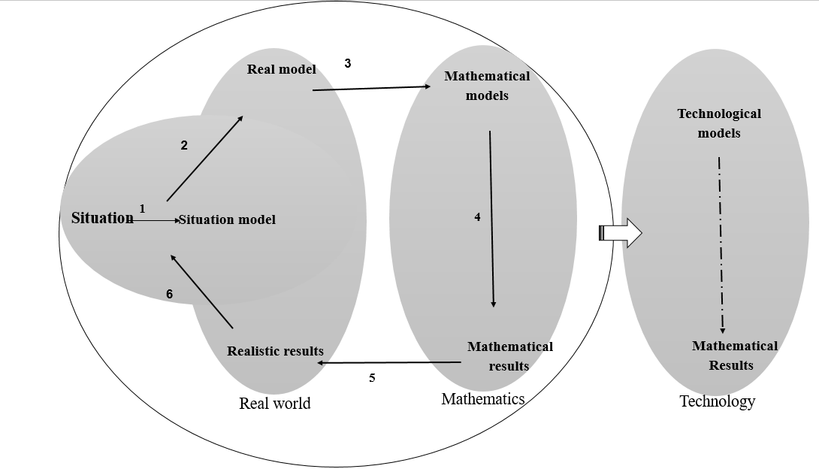  Fig 1. Modeling Cycle #1 | Utilization of digital tools at the end of a mathematical model: Following the elicitation and evaluation of the mathematical model, the participants reversed the mathematical model to create a technological model.
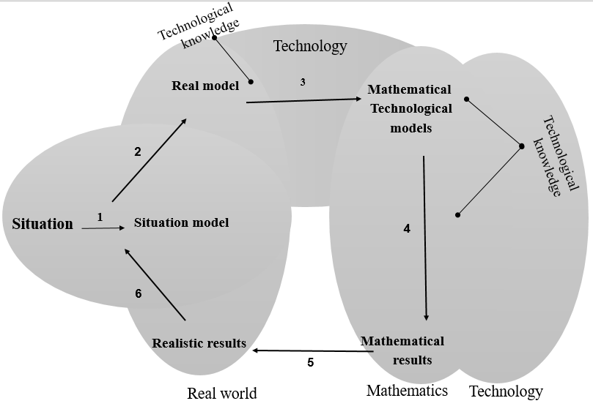  Fig 2. Modeling Cycle #2 | Utilization of digital tools throughout three actions of the modeling processes: This encompasses mathematizing, creating the mathematical model, and applying the mathematical model.
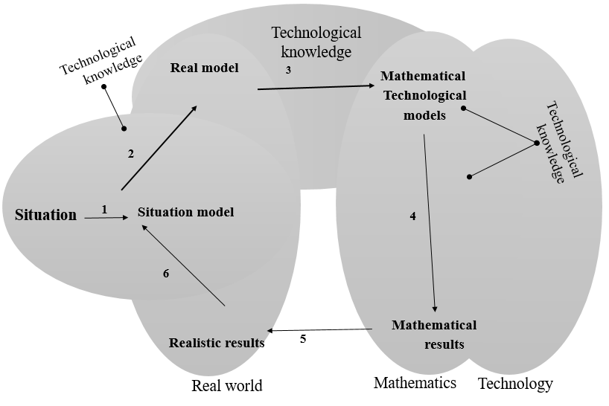  Fig 3.a. Modeling Cycle #3.a. | Utilization of digital tools across four stages of the modeling processes: This encompasses simplifying, mathematizing, creating the mathematical model, and applying the mathematical model.
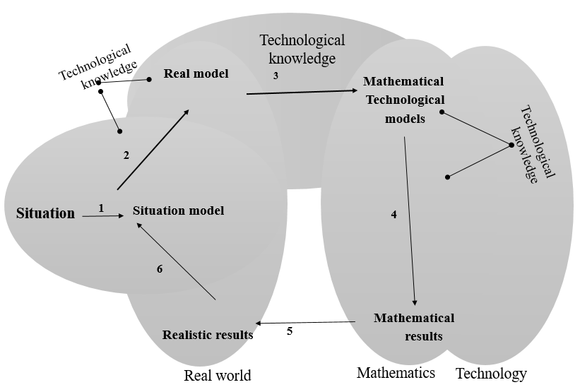  Fig 3. b. Modeling Cycle #3.b. | Utilization of digital tools throughout most stages of the modeling processes: This encompasses simplifying, creating the real model, mathematizing, creating the mathematical model, and applying the mathematical model.

In Table 3, Modeling Cycle #1 illustrates participants’ utilization of digital tools at the end of a mathematical solution. Modeling Cycle #2 illustrates participants’ partial use of digital tools throughout the modeling processes. While Modeling Cycle #3.a. and Modeling Cycle 3.b. illustrate participants’ advanced utilization of digital tools throughout all stages of the modeling processes.
Changes in digital tools utilization across the three activities
Table 4 represents the shifts in the use of digital tools throughout the modeling processes across the three activities. In this table, Modeling Cycle #1 emerges only during the first activity among one group. Nevertheless, in the third activity, almost all groups integrated digital tools and features throughout most modeling processes.
Table 4
Changes in digital tools utilization across the three activities
 | First Activity | Second Activity | Third Activity
Group 1 | Modeling Cycle #1 | Modeling Cycle #3.a. | Modeling Cycle #3.b.
Group 2 | Modeling Cycle #3.b. | Modeling Cycle #2 | Modeling Cycle #2
Group 3 | Modeling Cycle #3.b. | Modeling Cycle #3.b. | Modeling Cycle #3.b.
Group 4 | Modeling Cycle #2 | Modeling Cycle #2 | Modeling Cycle #3.b.
Group 5 | Modeling Cycle #2 | Modeling Cycle #3.b. | Modeling Cycle #3.b.
Group 6 | Modeling Cycle #2 | Modeling Cycle #3.b. | Modeling Cycle #3.b.
Features of digital tools utilized in the modeling process
As observed in Table 3, the utilization of digital tools varies across the five modeling phases/actions, from simplification, real model, mathematization, and mathematical model, applying the mathematical model. Internet is only employed in the simplification action of searching for data and information or as variable selection. Table 5 demonstrates the features of digital tools utilization and the specific digital functions employed in GeoGebra and spreadsheets throughout the modeling activities.
Table 5
The integrated digital functions across the three modeling activities
Modeling Phase\Action | GeoGebra | Spreadsheets
Simplification | Drawing.
Real Model | Mathematical drawing.  Drawing embodiment. | Displaying data using tables.
Mathematizing and Mathematical Model | Constructing and measuring.  Making simple calculations.  Constructing and customizing program functions. Using advanced functions. | Making simple calculations.  Constructing and customizing program functions.  Using advanced functions.
Applying the Mathematical Model | Calculating.  Experimenting and calculating. | Calculating.  Experimenting and calculating.
Table 5 shows that the drawing and measurement functions in GeoGebra were more practical for participants in simplifying and visualizing the real model compared to the spreadsheets. However, in the other modeling processes, similar functions were used in both digital tools.
Based on the levels of integrated digital functions, which are categorized from 0 to 3, the results obtained from the analyses (as described in the method section) demonstrate the presence of these various levels. Figure 4 illustrates the levels of integrated digital functions among the six groups throughout the three activities.

Fig 4. Levels of digital functions used in the modeling phases\actions among the six groups.
In general, the mathematizing actions and mathematical model phase received the highest level of digital tools utilization. In construct, simplification and the real model received the lowest level of digital tools utilization. The following section provides a detailed examination of the level of digital function utilization across the various modeling phases/actions.
Simplification. Digital tool utilization in the simplification actions occurred 11 times, with nine instances at Level 1 and 2 instances at Level 2. At Level 1, simplification involved drawing (refer to Episode 1) and searching for data or information. To use these functions, participants needed a basic knowledge of both GeoGebra and the Internet. At Level 2, simplification encompassed searching for data or information and selecting variables (see Episode 2). As illustrated in Figure 4, the level of digital tool utilization in the simplification phase did not influence the level of digital tool utilization in other modeling phases/actions.
Episode 1: Simplifying the Toothpaste tube activity by using GeoGebra
[2] Rula: When we regularly use the toothpaste tube, our consumption will increase.
[4] Ashar: Yes, it will increase.
[11] Rula: So, the toothpaste will finish faster.
[15] Bayan: Then let us draw circles with GeoGebra [draws two circles].
[21] Gadeer: When we enlarge the radius, the opening of the toothpaste tube enlarges too.
Episode 1 shows how the participants tried to simplify the problem to find out how the consumption of toothpaste will change over time. Rula [2;11], Ashar [4], and Bayan [15] used GeoGebra and drew circles to illustrate the opening of the toothpaste tube; this drawing function is considered an essential function in GeoGebra.
Episode 2: Simplifying the Huge T-Shirt activity by using the internet
[64] Alla: We must Fig out how many standard T-shirts it requires to make the huge one.
[65] Ola: We need to calculate the width and the length of the T-shirts.
[78] Rasha: And the medium.
[83] Alla: The length is 50 [after searching on the Internet].
[203] Olla: Small, medium, or large?
[207] Alla: The difference between the length is only 1 cm [after searching on the Internet].
Episode 2 shows how the participants found the t-shirt dimensions by searching on the internet (as presented in Alla’s [83, 207] interaction). The participants also used the internet to search for the different sizes of t-shirts and select different variables (as presented in Olla’s [203] interaction). These two episodes present different simplification processes. In Episode 1, the participants drew circles using GeoGebra, while in Episode 2, the participants used the Internet to search for information and select variables. It is noteworthy that drawing circles as a means of simplification also emerged among the groups that did not integrate digital tools (e.g., drew circles using pens and papers or used daily life examples to estimate the t-shirt dimensions).
Real model. Digital tool utilization in the real model phase occurred ten times, with eight instances at Level 1 and 2 instances at Level 2. At Level 1, digital tools were used for mathematical drawing and displaying data using tables (refer to Episode 3), while at Level 2, digital tools were employed for drawing embodiment (refer to Episode 4). Compared to including digital tools in other modeling phases/actions, the real model phase received the lowest level of digital tool utilization. It was similar to the level of digital tool utilization in the simplification action but less than the level of digital tool utilization in the mathematizing action.
Episode 3: Suggesting a real model at level 1 for the Toothpaste tube activity
[25] Rula: The solution is in the small cylinder [pointing at the first circle they drew with GeoGebra before drawing a similar circle].
[28] Ashar: The base of the cylinder will be more extensive, so the volume too will be bigger [pointing to the second circle drawn in GeoGebra and then drawing another similar circle].
[30] Ashar: So, the amount of toothpaste that will come from the toothpaste tube opening should be bigger.
Episode 4: Suggesting a real model at level 2 for the Toothpaste tube activity
[15] Esawi: We must find the amount of toothpaste that will come from the toothpaste tube opening.
[17] Shaheer: Let us draw the original opening [drawing a cylinder in GeoGebra].
[22] Sofian: Now we need to enlarge it.
[24] Sofian: Like that [draws a larger cylinder in GeoGebra].
In Episodes 3 and 4, Rula [25], Ashar [28,30], Shaheer [22], and Sofian [24] elicited real models to find out the amount of toothpaste that would come out of the toothpaste tube opening by comparing the original and the enlarged cylinder openings. In Episode 3, the participants drew another circle to illustrate the real model. While in Episode 4, participants used the embodiment of two cylinders.
Mathematizing and mathematical\technological model. Digital tool utilization in the mathematizing and mathematical model phases occurred 17 times, and it was distributed across levels (once at Level 1, six times at Level 2, and 10 times at Level 3). Level 2 involved making simple calculations (refer to Episode 5 and Fig. 5), while Level 3 encompassed the construction, customization of program functions, and the use of advanced functions (see Episode 6 and Fig 6).
Episode 5: Mathematical\technological model in spreadsheets for the Toothpaste tube activity
[203] Ola: We will do before and after [pointing at two columns].
[208] Alla: Put πr² here and the πr₁² here [writing each expression as a word in the first cell of each column].
[215] Rasha: Do you want to calculate the area of the circle each time?
[227] Rasha: No, it must be calculated using Excel functions [pointing to building a dynamic expression].
[260] Rasha: We must now multiply D by D, with cell D including the radius [writing a dynamic expression].
[278] Ola: Now E Minus C [cells C and E].
The participants discussed how to translate the mathematical model into a technological model. They first discussed the model’s frame and what it would look like. They then discussed using two columns, as shown in Ola’s [203] suggestion. Afterward, they thought about the data that they should use in the cells. They discussed whether to use words or variables, after which they constructed the technological model of dynamic expression (as presented by Alla [208], Rasha [215, 227], and Ola [278]). This is shown below in Fig 5.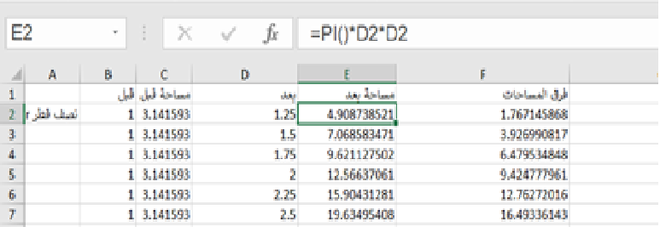
Fig 5. Translating the mathematical model using spreadsheets
In Fig 5, column B shows that the value of the radiuses before enlarging them is 1. In column C, the participants inserted the dynamic equation π*B2*B2. In column D, the participants inserted the values of the radiuses after enlarging them. In column E, the participants inserted the dynamic equation π*D2*D2 to calculate the area of each circle. In column F, the participants inserted an equation to calculate the differences between the areas.
Episode 6: Mathematical\technological model in GeoGebra for the Toothpaste tube activity
[165] Bayan: We must multiply the area bases by the height [of the cylinders].
[166] Rula: Let us use πr₁²*h to calculate the volume of the original cylinder and πr₂²*h to calculate the volume of the enlarged cylinder.
[160] Gadeer: Both are the same height.
[179] Ashar: The ratio is πr₂²*h: πr₁²*h.
[180] Rula: So, the radius that we identified has two decimals.
The participants elicited a mathematical/technological model by using their knowledge of both mathematics and digital tools. The model elicited is the ratio between the volume of the original cylinder and the volume of the enlarged cylinder (as presented by Ashar [179], who illustrated the amount of toothpaste that would come out of the tube). The extra technological knowledge can also be traced in Rula’s [180] identification of the optional values of the radiuses.
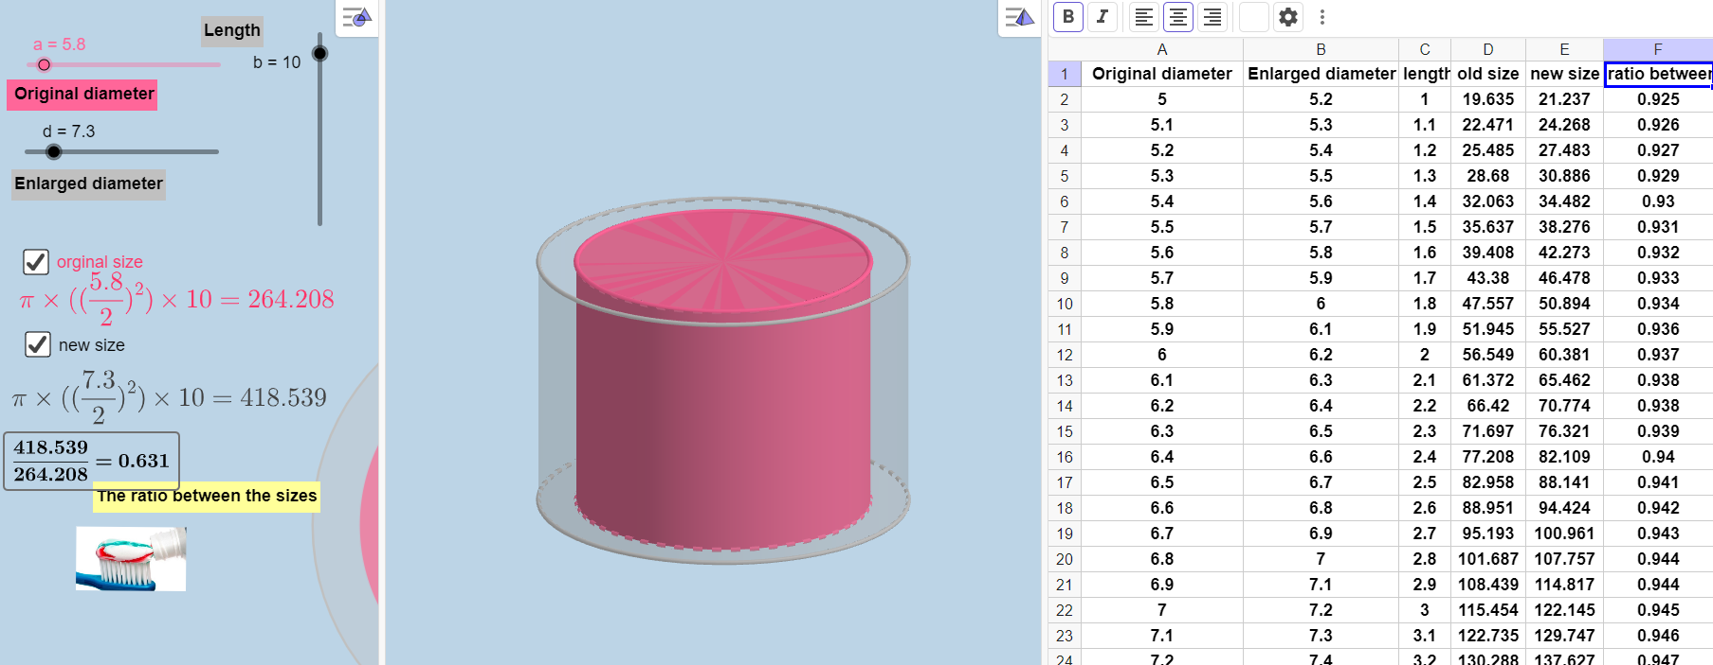
Fig 6. Illustrating the mathematical/technological model for the toothpaste tube activity
To the left of Fig 6, we can see a slide bar for the original radius, a slide bar for the enlarged radius, and a slide bar for the height of the cylinder. In the middle, we can see an image of the two cylinders. To the right side of Fig 6, the cells represent the relevant volumes of both cylinders. The volumes included in the cells were calculated using the equation πr²*h, which the participants constructed by themselves. Thus, the participants applied the mathematical/technological model by moving the slide bars to the right and left to get specific proportional values.
Applying the mathematical model. The level of digital tools utilized in the applying the mathematical action was always at Level 1, and it was lower than the level of digital tools utilized in the mathematical modeling phase. The level of digital tools utilized in this action mainly included calculating experimenting and calculating (see Episode 7), and the functions that were used were moving the slide bars in GeoGebra and substituting different values in the variables section.
Episode 7: Applying the mathematical model - experimenting and calculating
[192] Bayan: The radius is 3, so is the cylinder’s volume [moving the slide bar to get the value 3].
[193] Rula: 56 [referring to the volume of the cylinder]
[202] Bayan: [moving the slide bar] But if the radius is 1.5, then the volume of the cylinder is 14.
[203] Gadeer: Yes, the volume is 14.
[219] Ashar: The volume changes as the radius changes, so the consumption also changes. Here, the consumption changes by 4.
In Episode 7, the participants applied different values in the mathematical/technological model by moving the slide bars [192, 202]; this is considered an essential function in GeoGebra. Nevertheless, using this function, the participants reached the mathematical results 14 and 56 (as presented in [193, 202]). The participants also reached the mathematical result 4 (as presented in [219]).
Changes in the Level of digital tools utilization Among the Six Groups
The findings indicate that the level of utilization of digital tools did not always change with time (see Fig 7). For example, the level of digital tools utilized in Group 1 increased with time. However, in Group 2, the level of digital tools utilized was the highest during the first activity. Similarly, in Group 3, the level of digital tools utilized was the highest during the second activity rather than the third activity. In Group 6, the level of digital tools utilized increased during the second activity, but it remained at the same level during the third activity. The results also indicate that the level of digital tools utilized did not change according to the demands of each activity (see Fig. 8). For example, the first activity had a higher level of digital tools utilization than the second and third activities (Group 2). In comparison, the second activity had a higher level of digital tools utilization than the other two activities (Group 3). Moreover, the third activity had a higher level of digital tools utilization than the two other activities (Group 1). However, the average level of digital tools utilized in the modeling phases\actions among the six groups indicates an increase between the first and third activities and in all modeling phases/actions (except in applying the mathematical model, which remained almost the same across the three activities).

Fig 7. Changes in levels of digital tools utilization among the six groups

Fig 8. Changes in level of digital tools utilization among the six groups across each activity

Fig 9. The average of digital tools utilization complexity across the three activities

Discussion
This study investigates the features of the utilization of digital tools in modeling processes among prospective mathematics teachers. The findings showed two key changes in the participants’ use of digital tools: first, an improvement in digital tools through the modeling phases and actions, and second, an increased adoption of digital tool functions employed in each phase and action. These changes highlight participants' improved understanding of effective digital tool utilization through their involvement in modeling activities.
In the first activity, only two groups used digital tools for most of the modeling processes, while in the third activity, five groups used digital tools for most of the modeling processes. In the first activity, they limited their use of digital tools to the mathematical aspects of the modeling activity, while by the third activity, they also used the real-world aspects, which included the interpreting action and the real model. That means participants moved from viewing the digital tools as mere mathematicizing aids to integrating them as essential components for visualizing, developing, testing, and refining their model. This indicates that the digital tools transform into mathematical instruments that significantly affect students’ cognitive processes (Vergnaud, 2009). These results align with Jessen and Kjeldsen's (2023) findings, which reported that digital tools could extend beyond being mere calculators and shape students’ modeling processes. As emphasized by researchers (e.g., Zbiek et al., 2007), the progression of using the digital tools more for modeling processes can be attributed to the participants’ increased experience with these tools.,
The second change is in the adoption of more complex digital functions. The increase in the level of digital tools utilized among the six groups shows changes occurred between the first and the last activities in most of the modeling phases/actions. This means that the participants changed how they used digital tools, from a basic level to a more sophisticated level of use. For example, the findings show that through the mathematicizing action, the level of use increased from making simple calculations to constructing and customizing program functions. These changes show the practical aspect of learning the features of digital tools by utilizing their functions (Haspekia, 2014), as well as the development of participants’ mathematical digital competency (Geraniou & Jankvist, 2019).The participants come to understand the strengths and limitations of digital tools and learn which tools are suited to various mathematical situations.
Engaging in modeling activities offers the opportunity to develop proficiency in using digital tools. The modeling activities consist of open-ended problems that need to be interpreted and mathematicized by participants while working in small groups., This provides the opportunity for discussion and communication among participants (Shahbari & Peled, 2015) and is a highly interactive environment for the genesis of an artifact into an instrument (Artigue, 2002). In the current case, the discussion of the various features of digital tools leads to participants becoming more familiar with these features. These types of problem demand that participants choose multiple solution pathways; therefore, they have to identify the digital tool’s potential to meet the task challenge and then develop specific processes to use their digital tool efficiently (Geiger & Redmond, 2013). Another feature of modeling activities is the need to generalize models, as this is one of the principles of modeling (Lesh et al., 2000). It encourages participants to construct and use advanced functions, e.g., the dynamical spreadsheet models (Greefrath, 2011). In the current study, that means constructing dynamic equations in spreadsheets for the volume of cylinders in the toothpaste activity. Furthermore, the self-assessment feature in modeling activities through the modeling process (Lesh et al., 2000) encourages participants to discover verification and simulation features of digital tools, such as slide bars in GeoGebra, to assess the effect of different values of radiuses on the change of consumer in the toothpaste activity.
The primary implications of this research underscore the importance of incorporating courses that integrate modeling and digital tools into the curriculum of teacher training colleges. It emphasizes the need for prospective teachers to engage in a series of activities as learners rather than a single activity. This engagement of prospective teachers in multiple activities using digital tools can enhance the connection between modeling and technology and, at the same time, contribute to their understanding of the advanced functions of digital tools.
In light of these results, the study suggests conducting further research to explore teachers’ thoughts regarding using digital tools. This research should aim to understand why and when teachers prefer specific digital tools and for what purposes. Such an investigation will facilitate a comprehensive examination of changes in digital tool utilization across various phases/actions and provide insights into the overall effectiveness of digital tool utilization.

References
XXX (2015). International Journal of Science and Mathematics Education
XXX (2016)
XXX(2017) International Journal of Science and Mathematics Education
XXX (2018).
XXX (2023).
Altay, M. K., Özdemir, E. Y., & Akar, Ş. Ş. (2014). Pre-service elementary mathematics teachers’ views on model eliciting activities. Procedia-Social and Behavioral Sciences, 116, 345–349. ‏ https://doi: 10.1016/j.sbspro.2014.01.219
Alwast, A., & Vorhölter, K. (2022). Measuring pre-service teachers’ noticing competencies within a mathematical modeling context–an analysis of an instrument. Educational Studies in Mathematics, 109, 263–285. https://doi.org/10.1007/s10649-021-10102-8
Artigue, M. (2002). Learning mathematics in a CAS environment: The genesis of a reflection about instrumentation and the dialectics between technical and conceptual work. International Journal of Computers for Mathematical Learning, 7(3), 245–274. https://doi.org/10.1023/A:1022103903080
Arzarello, F., Ferrara, F., & Robutti, O. (2012). Mathematical modeling with technology: the role of dynamic representations. Teaching Mathematics and its Applications, 31(1), 20–30. https://doi.org/10.1007/s10649-021-10102-8
Blum, W., & Leiß, D. (2005). “Filling Up” - the problem of independence-preserving teacher interventions in lessons with demanding modeling tasks. In M. Bosch (Ed.), Proceedings of the fourth Congress of the European Society for Research in Mathematics education (CERME 4) (pp. 1623–1633). Fundemi Iqs, Universitat Ramon Llull.
Borba, M. C., Villarreal, M. E., & Soares, D. S. (2016). Modeling using data available on the internet. In C. Hirsch & E. McDuffie (Eds.), Mathematical modeling and modeling mathematics (pp. 143–152). Reston: National Council of Teacher of Mathematics.
Borromeo Ferri, R. (2006). Theoretical and empirical differentiations of phases in the modeling process. ZDM—The International Journal on Mathematics Education, 38(2), 86–95. https://doi.org/10.1007/BF02655883
Bukova-Güzel, E. (2011). An examination of pre-service mathematics teachers’ approaches to construct and solve mathematical modeling problems. Teaching Mathematics and its Applications: An International Journal of the IMA, 30(1), 19–36. https://doi.org/10.1093/teamat/hrq015
Cai, J., Cirillo, M., Pelesko, J., Ferri, R., Borba, M., Paulo, S., Geiger, V., Stillman, G., English, L., Wake, G., Kaiser, G., & Kwon, O. (2014). Mathematical modeling in school education: mathematical, cognitive, curricular, instructional, and teacher education perspectives. In P. Liljedahl, C. Nicol, S. Oesterle, & D. Allan (Eds), Proceedings of the 38th Conference of the International Group for the Psychology of Mathematics Education (pp. 145–172). PME.
Cai, J., LaRochelle, R., Hwang, S., & Kaiser, G. (2022). Expert and preservice secondary teachers’ competencies for noticing student thinking about modeling. Educational Studies in Mathematics, 109(2), 431–453. ‏ https://doi.org/10.1007/s10649-021-10071-y
Cetinkaya, B., Kertil, M., Erbas, A. K., Korkmaz, H., Alacaci, C., & Cakiroglu, E. (2016). Pre-service teachers’ developing conceptions about the nature and pedagogy of mathematical modeling in the context of a mathematical modeling course. Mathematical Thinking and Learning, 18(4), 287–314. ‏ https://doi.10.1080/10986065.2016.1219932
Cevikbas, M., Greefrath, G., & Siller, H. S. (2023). Advantages and challenges of using digital technologies in mathematical modeling education–a descriptive systematic literature review. Frontiers in Education, 8, 1142556. https://doi.org/10.3389/feduc.2023.1142556
Cevikbas, M., and Kaiser, G. (2022). Student engagement in a flipped secondary mathematics classroom. International Journal of Science and Mathematics Education. 20, 1455–1480. doi: 10.1007/ s10763-021-10213-x
Drijvers, P., Godino, J. D., Font, V., & Trouche, L. (2013). One episode, two lenses: A reflective analysis of student learning with computer algebra from instrumental and onto-semiotic perspectives. Educational Studies in Mathematics, 82(1), 23–49. https://doi.org/10.1007/s10649-012- 9416-8
English, L. D., Bergman Arleback, J., & Mousoulides, N. G. (2016). Reflections on progress in mathematical modeling research. In A. Gutierrez, G. Leder, & P. Boero (Eds.), The second handbook of research on the psychology of mathematics education: The Journey Continues (pp. 383–413). Sense Publishers. https://brill.com/view/book/edcoll/9789463005616/BP000012.xml
English, L. D., & Fox, J. L. (2005). Seventh-graders’ mathematical modeling on completion of a three-year program. In P. Clarkson, A. Downton, D. Gronn, M. Horne, A. McDonough, R. Pierce & A. Roche (Eds). Building connections: Theory, research and practice, (Vol. 1, pp. 321–328). Deakin University Press.
Galbraith, P., & Fisher, D. (2021). Technology and mathematical modelling: addressing challenges, opening doors. Quadrante, 30(1), 198-21. https://doi.org/10.48489/quadrante.23710
Galbraith, P., Renshaw, P., Goos, M., & Geiger, V. (2003). Technology-enriched classrooms: Some implications for teaching applications and modeling. In Q. Ye, W. Blum, S. K. Houston, & Q. Jiang (Eds.), Mathematical modeling in education and culture (pp. 111–125). Horwood. https://doi.org/10.1533/9780857099556.3.111
Geiger, V. (2011). Factors affecting teachers’ adoption of innovative practices with technology and mathematical modeling. In G. Kaiser, W. Blum, R. Borromeo Ferri & G. Stillman (Eds.), Trends in teaching and learning of mathematical modeling, (V.1, pp. 305–314). Springer. https://doi.org/10.1007/978-94-007-0910-2_31
Geiger, V., Faragher, R., & Goos, M. (2010). CAS-enabled technologies as “agents provocateurs” in teaching and learning mathematical modeling in secondary school classrooms. Mathematics Education Research Journal, 22(2), 48–68. https://doi.org/10.1007/BF03217565
Geiger, V., & Redmond, T. (2013). Designing mathematical modelling tasks in a technology rich secondary school context. In C. Margolinas (Ed.), Task design in mathematics education: Proceedings of ICMI Study 22 (pp. 119–128). Oxford: ICMI.
Geraniou, E., & Jankvist, U. T. (2019). Towards a definition of “mathematical digital competency.” Educational Studies in Mathematics, 102(1), 29–45. https://doi.org/10.1007/s10649-019-09893-8
Glaser, B. G. & Strauss, A. L. (1967). Discovery of grounded theory: Strategies for qualitative research. Aldine.
Greefrath (2011): Using Technologies: New Possibilities of Teaching and Learning Modelling – Overview. In Trends in Teaching and Learning of Mathematical Modelling: ICTMA 14, ed. G. Kaiser, W. Blum, R. Borromeo Ferri, and G. Stillman, 2009, Hamburg. pp. 301-304. New York: Springer.
Greefrath, G., Hertleif, C., & Siller, H. S. (2018). Mathematical modeling with digital tools—A quantitative study on mathematizing with dynamic geometry software. ZDM—The International Journal on Mathematics Education, 50(1–2), 233–244. https://doi.org/10.1007/s11858-018-0924-6
Greefrath, G., & Siller, H. S. (2018). GeoGebra as a tool in modeling processes. In L. Ball, P. Drijvers, S. Ladel, Siller, H. S., M. Tabach & C. Vale (Eds.), Uses of technology in primary and secondary mathematics education (pp. 363–374). Springer.
Greefrath, G., Siller, H. S., Klock, H., & Wess, R. (2022). Pre-service secondary teachers’ pedagogical content knowledge for the teaching of mathematical modeling. Educational Studies in Mathematics, 109(2), 383–407. ‏ https://doi.org/10.1007/s10649-021-10038-z
Guzey, S. S., & Roehrig, G. H. (2009). Teaching science with technology: case studies of science teachers’ development of technological pedagogical content knowledge (TPCK). Contemporary Issues in Technology and Teacher Education, 9(1), 25–45. ‏ https://www.learntechlib.org/primary/p/29293/.
Haines, C., & Crouch, R. (2007). Mathematical modeling and applications: Ability and competence frameworks. In W. Blum, P. L. Galbraith, H.-W. Henn & M. Niss (Eds.), Modeling and applications in mathematics education: The 14th ICMI study (pp. 417–424). Springer. https://doi.org/10.1007/978-0-387-29822-1_46
Haspekian, M. (2014). Teachers’ instrumental geneses when integrating spreadsheet software. In A. Clark-Wilson, O. Robutti, & N. Sinclair (Eds.), The mathematics teacher in the digital era: An international perspective on technology focused professional development (pp. 241–276). Dordrecht: Springer. https://doi.org/10.1007/978-94-007-4638-1_11
Hilton, A. (2018). Engaging primary school students in mathematics: Can iPads make a difference?. International Journal of Science and Mathematics Education, 16(1), 145–165. https://doi.org/10.1007/s10763-016-9771-5
Hoyles, C., Noss, R., Kent, P., & Bakker, A. (2010). Improving mathematics at work: The need for techno-mathematical literacies. Routledge. https://doi.org/10.1007/978-0-387-29822-1_46
Jacinto, H., & Carreira, S. (2017). Mathematical problem solving with technology: The technomathematical fluency of a student-with-GeoGebra. International Journal of Science and Mathematics Education, 15(6), 1115–1136. https://doi.org/10.1007/s10763-016-9728-8
Jessen, B. E., & Kjeldsen, T. H. (2023). Mathematical modeling and digital tools—and how a merger can support students’ learning. In In: Jankvist, U.T., Geraniou, E. (Eds), Mathematical competencies in the digital era, (Vol 20, pp. 99–118). Cham: Springer International Publishing. ‏ https://doi.org/10.1007/978-3-031-10141-0_6
Jupri, A., Drijvers, P., & van den Heuvel-Panhuizen, M. (2016). An instrumentation theory view on students’ use of an applet for algebraic substitution. The International Journal for Technology in Mathematics Education, 23(2), 63–79. DOI:10.1564/tme_v23.2.02
Kaiser, G., & Maaß, K. (2007). Modeling in lower secondary mathematics classroom—problems and opportunities. In W. Blum, W. Henne, & M. Niss (Eds.), Applications and modeling in mathematics education: The 14th ICMI study (pp. 99–108). Kluwer. https://doi.org/10.1007/978-0-387-29822-1_8
Kreckler J (2017) Implementing modelling into classrooms: results of an empirical research study. In G. A. Stillman, W. Blum, & G. Kaiser (Eds.), Mathematical Modelling and Applications. Crossing and Researching Boundaries in Mathematics Education (pp. 277–287). Springer. https://doi.org/10.1007/978-3-319-62968-1_24
Kaiser, G. (2007). Modeling and modeling competencies in school. In C. Haines, P. Galbraith, W. Blum & S. Khan (Eds.), Mathematical modeling: Education, engineering and economics, ICTMA 12 (pp. 110–119). Chichester: Horwood. https://doi.org/10.1533/9780857099419.3.110
Lesh, R., & Doerr, H. (2003). Foundations of a models and modeling perspective on mathematics teaching, learning, and problem solving. In R. Lesh & H. Doerr (Eds.), Beyond constructivism, models and modeling perspectives on mathematics problem solving, learning and teaching (pp. 3–34). Lawrence Erlbaum.
Lesh, R., Hoover, M., Hole, B., Kelly, A., & Post, T. (2000). Principles for developing thought-revealing activities for students and teachers. In R. Lesh & A. Kelly (Eds.), Handbook of research design in mathematics and science education (pp. 591–644). Mahwah, NJ: Erlbaum.
Lesh, R., & Lehrer, R. (2003). Models and modeling perspectives on the development of students and teachers. Mathematical Thinking and Learning, 5(2–3), 109–129. https://doi.org/10.1080/10986065.2003.9679996
‏Maaß, K. (2006). What are modeling competencies? ZDM—The International Journal on Mathematics Education, 38(2), 113–142. ‏ https://doi.org/10.1007/BF02655885
Maaß, K., & Gurlitt, J. (2011). LEMA – Professional development of teachers in relation to mathematical modeling. In G. Kaiser, W. Blum, R. Borromeo Ferri, & G. Stillman (Eds.), Trends in teaching and learning of mathematical modeling, (Vol. 1, pp. 629–639). Springer Netherlands. https://doi.org/10.1007/978-94-007-0910-2_60
Pittalis, M., & Drijvers, P. (2023). Embodied instrumentation in a dynamic geometry environment: Eleven-year-old students’ dragging schemes. Educational Studies in Mathematics, 113(2), 181–205. https://doi.org/10.1007/s10649-023-10222-3
Schukajlow, S., Krawitz, J., Kanefke, J. Blum, W. Rakoczy, K. (2023). Open modeling problems: cognitive barriers and instructional prompts. Educational Studies in Mathematics, 114(3), 4117-438. https://doi.org/10.1007/s10649-023-10265-6
Shin, D. (2022). Teaching mathematics integrating intelligent tutoring systems: Investigating prospective teachers’ concerns and TPACK. International Journal of Science and Mathematics Education, 20(8), 1659-1676. https://doi.org/10.1007/s10763-021- 10221-x
Siller, H.-S. & Greefrath, G. (2010). Mathematical modeling in class regarding technology. In V. Durand-Guerrier, S. Soury-Lavergne, and F. Arzarello (Eds.), Proceedings of the sixth congress of the European society for research in mathematics education (CERME 6) (pp. 2136–2145). ERME.
Stillman, G., Galbraith, P., Brown, J., & Edwards, I. (2007). A framework for success in implementing mathematical modeling in the secondary classroom. In J. Watson & K. Beswick (Eds.), Proceedings of the 30th mathematics education research group of Australasia conference mathematics: Essential research, essential practice, (Vol.2, pp. 688707). MERGA. http://www.merga.net.au/documents/RP642007.pdf
Utami, V. B., & Wilujeng, I. (2020). STEM application through simple technology to improve technology literacy. Journal of Physics: Conference Series, 1440(1), 12–50. DOI 10.1088/1742-6596/1440/1/012050
Van Dijke-Droogers, M., Drijvers, P., & Bakker, A. (2021). Statistical modeling processes through the lens of instrumental genesis. Educational Studies in Mathematics, 107(2), 235-260.‏ https://doi.org/10.1007/s10649-020-10023-y
Villarreal, M. E., Esteley, C. B., & Smith, S. (2018). Pre-service teachers’ experiences within modeling scenarios enriched by digital technologies. ZDM—The International Journal on Mathematics Education, 50(1–2), 327–341. https://doi.org/10.1007/s11858-018-0925-5
Villamizar, F., Martínez, A., Cuevas, C., & Espinosa-Castro, J. (2020, March). Mathematical modeling with digital technological tools for interpretation of contextual situations. Journal of Physics: Conference Series, 1514(1), 1–6. https://doi 10.1088/1742-6596/1514/1/012003
Weber, K., & Leikin, R. (2016). Recent advances in research on problem solving and problem posing. In A. Gutiérrez, P. Boero, & G. Leder (Eds.), The second handbook of research on the psychology of mathematics education (pp. 353–382). Sense. https://doi.org/10.1007/9789463005616_011
Yenmez, A. A., & Erbaş, A. K. (2023). Facilitating a sustainable transformation of sociomathematical norms through mathematical modeling activities. International Journal of Science and Mathematics Education, 21(3), 761-785.‏ https://doi.org/10.1007/s10763-022-10275-5
Zbiek, R. M., Heid, M. K., Blume, G. W., & Dick, T. P. (2007). Research on technology in mathematics education: A perspective of constructs. In F. K. Lester (Ed.), Second handbook of research on mathematics teaching and learning (pp. 1169–1207). Charlotte: Information Age.

Appendix A: The Huge Shirt Activity
Qatar has set a new record for the largest sports shirt in the world as part of a celebration held on Tuesday (November 23) at Aspire Park in Doha. The huge shirt was placed on the ground to be measured by Guinness rulers, and a new world record for a shirt’s size was announced, measuring 72.2 meters in length and 48.7 meters in width. Qatar Petrochemical Company contributed to producing this huge cotton shirt, which weighed six tons. The company’s general manager stated that registering this shirt in the Guinness Book of Records is part of a plan to support Qatar’s bid to host the 2022 FIFA World Cup. As an administrator, you are asked to find out how many real shirts the company needs to knit to make this huge shirt. Explain your findings.
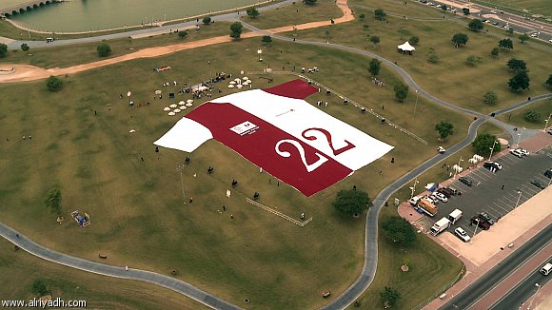

Appendix B: The Giant Foot Activity
Archaeologists occasionally find traces of giants in different parts of the world. This time, they have found footprints of a giant human foot, measuring 120 centimeters long. Scientists have several reasons to believe that historical giants had lived on our planet, but they are not revealing them. Ancient sources also confirm that the first human species that inhabited the planet millions of years ago were giants. You are required to find the height of the giant using the measurement of this footprint.

